ASSIGNMENT :

Pseudo Code :

CLASS VehicleOperations:
FUNCTION insertVehicle(vehicleId, userId, plate, model, battery):
TRY:
con = DBConnection.getConnection()
query = "INSERT INTO vehicles VALUES (?, ?, ?, ?, ?)"
ps = con.prepareStatement(query)
ps.setInt(1, vehicleId)
ps.setInt(2, userId)
ps.setString(3, plate)
ps.setString(4, model)
ps.setDouble(5, battery)

rows = ps.executeUpdate()
RETURN (rows > 0)
CATCH SQLException e:
DISPLAY "Database error: " + e.getMessage()
RETURN false
FINALLY:
CLOSE ps, con
END TRY
END FUNCTION

FUNCTION validateAndBookSlot(pointId, startTime, endTime):
TRY:
con = DBConnection.getConnection()
checkQuery = "SELECT COUNT(*) FROM reservations WHERE point_id = ? AND status = 'CONFIRMED' "
+ "AND ((start_time <= ? AND end_time >= ?) OR (start_time <= ? AND end_time >= ?))"
psCheck = con.prepareStatement(checkQuery)
psCheck.setInt(1, pointId)
psCheck.setTimestamp(2, startTime)
psCheck.setTimestamp(3, startTime)
psCheck.setTimestamp(4, endTime)
psCheck.setTimestamp(5, endTime)

rs = psCheck.executeQuery()
IF rs.next() AND rs.getInt(1) > 0:
DISPLAY "Conflict detected: Port already booked for this duration."
RETURN false
END IF

// Proceed to reserve
reserveQuery = "INSERT INTO reservations (point_id, start_time, end_time, status) VALUES (?, ?, ?, 'CONFIRMED')"
psReserve = con.prepareStatement(reserveQuery)
psReserve.setInt(1, pointId)
psReserve.setTimestamp(2, startTime)
psReserve.setTimestamp(3, endTime)
psReserve.executeUpdate()
RETURN true
FINALLY:
CLOSE rs, psCheck, con
END TRY
END FUNCTION
END CLASS

FUNCTION completeCharging(sessionId, energyUsedKwh, paymentMode):
TRY:
con = DBConnection.getConnection()
cstmt = con.prepareCall("{CALL sp_CompleteChargingSession(?, ?, ?)}")
cstmt.setInt(1, sessionId)
cstmt.setDouble(2, energyUsedKwh)
cstmt.registerOutParameter(3, Types.DECIMAL)
cstmt.execute()

calculatedCost = cstmt.getDouble(3)

payStmt = con.prepareStatement("INSERT INTO payments (session_id, amount_paid, payment_mode) VALUES (?, ?, ?)")
payStmt.setInt(1, sessionId)
payStmt.setDouble(2, calculatedCost)
payStmt.setString(3, paymentMode)
payStmt.executeUpdate()

RETURN calculatedCost
CATCH SQLException ex:
DISPLAY "Billing failure: " + ex.getMessage()
RETURN -1.0
FINALLY:
CLOSE cstmt, payStmt, con
END TRY
END FUNCTION

Class Diagram :
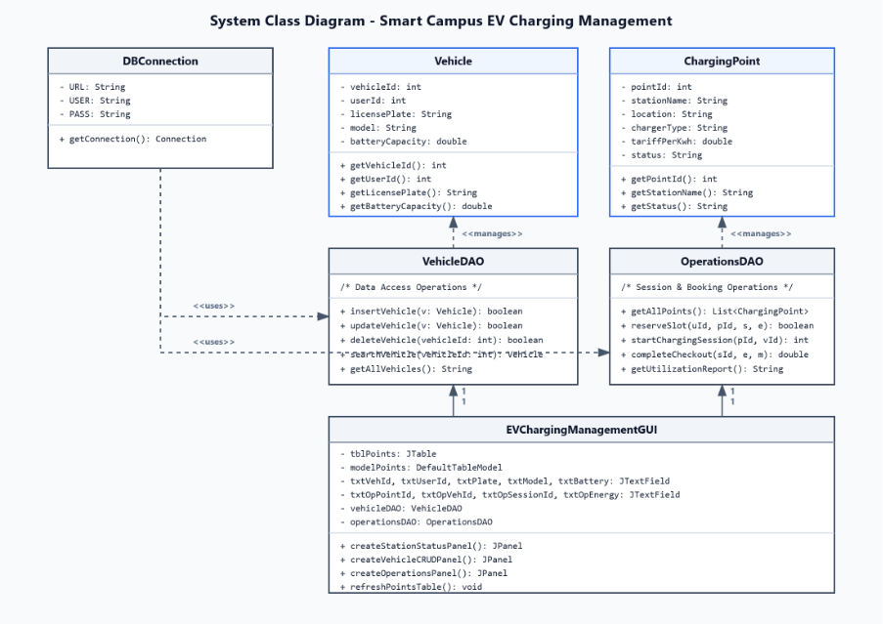
Use Case Diagram :
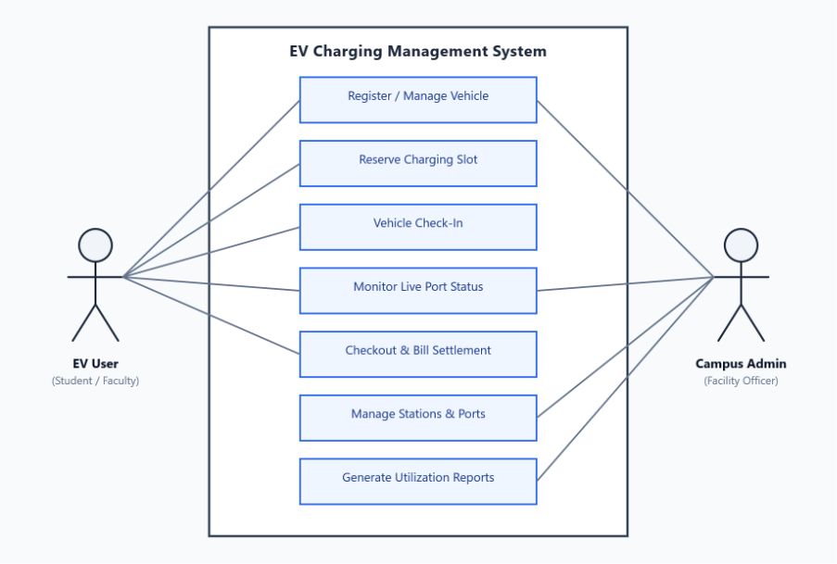
Activity Diagram :
