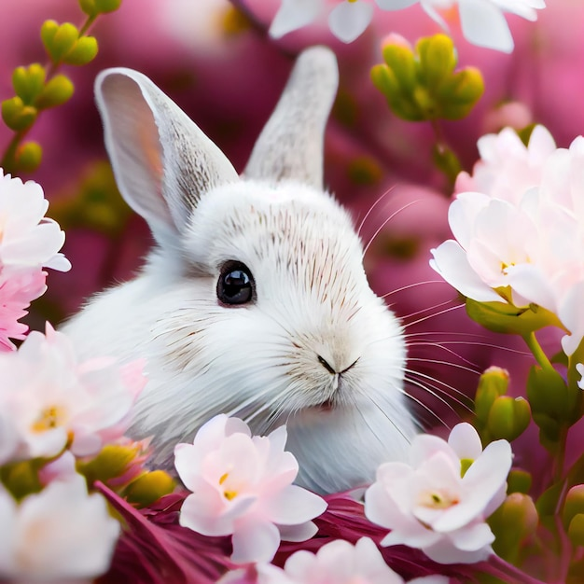

Rabbit

**“A rabbit’s greatest strength lies in its ability to bounce back.”**

**“A rabbit teaches us to hop over obstacles and keep moving forward.”**

**“Rabbits remind us that even the smallest creatures can leave a big impact.”**

**“In the presence of a rabbit, worries tend to hop away.”**

**“The joy of a rabbit is found in the simplicity of nibbling on life’s greens.”**

**“Rabbits symbolize fertility, growth, and new beginnings.”**

**“When life gets burrowed in chaos, be a rabbit and dig your way out.”**

**“Rabbits remind us to embrace our playful nature and hop into adventure.”**

**“A rabbit’s gentle twitching nose whispers secrets of the world around us.”**

**“Just like a rabbit’s ears, always stay alert to the opportunities around you.”**