ThinkBridge Api Details

(Endpoint, HttpMethod, Request Format)

**Picture Upload**

Method : Post

Endpoint : https://localhost:44302/api/picture/

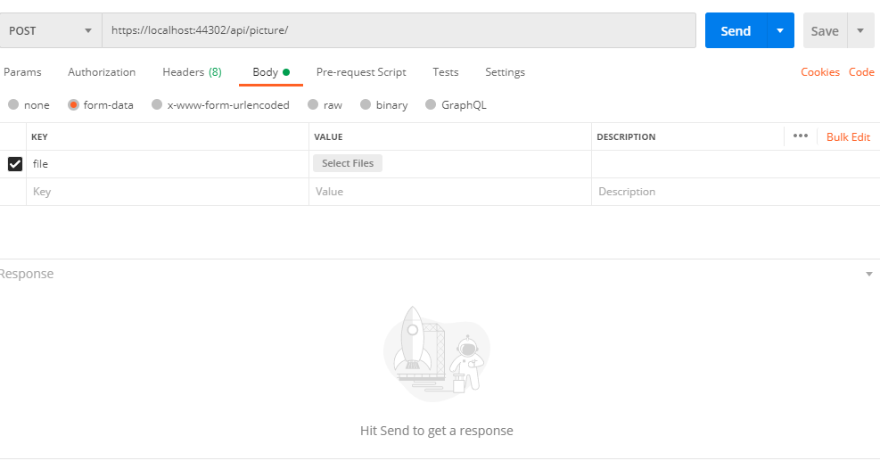

**Category – Crud Operations**

**Add Category**

**EndPoint :** [**https://localhost:44302/api/category/**](https://localhost:44302/api/category/)

**Method : Post**{

  "Name":"Category 4",  "Description": "Description",  "MetaKeywords": "MetaKeywords",  "MetaDescription": "MetaDescription",

  "MetaTitle": "MetaTitle",  "ParentCategoryId": 0,  "PictureId": 9,  "PictureUrl": **null**,

  "PageSize": 10,

  "AllowCustomersToSelectPageSize": **false**,

  "PageSizeOptions": **null**,

  "PriceRanges": **null**,

  "ShowOnHomePage": **false**,

  "IncludeInTopMenu": **false**,

  "Published": **true**,

  "Deleted": **false**,

  "DisplayOrder": 0

}

**Category List**

EndPoint : <https://localhost:44302/api/category/>

Method : Get

**Delete Category – Its soft delete**

EndPoint : <https://localhost:44302/api/category/>4

Method : Delete

**Update Category**

EndPoint : <https://localhost:44302/api/category/>

Method : Put

{

"Id":1,

  "Name":"Category 1 Update",

  "Description": "Description",

  "MetaKeywords": "MetaKeywords",

  "MetaDescription": "MetaDescription",

  "MetaTitle": "MetaTitle",

  "ParentCategoryId": 0,

  "PictureId": 9,

  "PictureUrl": **null**,

  "PageSize": 10,

  "AllowCustomersToSelectPageSize": **false**,

  "PageSizeOptions": **null**,

  "PriceRanges": **null**,

  "ShowOnHomePage": **false**,

  "IncludeInTopMenu": **false**,

  "Published": **true**,

  "Deleted": **false**,

  "DisplayOrder": 0

}

**Manufacturer**

**Add Manufacturer**

EndPoint : [https://localhost:44302/api/ manufacturer/](https://localhost:44302/api/category/)

Method : Post

{

  "Name": "Manufacturer 3",  "Description": "Description",  "MetaKeywords": "MetaKeywords",

  "MetaDescription": "MetaDescription",  "MetaTitle": **null**,  "PictureId": 10,  "PictureUrl": **null**,

  "PageSize": 10,  "Published": **true**,

  "Deleted": **false**,  "DisplayOrder": 0

}

**Delete Manufacturer**

EndPoint : https://localhost:44302/api/manufacturer/4

Method : Delete

**Get Manufacturer**

EndPoint : https://localhost:44302/api/manufacturer/4

Method : Get

**Manufacturer List**

EndPoint : https://localhost:44302/api/manufacturer/

Method : Get

**Manufacturer Update**

EndPoint : https://localhost:44302/api/manufacturer/

Method : Get  
{

  "Id":4,

  "Name": "Manufacturer  to update",

  "Description": "Description",

  "MetaKeywords": "MetaKeywords",

  "MetaDescription": "MetaDescription",

  "MetaTitle": **null**,

  "PictureId": 10,

  "PictureUrl": **null**,

  "PageSize": 10,

  "Published": **true**,

  "Deleted": **false**,

  "DisplayOrder": 0

}

**Product**

**Get Product**

EndPoint : <https://localhost:44302/api/product/1>

Method : Get

**Delete Product**

EndPoint : <https://localhost:44302/api/product/deleteproduct/1>

Method : Get

**Add Product**

EndPoint : <https://localhost:44302/api/product/t>

Method : Post

{

  "Name": "Test product 4",

  "ShortDescription": "ShortDescription",

  "FullDescription": "Full Decription",

  "ShowOnHomePage": **false**,

  "MetaKeywords": "TestMetaKey",

  "MetaDescription": "TestMetaDesc",

  "MetaTitle": "TestMetaTitle",

  "AllowCustomerReviews": **false**,

  "Sku": "ABCD",

  "IsShipEnabled": **false**,

  "IsFreeShipping": **false**,

  "ShipSeparately": **false**,

  "AdditionalShippingCharge": 0.0,

  "StockQuantity": 10000,

  "DisplayStockAvailability": **true**,

  "DisplayStockQuantity": **true**,

  "MinStockQuantity": 10,

  "NotifyAdminForQuantityBelow": 0,

  "AllowBackInStockSubscriptions": **false**,

  "OrderMinimumQuantity": 1,

  "OrderMaximumQuantity": 10,

  "NotReturnable": **false**,

  "DisableBuyButton": **false**,

  "AvailableForPreOrder": **false**,

  "PreOrderAvailabilityStartDateTimeUtc": **null**,

  "CallForPrice": **false**,

  "Price": 50.00,

  "OldPrice": 70.00,

  "ProductCost": 60.00,

  "BasepriceAmount": 50,

  "Weight": 0.0,

  "Length": 0.0,

  "Width": 0.0,

  "Height": 0.0,

  "AvailableStartDateTimeUtc": **null**,

  "AvailableEndDateTimeUtc": **null**,

  "DisplayOrder": 1,

  "Published": **true**,

  "Deleted": **false**

}

**Update Product**

EndPoint : https://localhost:44302/api/product/

Method : Put

{

  "Id": 4,

"Name": "Test product 4 To Update",

  "ShortDescription": "ShortDescription",

  "FullDescription": "Full Decription",

  "ShowOnHomePage": **false**,

  "MetaKeywords": "TestMetaKey",

  "MetaDescription": "TestMetaDesc",

  "MetaTitle": "TestMetaTitle",

  "AllowCustomerReviews": **false**,

  "Sku": "ABCD",

  "IsShipEnabled": **false**,

  "IsFreeShipping": **false**,

  "ShipSeparately": **false**,

  "AdditionalShippingCharge": 0.0,

  "StockQuantity": 10000,

  "DisplayStockAvailability": **true**,

  "DisplayStockQuantity": **true**,

  "MinStockQuantity": 10,

  "NotifyAdminForQuantityBelow": 0,

  "AllowBackInStockSubscriptions": **false**,

  "OrderMinimumQuantity": 1,

  "OrderMaximumQuantity": 10,

  "NotReturnable": **false**,

  "DisableBuyButton": **false**,

  "AvailableForPreOrder": **false**,

  "PreOrderAvailabilityStartDateTimeUtc": **null**,

  "CallForPrice": **false**,

  "Price": 50.00,

  "OldPrice": 70.00,

  "ProductCost": 60.00,

  "BasepriceAmount": 50,

  "Weight": 0.0,

  "Length": 0.0,

  "Width": 0.0,

  "Height": 0.0,

  "AvailableStartDateTimeUtc": **null**,

  "AvailableEndDateTimeUtc": **null**,

  "DisplayOrder": 1,

  "Published": **true**,

  "Deleted": **false**

}

**Product Category Mapping : Add Product in Category**

EndPoint : <https://localhost:44302/api/product/AddProductCategory>

Method : Post

{

  "ProductId": 1020,

  "CategoryId": 1

}

**Get Product Category**

**EndPoint :** [**https://localhost:44302/api/product/GetProductCategory/1020**](https://localhost:44302/api/product/GetProductCategory/1020)

**Method : Get**

**Delete Product Category**

**EndPoint :** [**https://localhost:44302/api/product/DeleteProductCategory/**](https://localhost:44302/api/product/DeleteProductCategory/)

**Method : Post**

{

  "ProductId": 1020,

  "CategoryId": 1

}

**Product Picture Mapping : Add Image in Product**

EndPoint : https://localhost:44302/api/product/AddProductPicture/

Method : Post

{

  "ProductId": 1020,

  "PictureId": 10

}

**Get Product Picture by product id**

EndPoint : <https://localhost:44302/api/product/GetProductPicture/1020>

Method : Get

**Delete Product Category**

**EndPoint : https://localhost:44302/api/product/DeleteProductPicture/**

**Method : Post**

{

  "ProductId": 1020,

  "PictureId": 9

}

**Manufacturer**

**Product Manufacture Mapping : Add**

**EndPoin :** [**https://localhost:44302/api/product/AddProductManufacturer/**](https://localhost:44302/api/product/AddProductManufacturer/)

**Method : Post**

{

  "ProductId": 1020,

  "ManufacturerId": 1,

  "IsFeaturedProduct":**false**,

  "DisplayOrder":1

}

**Get Product Manufacture by product Id**

**EndPoint :** [**https://localhost:44302/api/product/GetProductManufacturer/1020**](https://localhost:44302/api/product/GetProductManufacturer/1020)

**Method : Get**

**Delete Product Manufacture by product Id**

**EndPoint :** [**https://localhost:44302/api/product/DeleteProductManufacturer/1020**](https://localhost:44302/api/product/DeleteProductManufacturer/1020)

**Method : Post**

{

  "ProductId": 1020,

  "ManufacturerId": 1,

  "IsFeaturedProduct":**false**,

  "DisplayOrder":1

}

**Product Search – Paging, Filtering**

**EndPoint :** [**https://localhost:44302/api/product/GetProducts/**](https://localhost:44302/api/product/GetProducts/)

**Method : Post**

|  |  |  |
| --- | --- | --- |
| {    "Page": 1,    "PageSize": 3,    "SearchProductName": "t",    "SearchCategoryId": 0,    "SearchManufacturerId": 1  } | {    "Page": 1,    "PageSize": 3,    "SearchProductName": "t",    "SearchCategoryId": 0,    "SearchManufacturerId": 0  } | {    "Page": 1,    "PageSize": 3,    "SearchProductName": "t",    "SearchCategoryId": 1,    "SearchManufacturerId": 1  } |