

Day 1 — Web Development ki shuruaat
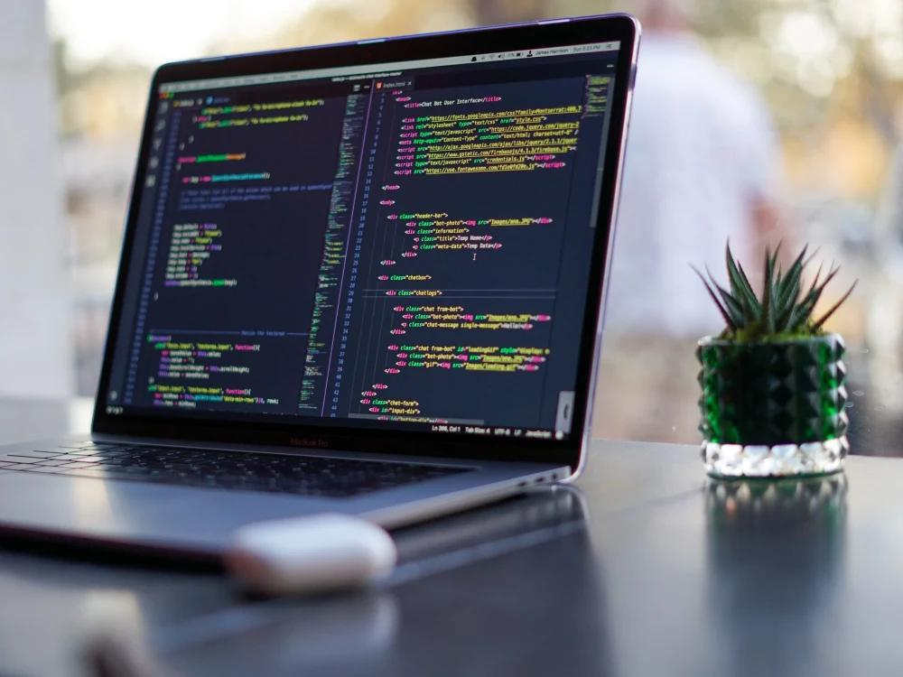

1. Aaj hum kya seekhenge?
Website kya hoti hai?
HTML, CSS aur JavaScript kya hain?
VS Code mein pehli website banana
Website ko browser mein chalana

2. Website kya hoti hai?
Website ek collection hoti hai webpages ka, jinhe hum internet browser mein dekh sakte hain.
Jaise:
- Google — search karne ke liye.
- YouTube — videos dekhne ke liye.
- Amazon — online shopping ke liye.
- Aapke institute ki website — courses aur admission ki information ke liye.

3. Website banane ki 3 main languages

HTML — Structure
Website mein heading, paragraph, image aur button kahan honge, ye batata hai.

CSS — Design
Website ke colors, size, layout aur decoration ko control karta hai.

JavaScript — Functionality
Button click, calculator, menus aur interactive features banane mein madad karta hai.
Ek simple example: HTML ghar ka structure hai, CSS us ghar ka paint aur decoration hai, aur JavaScript uske interactive features hain.

4. Apni pehli website banao
Aapke computer mein Windows 10 aur VS Code installed hain, isliye hum wahi use karenge.

Step 1 — Folder banao
Desktop par Web Development Course naam ka folder banao.
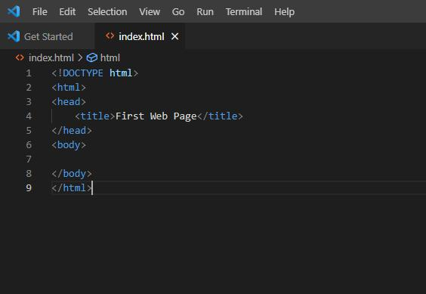
Step 2 — VS Code mein folder kholo
File → Open Folder par click karo aur apna folder select karo. Phir new file banao: index.html.

5. Apna pehla HTML code likho
index.html file mein neeche diya gaya code copy-paste karo.
<!DOCTYPE html>
<html lang="en">
<head>
<meta charset="UTF-8">
<meta name="viewport" content="width=device-width, initial-scale=1.0">
<title>My First Website</title>
</head>
<body>

<h1>Welcome to My Website!</h1>

<p>My name is a Web Developer.</p>

<button>Click Me</button>

</body>
</html>

Code ko easy language mein samjho
Code | Kaam
<!DOCTYPE html> | Browser ko batata hai ki document HTML5 hai.
<html> | HTML page ka main element hai.
<head> | Page ki settings rakhta hai.
<title> | Browser tab ka title set karta hai.
<body> | Page par dikhne wala content rakhta hai.
<h1> | Badi main heading banata hai.
<p> | Paragraph banata hai.
<button> | Button banata hai.

6. Website ko browser mein kaise chalayen?
- VS Code mein Ctrl + S dabakar file save karo.
- Folder mein index.html par double-click karo.
- Website Chrome mein khul jayegi.
Expected output

Welcome to My Website!
My name is a Web Developer.
Click Me
Ye aapki pehli website ka expected result hai. Button abhi sirf dikh raha hai; click karne par koi action nahi karega. JavaScript mein hum ise functional banana seekhenge.

7. Aaj ka homework

Day 1 Checklist
0/5 complete
Web Development Course naam ka folder banaya
index.html file banayi
HTML code likha
Website Chrome mein open ki
HTML, CSS aur JavaScript ka difference samjha
Sabse pehle apni website run karke dekho. Koi error aaye to usko Solve kroo

8. Chhota sa test
Question: Website par heading aur paragraph banane ke liye kaunsi language use hoti hai?
CSS
HTML
JavaScript

Shabash bro! 🎉🔥 Aapka Day 1 complete! Ab hum Web Development ka Day 2 start karte hain. Hum bilkul zero se, easy Roman Hindi mein seekhenge.

📘 Day 2: HTML Tags — Headings, Paragraphs, Links aur Images
Aaj hum apni website mein heading, text, link aur photo lagana seekhenge.

1. HTML Tags kya hote hain?
HTML tags browser ko batate hain ki website par kya dikhana hai.
Tag | Kaam
<h1> | Badi heading
<h2> | Chhoti heading
<p> | Paragraph ya text
<a> | Link banana
<img> | Image lagana
<br> | Nayi line par jana

2. VS Code mein practical karo
Apni index.html file kholo. Purana code hata kar ye code paste karo:
<!DOCTYPE html>
<html lang="en">
<head>
<meta charset="UTF-8">
<meta name="viewport" content="width=device-width, initial-scale=1.0">
<title>My Website</title>
</head>
<body>
<h1>Welcome to My Website</h1>
<h2>About Me</h2>
<p>Hello! My name is Ahshan.</p>
<p>I am learning Web Development.</p>
<h2>My Hobbies</h2>
<p>I like coding and designing websites.</p>
<a href="https://www.google.com">Open Google</a>
<br><br>
<img src="https://placehold.co/300x180"
alt="Sample Website Image">
</body>
</html>
Ab ye steps follow karo:
- Ctrl + S dabakar file save karo.
- Browser mein website refresh karo. (F5)
- Aapko headings, paragraphs, Google link aur ek sample image dikhni chahiye.
- Google link par click karke check karo.

3. Aaj ke important concepts
- <h1> se </h1> tak heading ka content hota hai.
- <p> paragraph banata hai.
- <a href="..."> kisi website ka link banata hai.
- <img> image dikhata hai. alt image ke baare mein text batata hai.
- src mein image ka address diya jata hai.

📘 Day 3 — HTML Lists, Links & Images
Aaj hum seekhenge:
- Ordered List — number wali list
- Unordered List — bullet wali list
- Links — ek page se doosre page par jana
- Images — website par photo lagana

1. Ordered List — Number wali list
<h2>Mere Subjects</h2>
<ol>
<li>HTML</li>
<li>CSS</li>
<li>JavaScript</li>
<li>Python</li>
</ol>
<ol> number wali list banata hai aur <li> har item ko dikhata hai.

2. Unordered List — Bullet wali list

<h2>Mere Hobbies</h2>
<ul>
<li>Coding</li>
<li>Gaming</li>
<li>Designing</li>
</ul>
<ul> bullet points wali list banata hai.

3. Link banana
<a href="https://www.google.com" target="_blank">
Google Open Karo
</a>
target="_blank" link ko naye browser tab mein kholta hai.

4. Website par image lagana

<h2>Meri Website ki Photo</h2>
<img
src="web.png"
alt="Sample Photo"
width="450"
height="600">
Aap apni photo bhi laga sakte ho. Photo ko apni index.html file ke paas rakho aur src="photo.jpg" likho, agar us photo ka naam photo.jpg hai.

🧑‍💻 Day 3 ka complete practical project
<!DOCTYPE html>
<html lang="en">
<head>
<meta charset="UTF-8">
<meta name="viewport" content="width=device-width, initial-scale=1.0">
<title>My Profile</title>
</head>
<body>
<h1>My Profile</h1>
<h2>About Me</h2>
<p>Hello! I am learning Web Development.</p>
<h2>My Skills</h2>
<ol>
<li>HTML</li>
<li>CSS</li>
<li>JavaScript</li>
</ol>

<h2>My Hobbies</h2>
<ul>
<li>Coding</li>
<li>Designing</li>
<li>Learning New Things</li>
</ul>

<h2>Useful Website</h2>
<a href="https://www.google.com" target="_blank">
Visit Google
</a>

<h2>Sample Image</h2>
<img src="web.png"
alt="My Sample Image"
width="300">

</body>
</html>

✅ Aaj ka task
Number aur bullet wali lists dikh rahi hain.
Google ka link naye tab mein khul raha hai.
Sample image website par dikh rahi hai.
Yaad rakho bro: HTML website ka structure banata hai. Agle lessons mein hum CSS se website ko sundar banana seekhenge. 💻

🎨 Day 4: CSS Kya Hai?
HTML se hum website ka structure banate hain aur CSS se website ko sundar banate hain jaise colors, background, text size, borders aur spacing.
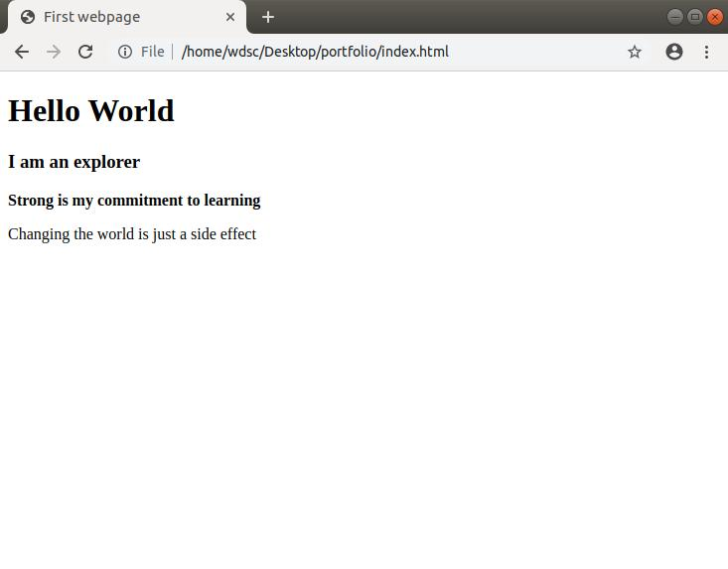
HTML
Simple structure, heading aur paragraph.
HTML + CSS
Colors, stylish heading aur sundar button.

Step 1: Apni pehli CSS website banao
VS Code mein index.html kholo. Purana code hata kar ye code likho karo:
<!DOCTYPE html>
<html lang="en">
<head>
<meta charset="UTF-8">
<meta name="viewport" content="width=device-width, initial-scale=1.0">
<title>My CSS Website</title>

<style>
body {
background-color: lightblue;
font-family: Arial, sans-serif;
text-align: center;
}

h1 {
color: darkblue;
font-size: 40px;
}

p {
color: black;
font-size: 20px;
}

button {
background-color: blue;
color: white;
padding: 12px 25px;
border: none;
border-radius: 8px;
}
</style>
</head>

<body>
<h1>Welcome To Indian CTI!</h1>
<p>Main Web Development seekh raha hoon.</p>
<button>Click Me</button>
</body>
</html>

Step 2: CSS ko samjho
CSS property | Kaam
background-color | Background ka color
color | Text ka color
font-size | Text ka size
text-align | Text ko left, center ya right karna
padding | Element ke andar ki jagah
border-radius | Corners ko gol karna
Important: CSS code ko <style> aur </style> ke beech likhte hain.

Step 3: Apni website check karo
- Ctrl + S dabao.
- Chrome mein website refresh karo.
- Light-blue background, dark-blue heading aur blue button dikhna chahiye.

📝 Day 4 Practice
Background ka color change karo.
Heading ka color ya size change karo.
Button ka color change karo.
Day 4 Complete! Ab aap HTML ke saath CSS bhi seekh rahe ho. Chalo ab Day 5: CSS Margin, Padding, Fonts aur Colors start karte hain.

📘 Day 5 — Website ko Professional Design dena

1. Margin aur Padding mein kya farq hai?
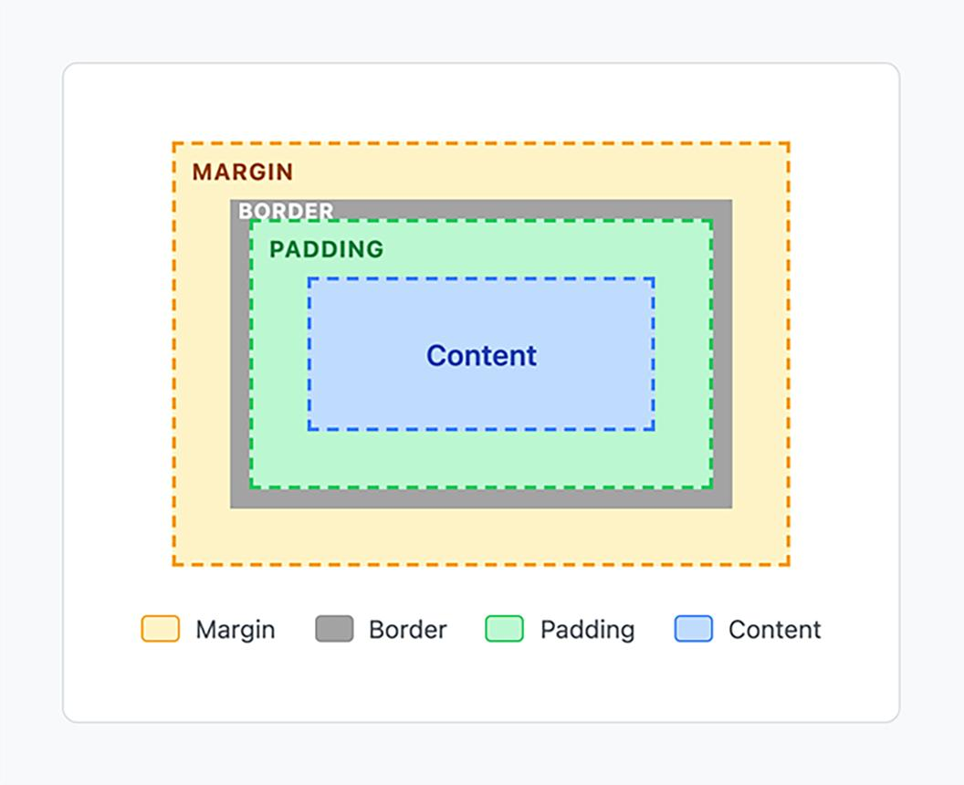

- Margin: Ek element aur doosre element ke beech ki jagah.
- Padding: Element ke border aur uske andar ke content ke beech ki jagah.
- Font: Text ka style aur size.
- Color: Text aur background ka rang.

2. VS Code mein practical karo
<!DOCTYPE html>
<html lang="en">
<head>
<meta charset="UTF-8">
<meta name="viewport" content="width=device-width, initial-scale=1.0">
<title>My Stylish Website</title>

<style>
body {
background-color: #f0f4ff;
font-family: Arial, sans-serif;
text-align: center;
margin: 0;
padding: 30px;
}

.card {
background-color: white;
padding: 30px;
margin: 20px auto;
max-width: 400px;
border-radius: 15px;
box-shadow: 0 4px 12px #b8c5dc;
}

h1 {
color: #1746a2;
font-size: 32px;
}

p {
color: #444444;
font-size: 18px;
line-height: 1.6;
}

button {
background-color: #1746a2;
color: white;
padding: 12px 24px;
border: none;
border-radius: 8px;
font-size: 16px;
cursor: pointer;
}
</style>
</head>
<body>
<div class="card">
<h1>My First Website</h1>
<p>Hello Bro! Main Web Development seekh raha hoon.</p>
<button>Learn More</button>
</div>
</body>
</html>

3. Code mein kya naya hai?
Property | Kaam
margin: 20px auto | Card ko center mein rakhne mein madad karta hai
padding: 30px | Card ke andar space deta hai
border-radius: 15px | Corners gol karta hai
box-shadow | Card ke peeche shadow deta hai
max-width: 400px | Card ki maximum width set karta hai
line-height: 1.6 | Text ki lines ke beech space deta hai

4. Aaj ka practice task
Apni website mein khud changes karo:
Margin ko 40px auto karke dekho.
Padding ko 40px karke dekho.
Heading ka color change karo.
Border radius ko 25px karke dekho.
0/4 tasks complete

📘 Day 6 — CSS Flexbox
Flexbox ek CSS technique hai jo website ke items ko left, right, center ya ek line mein arrange karne mein help karti hai.

1. Aaj kya banayenge?
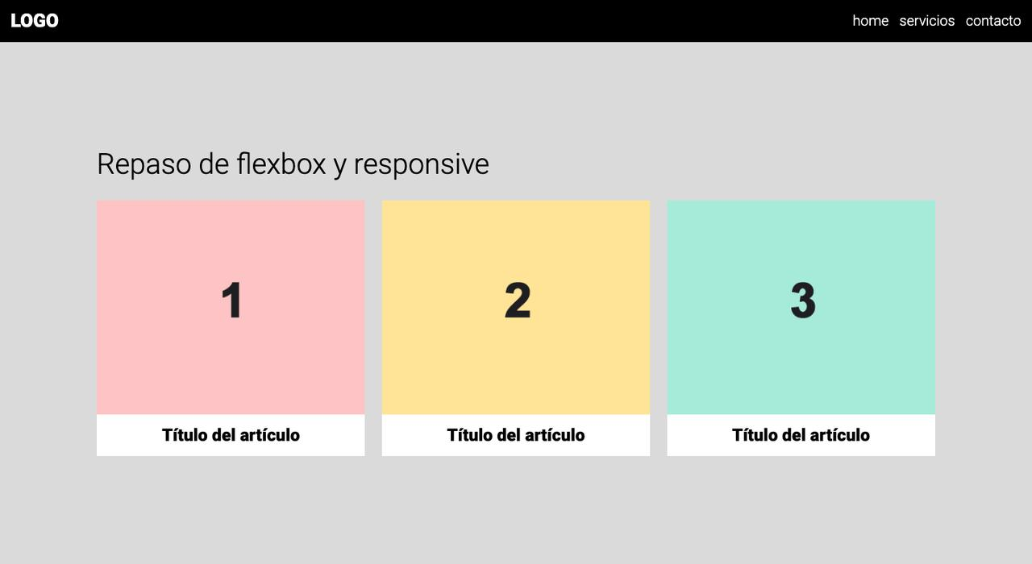
Aaj hum ek webpage banayenge jisme 3 cards ek line mein honge. Mobile screen par ye neeche ki taraf bhi arrange ho sakte hain.

2. VS Code mein code likho
<!DOCTYPE html>
<html lang="en">
<head>
<meta charset="UTF-8">
<meta name="viewport" content="width=device-width, initial-scale=1.0">
<title>Flexbox Practice</title>

<style>
body {
font-family: Arial, sans-serif;
background-color: #f1f5f9;
margin: 0;
padding: 20px;
}

h1 {
text-align: center;
color: #173b75;
}

.container {
display: flex;
justify-content: center;
align-items: stretch;
gap: 20px;
flex-wrap: wrap;
}

.card {
background-color: white;
padding: 25px;
width: 200px;
border-radius: 12px;
text-align: center;
box-shadow: 0 3px 10px #ccd3df;
}

.card button {
background-color: #2563eb;
color: white;
padding: 10px 15px;
border: none;
border-radius: 6px;
}
</style>
</head>

<body>

<h1>My Skills</h1>

<div class="container">

<div class="card">
<h2>HTML</h2>
<p>Website ka structure.</p>
<button>Learn HTML</button>
</div>

<div class="card">
<h2>CSS</h2>
<p>Website ka design.</p>
<button>Learn CSS</button>
</div>

<div class="card">
<h2>JavaScript</h2>
<p>Website mein functionality.</p>
<button>Learn JS</button>
</div>

<div class="card">
<h2>Python</h2>
<p>Website mein functionality.</p>
<button>Learn Python</button>
</div>
<div class="card">
<h2>C++</h2>
<p>Website mein functionality.</p>
<button>Learn C++</button>
</div>

</div>

</body>
</html>

3. Flexbox ki important properties
Property | Kaam
display: flex | Items ko Flexbox layout deta hai
justify-content: center | Items ko main direction mein center karta hai
align-items: center | Cross direction mein items align karta hai
gap: 20px | Items ke beech space deta hai
flex-wrap: wrap | Jagah kam hone par items ko agli line mein le jata hai
Practical tip: .container ke andar justify-content: center; ko justify-content: space-between; karke dekho. Cards ki positioning badal jayegi.

4. Day 6 practice checklist
5 cards ko ek line mein dikhaya.
gap ko 30px karke dekha.
flex-wrap: wrap ko samjha.
justify-content ki value change ki.
0/4 tasks complete

📘 Day 7: Website ko Mobile aur Computer ke liye banana

1. CSS Grid kya hai?
CSS Grid se hum website ke cards aur sections ko rows aur columns mein arrange kar sakte hain.
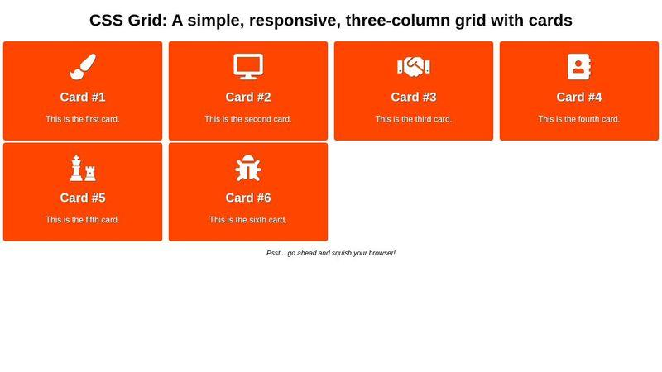
- Desktop: 3 cards ek line mein.
- Mobile: Screen chhoti hone par cards apne aap kam columns mein aa sakte hain.
- Responsive design: Website alag-alag screen sizes par adjust hoti hai.

2. VS Code mein practical project
<!DOCTYPE html>
<html lang="en">
<head>
<meta charset="UTF-8">
<meta name="viewport" content="width=device-width, initial-scale=1.0">
<title>Flexbox Practice</title>

<style>
body {
font-family: Arial, sans-serif;
background-color: #f1f5f9;
margin: 0;
padding: 20px;
}

h1 {
text-align: center;
color: #173b75;
}

.container {
display: flex;
justify-content: center;
align-items: stretch;
gap: 20px;
flex-wrap: wrap;
}

.card {
background-color: white;
padding: 25px;
width: 200px;
border-radius: 12px;
text-align: center;
box-shadow: 0 3px 10px #ccd3df;
}

.card button {
background-color: #2563eb;
color: white;
padding: 10px 15px;
border: none;
border-radius: 6px;
}
</style>
</head>
<body>
<h1>My Skills</h1>
<div class="container">
<div class="card">
<h2>HTML</h2>
<p>Website ka structure.</p>
<button>Learn HTML</button>
</div>

<div class="card">
<h2>CSS</h2>
<p>Website ka design.</p>
<button>Learn CSS</button>
</div>

<div class="card">
<h2>JavaScript</h2>
<p>Website mein functionality.</p>
<button>Learn JS</button>
</div>
<div class="card">
<h2>Python</h2>
<p>Website mein functionality.</p>
<button>Learn Python</button>
</div>
<div class="card">
<h2>C++</h2>
<p>Website mein functionality.</p>
<button>Learn C++</button>
</div>
</div>
</body>
</html>

3. Aaj ke important concepts
Code | Matlab
display: grid | Grid layout shuru karta hai
grid-template-columns | Columns ki sankhya aur size set karta hai
repeat(3, 1fr) | 3 barabar columns banata hai
gap: 20px | Cards ke beech space
@media | Screen size ke hisaab se CSS badalta hai
max-width: 600px | 600px ya usse chhoti screen ke liye rule

4. Apni website test karo
- Ctrl + S se save karo.
- Chrome mein website kholo.
- F12 dabao.
- Mobile/tablet icon par click karo.
- Alag-alag mobile sizes select karke dekho ki cards kaise badalte hain.

✅ Day 7 practice
Desktop par 3 columns dikh rahe hain.
Mobile par cards ek column mein aa rahe hain.
Cards ke beech gap change karke dekha.
Chrome mein mobile view test kiya.
0/4 tasks complete

📘 Day 8 — HTML Forms, Input aur Buttons
Forms ka use website par user se information lene ke liye hota hai, jaise Login, Registration aur Contact Us.

1. Aaj hum kya banayenge?
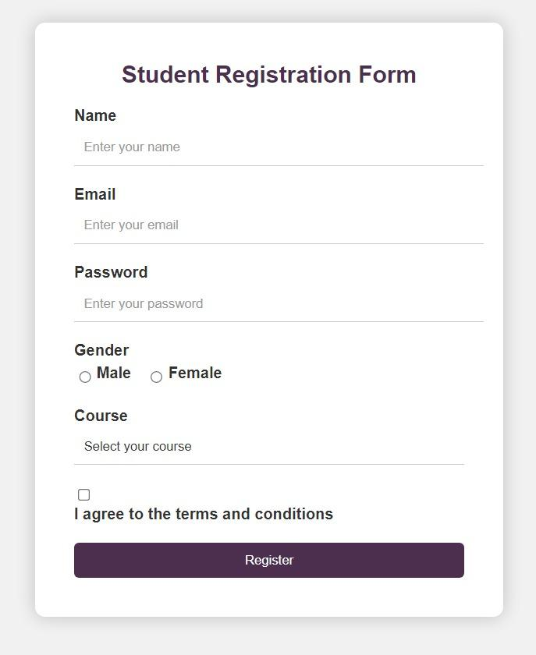
Aaj hum ek Student Registration Form banayenge.

2. VS Code mein code paste karo
<!DOCTYPE html>
<html lang="en">
<head>
<meta charset="UTF-8">
<meta name="viewport" content="width=device-width, initial-scale=1.0">
<title>Student Registration</title>

<style>
body {
font-family: Arial, sans-serif;
background: #eef2ff;
padding: 20px;
}

.form-box {
background: white;
max-width: 400px;
margin: 30px auto;
padding: 25px;
border-radius: 12px;
box-shadow: 0 4px 12px #cbd5e1;
}

h1 {
text-align: center;
color: #1d4ed8;
}

label {
display: block;
margin-top: 15px;
}

input, select {
width: 100%;
padding: 10px;
margin-top: 6px;
box-sizing: border-box;
border: 1px solid #aaa;
border-radius: 6px;
}

button {
width: 100%;
padding: 12px;
margin-top: 20px;
background: #1d4ed8;
color: white;
border: none;
border-radius: 6px;
cursor: pointer;
}
</style>
</head>

<body>

<div class="form-box">
<h1>Student Registration</h1>

<form>
<label for="name">Full Name</label>
<input type="text" id="name"
placeholder="INDIAN COMPUTER TRAINING INSTITUTTE" required>

<label for="email">Email</label>
<input type="email" id="email"
placeholder="INDIANCTI2GMAIL.COM" required>

<label for="password">Password</label>
<input type="password" id="password"
placeholder="INDIANCTI@IT" required>

<label for="course">Select Course</label>
<select id="course" required>
<option value="">Choose a course</option>
<option>Web Designing</option>
<option>Python</option>
<option>Power BI</option>
</select>

<button type="submit">Register</button>
</form>
</div>
</body>
</html>

3. HTML Form ke important tags
Tag / Property | Kaam
<form> | Form banata hai
<label> | Input ka naam batata hai
type="text" | Text enter karna
type="email" | Email input aur basic format check
type="password" | Password ko screen par hide karna
<select> | Dropdown list banana
required | Field bharna zaroori karta hai
<button> | Button banata hai
Important: Abhi ye sirf frontend form hai. Register button dabane par data database mein save nahi hota. Woh hum backend seekhne ke baad karenge.

4. Aaj ki practice
Apni checklist complete karo:
Name field mein apna naam enter karke dekho.
Email field mein galat format enter karke dekho.
Dropdown se course select karo.
Sab fields khaali rakhkar Register dabao aur required validation dekho.
📘 Day 9: HTML Form ke Advanced Elements

1. Radio Button aur Checkbox mein kya farq hai?
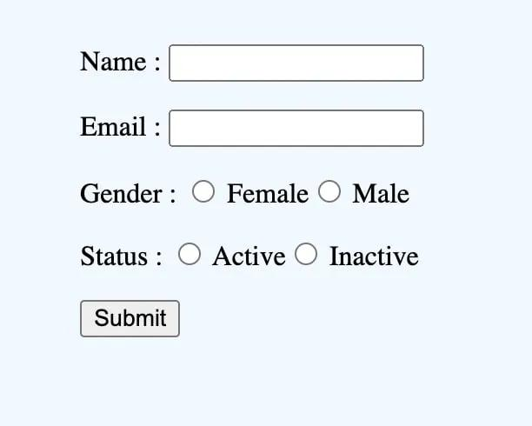
Radio Button
Jab user ko ek group mein se sirf ek option choose karna ho.
Example: Online ya Offline.
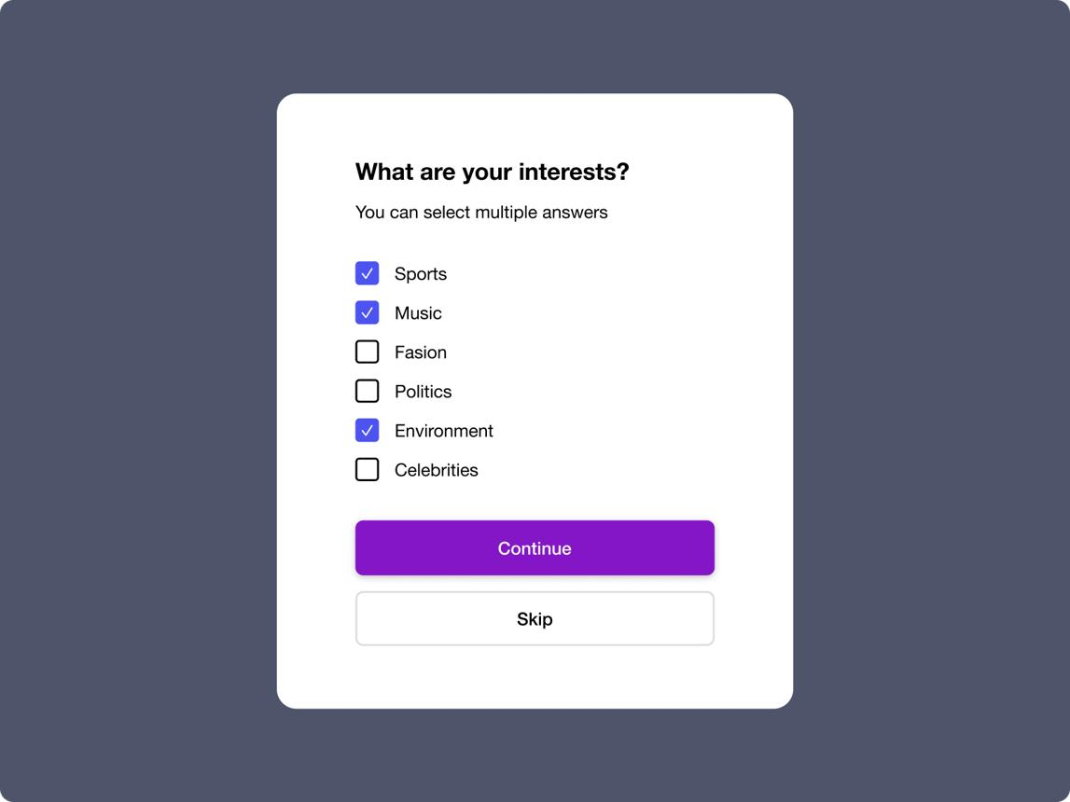
Checkbox
Jab user ek ya ek se zyada options select kar sakta ho.
Example: HTML, CSS aur JavaScript.

2. Textarea kya hai?
<textarea> ka use lamba message likhne ke liye hota hai, jaise Contact Us form mein message.

3. VS Code mein practical project
<!DOCTYPE html>
<html lang="en">
<head>
<meta charset="UTF-8">
<meta name="viewport" content="width=device-width, initial-scale=1.0">
<title>Course Admission Form</title>

<style>
body {
font-family: Arial, sans-serif;
background: #edf2ff;
padding: 20px;
}

.form-box {
max-width: 450px;
margin: 20px auto;
padding: 25px;
background: white;
border-radius: 12px;
}

h1 {
color: #1d4ed8;
text-align: center;
}

label {
display: inline-block;
margin: 8px 0;
}

input[type="text"],
textarea {
width: 100%;
padding: 10px;
box-sizing: border-box;
border: 1px solid #aaa;
border-radius: 6px;
}

fieldset {
margin: 15px 0;
border: 1px solid #ccc;
border-radius: 8px;
}

button {
width: 100%;
padding: 12px;
background: #1d4ed8;
color: white;
border: none;
border-radius: 6px;
cursor: pointer;
}
</style>
</head>

<body>

<div class="form-box">
<h1>Course Admission</h1>

<form>
<label for="student">Student Name</label>
<input type="text" id="student"
placeholder="Enter your name" required>

<fieldset>
<legend>Study Mode</legend>

<input type="radio" id="online"
name="mode" value="Online" required>
<label for="online">Online</label>

<input type="radio" id="offline"
name="mode" value="Offline">
<label for="offline">Offline</label>
</fieldset>

<fieldset>
<legend>GENDER</legend>

<input type="radio" id="MALE"
name="GENDER" value="MALE" required>
<label for="MALE">MAIL</label>

<input type="radio" id="FEMALE"
name="GENDER" value="FEMALE">
<label for="FEMALE">FEMALE</label>
</fieldset>

<fieldset>
<legend>Choose Your Skills</legend>

<input type="checkbox" id="html" name="skills" value="HTML">
<label for="html">HTML</label><br>

<input type="checkbox" id="css" name="skills" value="CSS">
<label for="css">CSS</label><br>

<input type="checkbox" id="js" name="skills" value="JavaScript">
<label for="js">JavaScript</label>
</fieldset>

<label for="message">Why do you want to learn?</label>
<textarea id="message" rows="4"
placeholder="Write your message"></textarea>

<button type="submit">Submit Form</button>
</form>
</div>

</body>
</html>

4. Important concepts samjho
Code | Kaam
type="radio" | Ek option choose karna
type="checkbox" | Multiple options choose karna
name="mode" | Dono radio buttons ko ek group banana
<textarea> | Lamba text likhna
<fieldset> | Related fields ko group karna
<legend> | Group ka title dena
Yaad rakho: Radio buttons ko ek group banane ke liye unka name same hona chahiye. Checkbox mein user multiple options select kar sakta hai.

5. Day 9 practice checklist
Online aur Offline radio buttons test karo.
HTML aur CSS dono checkboxes select karo.
Textarea mein ek message likho.
Form ke groups aur unke titles dekho.
0/4 tasks complete
Aaj aap seekhoge ki professional website ka structure kaise banate hain.

📘 Day 10 — HTML Semantic Tags
Semantic tags ka matlab hai aise HTML tags jo browser aur developer ko batate hain ki page ke kis hisse ka kya kaam hai.
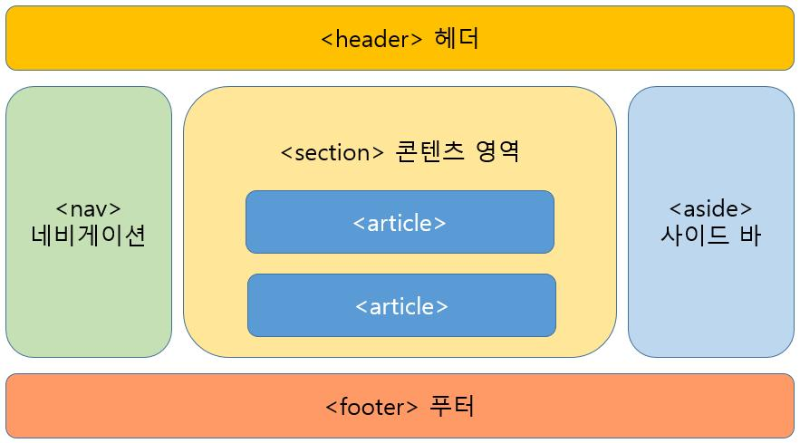

1. Important HTML tags
Tag | Kaam
<header> | Website ka top section
<nav> | Navigation links
<main> | Page ka main content
<section> | Content ka ek section
<article> | Independent content, jaise blog post
<aside> | Side content
<footer> | Page ka bottom section

2. VS Code mein professional webpage banao
<!DOCTYPE html>
<html lang="en">
<head>
<meta charset="UTF-8">
<meta name="viewport" content="width=device-width, initial-scale=1.0">
<title>Indian CTI - Web Designing</title>

<style>
* {
box-sizing: border-box;
}

body {
margin: 0;
font-family: Arial, sans-serif;
background: #f1f5f9;
color: #1e293b;
}

header {
background: #173b75;
color: white;
text-align: center;
padding: 25px;
}

nav {
background: #0f172a;
padding: 15px;
text-align: center;
}

nav a {
color: white;
text-decoration: none;
margin: 0 12px;
}

main {
max-width: 900px;
margin: 25px auto;
padding: 0 15px;
}

section, article {
background: white;
padding: 20px;
margin-bottom: 20px;
border-radius: 10px;
}

h2 {
color: #173b75;
}

footer {
background: #0f172a;
color: white;
text-align: center;
padding: 20px;
}

@media (max-width: 500px) {
nav a {
display: inline-block;
margin: 8px;
}
}
</style>
</head>

<body>

<header>
<h1>INDIAN CTI</h1>
<p>Learn Web Designing from Zero</p>
</header>

<nav>
<a href="#home">Home</a>
<a href="#courses">Courses</a>
<a href="#about">About</a>
<a href="#contact">Contact</a>
</nav>

<main>
<section id="home">
<h2>Welcome to Our Website</h2>
<p>Yahan hum Web Designing aur Development seekhte hain.</p>
</section>

<section id="courses">
<h2>Our Courses</h2>

<article>
<h3>HTML & CSS</h3>
<p>Website ka structure aur design banana seekho.</p>
</article>

<article>
<h3>JavaScript</h3>
<p>Website mein interactive features banana seekho.</p>
</article>
</section>

<section id="about">
<h2>About Us</h2>
<p>Hum beginners ko step-by-step Web Development sikhate hain.</p>
</section>

<section id="contact">
<h2>Contact Us</h2>
<p>Email: info@example.com</p>
</section>
</main>

<footer>
<p>Copyright 2026 - INDIAN CTI</p>
</footer>
</body>
</html>

3. Practical mein kya karna hai?
- Ctrl + S dabao aur browser refresh karo.
- Navigation mein Courses par click karo.
- Dekho browser page ke Courses section par jaata hai ya nahi.
- Mobile view mein bhi website test karo.

4. Day 10 checklist
Header aur footer dikh rahe hain.
Navigation links par click kiya.
Courses aur About sections dikh rahe hain.
Mobile view mein website check ki.
0/4 tasks complete
DAY 10 COMPLETE! Ab aap HTML aur CSS ki basic training complete karke JavaScript ki taraf badh rahe ho. Ab hum website ko interactive banana seekhenge.

📘 Day 11 — JavaScript ki Shuruaat
Aaj hum seekhenge:
- JavaScript kya hai?
- console.log() ka use
- Variables kya hote hain?
- Website par button click karne se message kaise dikhayein?

1. JavaScript kya hai?
HTML
Website ka structure banata hai.
CSS
Website ko sundar banata hai.
JavaScript
Website mein actions aur functionality add karta hai.

2. Pehla JavaScript program
<!DOCTYPE html>
<html lang="en">
<head>
<meta charset="UTF-8">
<meta name="viewport" content="width=device-width, initial-scale=1.0">
<title>My JavaScript Practice</title>
</head>
<body>

<h1>My First JavaScript</h1>

<p>Welcome To Indian CTI!</p>

<script>
console.log("Hello World!");
console.log("I am learning JavaScript.");
</script>

</body>
</html>

Output kaise dekhein?
- File ko Ctrl + S se save karo.
- Browser mein kholo.
- F12 dabao.
- Console tab par click karo.
Wahan Hello World! aur doosra message dikhna chahiye.

3. Variables kya hote hain?
Variable ek container ki tarah hota hai jisme hum data rakhte hain.
let studentName = "Ahshan";
let age = 21;
let course = "Web Development";

console.log(studentName);
console.log(age);
console.log(course);
Samjho:
- let — variable banane ke liye.
- studentName — variable ka naam.
- "Ahshan" — usmein rakhi hui value.
- console.log() — Console mein value dikhata hai.
Age sirf example hai; aap apni age ke hisaab se number badal sakte ho.

4. Button click par message dikhana
Ab ye practical karo. Is code ko apni index.html file mein paste karo:
<!DOCTYPE html>
<html lang="en">
<head>
<meta charset="UTF-8">
<meta name="viewport" content="width=device-width, initial-scale=1.0">
<title>JavaScript Button</title>
</head>
<body>
<h1>JavaScript Practice</h1>
<button onclick="showMessage()">Click Me</button>
<p id="message"></p>
<script>
function showMessage() {
document.getElementById("message").textContent =
"Helloooo..! JavaScript is Working!";
}
</script>
</body>
</html>

Ab browser refresh karo aur Click Me button dabao. Message screen par aana chahiye. 🎯

5. Day 11 practice checklist
Console mein Hello World print kiya.
Apne student name aur course ke variables banaye.
Button click par message dikhaya.
Message ko apne words mein change kiya.
0/4 tasks complete
Ab aap JavaScript bhi seekh rahe ho. Chalo ab Day 12 — JavaScript Data Types start karte hain. Aaj ka lesson aapko programming ki foundation strong karne mein help karega.

📘 Day 12: JavaScript Data Types
Data type batata hai ki variable ke andar kis tarah ka data rakha hai — jaise text, number ya true/false.

1. JavaScript ke important Data Types
String — Text
let name = "Ahshan";
Number — Sankhya
let marks = 85;
Boolean — True ya False
let isStudent = true;
Undefined — Value abhi assign nahi hui
let city;
Null — Jaanbujhkar khaali value
let result = null;

2. VS Code mein practical karo
<!DOCTYPE html>
<html lang="en">
<head>
<meta charset="UTF-8">
<title>JavaScript Data Types</title>
</head>
<body>

<h1>JavaScript Data Types</h1>
<p>Console mein output check karo.</p>

<script>
let studentName = "Ahshan";
let marks = 85;
let isStudent = true;
let city;
let result = null;

console.log(studentName, typeof studentName);
console.log(marks, typeof marks);
console.log(isStudent, typeof isStudent);
console.log(city, typeof city);
console.log(result, typeof result);
</script>

</body>
</html>
Ek important baat: JavaScript mein typeof null ka output "object" aata hai. Ye JavaScript ka purana behavior hai.

3. typeof ka kya kaam hai?
typeof se hum pata karte hain ki value ka data type kya hai.
Example:
console.log(typeof "Hello"); // string
console.log(typeof 100); // number
console.log(typeof true); // boolean

4. Day 12 ka mini quiz
1. `let name = "Ali";` ka data type kya hai?
Number
String
Boolean
2. `let marks = 90;` ka data type kya hai?
String
Number
Undefined
3. `let passed = true;` ka data type kya hai?
Boolean
String
Null
Check Answers
Day 12 Complete! Bahut badhiya! Ab hum JavaScript mein calculations aur comparisons karna seekhenge.

📘 Day 13 — JavaScript Operators
Operators ka use numbers ko calculate karne aur values ko compare karne ke liye hota hai.

1. Arithmetic Operators — Maths ki calculations
Operator | Kaam | Example | Answer
+ | Addition | 10 + 5 | 15
- | Subtraction | 10 - 5 | 5
* | Multiplication | 10 * 5 | 50
/ | Division | 10 / 5 | 2
% | Remainder | 10 % 3 | 1
** | Power | 2 ** 3 | 8

2. VS Code Practical
<!DOCTYPE html>
<html lang="en">
<head>
<meta charset="UTF-8">
<title>JavaScript Operators</title>
</head>
<body>

<h1>JavaScript Calculator</h1>
<p>F12 dabao aur Console mein output dekho.</p>

<script>
let a = 10;
let b = 5;

console.log("Addition:", a + b);
console.log("Subtraction:", a - b);
console.log("Multiplication:", a * b);
console.log("Division:", a / b);
console.log("Remainder:", a % b);
console.log("Power:", a ** b);
console.log("Equal:", a === b);
console.log("Greater:", a > b);
console.log("Less:", a < b);
</script>
</body>
</html>
Save karne ke liye Ctrl + S dabao. Browser mein open karke F12 → Console par jao.

3. Comparison Operators
Ye operators do values ko compare karte hain aur result true ya false dete hain.
Operator | Matlab
=== | Value aur data type dono same hain?
!== | Value ya data type different hai?
> | Kya pehli value badi hai?
< | Kya pehli value chhoti hai?
>= | Badi ya barabar?
<= | Chhoti ya barabar?
Example:
console.log(10 > 5); // true
console.log(10 < 5); // false
console.log(10 === 10); // true
console.log(10 === "10"); // false
Yaad rakho ko strict equality kehte hain. Ye value ke saath data type bhi check karta hai.

4. Mini Project — Marks Calculator

<!DOCTYPE html>
<html lang="en">
<head>
<meta charset="UTF-8">
<title>Marks Calculator</title>
</head>
<body>
<h1>Student Marks</h1>
<p id="result"></p>
<script>
let maths = 80;
let english = 75;
let computer = 90;
let total = maths + english + computer;
let percentage = (total / 300) * 100;
document.getElementById("result").textContent =
"Total Marks: " + total +
" | Percentage: " + percentage + "%";
</script>
</body>
</html>
Is program mein total marks 245 aur percentage lagbhag 81.67% aayegi.

5. Day 13 Practice Checklist
Arithmetic operators ke outputs Console mein dekhe.
true aur false wale comparisons test kiye.
Marks Calculator ka output dekha.
Marks ki values change karke dobara test kiya.
0/4 tasks complete

🚀 Day 15: JavaScript Logical Operators
आज हम सीखेंगे कि JavaScript में एक साथ कई conditions कैसे check करते हैं।

1. Logical Operators क्या हैं?
| Operator | मतलब | Example | |---|---|---| | && | AND — दोनों conditions सही हों | age >= 18 && hasID | | || | OR — कोई एक condition सही हो | day === "Sunday" || day === "Saturday" | | ! | NOT — result उलट देता है | !isRaining |

2. आज का Project: Login Checker
<!DOCTYPE html>
<html lang="en">
<head>
<meta charset="UTF-8">
<meta name="viewport" content="width=device-width, initial-scale=1.0">
<title>Login Checker</title>

<style>
body {
font-family: Arial, sans-serif;
background: #101827;
color: white;
text-align: center;
padding: 40px 15px;
}

.box {
max-width: 350px;
margin: auto;
padding: 25px;
background: #243247;
border-radius: 15px;
}

input, button {
box-sizing: border-box;
width: 100%;
padding: 12px;
margin: 8px 0;
border: none;
border-radius: 8px;
}

button {
background: #00c896;
font-weight: bold;
cursor: pointer;
}

#result {
margin-top: 15px;
}
</style>
</head>
<body>

<div class="box">
<h1>Login Checker 🔐</h1>

<input id="username" type="text"
placeholder="Enter username">

<input id="password" type="password"
placeholder="Enter password">

<button onclick="checkLogin()">Login</button>

<p id="result"></p>
</div>

<script>
function checkLogin() {
let username =
document.getElementById("username").value;

let password =
document.getElementById("password").value;

if (username === "" || password === "") {
document.getElementById("result").textContent =
"Please fill both fields!";
}
else if (
username === "student" &&
password === "1234"
) {
document.getElementById("result").textContent =
"Login Successful! 🎉";
}
else {
document.getElementById("result").textContent =
"Username or password is incorrect!";
}
}
</script>
</body>
</html>

3. Code को समझो
- || — अगर username या password खाली है, तो warning दिखेगी।
- && — username और password दोनों सही होने चाहिए।
- else — बाकी सभी स्थितियों में गलत login का message दिखेगा।
इस demo में username INDIAN CTI और password 123456789 है। यह केवल सीखने के लिए है, असली secure login system नहीं है।

4. Practice Task
खाली fields के साथ Login करके देखो।
सही demo username और password डालो।
गलत password डालकर देखो।
`&&` और `||` का अंतर अपने शब्दों में समझो।
0 of 4 tasks complete

🚀 Day 16: JavaScript Loops (for और while)
आज हम सीखेंगे कि एक ही काम को बार-बार करने के लिए JavaScript में Loops का इस्तेमाल कैसे होता है।

1. for Loop क्या है?
मान लो आपको वेबसाइट पर 1 से 10 तक नंबर दिखाने हैं। हर नंबर को अलग-अलग लिखने के बजाय हम Loop का इस्तेमाल कर सकते हैं।
for (let i = 1; i <= 10; i++) {
console.log(i);
}
इसका मतलब:
- let i = 1 — शुरुआत 1 से होगी।
- i <= 10 — Loop 10 तक चलेगा।
- i++ — हर बार नंबर 1 बढ़ेगा।

2. आज का Project: Number Counter
<!DOCTYPE html>
<html lang="en">
<head>
<meta charset="UTF-8">
<meta name="viewport" content="width=device-width, initial-scale=1.0">
<title>Number Counter</title>

<style>
body {
font-family: Arial, sans-serif;
background: #101827;
color: white;
text-align: center;
padding: 30px 15px;
}

.box {
max-width: 400px;
margin: auto;
padding: 25px;
background: #243247;
border-radius: 15px;
}

button {
background: #00c896;
padding: 12px 20px;
border: none;
border-radius: 8px;
cursor: pointer;
font-weight: bold;
}

#result {
line-height: 2;
overflow-wrap: anywhere;
}
</style>
</head>
<body>

<div class="box">
<h1>🔢 Number Counter</h1>
<p>Button click karke numbers dekho.</p>

<button onclick="showNumbers()">Start Counter</button>

<p id="result"></p>
</div>

<script>
function showNumbers() {
let output = "";

for (let i = 1; i <= 10; i++) {
output += i + " ";
}

document.getElementById("result").textContent = output;
}
</script>

</body>
</html>

3. while Loop का Example
जब तक condition सही रहती है, while Loop चलता रहता है।
let i = 1;

while (i <= 5) {
console.log(i);
i++;
}
यह Console में 1, 2, 3, 4, 5 दिखाएगा। ध्यान रहे, i++ भूलने पर condition हमेशा सही रह सकती है और Loop चलता रह सकता है।

4. आज की Practice
HTML file में Number Counter का code चलाओ।
Loop को 10 की जगह 20 तक चलाओ।
`while` Loop को 1 से 5 तक चलाकर देखो।
Console खोलकर output देखो (F12 → Console)।
0/4 tasks complete
Web Development Course का Day 17: JavaScript Arrays।
आज सीखेंगे कि एक ही variable में कई values कैसे store करते हैं और उन्हें अपनी website पर कैसे दिखाते हैं।

🚀 Day 17 — JavaScript Arrays

1. Array क्या होता है?
मान लो आपके पास 5 students के नाम हैं। हर नाम के लिए अलग variable बनाने के बजाय Array इस्तेमाल कर सकते हैं।
let students = ["Aman", "Rahul", "Priya", "Ali", "Neha"];

console.log(students);

Array में values कैसे access करें?
JavaScript में Array की counting 0 से शुरू होती है।
let students = ["Aman", "Rahul", "Priya"];

console.log(students[0]); // Aman
console.log(students[1]); // Rahul
console.log(students[2]); // Priya
- students[0] = पहला नाम
- students[1] = दूसरा नाम
- students.length = Array में कुल values

2. आज का Project — Student List Website
<!DOCTYPE html>
<html lang="en">
<head>
<meta charset="UTF-8">
<meta name="viewport" content="width=device-width, initial-scale=1.0">
<title>Student List</title>

<style>
body {
font-family: Arial, sans-serif;
background: #101827;
color: white;
text-align: center;
padding: 30px 15px;
}

.container {
max-width: 450px;
margin: auto;
background: #243247;
padding: 25px;
border-radius: 15px;
}

li {
background: #34445c;
margin: 10px 0;
padding: 12px;
border-radius: 8px;
text-align: left;
}

button {
padding: 12px 20px;
background: #00c896;
border: none;
border-radius: 8px;
cursor: pointer;
font-weight: bold;
}
</style>
</head>
<body>

<div class="container">
<h1>🎓 Student List</h1>

<p id="total"></p>

<ul id="studentList"></ul>

<button onclick="showStudents()">
Show Students
</button>
</div>

<script>
let students = [
"Aman","Rahul","Priya","Ali","Neha"
];
function showStudents() {
let list = document.getElementById("studentList");
list.innerHTML = "";
for (let i = 0; i < students.length; i++) {
list.innerHTML += "<li>" + students[i] + "</li>";
}
document.getElementById("total").textContent =
"Total Students: " + students.length;
}
</script>
</body>
</html>

3. नया Student कैसे जोड़ें?
इस Array में एक और नाम जोड़कर देखो:
students.push("Zoya");

console.log(students);
console.log(students.length);
push() Array के आखिर में नई value जोड़ता है।

4. Day 17 Practice
Student List website को browser में चलाओ।
Array में दो नए students के नाम जोड़ो।
`students[0]` की value check करो।
`students.push()` से नया नाम जोड़कर total check करो।
0/4 tasks complete
HTML, CSS aur JavaScript — teeno ek hi file mein, jise tum VS Code mein copy-paste karke chala sakte ho.

Complete Code — index.html
<!DOCTYPE html>
<html lang="en">
<head>
<meta charset="UTF-8">
<meta name="viewport" content="width=device-width, initial-scale=1.0">

<title>Student List Manager</title>

<style>
* {
box-sizing: border-box;
}

body {
margin: 0;
padding: 30px 15px;
font-family: Arial, sans-serif;
background: linear-gradient(135deg, #101827, #263c5a);
color: white;
}

.container {
width: 100%;
max-width: 600px;
margin: auto;
padding: 25px;
background: #1e293b;
border-radius: 18px;
box-shadow: 0 10px 30px #0005;
}

h1 {
text-align: center;
color: #38e8b0;
}

.subtitle {
text-align: center;
color: #cbd5e1;
}

input {
width: 100%;
padding: 13px;
margin: 8px 0;
border: 1px solid #475569;
border-radius: 8px;
font-size: 16px;
}

button {
padding: 12px 15px;
border: none;
border-radius: 8px;
cursor: pointer;
font-size: 15px;
font-weight: bold;
}

.add-btn {
width: 100%;
background: #10b981;
color: #06281e;
margin: 8px 0;
}

.delete-btn {
background: #ef4444;
color: white;
}

.search-box {
margin-top: 15px;
}

.student-item {
display: flex;
justify-content: space-between;
align-items: center;
gap: 10px;
padding: 12px;
margin-top: 10px;
background: #334155;
border-radius: 10px;
overflow-wrap: anywhere;
}

.student-name {
flex: 1;
}

#message {
min-height: 22px;
color: #38e8b0;
}

.total {
text-align: center;
color: #facc15;
font-size: 18px;
font-weight: bold;
}

@media (max-width: 400px) {
.container {
padding: 16px;
}

.student-item {
align-items: flex-start;
}
}
</style>
</head>

<body>

<div class="container">

<h1>🎓 Student Manager</h1>

<p class="subtitle">
Add, search and manage students
</p>

<form id="studentForm">
<input
type="text"
id="studentName"
placeholder="Enter student name"
maxlength="50"
required
>

<button type="submit" class="add-btn">
+ Add Student
</button>
</form>

<input
type="text"
id="searchInput"
class="search-box"
placeholder="🔍 Search student..."
>

<p class="total" id="totalStudents">
Total Students: 0
</p>

<p id="message" role="status"></p>

<div id="studentList"></div>

</div>

<script>
// Student names are stored in an array.
let students = [
"Aman",
"Rahul",
"Priya",
"Ali",
"Neha"
];

const studentForm = document.getElementById("studentForm");
const studentName = document.getElementById("studentName");
const searchInput = document.getElementById("searchInput");
const studentList = document.getElementById("studentList");
const totalStudents = document.getElementById("totalStudents");
const message = document.getElementById("message");

// Display students on the page.
function showStudents() {
const searchText = searchInput.value.trim().toLowerCase();

studentList.replaceChildren();

const filteredStudents = students
.map((name, index) => ({ name, index }))
.filter(student =>
student.name.toLowerCase().includes(searchText)
);

totalStudents.textContent =
"Total Students: " + students.length;

if (filteredStudents.length === 0) {
const emptyMessage = document.createElement("p");
emptyMessage.textContent = "No students found.";
studentList.appendChild(emptyMessage);
return;
}

filteredStudents.forEach(student => {
const item = document.createElement("div");
item.className = "student-item";

const name = document.createElement("span");
name.className = "student-name";
name.textContent = student.name;

const deleteButton = document.createElement("button");
deleteButton.className = "delete-btn";
deleteButton.textContent = "Delete";

deleteButton.addEventListener("click", function () {
students.splice(student.index, 1);

message.textContent =
student.name + " deleted successfully.";

showStudents();
});

item.appendChild(name);
item.appendChild(deleteButton);

studentList.appendChild(item);
});
}

// Add a new student.
studentForm.addEventListener("submit", function (event) {
event.preventDefault();

const name = studentName.value.trim();

if (name === "") {
message.textContent = "Please enter a student name.";
return;
}

students.push(name);

message.textContent = name + " added successfully!";

studentName.value = "";

showStudents();
studentName.focus();
});

// Search students as the user types.
searchInput.addEventListener("input", function () {
showStudents();
});

// Show the initial list.
showStudents();
</script>
</body>
</html>

VS Code mein kaise chalana hai?
- VS Code kholo.
- index.html file banao.
- Upar diya gaya poora code paste karo.
- Ctrl + S se save karo.
- File ko browser mein open karo.
Dhyan do: Yeh demo filhaal students ka data browser mein permanently save nahi karta. Page refresh karne par naye add kiye gaye names hat jayenge.
Ab se har project mein main tumhe complete, single-file code + easy Hindi explanation + practice task dunga, taaki tum zero se professional web development seekh sako. 💻

🚀 Day 19 — Student Profile Project
आज हम सीखेंगे कि किसी student का नाम, उम्र, शहर और marks एक ही object में कैसे रखते हैं।

पूरा कोड — index.html

<!DOCTYPE html>
<html lang="en">
<head>
<meta charset="UTF-8">
<meta name="viewport" content="width=device-width, initial-scale=1.0">
<title>Student Profile</title>

<style>
* {
box-sizing: border-box;
}

body {
margin: 0;
min-height: 100vh;
display: flex;
justify-content: center;
align-items: center;
padding: 20px;
font-family: Arial, sans-serif;
color: white;
background: linear-gradient(135deg, #101827, #314b72);
}

.card {
width: 100%;
max-width: 420px;
padding: 28px;
text-align: center;
background: #1e293b;
border: 1px solid #475569;
border-radius: 20px;
box-shadow: 0 15px 35px #0005;
}

.avatar {
width: 85px;
height: 85px;
display: grid;
place-items: center;
margin: 0 auto 15px;
background: #0d9488;
border-radius: 50%;
font-size: 42px;
}

h1 {
color: #5eead4;
}

.detail {
padding: 12px;
margin: 10px 0;
background: #334155;
border-radius: 9px;
text-align: left;
}

button {
width: 100%;
padding: 13px;
margin-top: 15px;
border: none;
border-radius: 9px;
background: #2dd4bf;
color: #102a2a;
font-size: 16px;
font-weight: bold;
cursor: pointer;
}

button:hover {
background: #5eead4;
}

#status {
color: #facc15;
}
</style>
</head>

<body>

<div class="card">
<div class="avatar">🎓</div>

<h1 id="studentName">Student Profile</h1>
<p>Welcome to the Student Dashboard!</p>

<div class="detail" id="studentAge"></div>
<div class="detail" id="studentCity"></div>
<div class="detail" id="studentCourse"></div>
<div class="detail" id="studentMarks"></div>

<button onclick="showProfile()">
Show Student Profile
</button>

<p id="status"></p>
</div>

<script>
// Create a JavaScript object.
let student = {
name: "Aman",
age: 18,
city: "Delhi",
course: "Web Development",
marks: 85
};

// Display the object values.
function showProfile() {
document.getElementById("studentName").textContent =
student.name;

document.getElementById("studentAge").textContent =
"Age: " + student.age;

document.getElementById("studentCity").textContent =
"City: " + student.city;

document.getElementById("studentCourse").textContent =
"Course: " + student.course;

document.getElementById("studentMarks").textContent =
"Marks: " + student.marks + "/100";

document.getElementById("status").textContent =
"Profile loaded successfully!";
}

// Display the profile automatically.
showProfile();
</script>

</body>
</html>

आसान भाषा में समझो
- student — एक object है।
- name, age, city — object की properties हैं।
- student.name — नाम की value निकालता है।
- student.marks — marks की value निकालता है।
- showProfile() — profile को वेबसाइट पर दिखाता है।

आज का Practice Task
- name में अपना पसंदीदा demo name डालो।
- city बदलकर अपना शहर लिखो।
- course को Full Stack Web Development करो।
- marks को 95 करके browser में result देखो।

🚀 Day 20 — Student Management System
इस project में तुम students को add कर सकते हो, उनका नाम search कर सकते हो और उन्हें delete भी कर सकते हो।

पूरा कोड — index.html
<!DOCTYPE html>
<html lang="en">
<head>
<meta charset="UTF-8">
<meta name="viewport" content="width=device-width, initial-scale=1.0">
<title>Student Management System</title>

<style>
* {
box-sizing: border-box;
}

body {
margin: 0;
padding: 30px 15px;
font-family: Arial, sans-serif;
background: linear-gradient(135deg, #101827, #243b55);
color: white;
}

.container {
width: 100%;
max-width: 700px;
margin: auto;
padding: 25px;
background: #1e293b;
border-radius: 18px;
box-shadow: 0 12px 35px #0005;
}

h1 {
color: #5eead4;
text-align: center;
}

.subtitle {
text-align: center;
color: #cbd5e1;
}

input {
width: 100%;
padding: 13px;
margin: 7px 0;
border: 1px solid #475569;
border-radius: 8px;
font-size: 16px;
}

button {
padding: 12px;
border: none;
border-radius: 8px;
cursor: pointer;
font-weight: bold;
}

.add-btn {
width: 100%;
margin-top: 8px;
background: #2dd4bf;
color: #102a2a;
}

.delete-btn {
background: #ef4444;
color: white;
}

.student-card {
display: flex;
align-items: center;
justify-content: space-between;
gap: 12px;
margin-top: 12px;
padding: 15px;
background: #334155;
border-radius: 10px;
}

.student-info {
overflow-wrap: anywhere;
}

.student-info p {
margin: 6px 0 0;
color: #cbd5e1;
}

.total {
margin-top: 20px;
text-align: center;
font-size: 18px;
color: #facc15;
}

#message {
min-height: 22px;
color: #5eead4;
}

@media (max-width: 450px) {
.container {
padding: 16px;
}

.student-card {
align-items: flex-start;
}
}
</style>
</head>

<body>

<main class="container">

<h1>🎓 Student Management</h1>
<p class="subtitle">Manage your student records</p>

<form id="studentForm">

<input
type="text"
id="name"
placeholder="Student name"
maxlength="50"
required
>

<input
type="number"
id="age"
placeholder="Student age"
min="5"
max="100"
required
>

<input
type="number"
id="marks"
placeholder="Marks (0 to 100)"
min="0"
max="100"
required
>

<button class="add-btn" type="submit">
+ Add Student
</button>

</form>

<input
type="search"
id="search"
placeholder="🔍 Search by student name"
>

<p class="total" id="total">Total Students: 0</p>
<p id="message" role="status"></p>

<section id="studentList"></section>

</main>

<script>
// Array containing student objects.
let students = [
{ id: 1, name: "Aman", age: 18, marks: 85 },
{ id: 2, name: "Priya", age: 19, marks: 92 },
{ id: 3, name: "Rahul", age: 18, marks: 67 }
];

let nextId = 4;

const form = document.getElementById("studentForm");
const nameInput = document.getElementById("name");
const ageInput = document.getElementById("age");
const marksInput = document.getElementById("marks");
const searchInput = document.getElementById("search");
const studentList = document.getElementById("studentList");
const total = document.getElementById("total");
const message = document.getElementById("message");

// Decide grade based on marks.
function getGrade(marks) {
if (marks >= 90) {
return "A+";
} else if (marks >= 80) {
return "A";
} else if (marks >= 70) {
return "B";
} else if (marks >= 60) {
return "C";
} else if (marks >= 40) {
return "D";
} else {
return "Fail";
}
}

// Display student records.
function displayStudents() {
studentList.replaceChildren();

const query = searchInput.value.trim().toLowerCase();

const filteredStudents = students.filter(function(student) {
return student.name.toLowerCase().includes(query);
});

total.textContent = "Total Students: " + students.length;

if (filteredStudents.length === 0) {
const emptyMessage = document.createElement("p");
emptyMessage.textContent = "No students found.";
studentList.appendChild(emptyMessage);
return;
}

filteredStudents.forEach(function(student) {
const card = document.createElement("div");
card.className = "student-card";

const info = document.createElement("div");
info.className = "student-info";

const heading = document.createElement("strong");
heading.textContent = student.name;

const details = document.createElement("p");
details.textContent =
"Age: " + student.age +
" | Marks: " + student.marks + "/100" +
" | Grade: " + getGrade(student.marks);

const deleteButton = document.createElement("button");
deleteButton.className = "delete-btn";
deleteButton.textContent = "Delete";

deleteButton.addEventListener("click", function() {
students = students.filter(function(item) {
return item.id !== student.id;
});

message.textContent =
student.name + " removed successfully.";

displayStudents();
});

info.appendChild(heading);
info.appendChild(details);

card.appendChild(info);
card.appendChild(deleteButton);

studentList.appendChild(card);
});
}

// Add a new student.
form.addEventListener("submit", function(event) {
event.preventDefault();

const name = nameInput.value.trim();
const age = Number(ageInput.value);
const marks = Number(marksInput.value);

if (
name === "" ||
ageInput.value === "" ||
marksInput.value === "" ||
!Number.isFinite(age) ||
!Number.isFinite(marks) ||
age < 5 ||
age > 100 ||
marks < 0 ||
marks > 100
) {
message.textContent =
"Please enter valid student details.";
return;
}

const newStudent = {
id: nextId++,
name: name,
age: age,
marks: marks
};

students.push(newStudent);

message.textContent =
name + " added successfully!";

form.reset();
displayStudents();
});

// Search as the user types.
searchInput.addEventListener("input", function() {
displayStudents();
});

// Show initial records.
displayStudents();
</script>

</body>
</html>

आज क्या सीखा?
- Array: कई students को एक जगह रखना।
- Object: हर student का नाम, उम्र और marks रखना।
- Function: Grade calculate करना।
- Loop: सभी students को दिखाना।
- filter(): Search और delete में records filter करना।
- Responsive CSS: मोबाइल और कंप्यूटर दोनों पर layout को adjust करना।
ध्यान दो: यह अभी learning demo है। Data फिलहाल browser की memory में रहता है; page refresh करने पर जो नए records जोड़े हैं, वे हट जाएँगे।

Practice
- एक नया student add करो।
- Marks 95 देकर grade देखो।
- किसी student को search करो।
- किसी student को delete करके देखो।

🚀 Day 21 — JavaScript DOM Manipulation
DOM का मतलब है कि JavaScript की मदद से हम webpage के elements को access करके बदल सकते हैं।
आज का project: Interactive Personal Dashboard 💻
इसमें तुम:
- अपना नाम बदल सकोगे।
- Background का color बदल सकोगे।
- Digital clock देख सकोगे।
- Button से welcome message बदल सकोगे।

पूरा कोड — index.html
<!DOCTYPE html>
<html lang="en">
<head>
<meta charset="UTF-8">
<meta name="viewport" content="width=device-width, initial-scale=1.0">

<title>Interactive Dashboard</title>

<style>
* {
box-sizing: border-box;
}

body {
margin: 0;
min-height: 100vh;
padding: 25px 15px;
font-family: Arial, sans-serif;
background: #101827;
color: white;
transition: background 0.4s;
}

.dashboard {
width: 100%;
max-width: 650px;
margin: 35px auto;
padding: 28px;
text-align: center;
background: #1e293b;
border: 1px solid #475569;
border-radius: 20px;
box-shadow: 0 15px 40px #0004;
}

h1 {
color: #5eead4;
}

#clock {
font-size: 30px;
font-weight: bold;
margin: 20px 0;
}

input {
width: 100%;
padding: 13px;
margin: 8px 0;
border: none;
border-radius: 8px;
font-size: 16px;
}

button {
padding: 12px 16px;
margin: 6px;
border: none;
border-radius: 8px;
background: #2dd4bf;
color: #102a2a;
font-weight: bold;
cursor: pointer;
}

button:hover {
opacity: 0.85;
}

.color-buttons {
margin-top: 20px;
}

#message {
min-height: 24px;
color: #facc15;
}

.hint {
color: #cbd5e1;
line-height: 1.6;
}
</style>
</head>

<body>

<main class="dashboard">

<h1 id="heading">My Personal Dashboard 🚀</h1>

<h2 id="welcome">Welcome, Student!</h2>

<p class="hint">
JavaScript DOM Manipulation Practice
</p>

<div id="clock">00:00:00</div>

<input
type="text"
id="nameInput"
placeholder="Enter your name"
maxlength="40"
>

<button onclick="changeName()">
Change Name
</button>

<button onclick="showMessage()">
Show Message
</button>

<p id="message"></p>

<hr>

<h3>Change Background Color</h3>

<div class="color-buttons">
<button onclick="changeBackground('#101827')">
Dark Blue
</button>

<button onclick="changeBackground('#14532d')">
Green
</button>

<button onclick="changeBackground('#581c87')">
Purple
</button>

<button onclick="changeBackground('#7c2d12')">
Brown
</button>
</div>

<button onclick="resetDashboard()">
Reset Dashboard
</button>

</main>

<script>
// Change the welcome name.
function changeName() {
const name = document
.getElementById("nameInput")
.value.trim();

if (name === "") {
document.getElementById("message").textContent =
"Please enter your name first!";
return;
}

document.getElementById("welcome").textContent =
"Welcome, " + name + "! 🎉";

document.getElementById("message").textContent =
"Name updated successfully!";
}

// Show a message.
function showMessage() {
document.getElementById("message").textContent =
"Keep learning! You are becoming a Web Developer. 💻";
}

// Change the page background.
function changeBackground(color) {
document.body.style.backgroundColor = color;
}

// Update the digital clock.
function updateClock() {
const now = new Date();

document.getElementById("clock").textContent =
now.toLocaleTimeString();
}

updateClock();
setInterval(updateClock, 1000);

// Reset dashboard settings.
function resetDashboard() {
document.getElementById("welcome").textContent =
"Welcome, Student!";

document.getElementById("nameInput").value = "";

document.getElementById("message").textContent = "";

document.body.style.backgroundColor = "#101827";
}
</script>

</body>
</html>

आसान भाषा में समझो
Code | काम
getElementById() | HTML element को ढूँढना
.textContent | Text बदलना
.style.backgroundColor | Background color बदलना
.value | Input की value पढ़ना
function | किसी काम के लिए code बनाना
setInterval() | एक तय समय के बाद बार-बार function चलाना

आज की Practice
पूरा code browser में चलाओ।
अपना नाम डालकर Change Name दबाओ।
तीनों या चारों background colors check करो।
Digital clock और Reset Dashboard check करो।
0/4 tasks complete
अब शुरू करते हैं Day 22 — JavaScript Events। आज भी तुम्हें पूरा code एक ही बार में मिलेगा।

🚀 Day 22: Interactive Events Website
JavaScript Events का मतलब है—जब user वेबसाइट पर कोई action करता है, जैसे button click करना, typing करना या mouse ले जाना, तो वेबसाइट उस पर response देती है।
आज के project में हम बनाएँगे एक Interactive Control Panel।

पूरा कोड — index.html

<!DOCTYPE html>
<html lang="en">
<head>
<meta charset="UTF-8">
<meta name="viewport" content="width=device-width, initial-scale=1.0">
<title>Interactive Control Panel</title>

<style>
* {
box-sizing: border-box;
}

body {
margin: 0;
min-height: 100vh;
padding: 25px 15px;
font-family: Arial, sans-serif;
background: #0f172a;
color: white;
transition: background 0.3s;
}

.container {
max-width: 650px;
margin: 25px auto;
padding: 25px;
text-align: center;
background: #1e293b;
border: 1px solid #475569;
border-radius: 20px;
box-shadow: 0 12px 35px #0005;
}

h1 {
color: #38e8b0;
}

.panel {
margin: 20px 0;
padding: 18px;
background: #334155;
border-radius: 12px;
}

input {
width: 100%;
padding: 12px;
margin: 10px 0;
border: none;
border-radius: 8px;
font-size: 16px;
}

button {
padding: 12px 16px;
margin: 5px;
border: none;
border-radius: 8px;
background: #2dd4bf;
color: #102a2a;
font-weight: bold;
cursor: pointer;
}

button:hover {
transform: translateY(-2px);
}

#hoverBox {
padding: 22px;
margin-top: 12px;
background: #475569;
border-radius: 10px;
transition: background 0.2s;
}

#message {
min-height: 24px;
color: #facc15;
overflow-wrap: anywhere;
}

.counter {
font-size: 35px;
font-weight: bold;
color: #5eead4;
}
</style>
</head>

<body>

<main class="container">

<h1>⚡ Interactive Control Panel</h1>
<p>Learn JavaScript Events by practicing!</p>

<!-- Click Event -->
<section class="panel">
<h2>1. Click Event</h2>

<p class="counter" id="count">0</p>

<button id="increaseBtn">Increase +</button>
<button id="decreaseBtn">Decrease -</button>
<button id="resetBtn">Reset</button>
</section>

<!-- Input Event -->
<section class="panel">
<h2>2. Input Event</h2>

<input
type="text"
id="nameInput"
placeholder="Type your name..."
maxlength="40"
>

<p id="liveText">Your name will appear here.</p>
</section>

<!-- Mouse Events -->
<section class="panel">
<h2>3. Mouse Events</h2>

<div id="hoverBox">
Move your mouse over this box!
</div>
</section>

<!-- Background Event -->
<section class="panel">
<h2>4. Background Color</h2>

<button data-color="#0f172a">Dark Blue</button>
<button data-color="#14532d">Green</button>
<button data-color="#581c87">Purple</button>
</section>

<p id="message" role="status">Ready to practice!</p>

</main>

<script>
// Select HTML elements.
const countElement = document.getElementById("count");
const increaseBtn = document.getElementById("increaseBtn");
const decreaseBtn = document.getElementById("decreaseBtn");
const resetBtn = document.getElementById("resetBtn");

const nameInput = document.getElementById("nameInput");
const liveText = document.getElementById("liveText");

const hoverBox = document.getElementById("hoverBox");
const message = document.getElementById("message");

// Counter value.
let count = 0;

function updateCounter() {
countElement.textContent = count;
}

// Click events.
increaseBtn.addEventListener("click", function() {
count++;
updateCounter();
message.textContent = "Counter increased!";
});

decreaseBtn.addEventListener("click", function() {
count--;
updateCounter();
message.textContent = "Counter decreased!";
});

resetBtn.addEventListener("click", function() {
count = 0;
updateCounter();
message.textContent = "Counter reset!";
});

// Input event: updates as the user types.
nameInput.addEventListener("input", function() {
const name = nameInput.value.trim();

if (name === "") {
liveText.textContent = "Your name will appear here.";
} else {
liveText.textContent = "Hello, " + name + "!";
}
});

// Mouse events.
hoverBox.addEventListener("mouseenter", function() {
hoverBox.style.backgroundColor = "#0f766e";
hoverBox.textContent = "Mouse entered! 🎉";
});

hoverBox.addEventListener("mouseleave", function() {
hoverBox.style.backgroundColor = "#475569";
hoverBox.textContent = "Move your mouse over this box!";
});

// Background buttons.
const colorButtons = document.querySelectorAll("[data-color]");

colorButtons.forEach(function(button) {
button.addEventListener("click", function() {
document.body.style.backgroundColor =
button.dataset.color;

message.textContent = "Background color changed!";
});
});
</script>

</body>
</html>

आज क्या सीखा?
Event | काम
Click | Button click होने पर
Input | Input की value बदलने पर
mouseenter | Mouse element के ऊपर आने पर
mouseleave | Mouse element से बाहर जाने पर
addEventListener() | किसी event पर action चलाना

Practice Task
Increase और Decrease buttons चलाओ।
Name box में typing करके देखो।
Mouse को hover box पर ले जाओ।
Background के तीनों colors check करो।
0/4 tasks complete
आज हम एक professional-looking Student Registration Form बनाएँगे। इसमें HTML, CSS और JavaScript का पूरा code एक ही file में होगा।

🚀 पूरा Project Code — index.html
<!DOCTYPE html>
<html lang="en">
<head>
<meta charset="UTF-8">
<meta name="viewport" content="width=device-width, initial-scale=1.0">

<title>Student Registration Form</title>

<style>
* {
box-sizing: border-box;
}

body {
margin: 0;
padding: 30px 15px;
min-height: 100vh;
font-family: Arial, sans-serif;
background: linear-gradient(135deg, #101827, #243b55);
color: #fff;
}

.container {
width: 100%;
max-width: 550px;
margin: 20px auto;
padding: 28px;
background: #1e293b;
border: 1px solid #475569;
border-radius: 18px;
box-shadow: 0 12px 35px #0005;
}

h1 {
text-align: center;
color: #5eead4;
}

.subtitle {
text-align: center;
color: #cbd5e1;
}

label {
display: block;
margin-top: 15px;
margin-bottom: 6px;
}

input, select {
width: 100%;
padding: 12px;
border: 1px solid #64748b;
border-radius: 8px;
font-size: 15px;
}

input:focus, select:focus {
outline: 2px solid #2dd4bf;
border-color: transparent;
}

button {
width: 100%;
margin-top: 22px;
padding: 14px;
border: none;
border-radius: 8px;
background: #2dd4bf;
color: #102a2a;
font-size: 16px;
font-weight: bold;
cursor: pointer;
}

button:hover {
background: #5eead4;
}

#message {
margin-top: 18px;
line-height: 1.6;
overflow-wrap: anywhere;
}

.success {
color: #86efac;
}

.error {
color: #fca5a5;
}

.hint {
margin-top: 6px;
font-size: 13px;
color: #cbd5e1;
}
</style>
</head>

<body>

<main class="container">

<h1>🎓 Student Registration</h1>

<p class="subtitle">
Enter your details to practice form validation.
</p>

<form id="registrationForm" novalidate>

<label for="fullName">Full Name</label>
<input
type="text"
id="fullName"
placeholder="Enter your name"
maxlength="60"
required
>

<label for="email">Email Address</label>
<input
type="email"
id="email"
placeholder="example@email.com"
required
>

<label for="age">Age</label>
<input
type="number"
id="age"
placeholder="Enter age"
min="13"
max="100"
required
>

<label for="course">Choose Course</label>
<select id="course" required>
<option value="">-- Select Course --</option>
<option value="Web Development">Web Development</option>
<option value="Python">Python Programming</option>
<option value="Power BI">Power BI</option>
<option value="Graphic Design">Graphic Design</option>
</select>

<p class="hint">
This is a practice form. It does not send or save data.
</p>

<button type="submit">Validate Form</button>

</form>

<div id="message" role="status" aria-live="polite"></div>

</main>

<script>
const form = document.getElementById("registrationForm");

const fullName = document.getElementById("fullName");
const email = document.getElementById("email");
const age = document.getElementById("age");
const course = document.getElementById("course");

const message = document.getElementById("message");

form.addEventListener("submit", function(event) {
event.preventDefault();

const nameValue = fullName.value.trim();
const emailValue = email.value.trim();
const ageValue = age.value;
const courseValue = course.value;

let errors = [];

// Validate name.
if (nameValue.length < 2) {
errors.push("Name must contain at least 2 characters.");
}

// Validate email format.
const emailPattern = /^[^\s@]+@[^\s@]+\.[^\s@]+$/;

if (!emailPattern.test(emailValue)) {
errors.push("Please enter a valid email address.");
}

// Validate age.
if (
ageValue === "" ||
!Number.isFinite(Number(ageValue)) ||
Number(ageValue) < 13 ||
Number(ageValue) > 100
) {
errors.push("Age must be between 13 and 100.");
}

// Validate course.
if (courseValue === "") {
errors.push("Please select a course.");
}

// Display errors or success.
message.replaceChildren();

if (errors.length > 0) {
message.className = "error";

const heading = document.createElement("strong");
heading.textContent = "Please fix these errors:";

const list = document.createElement("ul");

errors.forEach(function(error) {
const item = document.createElement("li");
item.textContent = error;
list.appendChild(item);
});

message.appendChild(heading);
message.appendChild(list);

} else {
message.className = "success";

const heading = document.createElement("h3");
heading.textContent = "Registration Details Valid! 🎉";

const details = document.createElement("p");
details.textContent =
"Name: " + nameValue +
" | Email: " + emailValue +
" | Age: " + ageValue +
" | Course: " + courseValue;

const note = document.createElement("p");
note.textContent =
"Demo only: your details have not been saved or submitted.";

message.appendChild(heading);
message.appendChild(details);
message.appendChild(note);
}
});
</script>

</body>
</html>

आसान भाषा में समझो
- event.preventDefault() — form submit होने पर page reload रोकता है।
- .trim() — text के आगे-पीछे की extra spaces हटाता है।
- if — details सही हैं या गलत, यह check करता है।
- errors.push() — error messages की list में नया error जोड़ता है।
- errors.length — कितनी गलतियाँ मिलीं, यह बताता है।
- addEventListener("submit", ...) — form submit होने पर validation चलाता है।
ध्यान दो: यह frontend validation है। Real website में server-side validation और सुरक्षित backend भी चाहिए।

आज की Practice
सभी fields खाली रखकर Validate Form दबाओ।
गलत email डालकर error देखो।
Age में 10 डालकर validation check करो।
सभी valid details भरकर success message देखो।
0/4 tasks complete
आज हम एक ऐसा project बनाएँगे जिसमें तुम्हारा data browser refresh करने के बाद भी save रहेगा। और हाँ, पूरा HTML + CSS + JavaScript code एक ही file में है।

🚀 Day 24: Notes App — Save Notes Permanently
इस project में तुम:
- नई notes बना सकते हो।
- Notes को browser में save कर सकते हो।
- Notes delete कर सकते हो।
- Page refresh करके भी अपनी notes देख सकते हो।

पूरा Code — index.html
<!DOCTYPE html>
<html lang="en">
<head>
<meta charset="UTF-8">
<meta name="viewport" content="width=device-width, initial-scale=1.0">
<title>My Notes App</title>

<style>
* {
box-sizing: border-box;
}

body {
margin: 0;
min-height: 100vh;
padding: 30px 15px;
font-family: Arial, sans-serif;
background: linear-gradient(135deg, #101827, #243b55);
color: white;
}

.container {
max-width: 750px;
margin: auto;
padding: 25px;
background: #1e293b;
border: 1px solid #475569;
border-radius: 18px;
box-shadow: 0 12px 35px #0005;
}

h1 {
text-align: center;
color: #5eead4;
}

.subtitle {
text-align: center;
color: #cbd5e1;
}

input, textarea {
width: 100%;
padding: 13px;
margin: 8px 0;
border: 1px solid #64748b;
border-radius: 8px;
font: inherit;
}

textarea {
min-height: 120px;
resize: vertical;
}

button {
padding: 11px 15px;
border: none;
border-radius: 8px;
cursor: pointer;
font-weight: bold;
}

.save-btn {
width: 100%;
background: #2dd4bf;
color: #102a2a;
}

.delete-btn {
background: #ef4444;
color: white;
}

.note {
margin-top: 15px;
padding: 16px;
background: #334155;
border-radius: 10px;
overflow-wrap: anywhere;
}

.note h3 {
margin-top: 0;
color: #5eead4;
}

.note p {
white-space: pre-wrap;
line-height: 1.6;
}

.note-date {
color: #cbd5e1;
font-size: 12px;
}

#message {
min-height: 22px;
color: #facc15;
}

.notes-heading {
margin-top: 28px;
}
</style>
</head>

<body>

<main class="container">

<h1>📝 My Notes App</h1>

<p class="subtitle">
Create and save your notes in this browser.
</p>

<form id="noteForm">

<input
type="text"
id="noteTitle"
placeholder="Enter note title"
maxlength="100"
required
>

<textarea
id="noteContent"
placeholder="Write your note here..."
maxlength="5000"
required
></textarea>

<button type="submit" class="save-btn">
Save Note
</button>

</form>

<p id="message" role="status" aria-live="polite"></p>

<h2 class="notes-heading">Your Saved Notes</h2>

<div id="notesList"></div>

</main>

<script>
const noteForm = document.getElementById("noteForm");
const noteTitle = document.getElementById("noteTitle");
const noteContent = document.getElementById("noteContent");
const notesList = document.getElementById("notesList");
const message = document.getElementById("message");

// Load saved notes from browser storage.
function loadNotes() {
try {
const savedData = localStorage.getItem("myNotes");

if (savedData === null) {
return [];
}

const parsedData = JSON.parse(savedData);

if (!Array.isArray(parsedData)) {
return [];
}

return parsedData.filter(function(note) {
return note &&
typeof note.id === "string" &&
typeof note.title === "string" &&
typeof note.content === "string" &&
typeof note.date === "string";
});
} catch (error) {
return [];
}
}

let notes = loadNotes();

// Save notes to browser storage.
function saveNotes() {
try {
localStorage.setItem("myNotes", JSON.stringify(notes));
return true;
} catch (error) {
message.textContent =
"Could not save notes. Browser storage may be unavailable.";
return false;
}
}

// Display notes on the page.
function displayNotes() {
notesList.replaceChildren();

if (notes.length === 0) {
const emptyMessage = document.createElement("p");
emptyMessage.textContent = "No notes yet. Create your first note!";
notesList.appendChild(emptyMessage);
return;
}

notes.forEach(function(note) {
const card = document.createElement("article");
card.className = "note";

const title = document.createElement("h3");
title.textContent = note.title;

const content = document.createElement("p");
content.textContent = note.content;

const date = document.createElement("p");
date.className = "note-date";
date.textContent = "Created: " + note.date;

const deleteButton = document.createElement("button");
deleteButton.className = "delete-btn";
deleteButton.textContent = "Delete Note";

deleteButton.addEventListener("click", function() {
const previousNotes = notes;

notes = notes.filter(function(item) {
return item.id !== note.id;
});

if (saveNotes()) {
message.textContent = "Note deleted successfully!";
displayNotes();
} else {
notes = previousNotes;
}
});

card.appendChild(title);
card.appendChild(content);
card.appendChild(date);
card.appendChild(deleteButton);

notesList.appendChild(card);
});
}

// Add and save a new note.
noteForm.addEventListener("submit", function(event) {
event.preventDefault();

const title = noteTitle.value.trim();
const content = noteContent.value.trim();

if (title === "" || content === "") {
message.textContent =
"Please enter both title and note content.";
return;
}

const newNote = {
id: Date.now().toString() + Math.random().toString(16).slice(2),
title: title,
content: content,
date: new Date().toLocaleString()
};

notes.unshift(newNote);

if (saveNotes()) {
message.textContent = "Note saved successfully! 🎉";
noteForm.reset();
displayNotes();
} else {
notes = notes.filter(function(note) {
return note.id !== newNote.id;
});
displayNotes();
}
});

// Show notes saved from previous visits.
displayNotes();
</script>

</body>
</html>

आसान भाषा में समझो
Code | काम
localStorage.setItem() | Browser में data save करता है
localStorage.getItem() | Saved data पढ़ता है
JSON.stringify() | JavaScript data को string में बदलता है
JSON.parse() | String को वापस JavaScript data में बदलता है
Date.now() | Unique ID बनाने में मदद करता है
ध्यान दो: यह data केवल उसी browser और storage में रहता है। Browser data clear करने या private browsing इस्तेमाल करने पर notes खो सकती हैं। इसमें password जैसी sensitive जानकारी save मत करना।

आज की Practice
एक नई note बनाकर Save Note दबाओ।
Page refresh करके देखो कि note बची है या नहीं।
दूसरी note बनाकर देखो।
एक note delete करो और फिर refresh करके check करो।
0/4 tasks complete
Day 25 — JavaScript Modules & Clean Code पर।
आज हम सीखेंगे कि professional developers अपने code को व्यवस्थित कैसे रखते हैं। अभी तुम्हारी practice के लिए पूरा project एक ही HTML file में रहेगा, ताकि copy-paste करके आसानी से चला सको।

🚀 Day 25: Professional Task Manager
इस project में तुम tasks add करोगे, complete mark करोगे, delete करोगे और browser refresh करने के बाद भी tasks save रहेंगे।
<!DOCTYPE html>
<html lang="en">
<head>
<meta charset="UTF-8">
<meta name="viewport" content="width=device-width, initial-scale=1.0">
<title>Professional Task Manager</title>

<style>
* {
box-sizing: border-box;
}

body {
margin: 0;
padding: 30px 15px;
min-height: 100vh;
font-family: Arial, sans-serif;
color: #f8fafc;
background: linear-gradient(135deg, #0f172a, #1e3a5f);
}

.app {
width: 100%;
max-width: 650px;
margin: 25px auto;
padding: 25px;
background: #1e293b;
border: 1px solid #475569;
border-radius: 18px;
box-shadow: 0 15px 35px #0004;
}

h1 {
color: #5eead4;
text-align: center;
}

.subtitle {
text-align: center;
color: #cbd5e1;
}

form {
display: flex;
gap: 10px;
margin: 25px 0;
}

input {
min-width: 0;
flex: 1;
padding: 13px;
border: 1px solid #64748b;
border-radius: 8px;
font-size: 16px;
}

button {
padding: 11px 14px;
border: none;
border-radius: 8px;
cursor: pointer;
font-weight: bold;
}

.add-btn {
background: #2dd4bf;
color: #102a2a;
}

.task {
display: flex;
align-items: center;
gap: 10px;
margin: 10px 0;
padding: 13px;
background: #334155;
border-radius: 10px;
}

.task-name {
flex: 1;
overflow-wrap: anywhere;
}

.task.completed .task-name {
color: #94a3b8;
text-decoration: line-through;
}

.delete-btn {
background: #ef4444;
color: white;
}

.task input[type="checkbox"] {
flex: 0 0 auto;
width: 18px;
height: 18px;
}

.stats {
display: flex;
justify-content: space-around;
gap: 10px;
margin: 20px 0;
padding: 15px;
background: #0f172a;
border-radius: 10px;
text-align: center;
}

.stats strong {
display: block;
color: #5eead4;
font-size: 22px;
}

#message {
min-height: 22px;
color: #facc15;
}

@media (max-width: 450px) {
form {
flex-direction: column;
}

.app {
padding: 17px;
}

.task {
flex-wrap: wrap;
}
}
</style>
</head>

<body>

<main class="app">
<h1>✅ Task Manager</h1>

<p class="subtitle">
Organize your day like a developer!
</p>

<form id="taskForm">
<input
type="text"
id="taskInput"
placeholder="Enter a new task..."
maxlength="150"
required
>

<button class="add-btn" type="submit">
+ Add Task
</button>
</form>

<div class="stats">
<div>
<strong id="totalCount">0</strong>
Total
</div>

<div>
<strong id="completedCount">0</strong>
Completed
</div>

<div>
<strong id="pendingCount">0</strong>
Pending
</div>
</div>

<p id="message" role="status" aria-live="polite"></p>

<section id="taskList"></section>
</main>

<script>
"use strict";

// 1. Select the HTML elements.
const taskForm = document.getElementById("taskForm");
const taskInput = document.getElementById("taskInput");
const taskList = document.getElementById("taskList");
const message = document.getElementById("message");

// 2. Load saved tasks safely.
function loadTasks() {
try {
const savedTasks = localStorage.getItem("professionalTasks");

if (savedTasks === null) {
return [];
}

const parsedTasks = JSON.parse(savedTasks);

if (!Array.isArray(parsedTasks)) {
return [];
}

return parsedTasks.filter(function(task) {
return task &&
typeof task.id === "string" &&
typeof task.name === "string" &&
typeof task.completed === "boolean";
});
} catch (error) {
return [];
}
}

let tasks = loadTasks();

// 3. Save tasks in the browser.
function saveTasks() {
try {
localStorage.setItem(
"professionalTasks",
JSON.stringify(tasks)
);

return true;
} catch (error) {
message.textContent =
"Unable to save. Browser storage may be full or unavailable.";

return false;
}
}

// 4. Update task statistics.
function updateStats() {
const completed = tasks.filter(function(task) {
return task.completed;
}).length;

document.getElementById("totalCount").textContent =
tasks.length;

document.getElementById("completedCount").textContent =
completed;

document.getElementById("pendingCount").textContent =
tasks.length - completed;
}

// 5. Display all tasks.
function renderTasks() {
taskList.replaceChildren();

if (tasks.length === 0) {
const empty = document.createElement("p");
empty.textContent = "No tasks yet. Add your first task!";
taskList.appendChild(empty);
}

tasks.forEach(function(task) {
const row = document.createElement("div");
row.className = "task";

if (task.completed) {
row.classList.add("completed");
}

const checkbox = document.createElement("input");
checkbox.type = "checkbox";
checkbox.checked = task.completed;
checkbox.setAttribute(
"aria-label",
"Mark " + task.name + " as complete"
);

checkbox.addEventListener("change", function() {
const oldValue = task.completed;
task.completed = checkbox.checked;

if (saveTasks()) {
message.textContent = task.completed
? "Task completed!"
: "Task marked as pending.";

renderTasks();
} else {
task.completed = oldValue;
renderTasks();
}
});

const name = document.createElement("span");
name.className = "task-name";
name.textContent = task.name;

const deleteButton = document.createElement("button");
deleteButton.className = "delete-btn";
deleteButton.textContent = "Delete";

deleteButton.addEventListener("click", function() {
const oldTasks = tasks;

tasks = tasks.filter(function(item) {
return item.id !== task.id;
});

if (saveTasks()) {
message.textContent = "Task deleted.";
renderTasks();
} else {
tasks = oldTasks;
renderTasks();
}
});

row.appendChild(checkbox);
row.appendChild(name);
row.appendChild(deleteButton);

taskList.appendChild(row);
});

updateStats();
}

// 6. Add a new task.
taskForm.addEventListener("submit", function(event) {
event.preventDefault();

const name = taskInput.value.trim();

if (name === "") {
message.textContent = "Please enter a task.";
return;
}

const newTask = {
id: Date.now().toString() +
Math.random().toString(16).slice(2),
name: name,
completed: false
};

tasks.unshift(newTask);
if (saveTasks()) {
message.textContent = "Task added successfully!";
taskForm.reset();
renderTasks();
taskInput.focus();
} else {
tasks = tasks.filter(function(task) {
return task.id !== newTask.id;
});
renderTasks();
}
});
// 7. Render saved tasks on startup.
renderTasks();
</script>
</body>
</html>

आज क्या सीखना है?
- Clean Code: code को छोटे, समझने योग्य functions में बाँटना।
- const और let: variables को सही तरीके से इस्तेमाल करना।
- Array Methods: filter() से tasks चुनना।
- Objects: हर task की जानकारी रखना।
- Local Storage: browser में tasks save करना।
- DOM Manipulation: HTML elements को JavaScript से बनाना।

JavaScript Modules क्या होते हैं?
बड़े projects में JavaScript को कई files में बाँटा जाता है, जैसे app.js, storage.js और ui.js। इन्हें import और export से जोड़ा जाता है। आज का code एक ही file में है ताकि इसे आसानी से चला सको; अगले practical lesson में हम multi-file structure सीख सकते हैं।
नई task add करो।
एक task को complete mark करो।
Page refresh करके saved tasks check करो।
एक task delete करके statistics check करो।
0/4 tasks complete
Note: Tasks इसी browser के Local Storage में रहती हैं। Browser data clear करने पर वे हट सकती हैं।

🚀 Web Development – Day 27

JavaScript API, Promises aur fetch()
Aasan example: kisi website ko students, products ya weather ka data kisi doosre server se chahiye, to woh API ke through data mangwa sakti hai.
Aaj hum ek Student Directory banayenge jo ek public test API se student data laayegi aur website par dikhayegi.

1. Teen concepts samjho
- API: Ek tareeka jisse do software aapas mein data share karte hain.
- Promise: JavaScript mein aise kaam ka result represent karta hai jo baad mein complete ho sakta hai.
- fetch(): Server se data request karne ke liye use hota hai.

2. Complete code — index.html
Is baar aapko sirf ek complete file banani hai. VS Code mein Day27-Student-Directory naam ka folder banao, usmein index.html file banao aur neeche ka poora code paste karo.
<!DOCTYPE html>
<html lang="en">
<head>
<meta charset="UTF-8">
<meta name="viewport" content="width=device-width, initial-scale=1.0">

<title>Day 27 - Student Directory</title>

<style>
* {
box-sizing: border-box;
}

body {
margin: 0;
padding: 30px 15px;
font-family: Arial, sans-serif;
background: #eef2ff;
color: #1e293b;
}

.container {
max-width: 1000px;
margin: auto;
}

header {
text-align: center;
margin-bottom: 25px;
}

header h1 {
color: #4338ca;
margin-bottom: 8px;
}

header p {
color: #64748b;
}

.toolbar {
display: flex;
gap: 10px;
margin-bottom: 20px;
}

input {
flex: 1;
min-width: 0;
padding: 13px;
border: 1px solid #cbd5e1;
border-radius: 10px;
font-size: 16px;
background: white;
}

button {
padding: 12px 18px;
border: none;
border-radius: 10px;
background: #4f46e5;
color: white;
font-weight: bold;
cursor: pointer;
}

button:hover {
background: #3730a3;
}

#status {
text-align: center;
margin: 20px 0;
color: #64748b;
}

.student-grid {
display: grid;
grid-template-columns: repeat(
auto-fit,
minmax(230px, 1fr)
);
gap: 18px;
}

.student-card {
padding: 22px;
background: white;
border-radius: 15px;
box-shadow: 0 5px 20px #0000000d;
border: 1px solid #e2e8f0;
}

.avatar {
width: 55px;
height: 55px;
display: grid;
place-items: center;
margin-bottom: 15px;
background: #e0e7ff;
color: #4338ca;
border-radius: 50%;
font-size: 22px;
font-weight: bold;
}

.student-card h2 {
font-size: 19px;
margin: 0 0 12px;
}

.student-card p {
font-size: 14px;
color: #64748b;
overflow-wrap: anywhere;
}

.student-card a {
color: #4338ca;
text-decoration: none;
}

.student-card a:hover {
text-decoration: underline;
}

.count {
display: inline-block;
margin-bottom: 20px;
padding: 10px 15px;
border-radius: 10px;
background: white;
}

@media (max-width: 480px) {
.toolbar {
flex-direction: column;
}
}
</style>
</head>

<body>
<main class="container">

<header>
<h1>🎓 Student Directory</h1>
<p>Day 27: Learn JavaScript API & Fetch</p>
</header>

<div class="toolbar">
<input
type="text"
id="searchInput"
placeholder="Search by name or email..."
aria-label="Search students"
>

<button id="loadButton" type="button">
Reload Students
</button>
</div>

<div class="count">
Total students: <strong id="studentCount">0</strong>
</div>

<p id="status" role="status" aria-live="polite">
Students load ho rahe hain...
</p>

<section
id="studentGrid"
class="student-grid"
aria-label="Student list"
></section>

</main>

<script>
const API_URL =
"https://jsonplaceholder.typicode.com/users";

const studentGrid =
document.getElementById("studentGrid");

const statusText =
document.getElementById("status");

const searchInput =
document.getElementById("searchInput");

const loadButton =
document.getElementById("loadButton");

const studentCount =
document.getElementById("studentCount");

let allStudents = [];

// API se students ka data lana
async function loadStudents() {
statusText.textContent = "Loading students...";
studentGrid.replaceChildren();
studentCount.textContent = "0";
loadButton.disabled = true;

try {
const response = await fetch(API_URL);

if (!response.ok) {
throw new Error("Server se data nahi mila.");
}

const students = await response.json();

allStudents = students;

displayStudents(allStudents);

statusText.textContent =
allStudents.length > 0
? "Students successfully load ho gaye!"
: "Koi student nahi mila.";

} catch (error) {
console.error("API Error:", error);

statusText.textContent =
"Data load nahi hua. Internet check karke retry karein.";
} finally {
loadButton.disabled = false;
}
}

// Students ko website par dikhana
function displayStudents(students) {
studentGrid.replaceChildren();

studentCount.textContent = students.length;

if (students.length === 0) {
statusText.textContent = "Koi matching student nahi mila.";
return;
}

statusText.textContent = "";

students.forEach(function(student) {
const card = document.createElement("article");
card.className = "student-card";

const avatar = document.createElement("div");
avatar.className = "avatar";
avatar.textContent = student.name.charAt(0).toUpperCase();

const name = document.createElement("h2");
name.textContent = student.name;

const email = document.createElement("p");
email.textContent = "Email: " + student.email;

const city = document.createElement("p");
city.textContent = "City: " + student.address.city;

const website = document.createElement("p");
website.textContent = "Website: ";

const websiteLink = document.createElement("a");
websiteLink.textContent = student.website;

// URL mein protocol nahi hai to HTTPS add karo
const safeWebsite = student.website.startsWith("http")
? student.website
: "https://" + student.website;

websiteLink.href = safeWebsite;
websiteLink.target = "_blank";
websiteLink.rel = "noopener noreferrer";

website.appendChild(websiteLink);

card.append(
avatar,
name,
email,
city,
website
);

studentGrid.appendChild(card);
});
}

// Search functionality
searchInput.addEventListener("input", function() {
const searchText = searchInput.value
.trim()
.toLowerCase();

const filteredStudents = allStudents.filter(
function(student) {
return (
student.name.toLowerCase().includes(searchText) ||
student.email.toLowerCase().includes(searchText)
);
}
);

displayStudents(filteredStudents);
});

// Reload button
loadButton.addEventListener("click", loadStudents);

// Page open hote hi data load karo
loadStudents();
</script>
</body>
</html>

3. Website kaise run karni hai?
- File save karo: Ctrl + S.
- index.html par right-click karo.
- Open with Live Server par click karo.
- Internet connected hona chahiye, kyunki data public API se aayega.
- Students ke cards, email, city aur website dikhni chahiye.
Hum practice ke liye JSONPlaceholder ki public test API use kar rahe hain.

GitHub
+1

4. Code ko aasan bhasha mein samjho
Step 1 — fetch()
Server se data maangta hai.
const response = await fetch(API_URL);
Step 2 — response.json()
Aaye hue JSON data ko JavaScript ke usable data mein badalta hai.
const students = await response.json();
Step 3 — async aur await
Data aane ka intezar karte hue asynchronous code ko aasan banate hain.
async function loadStudents() {
const response = await fetch(API_URL);
}
Step 4 — try aur catch
Agar request fail ho jaaye, to error ko handle karte hain.
try {
// Data load karo
} catch (error) {
console.error(error);
}

5. Aaj ki practice
Student Directory website run ki.
Students ke cards dekhe.
Search box mein naam ya email search kiya.
Reload Students button test kiya.
0 / 4 complete

🚀 Web Development – Day 28

JSON, API Data Filtering aur Professional Mini-Project
Aaj hum ek Product Explorer website banayenge, jismein products API se load honge aur user search, category filter aur price ke hisaab se products dekh sakega.
Aaj ka lesson aapko real-world e-commerce websites ki basic functionality samajhne mein help karega.

1. Aaj kya seekhenge?
- JSON: Data ko store aur share karne ka common format.
- response.json(): API response ko JavaScript data mein convert karna.
- filter(): Sirf matching products dikhana.
- map(): Array ke items ko transform karna.
- sort(): Products ko price ke hisaab se arrange karna.

2. Complete code — index.html
VS Code mein Day28-Product-Explorer naam ka folder banao. Uske andar index.html file banao aur poora code ek hi baar mein paste kar do.
<!DOCTYPE html>
<html lang="en">
<head>
<meta charset="UTF-8">
<meta name="viewport" content="width=device-width, initial-scale=1.0">
<title>Day 28 - Product Explorer</title>

<style>
* {
box-sizing: border-box;
}

body {
margin: 0;
font-family: Arial, sans-serif;
background: #f1f5f9;
color: #172033;
}

header {
padding: 35px 20px;
text-align: center;
color: white;
background: linear-gradient(135deg, #4338ca, #7c3aed);
}

header h1 {
margin: 0 0 10px;
font-size: clamp(26px, 5vw, 38px);
}

header p {
margin: 0;
color: #e0e7ff;
}

.container {
max-width: 1200px;
margin: auto;
padding: 25px 18px;
}

.filters {
display: grid;
grid-template-columns: repeat(auto-fit, minmax(180px, 1fr));
gap: 12px;
margin-bottom: 22px;
padding: 20px;
background: white;
border-radius: 14px;
box-shadow: 0 4px 15px #00000008;
}

input, select, button {
width: 100%;
padding: 12px;
border: 1px solid #cbd5e1;
border-radius: 8px;
font-size: 15px;
}

button {
border: none;
background: #4f46e5;
color: white;
font-weight: bold;
cursor: pointer;
}

button:hover {
background: #3730a3;
}

button:disabled {
opacity: 0.6;
cursor: not-allowed;
}

.summary {
display: flex;
justify-content: space-between;
gap: 12px;
flex-wrap: wrap;
margin: 20px 0;
}

.summary span {
padding: 12px 16px;
background: white;
border-radius: 9px;
}

.product-grid {
display: grid;
grid-template-columns: repeat(auto-fit, minmax(220px, 1fr));
gap: 20px;
}

.product-card {
overflow: hidden;
background: white;
border-radius: 14px;
box-shadow: 0 5px 18px #0000000b;
transition: transform 0.2s;
}

.product-card:hover {
transform: translateY(-4px);
}

.product-image {
display: block;
width: 100%;
height: 190px;
padding: 12px;
object-fit: contain;
background: #fff;
}

.product-info {
padding: 16px;
}

.category {
color: #6366f1;
font-size: 12px;
text-transform: uppercase;
font-weight: bold;
}

.product-info h2 {
min-height: 44px;
margin: 10px 0;
font-size: 17px;
}

.description {
min-height: 54px;
color: #64748b;
font-size: 13px;
line-height: 1.5;
}

.product-bottom {
display: flex;
align-items: center;
justify-content: space-between;
gap: 8px;
margin-top: 15px;
}

.price {
color: #15803d;
font-size: 21px;
font-weight: bold;
}

.rating {
color: #b45309;
font-size: 14px;
}

#status {
text-align: center;
color: #64748b;
margin: 25px 0;
}

.error {
color: #b91c1c !important;
}

@media (max-width: 480px) {
.product-grid {
grid-template-columns: repeat(2, minmax(0, 1fr));
gap: 10px;
}

.product-image {
height: 140px;
}

.product-info {
padding: 11px;
}

.product-info h2 {
font-size: 15px;
}

.product-bottom {
align-items: flex-start;
flex-direction: column;
}

.price {
font-size: 18px;
}
}
</style>
</head>

<body>
<header>
<h1>🛍️ Product Explorer</h1>
<p>Day 28 — Learn JSON, Filter, Map and Sort</p>
</header>

<main class="container">

<section class="filters" aria-label="Product filters">
<input
id="searchInput"
type="search"
placeholder="Search products..."
aria-label="Search products"
>

<select id="categorySelect" aria-label="Choose category">
<option value="all">All Categories</option>
</select>

<input
id="maxPrice"
type="number"
min="0"
placeholder="Maximum price ($)"
aria-label="Maximum price"
>

<select id="sortSelect" aria-label="Sort products">
<option value="default">Default order</option>
<option value="low">Price: Low to High</option>
<option value="high">Price: High to Low</option>
<option value="rating">Highest Rated</option>
<option value="name">Name: A to Z</option>
</select>

<button id="resetButton" type="button">
Reset Filters
</button>

<button id="reloadButton" type="button">
Reload Products
</button>
</section>

<div class="summary">
<span>Products found: <strong id="productCount">0</strong></span>
<span>Data source: Public test API</span>
</div>

<p id="status" role="status" aria-live="polite">
Products load ho rahe hain...
</p>

<section
id="productGrid"
class="product-grid"
aria-label="Products"
></section>
</main>

<script>
const API_URL = "https://dummyjson.com/products?limit=100";

const searchInput = document.getElementById("searchInput");
const categorySelect = document.getElementById("categorySelect");
const maxPriceInput = document.getElementById("maxPrice");
const sortSelect = document.getElementById("sortSelect");
const resetButton = document.getElementById("resetButton");
const reloadButton = document.getElementById("reloadButton");

const productGrid = document.getElementById("productGrid");
const productCount = document.getElementById("productCount");
const statusText = document.getElementById("status");

let allProducts = [];

// STEP 1: API se data load karna
async function loadProducts() {
statusText.className = "";
statusText.textContent = "Loading products...";
productGrid.replaceChildren();
productCount.textContent = "0";

reloadButton.disabled = true;

try {
const response = await fetch(API_URL);

if (!response.ok) {
throw new Error("Products load nahi ho sake.");
}

// JSON response ko JavaScript object mein convert karna
const data = await response.json();

// API ke products array ko save karna
allProducts = Array.isArray(data.products)
? data.products
: [];

if (allProducts.length === 0) {
statusText.textContent = "Koi product available nahi hai.";
return;
}

// Unique categories banana
const categories = [
...new Set(allProducts.map(product => product.category))
].sort();

// Dropdown mein categories add karna
categorySelect.replaceChildren();

const allOption = document.createElement("option");
allOption.value = "all";
allOption.textContent = "All Categories";
categorySelect.appendChild(allOption);

categories.forEach(category => {
const option = document.createElement("option");
option.value = category;
option.textContent = category;
categorySelect.appendChild(option);
});

statusText.textContent = "";
applyFilters();

} catch (error) {
console.error("API Error:", error);

statusText.className = "error";
statusText.textContent =
"Products load nahi hue. Internet check karke Reload dabayein.";

} finally {
reloadButton.disabled = false;
}
}

// STEP 2: Search, category aur price filter
function applyFilters() {
const searchText = searchInput.value.trim().toLowerCase();
const selectedCategory = categorySelect.value;
const maxPriceText = maxPriceInput.value.trim();
const maxPrice = Number(maxPriceText);
const hasMaxPrice = maxPriceText !== "";

let filteredProducts = allProducts.filter(product => {
const matchesName =
product.title.toLowerCase().includes(searchText);

const matchesCategory =
selectedCategory === "all" ||
product.category === selectedCategory;

const matchesPrice =
!hasMaxPrice || product.price <= maxPrice;

return matchesName && matchesCategory && matchesPrice;
});

// STEP 3: Sorting
const sortType = sortSelect.value;

if (sortType === "low") {
filteredProducts.sort((a, b) => a.price - b.price);
} else if (sortType === "high") {
filteredProducts.sort((a, b) => b.price - a.price);
} else if (sortType === "rating") {
filteredProducts.sort((a, b) => b.rating - a.rating);
} else if (sortType === "name") {
filteredProducts.sort((a, b) =>
a.title.localeCompare(b.title)
);
}

displayProducts(filteredProducts);
}

// STEP 4: Products ko cards mein dikhana
function displayProducts(products) {
productGrid.replaceChildren();
productCount.textContent = products.length;

if (products.length === 0) {
statusText.className = "";
statusText.textContent = "Koi matching product nahi mila.";
return;
}

statusText.className = "";
statusText.textContent = "";

// Map se har product ka card banana
const cards = products.map(product => {
const card = document.createElement("article");
card.className = "product-card";

const image = document.createElement("img");
image.className = "product-image";
image.src = product.thumbnail;
image.alt = product.title;
image.loading = "lazy";

image.addEventListener("error", () => {
image.alt = "Product image unavailable";
image.removeAttribute("src");
}, { once: true });

const info = document.createElement("div");
info.className = "product-info";

const category = document.createElement("div");
category.className = "category";
category.textContent = product.category;

const title = document.createElement("h2");
title.textContent = product.title;

const description = document.createElement("p");
description.className = "description";
description.textContent = product.description;

const bottom = document.createElement("div");
bottom.className = "product-bottom";

const price = document.createElement("span");
price.className = "price";
price.textContent = "$" + product.price.toFixed(2);

const rating = document.createElement("span");
rating.className = "rating";
rating.textContent = "★ " + product.rating;

bottom.append(price, rating);
info.append(category, title, description, bottom);
card.append(image, info);

return card;
});

// Saare cards ek saath add karna
productGrid.append(...cards);
}

// STEP 5: Filter controls ke events
searchInput.addEventListener("input", applyFilters);
categorySelect.addEventListener("change", applyFilters);
maxPriceInput.addEventListener("input", applyFilters);
sortSelect.addEventListener("change", applyFilters);

// Reset button
resetButton.addEventListener("click", () => {
searchInput.value = "";
categorySelect.value = "all";
maxPriceInput.value = "";
sortSelect.value = "default";

applyFilters();
});
// Reload button
reloadButton.addEventListener("click", loadProducts);
// Page open hote hi products load karna
loadProducts();
</script>
</body>
</html>

3. Website run kaise karni hai?
- File ko index.html naam se save karo.
- VS Code mein file par right-click karke Open with Live Server chuno.
- Internet connected rakho, kyunki products online API se aayenge.
- Search, category, maximum price aur sorting sab test karo.

4. Important code samjho
JSON se products nikalna
const data = await response.json();
allProducts = data.products;
filter() — matching products rakhna
const cheapProducts = allProducts.filter(
product => product.price < 50
);
map() — har product ka title nikalna
const names = allProducts.map(
product => product.title
);
sort() — price ke hisaab se arrange karna
const sorted = [...allProducts].sort(
(a, b) => a.price - b.price
);
Note: sort() original array ko modify karta hai. Isliye example mein [...allProducts] se copy banayi gayi hai.

5. Day 28 practice checklist
API se products load hue.
Search se product dhoonda.
Category filter use kiya.
Maximum price filter test kiya.
Price sorting aur Reset button test kiya.
0 / 5 complete

🚀 Web Development – Day 29

Favorites System + Local Storage + API
Aaj hum ek Product Favorites App banayenge, jismein aap products ko favorite kar sakte ho aur page refresh karne ke baad bhi aapke favorites save rahenge.
Is project mein hum seekhenge:
- API se products load karna.
- ❤️ Favorite aur unfavorite karna.
- localStorage mein favorites save karna.
- Sirf favorite products dekhna.
- Search aur category filter use karna.

1. Complete code — index.html
VS Code mein Day29-Favorite-Products naam ka folder banao. Uske andar index.html file banao aur neeche ka poora code Likh do.
<!DOCTYPE html>
<html lang="en">
<head>
<meta charset="UTF-8">
<meta name="viewport" content="width=device-width, initial-scale=1.0">
<title>Day 29 - Favorite Products</title>

<style>
* {
box-sizing: border-box;
}

body {
margin: 0;
font-family: Arial, sans-serif;
background: #f3f4f6;
color: #1f2937;
}

header {
padding: 35px 16px;
text-align: center;
color: white;
background: linear-gradient(135deg, #be123c, #7c3aed);
}

header h1 {
margin: 0 0 10px;
font-size: clamp(26px, 5vw, 38px);
}

header p {
margin: 0;
color: #ffe4e6;
}

.container {
max-width: 1150px;
margin: auto;
padding: 24px 16px;
}

.toolbar {
display: grid;
grid-template-columns: repeat(auto-fit, minmax(180px, 1fr));
gap: 12px;
padding: 18px;
background: white;
border-radius: 14px;
box-shadow: 0 4px 16px #0000000b;
}

input, select, button {
width: 100%;
padding: 12px;
border: 1px solid #d1d5db;
border-radius: 9px;
font-size: 15px;
}

button {
border: none;
color: white;
background: #4f46e5;
cursor: pointer;
font-weight: bold;
}

button:hover {
opacity: 0.88;
}

button:disabled {
opacity: 0.6;
cursor: not-allowed;
}

.favorite-view {
background: #be123c;
}

.reset-btn {
background: #475569;
}

.stats {
display: flex;
gap: 12px;
flex-wrap: wrap;
margin: 20px 0;
}

.stat {
flex: 1;
min-width: 140px;
padding: 16px;
background: white;
border-radius: 12px;
text-align: center;
}

.stat strong {
display: block;
margin-top: 6px;
font-size: 24px;
color: #be123c;
}

#status {
text-align: center;
color: #64748b;
margin: 25px 0;
}

.product-grid {
display: grid;
grid-template-columns: repeat(auto-fit, minmax(220px, 1fr));
gap: 18px;
}

.product-card {
position: relative;
overflow: hidden;
background: white;
border-radius: 14px;
box-shadow: 0 4px 16px #0000000c;
}

.product-image {
display: block;
width: 100%;
height: 200px;
padding: 15px;
object-fit: contain;
background: white;
}

.favorite-btn {
position: absolute;
top: 12px;
right: 12px;
width: 44px;
height: 44px;
padding: 0;
border-radius: 50%;
background: #f1f5f9;
color: #be123c;
font-size: 23px;
border: 1px solid #e2e8f0;
}

.product-info {
padding: 16px;
}

.category {
color: #7c3aed;
font-size: 12px;
text-transform: uppercase;
font-weight: bold;
}

.product-info h2 {
font-size: 17px;
min-height: 42px;
margin: 10px 0;
}

.description {
min-height: 54px;
color: #64748b;
font-size: 13px;
line-height: 1.5;
}

.product-footer {
display: flex;
justify-content: space-between;
align-items: center;
gap: 8px;
margin-top: 15px;
}

.price {
color: #15803d;
font-size: 20px;
font-weight: bold;
}

.rating {
color: #b45309;
font-size: 14px;
}

.empty {
text-align: center;
padding: 30px 10px;
color: #64748b;
}

@media (max-width: 480px) {
.product-grid {
grid-template-columns: repeat(2, minmax(0, 1fr));
gap: 10px;
}

.product-image {
height: 140px;
}

.product-info {
padding: 11px;
}

.product-info h2 {
font-size: 15px;
}

.product-footer {
align-items: flex-start;
flex-direction: column;
}

.price {
font-size: 18px;
}
}
</style>
</head>

<body>
<header>
<h1>❤️ My Favorite Products</h1>
<p>Day 29 — API + Local Storage + Favorites</p>
</header>

<main class="container">

<section class="toolbar" aria-label="Product controls">
<input
type="search"
id="searchInput"
placeholder="Search products..."
aria-label="Search products"
>

<select id="categorySelect" aria-label="Filter by category">
<option value="all">All Categories</option>
</select>

<button id="favoritesToggle" class="favorite-view" type="button">
❤️ Show Favorites
</button>

<button id="resetButton" class="reset-btn" type="button">
Reset Filters
</button>

<button id="reloadButton" type="button">
Reload Products
</button>
</section>

<section class="stats" aria-label="Product statistics">
<div class="stat">
All Products
<strong id="totalCount">0</strong>
</div>

<div class="stat">
Favorites
<strong id="favoriteCount">0</strong>
</div>

<div class="stat">
Showing
<strong id="showingCount">0</strong>
</div>
</section>

<p id="status" role="status" aria-live="polite">
Products load ho rahe hain...
</p>

<section
id="productGrid"
class="product-grid"
aria-label="Product list"
></section>

</main>

<script>
const API_URL = "https://dummyjson.com/products?limit=100";

const searchInput = document.getElementById("searchInput");
const categorySelect = document.getElementById("categorySelect");
const favoritesToggle = document.getElementById("favoritesToggle");
const resetButton = document.getElementById("resetButton");
const reloadButton = document.getElementById("reloadButton");

const productGrid = document.getElementById("productGrid");
const statusText = document.getElementById("status");

const totalCount = document.getElementById("totalCount");
const favoriteCount = document.getElementById("favoriteCount");
const showingCount = document.getElementById("showingCount");

let allProducts = [];
let showFavoritesOnly = false;

// Local Storage se saved favorite IDs load karna
function loadFavorites() {
try {
const saved = localStorage.getItem("day29Favorites");

if (!saved) {
return [];
}

const parsed = JSON.parse(saved);

if (!Array.isArray(parsed)) {
return [];
}

return parsed.filter(
id => Number.isInteger(id) && id > 0
);
} catch (error) {
console.error("Favorites load error:", error);
return [];
}
}

let favoriteIds = loadFavorites();

// Favorite IDs save karna
function saveFavorites() {
try {
localStorage.setItem(
"day29Favorites",
JSON.stringify(favoriteIds)
);
} catch (error) {
console.error("Favorites save error:", error);
statusText.textContent =
"Favorites save nahi ho sake. Browser storage check karein.";
}
}

// API se products load karna
async function loadProducts() {
statusText.className = "";
statusText.textContent = "Loading products...";
productGrid.replaceChildren();
reloadButton.disabled = true;

try {
const response = await fetch(API_URL);

if (!response.ok) {
throw new Error("API request failed");
}

const data = await response.json();

allProducts = Array.isArray(data.products)
? data.products
: [];

// Dropdown mein unique categories add karna
const categories = [
...new Set(allProducts.map(product => product.category))
].sort();

categorySelect.replaceChildren();

const allOption = document.createElement("option");
allOption.value = "all";
allOption.textContent = "All Categories";
categorySelect.appendChild(allOption);

categories.forEach(category => {
const option = document.createElement("option");
option.value = category;
option.textContent = category;
categorySelect.appendChild(option);
});

// Sirf maujood products ke favorite IDs rakhna
const validIds = new Set(allProducts.map(product => product.id));

favoriteIds = favoriteIds.filter(id => validIds.has(id));
saveFavorites();

statusText.textContent = "";
applyFilters();

} catch (error) {
console.error("API Error:", error);

statusText.className = "error";
statusText.textContent =
"Products load nahi hue. Internet check karke Reload dabayein.";

} finally {
reloadButton.disabled = false;
}
}

// Favorite ya unfavorite karna
function toggleFavorite(productId) {
if (favoriteIds.includes(productId)) {
favoriteIds = favoriteIds.filter(id => id !== productId);
} else {
favoriteIds.push(productId);
}

saveFavorites();
applyFilters();
}

// Search, category aur favorites filters
function applyFilters() {
const searchText = searchInput.value.trim().toLowerCase();
const category = categorySelect.value;

let filteredProducts = allProducts.filter(product => {
const matchesSearch =
product.title.toLowerCase().includes(searchText);

const matchesCategory =
category === "all" || product.category === category;

const matchesFavorite =
!showFavoritesOnly || favoriteIds.includes(product.id);

return matchesSearch && matchesCategory && matchesFavorite;
});

displayProducts(filteredProducts);
}

// Products ke cards banana
function displayProducts(products) {
productGrid.replaceChildren();

totalCount.textContent = allProducts.length;
favoriteCount.textContent = favoriteIds.length;
showingCount.textContent = products.length;

if (products.length === 0) {
const emptyMessage = document.createElement("p");
emptyMessage.className = "empty";
emptyMessage.textContent = showFavoritesOnly
? "Abhi koi favorite product nahi hai. ❤️ button dabakar favorite add karein."
: "Koi matching product nahi mila.";

productGrid.appendChild(emptyMessage);
statusText.textContent = "";
return;
}

statusText.textContent = "";

products.forEach(product => {
const card = document.createElement("article");
card.className = "product-card";

const image = document.createElement("img");
image.className = "product-image";
image.src = product.thumbnail;
image.alt = product.title;
image.loading = "lazy";

image.addEventListener("error", () => {
image.alt = "Image unavailable";
image.removeAttribute("src");
}, { once: true });

const isFavorite = favoriteIds.includes(product.id);

const favoriteButton = document.createElement("button");
favoriteButton.className = "favorite-btn";
favoriteButton.type = "button";
favoriteButton.textContent = isFavorite ? "♥" : "♡";
favoriteButton.setAttribute(
"aria-label",
isFavorite ? "Remove from favorites" : "Add to favorites"
);
favoriteButton.setAttribute(
"aria-pressed",
String(isFavorite)
);

favoriteButton.addEventListener("click", () => {
toggleFavorite(product.id);
});

const info = document.createElement("div");
info.className = "product-info";

const categoryLabel = document.createElement("div");
categoryLabel.className = "category";
categoryLabel.textContent = product.category;

const title = document.createElement("h2");
title.textContent = product.title;

const description = document.createElement("p");
description.className = "description";
description.textContent = product.description;

const footer = document.createElement("div");
footer.className = "product-footer";

const price = document.createElement("span");
price.className = "price";
price.textContent = "$" + product.price.toFixed(2);

const rating = document.createElement("span");
rating.className = "rating";
rating.textContent = "★ " + product.rating;

footer.append(price, rating);
info.append(categoryLabel, title, description, footer);

card.append(image, favoriteButton, info);
productGrid.appendChild(card);
});
}

// Sirf favorite products dikhana
favoritesToggle.addEventListener("click", () => {
showFavoritesOnly = !showFavoritesOnly;

favoritesToggle.textContent = showFavoritesOnly
? "🛍️ Show All Products"
: "❤️ Show Favorites";

applyFilters();
});

searchInput.addEventListener("input", applyFilters);
categorySelect.addEventListener("change", applyFilters);

resetButton.addEventListener("click", () => {
searchInput.value = "";
categorySelect.value = "all";
showFavoritesOnly = false;

favoritesToggle.textContent = "❤️ Show Favorites";

applyFilters();
});

reloadButton.addEventListener("click", loadProducts);

// Page khulte hi products load karo
loadProducts();
</script>
</body>
</html>

2. Run kaise karna hai?
- Code ko index.html mein save karo.
- VS Code mein right-click karke Open with Live Server chuno.
- Products load hone ka wait karo.
- Kisi product ke ❤️ button par click karo.
- Show Favorites dabao.
- Page refresh karke dekho — favorite products saved hone chahiye.

3. Aaj ka important concept
// Favorite IDs save karna
localStorage.setItem(
"day29Favorites",
JSON.stringify(favoriteIds)
);

// Favorite IDs wapas load karna
const saved = JSON.parse(
localStorage.getItem("day29Favorites") || "[]"
);
localStorage browser mein data save karta hai, aur JSON.stringify() array ko string mein convert karta hai. JSON.parse() us string ko wapas JavaScript data mein badalta hai.
Dhyan do: Ye favorites isi browser aur website origin par save hote hain. Browser data clear karne par ye delete ho sakte hain.

4. Practice checklist
Products API se load hue.
Product ko favorite kiya.
Show Favorites button test kiya.
Page refresh karke favorites check kiye.
Search aur category filter test kiye.
0 / 5 complete

🚀 Web Development – Day 30

Professional Shopping Cart Project 🛒
Aaj hum ek mini e-commerce website banayenge jismein customer products cart mein add kar sakega, quantity badha sakega aur total price calculate kar sakega.
Aaj hum ye features banayenge:
- Products API se load karna.
- Add to Cart button.
- Quantity + aur − controls.
- Product remove karna.
- Subtotal aur final total calculate karna.
- Cart ko localStorage mein save karna, taaki refresh ke baad bhi cart rahe.

1. Complete code — index.html
VS Code mein Day30-Shopping-Cart naam ka folder banao. Uske andar index.html file banao aur poora code ek hi baar mein likh do.
<!DOCTYPE html>
<html lang="en">
<head>
<meta charset="UTF-8">
<meta name="viewport" content="width=device-width, initial-scale=1.0">

<title>Day 30 - Shopping Cart</title>

<style>
* {
box-sizing: border-box;
}

body {
margin: 0;
font-family: Arial, sans-serif;
background: #f1f5f9;
color: #1e293b;
}

header {
padding: 28px 16px;
color: white;
text-align: center;
background: linear-gradient(135deg, #4338ca, #7c3aed);
}

header h1 {
margin: 0 0 8px;
font-size: clamp(26px, 5vw, 38px);
}

header p {
margin: 0;
color: #e0e7ff;
}

.container {
max-width: 1200px;
margin: auto;
padding: 24px 16px;
}

.section-title {
margin: 28px 0 16px;
}

.toolbar {
display: flex;
gap: 12px;
margin-bottom: 20px;
}

input, select, button {
padding: 12px;
border: 1px solid #cbd5e1;
border-radius: 9px;
font-size: 15px;
}

input, select {
background: white;
}

.toolbar input {
flex: 1;
min-width: 0;
}

button {
border: none;
background: #4f46e5;
color: white;
font-weight: bold;
cursor: pointer;
}

button:hover {
opacity: 0.88;
}

button:disabled {
opacity: 0.5;
cursor: not-allowed;
}

.product-grid {
display: grid;
grid-template-columns: repeat(auto-fit, minmax(210px, 1fr));
gap: 18px;
}

.product-card {
overflow: hidden;
background: white;
border-radius: 14px;
box-shadow: 0 4px 18px #0000000b;
}

.product-image {
display: block;
width: 100%;
height: 180px;
padding: 14px;
object-fit: contain;
background: white;
}

.product-info {
padding: 16px;
}

.product-info h3 {
min-height: 42px;
font-size: 16px;
margin: 8px 0;
}

.category {
color: #7c3aed;
font-size: 12px;
text-transform: uppercase;
}

.price {
margin: 12px 0;
color: #15803d;
font-size: 21px;
font-weight: bold;
}

.add-btn {
width: 100%;
}

.cart-box {
margin-top: 35px;
padding: 22px;
background: white;
border-radius: 15px;
box-shadow: 0 4px 18px #0000000b;
}

.cart-item {
display: grid;
grid-template-columns: 65px minmax(0, 1fr) auto;
align-items: center;
gap: 14px;
padding: 16px 0;
border-bottom: 1px solid #e2e8f0;
}

.cart-image {
width: 65px;
height: 65px;
object-fit: contain;
}

.cart-name {
margin: 0 0 7px;
font-size: 15px;
}

.cart-price {
color: #15803d;
font-weight: bold;
}

.quantity-controls {
display: flex;
align-items: center;
gap: 8px;
margin-top: 10px;
}

.quantity-controls button {
min-width: 34px;
padding: 7px 10px;
}

.remove-btn {
background: #dc2626;
}

.cart-summary {
max-width: 420px;
margin: 20px 0 0 auto;
}

.summary-row {
display: flex;
justify-content: space-between;
gap: 15px;
margin: 12px 0;
}

.total-row {
padding-top: 15px;
border-top: 1px solid #cbd5e1;
font-size: 22px;
font-weight: bold;
}

.checkout-btn {
width: 100%;
margin-top: 12px;
padding: 14px;
background: #15803d;
}

.status {
margin: 18px 0;
color: #64748b;
text-align: center;
}

.empty {
padding: 25px 10px;
color: #64748b;
text-align: center;
}

@media (max-width: 560px) {
.toolbar {
flex-direction: column;
}

.cart-box {
padding: 14px;
}

.cart-item {
grid-template-columns: 48px minmax(0, 1fr);
gap: 10px;
}

.cart-image {
width: 48px;
height: 55px;
}

.cart-item > .remove-btn {
grid-column: 2;
justify-self: start;
}
}
</style>
</head>

<body>
<header>
<h1>🛒 My Shopping Store</h1>
<p>Day 30 — Professional Shopping Cart</p>
</header>

<main class="container">

<h2 class="section-title">🛍️ Our Products</h2>

<div class="toolbar">
<input
id="searchInput"
type="search"
placeholder="Search products..."
aria-label="Search products"
>

<button id="reloadButton" type="button">
Reload Products
</button>
</div>

<p id="productStatus" class="status" role="status" aria-live="polite">
Products load ho rahe hain...
</p>

<section
id="productGrid"
class="product-grid"
aria-label="Available products"
></section>

<section class="cart-box">
<h2>🛒 Your Cart (<span id="cartCount">0</span> items)</h2>

<p id="cartMessage" class="empty">
Aapka cart abhi empty hai.
</p>

<div id="cartItems"></div>

<div class="cart-summary">
<div class="summary-row">
<span>Subtotal</span>
<strong id="subtotal">$0.00</strong>
</div>

<div class="summary-row">
<span>Shipping</span>
<strong id="shipping">$0.00</strong>
</div>

<div class="summary-row total-row">
<span>Total</span>
<strong id="grandTotal">$0.00</strong>
</div>

<button id="checkoutButton" class="checkout-btn" type="button">
Place Demo Order
</button>

<p class="status">
Demo project: koi real payment ya order place nahi hoga.
</p>
</div>
</section>

</main>

<script>
const API_URL = "https://dummyjson.com/products?limit=30";
const CART_KEY = "day30ShoppingCart";

const productGrid = document.getElementById("productGrid");
const productStatus = document.getElementById("productStatus");
const searchInput = document.getElementById("searchInput");
const reloadButton = document.getElementById("reloadButton");

const cartItems = document.getElementById("cartItems");
const cartMessage = document.getElementById("cartMessage");
const cartCount = document.getElementById("cartCount");

const subtotalElement = document.getElementById("subtotal");
const shippingElement = document.getElementById("shipping");
const grandTotalElement = document.getElementById("grandTotal");
const checkoutButton = document.getElementById("checkoutButton");

let products = [];
let cart = loadCart();

// Price ko currency format mein dikhana
function formatPrice(price) {
return "$" + price.toFixed(2);
}

// Local Storage se cart load karna
function loadCart() {
try {
const savedCart = localStorage.getItem(CART_KEY);

if (!savedCart) {
return {};
}

const parsedCart = JSON.parse(savedCart);

if (
parsedCart === null ||
typeof parsedCart !== "object" ||
Array.isArray(parsedCart)
) {
return {};
}

const cleanCart = {};

for (const [id, quantity] of Object.entries(parsedCart)) {
const productId = Number(id);

if (
Number.isInteger(productId) &&
productId > 0 &&
Number.isInteger(quantity) &&
quantity > 0 &&
quantity <= 99
) {
cleanCart[productId] = quantity;
}
}

return cleanCart;

} catch (error) {
console.error("Cart load error:", error);
return {};
}
}

// Cart save karna
function saveCart() {
try {
localStorage.setItem(CART_KEY, JSON.stringify(cart));
return true;

} catch (error) {
console.error("Cart save error:", error);
alert("Cart save nahi hua. Browser storage check karein.");
return false;
}
}

// API se products load karna
async function loadProducts() {
reloadButton.disabled = true;
productStatus.textContent = "Loading products...";
productGrid.replaceChildren();

try {
const response = await fetch(API_URL);

if (!response.ok) {
throw new Error("API request failed");
}

const data = await response.json();

products = Array.isArray(data.products)
? data.products
: [];

// Cart mein sirf loaded products ke IDs rakho
const validIds = new Set(products.map(product => product.id));

for (const id of Object.keys(cart)) {
if (!validIds.has(Number(id))) {
delete cart[id];
}
}

saveCart();
displayProducts(products);
renderCart();

productStatus.textContent =
products.length > 0
? "Products successfully load ho gaye!"
: "Koi product nahi mila.";

} catch (error) {
console.error("Product loading error:", error);

productStatus.textContent =
"Products load nahi hue. Internet check karke retry karein.";

} finally {
reloadButton.disabled = false;
}
}

// Products display karna
function displayProducts(list) {
productGrid.replaceChildren();

if (list.length === 0) {
productStatus.textContent = "Koi matching product nahi mila.";
return;
}

productStatus.textContent = "";

list.forEach(product => {
const card = document.createElement("article");
card.className = "product-card";

const image = document.createElement("img");
image.className = "product-image";
image.src = product.thumbnail;
image.alt = product.title;
image.loading = "lazy";

image.addEventListener("error", () => {
image.removeAttribute("src");
image.alt = "Image unavailable";
}, { once: true });

const info = document.createElement("div");
info.className = "product-info";

const category = document.createElement("div");
category.className = "category";
category.textContent = product.category;

const title = document.createElement("h3");
title.textContent = product.title;

const price = document.createElement("div");
price.className = "price";
price.textContent = formatPrice(product.price);

const addButton = document.createElement("button");
addButton.className = "add-btn";
addButton.textContent = "Add to Cart";
addButton.type = "button";

addButton.addEventListener("click", () => {
addToCart(product.id);
});

info.append(category, title, price, addButton);
card.append(image, info);

productGrid.appendChild(card);
});
}

// Cart mein product add karna
function addToCart(productId) {
const currentQuantity = cart[productId] || 0;

if (currentQuantity >= 99) {
alert("Maximum quantity 99 hai.");
return;
}

cart[productId] = currentQuantity + 1;

if (saveCart()) {
renderCart();
}
}

// Quantity change karna
function changeQuantity(productId, amount) {
const currentQuantity = cart[productId] || 0;
const newQuantity = currentQuantity + amount;

if (newQuantity <= 0) {
removeFromCart(productId);
return;
}

if (newQuantity > 99) {
alert("Maximum quantity 99 hai.");
return;
}

cart[productId] = newQuantity;

if (saveCart()) {
renderCart();
}
}

// Product remove karna
function removeFromCart(productId) {
delete cart[productId];

if (saveCart()) {
renderCart();
}
}

// Cart aur total prices display karna
function renderCart() {
cartItems.replaceChildren();

const cartProductIds = Object.keys(cart);
let itemCount = 0;
let subtotal = 0;

cartProductIds.forEach(id => {
const product = products.find(
item => item.id === Number(id)
);

if (!product) {
return;
}

const quantity = cart[id];

itemCount += quantity;
subtotal += product.price * quantity;

const row = document.createElement("div");
row.className = "cart-item";

const image = document.createElement("img");
image.className = "cart-image";
image.src = product.thumbnail;
image.alt = product.title;

image.addEventListener("error", () => {
image.removeAttribute("src");
image.alt = "Image unavailable";
}, { once: true });

const details = document.createElement("div");

const name = document.createElement("h3");
name.className = "cart-name";
name.textContent = product.title;

const linePrice = document.createElement("div");
linePrice.className = "cart-price";
linePrice.textContent =
formatPrice(product.price * quantity);

const controls = document.createElement("div");
controls.className = "quantity-controls";

const minusButton = document.createElement("button");
minusButton.textContent = "−";
minusButton.type = "button";
minusButton.setAttribute("aria-label", "Decrease quantity");

minusButton.addEventListener("click", () => {
changeQuantity(product.id, -1);
});

const quantityText = document.createElement("span");
quantityText.textContent = quantity;

const plusButton = document.createElement("button");
plusButton.textContent = "+";
plusButton.type = "button";
plusButton.setAttribute("aria-label", "Increase quantity");

plusButton.addEventListener("click", () => {
changeQuantity(product.id, 1);
});

controls.append(minusButton, quantityText, plusButton);
details.append(name, linePrice, controls);

const removeButton = document.createElement("button");
removeButton.className = "remove-btn";
removeButton.textContent = "Remove";
removeButton.type = "button";

removeButton.addEventListener("click", () => {
removeFromCart(product.id);
});

row.append(image, details, removeButton);
cartItems.appendChild(row);
});

cartCount.textContent = itemCount;

const isEmpty = itemCount === 0;
cartMessage.hidden = !isEmpty;

if (isEmpty) {
cartMessage.textContent = "Aapka cart abhi empty hai.";
}

const shipping = isEmpty ? 0 : (subtotal >= 100 ? 0 : 5);
const grandTotal = subtotal + shipping;

subtotalElement.textContent = formatPrice(subtotal);
shippingElement.textContent = isEmpty
? "$0.00"
: shipping === 0
? "FREE"
: formatPrice(shipping);

grandTotalElement.textContent = formatPrice(grandTotal);
checkoutButton.disabled = isEmpty;
}

// Search functionality
searchInput.addEventListener("input", () => {
const searchText = searchInput.value.trim().toLowerCase();

const filteredProducts = products.filter(product =>
product.title.toLowerCase().includes(searchText)
);

displayProducts(filteredProducts);
});

// Reload products
reloadButton.addEventListener("click", loadProducts);

// Demo checkout — real order nahi hai
checkoutButton.addEventListener("click", () => {
const totalItems = Object.values(cart).reduce(
(sum, quantity) => sum + quantity,
0
);

alert(
"Demo checkout successful!\n" +
"Total items: " + totalItems + "\n" +
"Total amount: " + grandTotalElement.textContent +
"\n\nYe practice project hai. Real order place nahi hua."
);
});

// Page start
loadProducts();
</script>
</body>
</html>

2. Website run karo
- File save karo — Ctrl + S.
- VS Code mein index.html par right-click karo.
- Open with Live Server select karo.
- Products load hone do.
- Add to Cart dabao, phir +, − aur Remove test karo.
- Page refresh karke check karo ki cart saved hai ya nahi.

3. Shopping cart kaise kaam karta hai?
Feature | Kaam
addToCart() | Product cart mein add karta hai
changeQuantity() | Quantity badhata ya ghatata hai
removeFromCart() | Product remove karta hai
renderCart() | Cart aur total amount update karta hai
saveCart() | Cart ko browser mein save karta hai

Total price ka formula
\[ \text{Subtotal}=\sum(\text{Price}\times\text{Quantity}) \]
Is project mein shipping ka demo rule hai: subtotal $100 ya zyada hone par free shipping, warna $5. Ye sirf practice ke liye hai.
Important: Abhi ye frontend demo hai. Ismein real payment, order database ya secure checkout nahi hai.

4. Day 30 practice checklist
Products load hue.
Do alag products cart mein add kiye.
Quantity + aur − test kiya.
Remove button aur total amount check kiya.
Refresh ke baad cart saved raha.
0 / 5 complete

🚀 Web Development – Day 31

Professional Login & Registration UI
Aaj hum ek modern login aur signup page banayenge, jismein:
- Login aur Registration ke beech switch.
- Show/Hide Password button.
- Form validation.
- Responsive design.
- Password confirmation aur error messages hoga.
Ek important baat: Aaj ka project frontend demo hoga. Real login system ke liye backend, secure password handling aur server-side authentication bhi chahiye.

1. Complete code — index.html
<!DOCTYPE html>
<html lang="en">
<head>
<meta charset="UTF-8">
<meta name="viewport" content="width=device-width, initial-scale=1.0">
<title>Day 31 - Login & Register</title>

<style>
* {
box-sizing: border-box;
}

body {
margin: 0;
min-height: 100vh;
padding: 25px 15px;
display: flex;
align-items: center;
justify-content: center;
font-family: Arial, sans-serif;
color: #1e293b;
background: linear-gradient(135deg, #dbeafe, #ede9fe, #fce7f3);
}

.wrapper {
width: 100%;
max-width: 440px;
}

.brand {
text-align: center;
margin-bottom: 22px;
}

.brand-icon {
display: inline-grid;
place-items: center;
width: 65px;
height: 65px;
border-radius: 20px;
color: white;
font-size: 30px;
background: linear-gradient(135deg, #4f46e5, #9333ea);
box-shadow: 0 10px 25px #4f46e533;
}

.brand h1 {
margin: 14px 0 7px;
font-size: 28px;
}

.brand p {
margin: 0;
color: #64748b;
}

.card {
padding: 28px;
background: white;
border: 1px solid #ffffff;
border-radius: 20px;
box-shadow: 0 18px 50px #312e8115;
}

.tabs {
display: grid;
grid-template-columns: 1fr 1fr;
gap: 6px;
padding: 5px;
margin-bottom: 24px;
background: #f1f5f9;
border-radius: 12px;
}

.tab {
padding: 12px;
color: #64748b;
background: transparent;
border: none;
border-radius: 9px;
font-weight: bold;
cursor: pointer;
}

.tab.active {
color: #4338ca;
background: white;
box-shadow: 0 2px 8px #0000000c;
}

h2 {
margin: 0 0 8px;
font-size: 25px;
}

.description {
margin: 0 0 24px;
color: #64748b;
line-height: 1.5;
font-size: 14px;
}

.field {
margin-bottom: 17px;
}

label {
display: block;
margin-bottom: 8px;
font-size: 14px;
font-weight: bold;
}

input {
width: 100%;
padding: 13px 14px;
border: 1px solid #cbd5e1;
border-radius: 10px;
outline: none;
font-size: 15px;
background: white;
transition: border-color 0.2s, box-shadow 0.2s;
}

input:focus {
border-color: #6366f1;
box-shadow: 0 0 0 3px #6366f120;
}

.password-wrap {
display: flex;
gap: 8px;
}

.password-wrap input {
flex: 1;
min-width: 0;
}

.show-password {
padding: 0 12px;
color: #4338ca;
background: #eef2ff;
border: 1px solid #c7d2fe;
border-radius: 10px;
cursor: pointer;
font-size: 13px;
font-weight: bold;
}

.options {
display: flex;
align-items: flex-start;
gap: 9px;
margin: 8px 0 20px;
color: #475569;
font-size: 13px;
line-height: 1.5;
}

.options input {
width: 16px;
height: 16px;
margin-top: 2px;
flex-shrink: 0;
accent-color: #4f46e5;
}

.options label {
margin: 0;
font-weight: normal;
cursor: pointer;
}

.primary-button {
width: 100%;
padding: 14px;
color: white;
background: linear-gradient(135deg, #4f46e5, #7c3aed);
border: none;
border-radius: 10px;
font-size: 16px;
font-weight: bold;
cursor: pointer;
transition: opacity 0.2s, transform 0.2s;
}

.primary-button:hover {
opacity: 0.92;
transform: translateY(-1px);
}

.message {
display: none;
margin-top: 17px;
padding: 12px;
border-radius: 9px;
font-size: 14px;
line-height: 1.5;
overflow-wrap: anywhere;
}

.message.error {
display: block;
color: #991b1b;
background: #fee2e2;
}

.message.success {
display: block;
color: #166534;
background: #dcfce7;
}

.footer {
margin-top: 22px;
text-align: center;
color: #64748b;
font-size: 12px;
line-height: 1.6;
}

[hidden] {
display: none !important;
}

@media (max-width: 420px) {
.card {
padding: 21px 17px;
}

.brand h1 {
font-size: 25px;
}
}
</style>
</head>

<body>
<main class="wrapper">

<header class="brand">
<div class="brand-icon">✦</div>
<h1>Welcome Back!</h1>
<p>Your next project starts here.</p>
</header>

<section class="card">

<div class="tabs" role="group" aria-label="Choose a form">
<button
class="tab active"
id="loginTab"
type="button"
aria-pressed="true"
>
Login
</button>

<button
class="tab"
id="registerTab"
type="button"
aria-pressed="false"
>
Register
</button>
</div>

<!-- LOGIN FORM -->
<form id="loginForm">
<h2>Login to your account</h2>
<p class="description">
Enter your details to continue.
</p>

<div class="field">
<label for="loginEmail">Email address</label>
<input
id="loginEmail"
type="email"
placeholder="you@example.com"
autocomplete="email"
required
>
</div>

<div class="field">
<label for="loginPassword">Password</label>

<div class="password-wrap">
<input
id="loginPassword"
type="password"
placeholder="Enter your password"
autocomplete="current-password"
required
>

<button
class="show-password"
type="button"
data-target="loginPassword"
>
Show
</button>
</div>
</div>

<button class="primary-button" type="submit">
Login
</button>

<div
id="loginMessage"
class="message"
role="status"
aria-live="polite"
></div>
</form>

<!-- REGISTER FORM -->
<form id="registerForm" hidden>
<h2>Create an account</h2>
<p class="description">
Fill in the details to try the registration demo.
</p>

<div class="field">
<label for="registerName">Full name</label>
<input
id="registerName"
type="text"
placeholder="Enter your name"
minlength="2"
maxlength="60"
autocomplete="name"
required
>
</div>

<div class="field">
<label for="registerEmail">Email address</label>
<input
id="registerEmail"
type="email"
placeholder="you@example.com"
autocomplete="email"
required
>
</div>

<div class="field">
<label for="registerPassword">Create password</label>

<div class="password-wrap">
<input
id="registerPassword"
type="password"
placeholder="At least 8 characters"
minlength="8"
maxlength="128"
autocomplete="new-password"
required
>

<button
class="show-password"
type="button"
data-target="registerPassword"
>
Show
</button>
</div>
</div>

<div class="field">
<label for="confirmPassword">Confirm password</label>

<div class="password-wrap">
<input
id="confirmPassword"
type="password"
placeholder="Enter password again"
minlength="8"
maxlength="128"
autocomplete="new-password"
required
>

<button
class="show-password"
type="button"
data-target="confirmPassword"
>
Show
</button>
</div>
</div>

<div class="options">
<input id="terms" type="checkbox" required>
<label for="terms">
I agree to the demo terms and conditions.
</label>
</div>

<button class="primary-button" type="submit">
Create Account
</button>

<div
id="registerMessage"
class="message"
role="status"
aria-live="polite"
></div>
</form>

</section>

<footer class="footer">
Day 31 · HTML + CSS + JavaScript
<br>
Practice UI only — no real account is created.
</footer>

</main>

<script>
const loginTab = document.getElementById("loginTab");
const registerTab = document.getElementById("registerTab");

const loginForm = document.getElementById("loginForm");
const registerForm = document.getElementById("registerForm");

const loginMessage = document.getElementById("loginMessage");
const registerMessage = document.getElementById("registerMessage");

// Switch between Login and Register
function showForm(formName) {
const isLogin = formName === "login";

loginForm.hidden = !isLogin;
registerForm.hidden = isLogin;

loginTab.classList.toggle("active", isLogin);
registerTab.classList.toggle("active", !isLogin);

loginTab.setAttribute("aria-pressed", String(isLogin));
registerTab.setAttribute("aria-pressed", String(!isLogin));

clearMessage(loginMessage);
clearMessage(registerMessage);
}

loginTab.addEventListener("click", function() {
showForm("login");
});

registerTab.addEventListener("click", function() {
showForm("register");
});

// Show or Hide password
document.querySelectorAll(".show-password").forEach(button => {
button.addEventListener("click", function() {
const input = document.getElementById(
button.dataset.target
);

const isHidden = input.type === "password";

input.type = isHidden ? "text" : "password";
button.textContent = isHidden ? "Hide" : "Show";
});
});

// Display a message
function showMessage(element, text, type) {
element.textContent = text;
element.className = "message " + type;
}

function clearMessage(element) {
element.textContent = "";
element.className = "message";
}

// Demo login validation
loginForm.addEventListener("submit", function(event) {
event.preventDefault();
clearMessage(loginMessage);

if (!loginForm.checkValidity()) {
loginForm.reportValidity();
return;
}

showMessage(
loginMessage,
"Form validation successful! Real login ke liye backend authentication connect karna hoga.",
"success"
);
});

// Demo registration validation
registerForm.addEventListener("submit", function(event) {
event.preventDefault();
clearMessage(registerMessage);

if (!registerForm.checkValidity()) {
registerForm.reportValidity();
return;
}

const password = document.getElementById(
"registerPassword"
).value;

const confirmPassword = document.getElementById(
"confirmPassword"
).value;

if (password !== confirmPassword) {
showMessage(
registerMessage,
"Passwords match nahi karte. Dono fields check karo.",
"error"
);

return;
}

showMessage(
registerMessage,
"Registration form valid hai! Ye demo hai — account create ya save nahi hua.",
"success"
);
});
</script>
</body>
</html>

2. Run kaise karein?
- Ctrl + S se file save karo.
- VS Code mein index.html par right-click karo.
- Open with Live Server select karo.
- Login aur Register tabs switch karke dekho.
- Password ka Show/Hide button test karo.
- Register form mein dono passwords alag likhkar submit karo. Error message aana chahiye.

3. Aaj ke important JavaScript concepts
Code | Kaam
addEventListener() | Click ya submit event handle karta hai
checkValidity() | Browser ki built-in form validation check karta hai
preventDefault() | Form submit ka default page reload rokta hai
type="password" | Password ko screen par hide karta hai
textContent | Message ko safely display karta hai
Security note: Ye sirf UI aur validation ka practice project hai. Ismein password save nahi hota aur actual login nahi hota. Real website mein backend authentication aur secure password storage implement karna zaroori hai.

4. Day 31 practice checklist
Login aur Register tabs test kiye.
Password Show/Hide test kiya.
Password mismatch error check kiya.
Valid form submit karke demo message dekha.
0 / 4 complete

Day 32: JavaScript OOP — Classes, Objects & Constructor
Aaj hum ek Student Management System banayenge jisme students add, search aur delete kar sakte hain. Is project se tum real website development ka important concept seekhoge.

1. Aaj kya seekhenge?
- class — blueprint banana
- constructor() — student ki details set karna
- new — naye objects banana
- this — current object ko refer karna
- Methods — object ke andar functions banana

2. VS Code mein project banao
Day32-Student-Management
Is folder ke andar ek file banao.
index.html

3. Complete code — copy-paste karo
<!DOCTYPE html>
<html lang="en">
<head>
<meta charset="UTF-8">
<meta name="viewport" content="width=device-width, initial-scale=1.0">
<title>Day 32 - Student Management</title>

<style>
* {
box-sizing: border-box;
}

body {
margin: 0;
padding: 25px;
font-family: Arial, sans-serif;
background: #eef2ff;
color: #1e293b;
}

.container {
max-width: 850px;
margin: auto;
}

h1 {
text-align: center;
color: #4338ca;
}

.card {
background: white;
padding: 22px;
margin: 20px 0;
border-radius: 14px;
box-shadow: 0 5px 18px #00000012;
}

input {
width: 100%;
padding: 12px;
margin: 7px 0;
border: 1px solid #cbd5e1;
border-radius: 8px;
font-size: 16px;
}

button {
padding: 10px 15px;
margin: 5px 3px 5px 0;
border: none;
border-radius: 7px;
background: #4f46e5;
color: white;
cursor: pointer;
}

button:hover {
opacity: 0.85;
}

.delete-btn {
background: #dc2626;
}

.student {
padding: 14px;
margin: 12px 0;
border: 1px solid #e2e8f0;
border-radius: 10px;
overflow-wrap: anywhere;
}

.student h3 {
margin-top: 0;
}

#message {
color: #4338ca;
font-weight: bold;
}

@media (max-width: 500px) {
body {
padding: 12px;
}
}
</style>
</head>

<body>
<div class="container">
<h1>🎓 Student Management System</h1>
<p style="text-align:center">Day 32 — JavaScript OOP</p>

<div class="card">
<h2>Add Student</h2>

<input id="name" type="text"
placeholder="Enter student name">

<input id="age" type="number"
placeholder="Enter age" min="1" max="120">

<input id="course" type="text"
placeholder="Enter course">

<button onclick="addStudent()">Add Student</button>
<p id="message" aria-live="polite"></p>
</div>

<div class="card">
<h2>Search Students</h2>

<input id="search" type="text"
placeholder="Search by name or course"
oninput="showStudents()">

<h3 id="count">Total Students: 0</h3>
<div id="studentList"></div>
</div>
</div>

<script>
// CLASS: Student ka blueprint
class Student {
constructor(name, age, course) {
this.name = name;
this.age = age;
this.course = course;
}

// METHOD: Student ki details
getDetails() {
return `${this.name} | Age: ${this.age} | Course: ${this.course}`;
}
}

// Student objects store honge
const students = [
new Student("Rahul", 18, "Web Design"),
new Student("Ammar", 19, "Python")
];

function addStudent() {
const name = document.getElementById("name").value.trim();
const age = Number(document.getElementById("age").value);
const course = document.getElementById("course").value.trim();
const message = document.getElementById("message");

if (!name || !course || !age || age < 1 || age > 120) {
message.textContent = "Please enter valid student details!";
return;
}

// NEW: Naya Student object banana
const student = new Student(name, age, course);

students.push(student);

document.getElementById("name").value = "";
document.getElementById("age").value = "";
document.getElementById("course").value = "";

message.textContent = "Student added successfully!";
showStudents();
}

function showStudents() {
const list = document.getElementById("studentList");
const search = document.getElementById("search")
.value.trim().toLowerCase();

list.replaceChildren();

const filteredStudents = students
.map((student, index) => ({ student, index }))
.filter(item =>
item.student.name.toLowerCase().includes(search) ||
item.student.course.toLowerCase().includes(search)
);

document.getElementById("count").textContent =
`Total Students: ${students.length} | Showing: ${filteredStudents.length}`;

if (filteredStudents.length === 0) {
list.textContent = "No students found.";
return;
}

filteredStudents.forEach(({ student, index }) => {
const card = document.createElement("div");
card.className = "student";

const heading = document.createElement("h3");
heading.textContent = student.name;

const details = document.createElement("p");
details.textContent = student.getDetails();

const deleteButton = document.createElement("button");
deleteButton.textContent = "Delete Student";
deleteButton.className = "delete-btn";
deleteButton.onclick = () => deleteStudent(index);

card.append(heading, details, deleteButton);
list.appendChild(card);
});
}

function deleteStudent(index) {
students.splice(index, 1);
document.getElementById("message").textContent =
"Student deleted!";
showStudents();
}

// Website start hote hi students dikhao
showStudents();
</script>
</body>
</html>

4. OOP ko easy example se samjho
CLASS
class Student
Jaise ek form ya blueprint, jisse student objects banenge.
CONSTRUCTOR
constructor(name, age, course)
Har naye student ki details set karta hai.
OBJECT
new Student("Rahul", 18, "Web Design")
Ek actual student object banata hai.
METHOD
getDetails()
Student ki details ek line mein return karta hai.

5. Aaj ki practice checklist
Website browser mein open ho gayi
Naya student add karke dekha
Name ya course se search kiya
Student delete karke dekha
Code mein class aur constructor samjha
0 of 5 completed
Day 33 Start karo →
Note: Ye project abhi data ko JavaScript array mein rakhta hai. Page refresh karne par naye students delete ho jayenge; agle lessons mein data permanently save karna seekh sakte hain.

Day 33 — Inheritance, Encapsulation & Polymorphism
Aaj ka project: Employee Management System 💻

Aaj kya seekhenge?
- Inheritance: Ek class ki properties doosri class mein use karna.
- Encapsulation: Data ko class ke andar manage karna.
- Polymorphism: Same method ka alag-alag classes mein alag behavior.
- extends aur super(): Parent class se features lena.

Step 1: VS Code mein file banao
Day33-Employee-System naam ka folder banao aur usmein index.html file create karo.

Step 2: Complete code Type karo
<!DOCTYPE html>
<html lang="en">
<head>
<meta charset="UTF-8">
<meta name="viewport" content="width=device-width, initial-scale=1.0">
<title>Day 33 - Employee System</title>

<style>
* { box-sizing: border-box; }

body {
margin: 0;
padding: 25px;
font-family: Arial, sans-serif;
background: #eef2ff;
color: #1e293b;
}

.container {
max-width: 850px;
margin: auto;
}

h1 {
text-align: center;
color: #4338ca;
}

.card {
background: white;
padding: 20px;
margin: 20px 0;
border-radius: 14px;
box-shadow: 0 5px 18px #00000012;
}

input, select {
display: block;
width: 100%;
padding: 12px;
margin: 10px 0;
border: 1px solid #cbd5e1;
border-radius: 8px;
font-size: 16px;
}

button {
padding: 10px 15px;
margin: 5px 3px 5px 0;
border: 0;
border-radius: 7px;
background: #4f46e5;
color: white;
cursor: pointer;
}

.delete {
background: #dc2626;
}

.employee {
border: 1px solid #e2e8f0;
padding: 14px;
margin-top: 12px;
border-radius: 10px;
overflow-wrap: anywhere;
}

#message {
color: #4338ca;
font-weight: bold;
}
</style>
</head>

<body>
<div class="container">
<h1>💼 Employee Management</h1>
<p style="text-align:center">Day 33 — JavaScript OOP</p>

<div class="card">
<h2>Add Employee</h2>

<input id="name" placeholder="Employee name">
<input id="age" type="number" min="18" max="100"
placeholder="Age (18 or above)">
<input id="department" placeholder="Department">

<select id="role">
<option value="developer">Developer</option>
<option value="designer">Designer</option>
</select>

<button onclick="addEmployee()">Add Employee</button>
<p id="message" aria-live="polite"></p>
</div>

<div class="card">
<h2>Employee List</h2>
<input id="search" placeholder="Search employees..."
oninput="showEmployees()">

<h3 id="count">Total: 0</h3>
<div id="list"></div>
</div>
</div>

<script>
// Parent class
class Employee {
#salary;

constructor(name, age, department) {
this.name = name;
this.age = age;
this.department = department;
this.#salary = 0;
}

setSalary(amount) {
if (Number.isFinite(amount) && amount >= 0) {
this.#salary = amount;
}
}

getSalary() {
return this.#salary;
}

getRole() {
return "General Employee";
}
}

// Child class: Inheritance
class Developer extends Employee {
constructor(name, age, department) {
super(name, age, department);
}

// Polymorphism: apna version
getRole() {
return "Software Developer";
}
}

class Designer extends Employee {
constructor(name, age, department) {
super(name, age, department);
}

getRole() {
return "Web Designer";
}
}

const employees = [];

function addEmployee() {
const name = document.getElementById("name").value.trim();
const age = Number(document.getElementById("age").value);
const department =
document.getElementById("department").value.trim();
const role = document.getElementById("role").value;
const message = document.getElementById("message");

if (!name || !department || !document.getElementById("age").value ||
!Number.isInteger(age) || age < 18 || age > 100) {
message.textContent = "Please enter valid details. Age must be 18–100.";
return;
}

let employee;

if (role === "developer") {
employee = new Developer(name, age, department);
} else {
employee = new Designer(name, age, department);
}

// Demo salary value, not a real payroll record
employee.setSalary(0);
employees.push(employee);

document.getElementById("name").value = "";
document.getElementById("age").value = "";
document.getElementById("department").value = "";

message.textContent = "Employee added successfully!";
showEmployees();
}

function showEmployees() {
const list = document.getElementById("list");
const query = document.getElementById("search")
.value.trim().toLowerCase();

list.replaceChildren();

const matching = employees
.map((employee, index) => ({ employee, index }))
.filter(item =>
item.employee.name.toLowerCase().includes(query) ||
item.employee.department.toLowerCase().includes(query) ||
item.employee.getRole().toLowerCase().includes(query)
);

document.getElementById("count").textContent =
`Total Employees: ${employees.length} | Showing: ${matching.length}`;

if (matching.length === 0) {
list.textContent = "No employees found.";
return;
}

matching.forEach(({ employee, index }) => {
const card = document.createElement("div");
card.className = "employee";

const title = document.createElement("h3");
title.textContent = employee.name;

const details = document.createElement("p");
details.textContent =
`Age: ${employee.age} | Department: ${employee.department}`;

const role = document.createElement("p");
role.textContent = `Role: ${employee.getRole()}`;

const salary = document.createElement("p");
salary.textContent = `Demo salary value: ${employee.getSalary()}`;

const remove = document.createElement("button");
remove.className = "delete";
remove.textContent = "Delete";
remove.onclick = () => {
employees.splice(index, 1);
showEmployees();
};

card.append(title, details, role, salary, remove);
list.appendChild(card);
});
}
</script>
</body>
</html>

Step 3: Concepts ko samjho
Concept | Code example | Meaning
Inheritance | extends Employee | Parent class ke features lena
Parent constructor | super(name, age, department) | Parent class ka constructor chalana
Encapsulation | #salary | Salary field ko class ke bahar se direct access hone se rokna
Polymorphism | getRole() | Developer aur Designer ke liye alag result
Important: Ye learning demo hai. Employee records sirf browser ki memory mein hain aur refresh par mit jayenge. Salary value bhi demo ke liye 0 hai.

Step 4: Practice checklist
Code browser mein run kiya
Developer add karke dekha
Designer add karke dekha
Search aur delete test kiya
extends, super() aur #salary samjha

Day 34 — JavaScript Error Handling & Debugging 🐞
Aaj hum ek Bug Finder Tool banayenge jo JavaScript errors ko samajhne aur unhe handle karne mein help karega.

1. Aaj kya seekhenge?
- try — code run karne ki koshish karna.
- catch — error ko handle karna.
- finally — code ko end mein run karna.
- throw — khud error generate karna.
- console.log() aur console.error() — debugging karna.

2. VS Code mein file banao
Folder ka naam Day34-Bug-Finder rakho aur usmein index.html file banao.

3. Complete code — copy-paste karo
<!DOCTYPE html>
<html lang="en">
<head>
<meta charset="UTF-8">
<meta name="viewport" content="width=device-width, initial-scale=1.0">
<title>Day 34 - Bug Finder</title>

<style>
* {
box-sizing: border-box;
}

body {
margin: 0;
padding: 25px;
font-family: Arial, sans-serif;
background: #0f172a;
color: #f8fafc;
}

.container {
max-width: 750px;
margin: auto;
}

h1 {
color: #38bdf8;
text-align: center;
}

.card {
background: #1e293b;
padding: 22px;
margin: 20px 0;
border-radius: 14px;
}

input, select {
width: 100%;
padding: 12px;
margin: 8px 0;
border: 1px solid #475569;
border-radius: 8px;
background: #0f172a;
color: white;
font-size: 16px;
}

button {
padding: 12px 16px;
margin-top: 10px;
border: none;
border-radius: 8px;
background: #0284c7;
color: white;
font-size: 15px;
cursor: pointer;
}

button:hover {
background: #0369a1;
}

#output {
padding: 15px;
min-height: 55px;
margin-top: 15px;
background: #020617;
border-radius: 8px;
overflow-wrap: anywhere;
}

.hint {
color: #cbd5e1;
line-height: 1.6;
}

code {
color: #7dd3fc;
}
</style>
</head>

<body>
<div class="container">
<h1>🐞 JavaScript Bug Finder</h1>
<p style="text-align:center">Day 34 — Error Handling</p>

<div class="card">
<h2>Calculator Test</h2>

<input id="first" type="number" placeholder="First number">
<input id="second" type="number" placeholder="Second number">

<select id="operation">
<option value="add">Addition (+)</option>
<option value="subtract">Subtraction (-)</option>
<option value="multiply">Multiplication (×)</option>
<option value="divide">Division (÷)</option>
</select>

<button onclick="calculate()">Run Test</button>

<div id="output" aria-live="polite">
Result yahan dikhega.
</div>
</div>

<div class="card">
<h2>Error Handling Example</h2>
<p class="hint">
Is button ko click karke try, catch aur finally ka example dekho.
</p>

<button onclick="testError()">Test Error</button>
<div id="errorOutput" aria-live="polite">
Error test yahan dikhega.
</div>
</div>

<div class="card">
<h2>Debugging Tips</h2>
<p class="hint">
1. VS Code mein code carefully check karo.<br>
2. Browser mein F12 dabao.<br>
3. Console tab kholo.<br>
4. Error message aur line number dekho.
</p>
</div>
</div>

<script>
function calculate() {
const firstInput = document.getElementById("first").value;
const secondInput = document.getElementById("second").value;
const operation = document.getElementById("operation").value;
const output = document.getElementById("output");

try {
if (firstInput.trim() === "" || secondInput.trim() === "") {
throw new Error("Dono numbers enter karo.");
}

const a = Number(firstInput);
const b = Number(secondInput);

if (!Number.isFinite(a) || !Number.isFinite(b)) {
throw new Error("Valid numbers enter karo.");
}

let result;

if (operation === "add") {
result = a + b;
} else if (operation === "subtract") {
result = a - b;
} else if (operation === "multiply") {
result = a * b;
} else if (operation === "divide") {
if (b === 0) {
throw new Error("Zero se divide nahi kar sakte.");
}

result = a / b;
}

output.textContent = "Success! Result: " + result;
console.log("Calculation successful:", result);

} catch (error) {
output.textContent = "Error: " + error.message;
console.error("Calculation error:", error.message);

} finally {
console.log("Calculator test finished.");
}
}

function testError() {
const errorOutput = document.getElementById("errorOutput");

try {
const age = -5;

if (age < 0) {
throw new Error("Age negative nahi ho sakti.");
}

errorOutput.textContent = "Test successful!";

} catch (error) {
errorOutput.textContent = "Caught: " + error.message;
console.error("Test error:", error.message);

} finally {
console.log("Error test finished.");
}
}
</script>
</body>
</html>

4. Practical test karo
Test 1 — Addition
First number: 20, Second number: 10. Result 30 aana chahiye.
Test 2 — Division by zero
First number: 10, Second number: 0. Error message aana chahiye.
Test 3 — Error button
Test Error click karo. catch error ko handle karega.

5. Aaj ki checklist
HTML file browser mein run ki
Calculator ke 4 operations test kiye
Division by zero error check kiya
Test Error button click kiya
F12 Console mein messages dekhe
0 / 5 complete

🚀 Web Development — Day 35

JavaScript Async/Await + API Project
Aaj hum ek Live User Directory banayenge jo API se users ka data load karegi. Ismein tum async, await, fetch(), try/catch aur loading messages use karoge.

1. VS Code mein folder banao
Day35-Async-API
Iske andar index.html file banao.

2. Complete code copy-paste karo

<!DOCTYPE html>
<html lang="en">
<head>
<meta charset="UTF-8">
<meta name="viewport" content="width=device-width, initial-scale=1.0">
<title>Day 35 - Live User Directory</title>

<style>
* { box-sizing: border-box; }

body {
margin: 0;
padding: 25px;
font-family: Arial, sans-serif;
background: #eef2ff;
color: #1e293b;
}

.container {
max-width: 1000px;
margin: auto;
}

h1 {
text-align: center;
color: #4338ca;
}

.toolbar {
display: flex;
gap: 10px;
flex-wrap: wrap;
margin: 20px 0;
}

input {
flex: 1;
min-width: 200px;
padding: 12px;
border: 1px solid #cbd5e1;
border-radius: 8px;
font-size: 16px;
}

button {
padding: 12px 18px;
background: #4f46e5;
color: white;
border: none;
border-radius: 8px;
cursor: pointer;
}

button:hover { background: #3730a3; }

#status {
padding: 12px;
background: white;
border-radius: 8px;
}

.users {
display: grid;
grid-template-columns: repeat(auto-fit, minmax(240px, 1fr));
gap: 16px;
margin-top: 20px;
}

.user-card {
background: white;
padding: 20px;
border-radius: 12px;
box-shadow: 0 4px 15px #00000010;
overflow-wrap: anywhere;
}

.user-card h3 { color: #4338ca; }

.email { color: #475569; }

@media (max-width: 500px) {
body { padding: 12px; }
}
</style>
</head>

<body>
<main class="container">
<h1>🌐 Live User Directory</h1>
<p style="text-align:center">
Day 35 — Async/Await + Fetch API
</p>

<div class="toolbar">
<input
id="search"
type="search"
placeholder="Search users by name..."
aria-label="Search users"
>
<button id="reload">Reload Users</button>
</div>

<p id="status" aria-live="polite">Ready to load users.</p>
<section id="users" class="users" aria-label="User list"></section>
</main>

<script>
const usersContainer = document.getElementById("users");
const status = document.getElementById("status");
const searchInput = document.getElementById("search");
const reloadButton = document.getElementById("reload");

let users = [];

// async function API se data load karega
async function loadUsers() {
status.textContent = "Loading users...";
reloadButton.disabled = true;
usersContainer.replaceChildren();

try {
// await API response ka wait karta hai
const response = await fetch(
"https://jsonplaceholder.typicode.com/users"
);

if (!response.ok) {
throw new Error("Server response: " + response.status);
}

const data = await response.json();

if (!Array.isArray(data)) {
throw new Error("Unexpected data received.");
}

users = data;
showUsers();

} catch (error) {
console.error("API error:", error);

status.textContent =
"Users load nahi hue. Internet check karke Reload Users dabao.";

} finally {
reloadButton.disabled = false;
}
}

function showUsers() {
const query = searchInput.value.trim().toLowerCase();

const filteredUsers = users.filter(user =>
user.name.toLowerCase().includes(query)
);

usersContainer.replaceChildren();

status.textContent =
`Total users: ${users.length} | Showing: ${filteredUsers.length}`;

if (filteredUsers.length === 0) {
status.textContent += " — No matching users.";
return;
}

filteredUsers.forEach(user => {
const card = document.createElement("article");
card.className = "user-card";

const name = document.createElement("h3");
name.textContent = user.name;

const email = document.createElement("p");
email.className = "email";
email.textContent = "Email: " + user.email;

const city = document.createElement("p");
city.textContent = "City: " + user.address.city;

const company = document.createElement("p");
company.textContent = "Company: " + user.company.name;

card.append(name, email, city, company);
usersContainer.appendChild(card);
});
}

searchInput.addEventListener("input", showUsers);
reloadButton.addEventListener("click", loadUsers);

// Page open hone par API call
loadUsers();
</script>
</body>
</html>

3. Aaj ke concepts
Code | Kaam
async | Function ko asynchronous banata hai
await | Promise ke result ka wait karta hai
fetch() | API se request bhejta hai
response.json() | JSON response ko JavaScript data mein convert karta hai
try/catch | Errors handle karta hai
finally | Success ya error, dono cases mein cleanup karta hai

4. Practice checklist
Website browser mein open ki
API se users load hue
Search se user find kiya
Reload Users button test kiya
Internet off ya API error message samjha
0 / 5 complete

🚀 Web Development — Day 36

Weather App — Live Weather Dashboard 🌦️
Aaj hum ek modern Weather App banayenge jisme city search, weather information, temperature aur responsive design hoga.

Step 1: VS Code mein folder banao
Folder: Day36-Weather-App
File: index.html

Step 2: Complete code copy-paste karo
Ye version Open-Meteo API use karta hai, jiske liye demo project mein API key ki zaroorat nahi hai. Internet connection zaroori hai.
<!DOCTYPE html>
<html lang="en">
<head>
<meta charset="UTF-8">
<meta name="viewport" content="width=device-width, initial-scale=1.0">
<title>Day 36 - Weather App</title>

<style>
* { box-sizing: border-box; }

body {
margin: 0;
min-height: 100vh;
padding: 24px;
font-family: Arial, sans-serif;
color: white;
background: linear-gradient(135deg, #0f172a, #2563eb, #38bdf8);
display: flex;
justify-content: center;
align-items: center;
}

.app {
width: 100%;
max-width: 650px;
padding: 28px;
border: 1px solid #ffffff45;
border-radius: 24px;
background: #ffffff18;
backdrop-filter: blur(12px);
box-shadow: 0 15px 45px #00000025;
}

h1 { text-align: center; }

.search {
display: flex;
gap: 10px;
margin: 24px 0;
}

input {
flex: 1;
min-width: 0;
padding: 13px;
border: none;
border-radius: 10px;
font-size: 16px;
}

button {
padding: 13px 17px;
border: none;
border-radius: 10px;
background: #facc15;
color: #1e293b;
font-weight: bold;
cursor: pointer;
}

button:disabled {
opacity: 0.6;
cursor: wait;
}

.current { text-align: center; padding: 10px; }

#icon { font-size: 64px; }

#temperature {
font-size: 54px;
font-weight: bold;
margin: 8px 0;
}

#description { font-size: 20px; }

.details {
display: grid;
grid-template-columns: repeat(2, 1fr);
gap: 14px;
margin-top: 25px;
}

.detail {
padding: 18px;
border-radius: 14px;
background: #ffffff20;
overflow-wrap: anywhere;
}

.detail span {
display: block;
margin-top: 8px;
font-size: 20px;
font-weight: bold;
}

#status {
text-align: center;
min-height: 24px;
line-height: 1.5;
}

@media (max-width: 480px) {
body { padding: 12px; }
.app { padding: 18px; }
.search { flex-direction: column; }
.details { gap: 9px; }
.detail { padding: 13px; }
#temperature { font-size: 44px; }
}
</style>
</head>

<body>
<main class="app">
<h1>🌦️ Weather Dashboard</h1>
<p style="text-align:center">Day 36 — Live Weather API</p>

<form class="search" id="searchForm">
<input
id="cityInput"
placeholder="Enter city, e.g. Delhi"
aria-label="City name"
required
>
<button id="searchButton" type="submit">Search</button>
</form>

<p id="status" aria-live="polite">
Enter a city to check its weather.
</p>

<section id="weather" hidden>
<div class="current">
<h2 id="cityName"></h2>
<div id="icon">🌤️</div>
<div id="temperature">--°C</div>
<div id="description"></div>
</div>

<div class="details">
<div class="detail">
🌡️ Feels like
<span id="feelsLike">--°C</span>
</div>

<div class="detail">
💧 Humidity
<span id="humidity">--%</span>
</div>

<div class="detail">
💨 Wind speed
<span id="wind">-- km/h</span>
</div>

<div class="detail">
🕒 Local time
<span id="localTime">--</span>
</div>
</div>
</section>
</main>

<script>
const form = document.getElementById("searchForm");
const cityInput = document.getElementById("cityInput");
const button = document.getElementById("searchButton");
const status = document.getElementById("status");
const weather = document.getElementById("weather");

function weatherDescription(code) {
if (code === 0) return ["Clear sky", "☀️"];
if ([1, 2].includes(code)) return ["Mostly clear / partly cloudy", "🌤️"];
if (code === 3) return ["Overcast", "☁️"];
if ([45, 48].includes(code)) return ["Foggy", "🌫️"];
if ([51, 53, 55, 56, 57].includes(code)) return ["Drizzle", "🌦️"];
if ([61, 63, 65, 66, 67, 80, 81, 82].includes(code)) {
return ["Rain", "🌧️"];
}
if ([71, 73, 75, 77, 85, 86].includes(code)) {
return ["Snow", "❄️"];
}
if ([95, 96, 99].includes(code)) return ["Thunderstorm", "⛈️"];
return ["Weather conditions", "🌡️"];
}

async function getWeather(city) {
button.disabled = true;
weather.hidden = true;
status.textContent = "Searching city and loading weather...";

try {
const geoUrl =
"https://geocoding-api.open-meteo.com/v1/search?name=" +
encodeURIComponent(city) +
"&count=1&language=en&format=json";

const geoResponse = await fetch(geoUrl);

if (!geoResponse.ok) {
throw new Error("City search service unavailable.");
}

const geoData = await geoResponse.json();
const place = geoData.results?.[0];

if (!place) {
throw new Error("City nahi mili. Spelling check karo.");
}

const params = new URLSearchParams({
latitude: place.latitude,
longitude: place.longitude,
current: [
"temperature_2m",
"relative_humidity_2m",
"apparent_temperature",
"is_day",
"weather_code",
"wind_speed_10m"
].join(","),
timezone: "auto"
});

const response = await fetch(
"https://api.open-meteo.com/v1/forecast?" + params
);

if (!response.ok) {
throw new Error("Weather service unavailable.");
}

const data = await response.json();
const current = data.current;

if (!current) {
throw new Error("Weather data nahi mila.");
}

const [description, icon] =
weatherDescription(current.weather_code);

document.getElementById("cityName").textContent =
place.name + (place.country ? ", " + place.country : "");

document.getElementById("icon").textContent =
current.is_day === 0 && current.weather_code === 0
? "🌙" : icon;

document.getElementById("temperature").textContent =
Math.round(current.temperature_2m) + "°C";

document.getElementById("description").textContent = description;

document.getElementById("feelsLike").textContent =
Math.round(current.apparent_temperature) + "°C";

document.getElementById("humidity").textContent =
current.relative_humidity_2m + "%";

document.getElementById("wind").textContent =
current.wind_speed_10m + " km/h";

document.getElementById("localTime").textContent =
current.time.replace("T", " ");

weather.hidden = false;
status.textContent = "Weather updated successfully!";

} catch (error) {
status.textContent = error.message ||
"Something went wrong. Please try again.";
console.error("Weather API error:", error);

} finally {
button.disabled = false;
}
}

form.addEventListener("submit", function(event) {
event.preventDefault();

const city = cityInput.value.trim();

if (city) {
getWeather(city);
}
});
</script>
</body>
</html>

Step 3: Test karo
- File save karo aur Live Server se open karo.
- Delhi enter karke Search dabao.
- Temperature, humidity aur wind speed dekho.
- Mumbai, Jaipur ya London search karke bhi test karo.
- Galat city name enter karke error handling check karo.
Yaad rakho: Weather API se milne wale current conditions aur temperature API ke update par depend karte hain.

Day 36 checklist
Weather app browser mein open ki
Delhi ka weather load kiya
Doosre shehar search kiye
Invalid city error test kiya
async/await aur API flow samjha
0 / 5 complete

🚀 Web Development — Day 37

Professional Quiz App 🧠
Aaj hum ek interactive quiz website banayenge jisme questions, multiple-choice options, score calculation, timer aur restart button hoga.

Step 1: VS Code mein folder banao
Folder: Day37-Quiz-App
File: index.html

Step 2: Complete code copy-paste karo
<!DOCTYPE html>
<html lang="en">
<head>
<meta charset="UTF-8">
<meta name="viewport" content="width=device-width, initial-scale=1.0">
<title>Day 37 - Quiz App</title>

<style>
* { box-sizing: border-box; }

body {
margin: 0;
min-height: 100vh;
padding: 20px;
display: grid;
place-items: center;
font-family: Arial, sans-serif;
color: #1e293b;
background: linear-gradient(135deg, #dbeafe, #ede9fe);
}

.app {
width: 100%;
max-width: 650px;
padding: 28px;
background: white;
border-radius: 20px;
box-shadow: 0 15px 40px #1e293b20;
}

h1 {
text-align: center;
color: #4f46e5;
}

.top {
display: flex;
justify-content: space-between;
gap: 12px;
flex-wrap: wrap;
margin: 20px 0;
font-weight: bold;
}

.progress {
height: 9px;
background: #e2e8f0;
border-radius: 20px;
overflow: hidden;
}

#progressBar {
height: 100%;
width: 0;
background: #6366f1;
transition: width 0.25s;
}

#question {
margin-top: 24px;
line-height: 1.5;
}

#options {
display: grid;
gap: 12px;
margin: 22px 0;
}

.option {
padding: 14px;
text-align: left;
background: #f8fafc;
color: #1e293b;
border: 2px solid #e2e8f0;
border-radius: 10px;
cursor: pointer;
}

.option:hover:not(:disabled) {
border-color: #818cf8;
}

.option.correct {
background: #dcfce7;
border-color: #16a34a;
}

.option.wrong {
background: #fee2e2;
border-color: #dc2626;
}

button:disabled {
cursor: default;
opacity: 0.9;
}

.controls {
display: flex;
justify-content: space-between;
gap: 10px;
}

.main-btn {
padding: 12px 18px;
background: #4f46e5;
color: white;
border: none;
border-radius: 9px;
cursor: pointer;
font-size: 15px;
}

.main-btn:disabled {
background: #a5b4fc;
}

#feedback {
min-height: 25px;
font-weight: bold;
}

#result {
text-align: center;
padding: 20px 0;
}

#finalScore {
font-size: 30px;
color: #4f46e5;
font-weight: bold;
}

[hidden] { display: none !important; }

@media (max-width: 480px) {
.app { padding: 18px; }
}
</style>
</head>

<body>
<main class="app">
<h1>🧠 Web Dev Quiz</h1>
<p style="text-align:center">Day 37 — JavaScript Project</p>

<section id="quiz">
<div class="top">
<span id="questionCount">Question 1 / 10</span>
<span>⏱️ <span id="timer">15</span>s</span>
<span id="score">Score: 0</span>
</div>

<div class="progress">
<div id="progressBar"></div>
</div>

<h2 id="question"></h2>
<div id="options"></div>
<p id="feedback" aria-live="polite"></p>

<div class="controls">
<button class="main-btn" id="nextBtn" disabled>
Next Question →
</button>
</div>
</section>

<section id="result" hidden>
<h2>🎉 Quiz Completed!</h2>
<p id="finalScore"></p>
<p id="message"></p>
<button class="main-btn" id="restartBtn">Play Again</button>
</section>
</main>

<script>
const questions = [
{
question: "1. HTML ka full form kya hai?",
options: [
"Hyper Text Markup Language",
"High Text Machine Language",
"Hyper Tool Multi Language",
"Home Text Markup Language"
],
answer: 0
},
{
question: "2. CSS ka use kis liye hota hai?",
options: [
"Database banane",
"Website style karne",
"Server band karne",
"Files delete karne"
],
answer: 1
},
{
question: "3. JavaScript mein variable declare karne ka ek tarika?",
options: ["style", "design", "let", "body"],
answer: 2
},
{
question: "4. Button click event ke liye kaunsa event use hota hai?",
options: ["hover", "click", "changeColor", "pressKeyOnly"],
answer: 1
},
{
question: "5. Array banane ka sahi example?",
options: [
"let a = (1, 2, 3)",
"let a = <1, 2, 3>",
"let a = {1; 2; 3}",
"let a = [1, 2, 3]"
],
answer: 3
},
{
question: "6. API data fetch karne ke liye kya use kar sakte hain?",
options: ["fetch()", "paint()", "border()", "heading()"],
answer: 0
},
{
question: "7. Flexbox activate karne ke liye kya likhte hain?",
options: [
"display: image",
"position: flex",
"display: flex",
"flex: display"
],
answer: 2
},
{
question: "8. JSON ka common use kya hai?",
options: [
"Images paint karna",
"Data exchange karna",
"CSS remove karna",
"Screen clean karna"
],
answer: 1
},
{
question: "9. Error handle karne ke liye kaunsa block use hota hai?",
options: ["try/catch", "if/color", "style/error", "loop/css"],
answer: 0
},
{
question: "10. Mobile-friendly website ke liye kya important hai?",
options: [
"Fixed width only",
"Very large text only",
"No viewport tag",
"Responsive design"
],
answer: 3
}
];

let currentQuestion = 0;
let score = 0;
let timeLeft = 15;
let timerId = null;
let answered = false;

const quiz = document.getElementById("quiz");
const result = document.getElementById("result");
const questionTitle = document.getElementById("question");
const optionsContainer = document.getElementById("options");
const nextBtn = document.getElementById("nextBtn");
const timerDisplay = document.getElementById("timer");
const feedback = document.getElementById("feedback");

function stopTimer() {
if (timerId !== null) {
clearInterval(timerId);
timerId = null;
}
}

function startTimer() {
stopTimer();
timeLeft = 15;
timerDisplay.textContent = timeLeft;

timerId = setInterval(() => {
timeLeft--;
timerDisplay.textContent = timeLeft;

if (timeLeft <= 0) {
stopTimer();
if (!answered) {
feedback.textContent = "Time up! Correct answer highlight kiya hai.";
chooseAnswer(-1);
}
}
}, 1000);
}

function loadQuestion() {
stopTimer();
answered = false;

const item = questions[currentQuestion];

document.getElementById("questionCount").textContent =
`Question ${currentQuestion + 1} / ${questions.length}`;

document.getElementById("score").textContent = `Score: ${score}`;

document.getElementById("progressBar").style.width =
`${(currentQuestion / questions.length) * 100}%`;

questionTitle.textContent = item.question;
feedback.textContent = "";
optionsContainer.replaceChildren();
nextBtn.disabled = true;

item.options.forEach((option, index) => {
const button = document.createElement("button");
button.className = "option";
button.textContent = option;
button.addEventListener("click", () => chooseAnswer(index));
optionsContainer.appendChild(button);
});

startTimer();
}

function chooseAnswer(selectedIndex) {
if (answered) return;

answered = true;
stopTimer();

const item = questions[currentQuestion];
const buttons = optionsContainer.querySelectorAll("button");

buttons.forEach((button, index) => {
button.disabled = true;

if (index === item.answer) {
button.classList.add("correct");
}

if (index === selectedIndex && index !== item.answer) {
button.classList.add("wrong");
}
});

if (selectedIndex === item.answer) {
score++;
feedback.textContent = "Correct! 🎉";
} else if (selectedIndex === -1) {
feedback.textContent = "Time up! Correct answer shown above.";
} else {
feedback.textContent = "Not quite! Correct answer shown in green.";
}

document.getElementById("score").textContent = `Score: ${score}`;
nextBtn.disabled = false;
nextBtn.textContent =
currentQuestion === questions.length - 1
? "See Result →"
: "Next Question →";
}

function showResult() {
stopTimer();
quiz.hidden = true;
result.hidden = false;

document.getElementById("progressBar").style.width = "100%";
document.getElementById("finalScore").textContent =
`${score} / ${questions.length}`;

const percentage = (score / questions.length) * 100;

document.getElementById("message").textContent =
percentage >= 80 ? "Excellent work! 🌟" :
percentage >= 50 ? "Good job! Keep practising! 💪" :
"Keep learning — you can improve! 📚";
}

nextBtn.addEventListener("click", () => {
if (!answered) return;

if (currentQuestion < questions.length - 1) {
currentQuestion++;
loadQuestion();
} else {
showResult();
}
});

document.getElementById("restartBtn").addEventListener("click", () => {
currentQuestion = 0;
score = 0;
timeLeft = 15;
result.hidden = true;
quiz.hidden = false;
loadQuestion();
});

loadQuestion();
</script>
</body>
</html>

Step 3: App ko test karo
- Browser mein file open karo.
- Har question ka ek option select karo.
- Timer ko observe karo.
- Saare 10 questions complete karke score dekho.
- Play Again dabakar quiz restart karo.

Step 4: Aaj ki checklist
Quiz browser mein run kiya
Questions aur options select kiye
Timer test kiya
Final score dekha
Play Again button test kiya
0 / 5 complete

🚀 Web Development — Day 38

Expense Tracker — Apne kharchon ka hisaab rakho 💰
Aaj hum ek professional Expense Tracker banayenge. Ismein tum expense add kar sakte ho, category select kar sakte ho, total calculate kar sakte ho, delete kar sakte ho aur data ko localStorage mein save kar sakte ho.

Step 1: VS Code mein folder banao
Folder: Day38-Expense-Tracker
File: index.html

Step 2: Complete code copy-paste karo
<!DOCTYPE html>
<html lang="en">
<head>
<meta charset="UTF-8">
<meta name="viewport" content="width=device-width, initial-scale=1.0">
<title>Day 38 - Expense Tracker</title>

<style>
* { box-sizing: border-box; }

body {
margin: 0;
padding: 24px;
font-family: Arial, sans-serif;
color: #1e293b;
background: #f1f5f9;
}

.container {
max-width: 900px;
margin: auto;
}

h1 {
color: #0f766e;
text-align: center;
}

.card {
background: white;
padding: 22px;
margin: 20px 0;
border-radius: 14px;
box-shadow: 0 5px 18px #0000000c;
}

.form-grid {
display: grid;
grid-template-columns: repeat(2, minmax(0, 1fr));
gap: 12px;
}

input, select {
width: 100%;
padding: 12px;
border: 1px solid #cbd5e1;
border-radius: 8px;
font-size: 15px;
}

button {
padding: 11px 15px;
border: none;
border-radius: 8px;
background: #0f766e;
color: white;
cursor: pointer;
}

button:hover { background: #115e59; }

.summary {
display: grid;
grid-template-columns: repeat(2, minmax(0, 1fr));
gap: 14px;
}

.summary-item {
background: #ccfbf1;
padding: 18px;
border-radius: 12px;
}

.summary-item p {
margin: 0 0 10px;
color: #115e59;
}

.summary-item strong {
font-size: 25px;
overflow-wrap: anywhere;
}

.expense {
display: flex;
justify-content: space-between;
align-items: center;
gap: 12px;
padding: 14px 0;
border-bottom: 1px solid #e2e8f0;
}

.expense-info { overflow-wrap: anywhere; }
.expense-info p { margin: 5px 0; color: #64748b; }

.amount {
font-weight: bold;
color: #0f766e;
}

.delete-btn { background: #dc2626; }
.delete-btn:hover { background: #b91c1c; }

.toolbar {
display: flex;
gap: 10px;
margin-bottom: 12px;
}

.toolbar select { flex: 1; }

#message {
min-height: 20px;
color: #0f766e;
}

@media (max-width: 550px) {
body { padding: 12px; }
.form-grid, .summary { grid-template-columns: 1fr; }
.expense { align-items: flex-start; }
.toolbar { flex-direction: column; }
}
</style>
</head>

<body>
<main class="container">
<h1>💰 Expense Tracker</h1>
<p style="text-align:center">Day 38 — JavaScript + Local Storage</p>

<section class="summary">
<div class="summary-item">
<p>Total Expenses</p>
<strong id="total">₹0.00</strong>
</div>

<div class="summary-item">
<p>Total Transactions</p>
<strong id="count">0</strong>
</div>
</section>

<section class="card">
<h2>Add Expense</h2>

<form id="expenseForm">
<div class="form-grid">
<input
id="title"
placeholder="Expense name"
maxlength="80"
required
>

<input
id="amount"
type="number"
placeholder="Amount (₹)"
min="0.01"
max="100000000"
step="0.01"
required
>

<select id="category" required>
<option value="Food">🍔 Food</option>
<option value="Travel">🚌 Travel</option>
<option value="Shopping">🛍️ Shopping</option>
<option value="Bills">💡 Bills</option>
<option value="Other">📦 Other</option>
</select>

<input id="date" type="date" required>
</div>

<button type="submit" style="margin-top:14px">
+ Add Expense
</button>

<p id="message" aria-live="polite"></p>
</form>
</section>

<section class="card">
<h2>Expense History</h2>

<div class="toolbar">
<select id="filter" aria-label="Filter expenses">
<option value="All">All Categories</option>
<option value="Food">Food</option>
<option value="Travel">Travel</option>
<option value="Shopping">Shopping</option>
<option value="Bills">Bills</option>
<option value="Other">Other</option>
</select>

<button type="button" id="clearAll" class="delete-btn">
Clear All
</button>
</div>

<div id="expenses"></div>
</section>
</main>

<script>
const STORAGE_KEY = "day38_expense_tracker";

const form = document.getElementById("expenseForm");
const expensesContainer = document.getElementById("expenses");
const message = document.getElementById("message");
const filter = document.getElementById("filter");

let expenses = loadExpenses();

// Browser storage se data load karo
function loadExpenses() {
try {
const saved = localStorage.getItem(STORAGE_KEY);

if (!saved) return [];

const parsed = JSON.parse(saved);

if (!Array.isArray(parsed)) return [];

return parsed.filter(item =>
item &&
typeof item.id === "string" &&
typeof item.title === "string" &&
typeof item.amount === "number" &&
Number.isFinite(item.amount) &&
item.amount > 0 &&
typeof item.category === "string" &&
typeof item.date === "string"
);
} catch (error) {
console.error("Could not load saved expenses:", error);
return [];
}
}

// Data ko browser mein save karo
function saveExpenses() {
try {
localStorage.setItem(STORAGE_KEY, JSON.stringify(expenses));
return true;
} catch (error) {
console.error("Could not save expenses:", error);
message.textContent =
"Data save nahi ho saka. Browser storage check karo.";
return false;
}
}

function formatMoney(amount) {
return amount.toLocaleString("en-IN", {
style: "currency",
currency: "INR"
});
}

function renderExpenses() {
expensesContainer.replaceChildren();

const selectedCategory = filter.value;

const visibleExpenses = expenses
.filter(item =>
selectedCategory === "All" ||
item.category === selectedCategory
)
.slice()
.sort((a, b) => b.date.localeCompare(a.date));

const total = expenses.reduce(
(sum, item) => sum + item.amount, 0
);

document.getElementById("total").textContent =
formatMoney(total);

document.getElementById("count").textContent =
expenses.length;

if (visibleExpenses.length === 0) {
expensesContainer.textContent = "No expenses to show.";
return;
}

visibleExpenses.forEach(item => {
const row = document.createElement("article");
row.className = "expense";

const info = document.createElement("div");
info.className = "expense-info";

const title = document.createElement("strong");
title.textContent = item.title;

const detail = document.createElement("p");
detail.textContent = `${item.category} • ${item.date}`;

const amount = document.createElement("div");
amount.className = "amount";
amount.textContent = formatMoney(item.amount);

const remove = document.createElement("button");
remove.className = "delete-btn";
remove.textContent = "Delete";
remove.setAttribute(
"aria-label", "Delete " + item.title
);

remove.addEventListener("click", () => {
deleteExpense(item.id);
});

info.append(title, detail);
row.append(info, amount, remove);
expensesContainer.appendChild(row);
});
}

function addExpense(event) {
event.preventDefault();

const title = document.getElementById("title").value.trim();
const amount = Number(document.getElementById("amount").value);
const category = document.getElementById("category").value;
const date = document.getElementById("date").value;

if (!title || !date || !Number.isFinite(amount) ||
amount <= 0 || amount > 100000000) {
message.textContent = "Please enter valid expense details.";
return;
}

const expense = {
id: crypto.randomUUID
? crypto.randomUUID()
: Date.now().toString() + Math.random().toString(16).slice(2),
title,
amount,
category,
date
};

expenses.push(expense);
saveExpenses();

form.reset();
document.getElementById("date").value =
new Date().toLocaleDateString("en-CA");

message.textContent = "Expense added!";
renderExpenses();
}

function deleteExpense(id) {
expenses = expenses.filter(item => item.id !== id);
saveExpenses();
message.textContent = "Expense deleted.";
renderExpenses();
}

document.getElementById("clearAll").addEventListener("click", () => {
if (expenses.length === 0) {
message.textContent = "There are no expenses to clear.";
return;
}

if (confirm("Delete all saved expenses?")) {
expenses = [];
saveExpenses();
message.textContent = "All expenses cleared.";
renderExpenses();
}
});

form.addEventListener("submit", addExpense);
filter.addEventListener("change", renderExpenses);

document.getElementById("date").value =
new Date().toLocaleDateString("en-CA");

renderExpenses();
</script>
</body>
</html>

Step 3: Project test karo
- Ek expense add karo — jaise Lunch, ₹150, Food.
- Ek aur expense add karo — jaise Bus, ₹50, Travel.
- Total ₹200 dikhna chahiye.
- Category filter use karo.
- Page refresh karke check karo ki expenses saved hain.
- Delete aur Clear All test karo.

Step 4: Aaj ki checklist
Expense add kiya
Total aur transaction count check kiya
Category filter use kiya
Refresh ke baad data check kiya
Delete aur Clear All test kiya
Note: localStorage isi browser mein data rakhta hai. Browser data clear karne par records delete ho sakte hain, isliye ise real financial records ke liye akela backup mat samajhna.

🚀 Web Development — Day 39

Personal Portfolio Website 🌐
Aaj hum ek modern portfolio website banayenge jisme tum apna naam, skills, projects aur contact information dikha sakte ho. Ye website tumhare web-designing course ke projects showcase karne ke kaam aa sakti hai.
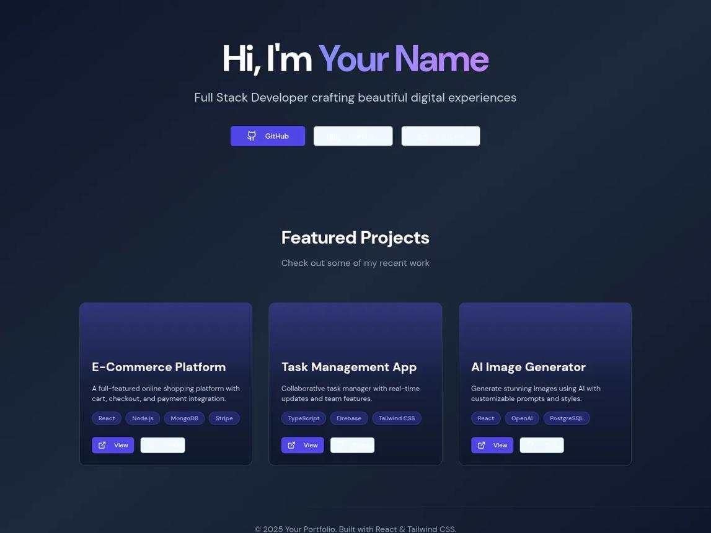
Design inspiration: dark background, gradient accents, project cards aur responsive layout.

Step 1: VS Code mein folder banao
- Folder: Day39-Portfolio
- File: index.html

Step 2: Complete code Type karo
<!DOCTYPE html>
<html lang="en">
<head>
<meta charset="UTF-8">
<meta name="viewport" content="width=device-width, initial-scale=1.0">
<meta name="description" content="Personal web development portfolio">
<title>My Portfolio | Web Developer</title>

<style>
* {
box-sizing: border-box;
margin: 0;
padding: 0;
}

:root {
--bg: #0b1020;
--panel: #141b30;
--text: #f8fafc;
--muted: #b8c2d8;
--accent: #a78bfa;
--border: #29334d;
}

html {
scroll-behavior: smooth;
}

body {
font-family: Arial, sans-serif;
background: var(--bg);
color: var(--text);
line-height: 1.6;
}

a {
color: inherit;
text-decoration: none;
}

.container {
width: min(1100px, 92%);
margin: auto;
}

header {
position: sticky;
top: 0;
z-index: 10;
background: #0b1020ed;
border-bottom: 1px solid var(--border);
backdrop-filter: blur(12px);
}

nav {
min-height: 72px;
display: flex;
align-items: center;
justify-content: space-between;
gap: 20px;
}

.logo {
font-size: 23px;
font-weight: bold;
color: var(--accent);
}

.nav-links {
display: flex;
gap: 22px;
flex-wrap: wrap;
}

.nav-links a:hover {
color: var(--accent);
}

.hero {
min-height: 490px;
display: flex;
align-items: center;
padding: 75px 0;
background:
radial-gradient(ellipse at 80% 20%, #7c3aed35, transparent 45%);
}

.tag {
color: var(--accent);
font-weight: bold;
letter-spacing: 2px;
text-transform: uppercase;
}

h1 {
font-size: clamp(38px, 7vw, 70px);
line-height: 1.1;
margin: 18px 0;
}

.gradient {
background: linear-gradient(90deg, #a78bfa, #38bdf8);
color: transparent;
background-clip: text;
-webkit-background-clip: text;
}

.hero p, .section-description {
max-width: 650px;
color: var(--muted);
font-size: 17px;
}

.buttons {
display: flex;
gap: 12px;
flex-wrap: wrap;
margin-top: 28px;
}

.btn {
display: inline-block;
padding: 12px 20px;
border: 1px solid var(--accent);
border-radius: 9px;
background: var(--accent);
color: #17112d;
font-weight: bold;
cursor: pointer;
}

.btn.secondary {
color: var(--text);
background: transparent;
}

section {
padding: 75px 0;
}

.section-title {
font-size: 34px;
margin-bottom: 12px;
}

.skills, .projects {
display: grid;
grid-template-columns: repeat(auto-fit, minmax(220px, 1fr));
gap: 18px;
margin-top: 28px;
}

.skill, .project, .about-card {
padding: 23px;
background: var(--panel);
border: 1px solid var(--border);
border-radius: 15px;
}

.skill h3, .project h3 {
color: var(--accent);
margin-bottom: 8px;
}

.skill p, .project p, .about-card p {
color: var(--muted);
}

.project {
transition: transform 0.2s, border-color 0.2s;
}

.project:hover {
transform: translateY(-5px);
border-color: var(--accent);
}

.project-icon {
font-size: 34px;
margin-bottom: 12px;
}

.project a {
display: inline-block;
margin-top: 15px;
color: var(--accent);
font-weight: bold;
}

.contact-card {
padding: 30px;
border: 1px solid var(--border);
border-radius: 16px;
background: var(--panel);
}

.contact-card p {
color: var(--muted);
margin: 12px 0;
}

footer {
padding: 25px 0;
text-align: center;
color: var(--muted);
border-top: 1px solid var(--border);
}

@media (max-width: 600px) {
nav {
padding: 15px 0;
align-items: flex-start;
flex-direction: column;
}

.nav-links {
gap: 13px;
font-size: 14px;
}

section {
padding: 55px 0;
}

.section-title {
font-size: 29px;
}
}
</style>
</head>

<body>
<header>
<nav class="container">
<a class="logo" href="#home">MyPortfolio.</a>

<div class="nav-links">
<a href="#home">Home</a>
<a href="#about">About</a>
<a href="#skills">Skills</a>
<a href="#projects">Projects</a>
<a href="#contact">Contact</a>
</div>
</nav>
</header>

<main>
<section class="hero" id="home">
<div class="container">
<span class="tag">Welcome to my portfolio</span>

<h1>
Hi, I'm <span class="gradient">INDIAN COMPUTER INSTITUTE</span><br>
Web Developer
</h1>

<p>
I am learning to build modern, responsive and interactive
websites using HTML, CSS and JavaScript. Welcome to my
personal portfolio.
</p>

<div class="buttons">
<a class="btn" href="#projects">Explore My Projects</a>
<a class="btn secondary" href="#contact">Contact Me</a>
</div>
</div>
</section>

<section id="about">
<div class="container">
<h2 class="section-title">About Me</h2>

<div class="about-card">
<p>
Hello! I am a beginner web developer who enjoys learning
website design and programming. I practise by creating
small projects and improving my coding skills every day.
</p>
</div>
</div>
</section>

<section id="skills">
<div class="container">
<h2 class="section-title">My Skills</h2>
<p class="section-description">
Technologies I am learning and using in my projects.
</p>

<div class="skills">
<article class="skill">
<h3>HTML5</h3>
<p>Building structured and accessible web pages.</p>
</article>

<article class="skill">
<h3>CSS3</h3>
<p>Styling, animations, layouts and responsive design.</p>
</article>

<article class="skill">
<h3>JavaScript</h3>
<p>Interactive features, events, APIs and application logic.</p>
</article>

<article class="skill">
<h3>Responsive Design</h3>
<p>Making websites work on mobile, tablet and desktop.</p>
</article>
</div>
</div>
</section>

<section id="projects">
<div class="container">
<h2 class="section-title">My Projects</h2>
<p class="section-description">
A selection of practice projects from my learning journey.
</p>

<div class="projects">
<article class="project">
<div class="project-icon">🛒</div>
<h3>Shopping Cart</h3>
<p>A product shopping interface with cart and quantity controls.</p>
<a href="#contact">Project Details ↓</a>
</article>

<article class="project">
<div class="project-icon">🌦️</div>
<h3>Weather App</h3>
<p>A weather dashboard that retrieves data from an API.</p>
<a href="#contact">Project Details ↓</a>
</article>

<article class="project">
<div class="project-icon">💰</div>
<h3>Expense Tracker</h3>
<p>An app to record expenses and calculate totals.</p>
<a href="#contact">Project Details ↓</a>
</article>
</div>
</div>
</section>

<section id="contact">
<div class="container">
<h2 class="section-title">Contact Me</h2>

<div class="contact-card">
<p>
Want to discuss a project or share feedback?
Add your real contact details below.
</p>

<p><strong>Email:</strong> indiancti@gmail.com</p>

<a class="btn" href="mailto:your-email@example.com">
Send Me an Email
</a>
</div>
</div>
</section>
</main>

<footer>
<div class="container">
<p>© <span id="year"></span> INDIAN COMPUTER TRAINING INSTITUTE. Built with HTML and CSS.</p>
</div>
</footer>

<script>
document.getElementById("year").textContent =
new Date().getFullYear();
</script>
</body>
</html>

Step 3: Apni website customize karo
- INDIAN COMPUTER INSTITUTE ko apne naam se replace karo.
- About section mein apne baare mein likho.
- Projects mein apne actual project details add karo.
- Email placeholder ko apne intended contact email se replace karo.
- Browser mein mobile aur desktop layout dono check karo.

Step 4: Day 39 checklist
Portfolio browser mein open ki
Apna naam aur About section edit kiya
Skills aur projects check kiye
Navigation links test kiye
Mobile responsive layout test kiya

🚀 Day 40: Advanced Portfolio — Dark/Light Mode + Project Filter
Aaj hum apni portfolio website ko aur professional banayenge. Is project mein tum seekhoge:
- 🌙 Dark Mode / Light Mode toggle
- 🔎 Projects ko category ke hisaab se filter karna
- 📱 Responsive design
- ✨ Smooth animations
- 📩 Contact form validation

Step 1: VS Code mein file banao
<!DOCTYPE html>
<html lang="en">
<head>
<meta charset="UTF-8">
<meta name="viewport" content="width=device-width, initial-scale=1.0">
<title>My Advanced Portfolio</title>

<style>
:root {
--bg: #101827;
--card: #1c2940;
--text: #f5f7ff;
--muted: #b7c2d8;
--accent: #8b5cf6;
}

body.light {
--bg: #f4f6fc;
--card: #ffffff;
--text: #182033;
--muted: #5c667a;
--accent: #6d3be8;
}

* {
box-sizing: border-box;
margin: 0;
padding: 0;
}

html {
scroll-behavior: smooth;
}

body {
font-family: Arial, sans-serif;
background: var(--bg);
color: var(--text);
transition: 0.3s;
line-height: 1.6;
}

header {
padding: 18px 8%;
display: flex;
justify-content: space-between;
align-items: center;
gap: 15px;
flex-wrap: wrap;
border-bottom: 1px solid #80808033;
}

.logo {
font-size: 23px;
font-weight: bold;
color: var(--accent);
}

nav {
display: flex;
gap: 18px;
align-items: center;
flex-wrap: wrap;
}

nav a {
color: var(--text);
text-decoration: none;
}

button, .btn {
background: var(--accent);
color: white;
border: none;
padding: 11px 16px;
border-radius: 9px;
cursor: pointer;
font-weight: bold;
}

button:hover, .btn:hover {
opacity: 0.85;
transform: translateY(-2px);
}

section {
padding: 65px 8%;
}

.hero {
min-height: 65vh;
display: flex;
flex-direction: column;
align-items: flex-start;
justify-content: center;
}

.hero h1 {
font-size: clamp(36px, 6vw, 62px);
line-height: 1.15;
margin: 15px 0;
}

.hero h1 span {
color: var(--accent);
}

.hero p, .muted {
color: var(--muted);
max-width: 650px;
}

.hero .btn {
display: inline-block;
margin-top: 22px;
text-decoration: none;
}

h2 {
font-size: 30px;
margin-bottom: 22px;
}

.filters {
display: flex;
flex-wrap: wrap;
gap: 10px;
margin-bottom: 25px;
}

.filters button {
background: var(--card);
color: var(--text);
border: 1px solid #80808055;
}

.filters button.active {
background: var(--accent);
color: white;
}

.projects {
display: grid;
grid-template-columns: repeat(auto-fit, minmax(220px, 1fr));
gap: 18px;
}

.project, .skill, .contact-box {
background: var(--card);
padding: 22px;
border-radius: 14px;
border: 1px solid #80808025;
}

.project {
animation: appear 0.35s ease;
}

.project h3 {
margin-bottom: 8px;
}

.project p {
color: var(--muted);
margin-bottom: 15px;
}

.tag {
color: var(--accent);
font-size: 13px;
font-weight: bold;
}

.skills {
display: grid;
grid-template-columns: repeat(auto-fit, minmax(130px, 1fr));
gap: 15px;
}

.skill {
text-align: center;
font-weight: bold;
}

form {
display: grid;
gap: 14px;
max-width: 550px;
}

input, textarea {
width: 100%;
padding: 13px;
border-radius: 8px;
border: 1px solid #80808055;
background: var(--card);
color: var(--text);
font: inherit;
}

textarea {
min-height: 120px;
resize: vertical;
}

#formMessage {
color: var(--accent);
font-weight: bold;
}

footer {
text-align: center;
padding: 25px;
color: var(--muted);
border-top: 1px solid #80808033;
}

@keyframes appear {
from { opacity: 0; transform: translateY(10px); }
to { opacity: 1; transform: translateY(0); }
}

@media (max-width: 600px) {
header { padding: 18px 5%; }
section { padding: 45px 5%; }
nav { gap: 12px; }
.hero { min-height: 55vh; }
}
</style>
</head>

<body>
<header>
<div class="logo">MyPortfolio.</div>

<nav>
<a href="#home">Home</a>
<a href="#projects">Projects</a>
<a href="#skills">Skills</a>
<a href="#contact">Contact</a>
<button id="themeBtn" type="button">☀️ Light Mode</button>
</nav>
</header>

<main>
<section class="hero" id="home">
<p class="tag">WELCOME TO MY PORTFOLIO</p>
<h1>Hello, I'm a <span>INDIAN CTI Web Developer</span></h1>
<p>
I create modern, responsive and interactive websites
using HTML, CSS and JavaScript.
</p>
<a class="btn" href="#projects">Explore My Projects ↓</a>
</section>

<section id="projects">
<h2>My Projects 💻</h2>
<p class="muted">Category select karke projects filter karo.</p>

<div class="filters">
<button class="active" data-filter="all">All</button>
<button data-filter="html">HTML/CSS</button>
<button data-filter="javascript">JavaScript</button>
<button data-filter="app">Web Apps</button>
</div>

<div class="projects" id="projectList">
<article class="project" data-category="html">
<span class="tag">HTML/CSS</span>
<h3>Landing Page</h3>
<p>A modern and responsive website homepage.</p>
</article>

<article class="project" data-category="javascript">
<span class="tag">JAVASCRIPT</span>
<h3>Quiz App</h3>
<p>An interactive quiz with questions and scores.</p>
</article>

<article class="project" data-category="app">
<span class="tag">WEB APP</span>
<h3>Expense Tracker</h3>
<p>Track expenses and calculate your total.</p>
</article>

<article class="project" data-category="javascript">
<span class="tag">JAVASCRIPT</span>
<h3>Weather App</h3>
<p>Search for weather information by city.</p>
</article>

<article class="project" data-category="app">
<span class="tag">WEB APP</span>
<h3>Task Manager</h3>
<p>Add and manage your daily tasks.</p>
</article>

<article class="project" data-category="html">
<span class="tag">HTML/CSS</span>
<h3>Portfolio Design</h3>
<p>A personal website to showcase your work.</p>
</article>
</div>
</section>

<section id="skills">
<h2>My Skills ⚡</h2>
<div class="skills">
<div class="skill">🌐 HTML</div>
<div class="skill">🎨 CSS</div>
<div class="skill">⚙️ JavaScript</div>
<div class="skill">📱 Responsive Design</div>
<div class="skill">🔗 APIs</div>
<div class="skill">💾 Local Storage</div>
</div>
</section>

<section id="contact">
<h2>Contact Me 📩</h2>
<div class="contact-box">
<p class="muted">Form fill karo aur validation test karo.</p>

<form id="contactForm">
<input
type="text"
id="name"
placeholder="Your Name"
required
>

<input
type="email"
id="email"
placeholder="Your Email"
required
>

<textarea
id="message"
placeholder="Your Message (minimum 20 characters)"
minlength="20"
required
></textarea>

<button type="submit">Validate Form</button>
<p id="formMessage" role="status"></p>
</form>
</div>
</section>
</main>

<footer>
© <span id="year"></span> MyPortfolio. Made with ❤️
</footer>

<script>
// 1. Dark / Light Mode
const themeBtn = document.getElementById("themeBtn");

themeBtn.addEventListener("click", function () {
document.body.classList.toggle("light");

const isLight = document.body.classList.contains("light");

themeBtn.textContent = isLight
? "🌙 Dark Mode"
: "☀️ Light Mode";
});

// 2. Project Category Filter
const filterButtons = document.querySelectorAll("[data-filter]");
const projects = document.querySelectorAll(".project");

filterButtons.forEach(function (button) {
button.addEventListener("click", function () {
const category = button.dataset.filter;

filterButtons.forEach(function (btn) {
btn.classList.remove("active");
});

button.classList.add("active");

projects.forEach(function (project) {
const matches =
category === "all" ||
project.dataset.category === category;

project.hidden = !matches;
});
});
});

// 3. Contact Form Validation
const contactForm = document.getElementById("contactForm");
const formMessage = document.getElementById("formMessage");

contactForm.addEventListener("submit", function (event) {
event.preventDefault();

const name = document.getElementById("name").value.trim();
const message = document.getElementById("message").value.trim();

if (name.length < 2) {
formMessage.textContent =
"Please enter a name with at least 2 characters.";
return;
}

if (message.length < 10) {
formMessage.textContent =
"Message must contain at least 10 characters.";
return;
}

formMessage.textContent =
"Form validation successful! 🎉";

contactForm.reset();
});

// 4. Automatic Year
document.getElementById("year").textContent =
new Date().getFullYear();
</script>
</body>
</html>

Step 2: Website run karo
- File ko index.html naam se save karo.
- VS Code mein Live Server se open karo, ya file ko browser mein kholo.
- Light/Dark Mode button test karo.
- All, HTML/CSS, JavaScript aur Web Apps buttons par click karo.
- Contact form mein alag-alag inputs test karo.
Important: Contact form abhi sirf validation karta hai. Ye message email par send nahi karta, kyunki uske liye backend ya email service connect karni hogi.

Day 40 Practice
Dark/Light Mode working
Project filters working
Contact form validation working
Mobile screen par design check kiya

Day 41 mein kya seekhenge?
- Git kya hai aur GitHub kya hai
- Git install karna Windows 10 par
- VS Code se Git use karna
- git init, git add, git commit
- Apne project ko GitHub par upload karna
Pehle Git install karne ke liye official website kholo:
Git for Windows
Windows 10 ke liye official Git installer
Git download karo
Step 1: Git install karo aur installation complete hone ke baad VS Code kholo.
Phir terminal mein ye command chalao:
git --version
Agar Git ka version number aa jaye, to installation successful hai.

Day 41: Git & GitHub — Complete Tutorial
Aaj hum seekhenge ki apni website ka code kaise save karna hai aur GitHub par kaise upload karna hai.

Step 1: Git download aur install karo

Git for Windows 10 ke liye Git version control software.
Official Git download website kholo
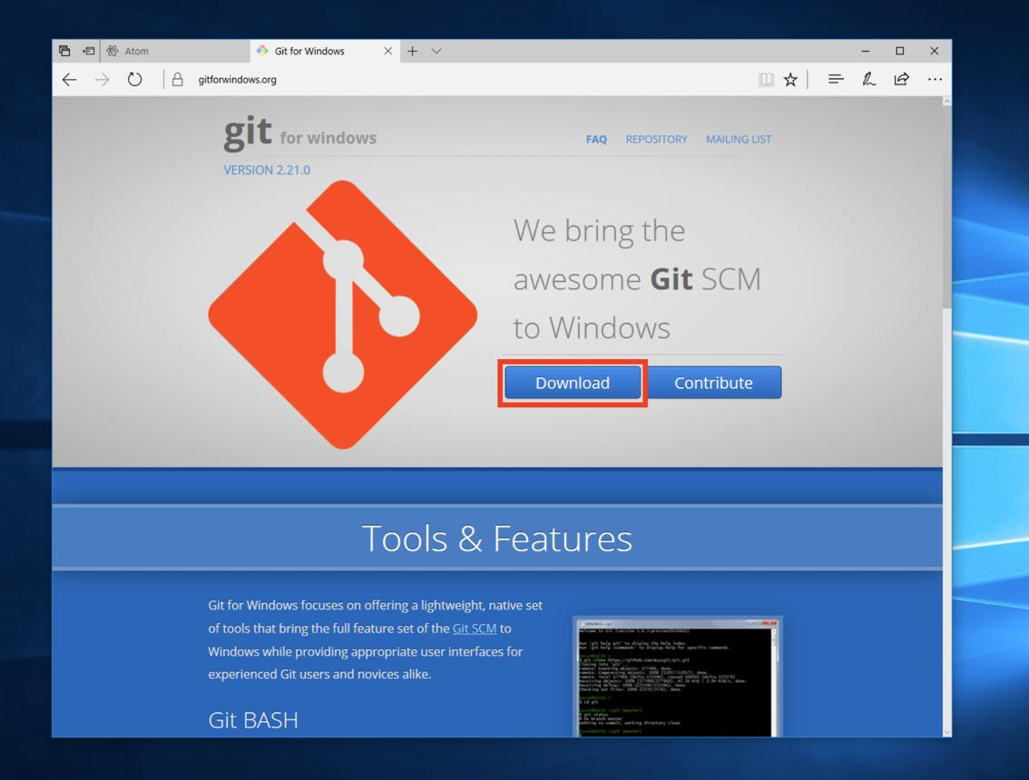
1. Download karo
Website par Windows ke liye installer download karo.
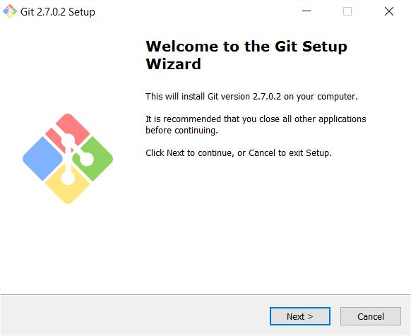
2. Installer chalao
Download hui .exe file open karo. Permission maange to official installer ko allow karo.
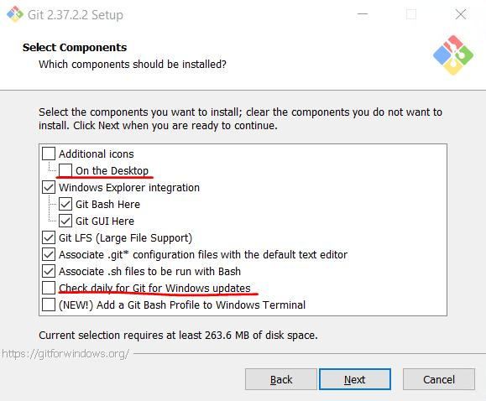
3. Installation complete karo
Beginner ke liye default options rehne do aur Next click karte jao. Aakhir mein Install aur phir Finish dabao.

Step 2: Git install hua ya nahi, check karo
- VS Code kholo.
- Upar menu mein Terminal → New Terminal par click karo.
- Neeche terminal mein ye command likho:
git --version
Agar output aisa aaye, to Git install ho gaya:
git version 2.xx.x.windows.x
Version number alag ho sakta hai.

Step 3: Git mein apna naam aur email set karo
Terminal mein apna naam aur GitHub par use karne wala email daalo:
git config --global user.name "Your Name"
git config --global user.email "your-email@example.com"
Your Name aur your-email@example.com ko apni details se replace karna.

Step 4: Apne website project ka folder kholo
VS Code mein:
- File → Open Folder par click karo.
- Apna portfolio project folder select karo.
- Confirm karo ki uske andar tumhari index.html file hai.
Ab terminal mein ye commands ek-ek karke chalao:
git init
git add .
git commit -m "My first portfolio website"
Inka matlab:
- git init — project mein Git start karta hai.
- git add . — files ko agle save ke liye select karta hai.
- git commit — selected files ka version save karta hai.
Agar commit ke time nothing to commit aaye, to ho sakta hai files pehle hi save ho chuki hon.

Step 5: GitHub account banao

GitHub
Online platform jahan apne code ke projects rakh sakte ho.
GitHub website kholo
- GitHub website par account banao ya sign in karo.
- New repository par click karo.
- Repository name rakho: my-portfolio
- Public ya Private select karo.
- Agar tum local project ko upload kar rahe ho, to README, license aur .gitignore ko abhi initialize mat karo.
- Create repository par click karo.
GitHub tumhe repository ka URL dega, jo kuch is tarah hoga:
https://github.com/YOUR-USERNAME/my-portfolio.git

Step 6: Apni website GitHub par upload karo
GitHub se mile apne repository URL ko use karke terminal mein ye command chalao:
git branch -M main
git remote add origin https://github.com/YOUR-USERNAME/my-portfolio.git
git push -u origin main
Pehle YOUR-USERNAME ko apne actual GitHub username se replace karna. Agar GitHub login ya browser authorization maange, to official login process complete karo.
Dhyan rahe: Passwords, API keys ya private information GitHub par upload mat karna.

Step 7: Website ko online live karo (GitHub Pages)
- GitHub par apni my-portfolio repository kholo.
- Settings → Pages mein jao.
- Build and deployment mein Deploy from a branch select karo.
- Branch main aur folder /(root) select karke Save karo.
- Publish hone ke baad Pages section mein tumhari website ka URL dikhega. Thoda wait karna pad sakta hai.
GitHub Pages static HTML, CSS aur JavaScript websites host kar sakta hai.

Abhi tumhara pehla task
sabse pehle Step 1 aur Step 2 complete karo. Phir mujhe batao terminal mein kya output aaya.
Bilkul bro! 😊 Chalo Windows 10 par Git download aur install bilkul zero se karte hain. Ek-ek step follow karna; pehle Git install aur test karenge, phir VS Code se connect karenge.

Day 41 — Step 1: Git download karo

Git for Windows
Git tumhare website code ke changes ka record rakhega.
Official download page kholo
- Upar diye gaye official link par click karo.
- Windows ke liye installer download karo. Agar 64-bit Git for Windows Setup ka option dikhe aur tumhara Windows 10 64-bit hai, to use select karo.
- Download complete hone tak wait karo.
Agar tumhe apne Windows ka 64-bit ya 32-bit hona nahi pata, to Settings → System → About → System type mein check kar sakte ho.

Step 2: Download hui file ko open karo
- Chrome mein Ctrl + J dabao. Downloads ki list khul jayegi.
- Git-...-64-bit.exe naam ki file par click karo.
- Agar Windows permission maange, to publisher check karke Yes dabao.

Step 3: Git install karo
Installer mein alag-alag screens aayengi. Beginner ke liye in settings ko follow karo:
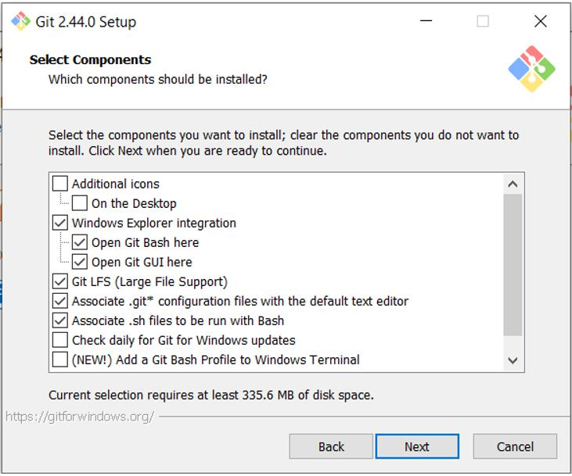
1. Select Components
Default settings rehne do. Next dabao.
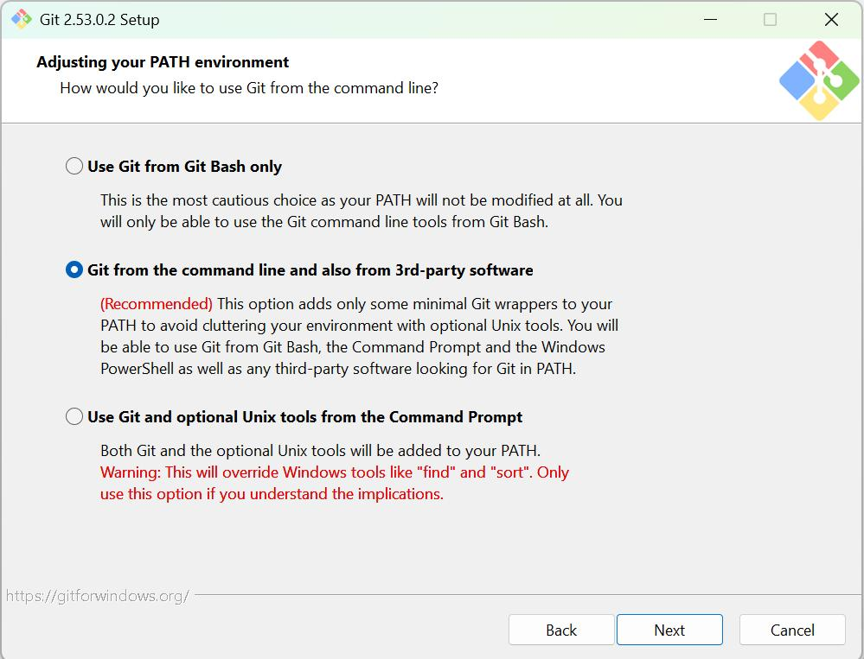
2. PATH Environment
Agar option dikhe, to Git from the command line and also from 3rd-party software select karo. Phir Next dabao.
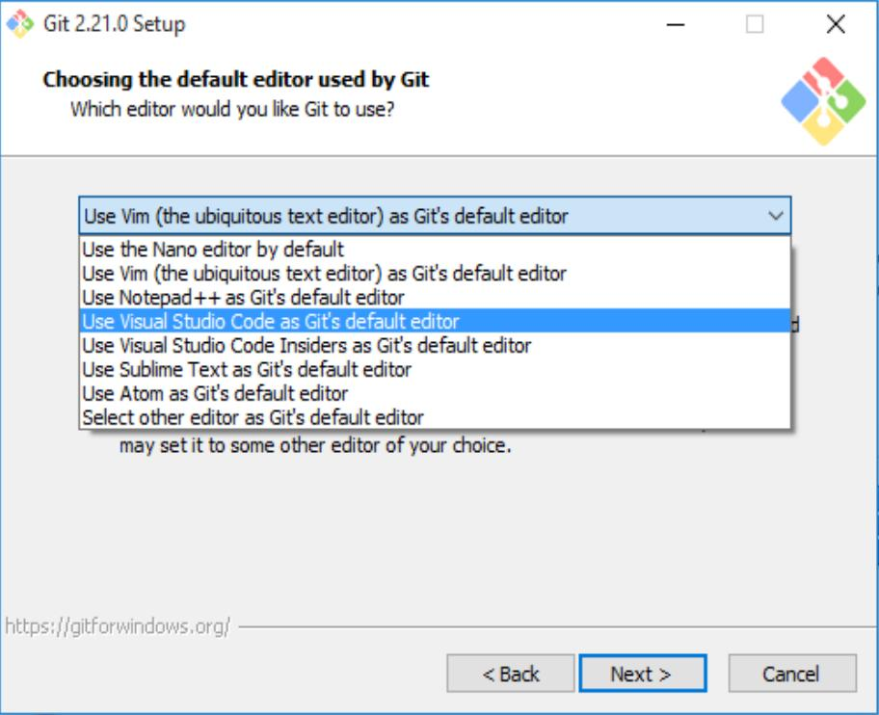
3. Default Editor
Agar editor select karne ka option aaye, to VS Code available ho to use select kar sakte ho. Warna default rehne do.
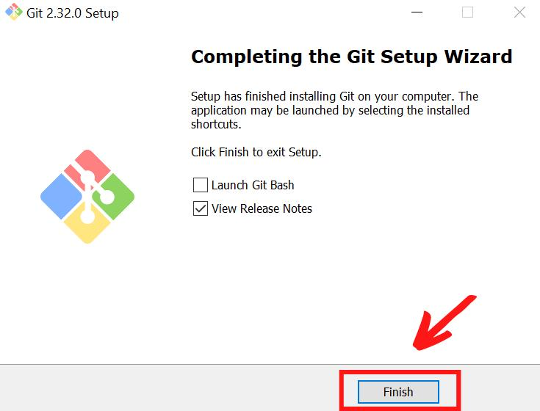
4. Baaki installation
Baaki screens par default settings rehne do, Next dabate jao, phir Install aur Finish dabao.
Reference: Git ki official installation guide.

Install for Windows

Step 4: Git sahi se install hua ya nahi?
Ab ye karo:
- VS Code kholo.
- Upar Terminal → New Terminal par click karo.
- Ye command type karo aur Enter dabao:
git --version
Agar git version 2.xx.x.windows.x jaisa output aata hai, to installation successful hai.
Agar 'git' is not recognized jaisa error aaye, to VS Code band karke dobara kholo aur command fir se try karo.
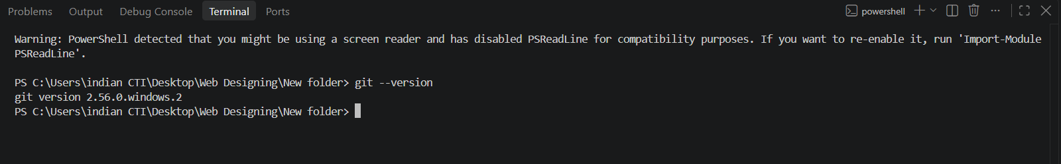
Git install ho gaya, ab hum VS Code ko Git ke saath connect karenge. Phir tum apni website ka code save kar paoge aur GitHub par upload karna seekhoge.

Day 41 — Step 5: VS Code mein Git setup

1. VS Code mein apna project kholo
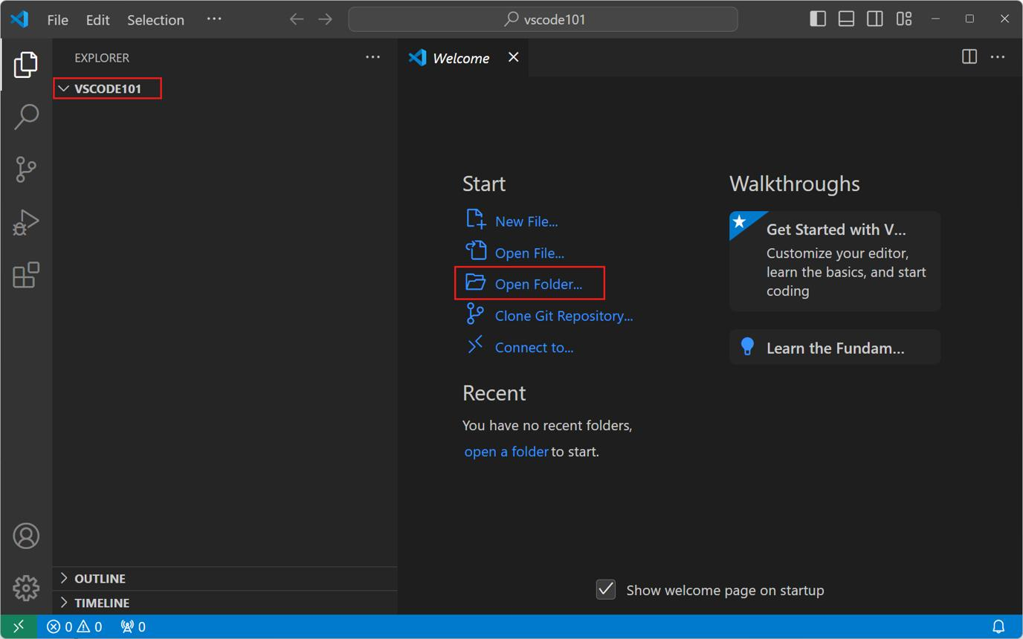
- VS Code open karo.
- File → Open Folder par click karo.
- Apna portfolio website wala folder select karo, jisme index.html hai.
- Select Folder par click karo.

2. Terminal kholo
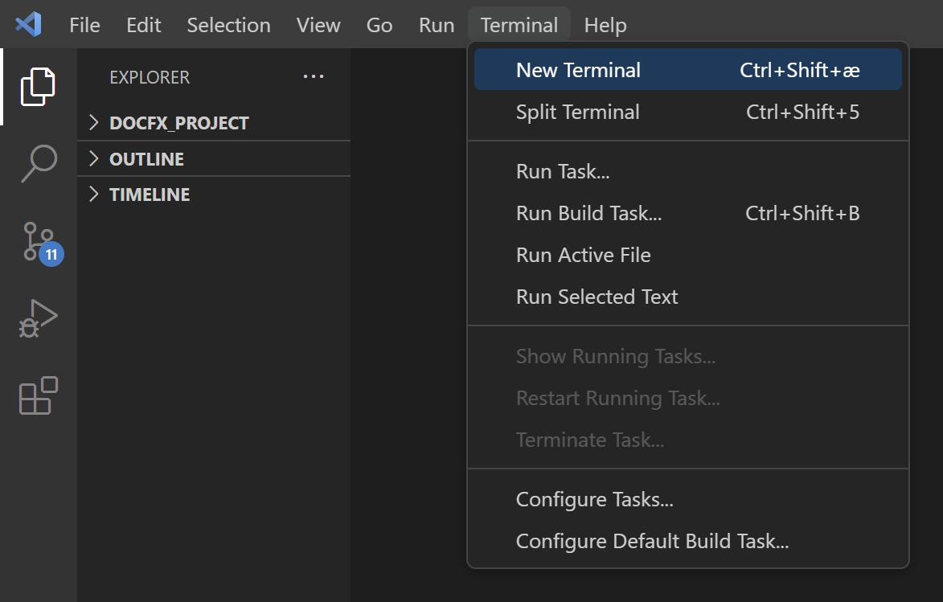
VS Code ke top menu mein:
Terminal → New Terminal
Ab terminal mein ye command chalao:
git --version
Agar version number aata hai, to VS Code Git ko access kar pa raha hai.

3. Git mein apna naam aur email set karo
Terminal mein apna naam aur email likho. Example ko apni details se replace karna:
git config --global user.name "My Name"
git config --global user.email "myemail@example.com"
Ye naam aur email tumhare commits ke saath record honge. GitHub par use hone wala email rakhna achha rahega.
Check karne ke liye:
git config --global --list

4. Apne project mein Git shuru karo
Ensure karo ki terminal mein tumhare project folder ka path dikh raha hai. Phir chalao:
git init
Ab project ki files check karo:
git status
Agar Untracked files mein index.html dikh raha hai, to bilkul theek hai.

5. Pehla save (Commit) karo
Ek-ek karke ye commands chalao:
git add .
git commit -m "My first portfolio website"
Agar commit successful ho gaya, to tumhari files ka pehla version Git mein save ho chuka hai. 🎉
Yaad rakho:
- git add . — files ko save karne ke liye select karta hai.
- git commit — selected changes ka version record karta hai.
- git status — batata hai ki project mein kya badla hai.

Ab tumhari baari
VS Code setup status
VS Code terminal mein Git version aa raha hai.
Git init aur pehla commit dono successful hain.
Kisi command mein error aa raha hai.
Next step →
Bro, agar kisi command par error aaye to uska screenshot bhej dena; hum usi ko fix karenge. 💻

