**Run Me Document**

1. Open WDAutomation project in Eclipse.
2. Check the test cases mentioned in sanitysuite.xml file. Location of this file in the project is as follows:  
   **WDAutomation/src/test/resources/testNgFileContainer/SanitySuite.xml**
3. If all required test cases are mentioned, no changes are required. Otherwise add all the required test cases in the required format, example given below:  
   **<class name = “package-name.testcase-name”/>**
4. This package name is the one that are created under /src/test/java location and testcase-name is the test java file mentioned in these packages.  
     
   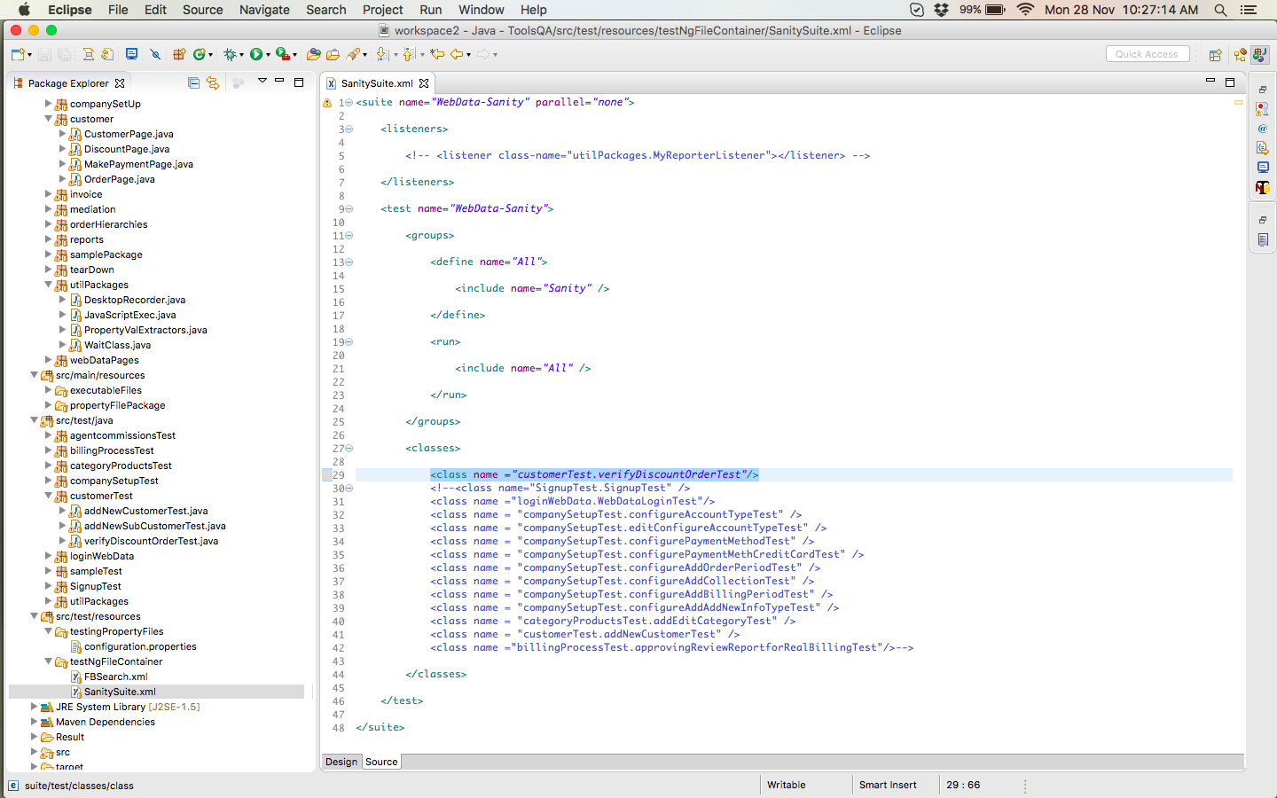
5. Go to RUN 🡪 Run Configurations and create new configuration under “Maven Build”, as shown in the screenshot.  
     
   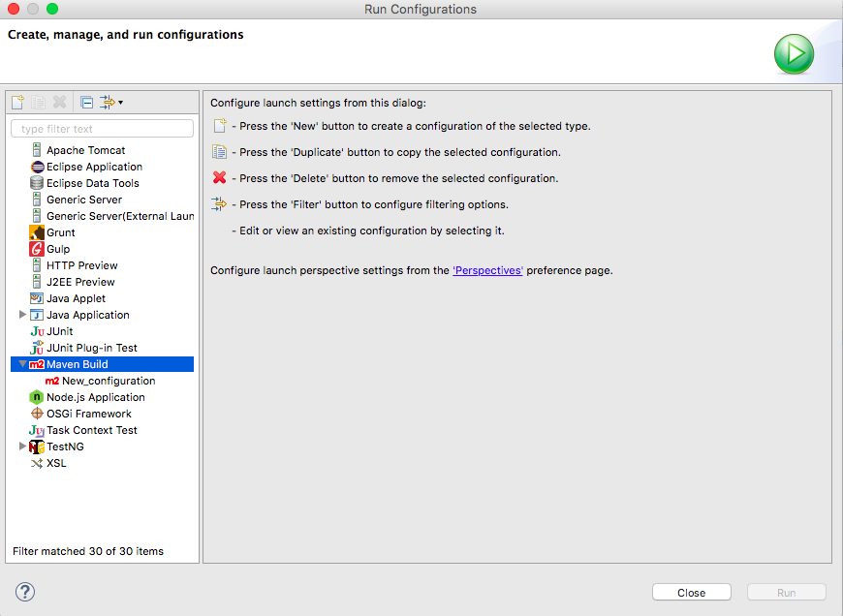
6. Add the following in the New Configuration’s Main Tab (Give any name to this configuration for example – WDAutomation RUN):
   1. Base directory: ${workspace_loc:/ToolsQA}
   2. Goals: test
   3. Profiles: WDAutomation
   4. User Settings: <live it blank>  
        
      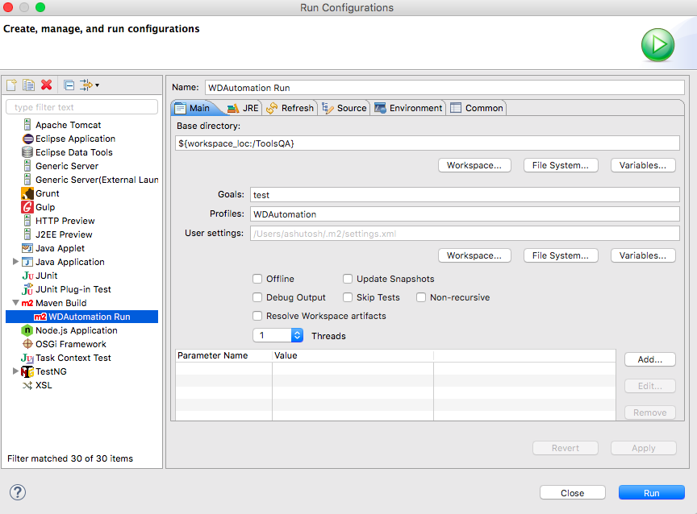
7. Click Apply button and then click Run button.
8. All the test cases mentioned in the sanitysuite.xml will start executing one by one.

**Configuration Properties** file changes, the changes done here are for URL and Browser to be used while execution.

1. Location of this file is – /src/test/resources/testingPropertyFiles/configuration.properties
2. Enter the value for url. This value will be used for signup scenario.  
   **url = http://www.abc.com/signup**
3. Enter the value for url1. This value will be used for executing the test cases post login.  
   **url1 = http://www.abc.com/login**
4. Enter the value for Browser as gc for google chrome and ff for firefox.  
   **Browser = gc**
5. Save the changes
6. Do ensure these changes are done before executing the test cases.