|  |  |  |
| --- | --- | --- |
| Page | Item Number | Description |
| Home | 1 | Home button |
|  | 2 | Links |
|  | 3 | Footer links to social media |
|  | 4 | Nav Bar |
|  | 5 | Footer |
|  | 6 | Heading |
|  | 7 | Text |
|  | 8 | Image 1 |
|  | 9 | Image 2 |
|  |  |  |



|  |  |  |
| --- | --- | --- |
| Page | Item Number | Description |
| About | 1 | Home button |
|  | 2 | Links |
|  | 3 | Footer links to social media |
|  | 4 | Nav Bar |
|  | 5 | Footer |
|  | 6 | Heading |
|  | 7 | Heading |
|  | 8 | Text |
|  | 9 | Heading & text |
|  | 10 | Heading & text |
|  |  |  |



|  |  |  |
| --- | --- | --- |
| Page | Item Number | Description |
| Portfolio | 1 | Icon of word doc |
|  | 2 | Screenshot of terminal app |
|  | 3 | Icon of github gist |
|  | 4 | Link will open in new window |
|  | 5 | Github icon |
|  | 6 | Linkedin icon |

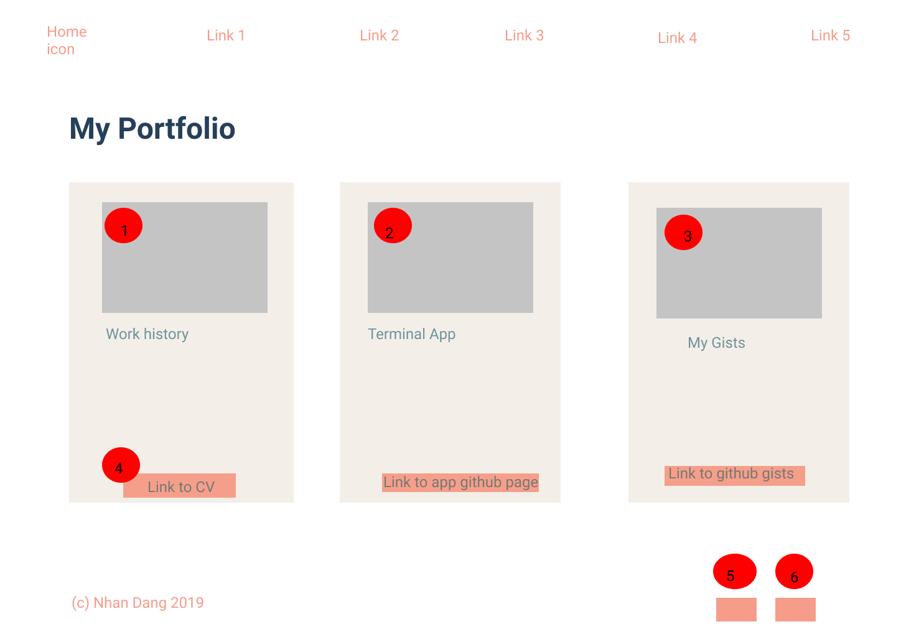

|  |  |  |
| --- | --- | --- |
| Page | Item Number | Description |
| Blog | 1 | Container for blog post – most recent |
|  | 2 | Blog post image |
|  | 3 | Side navbar for blogpost links |
|  | 4 | Blog post image 2 for previous post |

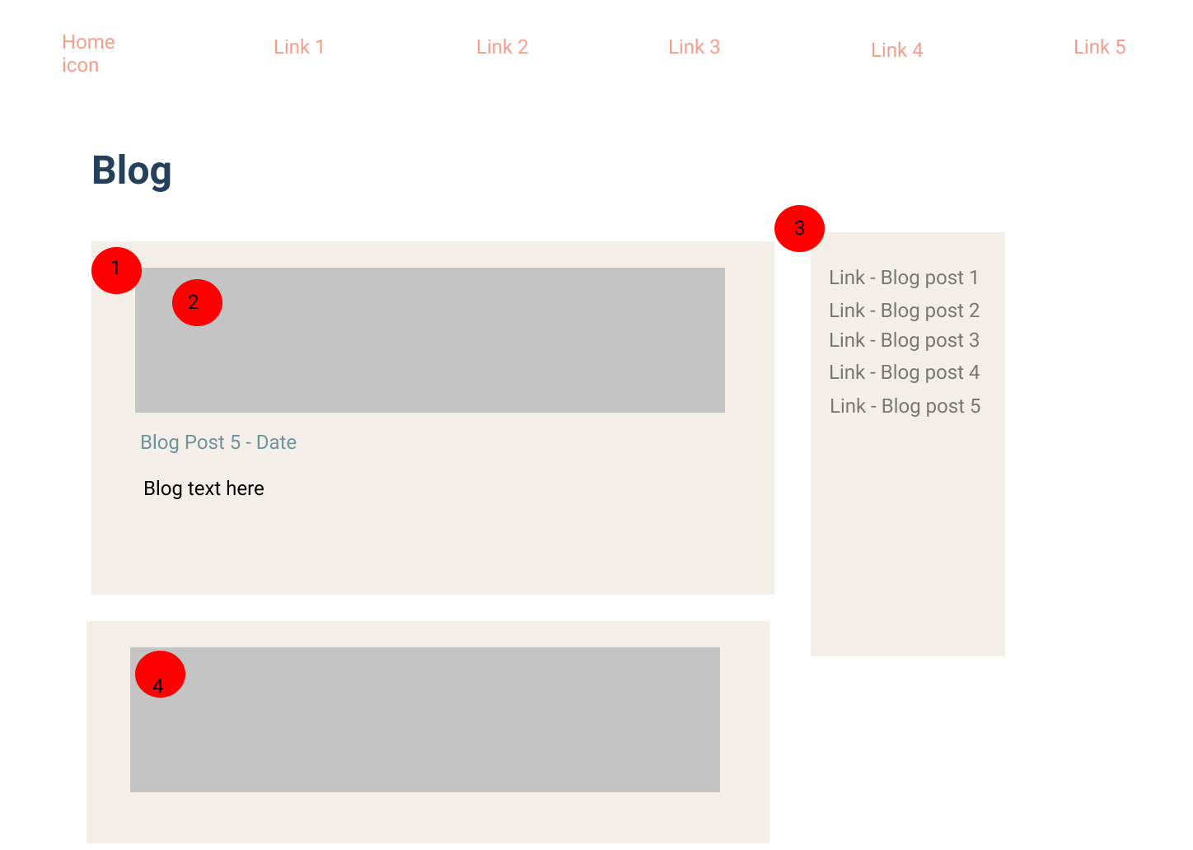

|  |  |  |
| --- | --- | --- |
| Page | Item Number | Description |
| Contact | 1 | Contact form |
|  | 2 | Submit – will be submitted via formspree |
|  | 5 | Footer – icon link for github |
|  | 6 | Footer – icon link for linkedin |

