Reviewers' comments:
Reviewer #1 (Remarks to the Author):
Vaidya et al present RAD, a new tool for identifying cell barcodes in long-read single-cell RNA-seq (scRNA-seq) dataset and then assigning each read to a cell barcode. As an essential first step in processing long-read scRNA-seq data, such tools and their performance are important and will continue to grow in importance as the use of long-read scRNA-seq expands.
We appreciate the reviewer’s comment on the importance of the problem.
Vaidya et al present results to suggest RAD has field leading performance. However, the benchmarking presented is insufficient to properly assess this - comparisons to other key tools are often not performed and the comparison between RAD and BLAZE on simulated data is performed in a way that prevents BLAZE from working as designed, leaving the manuscripts’ conclusions dependent on one atypical dataset. In addition, our own testing and benchmarking of RAD in reviewing this manuscript found some significantly different results to those reported by the authors. In summary - Important additional work is required to properly establish the performance of RAD compared to existing tools in the field.
The reviewer has given many constructive suggestions to improve the manuscript quality. We believe we have conducted substantially additional tests to properly establish the performance advantage of RAD as described below.
Major comments
1. The introduction contains a number of statements about existing tools in the field that are inaccurate. While all tools have limitations it is crucial to ensure these are described accurately.
We thank the reviewer for pointing out the inaccuracies in the introduction section. We will clarify or remove them and conduct corresponding benchmarks in the revised manuscript.
- Describing existing tools in the field (BLAZE and Flexiplex) the authors claim that “they depend on short-read matched data” (line 49) and that “processing long-read data effectively necessitates … paired short-read data” (line 57-58). And that RAD “ addresses these limitations” including “demultiplexing from long reads alone without requiring paired short-read sequencing data” (line 64). However, neither BLAZE nor Flexiplex require matched short-read data, or any short-read data at all. In fact the original motivation for us to create Blaze was to eliminate the (at the time) need for matched short-read data for barcode identification and demultiplexing.
We explicitly mentioned that “BLAZE generates whitelists from long reads but uses a quantile-based threshold…” to acknowledge that BLAZE can operate without a short-read whitelist. Our description that existing tools “depend on short-read matched data” is based on the observation that BLAZE and Flexiplex are substantially less accurate in some datasets without information inferred from paired short-read data, such as the expected number of cells. Based on new results from the expanded benchmarks, we will revise this part. Specifically, we will demonstrate that their whitelist generation step is less robust than RAD for sequencing platforms such as single-nucleus data.
- In addition, requiring an expected number of cells as in input parameter should not be characterised as being “short-read dependent”, as an approximate cell count (e.g., the target number of recovered cells) is typically known from the experimental design prior to sequencing. We also showed in the Blaze manuscript that this is extremely robust to reasonable deviations from the actual number of cells present. The authors mention this requirement as a key limitation of Blaze multiple times, but why inputting a single known value into Blaze is an important limitation is not made clear.
While users usually know how many cells are inputted, multiple factors could decrease the final number cells with high-quality reads. We have conducted a comprehensive analysis of the impact of the expected number of cells on BLAZE. On single-cell ONT data, BLAZE is robust to the tested estimates of 2,500, 5,000 and 10,000 cells. However, on single-nucleus ONT data, the expected-cell setting has a much larger impact on the number of false-positive barcodes, despite similar recovery of reference barcodes (Response Figure 1). Furthermore, for data like RAGE-seq, the number of expected cells is typically unknown and can range from XXX to XXX.
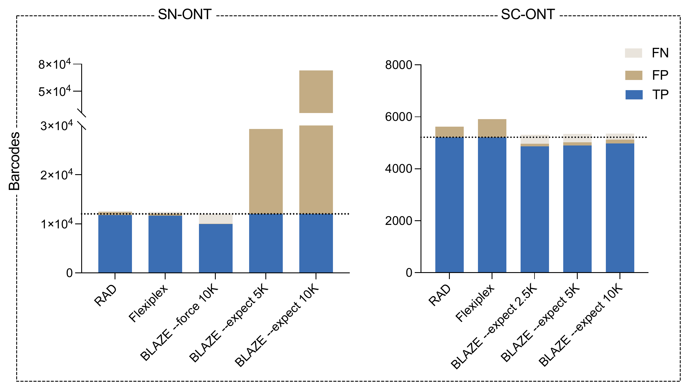
Response Figure 1. Effect of expected cell count option on barcode discovery. Stacked bars show true-positive (TP), false-positive (FP) and false-negative (FN) barcodes relative to the reference whitelist for single-nucleus ONT (SN-ONT, left) and single-cell ONT (SC-ONT, right) data. RAD and Flexiplex could automatically infer the expected cell count. Dotted lines indicate reference whitelist sizes; the SN-ONT axis contains a break.
- Blaze works with 10x spatial barcoding not just 10x 5’ and 3’ single-cell sequencing (line 45, 46)
We will clarify this by distinguishing conventional Visium from Visium HD, which has a split-barcode structure that BLAZE cannot directly process.
- Flexiplex does not require a pre-supplied barcode whitelist (contrary to the claim in lines 51 and 53). Neither does Blaze.
We will remove this sentence in the revised manuscript.
- The authors state that Blaze and Flexiplex “have limited ability to handle complex error types, such as chimeric and truncated reads”. However Flexiplex has a chimeric mode, which the publication suggested worked well. Furthermore the citation for these claimed limitations is a review, so it is not clear if there is any pre-existing data on which to base this statement.
We thank the reviewer for this suggestion. We will remove this description from the introduction section.
- The authors claim that “These complex errors compound during demultiplexing, resulting in both misidentification of barcodes and inadvertent overinflation of unique molecular identifier (UMI) counts due to error-generated singletons” (line 55-57). This claim might be true but is un-cited. Please provide a citation to show this applies to the current versions of Blaze and Flexiplex.
We believe this is a natural outcome of the computational artifacts so did not emphasize the citation. The errors are expected to affect absolute UMI counts, but we agree that the impact on relative UMI counts may be unknown. We will rewrite this description as:
“These complex errors compound during demultiplexing, resulting in both misidentification of barcodes and may overinflate of unique molecular identifier (UMI) counts due to error-generated singletons” and compare the relative UMI count in cells on real data sets in the revised manuscript.
- FlamesV2 (Wang et al https://doi.org/10.1101/2025.10.19.683327) is our end-to-end pipeline for long-read single-cell data processing, including barcode identification and demultiplexing. While the authors correctly note it contains Blaze and Flexiplex, the Flames V2 paper showed it can process a very wide range of single-cell data types including LR split-seq, 10x, and spatial barcoding on multiple platforms. The authors’ statement that Flames “inherits their constraints” (line 52) is in contrast to the demonstrated flexibility of FlamesV2 to process various sequencing modalities and read structures.
- Note that some of these same incorrect claims are also made in the discussion (lines 279-282).
We will make changes to the discussion section accordingly.
2. Lack of benchmarking against Flexiplex, the second key tool in the field
- A number of benchmarking analyses only compare RAD to Blaze. Comparison against Flexiplex is required as well. This is especially important since the Flexiplex paper claimed it had the best performance in the field. The authors report they were unable to test Flexiplex on the scTagger simulated data. However the Flexiplex publication performed benchmarking on this same dataset.
We have included Flexiplex throughout the expanded benchmark. Flexiplex achieved highest F1 in 4 samples; RAD had the highest F1 in 27 and BLAZE in 6 (Response Figure 3). Therefore, Flexiplex will be extensively benchmarked in the revised manuscript.
“We compared Flexiplex’s performance with two specialized tools for long-read single-cell demultiplexing, scTagger and FLAMES, on simulated data generated by Ebrahimi et al (2022). The simulation consisted of 5 million reads generated for 5000 cells. True barcode sequences were provided to each tool to benchmark them under a best-case scenario, where a perfect list of known barcodes is provided.”
3. The benchmarking methodology for the ScTagger simulated data uses a methodology that prevents BLAZE from working properly.
Figure 2 compares RAD and Blaze on the ScTagger simulated long-read single-cell RNA-seq data. A key step in the Blaze pipeline that allows it to identify true cell barcodes is that it filters raw barcode sequences based on per-base quality. The default is all bases must have a quality score of 15 for the raw barcode to be kept. Raw sequences with low quality bases (which likely represent sequencing errors and false positive barcode sequences) are therefore removed. However, on line 544 of the method the authors state: “For cross-tool compatibility, every base was assigned a Phred quality score of 20”. Therefore the authors have used a method which removed the base-level quality score from the reads and which will have prevented Blaze from functioning as designed. Changing quality scores like this is not usual practise in LR scRNA-seq anlaysis pipelines. The reported finding in the manuscript that Blaze found lots of false positive barcodes is likely due to this. These analyses need to be re-done using a methodology that allows Blaze to function as designed.
The reviewer’s concern motivated us to test a range of per-base quality scores (QScore) rather than uniform Phred-20 scores. We re-scored the same 4,993,805 ScTagger-L reads using the Badread nanopore2018 quality model and 11 paired shifts, spanning mean barcode-base scores of Q14.14–26.14 (mean barcode-base score XXX from the default Badread ), without changing the nucleotide sequences or read identities. RAD recovered all 5,000 true barcodes without false positives at every score level. BLAZE’s best whitelist F1 was 0.9914 (5,000 true positives and 87 false positives), compared with 1.0000 for RAD. BLAZE’s response to quality calibration was substantial, whereas RAD and both Flexiplex configurations were unchanged across this sweep (Response Figure 2).
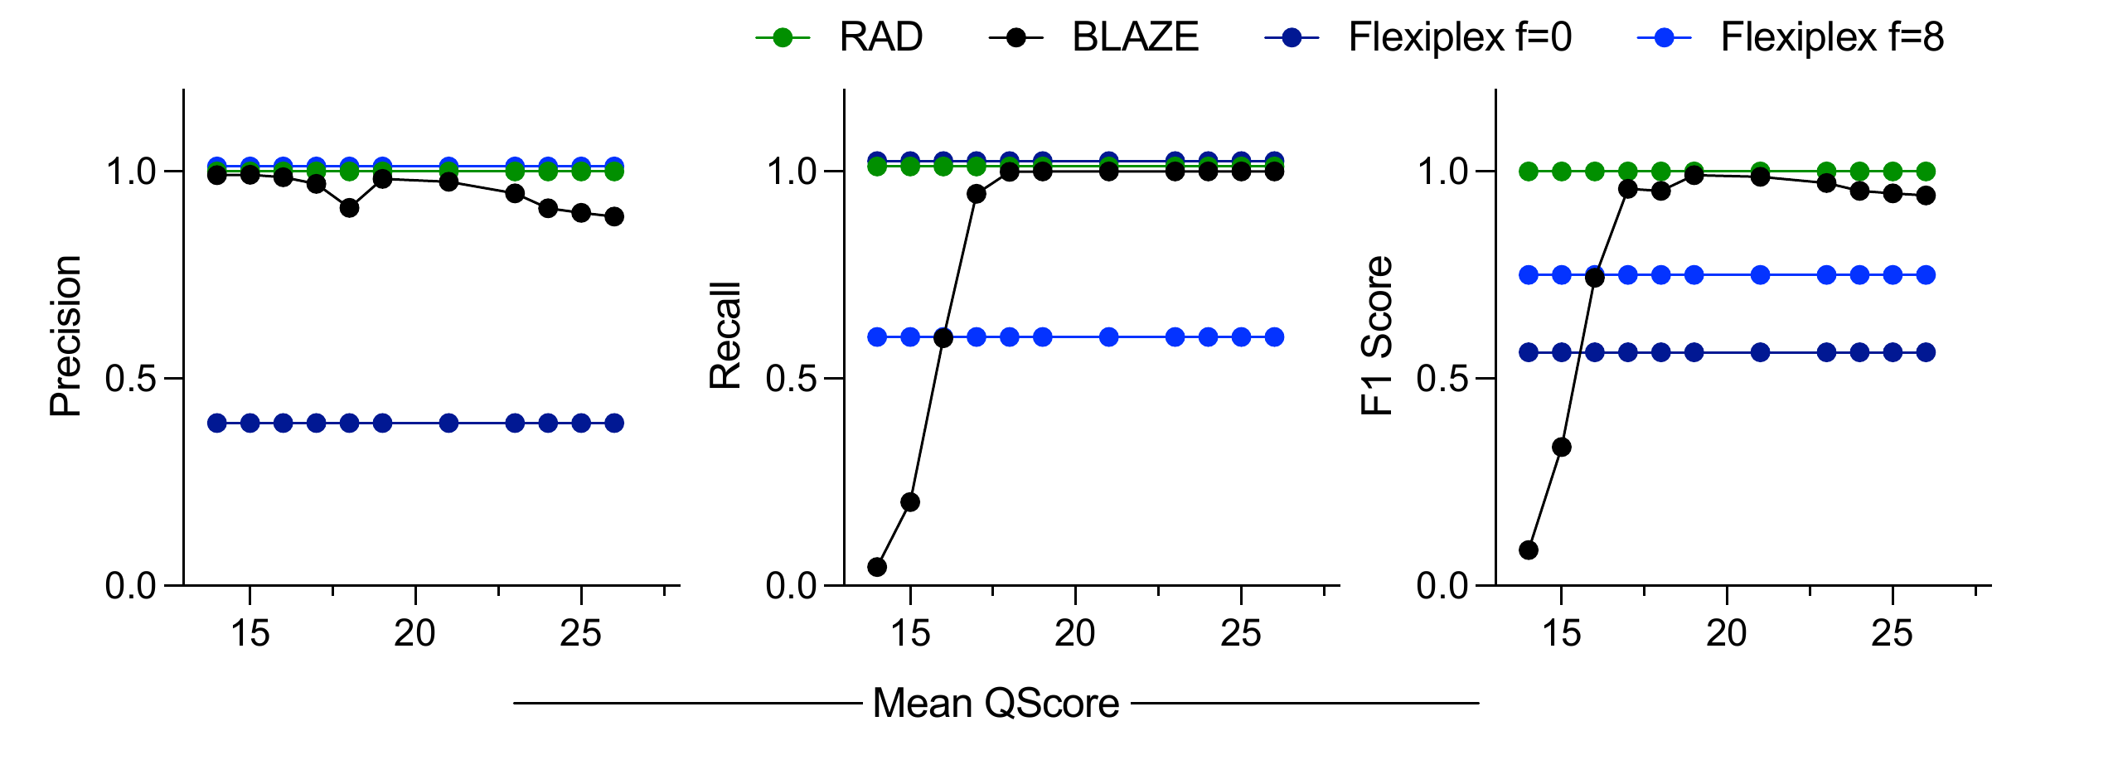
Response Figure 2. Effect of quality-score calibration on whitelist discovery. Precision, recall and F1 are shown for ScTagger-L (4,993,805 reads; 5,000 true barcodes) across 11 truth-conditioned Badread nanopore2018 quality shifts. The x-axis denotes mean barcode-base quality; nucleotide sequences were unchanged. BLAZE used 5,000 expected cells and minimum barcode quality Q15. Flexiplex used flank-edit distances of 0 and 8.
4. Overall benchmarking on real data sets is insufficient.
For the real datasets, BLAZE and Flexiplex were run on LongBench and Scmixology2, but these results were only used for runtime and computational efficiency comparisons. Therefore the only accuracy based benchmarking using real data was that using the RAGE-seq dataset. The performance of BLAZE on this dataset is highly unusual and does not correspond with the results of our own RAD vs BLAZE testing on real data (see point 5 below).
In addition, RAGE-seq was a bespoke protocol combining long-read scRNA-seq with 2 rounds of probe-based hybridisation capture to target sequencing to just 24 genes. It is possible the atypical results of BLAZE and flexiplex are specific to this dataset or data-type. This does not mean they cannot be benchmarked on RAGE-seq. However, conclusions drawn from a single highly specialised dataset with a very different data distribution to standard datasets in the field should be interpreted very cautiously.
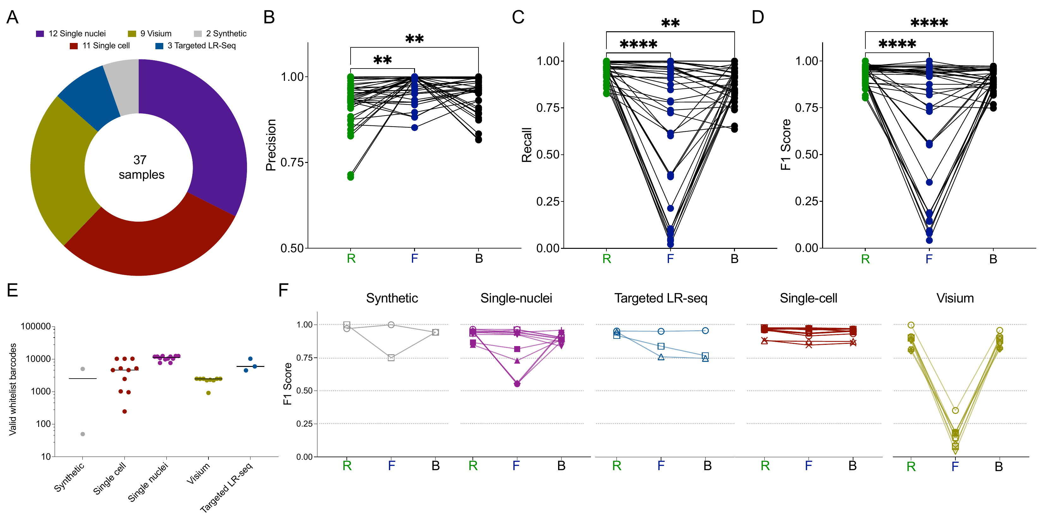
Response Figure 3. Barcode-calling performance across 37 samples. (A) Samples by modality. (B–D) Precision, recall and F1 for RAD, Flexiplex, and BLAZE, denoted as “R”, “F”, “B”, respectively, in plots; connected points denote the same sample. (E) Reference whitelist sizes by modality, with median bars. (F) F1 stratified by modality. Comparisons use the Friedman test with Dunn’s multiple-comparison correction against RAD; **P < 0.01 and ****P < 0.0001.
Regarding the Split-seq data and spatial (Visium) data - while BLAZE is not compatible with Split-seq/PARSE, FLAMESV2 (due to its incorporation of a modified version of Flexiplex) is. Therefore the performance of RAD should be compared to FLAMESV2 for these types of datasets.
As suggested, we have incorporated the FLAMESV2- version of Flexiplex in the evaluation of SPLIT-seq and Visium HD data. In the SPLIT-seq comparison shown here, RAD assigned 2,078,171 reads to the 568 published cells, compared with 1,156,252 for the component-based FLAMESV2/Flexiplex configuration with poly-T, an increase of 79.7%. When compared the reads per cells, RAD found significantly more reads than the FLAMESV2-version Flexiplex (Wilcoxon signed-rank test, p-value: 6.89e-43, median: 1979.5 vs 1102.5). This panel uses the component-based poly-T configuration, not MATCHED_SPLIT or the historical two-pass workflow.
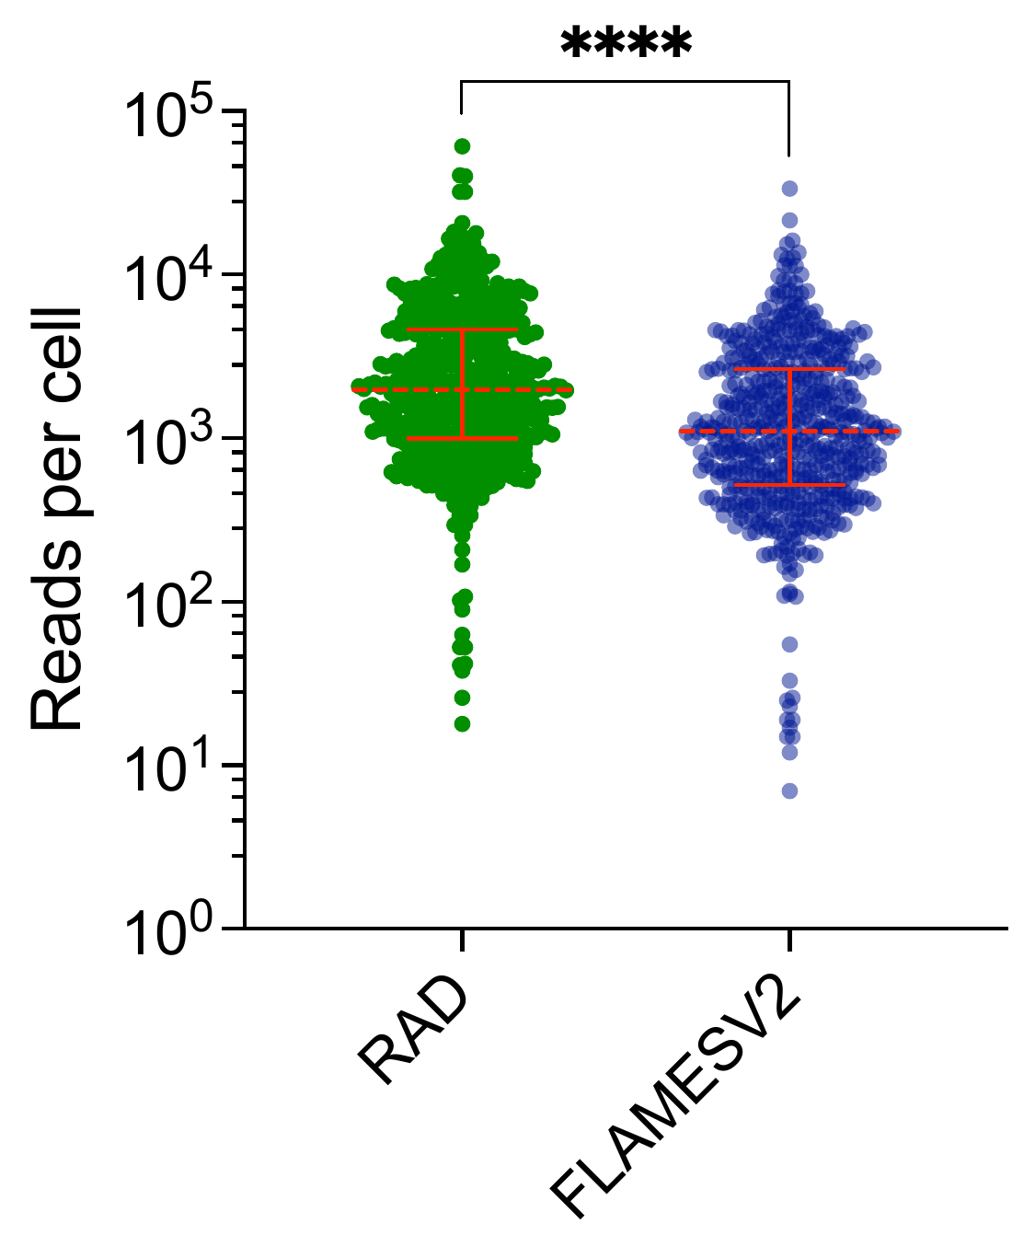
Response Figure 4. Read recovery in the 568 published LR-SPLIT-seq cells. Each point represents reads assigned to one cell by RAD or the FLAMESV2-version FLexiplex, plotted on a logarithmic scale. Red dashed lines indicate medians and bars indicate interquartile ranges. Median reads per cell were 1,979.5 for RAD and 1,102.5 for FLAMESV2. Paired two-tailed t-test, P = 6.89 × 10⁻⁴³ (****P < 0.0001).
5. Our own benchmarking of BLAZE vs RAD shows different results to those presented in the manuscript.
- We tested BLAZE vs RAD on 2 independent real datasets, both with matched Illumina short-reads to act as a proxy for a ground truth: iPSC-derived neurons from You et al 2023, and the LongBench data from (https://www.biorxiv.org/content/10.1101/2025.09.11.675724v3).
- In summary: BLAZE had higher precision, while RAD was more sensitive. F1 values were similar. The prioritisation of high precision in BLAZE was a deliberate design choice (see You et al 2023).
We appreciate the reviewer for the detailed comparison. The expanded benchmark distinguishes single-nucleus from single-cell sequencing data, since these protocols can yield different read distributions and demultiplexing outcomes (Response Figure 3). The datasets in the reviewer’s benchmark were from single-cell sequencing platform. Across all 37 samples, median F1 was 0.9504 for RAD, 0.9062 for BLAZE and 0.8755 for Flexiplex. We plan to emphasize robustness across sequencing modalities in the revision.
- RAD is faster, but has much higher memory requirements as the required memory scales with the number of reads. This could become a problem with large datasets, for example a dataset with 10x the reads of LongBench may require ~250Gb of RAM. In contrast, BLAZE has low and flat memory requirements as the dataset size increases. Nb: We would argue the LongBench data is more representative of current long-read scRNA-seq projects than the much smaller ~5 year old scMixology dataset. The authors tested both ScMixolgy and Longbench data in the manuscript, reporting both speed and memory usage for scMixolgy, but did not report memory usage for the larger LongBench dataset.
We identified and fixed a memory-allocation defect in scan-wl: repeated barcode observations were retained instead of being aggregated into counts. On the 117-million-read LongBench dataset, the corrected implementation had lower memory requirements than BLAZE, using 0.3178, 0.3265 and 0.3318 GB at 4, 16 and 32 threads, respectively (Response Figure 5). Memory increased by only 0.014 GB across an eightfold increase in thread count. The per-read observation buffer has been removed. These measurements concern whitelist discovery; whole-workflow runtime and peak memory are shown separately in Response Figure 6.
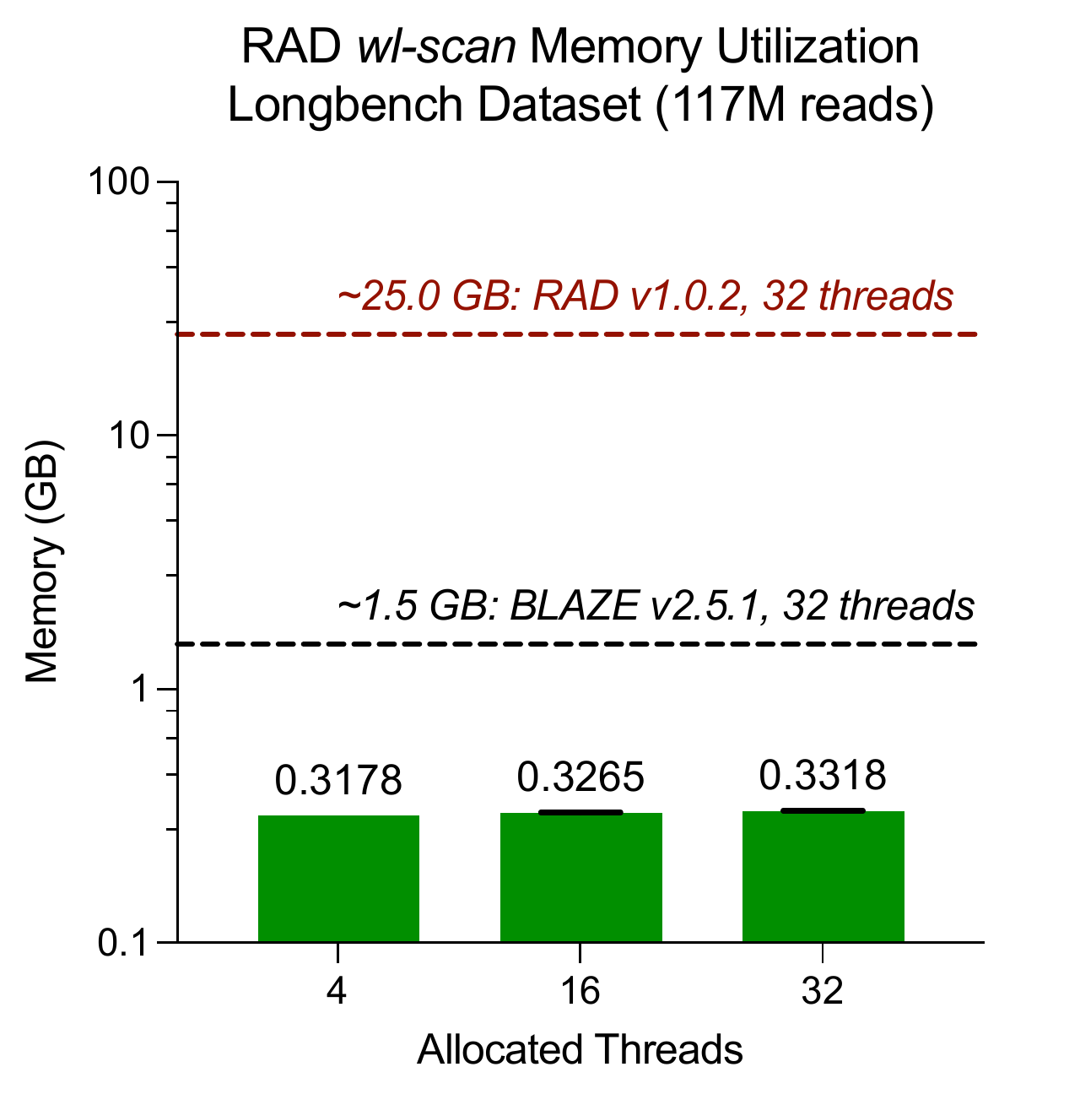
Response Figure 5. Memory use after the scan-wl correction. RAD whitelist discovery on the 117-million-read LongBench dataset used 0.3178, 0.3265 and 0.3318 GB at 4, 16 and 32 allocated threads. Dashed lines show the historical comparison values labeled in the plot for RAD v1.0.2 (approximately 25 GB) and BLAZE v2.5.1 (approximately 1.5 GB), both at 32 threads. This panel measures whitelist discovery, not the complete demultiplexing workflow.
- Overall, outside of running faster (but with much higher memory requirements) the advantages of RAD over BLAZE seem modest at best. See provided html report for full details.
The corrected implementation removes the excessive whitelist-discovery memory requirement. At 16 threads, total runtime was 1.75 hours for RAD versus 7.24 hours for BLAZE and 9.08 hours for Flexiplex on SN-ONT, and 1.49 versus 3.04 and 2.01 hours on SC-PacBio. Whole-workflow peak memory remained below 2.3 GB for all three tools across the tested thread counts (Response Figure 6).
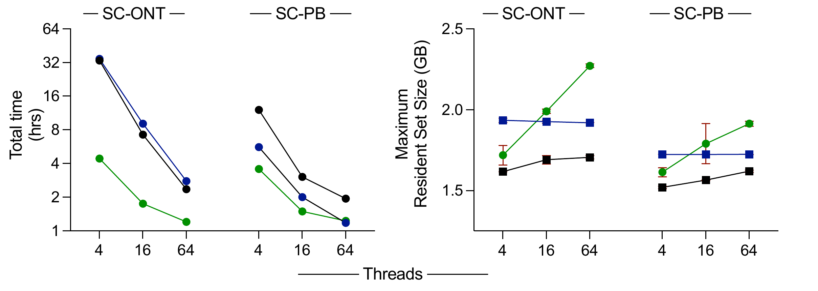
Response Figure 6. Whole-workflow runtime and memory on LongBench datasets. Total time (left) and maximum resident set size (right) are shown at 4, 16 and 64 threads for RAD (green), Flexiplex (blue) and BLAZE (black). Points summarize three runs; memory error bars show standard deviations. The ONT dataset is SN-ONT, labeled SC-ONT in the embedded artwork; SC-PB denotes single-cell PacBio. Runtime uses a logarithmic axis and memory is reported in GB.
Minor comments
We appreciate the reviewer for these comments. We will clarify them in the revised manuscript.
- Abstract - states there is a “high error rate inherent to LRS“. This statement is not correct. While one could argue about whether a ~1% error rate in Oxford Nanopore long-read is a high error rate, PacBIO long-read sequencing is extremely accurate and often reported to be more accurate that Illumina short-read sequencing.
- The narrative and focus of parts of the introduction could use improvement
- While the manuscript describes a versatile long-read single cell tool, only 1 previous long-read scRNA-seq study is described in the intro (Singh et al RAGE-seq). A wider focus would summarise the field and its potential better.
- Intro lines 32-35 - states targeted long-read sequencing has “fundamental” challenges. But no challenges are outlined or cited. These need to be better defined to evidence this statement and the motivation for this work.
- Line 36 - The author refer to long-read sequencing in general, but many of the subsequent details are specific to long-read single-cell sequencing. The authors should be clear about what methodologies they are referring to.
- Line 36 - 40 - the processing steps subsequent to read alignment, referred to the authors as “subsequent annotation” in long-read single-cell are also an area of very active computational development. This framing of the field doesn’t match the research activity in the field.
- Figure 1A is not totally clear. Arrows between the steps would help.
- Please define figure 1B abbreviations in figure legend.
- Please ensure the read length key and long-read sequence reads in Fig1C are relevant to RNA-seq. Long-read RNA-seq reads don’t go to 1250kb, they have a peak between 1-2kb and very rarely are more than 10kb.
- The analysis code repository linked to in the manuscript (https://github.com/indianewok/rad-manuscript) is not accessible. This also means we are unable to determine how BLAZE and Flexiplex were executed. It would be helpful if the commands and key parameters were also summarised in the Methods section.
We thank the reviewer for the comment. The repository for the evaluation code is public now.
- Can RAD operate without a supplied barcode whitelist? Line 63 says it performs whitelist generation. Line 95 says it uses supplied whitelists. I assume it can do both, but an explicit statement regarding this would be helpful for a reader.
RAD can operate with or without the barcode whitelist. We will make clarifications in the revision.
Signed
Mike Clark
University of Melbourne
Reviewer #1 (Remarks on code availability):
We were able to successfully install and run RAD. However, the analysis code repository linked to in the manuscript (https://github.com/indianewok/rad-manuscript) is not accessible.
The repository rad-manuscript is publicly accessible now.
Reviewer #2 (Remarks to the Author):
In this manuscript, Vaidya et al. present an error robust, read structure agnostic demultiplexer (RAD) for single cell long read sequencing and analysis. The authors claim that RAD allows users to easily specify read structures, such as adapter sequences and barcode positions. RAD can also rapidly extract these elements for each read and implements efficient barcode correction strategies. The authors performed benchmarking on synthetic and real world datasets and report that RAD is faster and achieves significantly higher sensitivity than existing pipelines, while maintaining comparable precision.
First, I would like to express my appreciation for work the authors have performed. The manuscript is very well written in a concise and clear manner.
We deeply appreciate this comment.
Major comments
1. The manuscript does not clearly demonstrate a major conceptual or technical advance, and the overall impact of the tool remains limited (taking into account the exiting tools).
We thank the reviewer for the many detailed and constructive suggestions. We believe that with the new preliminary data and revision plans (see below), it would be clear that RAD is not only a major technical advance but also yield better downstream analysis results.
2. Although I appreciate their work and their effort in developing such a tool, I doubt the suitability of the manuscript for the journal to which it has been submitted. I think this manuscript is better suited for a more computationally focused journal.
We appreciate the reviewer for this comment. Our labs have led the development of computational focused methods that are published on Nature Communications, such as Chromap (https://www.nature.com/articles/s41467-021-26865-w, published on 2021, with over 200 citations) for ultraefficient chromatin profiling sequencing data and PsiClass (https://www.nature.com/articles/s41467-019-12990-0) for highly efficient and accurate multi-sample transcriptome assembly. The efficient and easy-to-use long-read demultiplexing method will facilitate the adoption the single-cell long-read sequencing technology and have a broad impact on the biomedical research.
3. Although the authors provide a real application in the section “RAD enables isotype resolved BCR clonotype analysis and spatial mapping of class switch recombination”, it would have been beneficial to demonstrate RAD on additional single cell and spatial transcriptomics experiments. This would help clarify the broader applicability of the tool. In the same section, it would also be helpful to compare RAD with BLAZE and Flexiplex.
We have benchmarked RAD, BLAZE and Flexiplex on substantially more datasets, demonstrating the broader applicability of RAD: 12 single-nucleus, 11 single-cell, 9 Visium, 3 targeted long-read and 2 synthetic samples, for 37 samples in total (Response Figure 3).
4. Although RAD appears to show improvements in Figures 2 and 3, it would strengthen the manuscript to further elaborate on how these improvements affect downstream single cell data analysis.
The more sensitive and precise method should yield cleaner processed data and allows downstream analysis find clearer biological signals. Therefore, we evaluated downstream differential gene expression (DEG) analysis in the LongBench single-nucleus ONT (SN-ONT) dataset between cells from H146 and H526 cell lines. We utilized the paired short-read Illumina gene expression data across the 8,135 eligible genes for the ground truth. At BH-adjusted P < 0.05 and |log2 fold change| > 1, the Illumina reference contained 1,181 DEGs: 412 higher in H146 and 769 higher in H526. RAD recovered 654 with the same direction of change, compared with 556 for Flexiplex and 522 for BLAZE. RAD therefore had higher DEG sensitivity (55.38% versus 47.08% and 44.20%). Precision was 65.01% for RAD, 66.03% for Flexiplex, and 63.43% for BLAZE.
Across all 8,135 genes, RAD also showed the highest agreement with Illumina for signed log2 fold changes (Spearman ρ = 0.6145, versus 0.5654 for Flexiplex and 0.5487 for BLAZE) and for −log10(BH-adjusted P) (ρ = 0.4427, 0.3974, and 0.3886, respectively). Thus, RAD recovered more reference-supported differential-expression signals and better reproduced the ranking of signed fold changes, with overall DEG precision close to Flexiplex (Table 1).
Demultiplexer | Sensitivity | Precision | Spearman ρ  log2 fold change | Spearman ρ  BH-FDR confidence
RAD | 55.38% | 65.01% | 0.6145 | 0.4427
Flexiplex | 47.08% | 66.03% | 0.5654 | 0.3974
BLAZE | 44.20% | 63.43% | 0.5487 | 0.3886
Table 1. SN-ONT H146-versus-H526 differential-expression concordance with paired Illumina GEX. Sensitivity is the number of same-direction reference DEGs recovered divided by 1,181. Precision divides that number by all DEGs called by the tool: RAD 654/1,006, Flexiplex 556/842, and BLAZE 522/823. Both platforms use BH-adjusted P < 0.05 and |log2 fold change| > 1. Spearman correlations use all 8,135 common eligible genes; the adjusted-P correlations use uncapped −log10 values.
The analysis used each workflow’s positive-depth, Vireo-labeled H146/H526 cohorts: 709/419 cells for RAD, 290/219 for Flexiplex, 234/185 for BLAZE, and 263/195 for Illumina. Gene eligibility required at least 10 total molecules and detection in at least 1% of the H146-plus-H526 cells in each platform, followed by intersection across all four platforms. Counts were normalized to 10,000 per cell using library totals across all features. Two-sided Wilcoxon tests used log2(1 + normalized counts), with BH adjustment over the common gene set. This comparison retains each workflow’s recovered cells and sequencing depth; it is not restricted to shared barcodes or depth-matched.
5. In line 119, the authors state: “We also tested Flexiplex; however, its whitelist generation algorithm could not generate a whitelist for this dataset under default settings without user intervention and was excluded from this analysis.” They should have identified a dataset that allows a direct comparison among RAD, BLAZE, and Flexiplex.
All three tools are now compared across the same 37 samples (Response Figures 3 and 7). We have found datasets where Flexiplex yields good results in the expanded benchmark: 18 of the 37 samples had F1 > 0.90. However, RAD...
6. In lines 202–203, the authors state: “All three tools used under 5 GB of memory across whitelist generation and demultiplexing (Figure 4B).” However, RAD appears to use more memory. Additionally, in Figure 4C, where the authors test a large dataset, it would be valuable to also report memory, cup etc usage.
We have fixed the memory-allocation defect in RAD’s whitelist-discovery stage. On the 117-million-read dataset, scan-wl used 0.318–0.332 GB across 4–32 threads (Response Figure 5). Whole-workflow runtime and maximum resident set size are reported at 4, 16 and 64 threads for the SN-ONT and SC-PacBio datasets, with three runs per configuration (Response Figure 6).
7. As most genomics tools are transitioning to Python, I have concerns about the user-friendliness of this tool.
SIRAP + rRAD + meh
RAD is a high-performance method for sequencing processing with command line interface. This user interface is used in BLAZE and Flexiplex too, where the user-friendliness is independent from the programming language. We have provided comprehensive documentation and the default one-line command to improve the user-friendliness. That said, RAD also has an R interface in case users are more comfortable with environments like RStudio for data analysis.

In general, beyond the datasets analyzed and presented here, the authors should test RAD on several additional datasets with real biological interpretation and demonstrate how RAD improves the results ( comparing it other tools).
We thank the reviewer for this comment and hope the provided work can substantively demonstrate RAD’s value.

