Figure 1. RAD is a flexible, efficient, and broadly applicable tool for demultiplexing single-cell long read sequencing data. A. A schematic of RAD workflow. B-C. Total processing time (B) and maximum memory usage (C) for single-cell Oxford Nanopore Technologies (ONT) and single-cell Pacific Biosciences (PB, PacBio) LongBench datasets. D. Visualization of valid barcode spots (gray) determined by SpaceRanger (in_tissue metadata of gene expression output) from Visium HD spatial transcriptomic data (left) and log-transformed normalized read counts (log₁₀ ncpm) per 16-μm spot for Seurat (center) and RAD (right) processed data.
Figure 2. Benchmarking performance on synthetic data. A. Schematic of synthetic data used in performance evaluation and comparison of RAD (R, green), Flexiplex (F, light gray), and BLAZE (B, dark gray) in whitelist generation, demultiplexing, and analysis tasks. B-C. Whitelist generation performance. Quantitation of the true positive, false positive, and false negative barcodes generated by each method (B), and their resulting precision, sensitivity and F1 scores (C). D-E. Demultiplexing performance on native barcodes. Total read count (D), with false negative reads in red, and read depth (E) captured for native barcodes by each tool. F-H. Demultiplexing performance on error-corrected barcodes. The number of correctly and incorrectly assigned barcodes were quantified (F). For both correctly assigned (G) and incorrectly assigned (H) barcodes, total read counts (top) and read depth (bottom) captured by each tool. Statistical significance determined by one-way ANOVA (****p < 0.0001).
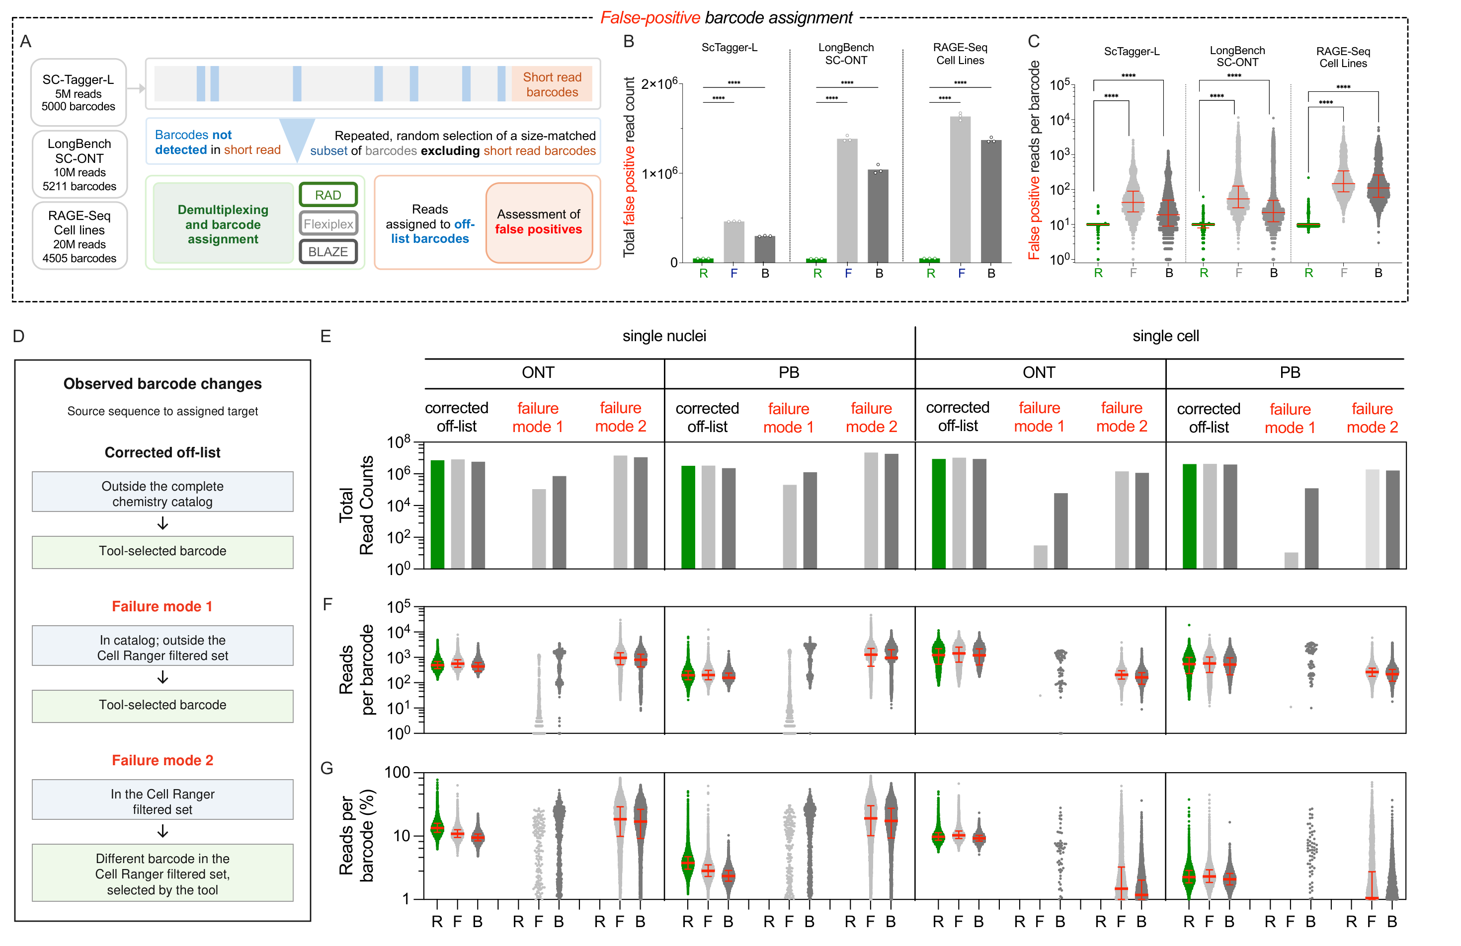
Figure 3. Adaptive whitelisting provides high fidelity barcode identification and correction. A-C. Characterization of false positive barcode assignment rate. Using three datasets, random, size matched sets of “off-list” barcodes were provided as the whitelist to each tool and the rate at which reads were assigned to this list was assessed (A). Quantification of the of total read count (B) and read depth (C) assigned to false positive barcodes by each tool. Statistical significance determined by one-way ANOVA (****p < 0.0001). D-G. Barcode correction was classified by exact observed source-barcode membership (D). Corrected off-list: a source outside the complete chemistry catalog was changed to a tool-selected target. Failure mode 1: a catalog-valid source outside the Cell Ranger filtered set was changed to a tool-selected target. Failure mode 2: a source in the Cell Ranger filtered set was changed to a different barcode in that set that was also selected by the tool. Counts used unique original-read–target-barcode pairs. Total counts (E), counts per target barcode (F), and class percentages among all such pairs assigned by the same tool to each target (G) were compared across the four LongBench inputs. These classes describe observed barcode changes and reference-set membership; they do not establish cellular origin or correction accuracy.

Figure 4. High performance across diverse datasets and read architectures. Long read data generated from 37 samples were chosen from a variety of experimental protocols, sample types, and read architectures (A). The short-read data characteristics have been plotted to illustrate the diversity of the underlying data B-E. This characterization included valid whitelist barcodes (B), total read count (C), GC content (D), and average Q (E). The long-read demultiplexing performance of each tool Using RAD (R, green), Flexiplex (F, light grey), and BLAZE (B, dark grey), was characterized using F1 scores (F), precision (G), and recall (H) for all 37 samples. The distributions and medians of F1 scores (I), precision (J), and recall (K) across all 37 samples are shown as box-and-whisker plots, with whiskers indicating the minimum and maximum values. Statistical significance determined by Friedman Test.

Figure 5. Benchmarking RAD performance on data with complex read structures. A-F. Performance of each tool in demultiplexing and mapping RAGE-seq-derived immune cell receptor reads when applied to a mixed pool of immune cells with distinct receptors. Composition of input cells (A). Comparison of total cells detected by RAD (R, green), Flexiplex (F, light gray), and BLAZE (B, dark gray) (B), number and identity of cell of each type (C), and the number of BCR and TCR reads mapped (D) by each tool. Number of reads with native or corrected barcodes (E) and read counts per barcode (F) mapped to each cell population by each tool. Statistical significance by paired two-tailed t-test (****p<0.0001). G-H. Performance of RAD (green) and FLAMESv2 (gray) in demultiplexing LR-Split-seq data. Detection of barcodes in LR-Splitseq dataset in which assignment requires successful identical of three barcodes per read (G). Long read and short-read UMI counts per cell were compared across the three cell types annotated in the original paper per tool (H). Dotted lines represent identity (x = y).
Figure 6. Improved single nuclei data depth and cell line annotation. A. Uniform Manifold Approximation Projection (UMAP) plot of LongBench single nuclei dataset depicting short read unassigned (peach), and short read annotated (other colors) nuclei per cell line. B. Performance of each tool in identifying short read-annotated (left) and short read-un-annotated (center) nuclei, with quantification of each cell line or failure mode (right). C. Total number of nuclei identified by each tool per cell line. Statistical significance defined by ANOVA with Dunnett’s multiple hypothesis correction.
Figure 7. Faithful and confident identification of differentially-expressed genes. A. Venn diagram depicting the overlap between genes identified as differentially expressed by each tool. B. Volcano plot depicting the fold change and confidence (FDR, False Discovery Rate) of differences in gene expression between H526 and H146 cell lines, between. Genes identified with greatest confidence (FDR > 10⁻²⁰) in Flexiplex or BLAZE are identified by name. Genes identified as key markers of small cell lung cancer (SCLC) types -A and SCLC-P, are distinguished by transcriptional regulators, ASCL1 and POU2F3 (red). C. Scatterplot of confidence in expression differences between BLAZE (x-axis) other tools (y-axis) for genes that are overexpressed in H146 (top) and H526 (bottom) nuclei, respectively. Red line indicates unity and slopes of best fit lines for RAD and Flexiplex are listed in inset. D. Accuracy of differentially expressed gene identification for each tool (F1 scores) as compared to ground truth, as defined by short read data across a sweep of fold-change (x-axis) and FDR (y-axis) cutoff thresholds. E. Olivia….

Figure 8. Comprehensive isotype-resolved B-cell clonotype analysis across transcriptomic datasets and in spatial context. A. Histogram of the total read counts across the IgH locus for Ramos, Nojima B cell culture, and Visium Tonsil datasets. The dots are colored by positional annotation. B. Heatmaps showing isotype composition across all recovered clones (top) and the subset of class-switching clones (bottom), defined as clones expressing reads from more than one constant region gene. C. Spatial visualization of the tonsil tissue section. Left: tissue microenvironmental regions. Right: RAD-recovered barcode positions overlaid on the tissue and colored by secretion status. D. Isotype heatmaps for three representative class-switching clones (identified by VDJ gene usage). First row indicates secretion status of the clone at that tissue spot; subsequent rows quantify reads at particular isotypes for each tissue spot. E. Spatial maps of the same three representative clones on the tonsil tissue section, with spots colored by the constant-region gene detected by RAD. Each sub-panel is annotated with VDJ gene usage and CDR3 amino acid sequence, enabling direct spatial inference of class-switch recombination history within tissue.

