**REPORT**

**ANDROID WORKSHOP**

**Objective:** To impart basic knowledge of ANDROID APP DEVELOPMENT.

**Venue:** CSE – Seminar Hall.

**Date:** 7th February 2018

**Date of submission of report:** 9th February 2018

**No. Of Participants:** 25 students of CSE branch attended the workshop.

**Event Description:**

One of the awaited events of CSI-IPEC chapter was conducted on 7th February 2018. The event planned was a workshop to be conducted on Android App Development. After telling the learners about installation of Android Studio we went off to telling them the basics of the Android application. Some faced problems during installation of Android Studio, some were unable to code, some were having difficulty in path setting of jdk, but all this was not enough to stop our Resource persons from doing what they were determined to do. Every problem was tackled well by the Organizing team. People attending the workshop were of not having same technical mind, but one thing was common ‘DEDICATION’ to learn something from the workshop

**Practical Knowledge:**

Basic knowledge of java is required.

**Technologies:**

ANDROID STUDIO.

***Core Members***

* Shivam Varshney.
* Stuti Srivastava
* Jai Srivastava
* Akshay Kumar Singh
* Nikhil Saxena
* Pranjal Gupta

**Some glimpses of the workshop:**

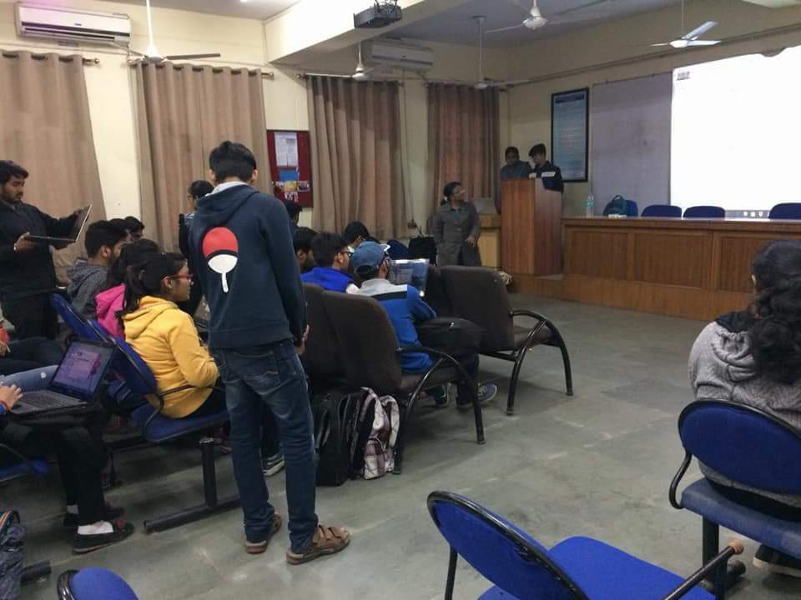

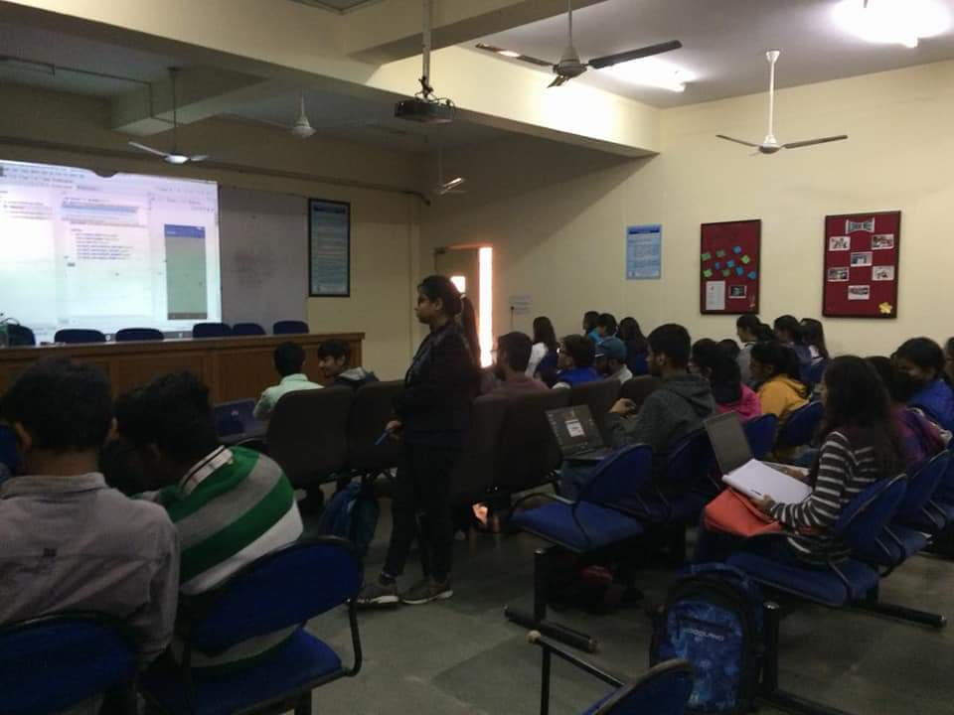

**Speaker:**

Akshay Kumar Singh(CSE 3rd year) and Nikhil Saxena(CSE 3rd year).

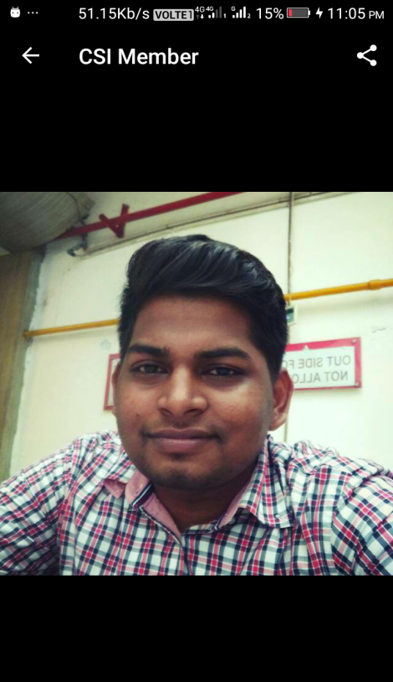 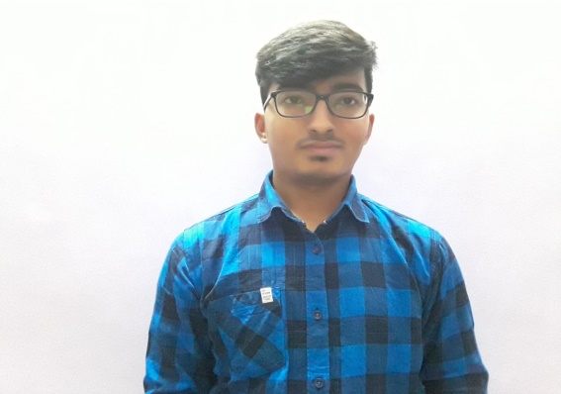

**No. Of Participants:** 25 students of CSE branch attended the workshop (List enclosed)

**Self-Assessment:** During the course of this entire process of seminar conduction, Team CSI has shown exemplary performance, coordination, team spirit and event management. Prior to the workshop, organizing students were given adequate knowledge of developing android application. Students attending workshop were happy to learn something out of university syllabus. As there is always scope of doing better, we will always try to make our next event better than previous.

**Conclusion:** Encouraging response from the participants and imparting basic knowledge about the latest technology. Further, knowledge imparting workshop/seminar maybe conducted with an estimation of better response.

AKANKSHA SINGH

Core-Member

**CSI-IPEC chapter**