**REPORT**

**CODE REVIEW**

-BY **TEAM CSI**

**Objective:** To identify and implement the various tags of different programming languages.

**NO. OF PARTICIPANTS: 1**8 Students (list enclosed)

**VENUE:** CSE-LAB 6

**DATE:** 13 November 2018

**TIME:** 4:30 p.m to 5:30 p.m

**EVENT DESCRIPTION:** A competition was organised in CSE-LAB by CSI IPEC STUDENT BRANCH in which students have to identify and implement the various tags of programming languages in a time limit of 60 minutes.

It consists of two rounds, first round consists of identification of the tags used in MCQ format and second round consists the problem statements which can be solved using the tags from above round. The teams present consisting of 2 members, in each team. Students from 1st, 2nd and 3rd year participated.

**SOME GLIMPSES OF THE EVENT:**

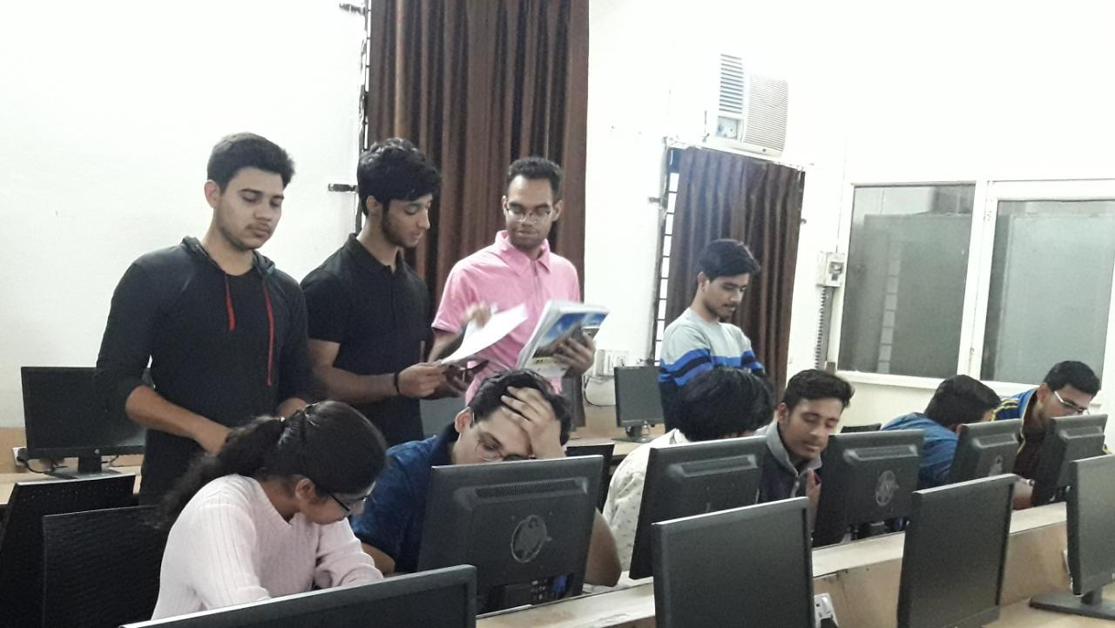

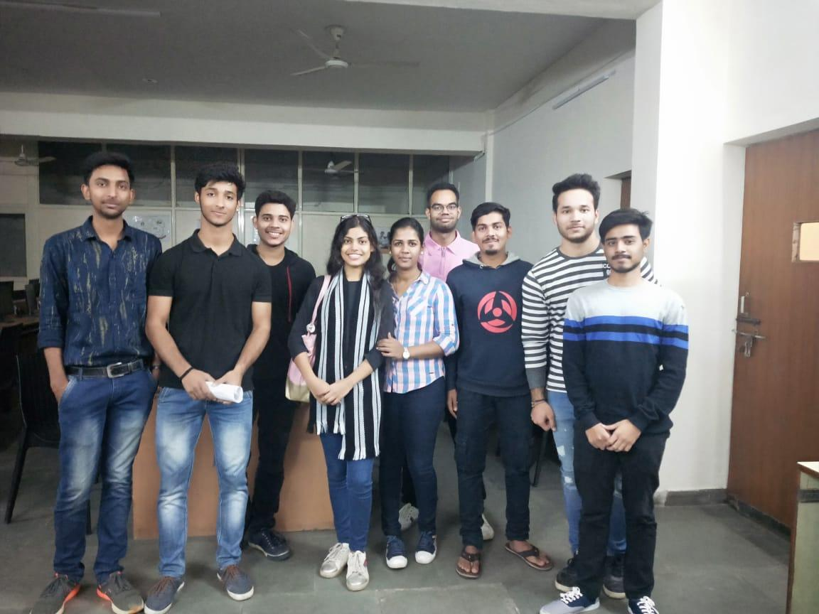

**REQUIREMENTS:**  Knowledge of basic programming languages such as C, C++, pyhton and JAVA.

**TECHNOLOGIES:** Compilers of C, C++, pyhton and JAVA.

**TEAM:** CSI-The Computer Society of India IPEC Branch Members present during the event-:

1) Vandana

2) Akanksha Singh

3) Shrayansh Jain

4) Pranjal Gupta

5) Nitish

6) Deepesh

7) Nitin

8) Mohak

9) Himanshu

**CONCLUSION:** The event was conducted excellently. Participants were very enthusiastic and interested alot. We wish they have learned something from this event. CSI will try to organise such competitions more and more.

**SELF-ASSESSMENT:** During the course of this entire process of seminar competition, Team CSI has shown exemplary performance, coordination, team spirit and event management.

**DATE OF SUBMISSION:** 15th November 2018

NITISH SHARMA

MEMBER(CSI)

**COMPUTER SOCIETY OF INDIA**