**REPORT**

**Test Your Basics**

- *BY TEAM CSI*

**Objective:**  To test the basic knowledge of C Language in students.

**Practical Knowledge:** Knowledge of C is required.

**No. Of Participants:** 17 Students(List Enclosed)

**Venue:** CSE – 3rd year section D

**Date: 13th April 2018**

**Event Description:**

With a view to provide a platform to c coders of IPEC, an event **TEST YOUR BASICS** was organized by **CSI-IPEC Student Chapter** on **13th April 2018**. To felicitate proper evaluation and select the dedicated candidates as winners, C Test was conducted in one round only.Total 17 enthusiastic participants have participated of which 6 Students have been selected as the winners. People attending the workshop are full dedicated for the test.

**Some glimpses of Test Your Basics Event:**

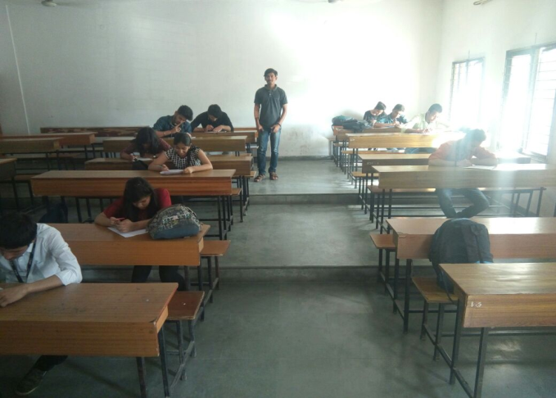 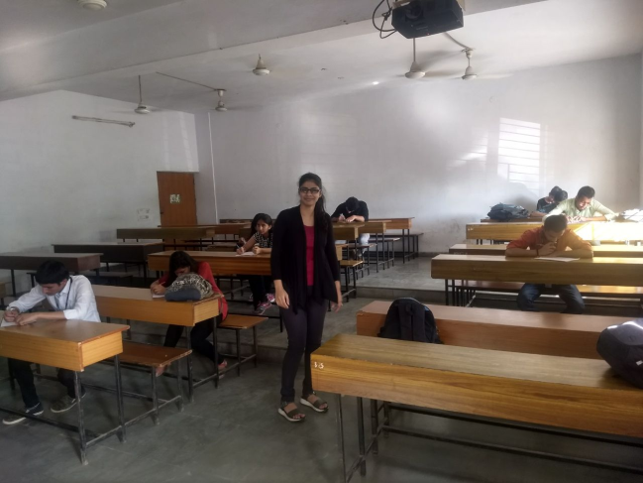

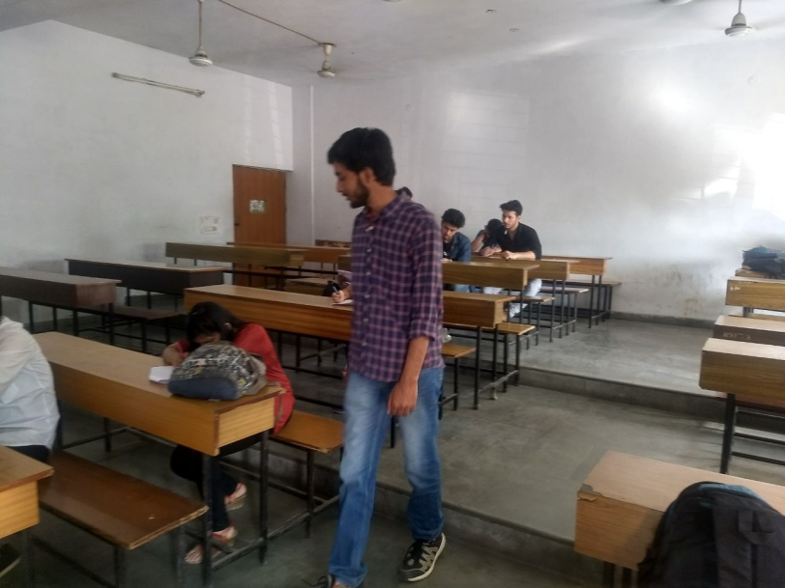

**Winners: 1st:** Siddhant Srivastava(1st yr-E)

Ritik Jain(2nd yr-CSE-C)

Pranjal(2nd yr-CSE-C)

**2nd :** Ambuj Singh(2nd yr CSE-A)

Isha Gupta(1st yr-H)

Anshuman Singh(2nd yr CSE-A)

**Self-Assessment:** We learned how to make such events more attractive and grab huge masses. Presentation is an important part in such events to make them look professionally organized. Team spirit, honest efforts and constant endeavor again proved to be the biggest driving force.

**Conclusion:**  We found that constant learners learn to showcase their talents in such competitions. We will try our best to provide them with such platforms.

**Organisers:**

* Diksha Khanna
* Shashank Kumar
* Pranjal Gupta
* Rishabh Jain
* Himanshu
* Devang

**Date of submission of report:** 17th of April 2018

SHASHANK KUMAR

**Core-Member**

**CSI-IPEC Student Chapter**