**Date:26 Oct, 2018**

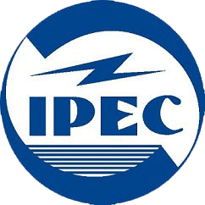**INDERPRASTHA ENGINEERING COLLEGE**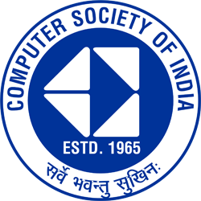

**Computer Science and Engineering Department**

**NOTICE**

**IPEC/CSE/2018-19/**

|  |  |
| --- | --- |
| **FROM:**HOD (CSE) | **TO: All Students of branches CS, IT and EC** |

**CSI-IPEC STUDENT BRANCH**

**CSI-IPEC STUDENT BRANCH** is organising an event called **“Geeky Web Master : CodeYour Imagination”** for 1st,2nd and 3rd year students of all branches CS, IT And EC..

**Event Description-:**

* A web page provided by us is to be designed within the time limit.
* This event is for students of branches CS, IT and EC.
* Team upto 2 accepted.
* Only 1 hour will be allotted for the round.
* No cost for participation.

**Eventdetails**

* Date :- Oct 1,2018
* Time :-4:30 onwards
* Venue:- CS lab-6

**Registration:**During lunch hours at registration desk or go to the link, [**https://tinyurl.com/y8rf6mch**](https://tinyurl.com/y8rf6mch)

* For any queries , get in touch at [**csiipec17@gmail.com**](mailto:csiipec17@gmai.com)or contact **Mr. Yash Mittal (contact no: 8860037008)** and **Miss Akanksha Singh( contact no:9650613715)**
* Join us at **https://www.facebook.com/CSI-IPEC-192603204657351/**

**Mr. Sarvesh Kumar Dixit Dr. Anchal Jain Dr. Rekha Kashyap**

(CSI-IPEC President) (CSI-IPEC Student Branch Counsellor) (HOD CSE)

**CC: To Director ( for kind information and request to upload on portal for all)**