**REPORT**

**JAVA APTITUDE TEST**

**Objective:**  To test the basic knowledge of Java Language in students.

**Practical Knowledge:** Knowledge of java is required.

**No. Of Participants:** 32 STUDENTS.

**Venue:** CSE – 3RD year section D

**Date:** 22th February and 23rd February 2018.

**Event Description:**

With a view to provide a platform to Java coders of IPEC, Java Aptitude Test was organized by CSI-IPEC Student Chapter on 22nd and 23rd of Feb. 2018. To felicitate proper evaluation and select the dedicated candidates as winners, Java Aptitude Test was divide into two rounds. Round 1 was conducted on 22nd Feb. 2018 with 32 enthusiastic participants of which 12 were selected for Round 2 based on scoring more than half the maximum marks. Round 2 was conducted on 23rd Feb. 2018 with 12 contestants, of which the winners were t be selected.

**Some glimpses of the Java Aptitude Test:**

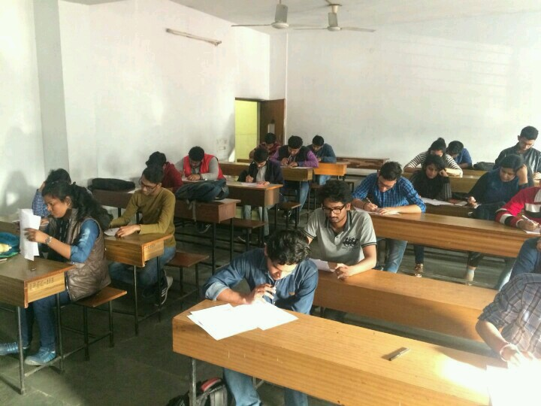

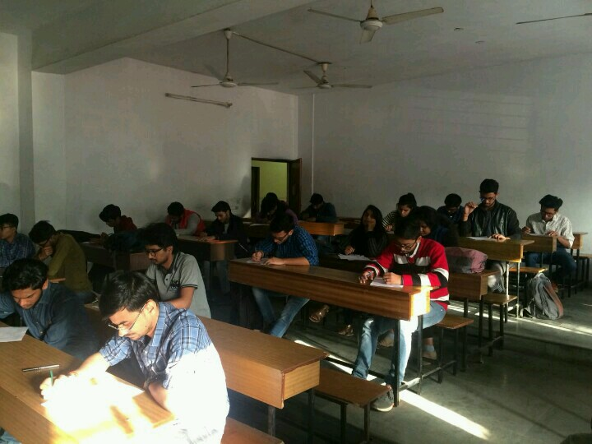

**Winners: 1st:** Shivam Yadav(3-D CSE) **and**

Sudhanshu (3-D CSE)

**2nd :** Shubham Bhardwaj(3-D CSE)

**3rd :** Shashank Singh (2-D CSE)

**Self-Assessment:** We learned how to make such events more attractive and grab huge masses. Presentation is an important part in such events to make them look professionally organized. Team spirit, honest efforts and constant endeavor again proved to be the biggest driving force.

**Conclusion:**  We found that constant learners learn to showcase their talents in such competitions. We will try our best to provide them with such platforms.

**Organisers:**

Praful Jain

Shivani Gupta

Diksha Khanna

Aditi Bajpai

**Date of submission of report:** 26th of February 2018

ADITI BAJPAI

Core-Member

CSI-IPEC Student Chapter