**REPORT**

**PYTHON WORKSHOP**

-BY TEAM CSI

**Objective:** To render basic knowledge of PYTHON Language and current trends in it.

**No. Of Participants:** 74 Students(List enclosed)

**Venue:** CSE – Seminar Hall.

**Date**:9th March 208

**Time:** 3:00 p.m. to 6:00 p.m.

**Event Description:**

A triumphant workshop was conducted in CSE-Seminar hall by experienced **Professional Corporate Trainer** from **Ardent Computech Pvt. Ltd.** Workshop was mainly for beginners and middle level coders in Python.. The introduction was followed by Functions,Memory models(names,mutable,immutable values),List of operations,Types,Expressions,Strings,Lists and Tuples and Data Structures(Stack,Queue,Heap) in it.Students were satisfied with the topics covered and the workshop ended with Vote of Thanks

**Some glimpses of the workshop:**

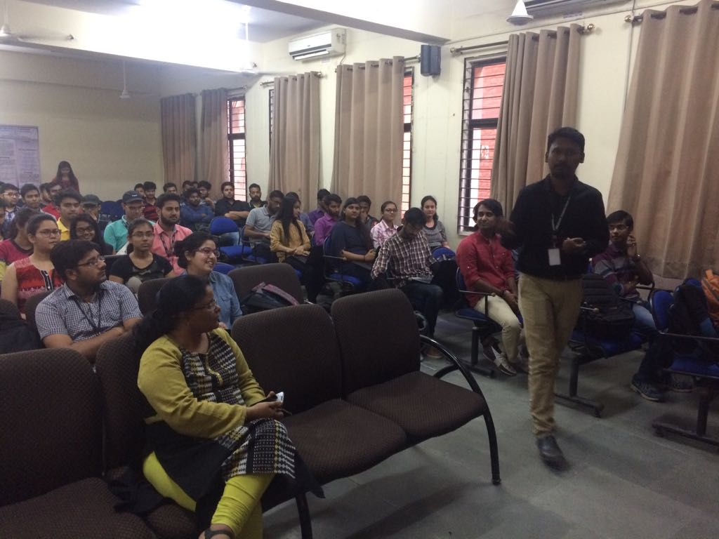

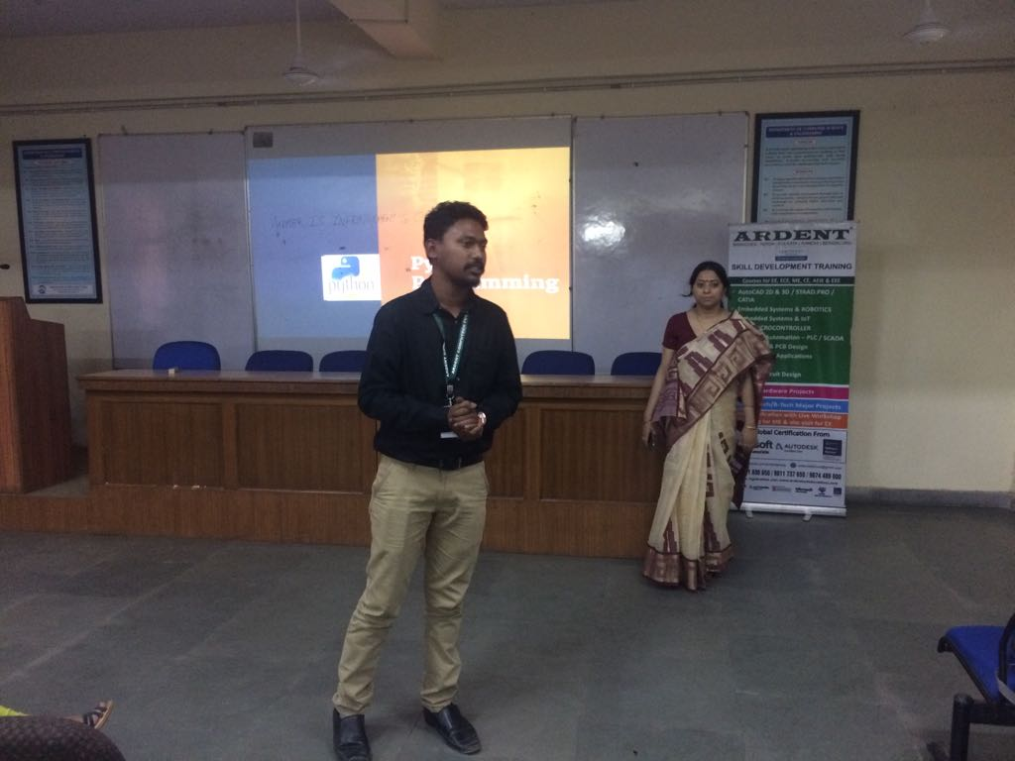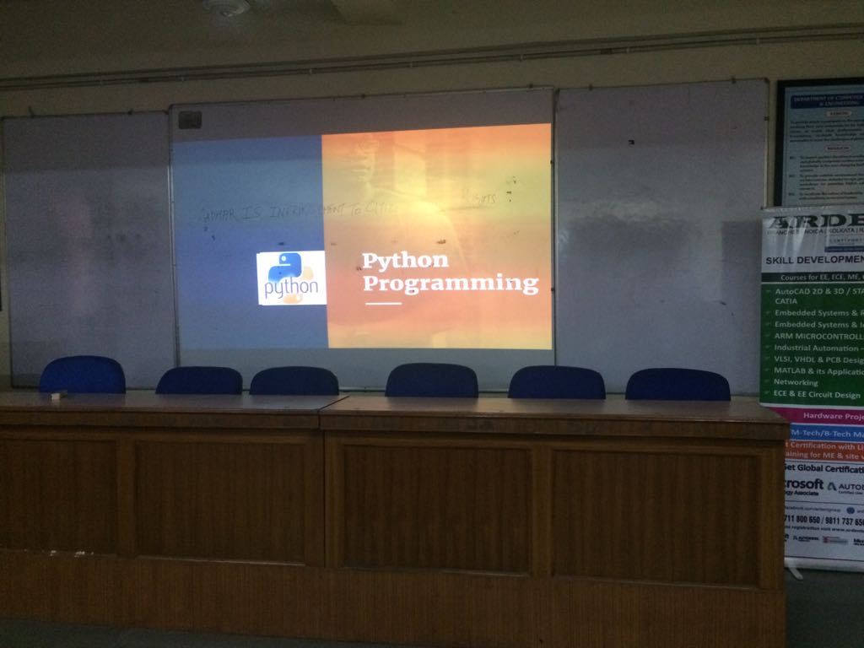

**Practical Knowledge:**

Basic knowledge of Programming.

**Technologies:**

* Participants were required to install ANACONDA 5.1 in their laptops.
* Python Software.

**Team: CSI-The Computer Society of India IPEC Branch**

*Core Members*

1) Sarvesh Dixit

2) Akanksha Singh

3) Shashank Kumar

4) Ayush Khanduri

5) Shivani Gupta

6) Akshay Kumar Singh

7) Shivam Varshney

**Speaker:**

**MR.JOYJIT GUHA**(Pursuing PHD from NIT Durgapur).He is an expert in **Python programming,PHP Language,Web Development and Java** with 8+ years experience in Software Development and has worked in many live projects.He is Consultant Trainer in **Wipro Technologies,TCS,RS Software** and in other corporate houses.He is a induction trainer for **Cognizant Technology Solutions**.He is also certified from **Hewlett Packard Enterprise & Microsoft**.

**Conclusion:**The motive of the workshop was to gain the knowledge about current trends in image and video processing with the usage on new tool which is compatible with current industrial trends. Scope in Python and future developments in Python.Students were highly satisfied with the content and delivery and CSI will try to organise such workshops more and more.

**Self-Assessment:** During the course of this entire process of seminar conduction, Team CSI has shown exemplary performance, coordination, team spirit and event management. There is always scope of improvement and CSI-IPEC Student Branch will always work better than before.

**Date of submission of report**: 5th APRIL 2018

STUTI SRIVASTAVA

Core-Member

**Computer Society of India**