REPORT

THE SCREENING TEST

-BY TEAM CSI

Objective: To write and tell a story about the picture shown at the screen.

No. Of Participants: Students (List enclosed)

Venue: CSE – 3rd year section B.

Date: 31st January 2019

Time: 4:30 p.m. to 5:45 p.m.

Event Description: This is a time bound event, team participation maximum two is accepted. It will consist two rounds first round is that a picture shown and based on that students tell their story. Second round include rapid fire round based on current affair, general knowledge and politics.

Some glimpses of the workshop:

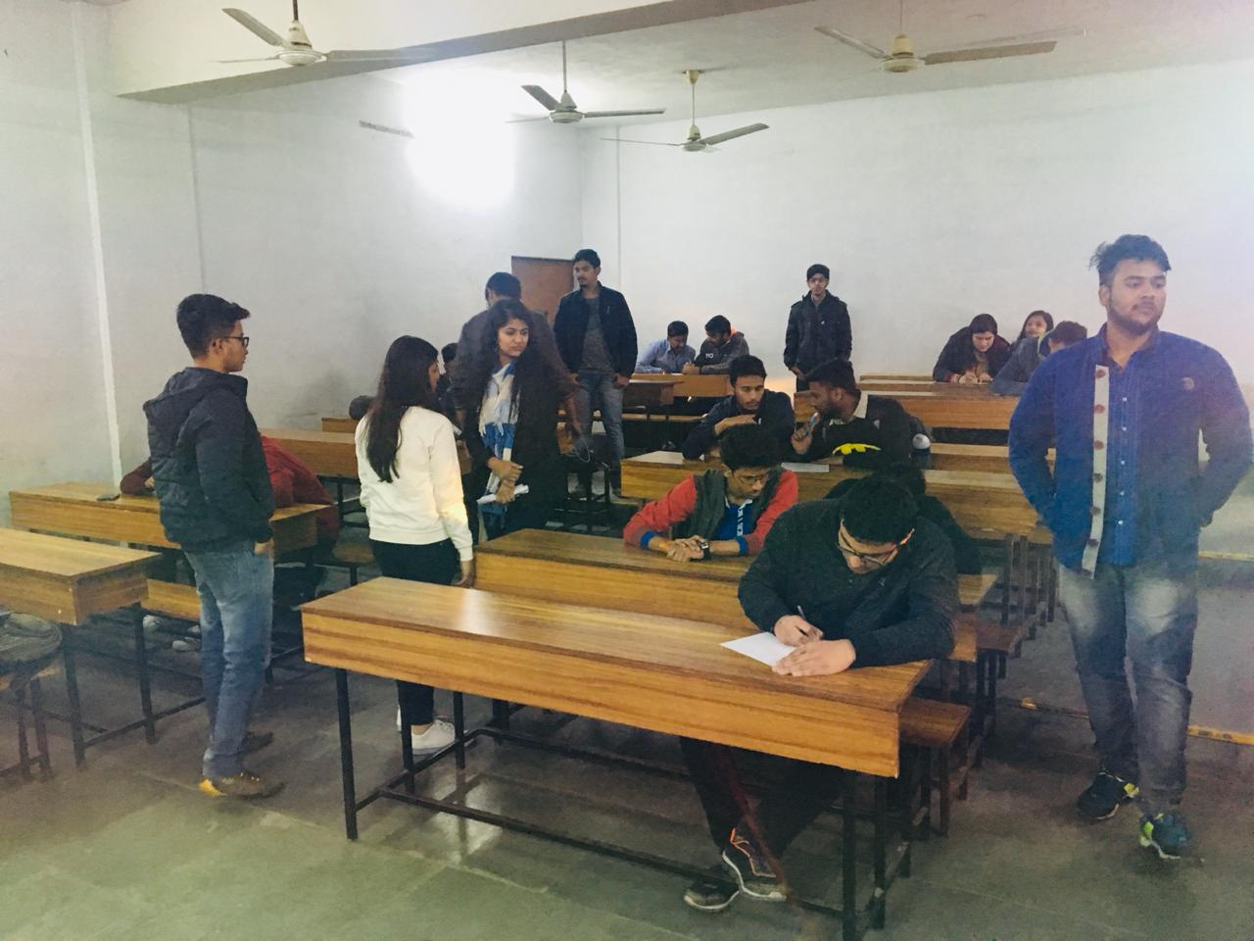

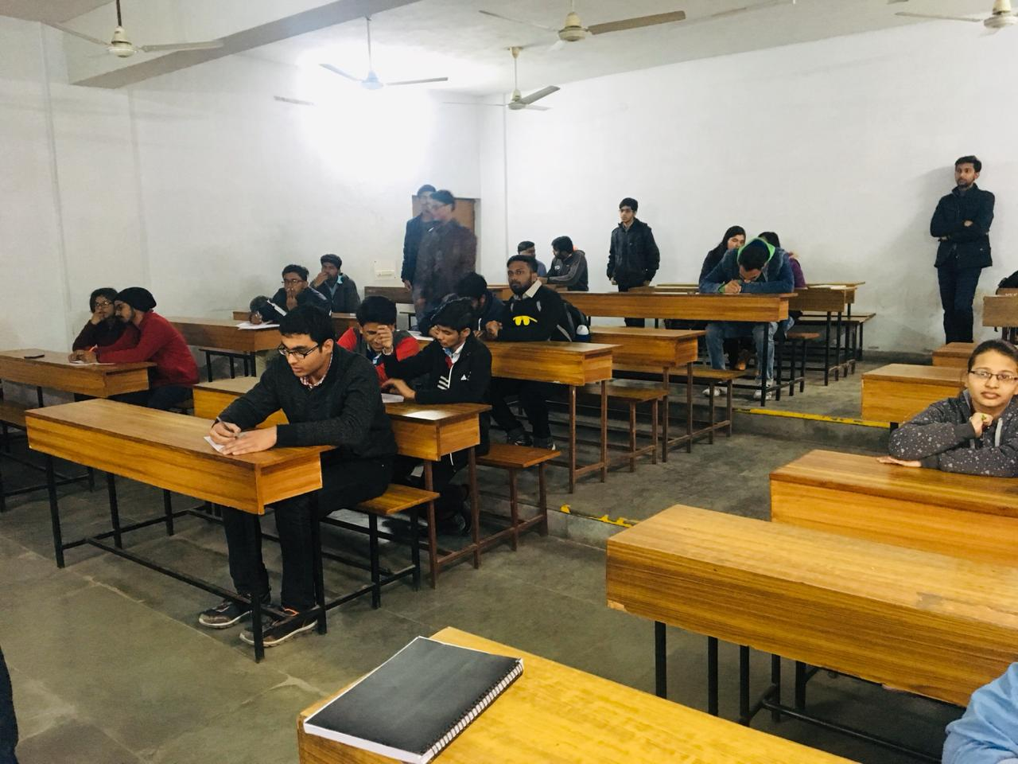

Team: CSI-The Computer Society of India IPEC Branch Core Members 1) Aditi Bajpai 2) Vartika sharma 3) Avanish Nisad 4) Deepansh Goel 5)Mayur Jaiswal  6) Shrayansh jain 7) Deepesh 8) Yash mittal 9) kaushlendra 10) Pranjal

Conclusion: The event was conducted excellently. Participants were very enthusiastic and interested alot. We wish they have learned something from this event. CSI will try to organise such competitions more and more.

Self-Assessment: During the course of this entire process of seminar competition, Team CSI has shown exemplary performance, coordination, team spirit and event management.

There is always scope of improvement and CSI-IPEC Student Branch will always work better than before.

Date of submission of report: 31st January 2019

ADITI BAJPAI

Core-Member Computer Society of India