AppointIE Business Dashboard User Guide
Sample Preview (≈ 5 pages) · v0.2.0
This is a sample only. Every screen explains what it does and how it works — not only a title and image. Screenshots are real captures from the seeded Demo Salon workspace.
Audience: Business owners and managers
Surface: AppointIE web dashboard (/dashboard, /bookings, …)
Demo login (local): pilot-owner@ieplatform.local / PilotPass123!
Workspace: Demo Salon (demo / MAIN)

Page 1 — Overview

What this guide covers
The Business Dashboard is where your team runs day-to-day AppointIE operations: appointments, customers, services, staff, reporting, and business settings.
This guide has two parts:
Part | Purpose
Feature catalog | Screen-by-screen: what you see and how each control works
How-to flows | Task recipes: step-by-step with screenshots

Who can use what
Role | Typical access
Business owner | Full access (operations + settings + billing + team)
Manager | Operations + most settings (depends on permissions)
Staff | Limited to assigned bookings and allowed modules

App shell — how it works
- Left navigation — switches modules. The active item stays highlighted so you always know where you are.
- Top bar — shows the current workspace and account menu. Switch workspace here before trusting any list or KPI.
- Main content — loads the selected module without signing you out.
- Soft-lock / plan banners (when shown) block create/add actions until you renew under Settings → Products.
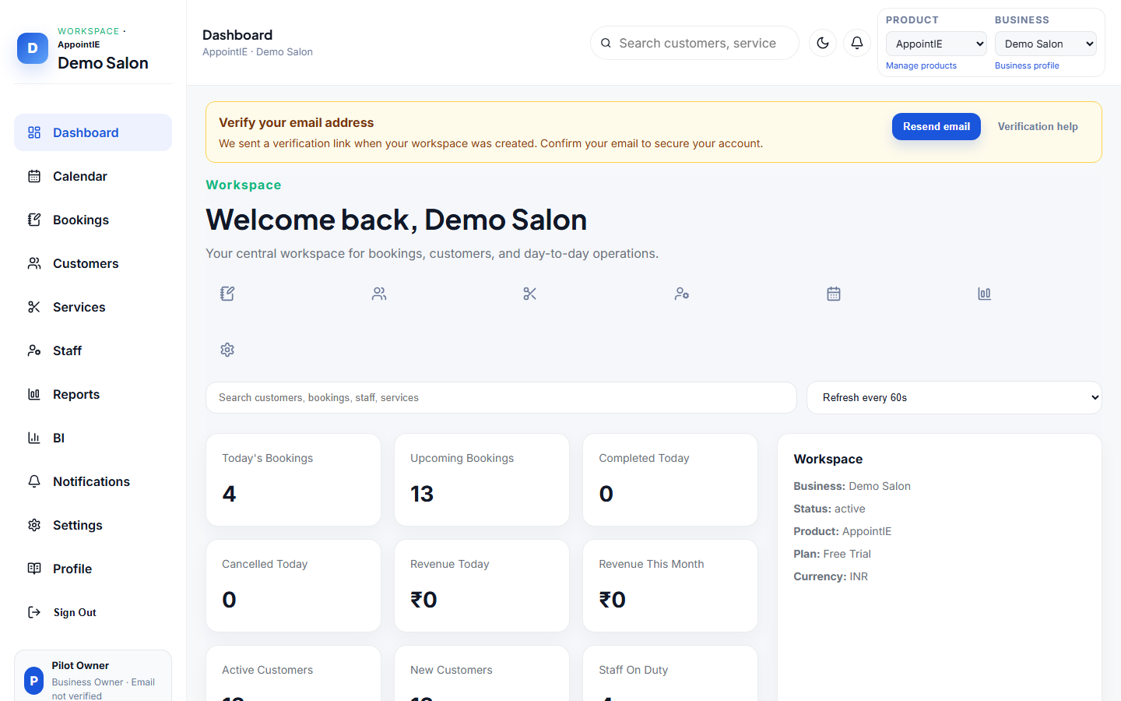
Figure 1 — App shell: Demo Salon workspace with Dashboard selected.

Page 2 — Feature catalog: Dashboard

What this screen does
The Dashboard is your daily home screen. It pulls live booking, customer, staff, and notification data for the active workspace so you can see today’s load and jump into common tasks.
How it works
- Open Dashboard in the left nav (default after sign-in).
- Confirm the welcome header shows the correct business name. If not, switch workspace from the account picker.
- Use quick-action icons under the welcome text to jump into create/booking or related modules.
- Type in Search to find customers, bookings, staff, or services; click a result to open that record.
- Optionally set auto-refresh (Manual or every N seconds) so KPI tiles and widgets re-fetch without a full reload.
- Read KPI tiles (today’s/upcoming/completed/cancelled bookings, revenue, customers, staff on duty, occupancy).
- Use Today’s Schedule for the next appointments; open Bookings when you need to confirm or cancel.
- Use Notification Center for unread alerts; open Notifications in the nav when the count is high.
- Scan Recent Activity, Calendar Preview, and Business Summary for supporting context.
- If a Getting started checklist appears, complete or dismiss it (dismiss stores a local preference).

Main regions
Region | What it shows / does
Welcome + quick actions | Workspace greeting and one-click shortcuts
Search + refresh | Find records; choose how often data reloads
KPI tiles | Counts and revenue derived from live lists
Today’s Schedule | Next appointments for today
Notification Center | Latest alerts with unread highlighting
Activity / Calendar / Summary | Supporting context for the day

Permissions
Requires at least business:read. Some quick actions also need write permissions (for example booking:write).
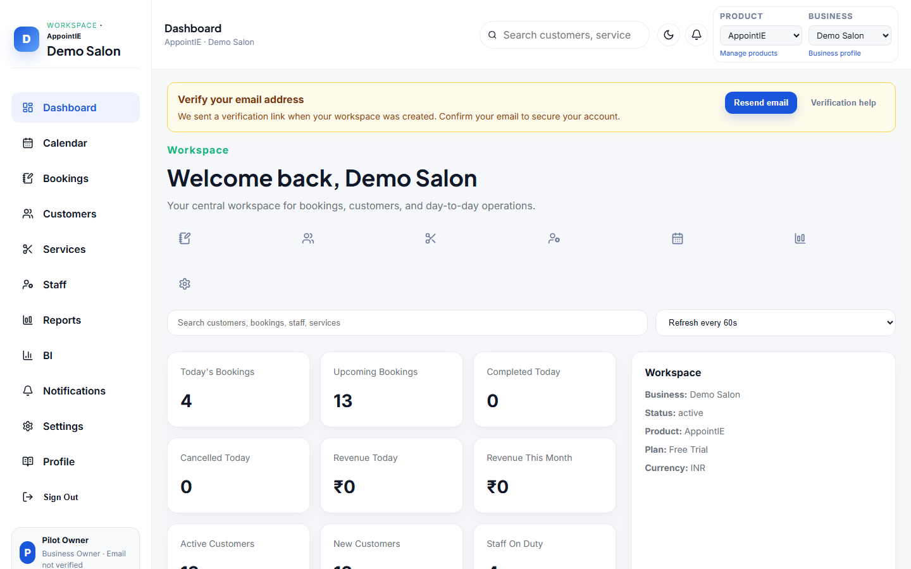
Figure 2 — Dashboard home with seeded KPIs (today’s bookings, customers, staff, and plan status).

Page 3 — Feature catalog: Bookings

What this screen does
Bookings is the operations list for appointments. Search the queue, confirm or cancel from the row, open detail, or create a new appointment through the booking engine.
How it works
- Open Bookings in the left nav.
- Search by booking number, customer, staff, or status (examples: DEMO-BK, Ananya, pending).
- Read each row: date/time, customer, service, staff, status, and available actions.
- Confirm appears only for pending/draft. Clicking it accepts the appointment; status updates in the list.
- Cancel appears when status is not already cancelled/completed. Cancelling removes it from the active schedule.
- Open booking detail for full information — service, customer, staff, timing, notes, and further actions.
- Click Create booking to open the create dialog (see Page 4).
- After create/confirm/cancel, the list refreshes so the new status is visible immediately.

Statuses you will see
Status | Meaning | Typical next action
pending | Waiting for confirmation | Confirm or Cancel
confirmed | Accepted and on the schedule | Open detail / Cancel if needed
checked_in | Customer has arrived | Complete from detail when available
completed | Service finished | View only
cancelled | Cancelled | View only
no_show | Customer did not attend | View only

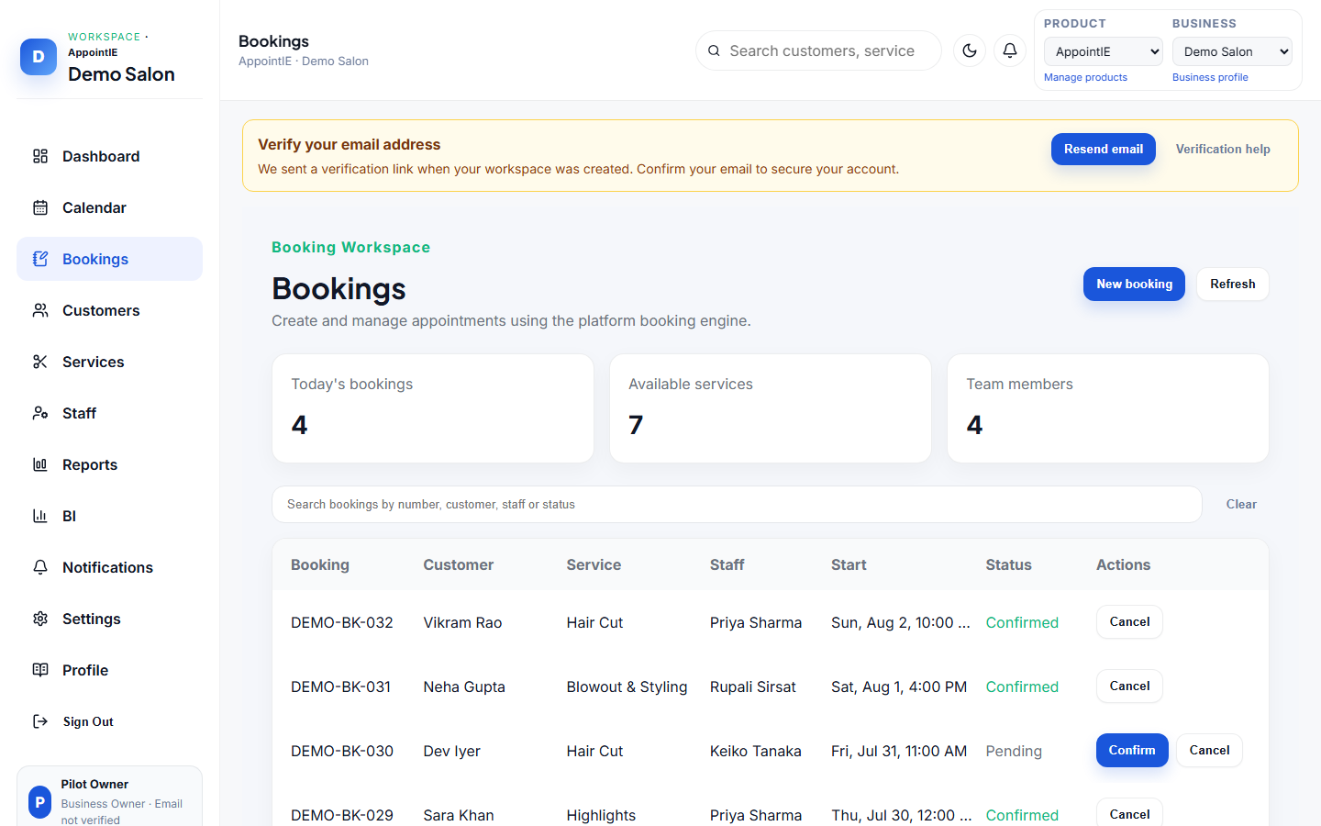
Figure 3 — Bookings list showing seeded DEMO-BK-* appointments with Confirm / Cancel actions.
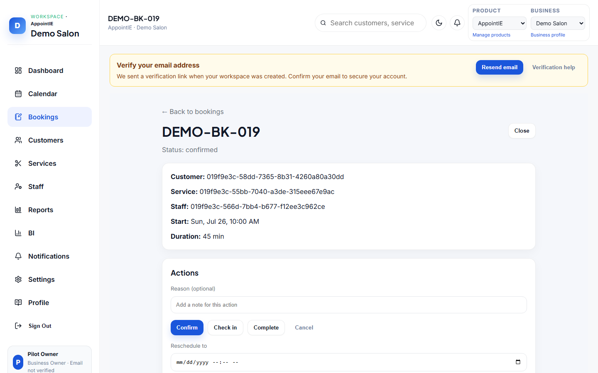
Figure 4 — Booking detail for a seeded Demo Salon appointment.

Page 4 — How-to: Create a booking

Goal
Create a new appointment for an existing customer and see it appear on the Bookings list (and Calendar for that date).

Prerequisites
- You are signed in as a user with booking write access
- At least one customer, service, staff, and office exist
- Demo Salon seed already provides these
- Soft-lock is not blocking create actions
How it works
- In the left nav, open Bookings.
- Click Create booking (primary button in the header).
- Select Customer, Service (sets duration/price context), Staff (must be bookable), Office/branch, and Start date/time inside availability.
- Submit with Create booking (button may show Creating booking… while the API runs).
- Confirm the new row appears with status pending or confirmed, and that it also shows under Calendar for that date.
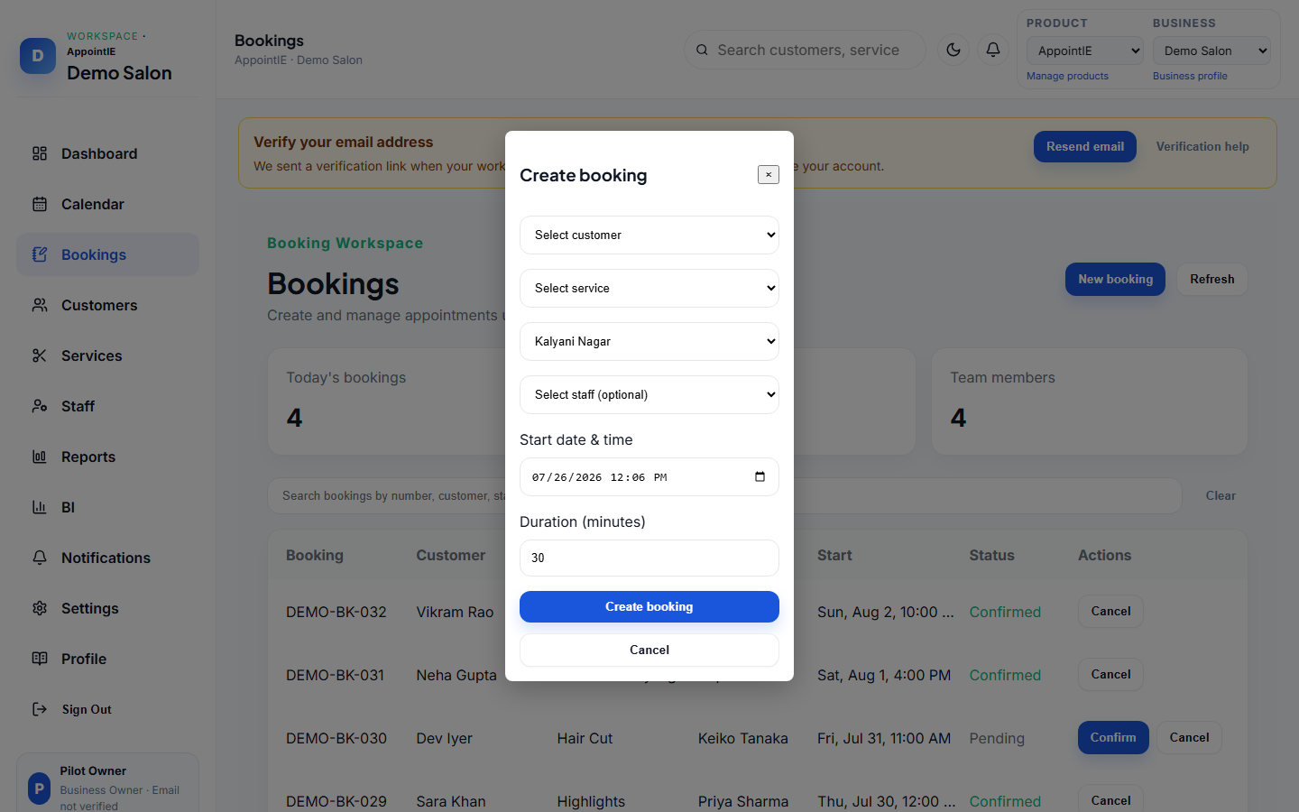
Figure 5 — Create booking dialog: pick customer, service, office, staff, and start time, then submit.

Expected result
- A new booking appears in the Bookings list
- It also appears on Calendar for that date
- The customer’s history reflects the new appointment
- Dashboard KPIs / Today’s Schedule update on the next refresh

If something fails
Problem | What to check
No staff in the dropdown | Staff must be active and bookable; check Staff
No offices listed | Add an office under Settings → Business (Branches/Offices)
Time rejected | Pick a slot inside business hours / staff availability
Soft-lock banner | Trial/plan period ended — renew from Settings → Products
Create stays pending / errors | Confirm API is up; retry after the previous request finishes

Page 5 — How the full guide will look

Final document outline (not in this sample)
IE-0005.03 Business Dashboard User Guide
- 1. Overview & roles
- 2. Getting started (sign-in, workspace, shell)
- 3. Feature catalog — Dashboard, Calendar, Bookings, Customers, Services, Staff, Reports & BI, Notifications, Settings, Profile
- 4. How-to flows — Create booking, Add customer, Create service, Add staff, Calendar day, Business profile, Billing, Reports & BI
- 5. Glossary & related docs

Screenshot conventions (final guide)
Rule | Detail
Format | PNG
Folder | assets/images/appointie/web-ops/
Naming | web-ops-<area>-<screen>.png
Viewport | Desktop ≈ 1280–1440px wide
Data | Captured from Demo Salon only (fictional customers)
Caption | Every image has a short Figure N line
Prose | Every screen has What this screen does + How it works (numbered steps)

What changes from this sample to the real guide
- Same screenshot style, but for all modules (not just Dashboard + Bookings)
- Every module gets a catalog section with how-it-works steps
- Every major task gets a how-to like “Create a booking”
- Document ID becomes official IE-0005.03 (this file stays a SAMPLE)
- Linked from the AppointIE README document index

End of sample preview.

