DATA 624 - Project 2
Marco Siqueira Campos
Sharon Morris
Jeff Nieman
Derek Nokes
Jose Zuniga
May 15, 2018

Data Preparation
In additional to the response variable, the original data set contains 32 predictors, each with 2571 observations.
We split the data into training (75%) and test sets (25%), then pre-processed the data.
After removing 4 rows corresponding to missing values of the response variable, 2567 observations for each of the 32 predictors remained for the development of our predictive model. Encoding of the Brand.Code variable as a set of dummy variables replaced the original Brand.Code variable with 3 dummy variables, increasing the number of predictors to 34. Although some models require this dummy variable encoding, other models are more performant using categorical predictors. We, therefore, used categorical predictors for some models and the equivalent dummy variable predictors for other models.

Data Exploration
So as not to inadvertently exploit information from the testing set in our model buiding, we explored only the training set.
We observed a missing value frequency of only 0.98% in the training set. The distribution of missing values across the predictors predictors are shown in the table and corresponding plots immediately below.
Missing Values By Predictor (Proportion Of Total Frequency)
predictorLabel | missingCount | missingFrequency
MFR | 208 | 0.3373
Brand.Code | 120 | 0.1946
Filler.Speed | 54 | 0.08757
PC.Volume | 39 | 0.06325
PSC.CO2 | 39 | 0.06325
Fill.Ounces | 38 | 0.06162
PSC | 33 | 0.05352
Carb.Pressure1 | 32 | 0.05189
Hyd.Pressure4 | 28 | 0.04541
Carb.Pressure | 27 | 0.04379
Carb.Temp | 26 | 0.04216
PSC.Fill | 23 | 0.0373
Fill.Pressure | 18 | 0.02919
Filler.Level | 16 | 0.02595
Hyd.Pressure2 | 15 | 0.02433
Hyd.Pressure3 | 15 | 0.02433
Pressure.Setpoint | 12 | 0.01946
Temperature | 12 | 0.01946
Hyd.Pressure1 | 11 | 0.01784
Oxygen.Filler | 11 | 0.01784
Carb.Volume | 10 | 0.01622
Carb.Rel | 8 | 0.01297
Alch.Rel | 7 | 0.01135
Usage.cont | 5 | 0.008108
Bowl.Setpoint | 2 | 0.003243
Carb.Flow | 2 | 0.003243
Balling.Lvl | 1 | 0.001622
Air.Pressurer | 0 | 0
Balling | 0 | 0
Density | 0 | 0
Mnf.Flow | 0 | 0
Pressure.Vacuum | 0 | 0
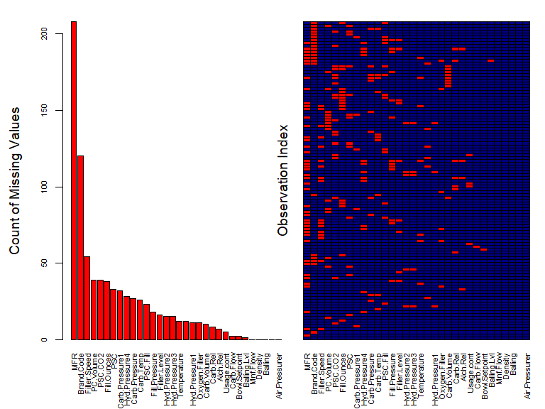
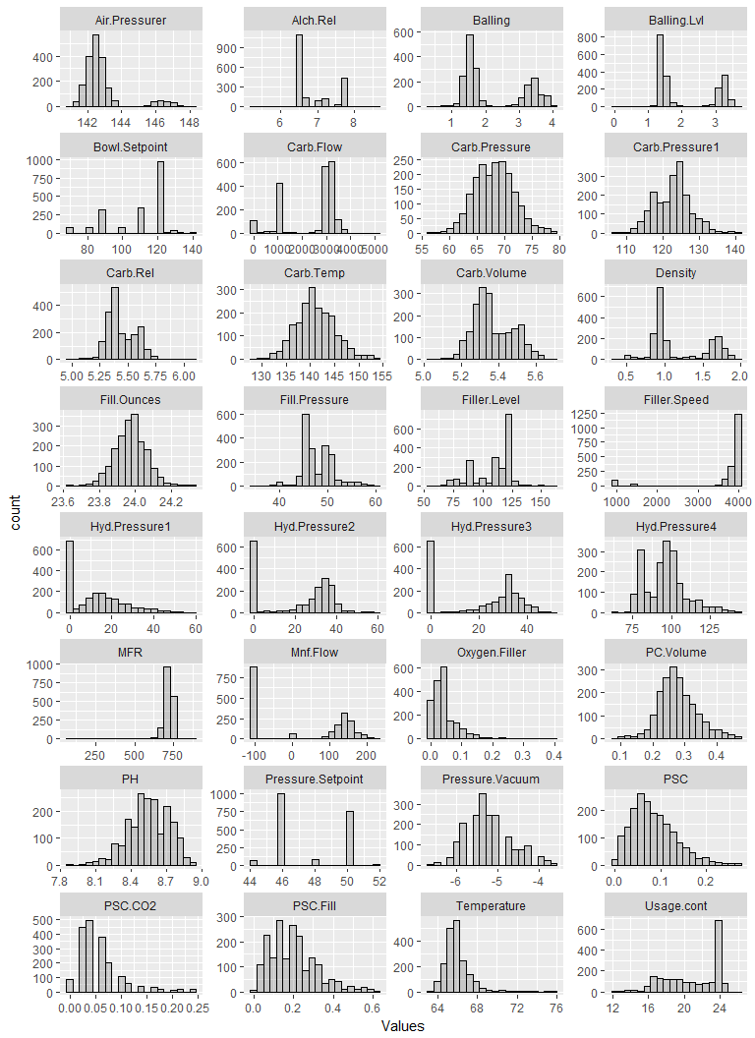
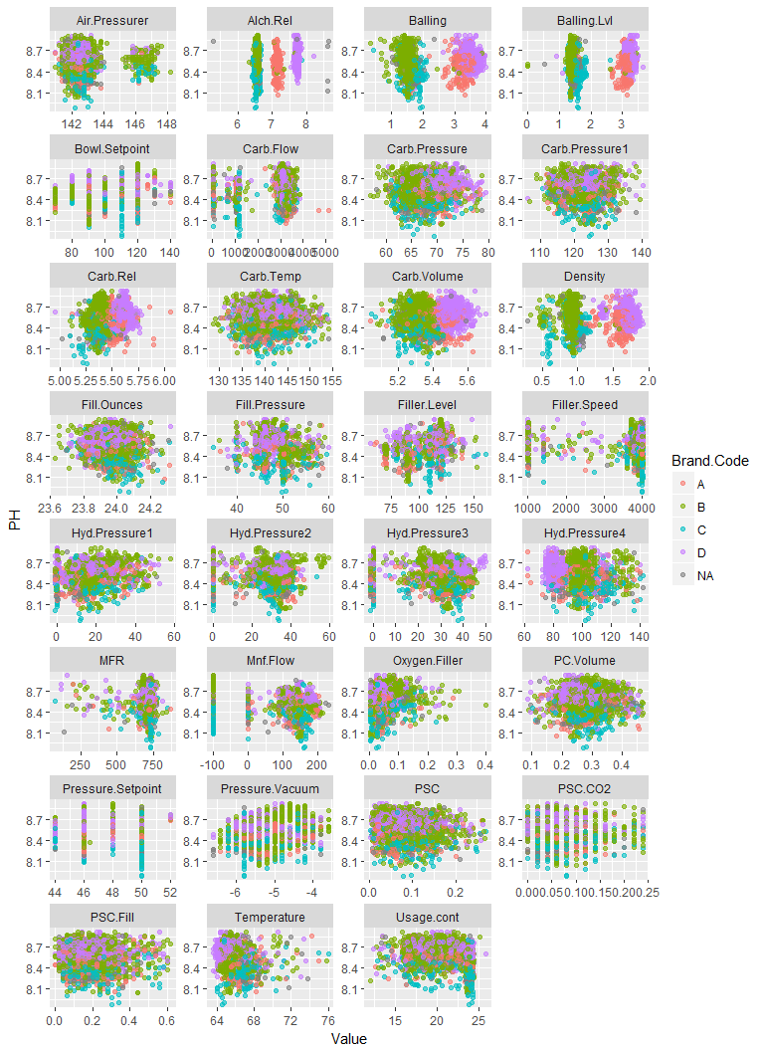
We can see from the above plots depicting the relationship between our predictors and the response, there there are few, if any, relationships that are apparent based simply on visualizing the data.
Selected Summary Statistics
 | vars | n | mean | sd | median | min | max | range | skew | kurtosis
Carb.Volume | 1 | 2561 | 5.37 | 0.11 | 5.35 | 5.04 | 5.70 | 0.66 | 0.39 | -0.47
Fill.Ounces | 2 | 2533 | 23.97 | 0.09 | 23.97 | 23.63 | 24.32 | 0.69 | -0.02 | 0.86
PC.Volume | 3 | 2532 | 0.28 | 0.06 | 0.27 | 0.08 | 0.48 | 0.40 | 0.34 | 0.67
Carb.Pressure | 4 | 2544 | 68.19 | 3.54 | 68.20 | 57.00 | 79.40 | 22.40 | 0.18 | -0.01
Carb.Temp | 5 | 2545 | 141.09 | 4.04 | 140.80 | 128.60 | 154.00 | 25.40 | 0.25 | 0.24
PSC | 6 | 2538 | 0.08 | 0.05 | 0.08 | 0.00 | 0.27 | 0.27 | 0.85 | 0.65
PSC.Fill | 7 | 2548 | 0.20 | 0.12 | 0.18 | 0.00 | 0.62 | 0.62 | 0.93 | 0.77
PSC.CO2 | 8 | 2532 | 0.06 | 0.04 | 0.04 | 0.00 | 0.24 | 0.24 | 1.73 | 3.73
Mnf.Flow | 9 | 2569 | 24.57 | 119.48 | 65.20 | -100.20 | 229.40 | 329.60 | 0.00 | -1.87
Carb.Pressure1 | 10 | 2539 | 122.59 | 4.74 | 123.20 | 105.60 | 140.20 | 34.60 | 0.05 | 0.14
Fill.Pressure | 11 | 2549 | 47.92 | 3.18 | 46.40 | 34.60 | 60.40 | 25.80 | 0.55 | 1.41
Hyd.Pressure1 | 12 | 2560 | 12.44 | 12.43 | 11.40 | -0.80 | 58.00 | 58.80 | 0.78 | -0.14
Hyd.Pressure2 | 13 | 2556 | 20.96 | 16.39 | 28.60 | 0.00 | 59.40 | 59.40 | -0.30 | -1.56
Hyd.Pressure3 | 14 | 2556 | 20.46 | 15.98 | 27.60 | -1.20 | 50.00 | 51.20 | -0.32 | -1.57
Hyd.Pressure4 | 15 | 2541 | 96.29 | 13.12 | 96.00 | 52.00 | 142.00 | 90.00 | 0.55 | 0.63
Filler.Level | 16 | 2551 | 109.25 | 15.70 | 118.40 | 55.80 | 161.20 | 105.40 | -0.85 | 0.05
Filler.Speed | 17 | 2514 | 3687.20 | 770.82 | 3982.00 | 998.00 | 4030.00 | 3032.00 | -2.87 | 6.71
Temperature | 18 | 2557 | 65.97 | 1.38 | 65.60 | 63.60 | 76.20 | 12.60 | 2.39 | 10.16
Usage.cont | 19 | 2566 | 20.99 | 2.98 | 21.79 | 12.08 | 25.90 | 13.82 | -0.54 | -1.02
Carb.Flow | 20 | 2569 | 2468.35 | 1073.70 | 3028.00 | 26.00 | 5104.00 | 5078.00 | -0.99 | -0.58
Density | 21 | 2570 | 1.17 | 0.38 | 0.98 | 0.24 | 1.92 | 1.68 | 0.53 | -1.20
MFR | 22 | 2359 | 704.05 | 73.90 | 724.00 | 31.40 | 868.60 | 837.20 | -5.09 | 30.46
Balling | 23 | 2570 | 2.20 | 0.93 | 1.65 | -0.17 | 4.01 | 4.18 | 0.59 | -1.39
Pressure.Vacuum | 24 | 2571 | -5.22 | 0.57 | -5.40 | -6.60 | -3.60 | 3.00 | 0.53 | -0.03
PH | 25 | 2567 | 8.55 | 0.17 | 8.54 | 7.88 | 9.36 | 1.48 | -0.29 | 0.06
Oxygen.Filler | 26 | 2559 | 0.05 | 0.05 | 0.03 | 0.00 | 0.40 | 0.40 | 2.66 | 11.09
Bowl.Setpoint | 27 | 2569 | 109.33 | 15.30 | 120.00 | 70.00 | 140.00 | 70.00 | -0.97 | -0.06
Pressure.Setpoint | 28 | 2559 | 47.62 | 2.04 | 46.00 | 44.00 | 52.00 | 8.00 | 0.20 | -1.60
Air.Pressurer | 29 | 2571 | 142.83 | 1.21 | 142.60 | 140.80 | 148.20 | 7.40 | 2.25 | 4.73
Alch.Rel | 30 | 2562 | 6.90 | 0.51 | 6.56 | 5.28 | 8.62 | 3.34 | 0.88 | -0.85
Carb.Rel | 31 | 2561 | 5.44 | 0.13 | 5.40 | 4.96 | 6.06 | 1.10 | 0.50 | -0.29
Balling.Lvl | 32 | 2570 | 2.05 | 0.87 | 1.48 | 0.00 | 3.66 | 3.66 | 0.59 | -1.49
Many of our models are sensitive to missing values. We used predictive mean matching (PMM) to impute missing values, filtered out near-zero variance predictors, then applied Box-Cox, centering, and scaling transformations.
We used a process that builds the proprecessing using only the training data, then applied that process to the test data.
After our preprocessing, our data contained no missing values (depicted in the plot immediately below).
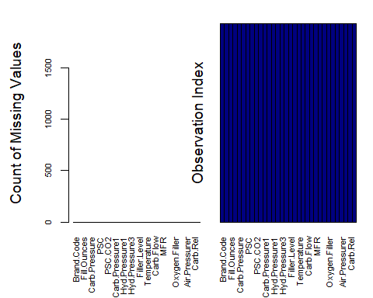

Model Tuning
For each model tested, we used a repeated 10-fold cross-validation with 10 repeats. The steps for this process are as follows:
- Training data was split into 10 distinct blocks of roughly equal size using random sampling with replacement
- 10 models were trained on the data, each with one of the distinct blocks held-out
- Each of the 10 models was used to predict its corresponding hold-out block
- The process was repeated 10 times
- Performance was computed based on the hold-out block data from all repeats
This process was intended to incorporate sampling variation into to parameter tuning process and thereby reduce the chances of overfitting.
As this process is computationally intensive - taking perhaps a full day on a 8-core workstation with 64 gigs of RAM - .RData files of each of the trained models have been posted to a dropbox link indicated in the Appendix. All of the code to fully replicate our study is included in the Appendix.
In the following sub-sections, we show the tuning profile from the repeated cross-validation for each of the 15 models tested. The random seed was set to the same value for each model training process to ensure that model performance could be compared. Performance for all models is summarized in the model selection section following the sub-sections illustrating each of the model tuning profiles.

Linear Regression Models
A linear regression model attempts to create a fit for the pH using a linear equation with the various predictors. These methods included Robust Linear Regression (RLM), Principle Component Regression (PCR), Partial Least Squares Regression (PLS) and ElasticNet (ENET).

Robust Linear Model (RLM)
The model was tuned over the following parameters:
## model parameter label forReg forClass probModel
## 1 rlm intercept intercept TRUE FALSE FALSE
## 2 rlm psi psi TRUE FALSE FALSE
The tuning profile is depicted immediately below.
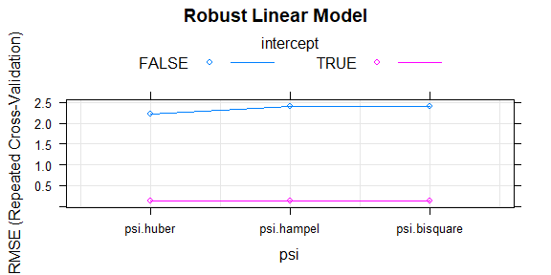

Principal Component Regression (PCR)
The model was tuned over the following parameters:
## model parameter label forReg forClass probModel
## 1 pcr ncomp #Components TRUE FALSE FALSE
The tuning profile is depicted immediately below.
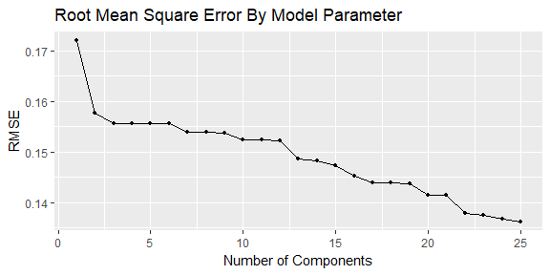

Partial Least Squares (PLS)
The model was tuned over the following parameters:
## model parameter label forReg forClass probModel
## 1 pls ncomp #Components TRUE TRUE TRUE
The tuning profile is depicted immediately below.
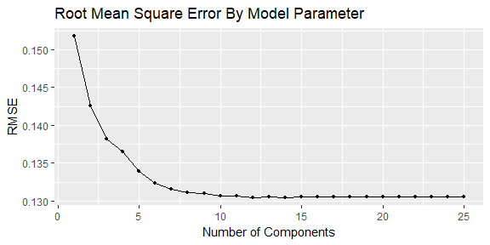

Elasticnet
The model was tuned over the following parameters:
## model parameter label forReg forClass probModel
## 1 enet fraction Fraction of Full Solution TRUE FALSE FALSE
## 2 enet lambda Weight Decay TRUE FALSE FALSE
The tuning profile is depicted immediately below.
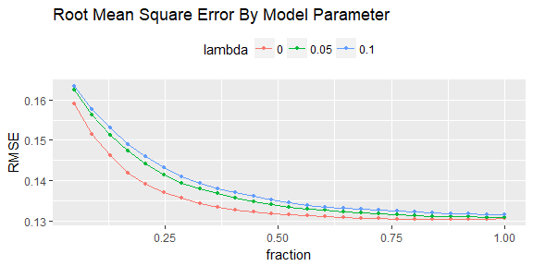

Nonlinear Regression Models
Nonlinear regression models do not assume that the best fit can be modeled as a line. They still attempt to model a prediction for pH based on mathematical relationships with the predictors, but they allow the use of nonlinear functions. We tested 7 modeling approaches: Averaged Neural Networks (ANN), 3 variations of Multivariate Adaptive Regression Splines (MARS), 2 variations of Support Vector Machines (SVM) and K-Nearest Neighbors (KNN).

Model Averaged Neural Network (ANN)
The model was tuned over the following parameters:
## model parameter label forReg forClass probModel
## 1 avNNet size #Hidden Units TRUE TRUE TRUE
## 2 avNNet decay Weight Decay TRUE TRUE TRUE
## 3 avNNet bag Bagging TRUE TRUE TRUE
The tuning profile is depicted immediately below.
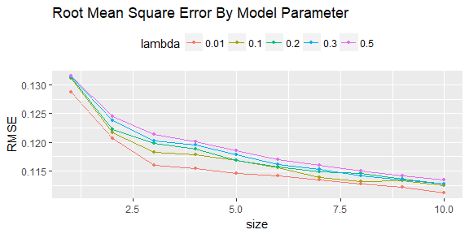

Multivariate Adaptive Regression Spline (MARS)
The model was tuned over the following parameters:
## model parameter label forReg forClass probModel
## 1 earth nprune #Terms TRUE TRUE TRUE
## 2 earth degree Product Degree TRUE TRUE TRUE
The tuning profile is depicted immediately below.
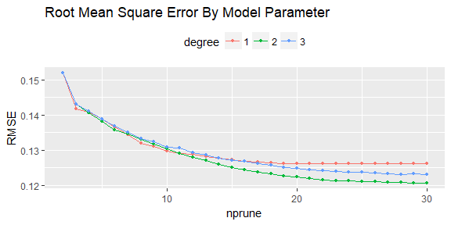

Bagged Multivariate Adaptive Regression Splines (MARS)
The model was tuned over the following parameters:
## model parameter label forReg forClass probModel
## 1 bagEarth nprune #Terms TRUE TRUE TRUE
## 2 bagEarth degree Product Degree TRUE TRUE TRUE
The tuning profile is depicted immediately below.
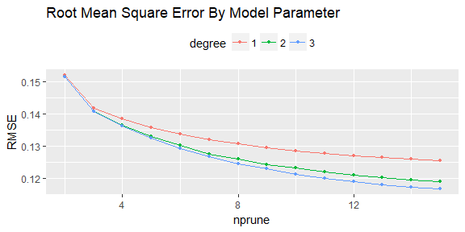

Bagged Multivariate Adaptive Regression Splines (MARS) using gCV Pruning
The model was tuned over the following parameters:
## model parameter label forReg forClass probModel
## 1 bagEarthGCV degree Product Degree TRUE TRUE TRUE
The tuning profile is depicted immediately below.
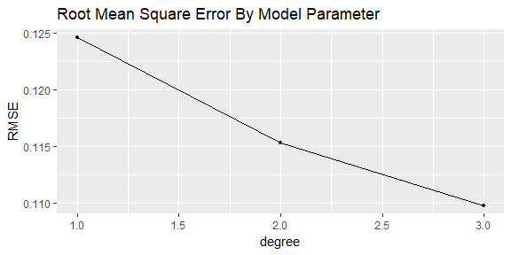

Support Vector Machines with Radial Kernel (SVM)
The model was tuned over the following parameters:
## model parameter label forReg forClass probModel
## 1 svmRadial sigma Sigma TRUE TRUE TRUE
## 2 svmRadial C Cost TRUE TRUE TRUE
The tuning profile is depicted immediately below.
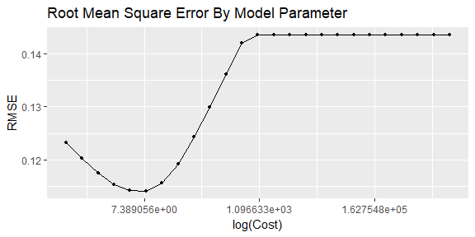

Support Vector Machines with Polynomial Kernel (SVM)
The model was tuned over the following parameters:
## model parameter label forReg forClass probModel
## 1 svmPoly degree Polynomial Degree TRUE TRUE TRUE
## 2 svmPoly scale Scale TRUE TRUE TRUE
## 3 svmPoly C Cost TRUE TRUE TRUE
The tuning profile is depicted immediately below.
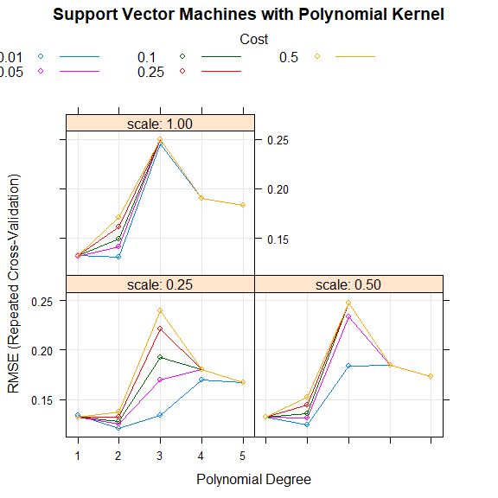

$K$-Nearest Neighbors (KNN)
The model was tuned over the following parameters:
## model parameter label forReg forClass probModel
## 1 knn k #Neighbors TRUE TRUE TRUE
The tuning profile is depicted immediately below.
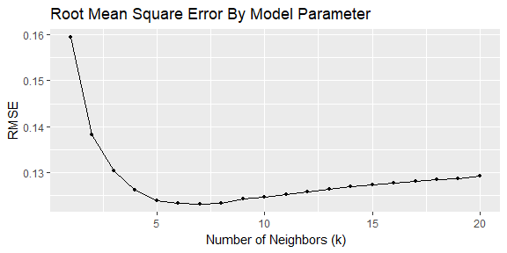

Tree-based Regression Models
The third overall approach we tried was to use tree-based models. These algorithms utilize decision trees, which branch out the data based on a series of either/or splits. We looked at 4 approaches: Classification and Regression Tree (CART), Random Forest (RF), Stochastic Gradient Boosting (SGB) and Cubist. Once again, we tuned each model, looking to optimize RMSE.

Classification and Regression Tree (CART)
The model was tuned over the following parameters:
## model parameter label forReg forClass probModel
## 1 rpart2 maxdepth Max Tree Depth TRUE TRUE TRUE
The tuning profile is depicted immediately below.
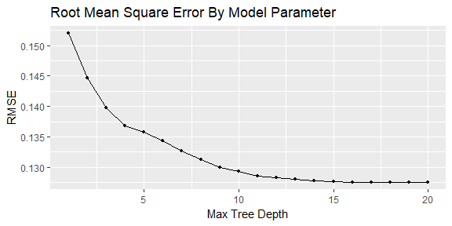

Random Forest
The model was tuned over the following parameters:
## model parameter label forReg forClass probModel
## 1 rf mtry #Randomly Selected Predictors TRUE TRUE TRUE
The tuning profile is depicted immediately below.
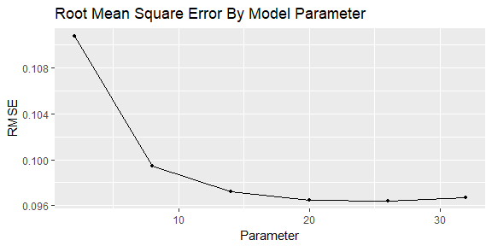

Stochastic Gradient Boosting (SGB)
The model was tuned over the following parameters:
## model parameter label forReg forClass
## 1 gbm n.trees # Boosting Iterations TRUE TRUE
## 2 gbm interaction.depth Max Tree Depth TRUE TRUE
## 3 gbm shrinkage Shrinkage TRUE TRUE
## 4 gbm n.minobsinnode Min. Terminal Node Size TRUE TRUE
## probModel
## 1 TRUE
## 2 TRUE
## 3 TRUE
## 4 TRUE
The tuning profile is depicted immediately below.
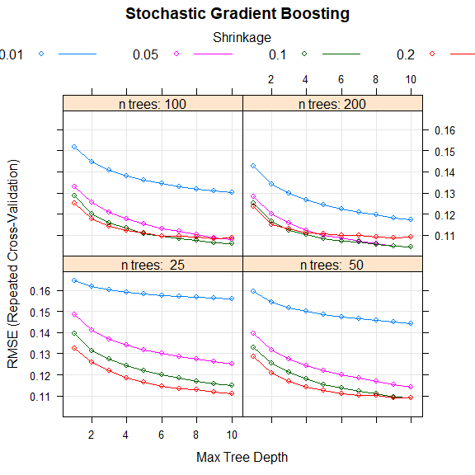

Rule-Based Cubist
The model was tuned over the following parameters:
## model parameter label forReg forClass probModel
## 1 cubist committees #Committees TRUE FALSE FALSE
## 2 cubist neighbors #Instances TRUE FALSE FALSE
The tuning profile is depicted immediately below.
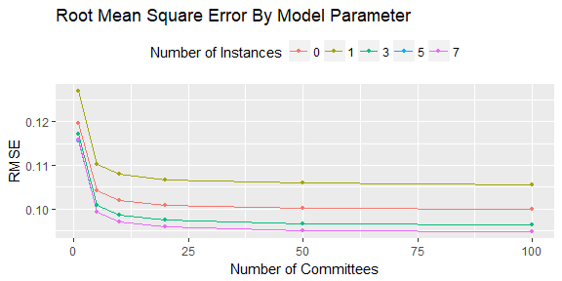

Model Selection
After tuning each model using the process described above, we applied each model to our test set, then compared the performance to the mean performance of the repeated K-fold cross-validation. Performance was relatively stable moving from the training set to the test set.
Training Based Repeated K-Fold Cross-Validation & Test Performance By Model
 | Mean RMSE | Mean R^2 | RMSE | R^2 | MAE
RLM | 0.1307 | 0.4271 | 0.1407 | 0.35 | 0.1087
PCR | 0.1363 | 0.3766 | 0.1457 | 0.2974 | 0.1118
PLS | 0.1304 | 0.4289 | 0.1405 | 0.3512 | 0.1087
Elasticnet | 0.1304 | 0.4289 | 0.1405 | 0.3502 | 0.1088
ANN | 0.1112 | 0.5932 | 0.1084 | 0.6103 | 0.0794
MARS | 0.1205 | 0.5145 | 0.1271 | 0.4691 | 0.096
Bagged MARS | 0.1168 | 0.5456 | 0.1244 | 0.4848 | 0.0938
Bagged MARS (gCV) | 0.1098 | 0.5952 | 0.1153 | 0.5569 | 0.0858
SVMr | 0.1141 | 0.5667 | 0.1192 | 0.5318 | 0.0864
SVMp | 0.1212 | 0.5098 | 0.129 | 0.4533 | 0.0927
KNN | 0.1231 | 0.5009 | 0.1257 | 0.4766 | 0.0913
CART | 0.1275 | 0.4557 | 0.1389 | 0.3661 | 0.1051
RF | 0.0964 | 0.6953 | 0.1146 | 0.5624 | 0.0826
GBM | 0.1044 | 0.6357 | 0.1057 | 0.6296 | 0.0727
Cubist | 0.0948 | 0.698 | 0.1023 | 0.6514 | 0.0716
Repeated K-Fold Cross-Validation Performance Summary By Model ($R^{2}$)
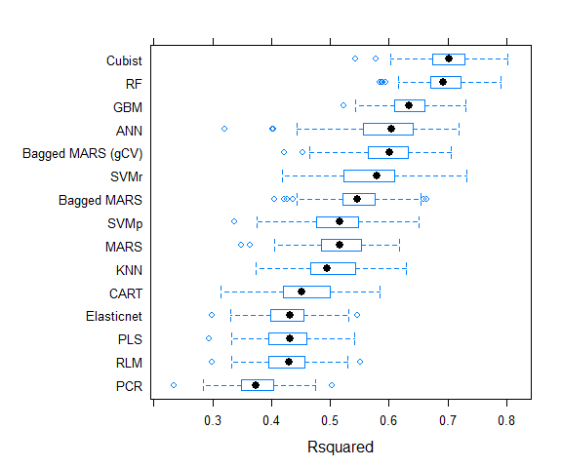
Repeated K-Fold Cross-Validation Performance Summary By Model ($R^{2}$)
 | Min. | 1st Qu. | Median | Mean | 3rd Qu. | Max. | NA’s
RLM | 0.2985 | 0.3955 | 0.4303 | 0.4271 | 0.4565 | 0.5517 | 0
PCR | 0.2336 | 0.3491 | 0.3741 | 0.3766 | 0.4035 | 0.5035 | 0
PLS | 0.2943 | 0.3949 | 0.4319 | 0.4289 | 0.4585 | 0.542 | 0
Elasticnet | 0.2992 | 0.3981 | 0.4319 | 0.4289 | 0.4549 | 0.5457 | 0
ANN | 0.3209 | 0.557 | 0.6041 | 0.5932 | 0.6405 | 0.7196 | 0
MARS | 0.3492 | 0.4852 | 0.5157 | 0.5145 | 0.552 | 0.6173 | 0
Bagged MARS | 0.4049 | 0.5225 | 0.5465 | 0.5456 | 0.5755 | 0.6643 | 0
Bagged MARS (gCV) | 0.4223 | 0.5657 | 0.6016 | 0.5952 | 0.6319 | 0.7066 | 0
SVMr | 0.4184 | 0.5238 | 0.5793 | 0.5667 | 0.6093 | 0.7326 | 0
SVMp | 0.3367 | 0.4766 | 0.5159 | 0.5098 | 0.5477 | 0.6506 | 0
KNN | 0.3743 | 0.4663 | 0.4943 | 0.5009 | 0.5428 | 0.6297 | 0
CART | 0.3142 | 0.4204 | 0.4511 | 0.4557 | 0.4994 | 0.5844 | 0
RF | 0.5838 | 0.6717 | 0.6932 | 0.6953 | 0.7213 | 0.7904 | 0
GBM | 0.5226 | 0.6104 | 0.6349 | 0.6357 | 0.6612 | 0.7302 | 0
Cubist | 0.5434 | 0.6739 | 0.7023 | 0.698 | 0.729 | 0.8027 | 0
Repeated K-Fold Cross-Validation Performance Summary By Model (RMSE)
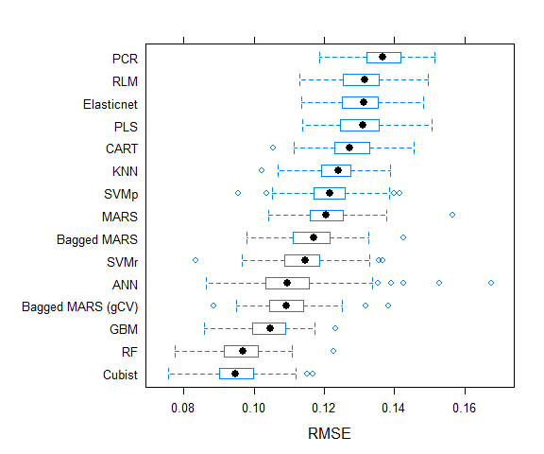
Repeated Cross-Validation Performance Summary By Model (RMSE)
 | Min. | 1st Qu. | Median | Mean | 3rd Qu. | Max. | NA’s
RLM | 0.113 | 0.1253 | 0.1315 | 0.1307 | 0.1354 | 0.1495 | 0
PCR | 0.1187 | 0.1321 | 0.1365 | 0.1363 | 0.1417 | 0.1513 | 0
PLS | 0.1137 | 0.1247 | 0.131 | 0.1304 | 0.1356 | 0.1506 | 0
Elasticnet | 0.1136 | 0.1253 | 0.1313 | 0.1304 | 0.1352 | 0.1483 | 0
ANN | 0.0865 | 0.1035 | 0.1094 | 0.1112 | 0.1155 | 0.1676 | 0
MARS | 0.1041 | 0.116 | 0.1205 | 0.1205 | 0.1253 | 0.1566 | 0
Bagged MARS | 0.0979 | 0.1112 | 0.1171 | 0.1168 | 0.1214 | 0.1425 | 0
Bagged MARS (gCV) | 0.0887 | 0.1044 | 0.1092 | 0.1098 | 0.1141 | 0.1384 | 0
SVMr | 0.0836 | 0.1087 | 0.1146 | 0.1141 | 0.1187 | 0.1365 | 0
SVMp | 0.0956 | 0.1172 | 0.1216 | 0.1212 | 0.1257 | 0.1414 | 0
KNN | 0.1023 | 0.1193 | 0.124 | 0.1231 | 0.1273 | 0.1388 | 0
CART | 0.1056 | 0.1234 | 0.1272 | 0.1275 | 0.1328 | 0.1454 | 0
RF | 0.0775 | 0.0916 | 0.097 | 0.0964 | 0.101 | 0.1227 | 0
GBM | 0.0859 | 0.0996 | 0.1047 | 0.1044 | 0.1088 | 0.1231 | 0
Cubist | 0.0756 | 0.0902 | 0.0947 | 0.0948 | 0.0998 | 0.1168 | 0
It is apparent from the compartive plots and tables above that use of ensemble techniques improves our results.
Based on the performance metrics, two tree-based models performed best: Random Forest and Cubist. Random Forest models create an ensemble of decision trees - using a multitude of trees to correct for overfitting. Cubist models create decision trees and then collapse them into rules. The rules help define the predicted values. In our case, this approach had the highest R-squared for best fit and the lowest errors measured by RMSE and MAE. Therefore, we chose this approach to continue our study.

Model Interpretation (Selected Model)
In this section, we examine the variable importance and partial dependence plots corresponding to our selected model.
Variable Importance (Selected Model)
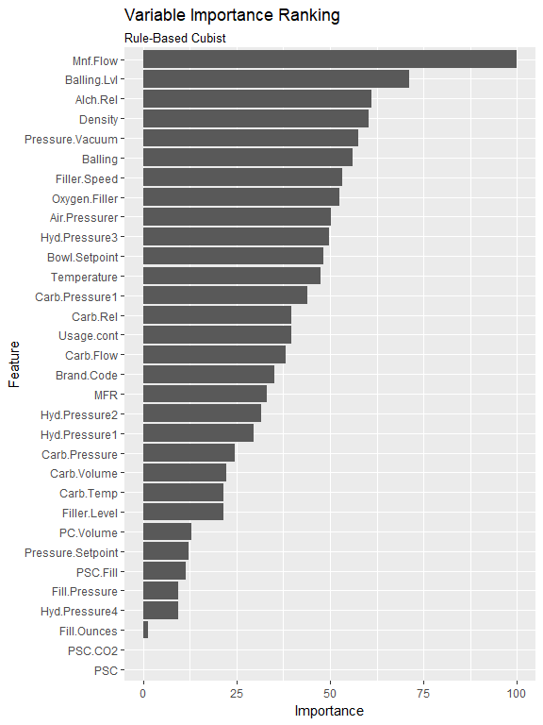
Partial Dependence for Top 10 Predictors (Selected Model)
Another common way to improve our understanding of complex models - particularly those constructed from ensembles of models - is to compute and review the partial dependence of the highest importance predictors. The partial dependence profile shows us how each predictor impacts the response (holding all other predictors constant), based on our tuned model.
The following plot depicts the partial dependence for the top 10 predictors:
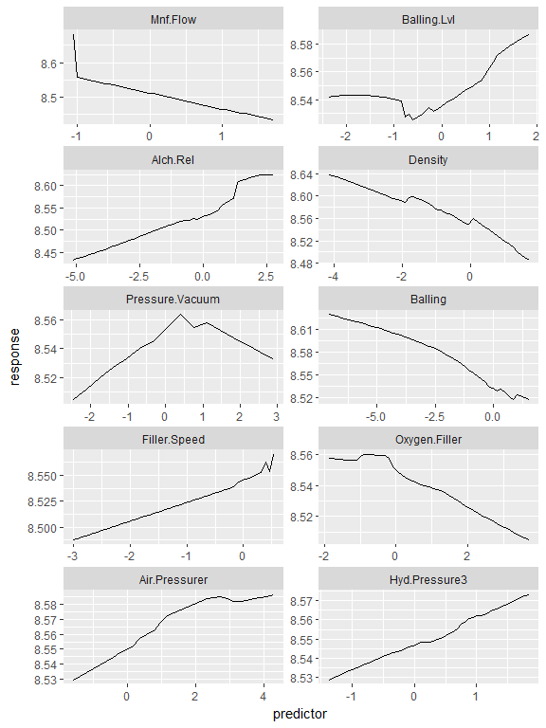
In the plot above, we can see that increasing the manufacturing flow, density, balling, and oxygen filler generally reduces the pH. In contrast, decreasing Alch.Rel, filler speed, air pressurer, and hydraulic pressure (#3) tends to reduce the pH. Finally, the relationships between pH and both balling level and pressure vacuum are more complex. For balling level, as the variable increases, the pH tends to rise, while a decrease initially increases the pH, then the response levels off. For pressure vacuum, as we move further away from 0.5, the pH tends to drop.

Final Model (Tuned on Training & Test Sets)
After selecting the Cubist model based on the training and test set performance, we re-trained the model using both the training and test sets before making our final prediction.
Repeated Cross-Validation Performance Summary - Final Model
 | Mean RMSE | Mean R^2
Cubist (Train) | 0.09478 | 0.698
Cubist (Train+Test) | 0.09226 | 0.7145
There was only a small diffence between to the first version of our selected model and this second, re-trained version of the model.

Out-of-Sample Predictions
Having selected the Cubist model, we then applied the model to our final out-of-sample predictor data set. This data set was composed of 267 possible scenarios, and excluded the pH values. We used our model to predict the pH values for each scenario. For ease of use, we have attached an Excel file with the predicted values for each scenario alongside the predictors used to make the predictions (see the ‘PH_Predicted’ tab).

References
P. Cichosz [2015], Data Mining Algorithms: Explained Using R, John Wiley & Sons, Ltd.
D. Dalpiaz, Applied Statistics with R [2017], University of Illinois at Urbana-Champaign. https://daviddalpiaz.github.io/appliedstats/
J. J. Faraway [2014], Linear Models with, R Second Edition, Chapman & Hall/CRC.
N. Fieller [2016], Basics of Matrix Algebra for Statistics with R, Chapman & Hall/CRC.
J. H. Friedman [1993], Fast MARS. Stanford University Department of Statistics, Technical Report 110.
J. H. Friedman and B W. Silverman [1989], Flexible Parsimonious Smoothing and Additive Modeling. Technometrics, Vol. 31, No. 1.
J. H. Friedman [1991], Multivariate Adaptive Regression Splines (with discussion). Annals of Statistics 19/1.
J. Fox and S. Weisberg [2011], An R Companion to Applied Regression, Second Edition, Thousand Oaks CA: Sage. URL: http://socserv.socsci.mcmaster.ca/jfox/Books/Companion
T. Hastie, R. Tibshirani, J. Friedman [2009], The Elements of Statistical Learning: Data Mining, Inference, and Prediction, Second Edition https://web.stanford.edu/~hastie/Papers/ESLII.pdf
M. Kuhn, [2018], A Short Introduction to the caret Package, R package, https://CRAN.R-project.org/package=caret.
M. Kuhn, K. Johnson [2013], Applied Predictive Modeling, First Edition, Springer
M. Kuhn, S. Weston, C. Keefer, and N. Coulter [2016], Cubist: Rule- And Instance-Based Regression Modeling, R package, https://CRAN.R-project.org/package=Cubist.
W. L. Martinez, A. R. Martinez [2015], Computational Statistics Handbook with MATLAB, Third Edition, Chapman and Hall/CRC.
S. Milborrow [2017], earth: Multivariate Adaptive Regression Splines, R package, https://CRAN.R-project.org/package=earth.
S. Milborrow [2015], plotmo: Plot a model’s response and residuals, R package, https://CRAN.R-project.org/package=plotmo.
G. Ridgeway [2017], gbm: Generalized Boosted Regression Models, R package, https://CRAN.R-project.org/package=gbm.
S. N. Wood [2017], Generalized Additive Models An Introduction with R, Second Edition, Chapman and Hall/CRC.
Wikipedia. Multivariate Adaptive Regression Splines. http://en.wikipedia.org/ wiki/Multivariate_adaptive_regression_splines, Accessed May 2018.

Appendix
The .RData files for each model can be found at the following dropbox link:
https://www.dropbox.com/sh/vsd2magdj4xtllc/AADeWmpoHzUdiBHy9bqF5r3ta?dl=0
Although we have provided the .RData files for each of the trained models, the code in this Appendix has flags that can be used to set to re-run the entire study.
# set download flag
downloadFlag<-FALSE
# set cashe flag
cacheFlag<-TRUE
# set evaluate model flag (if FALSE, load the model)
modelEvaluate<-FALSE
# set show code flag
showCodeFlag<-FALSE
# set error flag
errorFlag<-FALSE
# set warning flag
warningFlag<-FALSE
# set message flag
messageFlag<-FALSE
# import required packages
library(xlsx)
library(tidyverse)
library(caret)
library(forecast)
library(pander)
library(mice)
library(VIM)
library(parallel)
library(doParallel)
library(pdp)
library(psych)
# define random seed
randomSeed<-1234567
# find number of codes
nCores<-detectCores()
# define input/output variables
baseURL <- "https://raw.githubusercontent.com/jzuniga123"
file1URL<-"/SPS/master/DATA%20624/StudentData.xlsx"
file2URL<-"/SPS/master/DATA%20624/StudentEvaluation-%20TO%20PREDICT.xlsx"
outputDirectory <- "D:/Dropbox/github/DATA_624/"
inputFileName<-"StudentData.xlsx"
outputFileName<-"StudentEvaluation-PREDICT.xlsx"
# define full input file name
fullInputFileName<-paste0(outputDirectory,
inputFileName)
# define full output file name
fullOutputFileName<-paste0(outputDirectory,
outputFileName)
if (modelEvaluate==FALSE){
load(file=paste0(outputDirectory,"model_rlm.RData"))
load(file=paste0(outputDirectory,"model_pcr.RData"))
load(file=paste0(outputDirectory,"model_pls.RData"))
load(file=paste0(outputDirectory,"model_enet.RData"))
load(file=paste0(outputDirectory,"model_avnnet.RData"))
load(file=paste0(outputDirectory,"model_mars.RData"))
load(file=paste0(outputDirectory,"model_bagged_mars.RData"))
load(file=paste0(outputDirectory,"model_bagged_gCV_mars.RData"))
load(file=paste0(outputDirectory,"model_svm.RData"))
load(file=paste0(outputDirectory,"model_svm2.RData"))
load(file=paste0(outputDirectory,"model_knn.RData"))
load(file=paste0(outputDirectory,"model_cart.RData"))
load(file=paste0(outputDirectory,"model_rf.RData"))
load(file=paste0(outputDirectory,"model_gbm.RData"))
load(file=paste0(outputDirectory,"model_cubist.RData"))
load(file=paste0(outputDirectory,"model_cubist_full.RData"))
}
if (downloadFlag){
# download input file (xlsx)
download.file(paste0(baseURL, file1URL),fullInputFileName,
mode="wb")
# download output file (xlsx)
download.file(paste0(baseURL, file2URL),fullOutputFileName,
mode="wb")
}
# read input file (xlsx)
inSampleData <- xlsx::read.xlsx(fullInputFileName,
sheetIndex=1, header=T)
# read output file (xlsx)
outOfSampleData <- xlsx::read.xlsx(fullOutputFileName,
sheetIndex=1, header=T)
# remove input file name (xlsx)
#invisible(file.remove(fullInputFileName))
# remove output file (xlsx)
#invisible(file.remove(fullOutputFileName))
# find number of observations of each predictor
nObservations<-dim(inSampleData)[1]
# find number of predictors
nPredictors<-dim(inSampleData %>% select(-PH))[2]
# drop NAs from the response variable
inSampleDataRmNA <- inSampleData %>% drop_na(PH)
# configure replacement of categorical variables with dummy variables
dummyVariables <- dummyVars(" ~ .", data = inSampleDataRmNA,fullRank=T)
# replace categorical variables with dummy variables
inSampleDataRmNADv <- data.frame(predict(dummyVariables,
newdata = inSampleDataRmNA))
# extract response
responseDv <- inSampleDataRmNADv %>% select(PH)
# extract predictors
predictorsDv <- inSampleDataRmNADv %>% select(-PH)
# extract response
response <- inSampleDataRmNA %>% select(PH)
# extract predictors
predictors <- inSampleDataRmNA %>% select(-PH)
# find number of observations of each predictor
nObservationsRmNADv<-dim(predictorsDv)[1]
# find number of predictors
nPredictorsRmNADv<-dim(predictorsDv)[2]
# set training percent
trainPercent<-0.75
# define random seed
set.seed(randomSeed)
# create training set index
trainIndex<-createDataPartition(response$PH,p=trainPercent,list=FALSE)
# extract training set (used for visualization)
inSampleDataRmNATrain<-inSampleDataRmNA[trainIndex,]
# extract test set (used for visualization)
inSampleDataRmNATest<-inSampleDataRmNA[-trainIndex,]
# extract training set (used for modelling>)
inSampleDataRmNADvTrain<-inSampleDataRmNADv[trainIndex,]
# extract test set (used for modelling?)
inSampleDataRmNADvTest<-inSampleDataRmNADv[-trainIndex,]
# extract predictor training set
predictorsDvTrain<-predictorsDv[trainIndex,]
# extract predictor test set
predictorsDvTest<-predictorsDv[-trainIndex,]
# extract response test set
responseDvTrain<-responseDv[trainIndex,]
# extract response training set
responseDvTest<-responseDv[-trainIndex,]
# extract predictor training set
predictorsTrain<-predictors[trainIndex,]
# extract predictor test set
predictorsTest<-predictors[-trainIndex,]
# extract response test set
responseTrain<-response[trainIndex,]
# extract response training set
responseTest<-response[-trainIndex,]
# find number missing predictors
nMissingPredictorsTrain<-sum(is.na(predictorsTrain))
# find number of observations of each predictor
nObservationsTrain<-dim(predictorsTrain)[1]
# find number of predictors
nPredictorsTrain<-dim(predictorsTrain)[2]
# find total number of values
totalNTrain<-nObservationsTrain*nPredictorsTrain
# frequency of missing data
missingFrequencyTrain<-round((nMissingPredictorsTrain/totalNTrain)*100,2)
# find missing counts and frequency (%)
missingFrequencyOfTotalByPredictorTable <- inSampleDataRmNA %>%
# remove PH
select(-PH) %>%
# extract values by predictor
gather(predictorLabel,value) %>%
# group by predictor
group_by(predictorLabel) %>%
# count missing values by predictor
summarize(missingCount=sum(is.na(value))) %>%
# convert count to frequency
mutate(missingFrequency=(missingCount/totalNTrain)*100) %>%
# sort by missing frequency
arrange(desc(missingFrequency))
# define missing value color
notMissingColor<-"navyblue"
# define not missing value color
missingColor<-"red"
# create missing value visualization
aggr(inSampleDataRmNA %>% select(-PH), sortVars = TRUE, bar = FALSE,
prop = FALSE, gap = 1, cex.axis = 0.7,col = c(notMissingColor,
missingColor), ylab = c("Count of Missing Values", "Observation Index"))
# set number of bins
nBins<-20
# plot distribution before i
inSampleDataRmNATrain %>%
select(-Brand.Code) %>%
gather(Variable, Values) %>%
ggplot(aes(x = Values)) +
geom_histogram(alpha = 0.25, col = "black", bins = nBins) +
facet_wrap(~ Variable, scales = "free", nrow = 8)
inSampleDataRmNATrain %>%
gather(-PH, -Brand.Code, key="Var", value="Value") %>%
ggplot(aes(x=Value, y=PH, color=Brand.Code)) +
geom_point(alpha=0.6) +
facet_wrap(~ Var, scales = "free", nrow=8)
data_tbl<-psych::describe(inSampleData[,-1],IQR=T)[,c(1:5,8:10,11,12)]
knitr::kable(round(data_tbl,2), caption = "Selected Summary Statistics")
rm(data_tbl)
# impute missing values (using Predictive Mean Matching)
imputeMethodPMM<-mice(predictorsTrain,m=50,meth='pmm',seed=randomSeed,printFlag = F)
predictorsTrain<-complete(imputeMethodPMM)
# impute missing values (using Predictive Mean Matching)
imputeMethodPMM<-mice(predictorsTest,m=50,meth='pmm',seed=randomSeed,printFlag = F)
predictorsTest<-complete(imputeMethodPMM)
# define preprocess methods
preprocessMethods<-c('center','scale','BoxCox','nzv')
# set up preprocessor using only training set
predictorsPreprocessorTrain<-preProcess(predictorsTrain,
method=preprocessMethods)
# apply preprocessing to training and test set
# transform predictors (training set)
predictorsTrainTransformed<-predict(predictorsPreprocessorTrain,
predictorsTrain)
# transform predictors (test set)
predictorsTestTransformed<-predict(predictorsPreprocessorTrain,
predictorsTest)
# add dummy variables
# configure replacement of categorical variables with dummy variables
dummyVariables <- dummyVars(" ~ .", data = predictorsTrainTransformed,fullRank=T)
# replace categorical variables with dummy variables
predictorsDvTrainTransformed <- data.frame(predict(dummyVariables,
newdata = predictorsTrainTransformed))
# configure replacement of categorical variables with dummy variables
dummyVariables <- dummyVars(" ~ .", data = predictorsTestTransformed,fullRank=T)
# replace categorical variables with dummy variables
predictorsDvTestTransformed <- data.frame(predict(dummyVariables,
newdata = predictorsTestTransformed))
# define missing value color
notMissingColor<-"navyblue"
# define not missing value color
missingColor<-"red"
# create missing value visualization
aggr(predictorsTrainTransformed, sortVars = TRUE, bar = FALSE,
prop = FALSE, gap = 1, cex.axis = 0.7,col = c(notMissingColor,
missingColor), ylab = c("Count of Missing Values",
"Observation Index"))
# # set number of bins
# nBins<-20
# # plot distribution before i
# predictorsTrainTransformed %>%
# select(-Brand.Code) %>%
# gather(Variable, Values) %>%
# ggplot(aes(x = Values)) +
# geom_histogram(alpha = 0.25, col = "black", bins = nBins) +
# facet_wrap(~ Variable, scales = "free", nrow = 8)
# predictorsTrainTransformed
# set number of repeats
nRepeats<-10
# set number of folds for cross-validation
nFolds<-10 # original used 10
# set random seed
set.seed(randomSeed)
# create cluster (leave 1 core for OS)
cluster <- makeCluster(nCores-1)
# register cluster
registerDoParallel(cluster)
# set parallel flag
parallelFlag<-TRUE
# set up 10-fold cross validation
modelControl <- trainControl(method='repeatedcv',
repeats=nRepeats,number=nFolds,allowParallel = parallelFlag)
# define model type
modelType <- "rlm"
# set random seed
set.seed(randomSeed)
# start timer
startTime <- Sys.time()
# train model
model_rlm <- train(predictorsDvTrainTransformed, responseTrain,
method = modelType, trControl = modelControl)
# stop timer
endTime <- Sys.time()
# determine run time
runTime_rlm <- endTime - startTime
# save model
save(model_rlm,runTime_rlm,file = paste0(outputDirectory,
"model_rlm.RData"))
# tuning parameters
modelLookup(modelType)
# define title name
titleName <- "Root Mean Square Error Model Parameter"
# plot
rlm_G1<-model_rlm$results %>%
ggplot(aes(x = psi, y = RMSE, col = factor(psi))) +
geom_line() + geom_point(size = 1) +
labs(title = titleName, col = "psi") +
theme(legend.position = "top")
#rlm_G1
plot(model_rlm, main=model_rlm$modelInfo$label)
# determine variable importance
variableImportance_rlm<-varImp(model_rlm)
# define title name
TitleName<-'Robust Linear Model (RLM)'
# plot predictor importance
rlm_G2<-ggplot(variableImportance_rlm) +
# add title and subtitle
labs(title='Variable Importance Ranking',subtitle=TitleName)
# apply model to training set set
model_rlm_train_p <- predict(model_rlm, predictorsDvTrainTransformed)
# create data frame
df <- data.frame(obs = responseTrain, pred = model_rlm_train_p)
# summary performance (out-of-sample)
modelPerformanceTrain_rlm<-defaultSummary(df)
# apply model to test set
model_rlm_p <- predict(model_rlm, predictorsDvTestTransformed)
# create data frame
df <- data.frame(obs = responseTest, pred = model_rlm_p)
# summary performance (out-of-sample)
modelPerformance_rlm<-defaultSummary(df)
# combine in- and out- of-sample model performance
performanceTable_rlm<-cbind(modelPerformanceTrain_rlm,
modelPerformance_rlm)
# label
colnames(performanceTable_rlm)<-c("Train","Test")
# define model type
modelType <- "pcr"
# set random seed
set.seed(randomSeed)
# start timer
startTime <- Sys.time()
# train model
model_pcr <- train(predictorsTrainTransformed, responseTrain,
method = modelType, trControl = modelControl, tuneLength = 25)
# stop timer
endTime <- Sys.time()
# determine run time
runTime_pcr <- endTime - startTime
# save model
save(model_pcr,runTime_pcr,file = paste0(outputDirectory,
"model_pcr.RData"))
#plot(model_pcr, main=model_pcr$modelInfo$label)
# tuning parameters
modelLookup(modelType)
# define title name
titleName <- "Root Mean Square Error By Model Parameter"
# plot
pcr_G1<-model_pcr$results %>%
ggplot(aes(x = ncomp, y = RMSE)) +
geom_line() + geom_point(size = 1) +
labs(title = titleName, x = "Number of Components") +
theme(legend.position = "top")
pcr_G1
# determine variable importance
variableImportance_pcr<-varImp(model_pcr)
# define title name
TitleName<-'Principal Component Regression (PCR)'
# plot predictor importance
pcr_G2<-ggplot(variableImportance_pcr) +
# add title and subtitle
labs(title='Variable Importance Ranking',subtitle=TitleName)
# apply model to training set
model_pcr_train_p <- predict(model_pcr, predictorsTrainTransformed)
# create data frame
df <- data.frame(obs = responseTrain, pred = model_pcr_train_p)
# summary performance (out-of-sample)
modelPerformanceTrain_pcr<-defaultSummary(df)
# apply model to test set
model_pcr_p <- predict(model_pcr, predictorsTestTransformed)
# create data frame
df <- data.frame(obs = responseTest, pred = model_pcr_p)
# summary performance (out-of-sample)
modelPerformance_pcr<-defaultSummary(df)
# combine in- and out- of-sample model performance
performanceTable_pcr<-cbind(modelPerformanceTrain_pcr,
modelPerformance_pcr)
# label
colnames(performanceTable_pcr)<-c("Train","Test")
# define model type
modelType <- "pls"
# define tune length
tuneN<-25
# set random seed
set.seed(randomSeed)
# start timer
startTime <- Sys.time()
# train model
model_pls <- train(predictorsDvTrainTransformed, responseTrain,
method = modelType, trControl = modelControl, tuneLength = tuneN)
# stop timer
endTime <- Sys.time()
# determine run time
runTime_pls <- endTime - startTime
# save model
save(model_pls,runTime_pls,file = paste0(outputDirectory,
"model_pls.RData"))
#plot(model_pls, main=model_pls$modelInfo$label)
# tuning parameters
modelLookup(modelType)
# define title name
titleName <- "Root Mean Square Error By Model Parameter"
# plot
pls_G1<-model_pls$results %>%
ggplot(aes(x = ncomp, y = RMSE)) +
geom_line() + geom_point(size = 1) +
labs(title = titleName, x = "Number of Components") +
theme(legend.position = "top")
pls_G1
# # determine variable importance
# variableImportance_pls<-varImp(model_pls)
# # define title name
# TitleName<-'Principal Component Regression (PCR)'
# # plot predictor importance
# pls_G2<-ggplot(variableImportance_pls) +
# # add title and subtitle
# labs(title='Variable Importance Ranking',subtitle=TitleName)
# apply model to training set
model_pls_train_p <- predict(model_pls, predictorsDvTrainTransformed)
# create data frame
df <- data.frame(obs = responseTrain, pred = model_pls_train_p)
# summary performance (out-of-sample)
modelPerformanceTrain_pls<-defaultSummary(df)
# apply model to test set
model_pls_p <- predict(model_pls, predictorsDvTestTransformed)
# create data frame
df <- data.frame(obs = responseTest, pred = model_pls_p)
# summary performance (out-of-sample)
modelPerformance_pls<-defaultSummary(df)
# combine in- and out- of-sample model performance
performanceTable_pls<-cbind(modelPerformanceTrain_pls,
modelPerformance_pls)
# label
colnames(performanceTable_pls)<-c("Train","Test")
# define model type
modelType <- "enet"
# set random seed
set.seed(randomSeed)
# start timer
startTime <- Sys.time()
# train model
tg <- expand.grid(lambda = c(0, 0.05, .1),
fraction = seq(0.05, 1, length = 25))
model_enet <- train(predictorsDvTrainTransformed, responseTrain,
method = modelType, trControl = modelControl, tuneGrid = tg)
# stop timer
endTime <- Sys.time()
# determine run time
runTime_enet <- endTime - startTime
# save model
save(model_enet,runTime_enet,file = paste0(outputDirectory,
"model_enet.RData"))
#plot(model_enet, main=model_enet$modelInfo$label)
# tuning parameters
modelLookup(modelType)
# define title name
titleName <- "Root Mean Square Error By Model Parameter"
# plot
enet_G1<-model_enet$results %>%
ggplot(aes(x = fraction, y = RMSE, col = factor(lambda))) +
geom_line() + geom_point(size = 1) +
labs(title = titleName, col = "lambda") +
theme(legend.position = "top")
enet_G1
# determine variable importance
variableImportance_enet<-varImp(model_enet)
# define title name
TitleName<-'Elasticnet'
# plot predictor importance
enet_G2<-ggplot(variableImportance_enet) +
# add title and subtitle
labs(title='Variable Importance Ranking',subtitle=TitleName)
# apply model to training set
model_enet_train_p <- predict(model_enet, predictorsDvTrainTransformed)
# create data frame
df <- data.frame(obs = responseTrain, pred = model_enet_train_p)
# summary performance (out-of-sample)
modelPerformanceTrain_enet<-defaultSummary(df)
# apply model to test set
model_enet_p <- predict(model_enet, predictorsDvTestTransformed)
# create data frame
df <- data.frame(obs = responseTest, pred = model_enet_p)
# summary performance (out-of-sample)
modelPerformance_enet<-defaultSummary(df)
# combine in- and out- of-sample model performance
performanceTable_enet<-cbind(modelPerformanceTrain_enet,
modelPerformance_enet)
# label
colnames(performanceTable_enet)<-c("Train","Test")
# define model type
modelType <- "avNNet"
# define decay range
decayRange<- c(0.01, .1,0.2,0.3,0.5)
# define number of hidden units range
nHiddenUnitsRange<-c(1:10)
# define bagging flag
bagFlag<-F
# define trace flag
traceFlag<-F
# define max number of iterations
maxIterationsN<-500
# define parallel flag
parallelFlag<-T
# define max allowable number of weights
maxNumberOfWeights<-10 * (nPredictorsRmNADv + 1) + 10 + 1
# define linear output units flag
linearOutputUnitsFlag<-T
# set random seed
set.seed(randomSeed)
# start timer
startTime <- Sys.time()
# define parameter search grid
tg <- expand.grid(decay=decayRange, size = nHiddenUnitsRange,
bag = bagFlag)
# train model
model_avnnet <- train(predictorsDvTrainTransformed, responseTrain,
method = modelType, tuneGrid = tg, trControl = modelControl,
linout = linearOutputUnitsFlag, MaxNWts = maxNumberOfWeights,
trace = traceFlag,maxit = maxIterationsN,allowParallel = parallelFlag)
# stop timer
endTime <- Sys.time()
# determine run time
runTime_avnnet <- endTime - startTime
# save model
save(model_avnnet,runTime_avnnet,file = paste0(outputDirectory,
"model_avnnet.RData"))
#plot(model_avnnet, main=model_avnnet$modelInfo$label)
# tuning parameters
modelLookup(modelType)
# define title name
titleName <- "Root Mean Square Error By Model Parameter"
# plot
avnnet_G1<-model_avnnet$results %>%
ggplot(aes(x = size, y = RMSE, col = factor(decay))) +
geom_line() + geom_point(size = 1) +
labs(title = titleName, col = "lambda") +
theme(legend.position = "top")
avnnet_G1
# determine variable importance
variableImportance_avnnet<-varImp(model_avnnet)
# define title name
TitleName<-'Model Averaged Neural Network'
# plot predictor importance
avnnet_G2<-ggplot(variableImportance_avnnet) +
# add title and subtitle
labs(title='Variable Importance Ranking',subtitle=TitleName)
# apply model to training set
model_avnnet_train_p <- predict(model_avnnet, predictorsDvTrainTransformed)
# create data frame
df <- data.frame(obs = responseTrain, pred = model_avnnet_train_p)
# summary performance (out-of-sample)
modelPerformanceTrain_avnnet<-defaultSummary(df)
# apply model to test set
model_avnnet_p <- predict(model_avnnet, predictorsDvTestTransformed)
# create data frame
df <- data.frame(obs = responseTest, pred = model_avnnet_p)
# summary performance (out-of-sample)
modelPerformance_avnnet<-defaultSummary(df)
# combine in- and out- of-sample model performance
performanceTable_avnnet<-cbind(modelPerformanceTrain_avnnet,
modelPerformance_avnnet)
# label
colnames(performanceTable_avnnet)<-c("Train","Test")
# define model type
modelType <- "earth"
# set random seed
set.seed(randomSeed)
# define degree range
degreeRange<-1:3
# define n prune range
nPruneRange<-2:30
# start timer
startTime <- Sys.time()
# define grid
tg <- expand.grid(degree = degreeRange, nprune = nPruneRange)
# train model
model_mars <- train(predictorsDvTrainTransformed, responseTrain,
method = modelType, tuneGrid = tg, trControl = modelControl)
# stop timer
endTime <- Sys.time()
# determine run time
runTime_mars <- endTime - startTime
# save model
save(model_mars,runTime_mars,file = paste0(outputDirectory,
"model_mars.RData"))
# tuning parameters
modelLookup(modelType)
# define title name
titleName <- "Root Mean Square Error By Model Parameter"
# plot
mars_G1<-model_mars$results %>%
ggplot(aes(x = nprune, y = RMSE, col = factor(degree))) +
geom_line() + geom_point(size = 1) +
labs(title = titleName, col = "degree") +
theme(legend.position = "top")
mars_G1
# determine variable importance
variableImportance_mars<-varImp(model_mars)
# define title name
TitleName<-'MARS'
# plot predictor importance
mars_G2<-ggplot(variableImportance_mars) +
# add title and subtitle
labs(title='Variable Importance Ranking',subtitle=TitleName)
# apply model to test set
model_mars_train_p <- predict(model_mars, predictorsDvTrainTransformed)
# rename column
colnames(model_mars_train_p)<-'pred'
# create data frame
df <- data.frame(obs = responseTrain, pred = model_mars_train_p)
# summary performance (out-of-sample)
modelPerformanceTrain_mars<-defaultSummary(df)
# apply model to test set
model_mars_p <- predict(model_mars, predictorsDvTestTransformed)
# rename column
colnames(model_mars_p)<-'pred'
# create data frame
df <- data.frame(obs = responseTest, pred = model_mars_p)
# summary performance (out-of-sample)
modelPerformance_mars<-defaultSummary(df)
# combine in- and out- of-sample model performance
performanceTable_mars<-cbind(modelPerformanceTrain_mars,
modelPerformance_mars)
# label
colnames(performanceTable_mars)<-c("Train","Test")
# define model type
modelType <- "bagEarth"
# define degree range
degreeRange<-1:3
# define n prune range
nPruneRange<-2:15
# set random seed
set.seed(randomSeed)
# start timer
startTime <- Sys.time()
# define tuning grid
tg<-expand.grid(degree = degreeRange, nprune = nPruneRange)
# train model
model_bagged_mars <- train(predictorsDvTrainTransformed, responseTrain,
method = modelType,tuneGrid = tg,trControl = modelControl)
# stop timer
endTime <- Sys.time()
# determine run time
runTime_bagged_mars <- endTime - startTime
# save model
save(model_bagged_mars,runTime_bagged_mars,file = paste0(outputDirectory,
"model_bagged_mars.RData"))
# tuning parameters
modelLookup(modelType)
# define title name
titleName <- "Root Mean Square Error By Model Parameter"
# plot
bagged_mars_G1<-model_bagged_mars$results %>%
ggplot(aes(x = nprune, y = RMSE, col = factor(degree))) +
geom_line() + geom_point(size = 1) +
labs(title = titleName, col = "degree") +
theme(legend.position = "top")
bagged_mars_G1
# determine variable importance
variableImportance_bagged_mars<-varImp(model_bagged_mars)
# define title name
TitleName<-'Bagged MARS'
# plot predictor importance
bagged_mars_G2<-ggplot(variableImportance_bagged_mars) +
# add title and subtitle
labs(title='Variable Importance Ranking',subtitle=TitleName)
# apply model to training set
model_bagged_mars_train_p <- predict(model_bagged_mars,
predictorsDvTrainTransformed)
# create data frame
df<-data.frame(obs = responseTrain, pred = model_bagged_mars_train_p)
# summary performance (out-of-sample)
modelPerformanceTrain_bagged_mars<-defaultSummary(df)
# apply model to test set
model_bagged_mars_p <- predict(model_bagged_mars,
predictorsDvTestTransformed)
# create data frame
df<-data.frame(obs = responseTest, pred = model_bagged_mars_p)
# summary performance (out-of-sample)
modelPerformance_bagged_mars<-defaultSummary(df)
# combine in- and out- of-sample model performance
performanceTable_bagged_mars<-cbind(modelPerformanceTrain_bagged_mars,
modelPerformance_bagged_mars)
# label
colnames(performanceTable_bagged_mars)<-c("Train","Test")
# define model type
modelType <- "bagEarthGCV"
# define degree range
degreeRange<-1:3
# set random seed
set.seed(randomSeed)
# start timer
startTime <- Sys.time()
# define tuning grid
tg<-expand.grid(degree = degreeRange)
# train model
model_bagged_gCV_mars <- train(predictorsDvTrainTransformed, responseTrain,
method = modelType,tuneGrid = tg,trControl = modelControl)
# stop timer
endTime <- Sys.time()
# determine run time
runTime_bagged_gCV_mars <- endTime - startTime
# save model
save(model_bagged_gCV_mars,runTime_bagged_gCV_mars,
file = paste0(outputDirectory,"model_bagged_gCV_mars.RData"))
# tuning parameters
modelLookup(modelType)
# define title name
titleName <- "Root Mean Square Error By Model Parameter"
# plot
bagged_gCV_mars_G1<-model_bagged_gCV_mars$results %>%
ggplot(aes(x = degree, y = RMSE)) +
geom_line() + geom_point(size = 1) +
labs(title = titleName)
bagged_gCV_mars_G1
# determine variable importance
variableImportance_bagged_gCV_mars<-varImp(model_bagged_gCV_mars)
# define title name
TitleName<-'MARS using gCV Pruning'
# plot predictor importance
bagged_gCV_mars_G2<-ggplot(variableImportance_bagged_gCV_mars) +
# add title and subtitle
labs(title='Variable Importance Ranking',subtitle=TitleName)
# apply model to training set
model_bagged_gCV_mars_train_p <- predict(model_bagged_gCV_mars,
predictorsDvTrainTransformed)
# create data frame
df <- data.frame(obs = responseTrain, pred = model_bagged_gCV_mars_train_p)
# summary performance (out-of-sample)
modelPerformanceTrain_bagged_gCV_mars<-defaultSummary(df)
# apply model to test set
model_bagged_gCV_mars_p <- predict(model_bagged_gCV_mars,
predictorsDvTestTransformed)
# create data frame
df <- data.frame(obs = responseTest, pred = model_bagged_gCV_mars_p)
# summary performance (out-of-sample)
modelPerformance_bagged_gCV_mars<-defaultSummary(df)
# combine in- and out- of-sample model performance
performanceTable_bagged_gCV_mars<-cbind(modelPerformanceTrain_bagged_gCV_mars,
modelPerformance_bagged_gCV_mars)
# label
colnames(performanceTable_bagged_gCV_mars)<-c("Train","Test")
# define model type
modelType <- "svmRadial"
# set random seed
set.seed(randomSeed)
# start timer
startTime <- Sys.time()
# train model
model_svm <- train(predictorsDvTrainTransformed, responseTrain,
method = modelType, tuneLength = tuneN,trControl = modelControl)
# stop timer
endTime <- Sys.time()
# determine run time
runTime_svm <- endTime - startTime
# save model
save(model_svm,runTime_svm,file = paste0(outputDirectory,
"model_svm.RData"))
# tuning parameters
modelLookup(modelType)
# define title name
titleName <- "Root Mean Square Error By Model Parameter"
# plot
svm_G1<-model_svm$results %>%
ggplot(aes(x = C, y = RMSE)) +
scale_x_continuous(trans = "log") +
geom_line() + geom_point(size = 1) +
labs(title = titleName,x = 'log(Cost)')
svm_G1
# determine variable importance
variableImportance_svm<-varImp(model_svm)
# define title name
TitleName<-'SVM'
# plot predictor importance
svm_G2<-ggplot(variableImportance_svm) +
# add title and subtitle
labs(title='Variable Importance Ranking',subtitle=TitleName)
variableImportance_svm<-varImp(model_svm)
# apply model to training set
model_svm_train_p <- predict(model_svm, predictorsDvTrainTransformed)
# create data frame
df<-data.frame(obs = responseTrain, pred = model_svm_train_p)
# summary performance (out-of-sample)
modelPerformanceTrain_svm<-defaultSummary(df)
# apply model to test set
model_svm_p <- predict(model_svm, predictorsDvTestTransformed)
# create data frame
df<-data.frame(obs = responseTest, pred = model_svm_p)
# summary performance (out-of-sample)
modelPerformance_svm<-defaultSummary(df)
# combine in- and out- of-sample model performance
performanceTable_svm<-cbind(modelPerformanceTrain_svm,
modelPerformance_svm)
# label
colnames(performanceTable_svm)<-c("Train","Test")
# define model type
modelType <- "svmPoly"
# cost range
costRange<-c(0.01,0.05,0.1,0.25,0.5)
# define degree range
degreeRange<-c(1,2,3,4,5)
# define scale range
scaleRange<-c(0.25,0.5,1)
# set random seed
set.seed(randomSeed)
# start timer
startTime <- Sys.time()
# train model
tg <- expand.grid(C=costRange, degree=degreeRange, scale=scaleRange)
# train model
model_svm2 <- train(predictorsDvTrainTransformed, responseTrain,
method = modelType, tuneGrid = tg, trControl = modelControl)
# stop timer
endTime <- Sys.time()
# determine run time
runTime_svm2 <- endTime - startTime
# save model
save(model_svm2,runTime_svm2,file = paste0(outputDirectory,
"model_svm2.RData"))
#plot(model_svm2, main=model_svm2$modelInfo$label)
# tuning parameters
modelLookup(modelType)
# define title name
titleName <- "Root Mean Square Error By Model Parameter"
# plot
svm2_G1<-model_svm2$results %>%
ggplot(aes(x = C, y = RMSE)) +
scale_x_continuous(trans = "log") +
geom_line() + geom_point(size = 1) +
labs(title = titleName,x = 'log(Cost)')
#svm2_G1
plot(model_svm2, main=model_svm2$modelInfo$label)
# determine variable importance
variableImportance_svm2<-varImp(model_svm2)
# define title name
TitleName<-'SVM'
# plot predictor importance
svm2_G2<-ggplot(variableImportance_svm2) +
# add title and subtitle
labs(title='Variable Importance Ranking',subtitle=TitleName)
variableImportance_svm2<-varImp(model_svm2)
# apply model to training set
model_svm2_train_p <- predict(model_svm2, predictorsDvTrainTransformed)
# create data frame
df<-data.frame(obs = responseTrain, pred = model_svm2_train_p)
# summary performance (out-of-sample)
modelPerformanceTrain_svm2<-defaultSummary(df)
# apply model to test set
model_svm2_p <- predict(model_svm2, predictorsDvTestTransformed)
# create data frame
df<-data.frame(obs = responseTest, pred = model_svm2_p)
# summary performance (out-of-sample)
modelPerformance_svm2<-defaultSummary(df)
# combine in- and out- of-sample model performance
performanceTable_svm2<-cbind(modelPerformanceTrain_svm2,
modelPerformance_svm2)
# label
colnames(performanceTable_svm2)<-c("Train","Test")
# define model type
modelType <- "knn"
# define k range
kRange<-1:20
# set random seed
set.seed(randomSeed)
# start timer
startTime <- Sys.time()
# train model
tg <- data.frame(k = kRange)
model_knn <- train(predictorsDvTrainTransformed, responseTrain,
method = modelType, tuneGrid = tg, trControl = modelControl)
# stop timer
endTime <- Sys.time()
# determine run time
runTime_knn <- endTime - startTime
# save model
save(model_knn,runTime_knn, file = paste0(outputDirectory,
"model_knn.RData"))
#plot(model_knn, main=model_knn$modelInfo$label)
# tuning parameters
modelLookup(modelType)
# define title name
titleName <- "Root Mean Square Error By Model Parameter"
# define x label
xLabel = ' Number of Neighbors (k)'
# plot
knn_G1<-model_knn$results %>%
ggplot(aes(x = k, y = RMSE)) +
geom_line() + geom_point(size = 1) +
labs(title = titleName,x=xLabel)
knn_G1
# determine variable importance
variableImportance_knn<-varImp(model_knn)
# define title name
TitleName<-'K-Nearest Neighbors (KNN)'
# plot predictor importance
knn_G2<-ggplot(variableImportance_knn) +
# add title and subtitle
labs(title='Variable Importance Ranking',subtitle=TitleName)
variableImportance_knn<-varImp(model_knn)
# apply model to training set
model_knn_train_p <- predict(model_knn, predictorsDvTrainTransformed)
# create data frame
df<-data.frame(obs = responseTrain, pred = model_knn_train_p)
# summary performance (out-of-sample)
modelPerformanceTrain_knn<-defaultSummary(df)
# apply model to test set
model_knn_p <- predict(model_knn, predictorsDvTestTransformed)
# create data frame
df<-data.frame(obs = responseTest, pred = model_knn_p)
# summary performance (out-of-sample)
modelPerformance_knn<-defaultSummary(df)
# combine in- and out- of-sample model performance
performanceTable_knn<-cbind(modelPerformanceTrain_knn,
modelPerformance_knn)
# label
colnames(performanceTable_knn)<-c("Train","Test")
# define model type
modelType <- "rpart2"
# set random seed
set.seed(randomSeed)
# start timer
startTime <- Sys.time()
# define grid
tg <- expand.grid(maxdepth= seq(1,20,by=1))
# train model
model_cart <- train(predictorsDvTrainTransformed, responseTrain,
method = modelType, tuneGrid = tg, trControl = modelControl)
# stop timer
endTime <- Sys.time()
# determine run time
runTime_cart <- endTime - startTime
# save model
save(model_cart,runTime_cart,file = paste0(outputDirectory,
"model_cart.RData"))
#plot(model_cart, main=model_cart$modelInfo$label)
# tuning parameters
modelLookup(modelType)
# define title name
titleName <- "Root Mean Square Error By Model Parameter"
# define x label
xLabel = 'Max Tree Depth'
# plot
cart_G1<-model_cart$results %>%
ggplot(aes(x = maxdepth, y = RMSE)) +
geom_line() + geom_point(size = 1) +
labs(title = titleName,x=xLabel)
cart_G1
# determine variable importance
variableImportance_cart<-varImp(model_cart)
# define title name
TitleName<-'Classification and Regression Tree (CART)'
# plot predictor importance
cart_G2<-ggplot(variableImportance_cart) +
# add title and subtitle
labs(title='Variable Importance Ranking',subtitle=TitleName)
variableImportance_cart<-varImp(model_cart)
# apply model to training set
model_cart_train_p <- predict(model_cart, predictorsDvTrainTransformed)
# create data frame
df<-data.frame(obs = responseTrain, pred = model_cart_train_p)
# summary performance (out-of-sample)
modelPerformanceTrain_cart<-defaultSummary(df)
# apply model to test set
model_cart_p <- predict(model_cart, predictorsDvTestTransformed)
# create data frame
df<-data.frame(obs = responseTest, pred = model_cart_p)
# summary performance (out-of-sample)
modelPerformance_cart<-defaultSummary(df)
# combine in- and out- of-sample model performance
performanceTable_cart<-cbind(modelPerformanceTrain_cart,
modelPerformance_cart)
# label
colnames(performanceTable_cart)<-c("Train","Test")
# define model type
modelType <- "rf"
# define importance flag
importanceFlag<-TRUE
# set random seed
set.seed(randomSeed)
# start timer
startTime <- Sys.time()
P <- ncol(predictorsTrainTransformed)
# define grid
tg <- expand.grid(mtry=seq(2, P, by = floor(P/5)))
# train model
model_rf <- train(predictorsTrainTransformed, responseTrain,
method = modelType, tuneGrid = tg, trControl = modelControl,
importance = importanceFlag)
# stop timer
endTime <- Sys.time()
# determine run time
runTime_rf <- endTime - startTime
# save model
save(model_rf,runTime_rf,file = paste0(outputDirectory,
"model_rf.RData"))
#plot(model_rf, main=model_rf$modelInfo$label)
# tuning parameters
modelLookup(modelType)
# define title name
titleName <- "Root Mean Square Error By Model Parameter"
# define x label
xLabel = 'Parameter'
# plot
rf_G1<-model_rf$results %>%
ggplot(aes(x = mtry, y = RMSE)) +
geom_line() + geom_point(size = 1) +
labs(title = titleName,x=xLabel)
rf_G1
# determine variable importance
variableImportance_rf<-varImp(model_rf)
# define title name
TitleName<-'Random Forest'
# plot predictor importance
rf_G2<-ggplot(variableImportance_rf) +
# add title and subtitle
labs(title='Variable Importance Ranking',subtitle=TitleName)
variableImportance_rf<-varImp(model_rf)
# apply model to training set
model_rf_train_p <- predict(model_rf, predictorsTrainTransformed)
# create data frame
df<-data.frame(obs = responseTrain, pred = model_rf_train_p)
# summary performance (out-of-sample)
modelPerformanceTrain_rf<-defaultSummary(df)
# apply model to test set
model_rf_p <- predict(model_rf, predictorsTestTransformed)
# create data frame
df<-data.frame(obs = responseTest, pred = model_rf_p)
# summary performance (out-of-sample)
modelPerformance_rf<-defaultSummary(df)
# combine in- and out- of-sample model performance
performanceTable_rf<-cbind(modelPerformanceTrain_rf,
modelPerformance_rf)
# label
colnames(performanceTable_rf)<-c("Train","Test")
# define model type
modelType <- "gbm"
# define interaction depth
interactionDepth<-seq(1,10,by=1)
# define number of trees
nTrees<-c(25,50,100,200)
# define shrinkage
shrinkageRange<-c(0.01,0.05,0.1,0.2)
# define minimum terminal node size
minTerminalNodeSize<-10
# set random seed
set.seed(randomSeed)
# start timer
startTime <- Sys.time()
# define grid
tg <- expand.grid(interaction.depth=interactionDepth, n.trees=nTrees,
shrinkage=shrinkageRange, n.minobsinnode=minTerminalNodeSize)
# train model
model_gbm <- train(predictorsDvTrainTransformed, responseTrain,
method = modelType, tuneGrid = tg, trControl = modelControl,
verbose=F)
# ,importance = importanceFlag
# stop timer
endTime <- Sys.time()
# determine run time
runTime_gbm <- endTime - startTime
# save model
save(model_gbm,runTime_gbm,file = paste0(outputDirectory,
"model_gbm.RData"))
#plot(model_gbm, main=model_gbm$modelInfo$label)
# tuning parameters
modelLookup(modelType)
# # define title name
# titleName <- "Root Mean Square Error \n By Model Parameter"
# # define x label
# xLabel = 'Number of Committees'
# # plot
# gbm_G1<-model_gbm$results %>%
# ggplot(aes(x = maxdepth, y = RMSE)) +
# geom_line() + geom_point(size = 1) +
# labs(title = titleName,x=xLabel)
# # determine variable importance
# variableImportance_gbm<-varImp(model_gbm)
# # define title name
# TitleName<-'Stochastic Gradient Boosting (SGB)'
# # plot predictor importance
# gbm_G2<-ggplot(variableImportance_gbm) +
# # add title and subtitle
# labs(title='Variable Importance Ranking',subtitle=TitleName)
#
# variableImportance_gbm<-varImp(model_gbm)
plot(model_gbm, main=model_gbm$modelInfo$label)
# apply model to training set
model_gbm_train_p <- predict(model_gbm, predictorsDvTrainTransformed)
# create data frame
df<-data.frame(obs = responseTrain, pred = model_gbm_train_p)
# summary performance (out-of-sample)
modelPerformanceTrain_gbm<-defaultSummary(df)
# apply model to test set
model_gbm_p <- predict(model_gbm, predictorsDvTestTransformed)
# create data frame
df<-data.frame(obs = responseTest, pred = model_gbm_p)
# summary performance (out-of-sample)
modelPerformance_gbm<-defaultSummary(df)
# combine in- and out- of-sample model performance
performanceTable_gbm<-cbind(modelPerformanceTrain_gbm,
modelPerformance_gbm)
# label
colnames(performanceTable_gbm)<-c("Train","Test")
# define model type
modelType <- "cubist"
# define number of committees
nCommittees<-c(1,5,10,20,50,100)
# define number of neighbors
nNeighbors<-c(0,1,3,5,7)
# set random seed
set.seed(randomSeed)
# start timer
startTime <- Sys.time()
# define grid
tg <- expand.grid(committees = nCommittees, neighbors = nNeighbors)
# train model
model_cubist <- train(predictorsTrainTransformed, responseTrain,
method = modelType, tuneGrid = tg, trControl = modelControl)
# stop timer
endTime <- Sys.time()
# determine run time
runTime_cubist <- endTime - startTime
# save model
save(model_cubist,runTime_cubist,file = paste0(outputDirectory,
"model_cubist.RData"))
#plot(model_cubist, main=model_cubist$modelInfo$label)
# tuning parameters
modelLookup(modelType)
# define title name
titleName <- "Root Mean Square Error By Model Parameter"
# define x label
xLabel = 'Number of Committees'
# plot
cubist_G1<-model_cubist$results %>%
ggplot(aes(x = committees, y = RMSE,col=factor(neighbors))) +
geom_line() + geom_point(size = 1) +
labs(title = titleName,x=xLabel,col='Number of Instances')+
theme(legend.position = "top")
# determine variable importance
variableImportance_cubist<-varImp(model_cubist)
# define title name
TitleName<-'Rule-Based Cubist'
# plot predictor importance
cubist_G2<-ggplot(variableImportance_cubist) +
# add title and subtitle
labs(title='Variable Importance Ranking',subtitle=TitleName)
variableImportance_cubist<-varImp(model_cubist)
cubist_G1
# apply model to training set
model_cubist_train_p <- predict(model_cubist, predictorsTrainTransformed)
# create data frame
df<-data.frame(obs = responseTrain, pred = model_cubist_train_p)
# summary performance (out-of-sample)
modelPerformanceTrain_cubist<-defaultSummary(df)
# apply model to test set
model_cubist_p <- predict(model_cubist, predictorsTestTransformed)
# create data frame
df<-data.frame(obs = responseTest, pred = model_cubist_p)
# summary performance (out-of-sample)
modelPerformance_cubist<-defaultSummary(df)
# combine in- and out- of-sample model performance
performanceTable_cubist<-cbind(modelPerformanceTrain_cubist,
modelPerformance_cubist)
# label
colnames(performanceTable_cubist)<-c("Train","Test")
# save all models to single RData output file
save(model_rlm,model_pcr,model_pls,model_enet,model_avnnet,model_mars,
model_bagged_mars,model_bagged_gCV_mars,model_svm,model_svm2,model_knn,
model_cart,model_rf,model_gbm,model_cubist,
file=paste0(outputDirectory,"allModels.RData"))
# default summary is a wrapper around post-resample
# combine model performance
performanceTrainLinear<-rbind(modelPerformanceTrain_rlm,modelPerformanceTrain_pcr,
modelPerformanceTrain_pls,modelPerformanceTrain_enet)
# add model names
row.names(performanceTrainLinear)<-c('RLM','PCR','PLS','ENET')
# create data frame
trainLinear <- data.frame(performanceTrainLinear)
# combine model performance
performanceTrainNonLinear<-rbind(modelPerformanceTrain_avnnet,
modelPerformanceTrain_mars,modelPerformanceTrain_bagged_mars,
modelPerformanceTrain_bagged_gCV_mars,modelPerformanceTrain_svm,
modelPerformanceTrain_svm2,modelPerformanceTrain_knn)
# add model names
row.names(performanceTrainNonLinear)<-c('ANN','MARS','Bagged MARS',
'Bagged MARS (gCV)','SVM (Radial)','SVM (Polynomial)','KNN')
# create data frame
trainNonLinear <- data.frame(performanceTrainNonLinear)
# combine model performance
performanceTrainTree<-rbind(modelPerformanceTrain_cart,modelPerformanceTrain_gbm,
modelPerformanceTrain_rf,modelPerformanceTrain_cubist)
# add model names
row.names(performanceTrainTree)<-c('CART','GBM','RF','Cubist')
# create data frame
trainTree <- data.frame(performanceTrainTree)
# default summary is a wrapper around post-resample
# combine model performance
performanceTestLinear<-rbind(modelPerformance_rlm,modelPerformance_pcr,
modelPerformance_pls,modelPerformance_enet)
# add model names
row.names(performanceTestLinear)<-c('RLM','PCR','PLS','ENET')
# create data frame
validationLinear <- data.frame(performanceTestLinear)
# combine model performance
performanceTestNonLinear<-rbind(modelPerformance_avnnet,
modelPerformance_mars,modelPerformance_bagged_mars,
modelPerformance_bagged_gCV_mars,modelPerformance_svm,
modelPerformance_svm2,modelPerformance_knn)
# add model names
row.names(performanceTestNonLinear)<-c('ANN','MARS','Bagged MARS',
'Bagged MARS (gCV)','SVM (Radial)','SVM (Polynomial)','KNN')
# create data frame
validationNonLinear <- data.frame(performanceTestNonLinear)
# combine model performance
performanceTestTree<-rbind(modelPerformance_cart,modelPerformance_gbm,
modelPerformance_rf,modelPerformance_cubist)
# add model names
row.names(performanceTestTree)<-c('CART','GBM','RF','Cubist')
# create data frame
validationTree <- data.frame(performanceTestTree)
# runTime <-list("RLM"=runTime_rlm,"PCR"=runTime_pcr,"PLS"=runTime_pls,
# "Elasticnet"=runTime_enet,"ANN"=runTime_avnnet,"MARS"=runTime_mars,
# "Bagged MARS"=runTime_bagged_mars,"Bagged MARS (gCV)"=runTime_bagged_gCV_mars,
# "SVMr"=runTime_svm,"SVMp"=runTime_svm2,"KNN"=runTime_knn,"CART"=runTime_cart,
# "RF"=runTime_rf,"GBM"=runTime_gbm,"Cubist"=runTime_cubist)
# create object for resampled performance
rValues <- resamples(list("RLM"=model_rlm,"PCR"=model_pcr,"PLS"=model_pls,
"Elasticnet"=model_enet,"ANN"=model_avnnet,"MARS"=model_mars,
"Bagged MARS"=model_bagged_mars,"Bagged MARS (gCV)"=model_bagged_gCV_mars,
"SVMr"=model_svm,"SVMp"=model_svm2,"KNN"=model_knn,"CART"=model_cart,
"RF"=model_rf,"GBM"=model_gbm,"Cubist"=model_cubist))
# create resampled performance summary
modelPerformanceSummary<-summary(rValues)
# create dataframes
modelPerformanceSummaryTableRMSE<-data.frame(modelPerformanceSummary$statistics$RMSE)
modelPerformanceSummaryTableR2<-data.frame(modelPerformanceSummary$statistics$Rsquared)
# extract mean repeated CV out-of-fold performance
trainResampleSummary<-cbind(modelPerformanceSummaryTableRMSE['Mean'],
modelPerformanceSummaryTableR2['Mean'])
# combine repeated CV out-of-fold performance statistics and test performance
performanceSummaryTable<-cbind(trainResampleSummary,rbind(validationLinear,
validationNonLinear,validationTree))
# add labels
colnames(performanceSummaryTable)<-c("Mean RMSE",
paste("Mean","R^2"),"RMSE","R^2",
"MAE")
# plot ranked r-squared for each model
bwplot(rValues,metric="Rsquared")
bwplot(rValues,metric="RMSE")
cubist_G2
# extract variable importance
IV<-data.frame(variableImportance_cubist$importance)
# define number of predictors to plot
topN<-10
# iterate over each predictor and determine partial dependence
pd<-NULL
for (predictorName in row.names(IV)[order(-IV$Overall)][1:topN]){
tmp<-partial(model_cubist,pred.var=predictorName)
names(tmp)<-c("predictor","response")
pd<-rbind(pd,cbind(tmp,predictorName=predictorName))
}
# add variable importance plot
cubist_pdp<-ggplot(pd, aes(predictor, response)) +
geom_line() +
facet_wrap(~ predictorName, scales = "free",ncol=2)
# plot
cubist_pdp
# add test and train data for predictors and response
predictorsFull<-rbind(predictorsTrainTransformed, predictorsTestTransformed)
#responseFull<-rbind(responseTrain,responseTest)
responseFull<-c(responseTrain,responseTest)
# define model type
modelType <- "cubist"
# define number of committees
nCommittees<-c(1,5,10,20,50,100)
# define number of neighbors
nNeighbors<-c(0,1,3,5,7)
# set random seed
set.seed(randomSeed)
# start timer
startTime <- Sys.time()
# define grid
tg <- expand.grid(committees = nCommittees, neighbors = nNeighbors)
# train model
model_cubist_full <- train(predictorsFull, responseFull,
method = modelType, tuneGrid = tg, trControl = modelControl)
# stop timer
endTime <- Sys.time()
# determine run time
runTime_cubist_full <- endTime - startTime
# save model
save(model_cubist_full,runTime_cubist_full,file = paste0(outputDirectory,
"model_cubist_full.RData"))
# # resample
FullResample <-postResample(pred = predict(model_cubist_full,
newdata = predictorsFull), obs = responseFull)
#
rValues_Full<- resamples(list("Cubist (Train)"=model_cubist,
"Cubist (Train+Test)"=model_cubist_full))
# create resampled performance summary
finalModelPerformanceSummary<-summary(rValues_Full)
# create dataframes
finalModelPerformanceSummaryTableRMSE<-data.frame(finalModelPerformanceSummary$statistics$RMSE)
finalModelPerformanceSummaryTableR2<-data.frame(finalModelPerformanceSummary$statistics$Rsquared)
# extract mean repeated CV out-of-fold performance
trainResampleSummary<-cbind(finalModelPerformanceSummaryTableRMSE['Mean'],
finalModelPerformanceSummaryTableR2['Mean'])
colnames(trainResampleSummary)<-c('Mean RMSE','Mean R^2')
# pre-processing OutSample data
outOfSamplePredictors <- outOfSampleData %>% select(-PH)
# remove NAs, impute missing values
imputeMethodPMM<-mice(outOfSamplePredictors,m=50,meth='pmm',seed=randomSeed,
printFlag = F)
outOfSamplePredictors<-complete(imputeMethodPMM)
# define preprocess methods
preprocessMethods<-c('center','scale','BoxCox','nzv')
# set up preprocessor using test plus train
outOfSamplePredictorsPreprocessor<-preProcess(outOfSamplePredictors,
method=preprocessMethods)
# generate predictions
outOfSamplePredictorsTransformed <- predict(outOfSamplePredictorsPreprocessor,
outOfSamplePredictors)
# generate predictions
outOfSampleResponse <- predict(model_cubist_full, outOfSamplePredictorsTransformed)
# add forecast to out-of-sample data
outOfSampleData$PH <- outOfSampleResponse
# open workbook
wb = loadWorkbook(paste0(outputDirectory,outputFileName))
# remove sheet
removeSheet(wb, sheetName = "PH_Predicted")
# save workbook
saveWorkbook(wb, paste0(outputDirectory,outputFileName))
# add third data set in new worksheet
write.xlsx(outOfSampleData, file=paste0(outputDirectory,
outputFileName), sheetName="PH_Predicted", append=TRUE)
# stop cluster
stopCluster(cluster)
# de-register parallel processing cluster
registerDoSEQ()
# save
save.image(file = paste0(outputDirectory,"DATA_624_Project_2.RData"))
# create appendix of code

