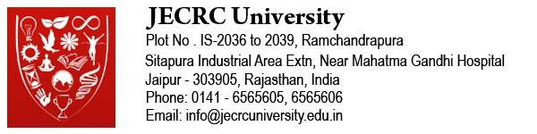



BCA Examination April-2020

HALL TICKET FOR EVEN SEMESTERS EXAM 2019-2020

|  |  |
| --- | --- |
|  | Roll No:1405011049 |
| Exam Type: | Regulation: |
| Program: | |

|  |  |  |  |  |  |
| --- | --- | --- | --- | --- | --- |
| Date | Day | Time | Subject | Section | Invigilator’s Signature |
|  |  |  |  |  |  |

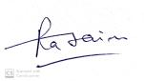

Deputy Controller of Examinations

Signature of Student

Instructions to Students:

1. Students have to enter examination hall before 15 minutes of starting of the examination.
2. Nobody will be allowed to enter after commencement of examination.
3. Mobile phone, smart watch and any other electronic device will not be allowed in exam hall. (Calculator will be allowed as per instruction of papers).
4. Mobile phone or any electronic gazettes in the examination hall tantamount to unfair means will be seized and seized device will not be returned before finalization of unfair means case.
5. You will be allowed to go to washroom only after one hour of the commencement of examination.
6. The evaluated answer sheets will be shown to the students by the concerned evaluators till 10th January 2020. If you fail to see the answer sheets by this date, you will not have any claim in future. No revaluation / rechecking of answer sheets is permitted.
7. If there is any discrepancy in the schedule of examination in the hall ticket, the schedule given in the time table will be final.