**Programming Assignment Report-2**

**Answer-1: We have three different random curves with three different time step values**

The red curve denotes the initial curve generated by the random closed curve generator and the blue curves denote the curves generated after propagation of curvature flow equation implemented by Euler-Lagrange minimization with the respective parameters. We can increase the number of iterations to shrink the curve successively inside the contour.

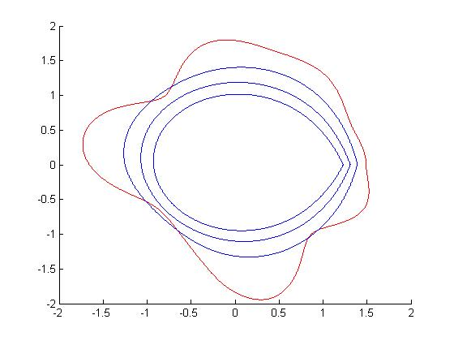

Figure-2 Time Step=0.5 and number of iterations=90000 each stage after 30000 iterations

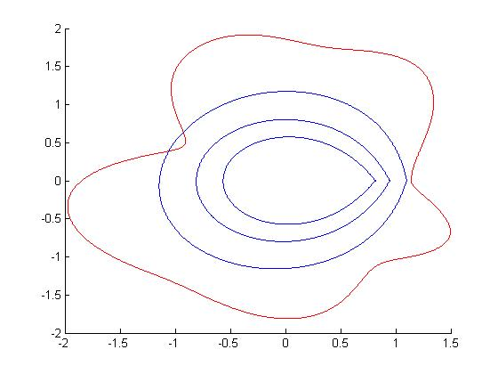

Figure-2 Time Step=1.2 number of iterations=90000 each stage after 30000 iterations

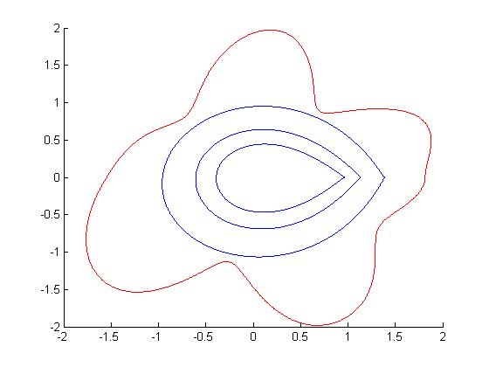

Figure-3 Time Step=1.6 and number of iterations=90000 each stage after 30000 iterations

* It can be clearly seen that when you increase the time step value for the curve for each iteration the initialized curve seems to be shrinking at a faster rate.
* Curvature Equation=derivative of (C(s;t) wrt t)=KN; where N->Normal Vector
* As the number of iterations keep on increasing the contour formation shrinks at a slower rate since the gradient value gradually decreases.

**Answer-2:**

Energy equation of snake=(alpha*v(ss)-Beta*v(ssss)) +Eext(Image)-> (Gradient Vector Field V)

. In this question, I have implemented the traditional snake instead of the GVF snake.

**Test Cases:** Square Image

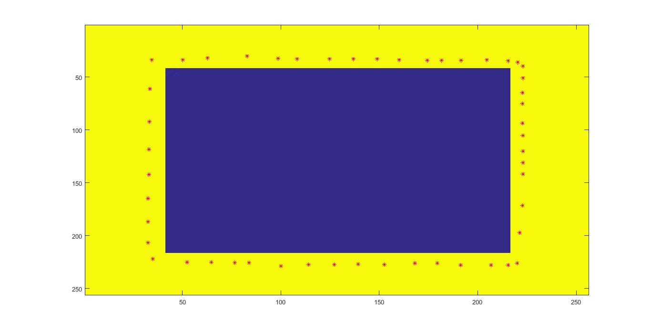

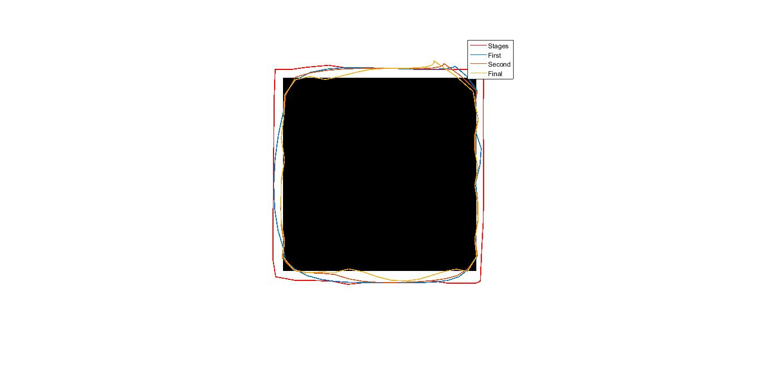

Pacman Image

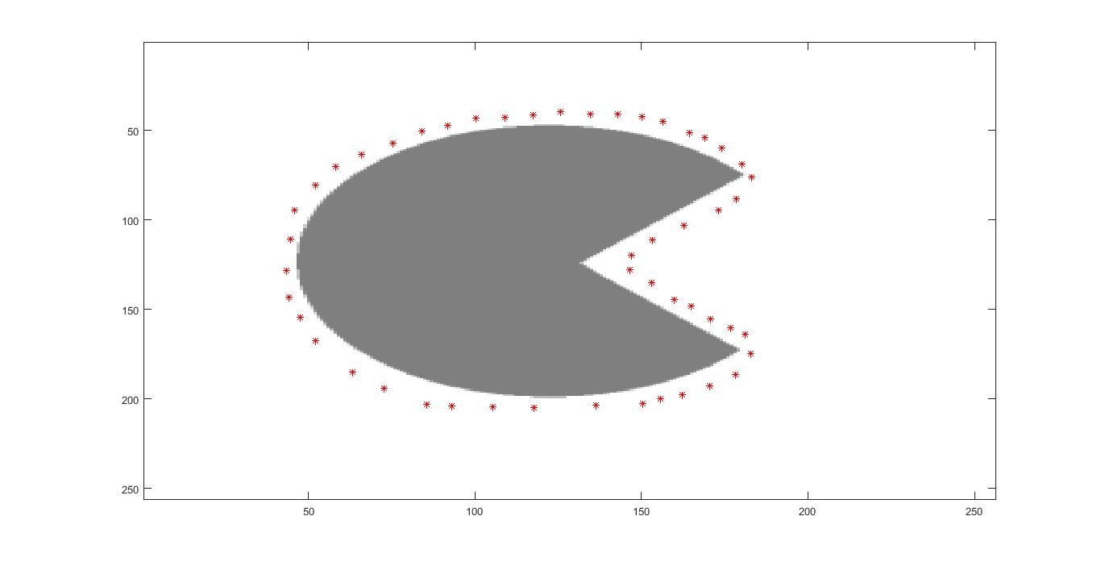

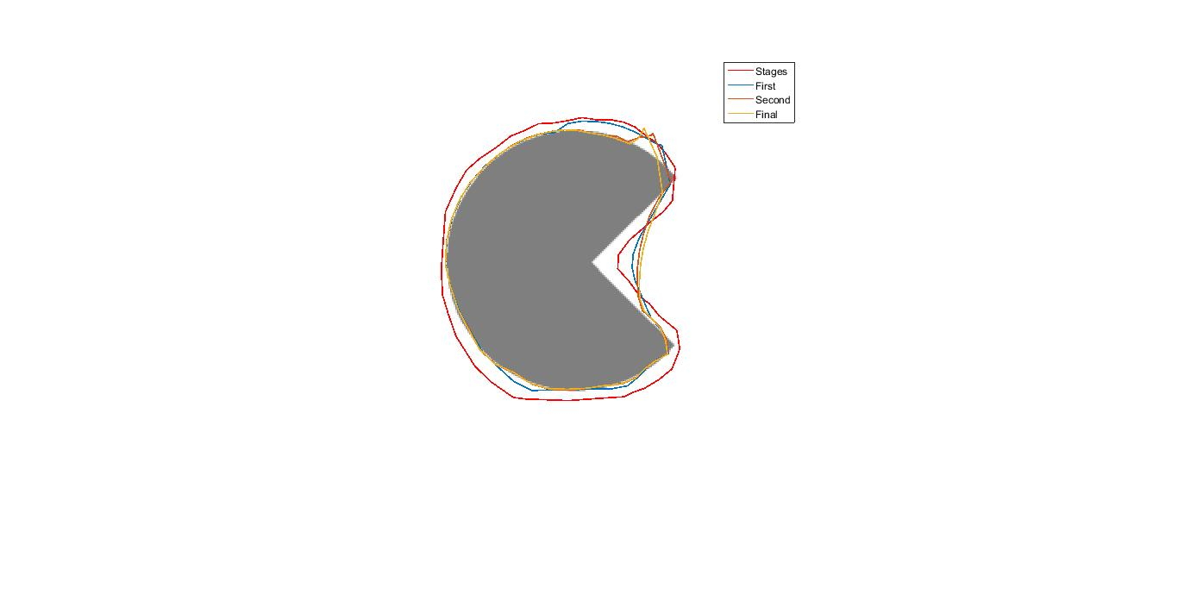

**Note: -**All the parameters that have been chosen for the image are specific to it and are adjusted per the nature of image.

