TIFF PDF Converter Documentation

Install Setup

1. Run Installer
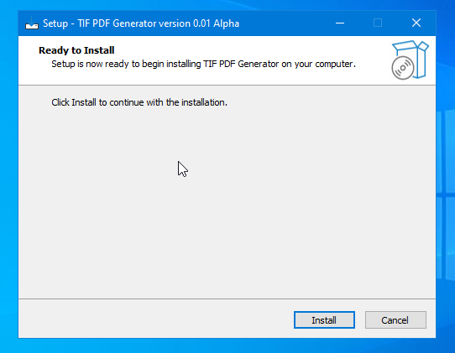

Click Install.
2. Install Ghostscript when new window appears.
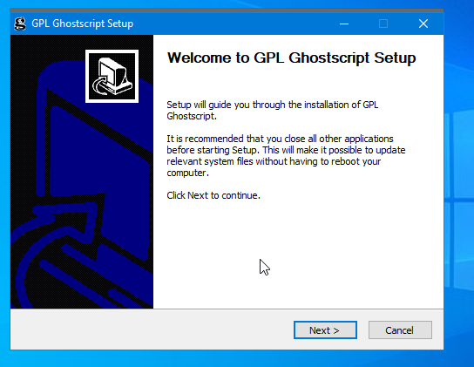

3. Finish Ghostscript installation. Make sure “Generate cidfmap for Windows CJK TrueType fonts” clicked.
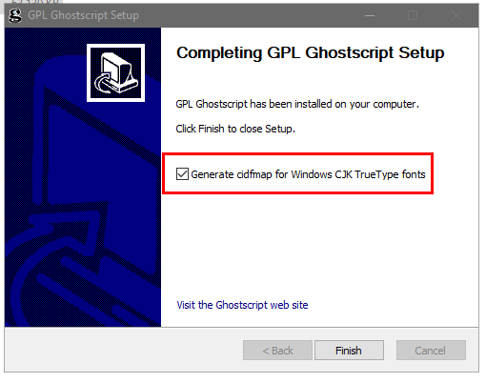

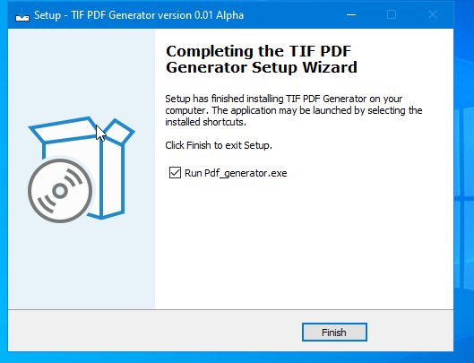
4.Finish Installation and open TIFF PDF Generator.

Usage
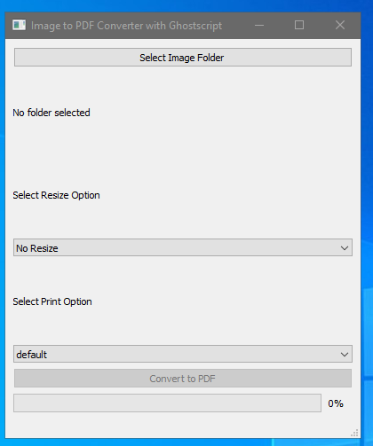

1. Select the folder in which TIFF files exist using Select Image Folder option. (Sometimes the folder looks empty. TIFF files won’t be shown.)
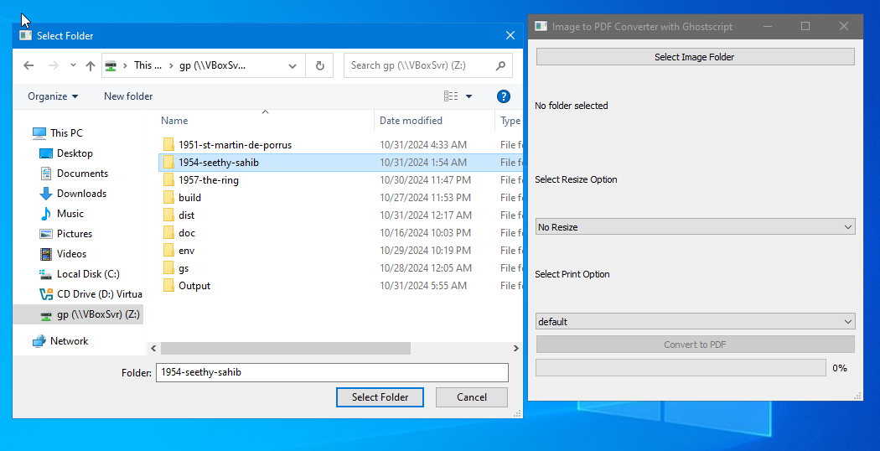
2. When the folder is chosen, the folder path appears in the UI and also number of files in the folder will be listed there (as shown in rectangle).
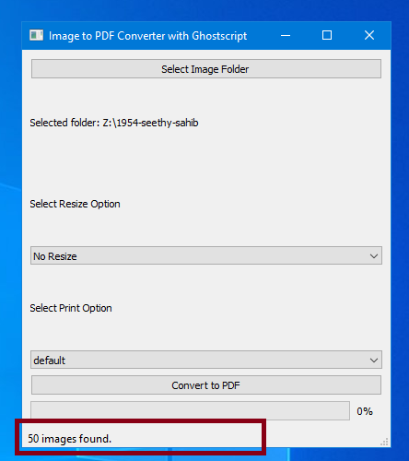
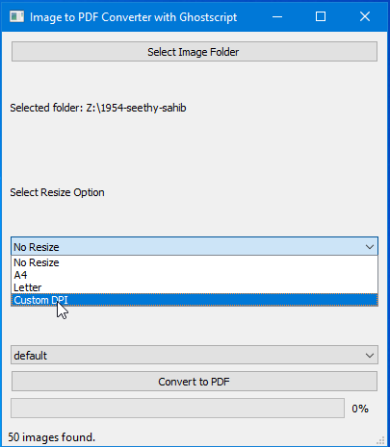
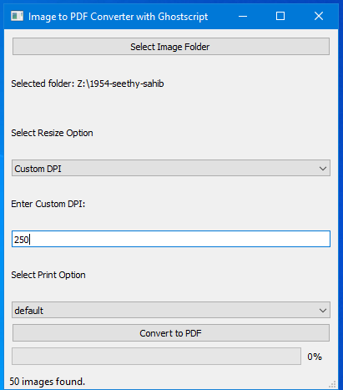
3. Select Custom DPI from Select Resize Option.
4. Enter required DPI (prefered DPI is 250).

5. Choose proper Print Option (Use default for usual cases). For higher quality, use prepress. For very low quality, use ebook.
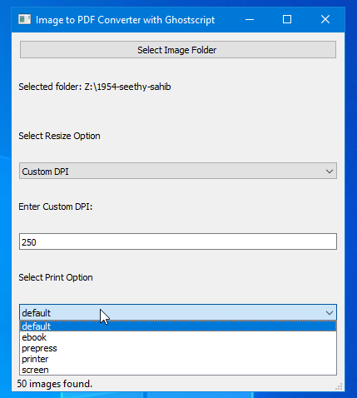
6. Now click Convert.
The progressbar will show 50% when img2pdf run successfully. It will show 100% when completed conversion and status bar will show successfully converted message with file path.
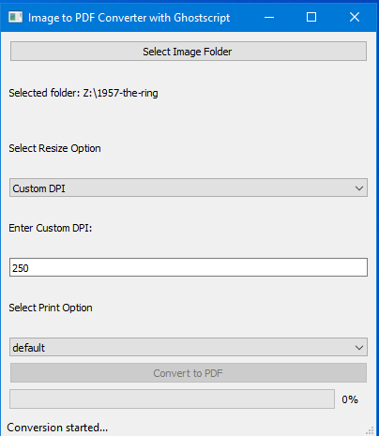
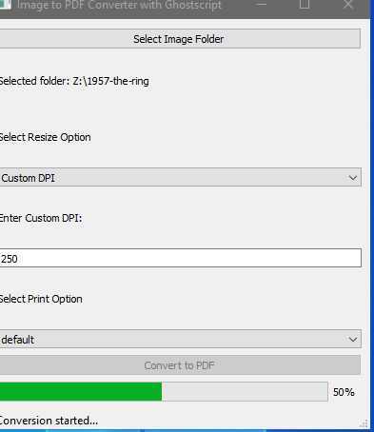
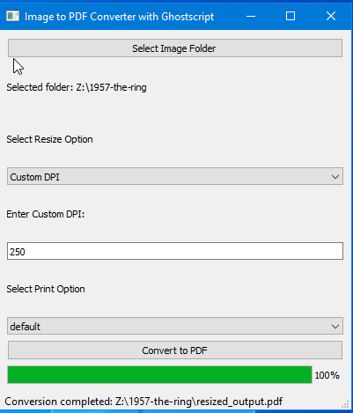

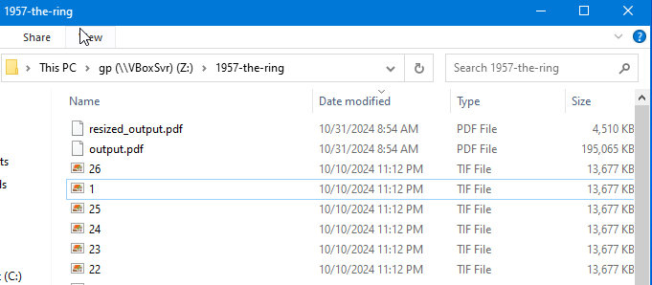
You can see two outputs in the TIFF folder – output.pdf, which is a combined pdf with large size and resized_output.pdf, which is resized to specified DPI.

Troubleshooting

Check Ghostscript installation

Open cmd (command prompt). Run gswin64c.
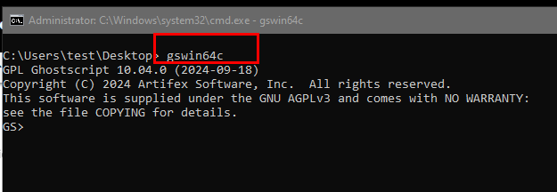
Output will show GS> along with version of Ghostscript.
If this command is not recognized, check ghostscipt installation path in C:\Program Files\gs\gs10.0.40.

If this folder is present and gswin64c is present inside bin folder in above path, add path to environmental variable.
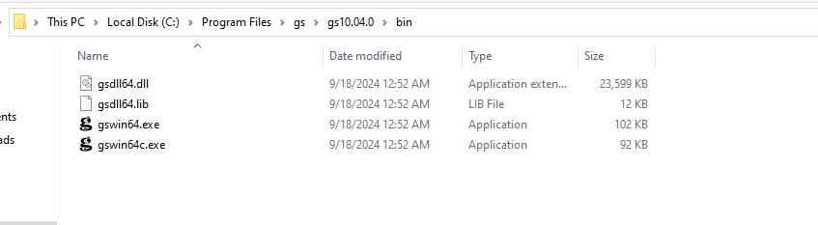
Steps:
Right click This PC. Open Properties. Window on right side will show up.
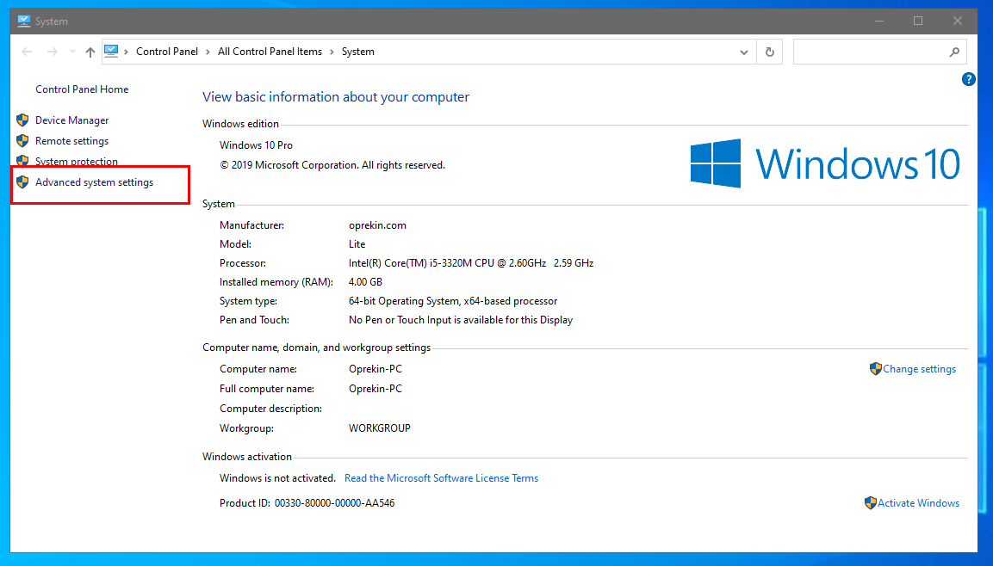
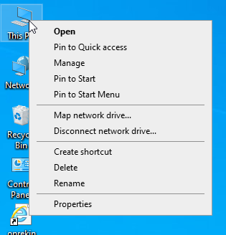

Alternatively, open this from Settings/Control Panel > System.
From there, open Advanced System Settings as shown in screenshot above.
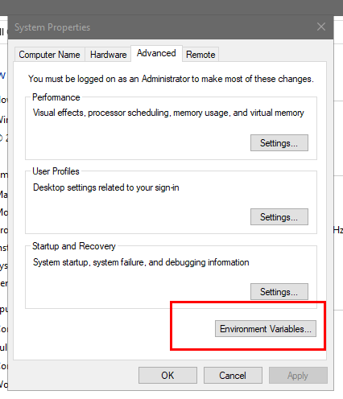

From Advanced Tab, choose Environment Variables. Now click on path and click Edit.
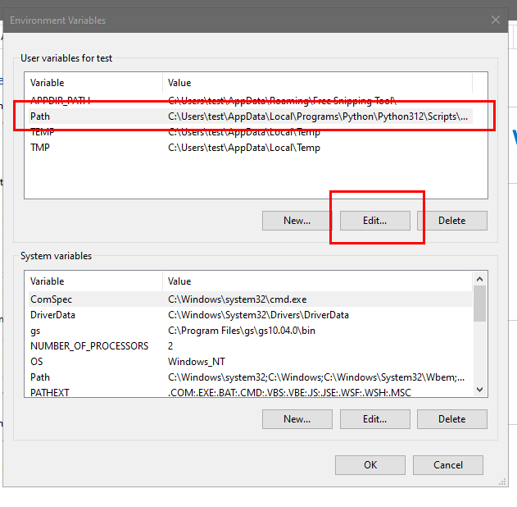
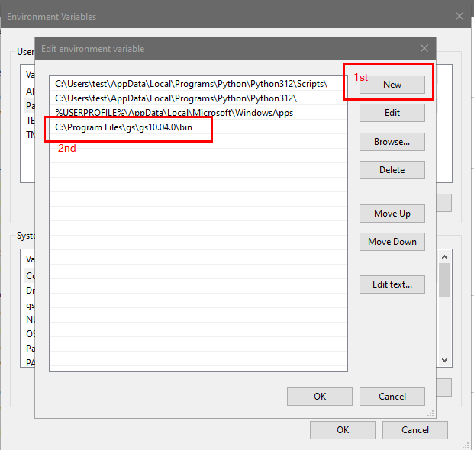
Now click New and add path to ghsotscript bin folder there (C:\Program Files\gs\gs10.0.40/bin) and click OK. The path will appear like below. Now check ghostscript installation again from command prompt again. It will show the version details.

