

Counselling &
Wellness Platform
___________________________

Development Proposal
Web Application + Android Application + Admin Dashboard

Prepared by
INDIC LABS
March 2026

1. Project Summary
We are building a complete counselling and wellness platform that Indic Labs will design, develop, and deploy. The platform consists of:

1. Web Application — A full-featured web platform accessible on any browser. It serves as BOTH the user-facing platform (assessments, counsellors, breathing exercises, theory sessions) AND the admin control panel (manage users, content, analytics). Users and admins access the same web app with role-based views.

2. Android Application — A premium mobile app published on the Google Play Store with all user-facing features. It connects to the same backend as the web app. Content managed by admins on the web dashboard is instantly reflected in the Android app.

One platform, two access points. Admin manages everything from the web dashboard. Users access the platform on both web and Android.

2. Complete Feature List

2.1 User Authentication & Onboarding
- User registration with email and password
- Secure login with JWT token-based authentication
- Forgot password flow with email reset link
- Profile setup after first login (name, phone, age, gender)
- Google social login (one-tap sign in)
- Android app: biometric login (fingerprint/face unlock)
- Android app: animated splash screen and 3-screen onboarding

2.2 User Home Dashboard
- Personalized greeting with time context (Good morning, Sarah)
- Daily mood check-in with emoji-based selector (5 moods)
- Quick action cards — Assessment, Counsellors, Theory, Breathing
- Bottom navigation bar (Home, Explore, Sessions, Profile)

2.3 Self-Assessment (Questionnaire System)
- Browse assessment categories (Anxiety, Depression, Stress, Self-esteem, etc.)
- Select difficulty level within each category (Basic, Intermediate, Advanced)
- Attempt questions one-by-one with progress bar and animated radio options
- Auto-scoring with category-wise breakdown
- Assessment history with date, score, and comparison to previous attempts
- Resume capability — pause and return to where you left off

Admin controls: Create categories, levels, questions (MCQ/Scale/Yes-No), and build questionnaires by selecting questions from the pool. Publish or unpublish assessments.

2.4 Counsellor Directory
- Browse counsellors with card-based listing (photo, name, specialization, experience, rating)
- Search by name and filter by specialization (Anxiety, CBT, Depression, etc.)
- Detailed profile page with qualifications, about section, expertise tags

Admin controls: Add, edit, delete counsellor profiles with photo upload and specialization tags.

2.5 Theory Sessions (Learning Content)
- Module-based learning content organized by topic
- Each session shows module count, estimated duration, and progress bar
- Track progress per session (Start / In Progress / Done)
- Rich text content with structured modules

Admin controls: Create theory sessions with multiple modules. Reorder, edit, publish/draft toggle. Track completion rates.

2.6 Breathing Exercises (New Feature)
Interactive guided breathing exercises with animated visual guides, similar to the Respire app. This is a wellness tool that helps users manage stress, anxiety, and relaxation.

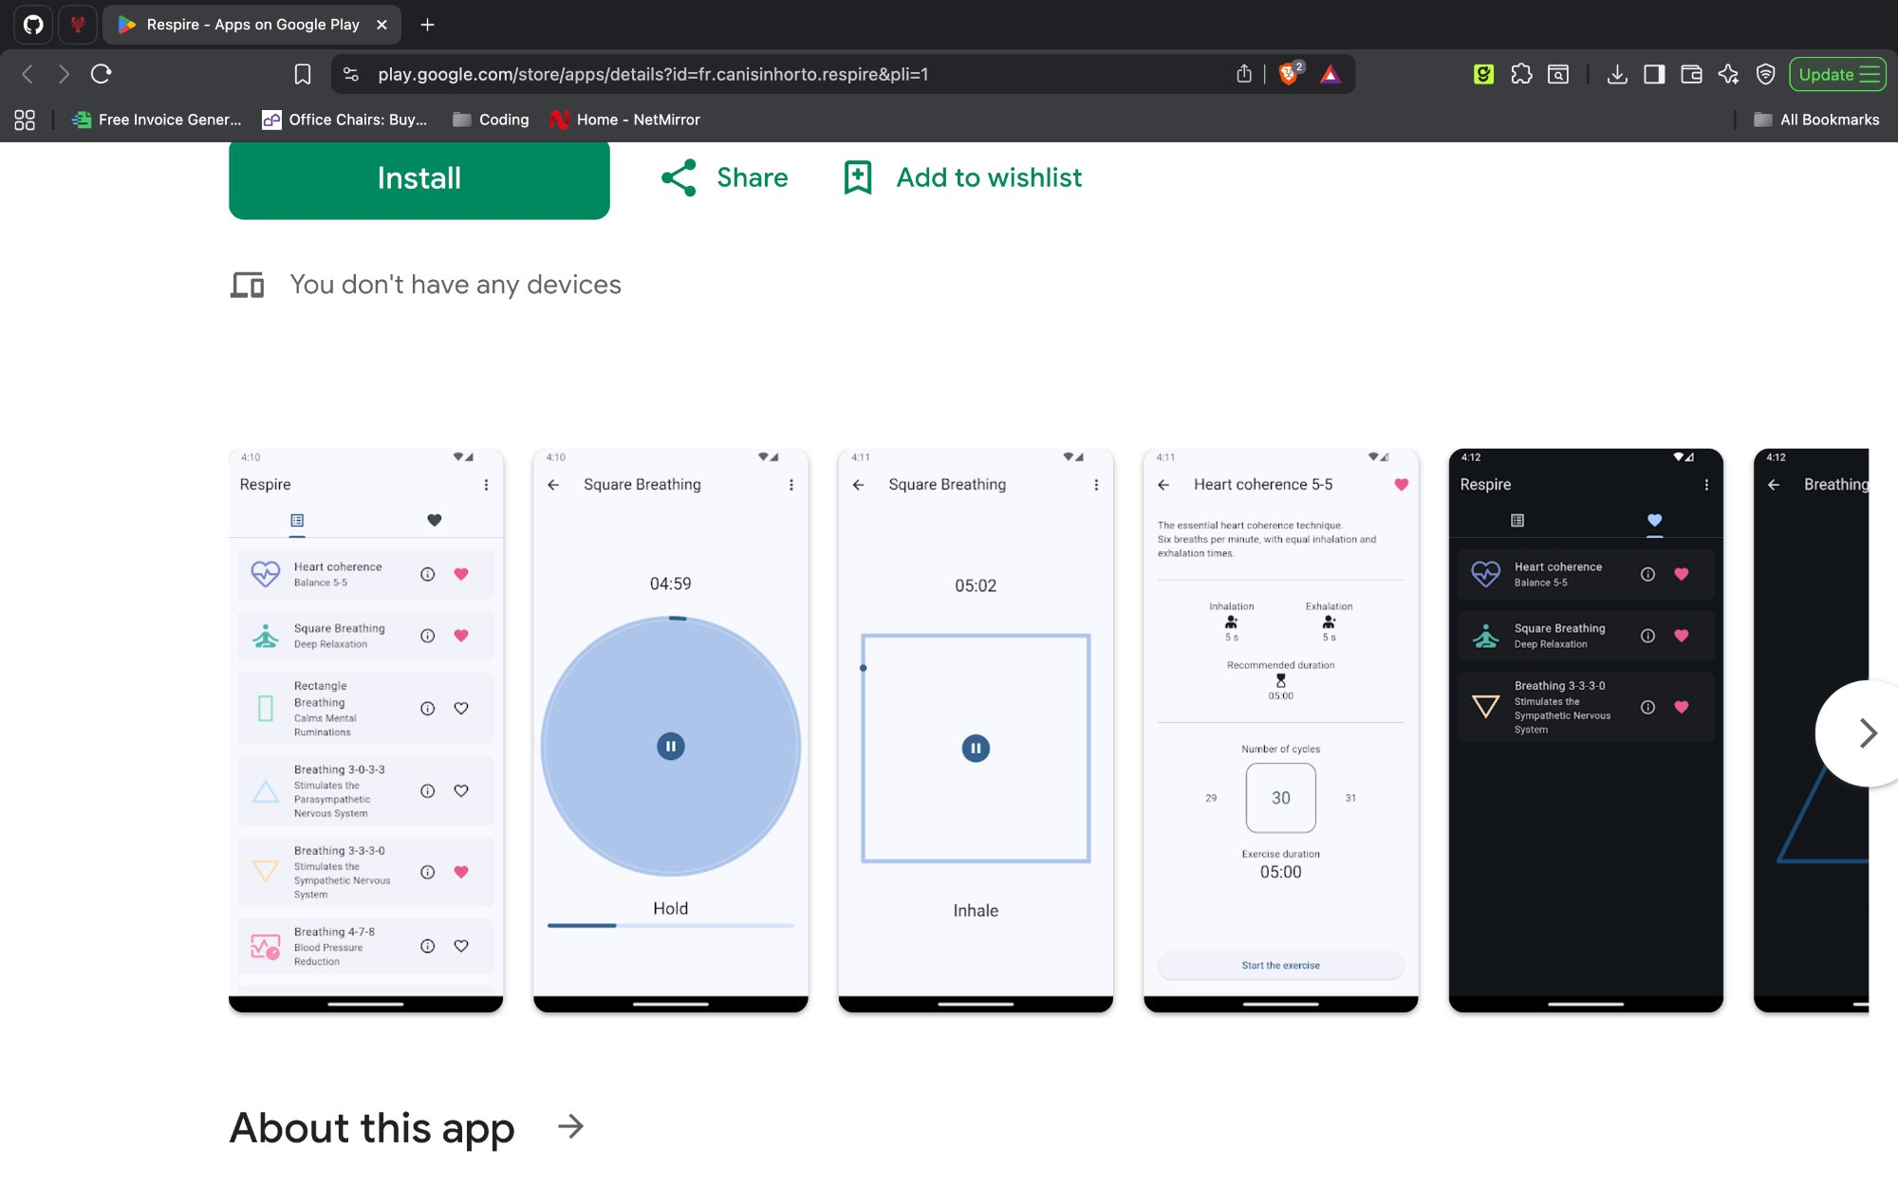
Reference: Breathing exercise app with animated visual guides

Exercises Included
- Heart Coherence (Balance 5-5) — 6 breaths per minute, equal inhale/exhale
- Square Breathing (Deep Relaxation) — inhale, hold, exhale, hold in a box pattern
- Rectangle Breathing — calms mental ruminations
- 4-7-8 Breathing — blood pressure reduction technique
- 3-0-3-3 Breathing — stimulates the parasympathetic nervous system
- Custom breathing patterns — admin can add new patterns with timings

Features per Exercise
- Animated visual guide (circular or square animation showing inhale/hold/exhale phases)
- Real-time timer with countdown display
- Phase indicator showing current state (Inhale, Hold, Exhale)
- Customizable duration and number of cycles
- Inhalation and exhalation time settings
- Haptic feedback on phase transitions (Android)
- Favourite/bookmark exercises for quick access

Admin controls: Create custom breathing patterns by setting inhale duration, hold duration, exhale duration, and hold duration. Set default cycles and recommended duration.

2.7 Analytics & Insights

User Analytics (Personal)
- Weekly wellness trend chart (bar visualization)
- Category-wise score breakdown (Anxiety, Stress, Self-esteem, Depression)
- Assessment count, average score, and improvement percentage

Admin Analytics (Dashboard)
- KPI cards: total users, active sessions, counsellor count, completion rate
- Registration trend chart (daily/weekly/monthly)
- Assessment distribution by category (donut chart)
- Counsellor load metrics
- CSV export for all analytics data with date range filter

2.8 User Profile & Settings
- Profile page with avatar, name, membership date, stats (assessments, sessions, streak)
- Edit profile (name, phone, avatar)
- Assessment history access
- Notification preferences
- Privacy and security settings
- Change password

2.9 Admin-Only Features
- User Management — search, filter, edit, activate/deactivate user accounts
- Bulk User Registration — upload CSV/Excel to register hundreds of users at once, with error reporting and upload history
- Questionnaire Builder — 4-step flow: Categories → Levels → Questions → Build & Publish
- Content Management — manage all theory sessions and breathing exercises from one dashboard
- Data Analytics — real-time charts, metrics, and CSV export
- Role-based access — admin and user roles with secure middleware

3. Delivery Timeline
Total delivery period: 3 months (12 weeks), delivered in 4 sprints with regular progress demos.

Sprint | Timeline | Deliverables
Sprint 1 | Week 1–3 | Project setup, database design, authentication system, admin and user layout shell, user management, counsellor management, bulk CSV registration
Sprint 2 | Week 4–6 | Questionnaire builder (category → level → questions → publish), theory session management, breathing exercises, analytics dashboard
Sprint 3 | Week 7–9 | User dashboard, mood tracking, user profile, user analytics. Web app feature-complete. Android app development (all user screens connected to same backend).
Sprint 4 | Week 10–12 | Quality assurance, bug fixes, performance optimization, Play Store submission, web deployment to client hosting, final handover.

Bi-weekly demo: At the end of every sprint, we will demonstrate the completed features to you for review and feedback before proceeding to the next sprint.

4. Investment

4.1 Development Cost

Description | Amount
Complete platform development (Web App + Android App + Admin Dashboard + all features listed above + breathing exercises + analytics + deployment) | ₹50,000
TOTAL DEVELOPMENT COST | ₹50,000 (Fifty Thousand Rupees Only)

This covers: UI/UX design, frontend development, backend API development, database design, all features listed in Section 2, testing, Play Store submission, and deployment to your hosting.

4.2 Payment Schedule (Part Payments)

Milestone | When | Amount | What You Get
Advance | On project start | ₹15,000 | Project setup, database, authentication, layout shell (Sprint 1 deliverables)
Mid-Payment | After Sprint 2 demo (Week 6) | ₹20,000 | Admin panel complete, questionnaire builder, theory, breathing exercises working on web
Final Payment | On project completion (Week 12) | ₹15,000 | Android app on Play Store, web app deployed on your hosting, complete handover

Each payment is made only AFTER you see and approve the deliverables for that milestone. No payment without working demo.

5. What You Need to Provide
The following are direct costs that you pay to the respective service providers. These are NOT included in our development fee and are paid directly by you.

Item | Estimated Cost | Pay To | When
Domain & Hosting (if new needed) | May not be required | Your existing website | We will check compatibility of your current hosting. If it supports Node.js, no new domain/hosting needed.
Hosting upgrade (if needed) | ₹500 – ₹700/month | Your current provider | Only if current hosting does not support Node.js
Google Play Store developer account | ₹2,100 (one-time) | Google | Before app submission (Week 10)
Apple App Store (if iOS needed later) | ₹8,200/year | Apple | Only if iOS is added in future
SSL Certificate | ₹0 (free) | Let's Encrypt | Automated, no action needed

Why You Pay These Directly
- If new hosting is needed, it is registered in YOUR name — you own it completely
- Play Store account is YOUR account — you have full control of your app listing
- These are recurring annual/monthly costs that you manage independently
- This ensures complete ownership and transparency — no vendor lock-in

Total out-of-pocket for you: ₹50,000 (development) + ~₹2,100 (Play Store) = ~₹52,100 to launch. Domain/hosting cost may be ₹0 if your existing setup is compatible.

6. What's Included in ₹50,000

- Premium UI/UX design (CRED/Flow-level dark and light mode)
- Complete web application with all user and admin features
- Android application with all user features
- Backend API development with secure authentication
- Database design and setup
- Questionnaire engine with category-level-question builder
- Breathing exercises module with animated visual guides
- Analytics dashboard with charts and CSV export
- Bulk user registration via CSV upload
- Play Store submission and deployment
- Web app deployment to your hosting provider
- 1 year post-launch support included (bug fixes, monitoring, security patches)
- Source code handover (you own the code)
- All necessary development plugins, libraries, and tools

6.1 What's NOT Included
- Hosting upgrade fees, if needed (we will check your current setup first)
- Play Store registration fee (₹2,100 one-time, paid by you)
- SMS OTP costs (if you choose SMS-based OTP instead of email)
- Content creation (you provide counsellor data, theory content, questions)
- Marketing and user acquisition
- Major feature additions after delivery (covered under maintenance contract if needed)

7. Post-Launch Support

1 YEAR OF FREE SUPPORT INCLUDED WITH THIS PROJECT.

12 months of complimentary support is included from the date of project completion. During this period, Indic Labs will provide the following at no additional cost:

- Bug fixes and issue resolution
- Server monitoring and uptime checks
- Security patches and updates
- Minor UI/UX adjustments based on user feedback
- Database maintenance and backup verification
- Play Store app update submissions (for bug fixes)
- Email/WhatsApp support with 24-hour response time

After 1 Year
After the complimentary support period, ongoing maintenance and feature development is available as a separate monthly contract:

Maintenance Plan | Monthly Fee | Includes
Basic | ₹10,000/month | Bug fixes, server monitoring, security patches, minor updates, 8-hour response time
Standard | ₹20,000/month | Everything in Basic + feature updates (up to 10 hours/month development time), 4-hour response time, weekly backup verification

Maintenance contracts are optional and can be started at any time after the 1-year free support period ends.

8. Quick Summary

Item | Details
Platform | Counselling & Wellness Platform
What You Get | Web App (user + admin) + Android App (user) + Backend API + Database
Features | Authentication, Assessments, Counsellors, Theory Sessions, Breathing Exercises, Analytics, Bulk Registration, User Management
Design | Premium dark + light mode, CRED/Flow-level aesthetic
Timeline | 3 months (12 weeks) with regular demos
Development Cost | ₹50,000 (paid in 3 installments)
Your Direct Costs | ~₹2,100 (Play Store — paid by you directly). Hosting may be ₹0 if existing setup works.
Post-Launch | 1 year free support included (bug fixes, monitoring, security patches)
Code Ownership | Full source code handover — you own everything
Scalability | Built to handle 10,000+ users from day one

Acceptance
Please confirm your acceptance of this proposal by signing below or responding to this document via email.

For Indic Labs:


Yash Rawal
CEO, Indic Labs
Date: March 13, 2026

For Client:

Name: ___________________________________

Signature: ______________________________

Date: ___________________________________

___________________________


Yash Rawal
CEO, Indic Labs
Sector 4, Hiran Magri, Udaipur, Rajasthan – 313002
March 13, 2026

