MindCare
B2B2C Counselling & Wellness Platform

Revised Platform Plan
Version 2.0 | March 2026

Client: Indic Labs
Prototype Deadline: 1st Week of April 2026
Platforms: Web App + Android App

Table of Contents

Executive Summary
MindCare is transitioning from a B2C to a B2B2C model, partnering with schools and corporates to provide counselling and wellness services. Organizations receive unique codes for their members, who get free credits for consultations. This document outlines the complete platform architecture, user flows, and implementation timeline.

Platform Mind Map
The following mind map provides a visual overview of the MindCare platform architecture, showing the relationships between key components:
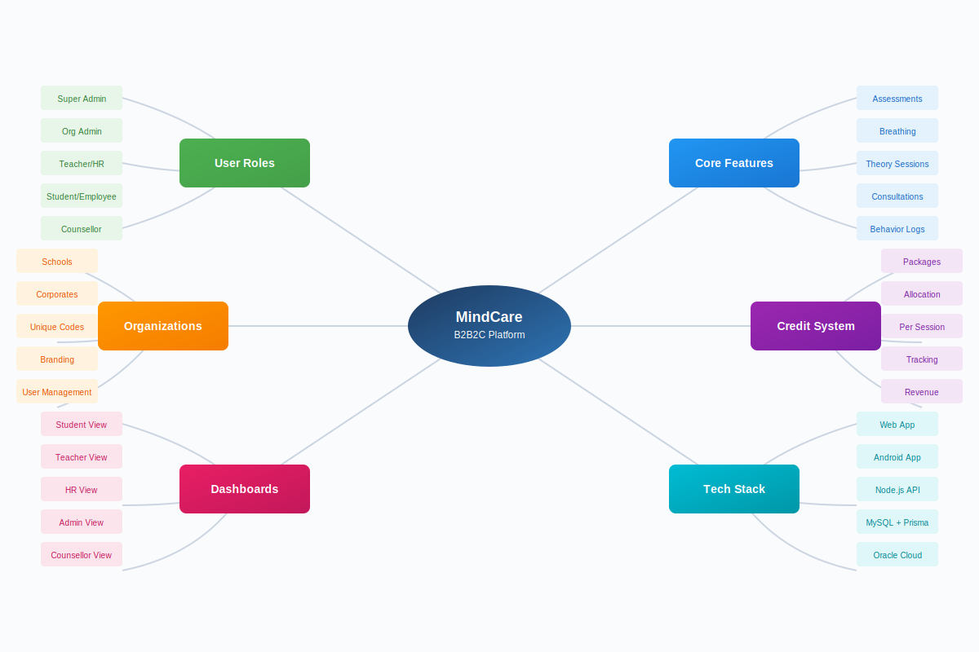

Business Model Evolution

Previous Model (v1) — B2C
- Individual users sign up directly
- Take self-assessments
- Browse and connect with counsellors

New Model (v2) — B2B2C
- MindCare partners with Schools & Corporates
- Each organization gets a unique code (e.g., DELHI-PUBLIC-2026)
- Students/Employees join using their organization code
- Members receive FREE credits for consultations
- Teachers log student behavior & flag counseling needs
- HR monitors employee wellness trends

User Roles
The platform supports seven distinct user roles, each with specific permissions and responsibilities:
Role | Who | Responsibilities
Super Admin | MindCare Team | Manage everything — organizations, counsellors, billing, platform
Org Admin | Principal / HR Head | Manage their org — invite users, view reports, assign assessments
Teacher | School Teacher | Log student behavior, flag students for counseling, view class wellness
HR Manager | Corporate HR | View employee wellness trends, assign assessments, manage credits
Student | School Student | Take assessments, breathing exercises, book counseling (free credits)
Employee | Corporate Employee | Same as student but in corporate context
Counsellor | In-house or External | Manage availability, conduct sessions, write notes

Platform Architecture
The MindCare platform consists of three client applications sharing a unified backend:

Client Applications
- Web App — For Students, Employees, Teachers, and Counsellors
- Android App — For Students and Employees (mobile-first experience)
- Admin Dashboard — For Super Admins and Org Admins

Backend Stack
- REST API built with Node.js and Express
- MySQL database with Prisma ORM
- JWT-based authentication
- Hosted on Oracle Cloud (free tier)

Application Flows

Onboarding Flow
- User opens app
- Enter Organization Code (e.g., DELHI-PUBLIC-2026)
- App validates code and displays organization name + logo
- Login (existing users) or Register (new users)
- Redirect to role-based dashboard

Student / Employee Flow
Dashboard Features:
- Mood Check-in — Daily emoji-based mood tracking
- Self Assessments — Assigned (mandatory) and free (optional)
- Breathing Exercises — Animated guided sessions
- Theory Sessions — Educational modules with progress tracking
- Book Consultation — Browse counsellors, pick slots, book with credits
- Credits Balance — "5 free sessions remaining"

Teacher Flow
Dashboard Features:
- My Classes — View assigned classes and sections
- Student Directory — All students in assigned classes
- Behavior Log — Log entries with date, category, notes, severity
  - Categories: Academic, Social, Emotional, Behavioral
  - Severity: Low, Moderate, High, Critical
- Flag for Counseling — Triggers notification to counsellor and admin
- Class Wellness Overview — Mood scores, assessment completion, flagged students

HR Manager Flow
- Employee Wellness Overview — Department-wise scores and trends
- Assign Assessments — Select department, choose assessment, set deadline
- Credit Management — View allocation, usage, and request more
- Reports — Downloadable CSV/PDF exports

Counsellor Flow
- Today's Schedule — View upcoming sessions
- My Clients — View history, assessments, behavior logs
- Availability Management — Set weekly schedule, block dates, session duration
- Flagged Students — Review behavior logs, schedule consultations
- Session Notes — Private notes per session, summary visible with consent

Credit System

Credit Packages
Package | Sessions | Price
Starter | 50 sessions | ₹25,000
Growth | 200 sessions | ₹80,000
Enterprise | 500 sessions | ₹1,50,000

Credit Distribution Models
- Equal Distribution — 5 credits per student/employee
- Custom Allocation — HR/Admin allocates individually
- Shared Pool — Organization pool, first-come first-served

Booking Flow
- User initiates booking
- System checks: Does user have credits OR does org pool have credits?
- If YES: Book session, deduct 1 credit
- If NO: Display "No credits available. Contact your admin."

Database Schema

New Models

Organization
- id, name, type (SCHOOL/CORPORATE), code (unique)
- logo, address, contactEmail, contactPhone
- creditBalance, status, createdAt

OrganizationMember
- id, userId, organizationId
- role (STUDENT/EMPLOYEE/TEACHER/HR/ORG_ADMIN)
- class/department, creditBalance, joinedAt

Consultation
- id, userId, counsellorId, organizationId
- slotDate, slotTime, duration, type (IN_PERSON/VIDEO)
- status (BOOKED/COMPLETED/CANCELLED/NO_SHOW)
- creditUsed, notes (private), summary (shareable)

BehaviorLog
- id, studentId, teacherId, organizationId
- date, category (ACADEMIC/SOCIAL/EMOTIONAL/BEHAVIORAL)
- severity (LOW/MODERATE/HIGH/CRITICAL)
- notes, flagForCounseling, counselingStatus

Implementation Timeline
10-day sprint from March 23 to April 1, 2026
Day | Tasks
Day 1 | Foundation — Organization model, org code validation, update auth flow
Day 2 | Roles & Members — OrganizationMember model, role-based middleware, user management
Day 3 | Credits & Availability — Credit system, ConsultationSlot model, counsellor schedule
Day 4 | Consultation Booking — Booking API, consultation management, user booking page
Day 5 | Teacher Features — BehaviorLog model, teacher dashboard, flag for counseling flow
Day 6 | Assignments — Assignment model, admin assignment UI, student view
Day 7 | Analytics & Reports — Org-level analytics, wellness charts, CSV export
Day 8 | Integration & Polish — End-to-end flow, navigation, error handling
Day 9 | Testing & Fixes — E2E testing, bug fixes, demo data seeding
Day 10 | Prototype Ready — Final testing, deploy to Oracle Cloud, share with client

Reuse Scorecard
Approximately 75% of existing code is directly reusable for the new B2B2C model:
Component | Reuse % | Changes
Express API + Prisma + JWT auth | 100% | Add org middleware
Breathing exercises (animated) | 100% | Zero changes
Theory sessions + progress | 95% | Add assignment link
Assessment quiz flow | 90% | Add assignment flag
Counsellor list + detail | 80% | Add availability + booking
User management | 80% | Scope to org
Admin dashboard | 70% | Org-scoped + role-based
Android app (6 screens) | 70% | Add org code + booking
Dark/light mode + design system | 100% | Zero changes
Rate limiting + security | 100% | Zero changes

Phase 2 Features (Post-Prototype)
The following features are planned for Phase 2, after prototype validation:
Feature | Reason for Deferral
Video call integration (Zoom/Meet) | Complex integration; use join link for now
Payment gateway | Manual billing sufficient for prototype
iOS app | Android first for market validation
Push notifications | Requires Play Store submission
Counsellor rating/review | Needs real session data
Multi-language support | English first for prototype
Custom branding per org | After MVP validation
Detailed treatment plans | Pending counsellor feedback

Risk Assessment
Risk | Impact | Mitigation
10 days is tight for all features | High | Prioritize booking + org code for demo
Counsellor availability is complex | Medium | Start with simple time slots, no recurring
Credit system edge cases | Medium | Keep it simple — 1 credit = 1 session
Role-based access (7 roles) | Medium | Start with 4 core roles for prototype
Android changes needed | Low | Update login flow + add booking screen only

Summary
Old app: Individual users → assessments + breathing
New app: Organizations → students/employees → full wellness platform
Reuse: ~75% of existing code
Timeline: 10 days to working prototype
Cost: ₹0/month hosting (Oracle free tier) + ₹2,100 Play Store

