1. Copy the Oracle folder to C:\Windows\Program Files
   1. (Not the “program files (x86)” folder)
2. Run Regedit and copy the user ID (the one highlighted below)
   1. 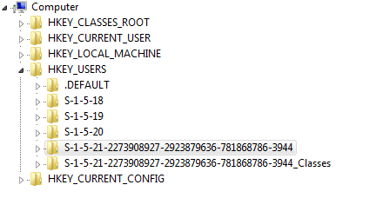
3. Open the Reg Folder and edit the two files that have HKEY_USERS in the title with Notepad.
4. Edit -> Replace
   1. Copy the current user key in the file and replace with the Win7 user id
      1. (Ignore that they are the same below, it’s just so you can picture the replacing of the text)
   2. 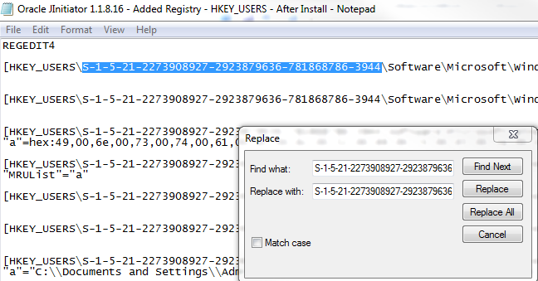
5. Run all the registry entries I created. You’ll get an error on one of them, but just ignore it. It should be on the HKEY_Local_Machine one, just make sure you don’t get an error anywhere else.