Ecosteader & Company

Ecological Democracy Begins Locally
An Ecosteader is one who recognizes that humans are but one user of shared soil. Shared caretaking of soil and watershed areas surrounding either urban rural environments improves the overall ecosystem. All the creatures that are not humans -- from birds to fish to flora to fauna -- benefit from cleaner waters and soils. This philosophy is also known as Community Ecology. Being an Ecosteader involves systems-level thinking. With the advent of AI and technology, we know that smart systems require networking, and in order to best take a systems-level approach, people need to network. But wait! We're not talking about "networking" the traditional greed-driven ways that have driven rapacious men to try to make easy money on American real estate "development". Please read on...

We are anti-Realtors, anti-landlords, and against corrupt politicians.
Instead, we promote practical, simple, and earth-friendly stewardship of lands, including nature preservation areas, habitat restoration areas, and America's public lands. We're supportive of efforts in county-level infrastructure, where laws and shared community vision and goals can be articulated and implemented by the residents themselves through democratic processes. We are also staunchly anti-HOA; HOAs divert what should be publicly-accountable taxpayer dollars into privately-managed coffers with no accountability, forcing residents to be governed under rules and bylaws that promote gerrymandering and exclusionary zoning that is harmful to ecosystems (golf courses and country “border walls” are harmful walls). They also destroy community spirit. Ecosteader & Company is a registered B Corp for "Public Benefit". We have a non-profit mission: to raise awareness of the ecological and economical benefits of ecosteading. Please read our Terms of Service for more detail:
https://www.ecosteader.com/terms

Useful tips for success
- “Just say NO to GOLF COURSES, BORDER WALLS, and HOAs”
- “No dollar of rent shall be collected on any Ecostead; neither are hoteliers permitted one penny of untaxable income. The rent / lease models are not compatible with sustainable communities and are individuals collecting rents, lease payments, and fees such as for HOAs are punished immediately.”
- Failure to pay taxes on any improper setup results in imprisonment.
- “Advertising is prohibited; promotional sales, gimmicks, and scams result in banishment. ”
- “REQUIRED is the acknowledgement of outstanding treaty rights above and beyond colonial

Ecosteader & Company supports these nonprofit organizations:

- Native American Rights Fund (NARF.org) “As the oldest and largest nonprofit National Indian Rights organization in the country, NARF stands firm to end the suffering for all those who are unable to fight alone.”
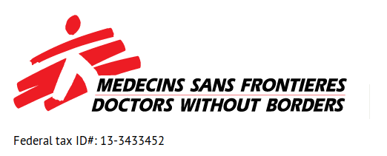
“Five priority areas: (1) Accountability of governments to Native Americans; (2) Preservation of tribal existence; (3) Protection of tribal natural resources; (4) Promotion of Native American human rights; (5) Development of Indian law and educating the public about rights, laws, and issues.”

2. Doctors Without Borders (Mèdecins Sans Frontieres)
3. The Nature Conservancy

4.

5.

