Notes on Decolonization

Ecosteader & Company
ecosteader.com

Winter Solstice 2019

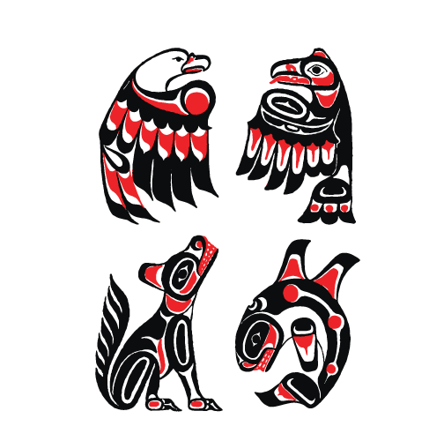Figure ㉠: Kitasoo / Xai’xais
“The First Nations community of Klemtu in the heart of the Great Bear Rainforest.” https://klemtu.com/

For more info on the artwork sources, adaptations, and the use of symbols among various First Nations, see: https://ecosteader.com/@indie/103062621450279926

“American colonial ideas of self-government came as much from the colonists’ observations of tribal governments as from their Protestant or Greco-Roman heritage. Neither Greece nor Rome had the kind of pluralistic democracy as that concept had been understood in the United States since Andrew Jackson, but the tribes, particularly the gynarchical tribal confederacies, did. It is true that the oligarchic form of government that colonial Americans established was originally based on Greco-Roman systems in a number of ways, such as its restriction of citizenship to propertied white males over twenty-one years of age, but it was never a form that Americans as a whole have been entirely comfortable with. Politics and government in the United States during the Federalist period also reflected the English common law system as it had evolved under patriarchal feudalism and monarchy – hence the United States’ retention of slavery and restriction of citizenship to propertied white males.”

~ Paula Gunn Allen
“Pushing Up the Sky”. The Sacred Hoop
1986

So it’s 2019 and this is still, sadly, our greatest threat.

Australia’s under threat
Colonialism bad
White supremacists worse
Universe’s extreme last call “backup emergency plan” to save baby Yodas

Koalas
Unique marsupial species
Native Eucalyptus
Smart teams of birds
etc

And its governor goes and tries to hide in Hawai’i?
The US has an impeached coward trying to run the show.

Land Acknowledgements

Resources include languages and people:

https://native-land.ca

https://friendsoftheinyo.org/landacknowledgement

Decolonize

America. It's the place European colonists came and stole land from the natives, claiming they just wanted a better life for their children. Ignorant, idiotic farmers killed the native buffalo -- which were far too big and powerful for the white man -- to let cattle ranchers trample for hamberders terrorize the lands. Ignorant, idiotic colonists ripped up vibrant and precious ecosystems that were already abundant with food to build nasty hotels, HOAs, golf courses, strip malls and roads. Those Europeans grew fat and lazy while the working homeless people who served them piled up on the streets, unable to sleep peacefully. Still yet, the delusional landlords and PMCs keep demanding increasingly expensive leases and rents and fees and real estate commissions as if it were their "right".

As if they’re going to be able to buy their way out of 6+++++++++++++++++++++++++++++++++++++++++++++++++++++++++++++++++++++++++++++++++++++++++++++++++++++++++++++++++++++++++++++++++++++++++loppppppp; (s) of crimes
!

(apparently the cat knows something about that. anyway)

Colonists obviously didn’t plan that far ahead. They never were good at predicting.

Because of course, those colonists forgot where they came from.
And they failed to learn the intricate details of history,
doomed to repeat mistakes of past.

Is modern-day America really stupid enough to recreate messes that were supposed to be cleaned up in the 70’s?

No, your colonial ideas don’t work here ... the evidence is indisputable.

These lands are not “belong to”, Republikkkans.
their deals do not mean anything
they have no conquests
they never won.

Sovereignty

Acknowledge it.

Inherent to the particle.

Intricate Details

Are usually not possible
in the vicinity of destruction.

Sinkholes happen.

Endnotes // include this astoundingly obvious advice:

DO NOT BASE ANYTHING ON A FAILED SYSTEM.

FAILED SYSTEMS INCLUDE OLIGARCHIES; EXCLUDE PATRIARCHAL OLIGARCHIES.

FAILED SYSTEMS INCLUDE EUROPEAN MONARCHIES; EXCLUDE EUROPEAN MONARCHIES.

* ~ * ~ *

EXCLUDE ALL REALTORS, BROKERS, HOTELIERS, LANDLORDS, PROPERTY MANAGEMENT COMPANIES, LLCS, AND OTHER TRAVESTIES RESULTANT FROM COLONIAL IDEAS ABOUT “HOW TO MAKE MONEY EXPLOITING LAND”

IF YOU WORK FOR THEM, EVEN AS A “SECRETARY”, YOU’RE JUST A COMPLICIT ENABLER.
GET HELP.
THERE ARE NO EXCUSES.

...

