Kuwaiba Open Network Inventory
Version 0.3 [08.11.2011]
Administrator Manual

Please visit http://kuwaiba.sourceforge.net for documentation, latest updates and upcoming events

Change History
Responsible | Description | Date | Reviewed by
Charles Bedón  charles.bedon@zoho.com | First version. It uses the number 0.3 just to keep compatibility with the version number used for the user manual | January 19th 2011
Charles Bedón  charles.bedon@kuwaiba.org | Corrections regarding to the changes made in the version 0.3 beta 2 | March 17th 2011
Charles Bedón  charles.bedon@kuwaiba.org | Added details related to the database setup. Added a troubleshooting section | November 8th 2011

Table of Contents
Change History 2
License 4
Disclaimer 4
Important 4
Chapter 1. System Architecture: The Easy Way 5
Chapter 2. Server Installation 7
Requirements 7
Step by step guide 7
Chapter 3. Client Installation 13
Requirements 13
Step by step guide 13
Chapter 4. Administrative tasks 14
Chapter 5. Troubleshooting 15
Resources 16

License
This document is published under the terms of a license Creative Commons by-nc-sa. You can find details about it at
http://creativecommons.org/licenses/by-nc-sa/2.0/
 | Kuwaiba Server and Client are licensed under EPL v1. You can find the whole text of this license at  http://www.eclipse.org/legal/epl-v10.html

Disclaimer
- Netbeans and Java are registered trademarks of Oracle and/or its affiliates. Other names may be trademarks of their respective owners. The Kuwaiba project is not endorsed in any way to any of them.

- This document is provided “as is”, with no warranty at all. Install the software and follow the instructions included at your own risk.

- Kuwaiba uses third-party components licensed under compatible licenses (LGPL, BSD-like). You can find a complete list at the project's web page.

Important
This is a preliminary version of this document covering the features included in the version 0.3 beta 2, If you're using a version in the 0.2.x branch, please download the AdministratorManual_021.pdf available at: https://sourceforge.net/projects/kuwaiba/files/Docs/

Most of the pictures in the present manual have the original resolution. If you can't see them correctly, please zoom in and they'll be shown clearly.

Chapter 1. System Architecture: The Easy Way
Kuwaiba is a plain client/server application. It currently uses Java in both ends but that's not actually mandatory. You can write your own server in Python and the client using the Microsoft's Compact Framework. That's possible because at the very beginning of the project we took the design decision of deploying webservices as a way to ensure the interoperability between components. It was also our intention to provide a database and application server agnostic environment, so the server side components are highly decoupled. A summarized (See a detailed, developer friendly architecture on the project's blog [1])
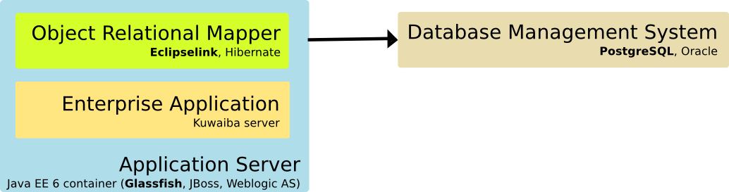Figure 1. Simplified server architecture
These are the main components at server side. There is a Java EE 6-compliant and EJB Container application server (Tomcat won't work, for example, we have not tested in JBoss). Currently we're using Glassfish 3.0.1 (GlassFish v3.1 compatibility has only been tested as of version 0.3 beta2). The Kuwaiba server is deployed on it using the .ear file included in the release bundle. The application uses an ORM as the abstraction layer to access the database. The one used so far is Eclipselink. Finally, the database management system. PostgreSQL has proven fast and reliable RDBMS, and that's why it's been chosen as backend here, but theoretically you can be use any other supported by Eclipselink.
Since it goes beyond the scope of the present document, we won't dig deeper into the detailed system architecture (it's more a developers issue) but the deployment one. This is, what elements compose an ideal setup and how they're all related:
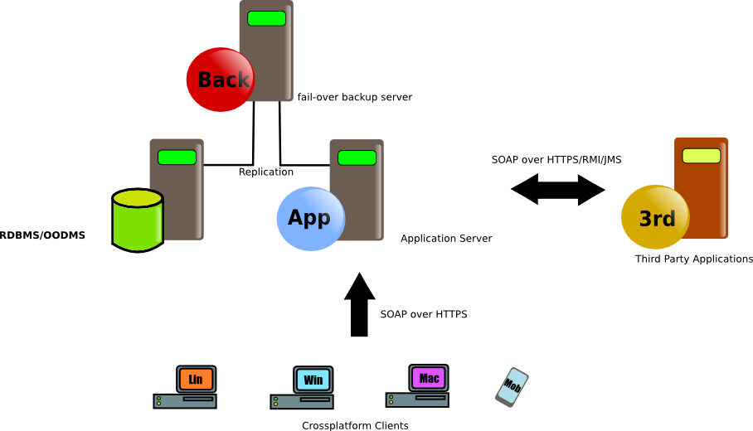Figure 2. Ideal deployment architecture
This is a pretty common approach so there's not too much to explain but the fact that the server publishes its capabilities by exposing a valid WSDL [2] to be consumed by the clients. Third party applications (such as ERPs, Alarm Management Systems and Network/Element Management Systems) could be integrated using a wide variety of methods. These interfaces are not implemented yet, though.
Given the application maturity level (version 0.3), there's no need for such a complicated setup, and you can host everything in the same computer. The pieces in this puzzle will be placed as soon as the planned features are implemented, and this manual will be updated accordingly.

Chapter 2. Server Installation
The application can be installed in Microsoft WindowsTM or Unix-like OS. The instructions are basically the same, and we will point out the differences when necessary.

Requirements
- PostgreSQL 8+ installed. You can find detailed instructions here[3]. To simplify the process, just download the tar.gz distribution and extract it in your preferred location.
- An application server. The instructions presented in this document apply to Glassfish v3.0.1 or v3.1 (the latter only if you're using a server version 0.3beta2 or above). You can find details here[4]. To simplify the process, just download the .zip distribution and extract it in your preferred location
- JDK 1.6

Step by step guide
- Download the latest stable server bundle. It's a .tar.gz file of ~1MB.
- Create the database cluster (this is, the physical place where PostgreSQL will put the db files). Open a command prompt/console and write:
mkdir mydata //creates the data directory
$POSTGRES_DIR/bin/initdb mydata //initialize the cluster

- Start the PostgreSQL server pointing to the cluster we just created
$POSTGRES_DIR/bin/pg_ctl -D mydata --silent start

- Create a role in PostgreSQL called kuwaibadbuser (actually, you can use any username you want). Choose a password (we will configure the access to the database in the application server, so take note about what password you used).
PSQL_PROMPT# CREATE ROLE kuwaibadbuser WITH LOGIN ENCRYPTED PASSWORD 'kuwaiba';
- Create the a database called kuwaibadb, having as owner kuwaibadbuser. This can be done using a graphical client such us PGAdmin, but to keep the line, we will use the utility “psql”, which is a command line client for PostgreSQL:
$POSTGRES_DIR/bin/psql -d postgres //log in to the default db
PSQL_PROMPT# CREATE DATABASE kuwaibadb WITH OWNER kuwaibadbuser;
PSQL_PROMPT# \q //log out

- Restore any backup file that comes into the server bundle. As of version 0.1.1, the server installer comes with three different databases: kuwaibadb_empty.backup: a db with the class metadata, but no objects created or containment hierarchy defined (you can use the Class and Attribute Customizer), kuwaibadb_container_hierarchy.backup, which is a db with a basic containment hierarchy defined and kuwaibadb_test_data.backup is the same as the previous one but with demo data inside. If you want to define your containment hierarchy from scratch use the first one or you can use the basic ready-to-use second one. For sure, you will have to create your own containment “entries”.
$POSTGRES_DIR/bin/pg_restore --host <host> --port 5432 --username <user> --dbname kuwaibadb --clean --verbose "<path_to_backup_file>"

- The database is now configured. Now install the JDK, this is just next → next → next.
- Open again a command prompt/console and start the application server (Glassfish). Note: Depending on your OS you may need to set the JAVA_HOME environment variable before to run the following command to point to the JDK installation directory.

$GLASSFISH_DIR/bin/asadmin start-domain domain1

If the domain doesn't exist, create one.

$GLASSFISH_DIR/bin/asadmin create-domain domain1
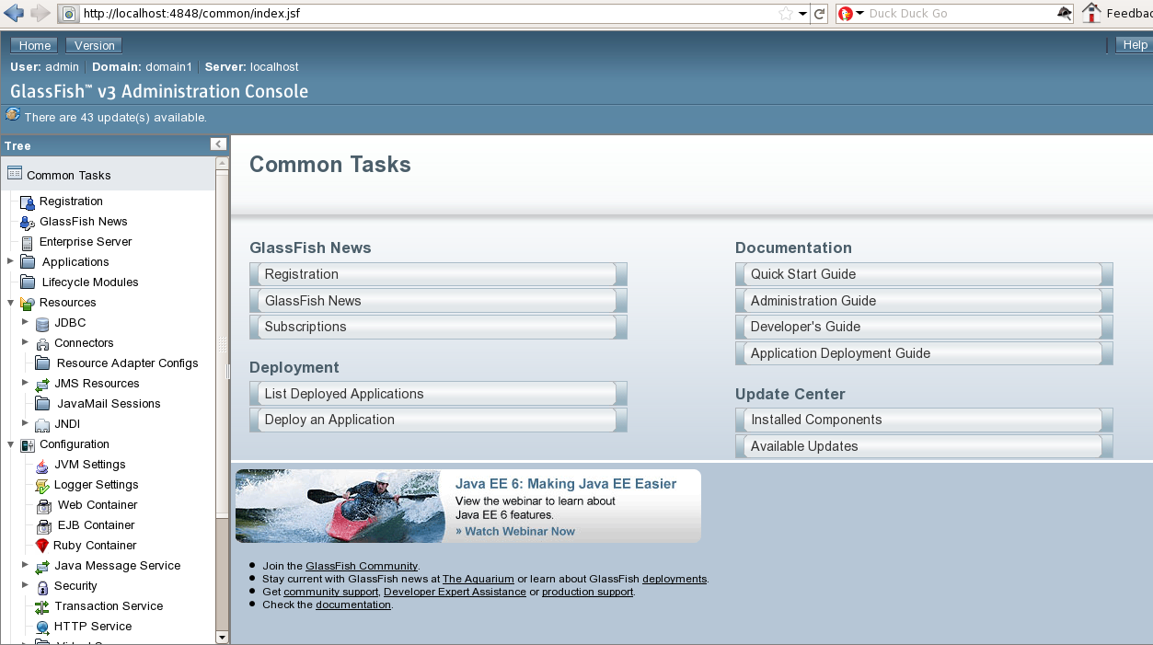Figure 3. Glassfish web management console
- Once the server is up and running, it will provide a web management interface listening at port 4848.
- Kuwaiba uses “Container Managed Persistence”, which means, among other things, that the application server is the responsible to access the database and handle the system transactions. As such, the database connection information is configured within it. In the section Resources → JDBC → Connection Pools create a new pool.

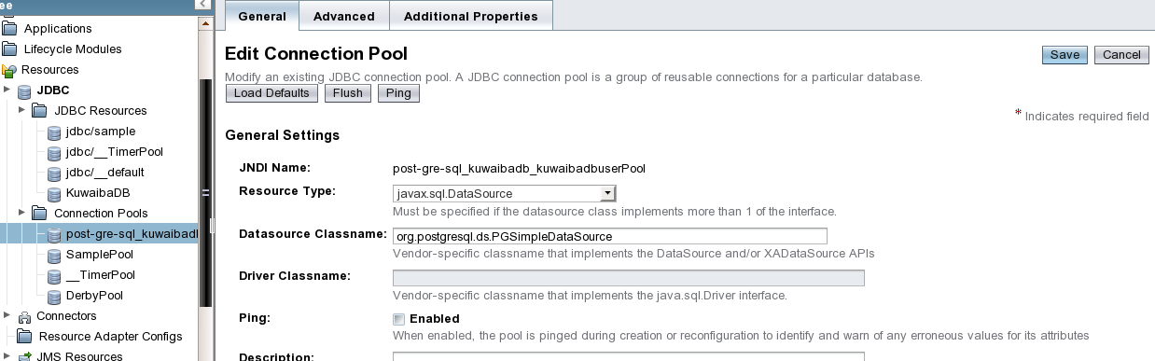Figure 4. First step creating a Connection Pool
These values should be enough (You can use any JNDI name):
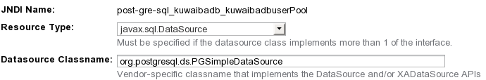Figure 5: Values to create a connection pool
Note that these values are PostgreSQL-specific, if you are going to use other RDBMS, see your vendor documentation for the right values.

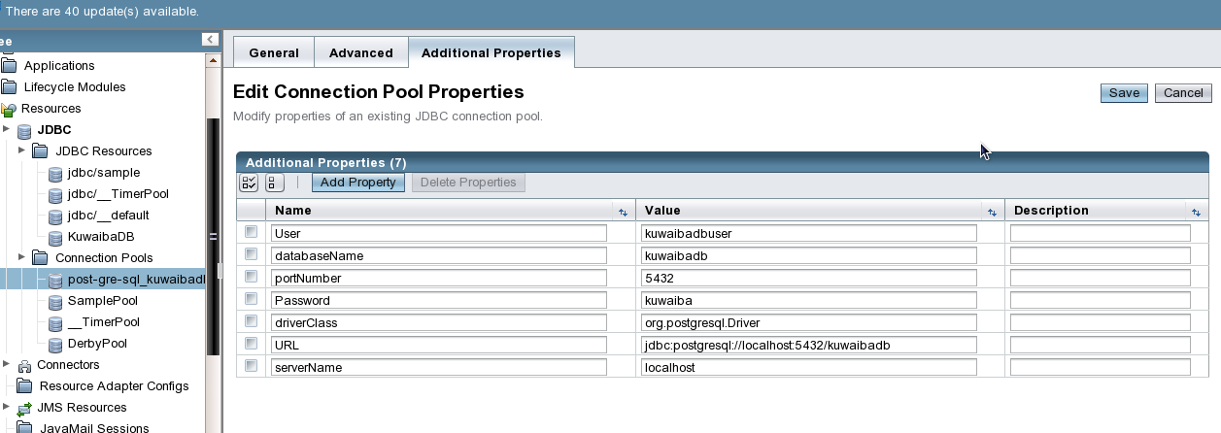Figure 6. Additional properties
The second form has the important stuff related to user credentials and server location:
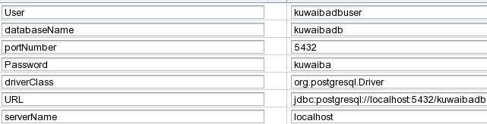Figure 7: Additional properties detailed
Set the values according to your own settings

- In Resources → JDBC → JDBC Resources, create a new one:

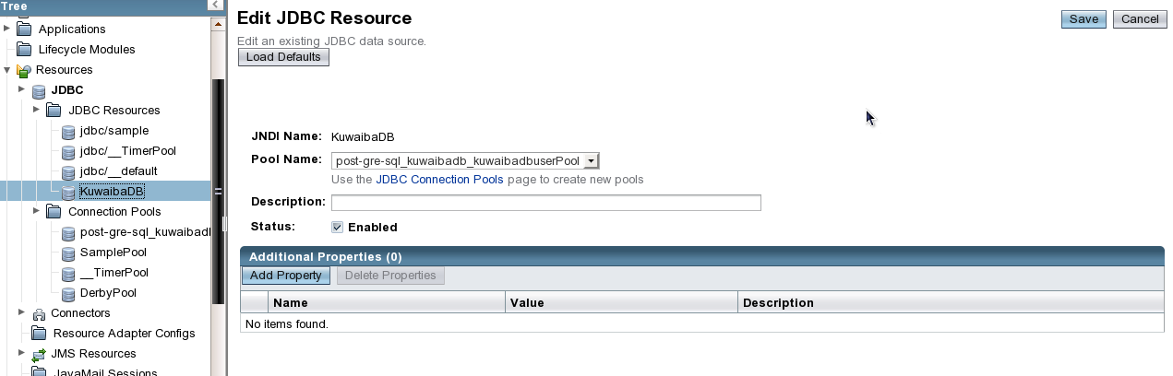Figure 8: Creating a new JDBC Resource
These values are enough:
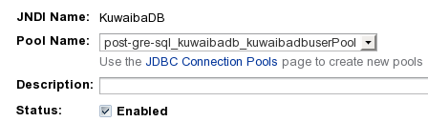Figure 9: Creating a new JDBC Resource detailed
In “Pool Name” choose the pool you just created. The JNDI name must be KuwaibaDB, since it's the name configured by default in the server deployment package.

- Now we are ready to deploy the enterprise application. Take the .ear file you will find in the server bundle and upload/publish it using the section Applications → Deploy

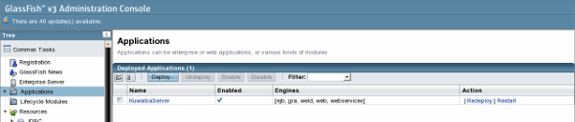Figure 10: Deploying the application
- Test if the application was actually deployed by opening the URL http://<your_server>:8080/kuwaiba/KuwaibaService
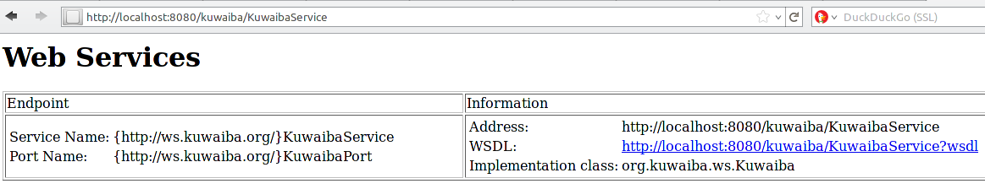Figure 11: Testing the application
Additionally you can check the command prompt/console you used to launch the server to see if an error was thrown.

Note: You may find errors in the window used to launch the PostgreSQL saying:

ERROR: constraint "XXX” relation "XXX" already exists

It's safe to ignore them. When the application is deployed, it tries to create an empty database schema, but it was already done when you restored the database in the step 5.

Chapter 3. Client Installation
The client is 100% Java, and it should work in all supported platforms.

Requirements
- JRE 1.5+
- At least 20MB of free space

Step by step guide
- Download the last stable client bundle.
- Extract the file in the client machines
- Execute the binary suitable for your platform located at $EXTRACTION_DIR/kuwaibainventory/bin directory (kuwaibainventory.exe for Windows, kuwaibainventory for Unix-like systems).
- You may need to change the file permissions to make the binary executable under Unix-like OS:
chmod 755 $EXTRACTION_DIR/kuwaibainventory/bin/kuwaibainventory

Chapter 4. Administrative tasks
- Migrations. In this early versions, the datamodel changes periodically, since new business elements are added. For versions prior to 0.3 stable (not released yet) you have to install everything from scratch if you decide to change from a version 0.x.y to a 0.z.y (i.e., 0.1.1 to 0.2). If migrating between versions in the same brach (say 0.2 alpha to 0.2.1) you can use the old database. As of 0.3 stable, it's planned to provide exporting capabilities so you can jump from version to version as seamlessly as possible.
Note: To test version 0.3 alpha only you can use your 0.2.x database without problems. 0.3 beta2 version is not backward compatible.

- Old sessions disposal. Since version 0.2 the concept of “user session” was introduced. A webservice (the way the kuwaiba client talks to the server) is by nature stateless. There are ways to circumvent this issue, but finally we chose to store the user sessions in the database, caching as much as we can. Every time an user logs in successfully a new record in the table “usersession” is created and when the client is closed, the session record is deleted. If the client is closed abruptly (it doesn't issue the closeSession message) or the server is shutdown having open sessions, spurious records will stay in that table. For next version is expected to provide a watchdog process to deal with this kind of situations, but by now, the only way to get rid off these zombie session is to delete them manually. Periodically, you should run the SQL sentence:

DELETE FROM usersession

- Database backup. There's a lot of documentation on this topic, mostly at the PostgreSQL site [5]. The simplest way is:

pg_dump -h db_host -U user_name db_name > dump_file.sql

You can also run pg_dumpall to backup everything:

pg_dumpall > db.out

- Misc errors. In these early stages, the application still has some rough edges and throws exceptions given special scenarios. You should take check the server log file periodically and report any bug you find so we can fix the problem in next releases.

Chapter 5. Troubleshooting
- If you install Glassfish under MS Windows 7/Vista in c:\glassfishv3, check you have proper permissions to write on this location, since due to system restrictions it's not possible by default. That will affect the domain creation and application deployment processes.
- In some cases, if you install Glassfish before to install the JDK under MS Windows, the variable AS_JAVA in $GLASSFISH_INSTALL_DIR/glassfish/config/asenv.bat is set to a wrong path. It should be pointing to the JAVA_HOME value (this is, the JDK installation directory).

Resources
[1] Kuwaiba: Architecture and Data Model http://kuwaiba.sourceforge.net/blogs/?p=48
[2] WebService API http://kuwaiba.sourceforge.net/javadoc/server/war/webservice/KuwaibaWebservice.html
[3] PostgreSQL installation guide http://www.postgresql.jp/document/pg632doc/postgres/c1802.htm
[4] Glassfish installation guide http://www.installationwiki.org/Installing_GlassFish
[5] PostgreSQL backup instructions http://www.postgresql.org/docs/current/static/backup.html

