Kuwaiba Open Network Inventory
Version 0.5.1 [12.12.2013]
Administrator Manual

Please visit http://www.kuwaiba.org/ for documentation, latest updates and upcoming events

Change History
Responsible | Description | Date | Reviewed by
Charles Bedón  charles.bedon@zoho.com | First version. It uses the number 0.3 just to keep compatibility with the version number used for the user manual | January 19th 2011
Charles Bedón  charles.bedon@kuwaiba.org | Corrections regarding to the changes made in the version 0.3 beta 2 | March 17th 2011
Charles Bedón  charles.bedon@kuwaiba.org | Added details related to the database setup. Added a troubleshooting section | November 8th 2011
Charles Bedón  charles.bedon@kuwaiba.org | Adaptation to version 0.4 | May 22nd 2012 | Adrián Martínez  adrian.martinez@kuwaiba.org
Charles Bedón  charles.bedon@kuwaiba.org | Multiples fixes and clarifications | July 13th 2012 | Adrián Martínez  adrian.martinez@kuwaiba.org
Charles Bedón  charles.bedon@kuwaiba.org | Style corrections | December 12th 2013 | Adrián Martínez  adrian.martinez@kuwaiba.org

Table of Contents
Change History 2
License 4
Disclaimer 4
Typographic Conventions 5
Chapter 1. System Architecture: The Easy Way 6
Chapter 2. Server Installation 8
Requirements 8
Step by step guide 8
Chapter 3. Client Installation 14
Requirements 14
Step by step guide 14
Chapter 4. Troubleshooting 15
Resources 16

License
This document is published under the terms of a license Creative Commons by-nc-sa. You can find details about it at
http://creativecommons.org/licenses/by-nc-sa/2.0/
 | Kuwaiba Server and Client are licensed under EPL v1. You can find the whole text of this license at  http://www.eclipse.org/legal/epl-v10.html

Disclaimer
- Netbeans and Java are registered trademarks of Oracle and/or its affiliates. Other names may be trademarks of their respective owners. The Kuwaiba project is not endorsed in any way to any of them.

- This document is provided “as is”, with no warranty at all. Install the software and follow the instructions included at your own risk.

- Kuwaiba uses third-party components licensed under compatible licenses (LGPL, BSD-like). You can find a complete list at the project's web page.

Important
As of version 0.4, Kuwaiba uses as backend a graph-oriented database called Neo4J. The libraries related to this DBMS are released under the GPL version which is NOT compatible with our EPL v1. This means we can not redistribute them along with our product, however, we reached an agreement with Neo Technology, the holders of the N4J's copyrights and code owners to do so, under the condition that the database won't be used for any purpose but to serve Kuwaiba. If you don't agree with this condition, consider to download the N4J-less version, download the libraries on your own and copy them manually to the respective directories.

Typographic Conventions

Courier New font type
This font is used for commands that should be run in the command line. Example:
ls -al /etc
Please take into account that in some occasions, the commands must be run from a particular path. If this is the case, the command is preceded by a Unix shell variable notation (the symbol “$” plus a text) to indicate that. Example:

$GLASSFISH_INSTALL_DIR/asadmin start-domain domain1

Tells you that the command asadmin start-domain domain1 must be run under the Glassfish installation directory. The meaning of the preceding variable is usually explained above the text.

This font may also be used to highlight a message shown in the console (i.e errors or warnings)

Italics
Italics are used to indicate the contents of a given file. The file the text is referring to is usually mentioned above the content itself. Example:
connection_username=
connection_password=
connection_database=kuwaiba.db
conection_DB_PATH =target
connection_host=localhost
connection_port=

Green-colored, bold font
This color is used to highlight a file name. Example: EnterpriseApplication.ear

Chapter 1. System Architecture: The Easy Way
Kuwaiba is a plain client/server application. It currently uses Java in both ends but that's not mandatory. You can write your own server in Python and the client using the PERL, for example. That's possible because at the very beginning of the project we took the design decision of deploying webservices as a way to ensure the interoperability between components. It was also the aim to provide a database and application server agnostic system, so the server side components are highly decoupled. A summarized (See a detailed, developer friendly architecture at the project's web page [1])
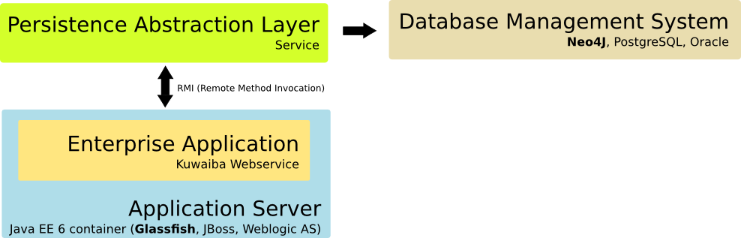Figure 1. Simplified server architecture
These are the main components at server side. There is a Java EE 6-compliant and EJB Container application server. The recommended setup suggests Glassfish (the last tested version is 3.1). The server installation bundle includes a .ear file which should be deployed on this server. This web application provides a webservice, which is the primary interface to clients, a business rules engine and session management. The enterprise application has a light load of business logic, since most of it is located at a service called Persistence Service (implementing the Persistence Abstraction Layer in the proposed architecture), which is a stand-alone daemon that exposes a set of remote objects accessible through RMI (Remote Method Invocation). This daemon may run in a different machine than that running the application server supporting the web service. Finally, the database management system: if you provide your own implementation of the Persistence Abstraction API, you can use any DBMS, but the default, reference implementation uses a graph-oriented backend called Neo4J[2]. Old versions (0.3.x and prior) used PostgreSQL and an ORM (Object Relational Mapper) called Eclipselink, but that's no longer the case. Neo4J may work as a service, providing a REST API or it may be used as an embedded database. Kuwaiba uses the latter, so you don't have to start any additional application.
Since it goes beyond the scope of the present document, we won't dig deeper into the detailed system architecture (it is more a developers issue) but the deployment one. This is, what elements compose an ideal setup and how they're all related:
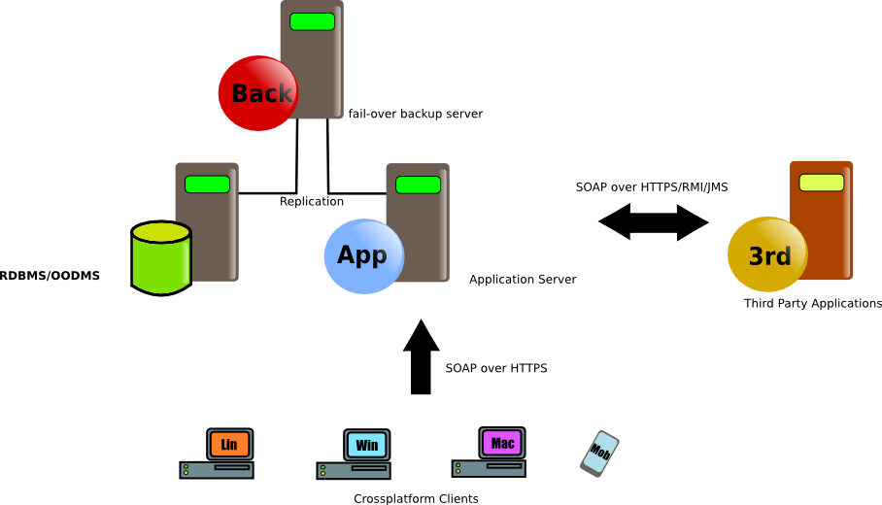Figure 2. Ideal deployment architecture
This is a pretty common approach so there's not too much to explain but the fact that the server publishes its capabilities by exposing a valid WSDL [3] to be consumed by the clients. Third party applications (such as ERPs, Alarm Management Systems and Network/Element Management Systems) could be integrated using it or alternative methods such as RMI or JMS, but these interfaces are not available yet, though.
Given that the project is still in its early stages (version 0.4), there's no need for such a complicated setup, and you can host everything in the same computer (or place the Persistence Service in a separate machine if desired).

Chapter 2. Server Installation
The application can be installed in Microsoft WindowsTM or Unix-like OS. The instructions are basically the same, and the differences will be pointed out when necessary.

Requirements
- An application server. The instructions presented in this document apply to Glassfish v3.0.1 or v3.1 (the latter only if you're using a server version 0.3beta2 or above). You can find details on its installation process here[4]. To simplify the process, just download the .exe/.bin installer and execute it choosing the default options.
- JDK 1.6.

Step by step guide
- Download the latest stable server bundle. As of version 0.4 stable, there are two options: One including the Neo4J (the database) libraries (named KuwaibaServer-[VERSION]_[STAGE]_full.tar.bz2) and another lacking of them (named KuwaibaServer-[VERSION]_[STAGE]_without_neo4j_libs.tar.bz2). The reason for this, is that Neo4J libraries are licensed under GPL v2, which is incompatible with Kuwaiba's license (EPL v1.0), so they can't be redistributed along with the standard package. However, we reached an agreement with Neo Technology, the developers of Neo4J. They're providing Kuwaiba project with an OEM license to overcome this problem, but they require the resulting database to be used ONLY for Kuwaiba. If you don't agree with this condition, just download the Neo4J-less bundle and grab the libraries yourself from the Neo Technology site following the instructions stated in further stages.
The files mentioned above are compressed using bzip. Untar the contents (tar -xjf KuwaibaServer-[VERSION]_[STAGE]_full.tar.bz2 or KuwaibaServer-[VERSION]_[STAGE]_without_neo4j_libs.tar.bz2 under UNIX-like systems or use a program like WinRar under Windows platforms).
You will find the following files/directories:
dbs | Default databases.  kuwaiba_db_empty.tar.bz2 contains the basic schema and a user. Use this if you're going to start from scratch.  kuwaiba_db_containment.tar.bz2  Contains the basic schema plus a sample containment hoerarchy and some lits types.  kuwaiba_db_sample_data.tar.bz2  Contains the data in the databases above plus sample business data.  To use a particular database, just unpack the contents of the desired backup into the “services/target” directory (provided you already deleted the existing kuwaiba_db directory)
service | Contains the jar file with the Persistence Service daemon and the required libraries
service/target/kuwaiba_db | Contains the default database
service/persistence.properties | File with connection settings
EnterpriseApplication.ear | File containing the web application to be deployed in order to provide the web service API.
class_hierarchy.xml | XML document with the data model used in Kuwaiba. It's included only as reference.
CHANGELOG | A text file with the incremental changes on the server side code.
DATAMODEL | A text file with the incremental changes on the data model (new classes, attributes, etc).
INSTALL | Installation notes.
LICENSE | EPL v1.0 text
README | General information.
THIRDPARTY | List of third-party libraries/tools used in Kuwaiba

- Start the RMI Registry, which, according to the Oracle documentation is “A remote object registry is a bootstrap naming service that is used by RMI servers on the same host to bind remote objects to names. Clients on local and remote hosts can then look up remote objects and make remote method invocations.”. rmiregistry command “creates and starts a remote object registry on the specified port on the current host. If port is omitted, the registry is started on port 1099. The rmiregistry command produces no output and is typically run in the background”. To start it, use the following command:

$JDK_INSTALL_DIR/bin/rmiregistry

Being $JDK_INSTALL_DIR the directory where your Java SDK is installed. No output from this command should be expected.
- Grant permissions so the remote objects can be exposed through the RMI interface. This is done by creating a text file called “.java.policy” (note the dot before the name). Place it on your user directory (/home/<username> in UNIX environments, or c:\Documents and Settings\<username> or c:\users\<username> in Windows environments). It should contain:

grant {
permission java.util.PropertyPermission "*","read,write";
permission java.util.PropertyPermission "sun.arch.data.model","read";
permission java.io.FilePermission "persistence.properties","read";
permission java.io.FilePermission "<<ALL FILES>>","read,write,delete";
permission java.lang.RuntimePermission "accessDeclaredMembers", "read";
permission java.lang.RuntimePermission "shutdownHooks", "write";
permission java.lang.RuntimePermission "modifyThread";
permission java.net.SocketPermission "127.0.0.1","connect,accept,resolve";
};

Please note that you should NOT run the service as root or as an Administrator. This settings can be used if the persistence service AND the application run in the same box (the last line governs who can get connected to the service, in this case, only those applications running in the same computer). For more information about permissions, please check the official documentation by Oracle [5][6].

Note as well that these security settings will be applied for all applications running in that computer, so you might need to add more rules in order to meet other programs' requirements. It's also possible to use a policy file only for the Persistence Service daemon by adding the -Djava.security.policy=PATH_TO_YOUR_CUSTOM_POLICY_FILE flag to the command in the step below to avoid placing a general file for every application.

- This step is optional. If you chose to download the Neo4J-less bundle (KuwaibaServer-[VERSION]_[STAGE]_without_neo4j_libs.tar.bz2), go to http://neo4j.org/download/ and get the version 1.7.2 or superior. Once you have downloaded and unzipped the installer, copy all the files under the directory “lib” except “neo4j-udc-X.Y.Z.jar” into the directory “services/libs” contained in the server bundled you uncompressed. The contents of “services/libs” would look like this after performing such operation (This example considers version 1.7.2 of Neo4J):

geronimo-jta_1.1_spec-1.1.1.jar | neo4j-graph-matching-1.7.2.jar | neo4j-shell-1.7.2.jar
scala-library-2.9.0-1.jar | lucene-core-3.5.0.jar | neo4j-jmx-1.7.2.jar
org.apache.servicemix.bundles.jline-0.9.94_1.jar | server-api-1.7.2.jar | neo4j-cypher-1.7.2.jar
neo4j-kernel-1.7.2.jar | PersistenceAbstractionAPI.jar | wax_1.0.1.jar
neo4j-graph-algo-1.7.2.jar | neo4j-lucene-index-1.7.2.jar | PersistenceServiceRemoteInterfaces.jar

Important: If you are using a version other than 1.7.2, please modify the file MANIFEST.MF, which compressed within the file PersistenceService.jar, in the directory META-INF using the file names according to your N4J version.

- To start the Persistence Service, open a console and go to the service directory in the server installation bundle you just uncompressed and type for Unix-like systems (on a single line!):

java -Djava.rmi.server.codebase="file:///PATH_WITH_NO_SPACES_TO_YOUR_UNTARRED_FILES/service/lib/PersistenceServiceRemoteInterfaces.jar file:///PATH_WITH_NO_SPACES_TO_YOUR_UNTARRED_FILES/service/lib/PersistenceAbstractionAPI.jar" -jar PersistenceService.jar

Important: Make sure that you're not using any path containing spaces, since due to an unresolved Java bug [7], it will cause a MalformedURLException. See the troubleshooting section at the end of the document if you get a ClassNotFoundException.

Important: Under Windows platforms, the path must be specified as follows: “file:/<path_with_no_spaces>/PersistenceServiceRemoteInterfaces.jar file:/<path_with_no_spaces>/PersistenceAbstractionAPI.jar” (on the same line!). Note the single slashes (“/”).

Important: The paths are absolute.

This command will start the server and tell it that the libraries needed to publish the remote objects (they're also used in the web application) are located in the “lib” directory. If you get a java.lang.NoClassDefFoundError or a java.net.MalformedException refer to Chapter 4 Troubleshooting.

You can terminate the process by hitting CTRL+C on the console.

- Open a command prompt/console and start the application server (Glassfish). Note: Depending on your OS you may need to set the JAVA_HOME environment variable to point to the JDK installation directory before to run the following command.

$GLASSFISH_DIR/bin/asadmin start-domain domain1
If the domain doesn't exist, create one.

$GLASSFISH_DIR/bin/asadmin create-domain domain1
If you get any errors in this step, please refer to the Chapter 4 Troubleshooting.

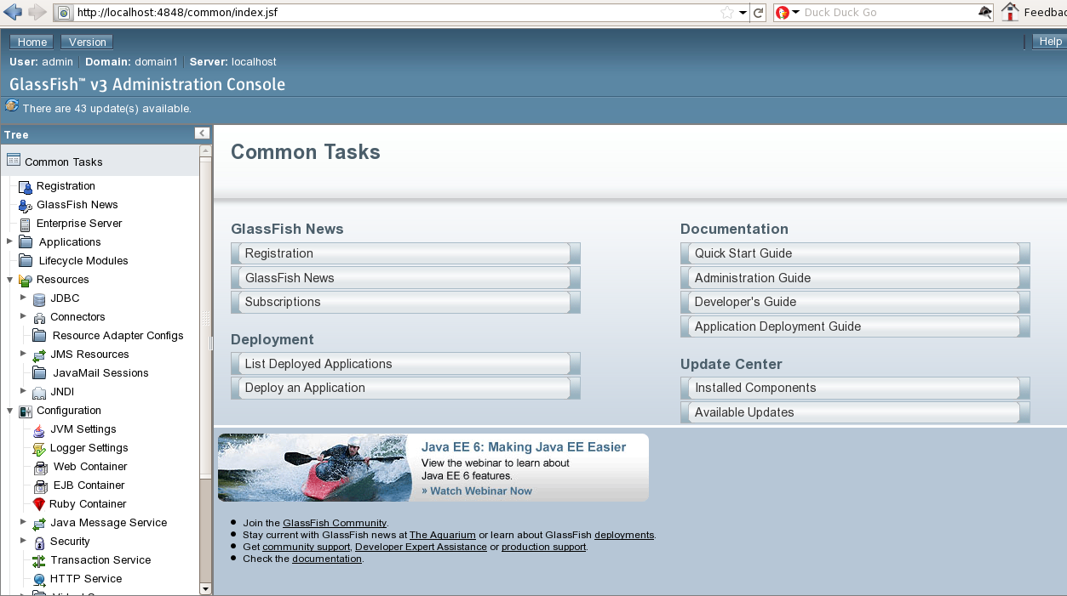Figure 3: Glassfish web management console
- Once the server is up and running, it will provide a web management interface listening in the port 4848 (http://<server_domain_name_or_ip>:4848). Don't forget the credentials you provided during the application server installation process because they will be used for further administration procedures.

- Now you are ready to deploy the enterprise application. Take the .ear file you will find in the server bundle (probably called EnterpriseApplication.ear) and upload/publish it using the section Applications → Deploy

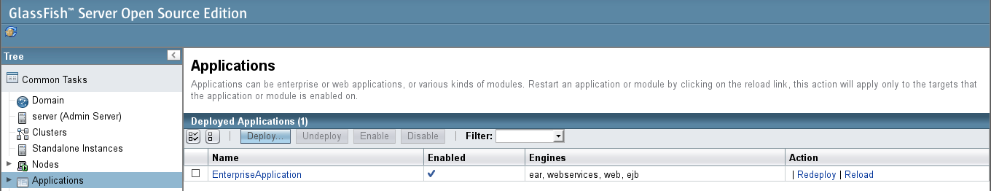Figure 4: Deploying the application
- Test if the application was actually deployed by opening the URL http://<your_server>:8080/kuwaiba/

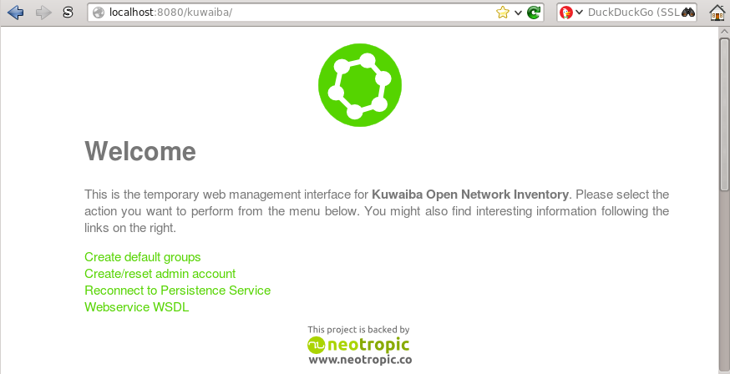Figure 5: Testing the application
Additionally you can check the command prompt/console you used to launch the server to see if an error was thrown. Sometimes, the errors are logged only in the server log file, located at $GF_INSTALL_DIR/glassfish/domains/domainx/logs/. Where $GF_INSTALL_DIR is the installation directory of Glassfish

Chapter 3. Client Installation
The client is 100% Java, and it should work in all supported platforms.

Requirements
- JRE 1.6. Important: There are known issues related to JRE 1.7 under some versions of Windows.
- At least 20MB of free space

Step by step guide
- Download the last stable client bundle.
- Extract the file in the client machines
- Execute the binary suitable for your platform located at $EXTRACTION_DIR/kuwaibainventory/bin directory (kuwaibainventory.exe for Windows, kuwaibainventory for Unix-like systems). $EXTRACTION_DIR is the directory where you extracted the files.
- You may need to change the file permissions to make the binary executable under Unix-like OS:
chmod 755 $EXTRACTION_DIR/kuwaibainventory/bin/kuwaibainventory

Chapter 4. Troubleshooting
- If you install Glassfish under MS Windows 7/Vista in c:\glassfishv3, check you have proper permissions to write on this location, since due to system restrictions it's not possible by default. That will affect the domain creation and application deployment processes.
- In some cases, if you install Glassfish before to install the JDK under MS Windows (specially versions 7 and Vista) or when the instaler detects a wrong version of Java, the variable AS_JAVA in $GLASSFISH_INSTALL_DIR/glassfish/config/asenv.bat is set to a wrong localtion. It should be pointing to the JAVA_HOME value (this is, the JDK installation directory). The direct result of a wrong path is an error similar to “”
- If you get a java.lang.NoClassDefFoundError error while launching the Persistence Service, check the paths you provided with the flag -Djava.rmi.server.codebase. Note that this parameter refers to two .jar files (PersistenceAbstractionAPI.jar and PersistenceServiceRemoteInterfaces.jar), so be sure that the path you are specifying actually exists. If after checking the paths they look correct, but you are still getting this exception, stop the rmiregistry process and point the environment variable CLASSPATH to the directory where the jar files mentioned above are located. To do this in Linux use the command:
export CLASSPATH=$CLASSPATH:<path_to the directory>
In windows, there's a similar command
set CLASSPATH=%CLASSPATH%;<path_to the directory>
Then, in the same terminal, start rmiregistry again.
- If you get a java.net.MalformedURL double check the way you're defining the paths and make sure that they don't have spaces (for example “c:/Documents and Settings/KuwaibaServer_0.4/service/libs/PersistenceServiceRemoteInterfaces.jar” will give you problems, try copying the directory to a location such as “c:/KuwaibaServer_0.4/service/libs/PersistenceServiceRemoteInterfaces.jar”).
- If you get a java.security.AccessControlException: access denied (java.util.PropertyPermission user.dir read) error while launching the Persistence Service, check you have a .java.policy file as mentioned in the point 3 of Chapter 2 Server Installation. Check the according Oracle documentation on policy files for details [5] [6]. If you still experiment problems, you could try replacing the content of the .java.policy file with the following lines:
grant{
permission java.security.AllPermission;
};
Avoid this as much as possible as it could result in undesired security implications.

Resources
[1] Kuwaiba: Platform Architecture http://www.kuwaiba.org/wiki/index.php?title=Platform_Architecture
[2] Neo4J http://www.neo4J.org
[3] WebService API http://www.kuwaiba.org/docs/server/wsapi
[4] Glassfish installation guide http://www.installationwiki.org/Installing_GlassFish
[5] Policy files http://docs.oracle.com/javase/1.3/docs/guide/security/PolicyFiles.html
[6] Permissions http://docs.oracle.com/javase/6/docs/technotes/guides/security/permissions.html
[7] Bug related to URLs with spaces http://bugs.sun.com/bugdatabase/view_bug.do?bug_id=4496398

