Kuwaiba Open Network Inventory
Version 0.1.1 [11.09.2013]
Optical Networks Model

Please visit http://www.kuwaiba.org for documentation, updates and upcoming events

Change History
Responsible | Description | Date | Reviewed by
Charles Bedón  charles.bedon@kuwaiba.org | First version aimed to be the base for 0.4.x series optical networks support | May 27th 2011
Charles Bedón  charles.bedon@kuwaiba.org | Fixes to graphics | September 11th 2013

License
This document is published under the terms of a license Creative Commons by-nc-sa. You can find details about it at
http://creativecommons.org/licenses/by-nc-sa/2.0/
 | Kuwaiba Server and Client are licensed under EPL v1. You can find the whole text of this license at  http://www.eclipse.org/legal/epl-v10.html

Disclaimer
Some brands are mentioned as example for different types of equipment. This project is not endorsed to any of the related companies and they're the sole owners of such brands.

Background
Until not so many years ago, optical-based technologies were used as part of the backbone networks only. Lately, due to the ever increasing traffic caused by new multimedia services offered by ISPs and content providers, their scope has been progressively broadened to reach the subscribers premises. Kuwaiba will address the inventory of both scenarios.
In core networks, the normal situation (with a few variants) is depicted in the figure 2. Normally there are DWDM muxes which gather aggregate traffic from a SDH/SONET/GBEthernet transport networks and bundle it into single links using multiple wavelengths (also known as lambdas, see figure 1). Depending on the distances and distributions of nodes in the network, additional optical amplifiers or splice boxes may need to be placed. It's important to point out that from the physical point of view, it's relevant to take into account both transmission and reception ports (and the fibers connected to them) since they actually occupy ports on ODFs and splice boxes, but from the logical point of view only is one seen.
For low traffic or old transport networks, the wavelength multiplexing process might not be necessary, and the layer 2 equipment is connected directly.

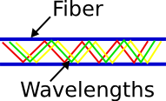Figure 1. Multiple wavelengths multiplexed into the same optical media

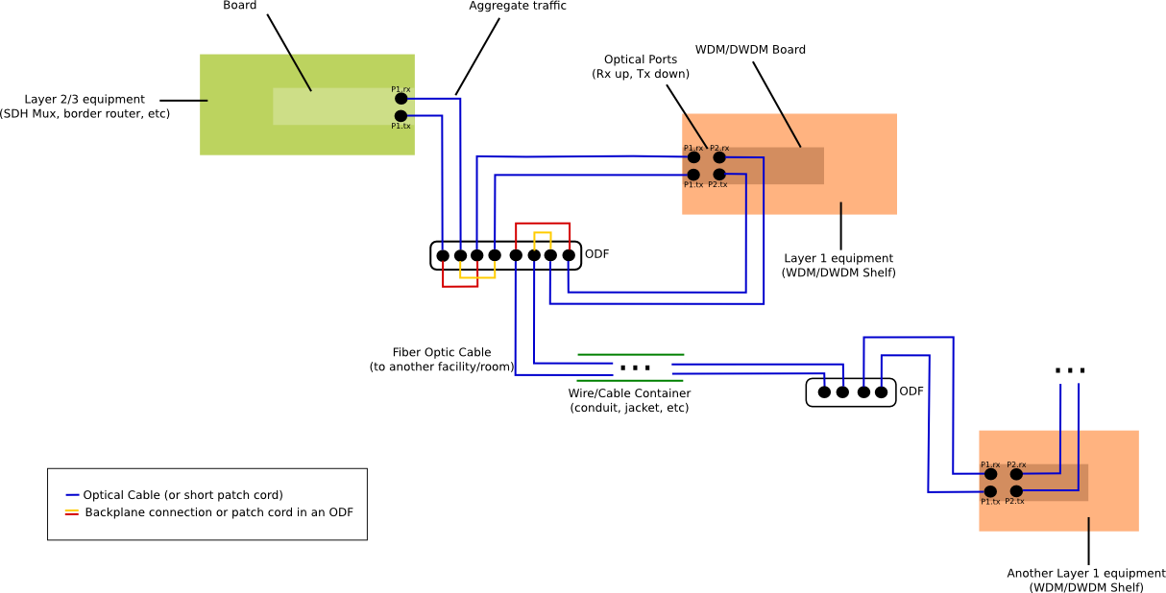Figure 2. Typical optical connection between two nodes in a core network (Note: each pair of ports represents reception (rx) and transmission (tx) ports).
Zoom in if you experience distortion displaying the image
In short, a sample trace from a layer 2/3 equipment to another through a DWDM network could be described like this (same for rx and tx cables):
Node A
[Layer 2/3 equipment] → [board] → [OpticalPort]
[ODF] → [OpticalPort] → Optical Patch Cord → [OpticalPort]
[DWDMMux] → [Board] → [Input OpticalPort]
[DWDMMux] → [Board] → [Output OpticalPort]
[ODF] → [OpticalPort] → Optical Patch Cord → [OpticalPort]
Transit
[WireContainer] (Optional) → [OpticalLink] → [Wavelength]
Node B
[ODF] → [OpticalPort] → Optical Patch Cord → [OpticalPort]
[DWDMMux] → [Board] → [Input OpticalPort]
[DWDMMux] → [Board] → [Output OpticalPort]
[ODF] → [OpticalPort] → Optical Patch Cord → [OpticalPort]
[Layer 2/3 equipment] → [board] → [OpticalPort]

On the last mile side, the scenario is depicted in figure 3. This model is simple and might require tuning in the future. The transport network border, represented by a layer 3 equipment is connected through an optical or electrical cable to the OLT (Optical Line Terminal), which is in charge of distribute the upstream traffic to the subscribers performing different kinds of multiplexing/demultiplexing techniques (among other things). From the OLT are pulled the actual last mile fibers which are bundled into a cable container (a conduit) and deployed across the city until it gets to a cabinet (outdoors or indoors) where the fibers are taken to the customers premises. In Active Optical Networks (AON), this distribution process is made by switches or routers, while in Passive Optical Networks (PON) scenarios a simple splice box is enough.
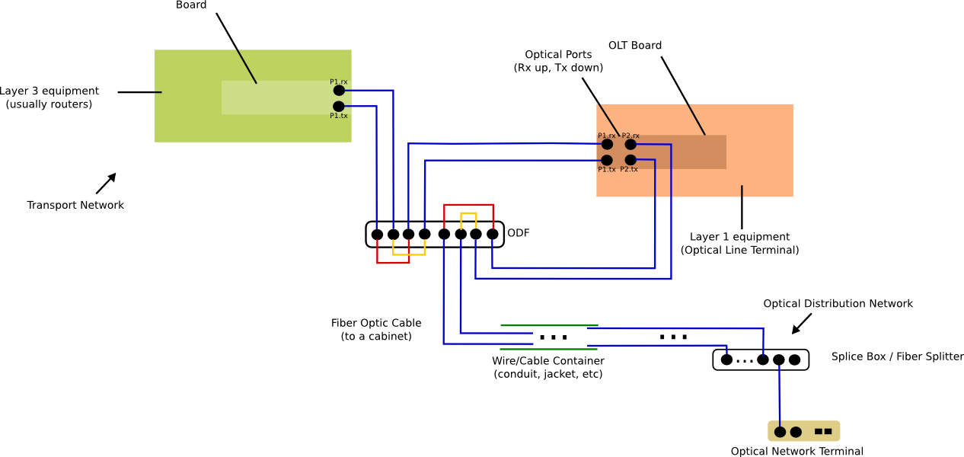Figure 3. Typical setup for a last mile network (Note: Active Optical Networks use active elements such as switches or routers to deliver the services to the end users instead of splitters)
Zoom in if you experience distortion displaying the image
A simplified overview of how the service would look like in the field can be seen in the following picture:

Zoom in if you experience distortion displaying the image
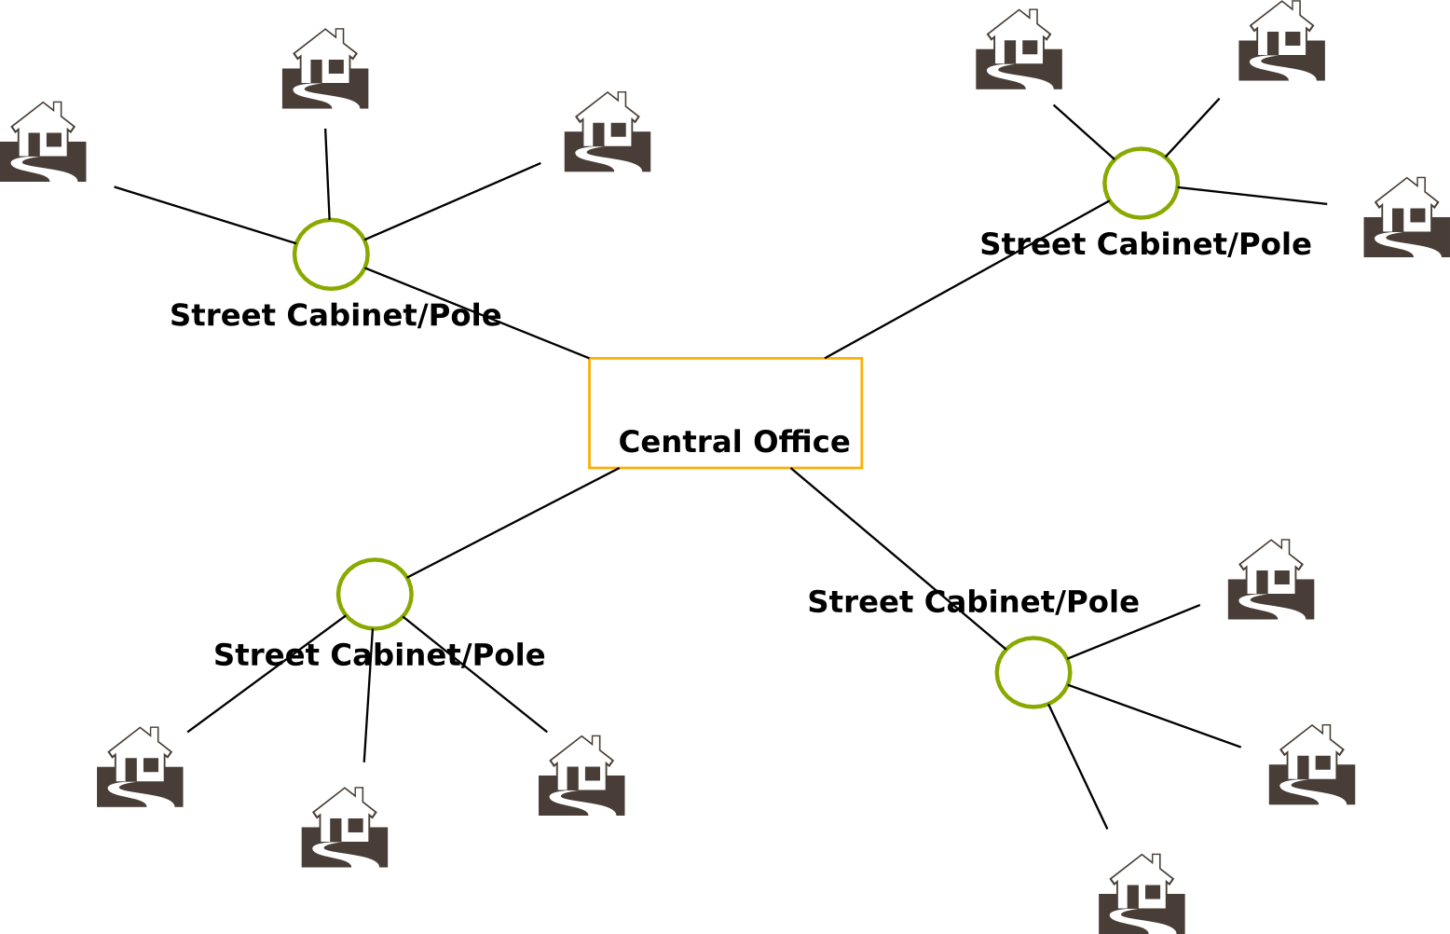Figure 4. Simplified diagram of the last mile segment
The segment between the central office and the local distributors is often shared using DWDM or time multiplexing techniques. A possible route for the last mile can be described like this:

Central Office
[OpticalLineTerminal] → [board] → [OpticalPort]
[ODF] → [OpticalPort] → Optical Patch Cord → [OpticalPort]
Transit
[WireContainer] (Optional) → [OpticalLink] → [Wavelength]
Local distributor (usually a street cabinet or a pole)
[Cabinet] → [InternalRack] → [OpticalSwitch] → [Input OpticalPort]
[Cabinet] → [InternalRack] → [OpticalSwitch] → [Output OpticalPort]
Transit
[WireContainer] (Optional) → [OpticalLink] → [Wavelength]
Customer Premise
[OpticalNetworkTerminal] → [Board] → [Input OpticalPort]
[OpticalNetworkTerminal] → [Board] → [Output ElectricalPort]

Class Modeling
The class diagram with the relevant elements to be used in the core network model (zoom in for details) is as shown in figure 5.
DWDMMux: A simple DWDM multiplexer. Examples: Alcatel-LucentTM's 1625 LambdaXtreme or HuaweiTM's BWS 1600G.
DWDMBoard: Expansion board used in DWDMMux (there's a containment relationship).
OpticalPort: An optical port featuring a connector such as FC/PC. Instances should be contained within a board supporting optical ports (not limited to DWDMBoards).
OpticalAmplifier: A simple (active) optical amplifier. Example: PacketLightTM's PL-1000IL.
OpticalLink: Represents a simple fiber cable. OpticalLink instances are contained within a WireContainer (however that is not mandatory).
Wavelength: Represents a single wavelength (lamda) within a fiber, usually traveling with others. There's a containment relationship between classes Wavelength and OpticalLink.
A Wavelelength instance represents the wavelength of a single ray of light within a fiber (also known as a “lambda”). That's why this class has a composition relationship with “OpticalLink”, which represent such optical cable.
Zoom in if you experience distortion displaying the image
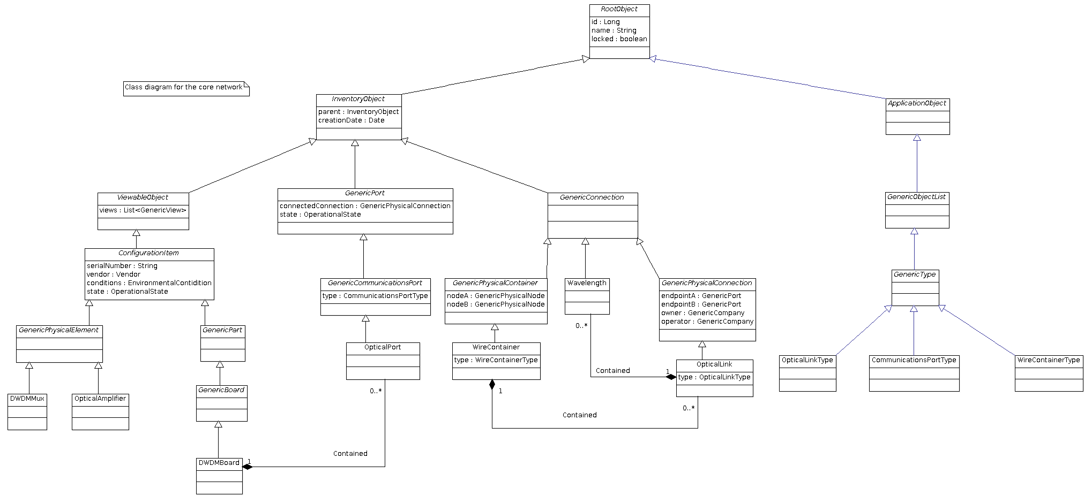Figure 5. Class diagram describing the core optical networks model
As for the las mile segment, the corresponding class diagram is shown in figure 6 (zoom in for details). Please note that some of the classes are not only exclusive of this model (most of them types of services).
AdministrativeItem: Root [abstract] class for all of those elements within the inventory used for administrative purposes such as services, contracts, etc.
GenericService: Root [abstract] class for all services.
GenericDataService: Root [abstract] class for all services that offer a fixed (or variable) bandwidth. Some of the subclasses are: CableDataService (for HFC networks), FTTHService, GigaEthernetService, MobileDataService, SatellitalDataService, PDHService, SDHService, SONETService and all XDSL-like services (ADSLService, SDSLService, VDSLService).
GenericMediaService: Root [abstract] class for all services involving multimedia (voice/video) data. Some of its children are CableTVService, IPTVService, VoIPService, VoiceService and SatellitalMediaService.
Note: Services that don't fit in any of the past two categories are direct subclasses of GenericService. In this group we can find HostingService, VPSService and HousingService.
ConfigurationItem: Root [abstract] class for all elements which can be configured somehow from ports to multiplexers or antennas.
GeneralPhysicalElement: Root [abstract] class for all physical elements, usually equipment.
OpticalAmplifier: A simple optical amplifier (as seen in the past section).
OpticalLineTerminal: It's an equipment usually located at the central offices which enables the delivery of FTTx services. It's the edge between the transport network and the access network. See HuaweiTM's SmartAX MA5603T, the MotorolaTM 's AXS1800 or the ZTETM's ZXA10 C220 for examples.
OpticalNetworkTerminal: It's an equipment placed at the customer's premise and it's the endpoint of the service. See MotorolaTM's ONTXX series (like the ONT1400GT2) and the HuaweiTM's HG866.
GenericPart: Root [abstract] class for all removable parts (and ports).
GenericPart: Root [abstract] class for all boards.
ONTBoard: A board used in an optical network terminal.
OLTBoard: A board used in an optical line terminal.
GenericContainer: Root [abstract] class for all elements that are, by definition, designed to contain something instead of being and equipment itself. Subclasses of this are Rack, ODF (Ooptical Distribution Frame), MDF (Main Distribution Frame), SpliceBox, FiberSplitter and FiberCassette.
GenericPhysicalNode: As seen in the physical networks model, subclasses of the root class are all those constructions which can be connected using a PhysicalContainer (that is conduits, ladders, etc). Here you can find Building, Pole, OutdoorCabinet and Shelter among others.
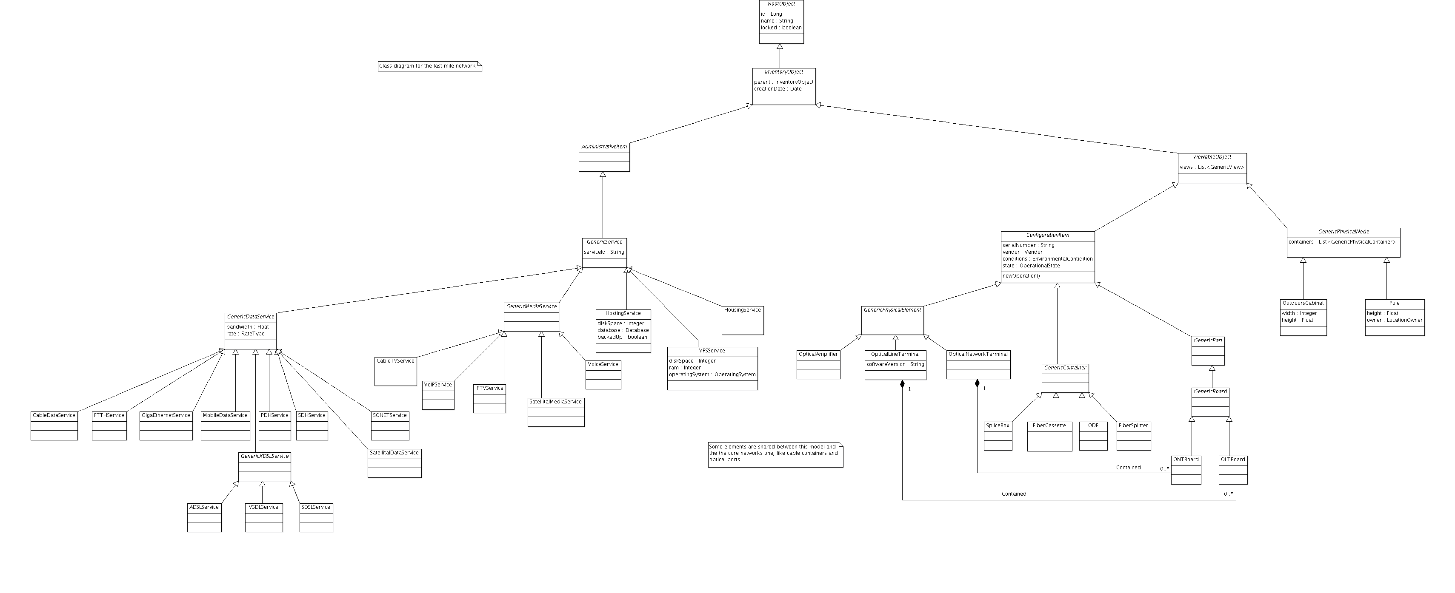Figure 6. Class diagram for the last mile network. Please note that some elements are shared with the past figure

Zoom in if you experience distortion displaying the image

Resources
- Physical Layer Model. Kuwaiba Project. 2010.
- Optical networks portfolio, Alcatel-Lucent. http://www.lucent.com/wps/portal/Products/category?LMSG_CABINET=Solution_Product_Catalog&LMSG_CONTENT_FILE=Product_Categories/Product_Category_000039.xml&LMSG_SELECTEDCATEGORY=Y

