Kuwaiba Open Network Inventory
Version 0.3 [16.05.2011]
User Manual

Please visit http://www.kuwaiba.org for documentation, latest updates and upcoming events

Change History
Responsible | Description | Date | Reviewed by
Charles Bedón  charles.bedon@zoho.com | First issue shipped with version 0.1.1. | September 28th 2010
Charles Bedón  charles.bedon@zoho.com | Update to cover the new features in version 0.2 | November 26th 2010
Charles Bedón  charles.bedon@zoho.com | Update to cover the bugfixes and changes in version 0.2.1 | December 26th 2010
Charles Bedón  charles.bedon@zoho.com | Changes in version 0.3 alpha | January 18th 2011
Charles Bedón  charles.bedon@zoho.com | Changes in version 0.3 beta | February 3rd 2011
Charles Bedón  charles.bedon@kuwaiba.org | Changes in version 0.3 beta 2 | March 13th 2011
Charles Bedón  charles.bedon@kuwaiba.org | Changes in version 0.3 stable (the clear button in the graphical query editor) | May 16th 2011

License
This document is published under the terms of a license Creative Commons by-nc-sa. You can find details about it at
http://creativecommons.org/licenses/by-nc-sa/2.0/
 | Kuwaiba Server and Client are licensed under EPL v1. You can find the whole text of this license at  http://www.eclipse.org/legal/epl-v10.html

Disclaimer
- Netbeans and Java are registered trademarks of Oracle and/or its affiliates. Other names may be trademarks of their respective owners. The Kuwaiba project is not endorsed in any way to any of them.

- This document is provided “as is”, with no warranty at all. Install the software and follow the instructions included at your own risk.

- Kuwaiba uses third-party components licensed under compatible licenses (LGPL, BSD-like). You can find a complete list at the project's web page.

Important
This is a preliminary version of this document covering the features included in the version 0.3 Stable, If you're using a version in the 0.2.x branch, please download the UserManual_021.pdf available at: https://sourceforge.net/projects/kuwaiba/files/Docs/

Most of the pictures in the present manual have the original resolution. If you can't see them correctly, please zoom in and they'll be shown clearly.

Chapter 1. Network Inventory Management in a nutshell
When you have a lot of things is easy to lose some of them and it's even easier to end up with a monumental mess if you're not organized enough. As a result, you will find yourself buying something you already have but you haven't managed to find, or wasting precious resources (money or space) storing stuff you barely know what is for.
The same happens to the IT and telecommunications infrastructure (actually in nearly every business handling assets [1]). It tends to be complex and its components lose visibility as the base of users/subscribers/customers increases. So it's common to see servers, workstations, antennas and equipment of all species piled in some dark room. In the mean time, sysadmin or technical guy's mind apart, it's not possible to find the updated information about the operative elements configuration or even location, the rack space is wasted and the patch panels are a land of no one, so how will anyone know which cable to pull?.
They say you can't manage what you can't control, and you can't control what you don't measure, and that's more or less the point of all this inventory thing. If you have under control what you have and the way everything is related will be more likely to achieve the goals of the Operations Department or the IT Staff, if they use this information to attend the incidents effectively and plan the capacity the more accurately way possible, among other things.
Having said this, three possible types of resources may be identified:
- Physical: These are the equipment, pipes, cables, fiber optics, facilities, parts and in general every physical asset from a port to a building.
- Logical: These are all the resources related to non-tangible technology assets. In this group fits timeslots, virtual circuits, VLANs, disk space, available bandwidths, etc.
- Administrative: These are all those related to administrative tasks, human resources or services. Here you can find customers, services associated to those customers, SLAs (and related parameters like availability or throughput), account managers, technical staff assigned to those services, vendors, brands. In short, all not-operational resources related to a given service management workflow.
As you may guess (or have experienced), to have all this information updated and complete at a single point is a hard task. Mostly because IT and telecommunications are ever changing environments and your network configuration layout can shift overnight. Updating all the data manually is almost impossible, but fortunately, you can grab a good part of it from the network elements if the have proper management interfaces.
From an ITIL perspective [2], within the Service Transition process there's a key concept called “CMDB”. In short, is a place where you have Configuration Items (CIs, any IT asset that can be configure or have configuration information) and their relationships. Yes, not only the objects. Indeed, multiplexers, radios, routers are not islands. They're connected physically or logically, and people may be related to them as well. A network inventory system is CMDB but may extend its functionality in order to provide workflow management, network designing features, etc. But the core of it is a Configuration Management Database.
But one thing is different from other scenarios is that technology assets may not be physical. If you have a core using SDH you need to know what VCs are free, which ones are protected and what kind of protections they have, but if you manage switches you may want to now the bit rate configured for a given port or how the VLANs are set up. At application level, you'd like to know what DNS are configured for a given Web Servers or where are the Domain Servers...
Kuwaiba Open Network Inventory aims to be a solution for this scenario. It is completely Object Oriented, so you can model your network according to your needs, no matter if you're an ISP, a carrier or just a guy with a large IT infrastructure. Remember, Kuwaiba is under active development and new models are added every release. Please request the ones you consider as top priority in this thread [3].

Chapter 2. The login window
The default user/password is admin/kuwaiba. When you execute the binary at $CLIENTPATH/bin/kuwaibainventory (Unix-like systems) or $CLIENTPATH/bin/kuwaibainventory.exe (Microsoft Windows® systems) you'll get a window like this (remember, you need JRE1.6 or superior to run the client. Check here [4] for details):
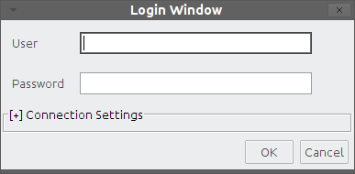Figure 1: Login window with the Connection Settings panel collapsed

Pressing “Cancel” will close the application, and pressing “OK” will attempt to log into the system using the default connection values. This is, localhost as server, 8080 as server port and “/kuwaiba/KuwaibaService” as WSDL location. If you deployed the server with the default settings in the same box as the client, this should be enough.

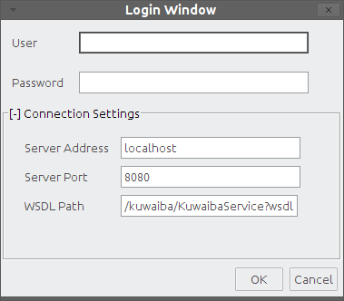Figure 2: Login window with the Connection Settings panel expanded

You can expand the Connection Settings panel in case you want to change those values.
- Server address: Name or IP address where the server is running
- Server port: Port where the applications server is listening at.
- WSDL Path: Path to be appended to the server address and port to form the valid URL to access the WSDL expose the methods to be consumed. It's important to point out that the Kuwaiba desktop client has a webservice client within, and that's the mechanism used to interact with the server. If you're not sure about this value, try typing in web browser an URL like this:
http://<server_address>:<server_port><wsdl_location>
A XML document must be displayed
If you were able to log in successfully, the first thing you will see is an empty window with only a toolbar at the top.
Troubleshooting: You can get a “Not enough privileges” message in case the user/password provided are invalid. If you get an “EJBException” that means an internal server error occurred, so you probably need to take a look at the server log for details, but most of the problems in this regard has to do with the database connection (the database server is not running, can't be reached or the credentials used to access it are invalid). Contact the application administrator if you get this error. A “HTTPServletException: Connection refused” indicates that the server is not running at all (or couldn't be found), check if the WSDL location is correct.
Figure 3: Default toolbar layout

New Query Builder (Chapter 9)
Legacy Query Builder (Chapter 9)
Refreshes the local cache. Use it whenever you make a change to the class metadata (i.e, when you change the icon or display name for a given class or when you add a new list type element). Also hit this button if you add a new list type item (See chapter 8).
Graphical Views for a given object (Chapter 7)
User and Group Management (Chapter 10)
Attribute Manager (Chapter 3)
Class Manager (Chapter 4)
Container Hierarchy (Chapter 5)
List Manager (Chapter 8)
Navigation Tree (Chapter 6)
Refreshes the current focused component

Chapter 3. The Attribute Manager
One of the key features in Kuwaiba is that it is completely object oriented. That means that every business element (Router, City, Port) is actually treated as an object within the application. As such, every attribute is a Field into a Class [5]. You can customize how these attributes are displayed in module called “Attribute Editor” as shown in this figure:
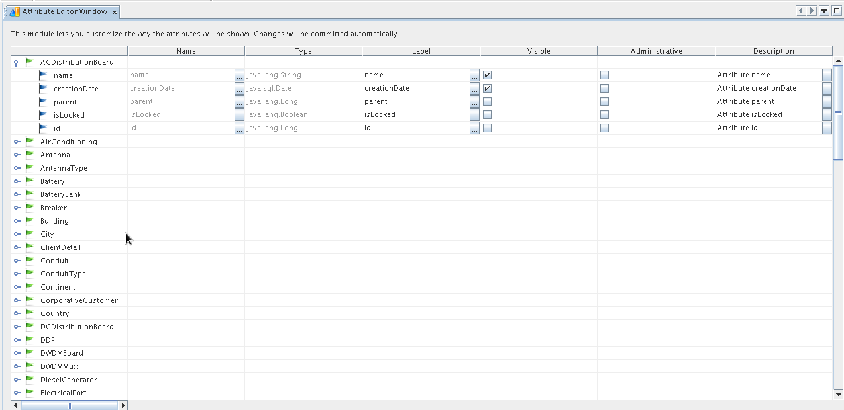Figure 1: Attribute Editor main window
The first column (unlabeled) contains the available classes for the current release. Every row can be expanded to show the attributes related to each one.
The second, is a read-only field showing the real name of the attribute, this is, the name used internally to reference it.
The third is read only too and shows the attribute type. It can be a native one like Integer, String, Boolean, Float or Date, a list type attribute (those where you can pick the value from a list) or even a multi-choice type (those where you can pick multiple values at a time from a list). It's only for information purposes.
The fourth shows the attribute display label. This label will be used in the properties window. You should edit it in order to show a friendly text instead of the default attributes real name (ie.: real name: “rackUnits” suggested display label: “Rack Units”).
The fifth marks the attribute as “Visible”. Useful for those attribute you don't want to show to the end user. By default “id” and “parent” are hidden for all classes.
The sixth is intended for documentation purposes. In the description field you can place a small explanation about a given attribute (no more than 255 characters). This will be shown at the bottom of the Properties window when the attribute is selected. You can press the button to get a bigger space to write as shown in the figure 5.

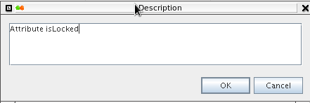Figure 2: Custom editor for field “Description”

Note 1: If you don't find the attribute or class you need, you may wish to request it at this forum thread [3]. Next versions of Kuwaiba will support a dynamic data model, when you will be able to add classes and attributes on the fly. You can see the current data model in a graphical fashion here [9]
Note 2: If you don't see the change(s) you just made reflected in the Navigation Tree, please press the Refresh Local Cache and Component Refresh buttons in the main toolbar. Note that the Navigation Tree has to be focused for the refresh to be performed.

Shortcut: CTRL+A

Hint: Selecting any node in the tree and writing a text string will attempt to search for a class or attribute starting with such string. If there are several matches, F3 will jump to the next one.

Chapter 4. The Class Manager
Just the same way you can customize the way the attributes are shown in the Properties window, you can change the display preferences for classes (and their respective instances) themselves.
Save the changes
Refresh/Reload the class list
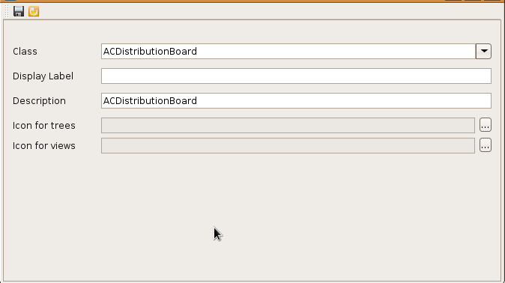Figure 1: Class Customizer main window

The Class combo box lets you choose the class to be customized.
Display Label is intended to change the way the class name is shown in the navigation tree and Property windows. This is particularly useful for internationalization purposes, ie.: Changing “Country” for “País” if you want it in Spanish language.
The field Description, lets you to annotate the selected class, so people can know what is it about. For example, what an “IDU” is may not be as clear as “Country” for some users. This will take special importance in next releases when complete models are supported, and you would like to document how all elements are related (for example, how to connect two antennas using a radio link).
The Icon for trees is a png, jpg or gif image with no more than 16x16 pixels which will be used for the instances of the given class in the trees and query results. You can choose the file from a File Chooser as shown in the figure 7.
The Icon for views is a png, jpg or gif image with no more than 32x32 pixels which will be used for the instances of the given class in the physical views (see chapter 8 for details on this kind of view). For example, in a City physical view you will see buildings on it. The icon you choose is the one shown there, over a map of the city (if you add the map as the view background). You can choose the file from a File Chooser as shown in the figure 7.
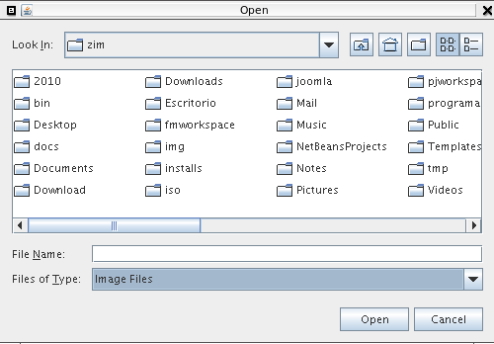Figure 2: File chooser to pick an image file

Note: If you don't find the class you need, you may wish to request it at this forum thread [3]. Next versions of Kuwaiba will support a dynamic data model, when you will be able to add classes and attributes on the fly.
As of version 0.3, there's also a class hierarchy viewer which can be invoked by selecting the menu item Tools → Administrative → Class Management → Show Class hierarchy. You may need to organanize some nodes, but in general is a good way to visualize the whole data model.

Shortcut: CTRL+M

Hint: When you drop down the combo box, you can find a class by typing the first letters of its name.
Note: If you don't see the change(s) you just made reflected in the Navigation Tree, please press the Refresh Local Cache and Component Refresh buttons in the main toolbar. Note that the Navigation Tree has to be focused for the refresh to be performed.

Chapter 5. The Containment hierarchy
Another key concept in Kuwaiba is containment. It consists of the ability to define what kind of objects can be created inside a given one. For example, a Country can be inside a Continent, but can't be inside a Rack. A port is usually within a board, and not inside a City. These business rules can be defined using the Containment Hierarchy Manager.
As of version 0.1.1, the server installer comes with three different databases: kuwaibadb_empty.backup: a db with the class metadata, but no objects created or containment hierarchy defined (you can use the Class and Attribute Customizer), kuwaibadb_container_hierarchy.backup, which is a db with a basic containment hierarchy defined and kuwaibadb_test_data.backup is the same as the previous one but with demo data inside. If you want to define your containment hierarchy from scratch use the first one or you can use the basic ready-to-use second one. For sure, you will have to create your own containment “entries”.

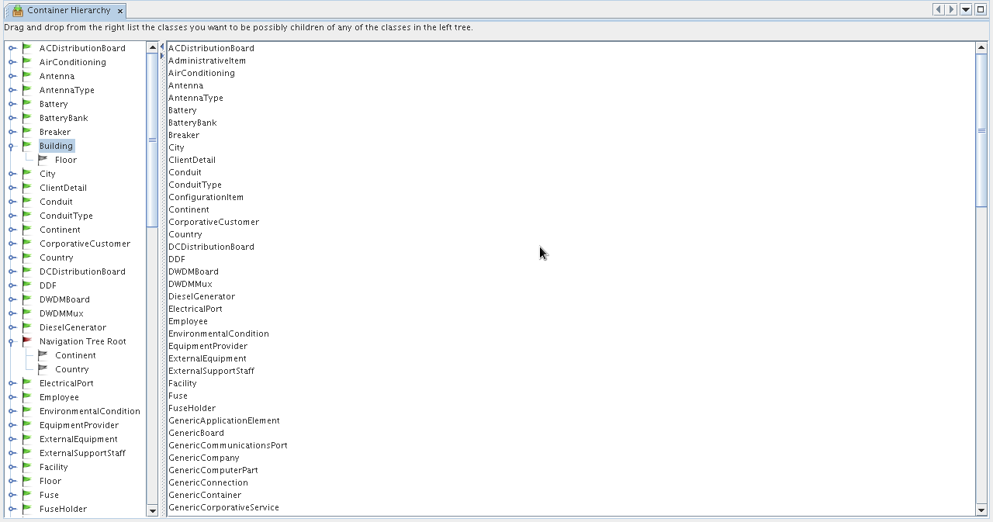Figure 1: Containment Hierarchy Manager main window
The main window is divided in two panels. The one at the left is a tree that holds all the classes plus the Navigation Tree Root. The children of every node are the possible classes that can be contained. In the figure above we can see two nodes expanded: Building, which has only one node called Floor. That means that below a given building you will only be able to add floors as direct children. If you don't care about floors, just drag Room or whatever fits your needs from the list at the right side.
Within “Navigation Tree Root” we can find two children: Country and Continent, which means that you can only add instances of these classes to the navigation tree's root (the first level, marked with a star icon, as shown in the next chapter).

If you want to remove a children just right-click on it and select “Remove”, and instances from that class will no longer be available to be added under the parent class.

Shortcut: CTRL+H

Hint: Selecting any node in the tree and writing a text string will attempt to search for a class or attribute starting with such string. If there are several matches, F3 will jump to the next one. The same applies to the list at the right panel.

Important: Containment hierarchy is not the same as Class hierarchy. It's a common mistake to confuse these terms. Containment hierarchy, as stated before is the way an object can contain in the real world another one (as in a box that holds small objects within). Class hierarchy is an object oriented programming concept (see inheritance [5][8]) that refers how code can be reused passing some code and attributes from a class to another (as the class Employee can inherit the attributes “name” and “gender” and the methods -logic- “walk” and “breath” from a class Person).

Chapter 6. The Navigation Tree
There's not too much to comment here, since it's a common feature in all systems.
This module is composed by two windows: The tree itself, which shows the business objects organized according to the hierarchy defined with the tool described in the previous chapter.
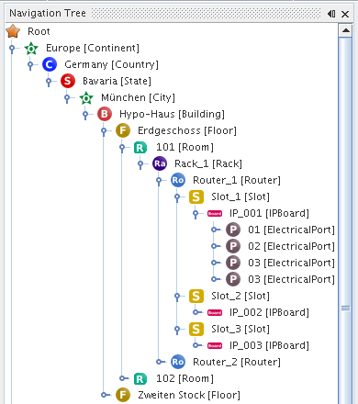Figure 1: Navigation tree

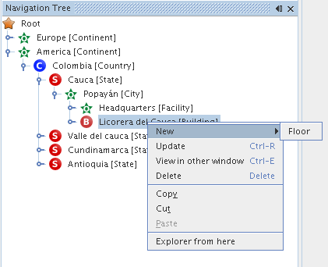Figure 2: Navigation tree. Object options

Each node represents an object, and it has actions associated:
- New: Creates a new object of a given class, depending on what was configured at the Containment Hierarchy Manager.
- Update: Refreshes the node's information
- View in other window: The default Properties window updates itself depending on what node is selected. If you want a property window showing the object's information permanently, choose this option.
- Delete: Deletes the current object and any object below it (if you delete a Country, it will delete states, cities, buildings and any other contained element as well).
- Copy/Cut/Paste: Usual actions, only applicable if the target object allows it (you can't cut a Rack and paste it into a Continent if the containment was not configured to support such operation). Important: The CTRL+C and CTRL+V shortcuts was disabled in version 0.2.1 due to technical issues, but you can use the context menu to perform these actions. It's also possible to move an object by dragging and dropping the selected element or making a copy of an object by holding pressed the CTRL key while you drag and drop it.
- Explorer from here: Spawns another window showing a tree whose root is the selected node. Useful to explore places located deeply into the hierarchy, like ports.
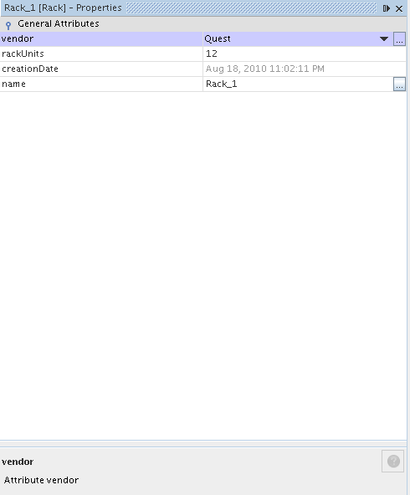Figure 3: Properties Window

The other window is the Properties Window as shown in the figure 11. This one displays the visible attributes and lets you edit them. Every change is automatically committed to the database once you hit “Enter”.

Important: Properties window is not opened automatically with the navigation tree. You have to open it by selecting the menu Windows → Properties.

Shortcut: CTRL+N

Hint: The navigation tree supports in-line editing. If you hit F2 when a single node is selected, you will be able to edit the object's name

Chapter 7. Object Physical View

This module is used to get presents a graphical representation of how elements are connected physically into the selected object. Currently version (0.3) only supports a default view, which is basically all direct children and the connections between them. Note: Only instances of subclasses of ViewableObject can use this module (i.e. ports don't have views). Please refer to the data model for details [9].

Before to show the general features in this module, it's important to make some concepts clear. This is a physical-only topology. It's only about cables, ports, etc. in order to support this scenario, the data model provides four entities (note: Although it's similar approach, the following concepts are not related to power connections, only communication ones):

Connections: These are all point-to-point links. In the current data model, there are three types of connections: ElectricalLink (for electrical connections like coaxial, twisted pairs and the like), OpticalLink (for fiber optics) and RadioLink (for radio links -WiFi, Microvave, WiMax, etc-).

Containers: All objects that can be used to contain, “conduct” and protect connections (understanding a “connection” as we defined above). There are two types of containers: WireContainer (used to contain all kind of cables -wires and fibers-) and WirelessContainer (used to contain radio channels or any other non-tangible medium).

Nodes: These are all those objects were a container can end. For this release there are seven possible classes: Tower, Warehouse, Facility, Shelter, Building, Floor and Room (in the data model context, all these are somehow subclasses of GenericPhysicalNode)

Endpoints: These are all those objects where a connection can end. In practice, they're all kind of ports (in the data model context, all these are somehow subclasses of GenericPort).

Important: You can only connect nodes using containers and endpoints using connections.

In order to use this module is necessary to have the Navigation Tree already opened, and every time a node is selected, the view for such element will be shown in the canvas. If you haven't saved previously a view for an object, the default place all children in a single line with a padding of 100 pixels between every child.

The figure below shows a custom view for a demo city. As this is an example, the container hierarchy defined has been simplified as well (Root → City → Building → OpticalPort)
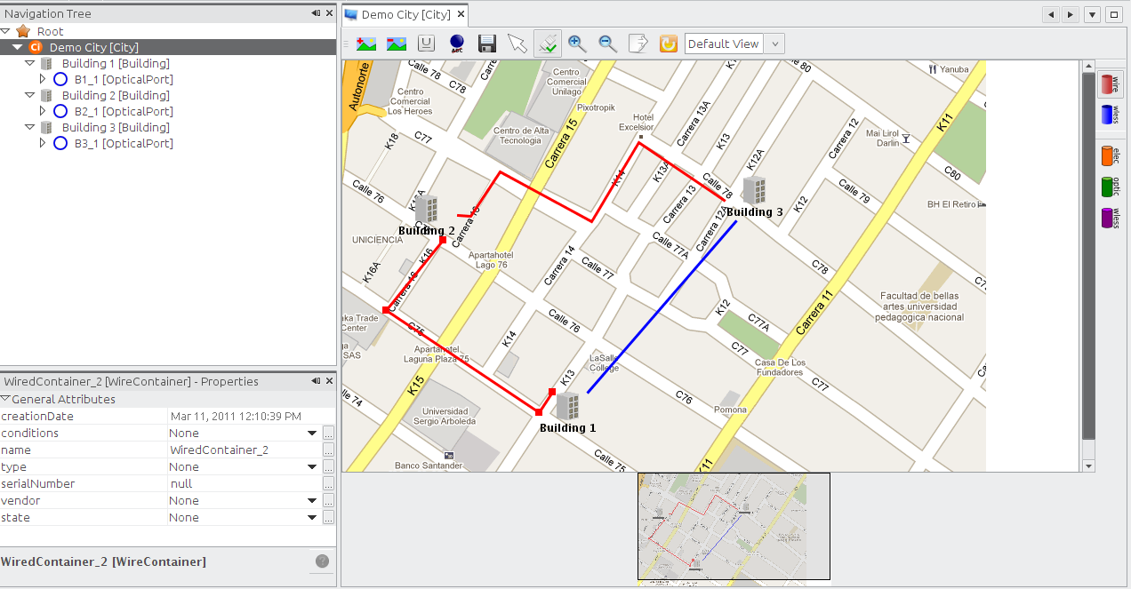Figure 1: Custom view for a demo city (the background is an image from GoogleMaps). It has two wired containers (red) and a wireless one (blue)
Add background
Remove background
Format text (font type, size and color for labels)
Show/hide the node labels
Save view
Select tool (used to move and select objects, it's selected by default)
Connect tool. Used to connect elements. Whenever selected, the “WireContainer” button is pushed automatically by default.
Zoom in
Zoom Out
Refresh view
Available views for the current object. By now, only the default view is listed. Future releases will include extra views.
Export view to JPG/PNG formats
Select it to create a WireContainer between two Nodes (). Tis option is selected by default
Select it to create a WirelessContainer between two Nodes
Select it to create an ElectricalLink between two endpoints (ports)
Select it to create an OpticalLink between two endpoints (ports)
Select it to create an WirelessLink between two endpoints (ports)

Example: If you want to connect two ports located in equipments inside different buildings using a cable (this is, an electrical transmission medium), press , then and finally click on the source building and drag the cursor to the target building as shown in figure 13:

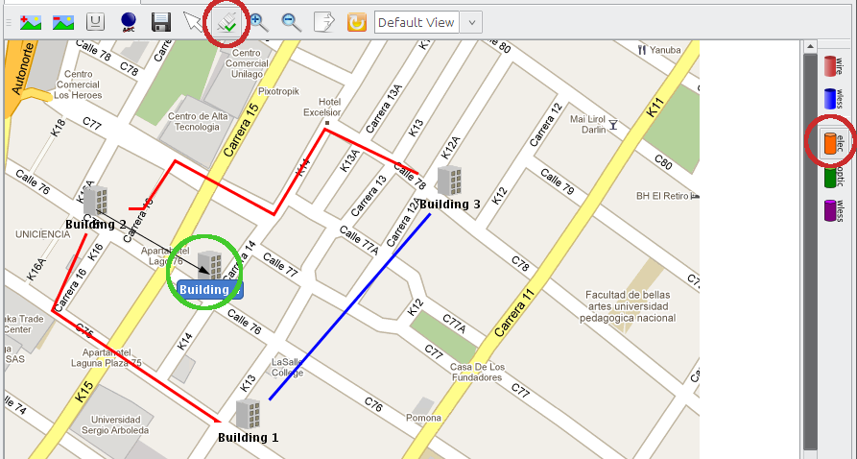Figure 1: Creating an electrical link
This will launch a wizard where you can select the port you want to connect and set the properties of the new object.

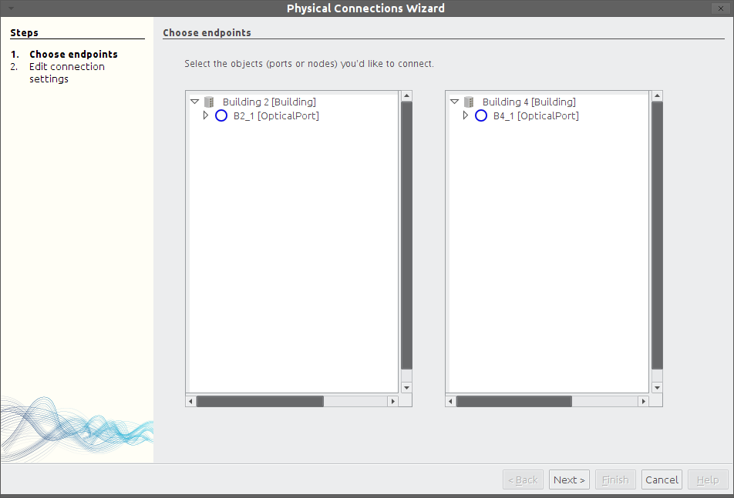Figure 1: Wizard to create an electrical link
You will get warnings if you try to connect the wrong elements. So far port mappings are not supported, so you can, for example, connect an electrical port with an optical one. This kind of constraints will be added future releases.

In the second step, you will be prompted for the basic information related to the new object to be created. These are the name and type. The type is a list that you customize in the List Type Manager (See Chapter 8). Just add whatever you need to the Electrical/Optical/WirelessLinkType and Wire/WirelessContainerType list (see figure below).
Note: If the item you add is not shown in the combobox when creating the connection, you may need to refresh the local cache ( button)

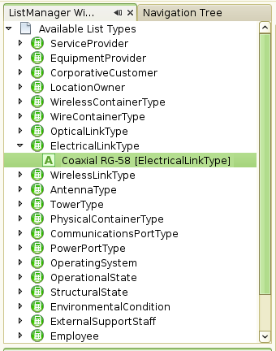Figure 2: Electrical link types

The wizard will look like this:

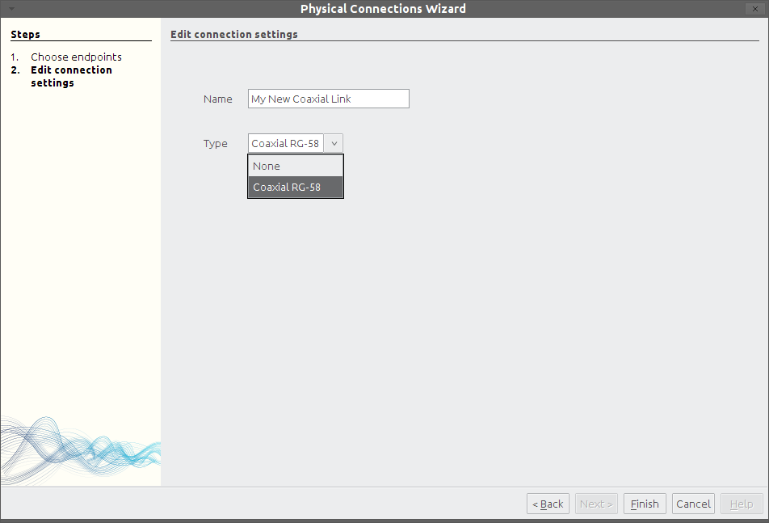Figure 3: Step two: Basic information

Then the action is confirmed and the view is updated:
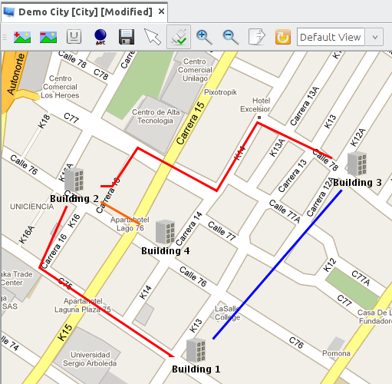Figure 4: Connection successfully created (orange)
It's also possible to add and remove control points to the connections. Control points are those breakpoints on the lines to change their direction to follow a path.
In some cases the background is just to dark to use a black font, or the default font it self is too small. You can format the text displayed using the format button . The changes will be persisted across sessions for all views.
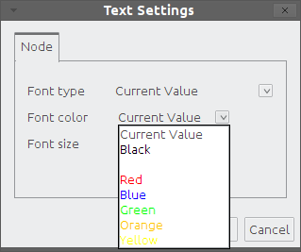Figure 5: Text format options

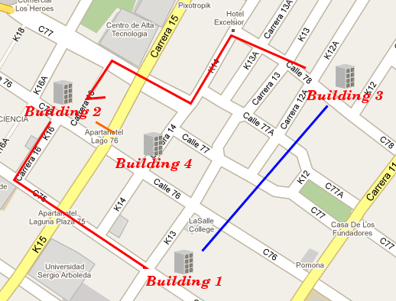Figure 6: Changing the text format
If at this point you wonder how to make a path for a connection, here is the answer:
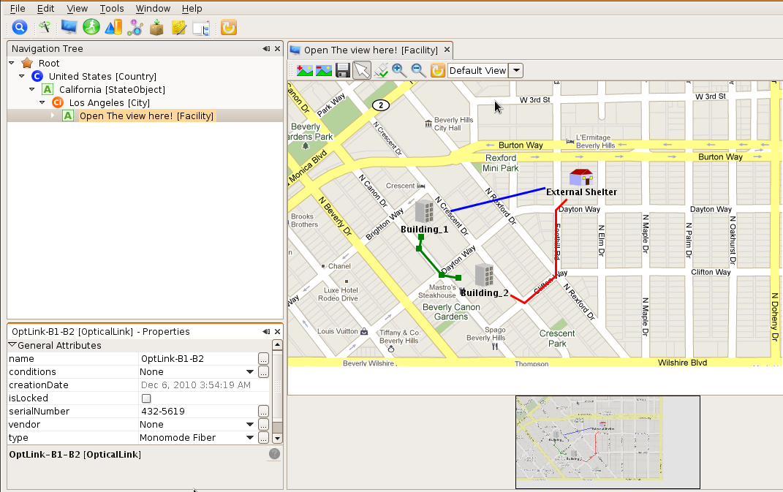Figure 7: A simple view with paths and control points
To see the detailed information about an object within the view you just have to select it using a single click, and it will be shown in the Properties Window. Once selected, you'll see the current control points. To add a new one double click the line representing the connection and move it as you wish. To remove a control point double click on the desired node as well.

Remember that every change in the connection path will mark the view as unsaved and you'll have to save it manually.

Shortcut: CTRL+SHIFT+W

Hint: The object physical view supports in-line editing. If you double click a single node, you will be able to edit the object's name.

Hint 2: If you create/delete an object in the navigation tree, you must refresh the view (button ) to see the new nodes.

Next versions: Future versions will include geolocation-aware views and views particular elements like racks (placing the elements inside depending on the “rackunits” attribute) so you can track the available space.

Chapter 8. Lists Manager
As commented in the chapter “Attribute Manager”, some attributes have a list type. The actual value is picked from a list of items. This is very usual when dealing with vendors or models.
You can create new list items by using the module called “List Manager”. This module consists of a simple navigation tree similar to the one seen in the last chapter.
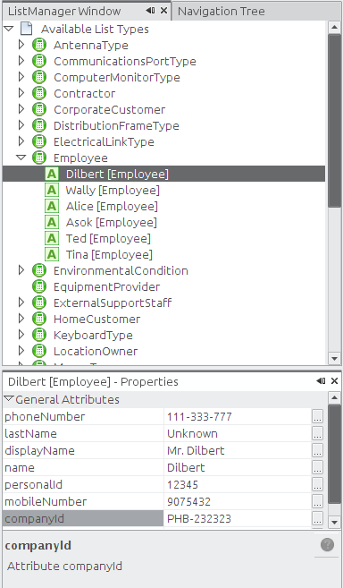Figure 1: List Manager main window

By right-clicking and choosing “New” over a selected list type, you can create new items. The details for every item can be edited using the standard Properties Window as seen in the past chapter.

If the changes are not inmediately reflected when editing an object, use the refresh cache button and update the object (Right click on the object node → Update).
Shortcut: CTRL+L

Hint: Selecting any node in the tree and writing a text string will attempt to search for a class or attribute starting with such string. If there are several matches, F3 will jump to the next one. The same applies to the list at the right panel.

Note: You may need to refresh the local cache ( button) if you change the name of any item so the change can take effect for already opened objects.

Chapter 9. Querying
As of version 0.3, a new graphical query editor was introduced, but the old one has been kept for at least two more versions.

Legacy Query Editor
This module is pretty simple and will be removed after version 0.5. The main window is divided in two: The right side panel shows a list of all classes that can be queried.
The left panel updates itself whenever you select a new item on the list, showing all the visible attributes for that class. At the left, every attribute has a checkbox. You have to select the ones you want to filter, afterwards, the attribute editor (text field, list, checkbox) will get enabled and you will be able to set your search criteria.
If you choose many attributes, the logical connector is AND. And if you select a text field, the comparison would act as a SQL “like” clause case-insensitive.
Begin search icon
Save search (not operational)

Example: You want to search for all racks whose brand is Quest and its name begins with “rack_”, you will have to select the attributes “vendor” and name, and select the appropriate value from the object list and put the text “rack_” on the field “name”.
The example in figure 21 shows a search for all States whose name contains the String “Cauca”. The results are shown in a component at the left.
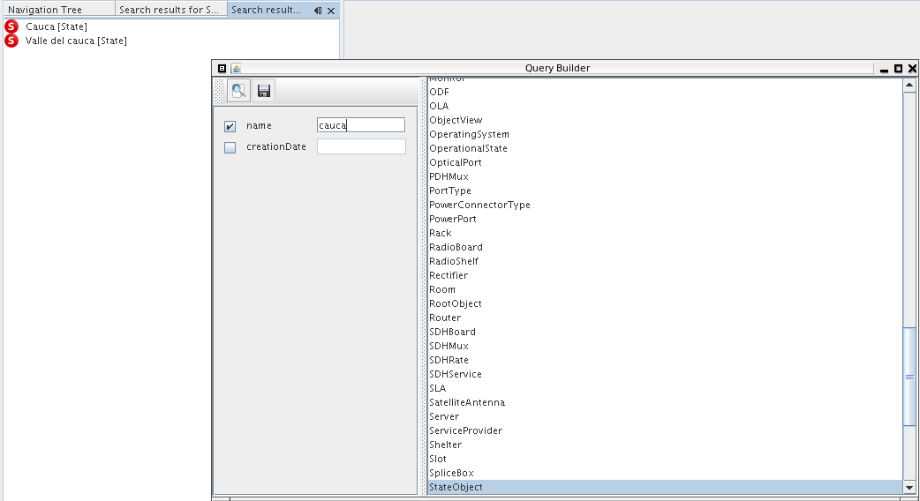Figure 1: Query module main window
Shortcut: CTRL+F

Hint: If you don't select any checkbox, it will search for all the elements of the given class within the database. Note: saving feature is not operational.

Graphical Query Editor
This is the new supported method to design and perform queries. It has a graphical interface, based on nodes to represent the search criteria and connections to express the relationships. Once selected, you will get a blank canvas with a toolbar on top with the following elements:
Figure 1: Graphical query editor general toolbar
Select the element class you want to search for. In this list you're going to find only business-related classes (network elements, cables, etc), not system classes (users, sessions, etc)
Open a previously saved query
Save the current query. The queries are stored in the database using an XML format [6]
Deletes a saved query or clean the canvas is it's an unsaved one
Cleans the current query (clear completely the canvas for temporal queries or clear all nodes but the root for saved queries)
Edit details about the current query (name, description and owner)
Organize the node automatically
Executes the current query.
The logical connector to be used to chain the query predicates. The default connector is AND.
Max number of results per page. The default value is 10. Only integer values are allowed.

When you select a class from the drop-down box, a graphical representation of it will be placed on the canvas
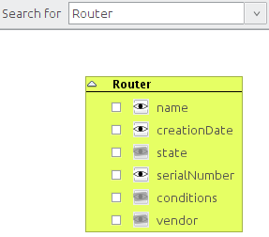Figure 2: Node added after selecting a class

In the example above the class Router was selected, and the corresponding node is created. You can search for a wider range of elements if you select an abstract class (often called GenericSomething). In the example above will search for all Routers in the database, but if you choose GenericPhysicalNode it will search for all physical nodes, this is, all objects that can be connected using a container (see Chapter 7 Object Physical View for more information about containers). That includes: buildings, rooms, floors, towers, shelters and facilities. Note that the root class node is colored green
Note: If you want to see all objects in the database (at least all relevant to the inventory) search for InventoryObject, which is the root of all classes related to the inventory. To see the complete hierarchy see related javadoc in the final chapter [7].
Back to the original example, if you just leave the router without modifications and execute the query , it will search for all routers available in the database and it will show only a column with the object's display name
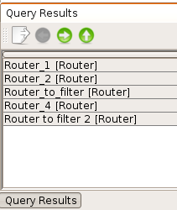Figure 3: Query results for all routers

The window above is shown at the bottom of the main window and also has a tool bar with the following buttons:
Export the results to popular formats like CSV, XML,ODT and DOC (Only operational for XML and CSV so far)
Previous page
Next page
All results

Now, if we want to see more fields related to the found elements, we should use the “field visibility icons”. They're those eyes you can see along with the attributes names (). By default none of them are selected, which means that no additional fields will be shown in the result list but the objects themselves. Think of them like the parts of a conventional SQL sentence that follows the SELECT clause:
SELECT creationDate, serialNumber FROM Router
You can obtain a query like this pushing the toggle buttons with the eyes on it beside “serialNumber” and “creationDate” just like the figure below

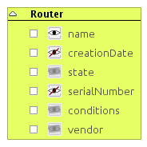Figure 4: creationDate and serialNumber to be shown in the result list

When selected, the visibility icon turns into an eye crossed by a red line (). If you don't want this attribute to be shown in the result list, press it again. This is what you will see when you execute the query:
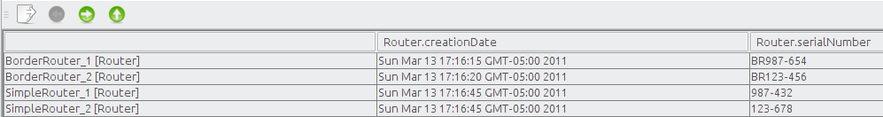Figure 5: Result set showing some fields
Now you may be wondering why the attributes “vendor”, “conditions” and “state” have their visibility icons disabled. That's because they're list type attributes (See Chapter 8. List Manager for details about list type attributes). Making again a comparison SQL, these attributes are related to other “tables” (other classes, actually). You have two ways to use these list type attributes as criteria: the first is just selecting the attribute's checkbox and choosing from a list the value that you'd like to use:
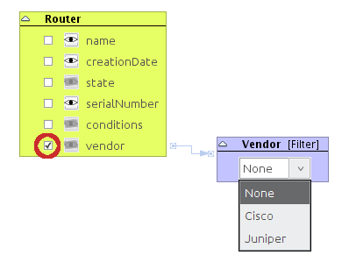Figure 6: Using a list type attribute as filter
Or you can pick manually what fields belonging to the relationship must be included in the result set. To do this, you first have to toogle the simple class node filter (in our example labeled as “Vendor [Filter]”) to a detailed view. You can do by right-clicking on the node's header and choosinig the option “Toggle Simple/Detailed view”:
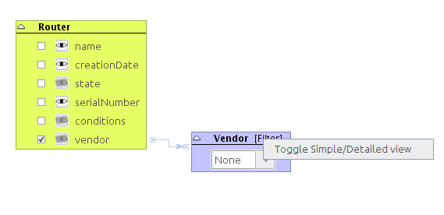Figure 7: Changing the detail level on a class filter
The result is a node similar to the root one, but colored light orange ():
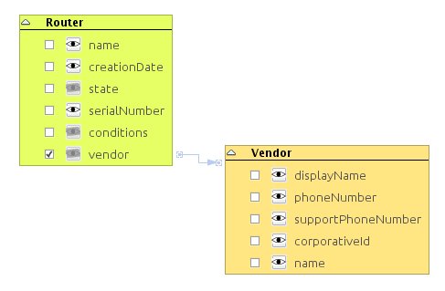Figure 8: Expanded class node filter
You can toggle the node to the original fashion by repeating the procedure.
Example: We want to search for all routers and we want to see the fields creation date, serial number, vendor and operational state. That would be:
- Enabling the visibility icon for the attribute “creationDate”
- Checking the checkbox in the attributes “vendor” and state and expanding the resulting nodes (we'll talk about the checkbox later in this chapter)
- Enabling the visibility icon for the attribute “name” in both newly spawned nodes.
Let's see this in a picture:
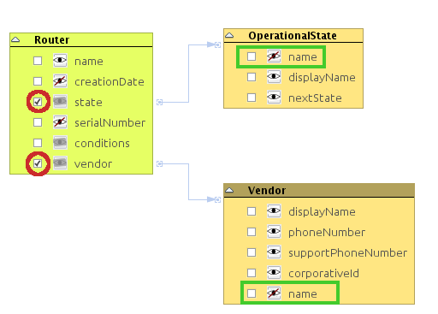Figure 9: Simple query showing three fields from different classes
Resulting in a set like this:
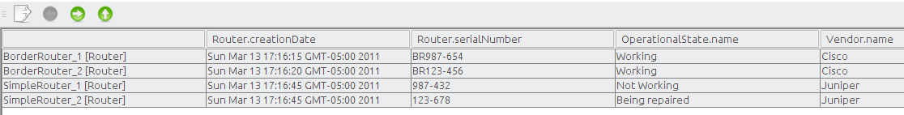Figure 10: Result set for the last query
Note: The operational states and vendors were created using the List Manager (under OperationalState and Vendor, respectively) and their properties set in the Properties window.

The question now is “what are those checkboxes for?” Well, they're used to construct the query predicates. Every time you select one of them, a new node is spawned. If the attribute is a basic one (String, Integer, Float, Boolean or Date), you will get a node like these (otherwise you will get the class nodes seen above):

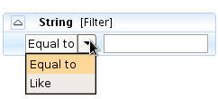Figure 11: Filter for Strings

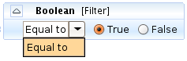Figure 12: Filter for boolean values

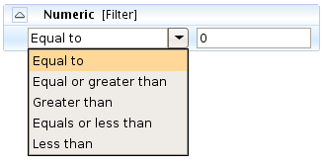Figure 13: Filter for numeric values (integers and floats)

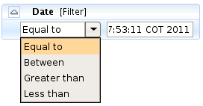Figure 14: Filter for dates (not operational yet)

You can chain as many class nodes as you need (they will act as a JOIN statement is SQL). Important: In version 0.3 this JOIN is an INNER JOIN, in next releases it will be changed to a LEFT JOIN (due technical issues related to the JPA backend ).
Example 2: We're going to search for Routers whose name contains the string “border” and the operational state is equal to “Working” and have Cisco as vendor. The fields to be shown must be “creationDate” and “operationalState”. Note tha the result limit is set to 1 per page.
The query would look like this:
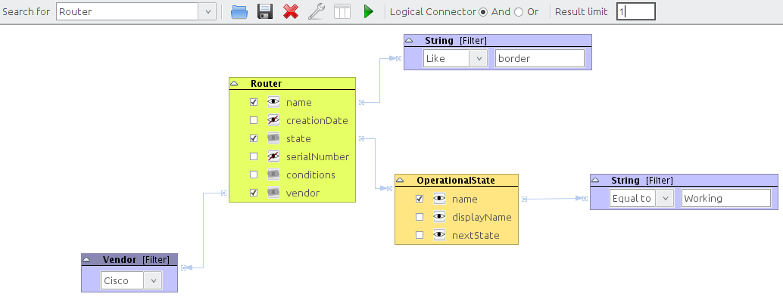Figure 15: Complex query using an AND logical connector
Please note that the condition “Equal to” is case-sensitive, while “Like” it's not.
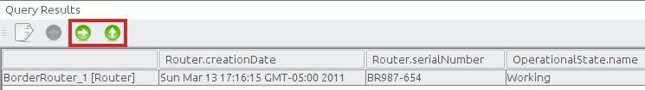Figure 16: Result set for the complex query
If you hit the “Next Page” button () you will get the second result and so on. The “Show all” button () will retrieve the full list of results.

Exporting results
You can export the results in four formats: CSV, XML, Microsoft Word (DOC) and Open Document Text (ODT). So far is only possible to export to CSV and XML. This is done by pressing the Export icon (), which will open a window to choose the location of the output file and the format:
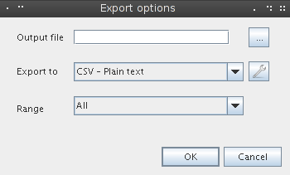Figure 17: Search results export options

Output file contains the destination (once you choose a directory with the file chooser, a random name will be generated, but you can change it as you wish). Note that writing file the extension is not mandatory, since it will detect the type and append the extension before to save the file.
Export format to let's you choose the output format. The configure button () lets you set some particular options regarding to the selected format. Currently only CSV has advanced options:
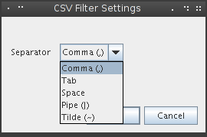Figure 18: CSV filter settings

There you can choose the separator character between fields. The available options are: Comma(,), Tab ( ), Space ( ), Pipe (|) and Tilde (~).
Finally Range is used to specify whether whole results should be exported or only the current page.
Note: The XML structure used to export the results can be checked here[6]

Saving and restoring queries
The queries can be saved as public or private. It's probable that someone wants to execute the same query on a regular basis and if that's the case for many users, he/she would want to let other users to use the such query. After you design a query, you can save it and this small window will prompt for some basic information:
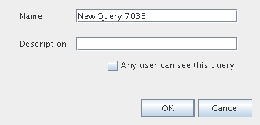Figure 19: Setting the query metadata before to save it

Name is the query name.
Description is the query description
The last check box lets you to make the current query public. By default, the query is private, so you don't pollute the list of available queries for the rest of the users.
You can change these settings anytime using the configure button().
To open a query, just use the open button(). Then you will be asked if you want to see only your queries or both your queries and the public ones:
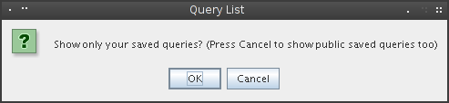Figure 20: Dialog to choose what queries should be listed
Answering “Cancel” will show you both. “OK” will list only those owned by you.

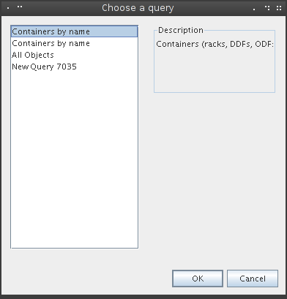Figure 21: List of available queries

Now you just have to select the one you need and you're done!
Important: Please note that when a query is saved the values used to filter won't be saved, since the filter nodes are used as open parameters. For example:
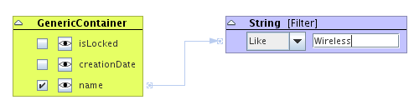Figure 22: Example of a parametrized query
In the query above, the value “Wireless” won't be saved anywhere. Just the structure and the condition (“like”, in this case). The blue box is a parameter. It's supposed that you will fill it with the value you need depending on what you're looking for.

Hint: You can sort the search results by right-clicking the column header (this will perform an alphabetical sort)
Note: Every time you run a query, a new window with the results will be opened, so don't forget to close those you don't need to save memory.

Chapter 10. User and Group Management
This feature lets you define new application users and relate/unrelate them from application groups. By default there is only one user (admin, password kuwaiba) and no groups. You can edit everything, even its username.
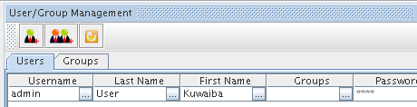Figure 1: User/Group Management main window

The module shows three buttons at its own toolbar:
- Add user: Adds a new user. It's placed at the end of the list and its name is a composition of the string “user” and a random number between 0 and 10000.
- Add groups: Adds a new group. It's placed at the end of the list and its name is a composition of the string “group” and a random number between 0 and 10000.
- Refresh: Refreshes the selected tab (users or groups)
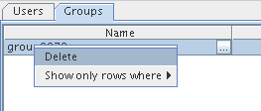Figure 2: Deleting a group

If you want to delete an user or a group, just right click the element and choose “Delete”. Deleting a group won't delete the related users.

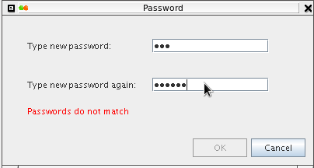Figure 3: Changing a password

If you want to change an user's password, click the button in the “Password” or “Group” column and a custom editor will be shown.
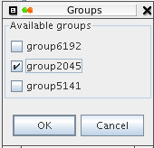Figure 4: Changing an user group association

Currently is only possible to add/remove groups to/from a user (not vice versa)
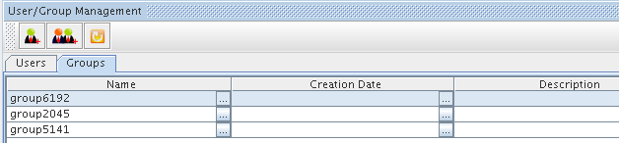Figure 5: Group list

Shortcut: CTRL+U

Hint: Selecting any node in the tree and writing a text string will attempt to search for a username with such string. If there are several matches, F3 will jump to the next one.

Resources
[1] Definition of Asset. http://en.wikipedia.org/wiki/Asset
[2 ] Overview of ITIL. http://en.wikipedia.org/wiki/ITIL
[3] Thread to request changes in the data model https://sourceforge.net/projects/kuwaiba/forums/forum/1129209/topic/3734242
[4] Client installation instructions http://kuwaiba.sourceforge.net/index.php?option=com_content&view=article&id=58:client-instructions&catid=38:user-documentation&Itemid=55
[5] Object Oriented Programming. http://en.wikipedia.org/wiki/Object-oriented_programming
[6] XML in Kuwaiba. https://sourceforge.net/apps/mediawiki/kuwaiba/index.php?title=XML_Documents
[7] Class hierarchy http://kuwaiba.sourceforge.net/javadoc/server/ejb/overview-tree.html
[8] Class inheritance http://en.wikipedia.org/wiki/Inheritance_%28object-oriented_programming%29
[9] Picture showing the data model as a class hierarchy tree
http://kuwaiba.sourceforge.net/images/model_03final.gif

