Kuwaiba Open Network Inventory
Version 0.1 [07.02.2012]
Network Layer Model

Please visit http://kuwaiba.sourceforge.net for documentation, latest updates and upcoming events

Change History
Responsible | Description | Date | Reviewed by
Charles Bedón  charles.bedon@kuwaiba.org | First version aimed to be the base for the 0.4.x series network layer elements support | February 10th 2012 | Adrián Martínez  adrián.martinez@kuwaiba.org

License
This document is published under the terms of a license Creative Commons by-nc-sa. You can find details about it at
http://creativecommons.org/licenses/by-nc-sa/2.0/
 | Kuwaiba Server and Client are licensed under EPL v1. You can find the whole text of this license at  http://www.eclipse.org/legal/epl-v10.html

Disclaimer
Some brands are mentioned as example for different types of equipment. This project is not endorsed to any of the related companies and they're the sole owners of such brands.

Chapter 1. Network Layer: Relevant Concepts
Kuwaiba uses the OSI model [1] as a base to define its different data models. The third tier included in such model is precisely the Network Layer. It deals with all the elements in charge of finding a proper route between two endpoints in a communication. The most important protocol in this layer is IP (Internet Protocol) and it's the base for this model.
In this scenario, we can identify four types of elements:
- Logical Connections: IP is a connectionless protocol, which means that there's no a fixed path (i.e. a virtual circuit) for every single “conversation” between two hosts. The packets are routed by network elements (typically routers) depending on certain parameters and routing protocols. Although there are no dedicated paths, in order to visualize the network layer topologies it's usual to represent the connections as point to point links picturing a hop in the route (See CiscoWorks® LMS).
- Logical Items: Logical resources that should be related to a service provided to a given the customers. We can include in this group VLANs and VPNs. Although a VLAN is more a layer 2 concept, it's mentioned here since it's easier to put it in context when talking about layer 3 elements. Within this group are also included the network addresses (which are a technological asset) and/or subnets.
- Network Elements: This is the equipment (hardware) necessary to accomplish network layer tasks, such as routers, layer 3 switches or hybrid appliances like most firewalls or redirectors.
- Endpoints: These are the actual points where a logical IP “conversation” ends. In this context, the most accurate term to describe them is network interfaces. These endpoints are identified by network addresses. A single physical port may have many addresses assigned.
- Administrative items: Due to the growing convergence, most of the traffic (voice, video, data, etc) is now routed through packet switching networks. It's clear that real time services should have priority over others and that some customers have higher expectations in terms of quality and reliability. For that reason emerges the concept of “Quality of Service” (to be fair is an old expression, but it has taken a special relevance in the last years). The whole point of it is to establish well known levels on the quality of the service that is being offered according to parameters agreed between the the consumer and the service provider. These agreements are represented by contracts that are commonly known as “SLA” (Service Level Agreement). In the context of frameworks such as ITIL there's also another type of contract called “OLA” (Operations Level Agreement) which is subscribed between parties inside the same organization to ensure a service level in order to make the internal processes to flow properly.

Chapter 2. Data Model
In this chapter, we'll explore the Class data model conceived in order to implement the network layer considering a scenario as described in the past chapter. The following diagram shows the general class diagram used to support the network layer module. Zoom in as you need or get the last version from the SVN tree [2].

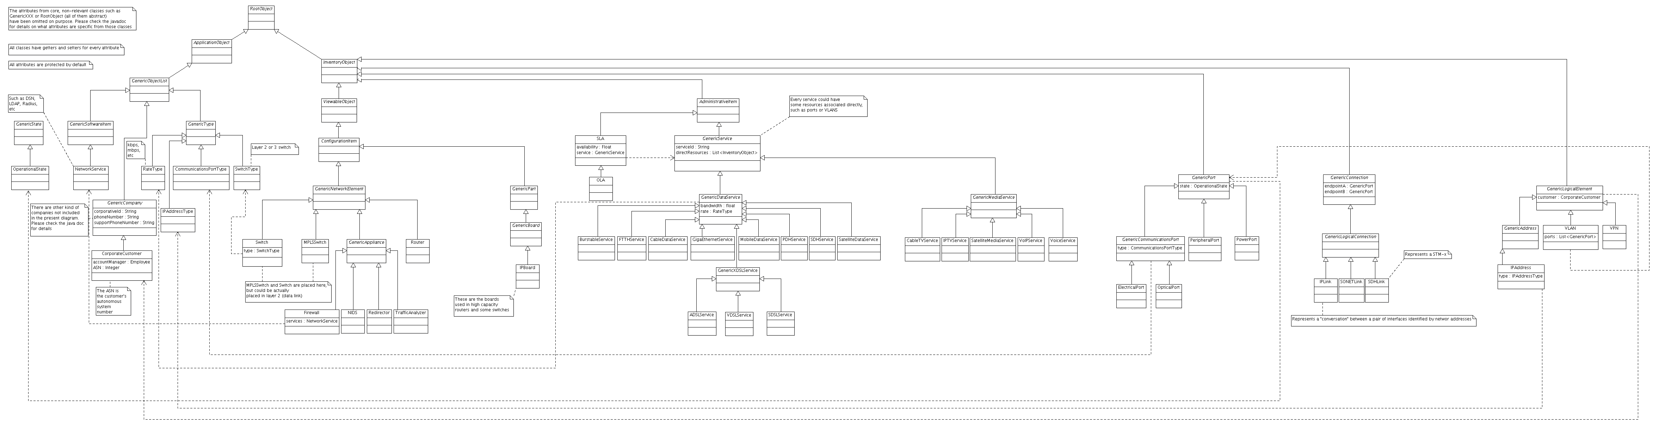Figure 1: General Class Diagram (zoom in for details)

In the figure 1 we can see the 5 types of elements mentioned in the past chapter. The root class for all network layer equipment is GenericNetworkElement, which has as subclasses all the commonly used gear, such as Routers or appliances. Switch has been included in this model even when it's actually a layer 2 equipment since most of the switches deployed nowadays have layer 3 capabilities. In order to identify if a given instance is a layer 2 or layer 3 switch, it's recommended to create a new SwitchType instance and set the attribute “type” of such switch to the corresponding value. The boards which could be inserted into a network layer equipment are called “IPBoards” and are classified as parts (subclasses of GenericPart and GenericBoard), and should be configured as possible children of Slot or any of the GenericNetworkElement in the Containment Manager. As for the endpoints, they will be treated as simple ports.

The IP “connections”, represented by the class “IPLink” will have two endpoints, which are in the end, two network interfaces. As a network interface may have many IP addresses assigned, many IPLinks can reach a single network interface (port), but there will be a unique link between a pair of network addresses. As stated above, this kind of links have only visualization purposes.

Any kind of service may have a SLA, but the relationship is unidirectional and the service is not aware of SLAs associated to it. This has been designed like this because a service doesn't have to have an actual SLA (i.e VoiceService). The same situation applies for VLANs, VPNs and IPAddress instances. They're related to a customer (a CorporateCustomer to be accurate) but the customer doesn't really know that it has any of those elements associated.

The present model is quite simple. In short it can be described like this: Network equipment like routers or switches (represented by classes Router and Switch) may contain inside Slots or IPBoards. These boards in turn, can contain ports (ElectricalPorts or OpticalPorts). These ports have IP addresses assigned, and those ones are written directly in the attribute “name” or “label” of such port, making them network interfaces. Those network interfaces are connected via IPLinks, which are logical constructions whose endpoints are a pair of network addresses assigned to physical ports. The objective of such constructions is to visualize network topologies like the one in the figure 2 (screenshot taken from a Nagios interface).

The VPNs, VLANs and IPAddresses are related directly to the customer, just like the services. Finally, SLAs are related to those services. In addition, VLANs use a set of ports.
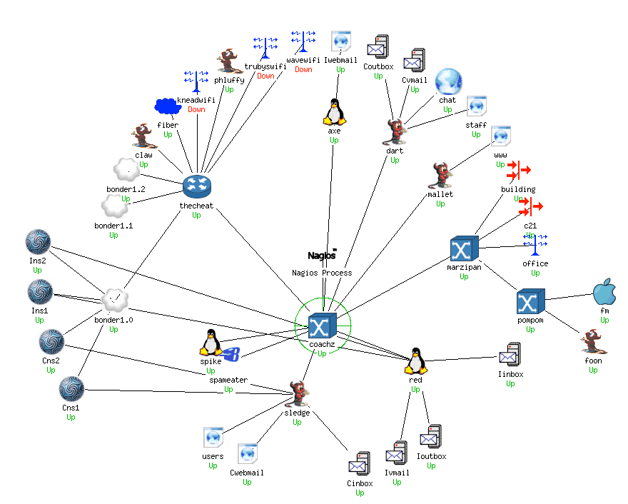Figure 2: Kind of topology that can be constructed using the current model (screenshot taken from a Nagios setup)

Chapter 3. Types
In this chapter we will detail the types and object list items proposed.

Name | Class
Kbps  Mbps  Gbps | RateType
Please Refer to the Physical Layer Model for details [2] | CommunicationsPortType
Layer 2  Layer 3 | SwitchType
IPv4  IPv6  IPv4 subnet  IPv6 subnet | IPAddressType

Miscellaneous object list items
Name | Class
Operational  Being repaired  Not Operational | OperationalState
DNS  LDAP  Web  Samba  NFS  FTP  Remote Shell  Database  Mail | NetworkService

Resources
[1] OSI Model.http://en.wikipedia.org/wiki/OSI_model.
[2] Documentation in the SVN tree. https://kuwaiba.svn.sourceforge.net/svnroot/kuwaiba/docs

