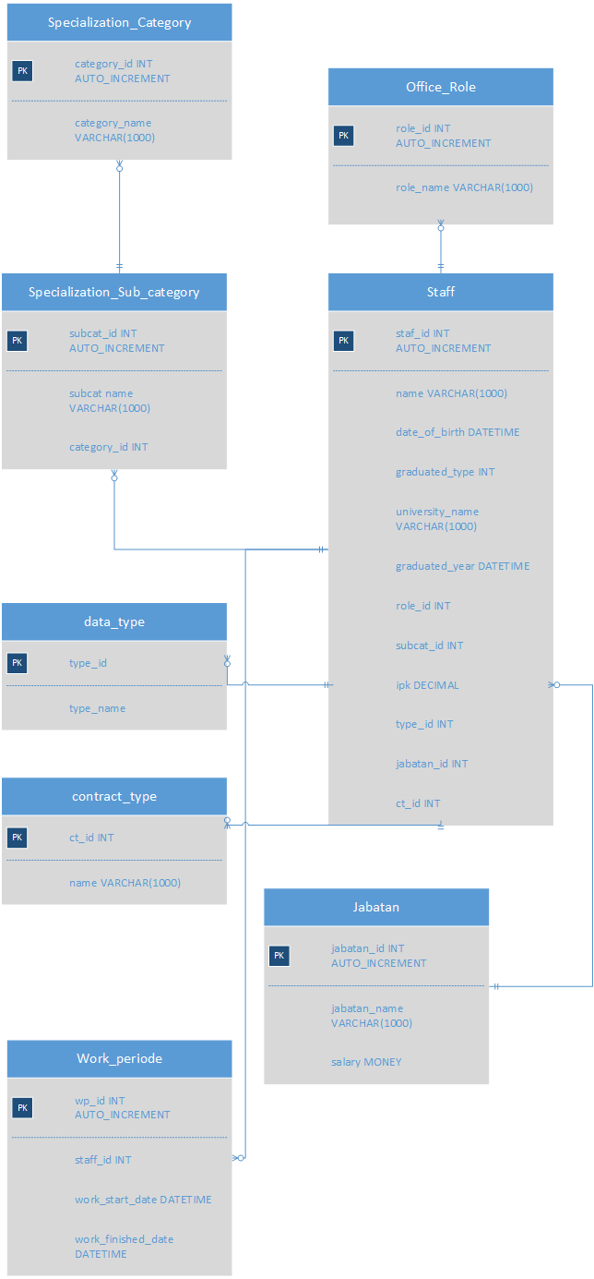
Sample Table

- Sector

category_id | category_name
1 | Civil
2 | Architecture
3 | Urban
4 | M/E

- Subsector

subcat_id | subcat_name | category_id | Category_name
1 | Road | 1 | Civil
2 | Rail | 1 | Civil
3 | Airport | 1 | Civil
4 | Port | 1 | Civil
5 | Building | 2 | Architecture
6 | Mobility | 3 | Urban

- Project_Role

Role_id | Role_name
1 | Education
2 | Design
3 | Management (Profit)
4 | Management (Skill)

- Data_Type

Type_id | Type_name
1 | Row Data
2 | Confirmed
3 | Updated

- Contract_type

Type_id | Type_name
1 | Permanent
2 | Outsourced
3 | Contract
- Posisi

Jabatan_id | Jabatan_name | Salary
1 | Junior | 3000usd
 | Middle | 8000usd
3 | Senior | 30000usd
4 | Supervisor | 50000usd
5 | Management | 70000usd
6 | Senior Management | 100000usd
7 | General Management | 200000usd
8 | Director | Share

- Expert

Staff_id | Name | DOB | Graduated_type | University_name | Graduated_year | Role_id | Role_name | Subcat_id | IPK | Type_ID | Jabatan_id
1 | John | 22/10/1970 | Diplomae | MIT | 1990 | 1 | Education | 1 | - | 1 | 1
2 | Joan | 21/05/1977 | Bachelor | Cambridge_university | 1995 | 1 | Education | 1 | 3.65 | 1 | 1

- Working_periode

WP_id | Staff_ID | Staff_name | Work_Start_Date | Work_Finish_Date
1 | 1 | John | 22/01/2019 | 22/11/2019
2 | 2 | Joan | 22/02/2018 | 15/11/2019

- History WP

