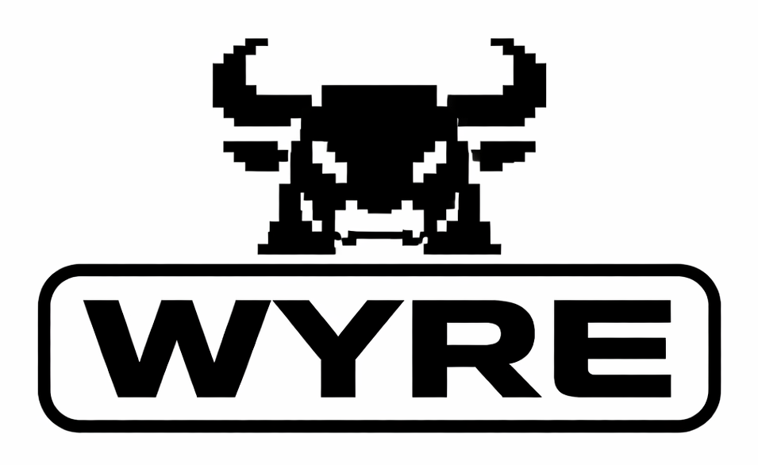

Advanced Amiga
Analyser
  - 2026 reproduction of the original manual
A Wyoretro reproduction
Reconstructed operating edition v0.9
Original product and manual by Wilcom Australia
Historical distribution and support by Grapevine Group
https://wyoretro.com
13 October 2026

About this reproduction
Wilcom Australia hardware and software
Wyoretro reproduction v0.9 • 13 October 2026
Use this guide to check Amiga ports, free memory, floppy drives and audio, and to inspect the system configuration. It explains how to connect the supplied dongles, run each test and interpret the results.
Scope This is a modern operating guide derived from the surviving original manual photographs. It is not a facsimile, a Wilcom release, or a substitute for the service manual for the particular Amiga under test. The original interface illustrations may differ from the locally preserved disk labelled v2; use ABOUT to record the version actually running.

Before you connect anything
Power off Switch the Amiga off before you connect or remove any dongle. Also switch it off before you reconnect the mouse or RGB monitor.
Disk data READ/WRITE writes to the selected floppy disk. Use a disposable test disk whose contents can be lost. Do not use an original software disk or the only copy of any data.
Test results A successful test applies to the functions and conditions tested. It does not prove that the whole computer is fault free. Record the software version, connections and test duration.

Find a procedure
Page | Subject
3 | Identify the hardware and indicators
4 | Connect the hardware and start the software
5–6 | Use the interface and test the game ports
7–8 | Test the parallel and serial ports
9–10 | Test free memory and interpret results
11–12 | Test floppy drives and compare drive alignment
13–14 | Check video port power and test audio
15–16 | Inspect configuration and investigate failures
17 | Record the results
18–19 | Source credits and reproduction notes

Identify the hardware
Identify each dongle by its label before connecting it. The photograph shows one surviving set; check the labels on the set in use. A missing, incorrect or damaged dongle can prevent a valid result.
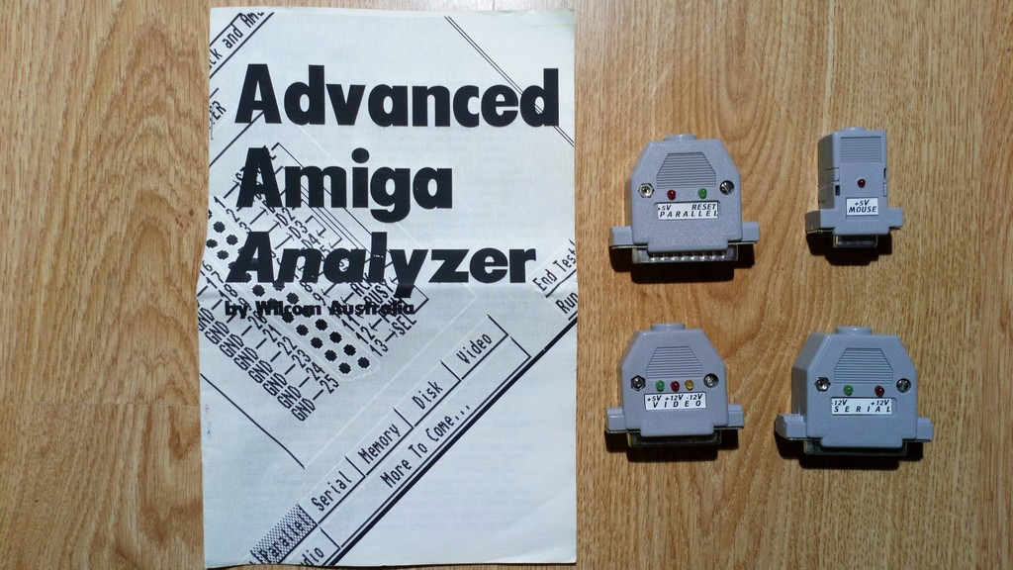
Original hardware photograph P03. The manual is at left. Parallel and mouse dongles are above the video and serial dongles.
Dongle | Purpose | Visible labels
Parallel | Signal test and indicators | +5V, RESET
Mouse or game | Game port power check | +5V
Video | Video port power check | +5V, +12V, −12V
Serial | Signal test and indicators | −12V, +12V
Voltage labels identify the rails associated with the indicators. An illuminated LED is an indication of power presence, not a calibrated voltage measurement or proof of performance under load. The RESET label is visible, but its expected behaviour during testing is not explained in the surviving pages.
The original introduction says that A1000 tests require gender changers. Check connector fit and the correct adapter wiring before use. Never force a connector.
Source: P03 hardware photograph; P06 introduction. Indicator measurement limits are modern explanatory guidance.

Connect and start

Prepare the test
Have the Analyzer hardware, a bootable copy of its software disk, a working display, a known-good mouse and joystick, and speakers available. For drive tests, also have a blank formatted 3.5-inch 880 KB test disk. Preserve original disks and use working copies.
Inspect the connectors for bent pins or damage. Confirm that every dongle matches its intended port. Close other applications that may use the ports before testing.

Check the port power
1. Switch the Amiga off.
2. Disconnect the mouse and the RGB monitor as required to fit the game and video dongles.
3. Connect the correctly labelled dongles to the corresponding ports. Fit any required, verified adapters while power is off.
4. Switch the Amiga on and observe the power indicators. A video power check does not require a picture on the disconnected RGB monitor.
5. Record any power indicator that does not illuminate. Switch the Amiga off before inspecting or changing a connection. Do not treat an unexplained indicator as a confirmed motherboard fault.
6. When the power check is complete, switch the Amiga off. Remove the game and video dongles. Reconnect the mouse and monitor. Leave the parallel and serial dongles fitted for their signal tests.
Indicator interpretation The original introduction broadly refers to all LEDs lighting. This edition distinguishes the labelled power indicators from the parallel RESET indicator, whose behaviour still needs verification.

Start a test session
1. Insert a working copy of the Analyzer boot disk and switch the Amiga on. Start the Analyzer if the disk does not launch it automatically. The exact startup sequence depends on the disk copy.
2. Select ABOUT and record the software version. Record the Amiga model and configuration.
3. Choose the required test. Use HELP for information about that test.
4. Select RUN TEST. Watch the first cycle and record any error exactly as shown.
5. Select END TEST when the required checks are complete. Record the elapsed time or pass count.
6. Before changing external hardware connections, end the test and switch the Amiga off.
Source: P06 introduction and interface; P07 ABOUT and window controls. Inspection, working-copy and recordkeeping steps are modern operating guidance.

Use the interface

Select and control a test
The test buttons are arranged in two rows at the lower left. Select a button to change the test. A greyed button means that the Analyzer could not allocate the hardware required for that test; it does not by itself establish a hardware failure.
Control | Action
RUN TEST | Start the selected test.
END TEST | Stop the current test. Tests normally continue until stopped.
HELP | Open help for the current test.
ABOUT | Show product and software version information.
Window close gadget | Exit to the environment from which the Analyzer was started.
Connector pin diagram | Click a pin for signal and associated hardware information.
Hardware suggestions in the original program are primarily based on A2000 schematics. Motherboard layouts and revisions differ. Confirm a component location against the service information for the actual machine before attempting a repair.
Source: P06 and P07, original section 2.

Game Port Tester
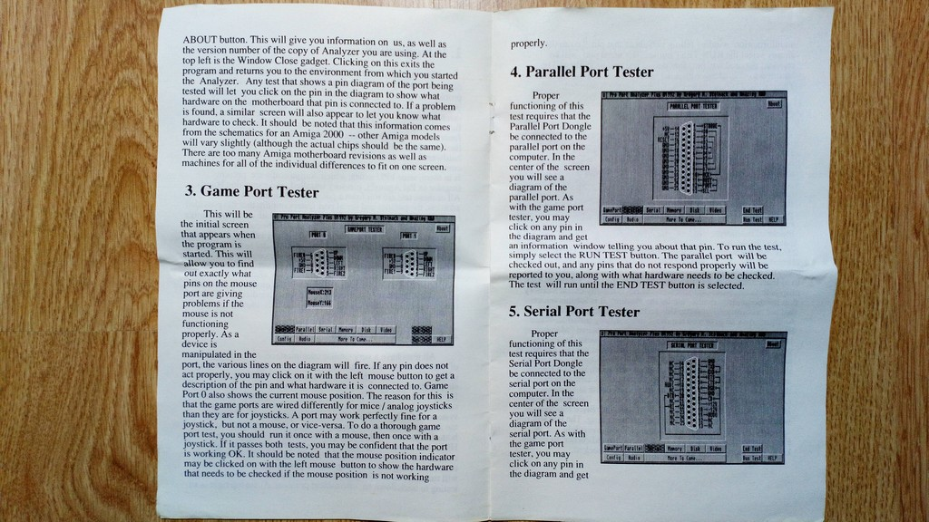
Game Port Tester reproduced from original manual photograph P07.
This is the initial screen when the program starts. It shows changes in the signals as a mouse or controller is operated. Port 0 also shows mouse position. Mouse and analog joystick operation uses different circuitry from a digital joystick; one device working does not establish that the other will work.
1. With power off, connect a known-good mouse to the port being checked. Start the Analyzer and select the game port test.
2. Move the mouse and operate its buttons. Observe the corresponding signal activity. For Port 0, check the displayed mouse position.
3. Click a signal pin that does not respond to read its description. If mouse position is wrong, click the mouse position indicator for the associated hardware guidance.
4. Switch the Amiga off before changing the device. Connect a known-good joystick.
5. Restart the Analyzer. Operate each joystick direction and button, and observe the signal activity.
6. Repeat for the other port as appropriate. Record the device and port for each result.
If a response is absent, compare with another known-good input device before concluding that the port is defective. Use another working control method if the mouse port under test cannot operate the interface.
Source: P06 and P07, original sections 2 and 3. Device substitution is modern diagnostic guidance.

Parallel Port Tester
Parallel Port Tester reproduced from original manual photograph P07.
The parallel signal test requires the supplied Parallel Port Dongle. A printer or ordinary cable is not a substitute. The central connector drawing gives access to information about individual pins.
1. Switch the Amiga off. Disconnect external equipment from the parallel port and fit the correct Parallel Port Dongle.
2. Start the Analyzer and select the parallel test.
3. Click a connector pin if you need its signal description or associated hardware information.
4. Select RUN TEST. Observe the reported failures.
5. For each failure, record the pin or signal exactly as displayed, together with the suggested hardware to check.
6. Select END TEST. Switch the Amiga off before removing or reseating the dongle.
The test continues until END TEST is selected. For an intermittent problem, record the running time as well as the result.
Source: P07, original section 4.

Serial Port Tester
Serial Port Tester reproduced from original manual photograph P07.
The serial signal test requires the supplied Serial Port Dongle. Its operation is similar to the parallel test.
1. Switch the Amiga off. Disconnect external equipment from the serial port and fit the correct Serial Port Dongle.
2. Start the Analyzer and select the serial test.
3. Click a connector pin to inspect its signal and hardware information.
4. Select RUN TEST. Record any failed pin or signal and the accompanying hardware guidance.
5. Select END TEST when finished. Switch the Amiga off before changing the connection.

If a port test is unavailable or fails
A program that used the serial port may not have released it. Exit that program and restart from the Analyzer disk. If the test becomes available, repeat it with the correct dongle.
If a signal fails, first check the dongle identity, connector condition and fit with the power off. Repeat under the same conditions. A failed test can implicate the dongle, connector or computer; the software suggestion alone does not isolate the cause.
Repair boundary Use the correct machine schematic for further electrical diagnosis. The surviving sources do not establish the loopback wiring needed to build or validate a replacement dongle.
Source: P07 and P08, original sections 4 and 5; P06 on hardware allocation. Fault isolation and repair boundary are modern guidance.

Test free memory
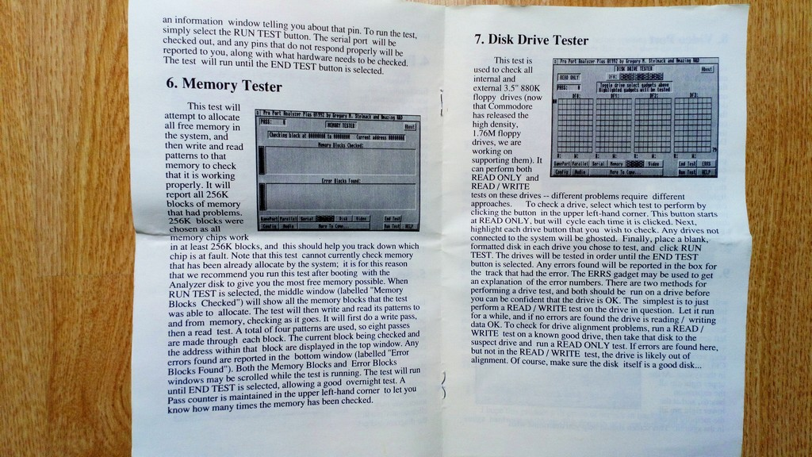
Memory Tester reproduced from original manual photograph P08.
The Memory Tester attempts to allocate all free memory and checks it by writing and reading patterns. Memory already allocated by the operating system cannot be tested. Booting from the Analyzer disk maximises the available memory, but does not make this a test of every installed byte.

Run the test
1. Boot from a working copy of the Analyzer disk with as little other software running as practical.
2. Select the memory test and then RUN TEST.
3. Record the memory regions or blocks shown in Memory Blocks Checked. These are the regions the program was able to allocate.
4. Watch Error Blocks Found and the current address display. Record any reported failing block or address exactly.
5. Let the test run for the required observation period. Record the pass count and elapsed time.
6. Select END TEST. Save the observations before exiting or restarting.
Source: P08, original section 6. Result interpretation continues on the next page.

Interpret memory results

Read the displays
Display | Meaning
Memory Blocks Checked | Allocated regions being checked; the window can be scrolled during testing.
Error Blocks Found | Blocks in which errors were detected; the window can be scrolled during testing.
Current block and address | Progress through the current memory region.
Pass counter | Number of completed checks reported by the program.
The original manual describes four patterns. Each pattern is written and read, giving eight passes through each block. It does not name the patterns or precisely define how these internal operations relate to the displayed pass counter. Record the counter as displayed; do not label this as a particular modern memory-test algorithm.

Interpret the result
Errors are reported in 256 KB blocks. This reporting granularity can help locate an affected region, but it is not a universal mapping from a block to one physical memory chip. The mapping depends on the machine and any expansion hardware.
A test with no errors means that no errors were detected in the allocated memory under those test conditions. It does not cover operating-system memory, unallocated regions, every possible pattern, or all temperature and timing conditions.
For an intermittent fault, the original manual suggests extended or overnight testing. Record the duration, pass count and machine configuration so that a later run can be compared meaningfully.
Source: P08, original section 6. Limits on interpretation are modern explanatory guidance.

Test floppy drives
Disk Drive Tester reproduced from original manual photograph P08.
The original manual documents internal and external 3.5-inch 880 KB drives. It says support for 1.76 MB drives was being developed; this is not evidence that the software version in use supports them. Unconnected drives are greyed out.
READ/WRITE destroys test-disk contents Use a blank formatted disposable disk. Keep the Analyzer disk and original data disks out of every drive selected for a write test.

Run a drive test
1. Prepare a known-good, formatted 880 KB test disk. If external drives must be connected, switch the Amiga off before changing those connections.
2. Start the Analyzer and select the disk test.
3. Inspect the mode button at the upper left. The original program starts in READ ONLY; clicking the button changes the mode. Confirm the displayed mode before every run.
4. Select each connected drive that you intend to test. Check the drive selections again before using READ/WRITE.
5. Insert a suitable test disk in each selected drive, then select RUN TEST.
6. Observe the track error boxes. Select ERRS for explanations of the displayed error numbers. Record the drive, track and code exactly.
7. Select END TEST when finished. The program otherwise tests the selected drives in sequence and continues running.
Source: P08, original section 7. Drive comparison continues on the next page.

Compare floppy drive results

Check reading and writing
Use READ/WRITE on a known-good disposable disk to exercise the drive. If an error occurs, repeat with another known-good test disk before attributing the fault to the drive. A drive that reads its own recordings can still have trouble reading disks made elsewhere.

Compare interchange between drives
1. Run READ/WRITE on a known-good test disk in a known-good reference drive. Confirm that the reference run reports no errors.
2. Stop the test. Put that disk in the suspect drive.
3. Select READ ONLY for the suspect drive and run the test.
4. Record any errors. Recheck the disk in the reference drive if the suspect drive reports failures.
The original manual proposes this comparison as an alignment check. Failure to read the reference disk can suggest alignment trouble, but it can also result from media, head contamination, signal or other drive faults. The test does not measure alignment and is not a procedure for adjusting the drive.
Use ERRS in the running software as the error-code reference. The photographs show the control but do not provide a complete code list.
Source: P08, original section 7. Data-loss warning, repeat checks and limits of alignment inference are modern guidance.

Video Port power check
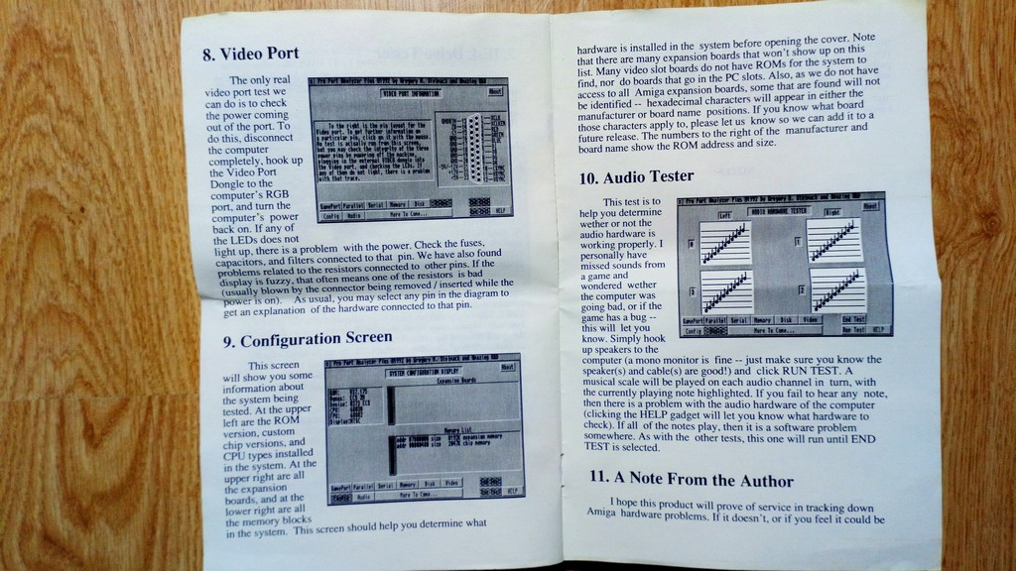
Video Port reproduced from original manual photograph P09.
The Video Port Dongle checks power at the video connector. It does not establish that the picture, sync signals or colour outputs are correct.
1. Switch the Amiga off.
2. Disconnect the RGB monitor from the computer. Fit the Video Port Dongle.
3. Switch the Amiga on. Observe the labelled power indicators and record any that do not illuminate.
4. Switch the Amiga off. Remove the dongle and reconnect the monitor before restarting for on-screen tests.
If a power indicator remains off, check the connection and dongle condition with the power off. The original manual points to fuses, capacitors and filters associated with the affected pin. Any further diagnosis must use the correct schematic for the machine.
In the software video screen, click a connector pin for the associated hardware explanation. This information screen is separate from observing the physical LEDs. The original also links some picture faults to resistors at the connector; that suggestion is not a complete diagnosis of a fuzzy picture.
Source: P09, original section 8.

Audio Tester
Audio Tester reproduced from original manual photograph P09.
The test plays a musical scale on each audio channel in turn. The current note is highlighted. Listen through a known-good audio path so that a cable, amplifier or speaker fault does not conceal the computer output.
1. Connect a suitable speaker or amplifier setup that lets you hear both Amiga audio outputs. Use known-good cables and a moderate listening level.
2. Start the Analyzer and select the audio test.
3. Select RUN TEST. Listen as the scale plays on each channel, and compare the sound with the highlighted notes.
4. Record a missing, distorted or intermittent note together with the displayed channel.
5. Select HELP for the hardware guidance associated with the test.
6. Select END TEST when finished. The sequence otherwise repeats.
If a note is missing, check the external audio path before assigning the fault to the Amiga. Do not join the left and right outputs directly together to obtain mono sound.
Hearing every note is evidence that the exercised audio path worked during this test. The original manual goes further and suggests that remaining faults are software-related; this edition does not treat a single successful run as proof that all audio hardware is good.
Source: P09, original sections 8 and 10. Audio connection and diagnostic qualifications are modern guidance.

Configuration Screen
Configuration Screen reproduced from original manual photograph P09.
Use this screen to record the system before testing. The upper-left area reports ROM version, custom-chip versions, CPU and FPU information. The upper-right area lists detected expansion boards. The lower-right area lists memory blocks.
Record manufacturer and board identifiers even when no useful name appears. The original manual warns that some expansion boards will not appear at all, including some video-slot and PC-slot boards. Hexadecimal identifiers can appear in place of names when the program lacks a matching description.
The original describes numbers to the right of the manufacturer and board name as ROM address and size. Do not interpret an incomplete list as proof that a board is absent, or a displayed name as independent verification of its hardware.
Source: P09, original section 9.

Troubleshooting

Investigate a failed or incomplete test
Observation | Next check
A test button is greyed out | Close software that uses the resource. Restart from the Analyzer disk and try again.
A power LED is off | Power off. Verify the dongle, connection and label. Record the affected rail before electrical diagnosis.
A parallel or serial pin fails | Power off and inspect the correct dongle and connector. Repeat and record the exact signal.
Mouse or joystick activity is absent | Try a known-good device. Test mouse and joystick functions separately.
Memory errors appear | Record blocks, addresses, pass count and configuration. Repeat under documented conditions.
Floppy errors appear | Read ERRS. Try another known-good disposable disk and compare with a reference drive.
An audio note is missing | Record the channel and note. Check cables, speakers and both output paths.
An expansion board is unnamed or absent | Record identifiers and compare with the physical inventory and board documentation.

Keep evidence before repair
Save the exact error text, pin number, address or track code before shutting down. Record whether the result repeats and what changed between runs. If a fault persists, use the service information for that Amiga model and board revision. The Analyzer narrows the investigation; it does not by itself identify a component that must be replaced.
Source: P06–P09, particularly section 9 on P09. Troubleshooting sequence is a modern synthesis of the source procedures.

Test record
Complete one record for each machine and configuration. Use “not tested” for checks that were not performed; an empty field must not be interpreted as a pass.
Date and operator: _______________________________________________________
Machine or inventory ID: __________________________________________________
Amiga model and board revision: ____________________________________________
Software version from ABOUT: ______________________________________________
ROM and CPU: _____________________ Memory and expansions: ________________
_______________________________________________________________________
Dongle set and adapters: __________________________________________________
Reference mouse, joystick, speakers and test disks: ______________________________
_______________________________________________________________________
Check | Result and identifying details
Port power indicators
Game Port 0 with mouse
Game Port 0 with joystick
Game Port 1 with mouse
Game Port 1 with joystick
Parallel signals
Serial signals
Free memory regions and errors
Memory time and pass count
Drive and mode tested
Disk errors and reference drive
Video port power
Audio channels
Configuration observations
Conditions or changes between runs: __________________________________________
_______________________________________________________________________
Outstanding faults and checks not performed: __________________________________
_______________________________________________________________________

Source credits
This 2026 Wyoretro reproduction draws on the original Wilcom Australia manual and the project records listed below. Original material is credited to its identified creators; no ownership of the original manual or software is claimed.

Original manual and photographs
This operating edition follows the surviving original manual photographs. The source keys below identify the exact files retained in the project Artifacts folder. The original photographs remain the authority for the historical wording.
Key | File and content
P03 | advenced_amiga_analyzer_03.jpg — manual and four labelled dongles.
P06 | advenced_amiga_analyzer_06.jpg — introduction and beginning of general interface.
P07 | advenced_amiga_analyzer_07.jpg — interface continuation, game, parallel and start of serial instructions.
P08 | advenced_amiga_analyzer_08.jpg — serial continuation, memory and disk instructions.
P09 | advenced_amiga_analyzer_09.jpg — video, configuration, audio and start of author’s note.
P10 | advenced_amiga_analyzer_10.jpg — cover and historical licensing and support information.
Original product and manual attribution: Wilcom Australia. The photographed cover names Grapevine Group as the historical support contact. Its address and telephone number are historical information, not a current support route.
Photographs P03 and P06–P10 were supplied through the Advanced Amiga Analyzer Documentation project collection. The photographer and original hosting source are not identified in the supplied records. All nine hardware and screen illustrations derive from P03, P07, P08 and P09; no new software screenshots are included in v0.9.

Project records and background
Project context: Wilcom Advanced Amiga Analyzer Codex Handover, 13 October 2026 at 09:39; Advanced Amiga Analyzer Documentation project note, updated 18 September 2026; Advanced Amiga Analyzer Project TODO and Advanced Amiga Analyzer Documentation Project research checklist, dated 14 July 2026. These records establish project history and outstanding work, not independent technical verification.
Prior editorial files inspected: Advanced Amiga Analyzer Draft Instruction Manual and Advanced Amiga Analyzer Polished English Edition. The former is an earlier reconstruction; the latter is only a proposal for editing a translated review. Neither overrides the photographed manual.
Background review retained with the project as Advanced Amiga Analyzer.pdf: the handover identifies Pascal Janin, Amiga News, May 1997, republished by Obligement. This secondary reference was not used to supply operating instructions in this edition.
https://obligement.free.fr/articles/advanced_amiga_analyzer.php
Branding: WYRE bull logo from the Wyoretro graphics collection, source file WYRE2 logo.png. Website address confirmed from the project record WYORETRO.com Architecture and Workflow Summary. Reproduction text, layout and modern operating guidance prepared for Wyoretro with Codex assistance.

Reproduction notes
Advanced Amiga Analyser — a 2026 Wyoretro reproduction of the original manual. Reconstructed operating edition v0.9, dated 13 October 2026.
https://wyoretro.com

Editorial treatment
The eight screen illustrations are cropped views of the original manual photographs. They retain the photographic perspective and source resolution. They are not fresh captures from v2 software. Small labels may be indistinct; use the written instructions and the live software controls when operating the Analyzer.
Procedures have been reorganised and rewritten in short, direct English. UI labels are retained where established by the source. Source notes distinguish modern operating guidance from the original instructions. This document is not a verbatim archival transcription and does not claim formal ASD-STE100 certification.
The earlier reconstructed draft and the document titled Polished English Edition are not primary authorities. The latter contains only an editorial proposal for a translated review. No operating instruction here depends on that proposal or on the secondary magazine review.

Future screen images
The original photographed screen illustrations remain in v0.9. Cleaner images will be captured through HDMI and used to replace them in a later revision. Each replacement should record the running software version, Amiga configuration and capture date, and receive an updated caption and source credit.

What this edition does not establish
The final author’s note is incomplete in P09. Its missing continuation is not reconstructed. The photographed pages also do not establish a complete software release history, model-by-model compatibility, 1.76 MB support, a full error-code table, numerical voltage tolerances, or dongle loopback wiring and schematics.
The project contains a disk image named Advanced Amiga Analyzer v2.adf. A filename alone does not verify its contents or release version. This edition has been checked against the photographs, but the procedures have not been validated by a new bench test of that disk and hardware.
The supplied cover attributes the product to Wilcom Australia and gives Grapevine Group contact information. Those details are historical attribution, not a current support route. A complete facsimile and full archival transcription remain separate preservation outputs requiring the missing source material.
Reproduced by Wyoretro in 2026. Original Wilcom Australia material and Grapevine Group attribution are acknowledged on the preceding source credits page.
https://wyoretro.com

