**Pyber: Observations**

1. In rural areas, the number of rides are less as well as the number of drivers. The Average fare is also mostly high in the rural areas. However, in the urban and suburban areas the average fare is almost consistent and largely between 20-35. The number of rides and drivers in urban cities are more comparatively. The scatter plot is a good indication of this.

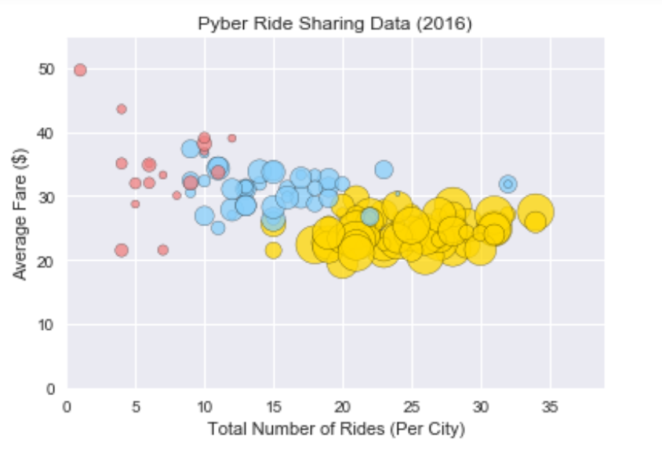

1. By compassion, the urban areas have the highest total fare % followed by suburban and then followed by rural.

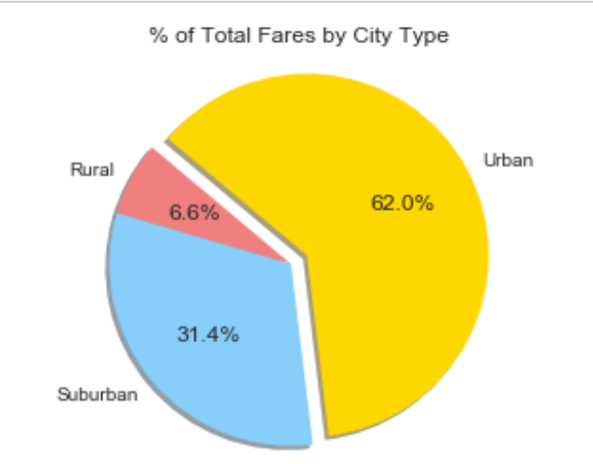

1. The total % of riders are the highest in urban areas followed by suburban and then followed by the rural areas.

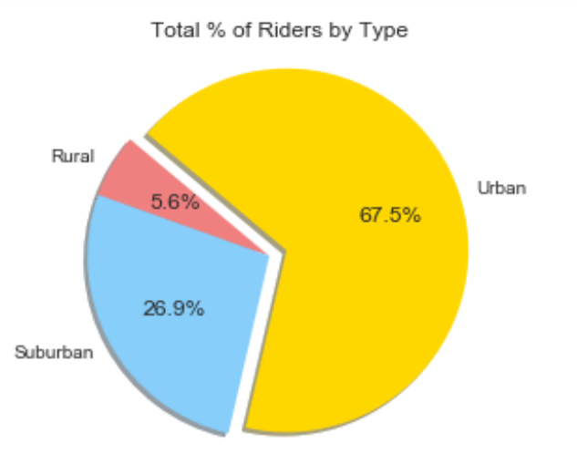

1. The total % of drivers are highest in the urban areas followed by the suburban areas and the least is in the rural areas.

