**Dataset:**

**Predictor Variables (X):**

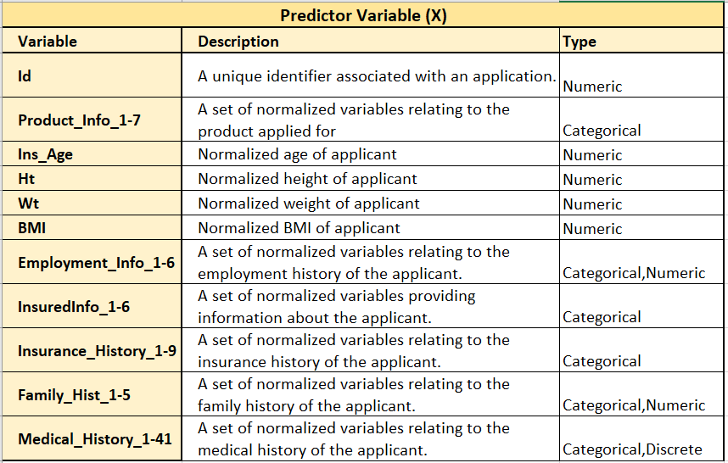

**Response Variable (Y):**

The response variable has 8 possible ratings and shows the predicted risk level for an applicant.

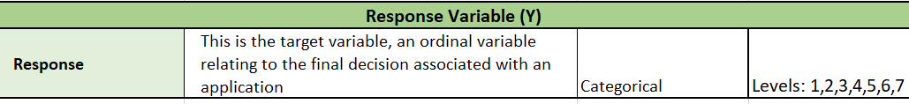

**Missing Values:**

**Deleted Columns**

**Full Dataset**

***125 columns***

**Cleaned Dataset for nulls**

**Substituted with median values**

**Reduced columns based on RFC weights**

***51 columns***

**Models and Scores:**

