**Nama : Indirwan Ihsan Hasibuan**

**Kode Peserta :JVSB01ONL05**

**Sesi :12**

**Requirement 1**

//Query Requirement 1//

-- Adminer 4.8.1 MySQL 5.5.5-10.4.24-MariaDB dump

SET NAMES utf8;

SET time_zone = '+00:00';

SET foreign_key_checks = 0;

SET sql_mode = 'NO_AUTO_VALUE_ON_ZERO';

USE `melodi_indah`;

DROP VIEW IF EXISTS `combine-all-data`;

CREATE TABLE `combine-all-data` (`id_lagu` int(12), `judul` varchar(50), `id_album` int(12), `format` enum('CD','MC'), `id_ssn` int(12), `nama` varchar(50), `nama_instrumen` enum('Gitar','Piano','Flute'), `kunci_musik` enum('C','E','G'));

DROP VIEW IF EXISTS `combinelagualbum`;

CREATE TABLE `combinelagualbum` (`id_lagu` int(12), `id_album` int(12));

SET NAMES utf8mb4;

DROP TABLE IF EXISTS `tb_album`;

CREATE TABLE `tb_album` (

`id_album` int(12) NOT NULL AUTO_INCREMENT,

`tgl_copy` date NOT NULL,

`format` enum('CD','MC') NOT NULL,

PRIMARY KEY (`id_album`)

) ENGINE=InnoDB DEFAULT CHARSET=utf8mb4;

DROP TABLE IF EXISTS `tb_instrumen`;

CREATE TABLE `tb_instrumen` (

`id_instrumen` int(10) NOT NULL AUTO_INCREMENT,

`nama_instrumen` enum('Gitar','Piano','Flute') NOT NULL,

`kunci_musik` enum('C','E','G') NOT NULL,

PRIMARY KEY (`id_instrumen`)

) ENGINE=InnoDB DEFAULT CHARSET=utf8mb4;

DROP TABLE IF EXISTS `tb_instrumus`;

CREATE TABLE `tb_instrumus` (

`id_instrumus` int(11) NOT NULL AUTO_INCREMENT,

`id_ssn` int(12) NOT NULL,

`id_instrumen` int(10) NOT NULL,

PRIMARY KEY (`id_instrumus`),

KEY `id_ssn` (`id_ssn`),

KEY `id_instrumen` (`id_instrumen`),

CONSTRAINT `tb_instrumus_ibfk_1` FOREIGN KEY (`id_ssn`) REFERENCES `tb_musisi` (`id_ssn`),

CONSTRAINT `tb_instrumus_ibfk_2` FOREIGN KEY (`id_instrumen`) REFERENCES `tb_instrumen` (`id_instrumen`)

) ENGINE=InnoDB DEFAULT CHARSET=utf8mb4;

DROP TABLE IF EXISTS `tb_lagu`;

CREATE TABLE `tb_lagu` (

`id_lagu` int(12) NOT NULL AUTO_INCREMENT,

`judul` varchar(50) NOT NULL,

`pengarang` varchar(50) NOT NULL,

PRIMARY KEY (`id_lagu`)

) ENGINE=InnoDB DEFAULT CHARSET=utf8mb4;

DROP TABLE IF EXISTS `tb_musisi`;

CREATE TABLE `tb_musisi` (

`id_ssn` int(12) NOT NULL AUTO_INCREMENT,

`nama` varchar(50) NOT NULL,

`alamat` tinytext NOT NULL,

`no_telp` int(15) NOT NULL,

PRIMARY KEY (`id_ssn`)

) ENGINE=InnoDB DEFAULT CHARSET=utf8mb4;

DROP TABLE IF EXISTS `combine-all-data`;

CREATE ALGORITHM=UNDEFINED SQL SECURITY DEFINER VIEW `combine-all-data` AS select `tl`.`id_lagu` AS `id_lagu`,`tl`.`judul` AS `judul`,`ta`.`id_album` AS `id_album`,`ta`.`format` AS `format`,`tm`.`id_ssn` AS `id_ssn`,`tm`.`nama` AS `nama`,`ti`.`nama_instrumen` AS `nama_instrumen`,`ti`.`kunci_musik` AS `kunci_musik` from (((`tb_lagu` `tl` join `tb_album` `ta`) join `tb_musisi` `tm`) join `tb_instrumen` `ti`);

//Proses pemilihan data yang ingin ditampilkan//

Urutan yang di tampilkan berdasarkan data dari table:

lagu > album > musisi > instrumen

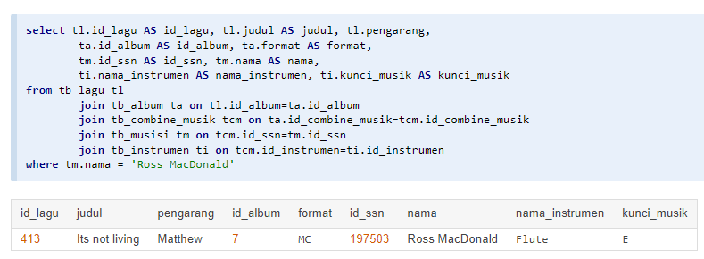

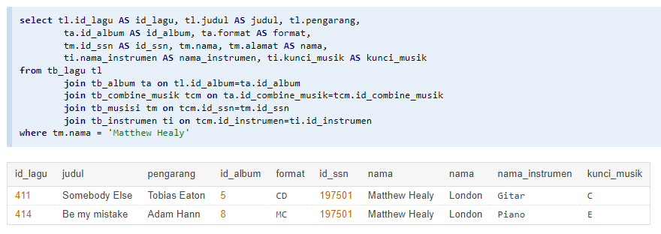

* Yang ini untuk menampilkan 1 musisi yang memiliki 2 judul lagu, dan di tambahkan query alamat musisi.