Requirement 2

1. Struktur Database Company

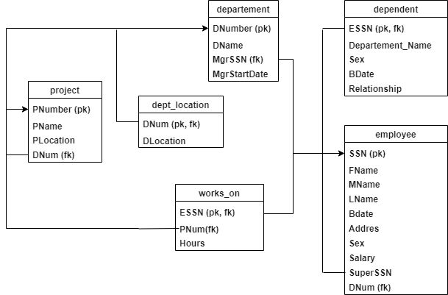

1. Requirement
2. **Create table Department**

DROP TABLE IF EXISTS `department`;

CREATE TABLE `department` (

  `DNumber` int(11) NOT NULL,

  `DName` varchar(15) NOT NULL,

  `MgrSSN` char(9) NOT NULL,

  `MgrStartDate` date DEFAULT NULL,

  PRIMARY KEY (`DNumber`),

  UNIQUE KEY `Dept_DName_Unique` (`DName`),

  KEY `Dept_MgrSSN_FK` (`MgrSSN`),

CONSTRAINT `Dept_MgrSSN_FK` FOREIGN KEY (`MgrSSN`) REFERENCES `employee` (`SSN`) ON DELETE CASCADE

) ENGINE=InnoDB DEFAULT CHARSET=latin1;

**Insert Table Department**

INSERT INTO `department` (`DNumber`, `DName`, `MgrSSN`, `MgrStartDate`) VALUES

(1, 'HRD',  'A111', '2004-01-20'),

(2, 'FINANCE',  'A112', '2003-03-17'),

(3, 'HUMAS',  'A113', '2006-05-28'),

(4, 'PRODUKSI', 'A114', '2005-02-10');

1. **Create table Dependent**

CREATE TABLE `dependent` (

  `ESSN` char(9) NOT NULL,

  `Dependent_Name` varchar(15) NOT NULL,

  `Sex` char(1) DEFAULT NULL,

  `BDate` date DEFAULT NULL,

  `Relationship` varchar(8) DEFAULT NULL,

  PRIMARY KEY (`ESSN`,`Dependent_Name`),

  CONSTRAINT `Dependent_ESSN_FK` FOREIGN KEY (`ESSN`) REFERENCES `employee` (`SSN`)

) ENGINE=InnoDB DEFAULT CHARSET=latin1;

**Insert table Department**

INSERT INTO `dependent` (`ESSN`, `Dependent_Name`, `Sex`, `BDate`, `Relationship`) VALUES

('A111',  'Beni', 'M',  '2005-09-20', 'DAUGHTER'),

('A111',  'Beti', 'F',  '2007-12-01', 'SON'),

('A111',  'Dina', 'F',  '0000-00-00', 'WIFE'),

('A112',  'Amel', 'F',  '0000-00-00', 'WIFE'),

('A112',  'Roy',  'M',  '2007-11-21', 'SON'),

('A112',  'Wandi',  'M',  '1990-10-19', 'HUSBAND'),

('A113',  'Devy', 'F',  '0000-00-00', 'DAUGHTER'),

('A113',  'Roby', 'M',  '1980-08-20', 'HUSBAND'),

('A114',  'Ratih',  'F',  '0000-00-00', 'DAUGHTER'),

('A114',  'Rini', 'F',  '0000-00-00', 'WIFE'),

('A114',  'Susan',  'F',  '0000-00-00', 'WIFE'),

('A115',  'Riko', 'M',  '0000-00-00', 'SON'),

('A115',  'Tika', 'F',  '0000-00-00', 'DAUGHTER'),

('A116',  'Dito', 'M',  '0000-00-00', 'SON'),

('A117',  'Nindy',  'F',  '0000-00-00', 'WIFE');

1. **Create table dept_location**

CREATE TABLE `dept_locations` (

  `DNum` int(11) NOT NULL,

  `DLocation` varchar(15) NOT NULL,

  PRIMARY KEY (`DNum`,`DLocation`),

  CONSTRAINT `DLoc_DNum_FK` FOREIGN KEY (`DNum`) REFERENCES `department` (`DNumber`)

) ENGINE=InnoDB DEFAULT CHARSET=latin1;

**Insert table dept_location**

INSERT INTO `dept_locations` (`DNum`, `DLocation`) VALUES

(1, 'Office Tower'),

(2, 'Office Tower'),

(3, 'KCU'),

(4, 'KCP');

1. **Create table employee**

CREATE TABLE `employee` (

  `SSN` char(9) NOT NULL,

  `FName` varchar(15) NOT NULL,

  `MName` char(1) DEFAULT NULL,

  `LName` varchar(15) NOT NULL,

  `BDate` date DEFAULT NULL,

  `Address` varchar(30) DEFAULT NULL,

  `Sex` char(1) DEFAULT NULL,

  `Salary` decimal(10,2) DEFAULT NULL,

  `SuperSSN` char(9) DEFAULT NULL,

  `DNum` int(11) NOT NULL,

  PRIMARY KEY (`SSN`),

  KEY `Employee_SuperSSN_FK` (`SuperSSN`),

  CONSTRAINT `Employee_SuperSSN_FK` FOREIGN KEY (`SuperSSN`) REFERENCES `employee` (`SSN`) ON DELETE CASCADE

) ENGINE=InnoDB DEFAULT CHARSET=latin1;

**Insert table employee**

INSERT INTO `employee` (`SSN`, `FName`, `MName`, `LName`, `BDate`, `Address`, `Sex`, `Salary`, `SuperSSN`, `DNum`) VALUES

('A110',  'Andi', NULL, 'Sasmita',  '1995-02-27', 'Bali', 'M',  3750000.00, 'A112', 2),

('A111',  'Indirwan', 'I',  'Hasibuan', '1997-10-14', 'Medan',  'M',  15000000.00,  'A111', 1),

('A112',  'Yusuf',  'R',  'Tamba',  '0000-00-00', 'Medan',  'M',  4000000.00, NULL, 2),

('A113',  'Winda',  NULL, 'Aja',  '1998-03-19', 'Jambi',  'F',  4500000.00, NULL, 3),

('A114',  'Kevin',  NULL, 'Pachira',  '1987-05-18', 'Kisaran',  'M',  3500000.00, NULL, 4),

('A115',  'Pevita', NULL, 'Pearce', '1986-06-16', 'Tangerang',  'F',  3500000.00, 'A111', 1),

('A116',  'Raline', NULL, 'Syah', '1985-12-11', 'Jaksel', 'F',  3500000.00, 'A111', 1),

('A117',  'Diana',  'Y',  'Haidar', '1990-08-03', 'Bali', 'F',  4500000.00, 'A111', 1),

('A118',  'Muhammad', 'A',  'Rojali', '1992-06-05', 'Tangerang',  'M',  3500000.00, 'A111', 1),

('A119',  'Muhammad', 'R',  'Pratama',  '1994-01-21', 'Jambi',  'M',  3200000.00, 'A111', 2);

1. **Create table project**

CREATE TABLE `project` (

  `PNumber` int(11) NOT NULL,

  `PName` varchar(15) NOT NULL,

  `PLocation` varchar(15) DEFAULT NULL,

  `DNum` int(11) NOT NULL,

  PRIMARY KEY (`PNumber`),

  UNIQUE KEY `Project_PName_Unique` (`PName`),

  KEY `Project_DNum_FK` (`DNum`),

  CONSTRAINT `Project_DNum_FK` FOREIGN KEY (`DNum`) REFERENCES `department` (`DNumber`) ON DELETE CASCADE

) ENGINE=InnoDB DEFAULT CHARSET=latin1;

**Insert table project**

INSERT INTO `project` (`PNumber`, `PName`, `PLocation`, `DNum`) VALUES

(1, 'Database', 'Jakarta',  1),

(2, 'Springboot', 'Jakarta',  2),

(3, 'FrondEnd', 'Bekasi', 2),

(4, 'BackEnd',  'Tangerang',  2),

(5, 'QATest', 'Depok',  3),

(6, 'Code', 'Bali', 3),

(7, 'Break',  'Tangerang',  4),

(8, 'Deep', 'Depok',  4);

1. **Create table works_on**

CREATE TABLE `works_on` (

  `ESSN` char(9) NOT NULL,

  `PNum` int(11) NOT NULL,

  `Hours` decimal(3,1) NOT NULL,

  PRIMARY KEY (`ESSN`,`PNum`),

  KEY `Works_PNum_FK` (`PNum`),

  CONSTRAINT `Works_ESSN_FK` FOREIGN KEY (`ESSN`) REFERENCES `employee` (`SSN`) ON DELETE CASCADE,

  CONSTRAINT `Works_PNum_FK` FOREIGN KEY (`PNum`) REFERENCES `project` (`PNumber`) ON DELETE CASCADE

) ENGINE=InnoDB DEFAULT CHARSET=latin1;

**Insert table works_on**

INSERT INTO `works_on` (`ESSN`, `PNum`, `Hours`) VALUES

('A110',  2,  34.0),

('A110',  3,  78.0),

('A111',  1,  90.0),

('A111',  2,  98.0),

('A112',  2,  55.0),

('A112',  3,  78.0),

('A113',  3,  53.0),

('A113',  4,  77.0),

('A114',  4,  77.0),

('A114',  5,  98.0),

('A114',  7,  85.0),

('A114',  8,  68.0),

('A115',  5,  57.0),

('A115',  6,  87.0),

('A116',  6,  87.0),

('A116',  7,  45.0),

('A117',  7,  40.0),

('A117',  8,  88.0),

('A118',  1,  78.0),

('A118',  8,  87.0),

('A119',  1,  88.0),

('A119',  2,  65.0);

Query

1. Tampilkan dependent_name dan relationship dengan employee yang namanya diawali huruf I ?

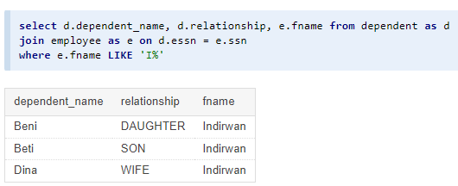

1. Banyaknya employee yang mengerjakan project PNum = 1 ?

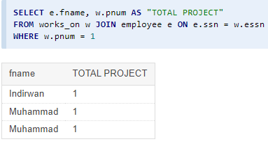

1. Banyaknya employee yang memiliki salary lebih dari 3500000 ?

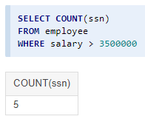

1. Banyaknya project yang dikerjakan DNum =2 ?

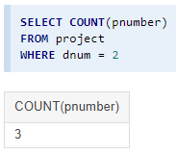

1. Hitung total dan rata-rata salary dari setiap departemen ?

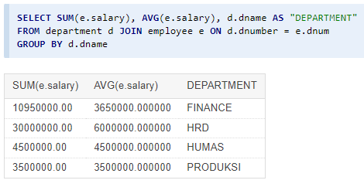

1. Banyaknya employee dari setiap department dan urutkan berdasarkan employee terbanyak ?

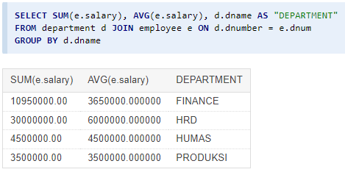

1. Total hours perweek dari semua employee untuk setiap project ?

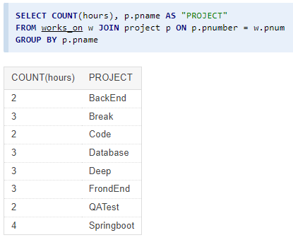

1. Employee yang memiliki total hours perweek lebih besar dari 140 hours dan urutkan berdasarkan jumlah jam kerja terbanyak?

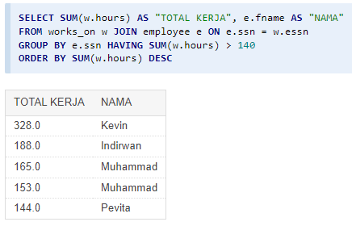

1. Kelompokkan bonus employee berdasarkan jumlah jam kerjanya ? (Jika >= 200 hours, maka bonus = 50%; Jika >= 150 hours, maka bonus = 25%, Selainnya bonus = 10%)

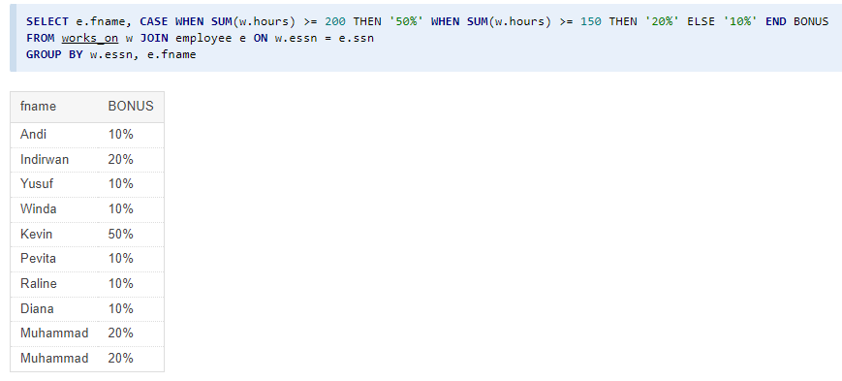

1. Banyaknya project yang dikerjakan tiap employee dan urutkan dari yang terbanyak ?

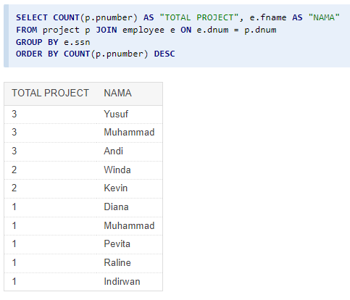

1. Employee yang bekerja pada 4 project ?

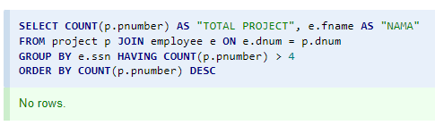

1. Employee yang memiliki rata-rata hours perweek = 70 jam dan bekerja pada 2 project ?

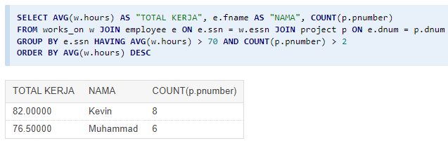

1. Banyaknya Dependent berdasarkan relationship dengan employee ?

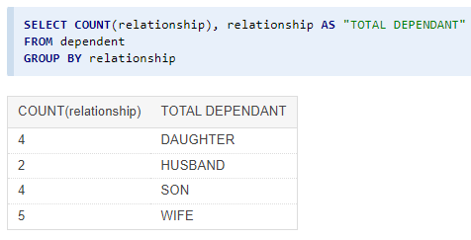

1. Berapa lama Manager tiap Department sudah menjabat ?

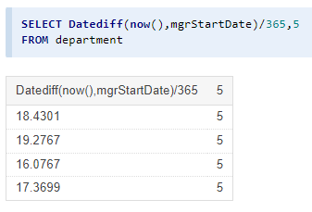

1. Lokasi project yang menjadi tempat lebih dari satu department?

