Indistylex Physical Shop Setup Guide
Billing equipment · Labels & stickers · Store setup · Where to buy · Prices
All pictures, steps, and purchase links in one document.

1. What a proper Indistylex shop needs
Area | Must-have | Nice-to-have
Billing | Laptop/POS + receipt printer + barcode scanner | Cash drawer, customer display
Labelling | Barcode label printer + hang tags + stickers | Woven care labels
Payments | UPI QR + cash | Card swipe / Soundbox
Store | Racks, hangers, mirror, trial area, carry bags | Mannequins, LED, CCTV
Stock | SKU list matching website (size + colour) | Sync with Indistylex admin

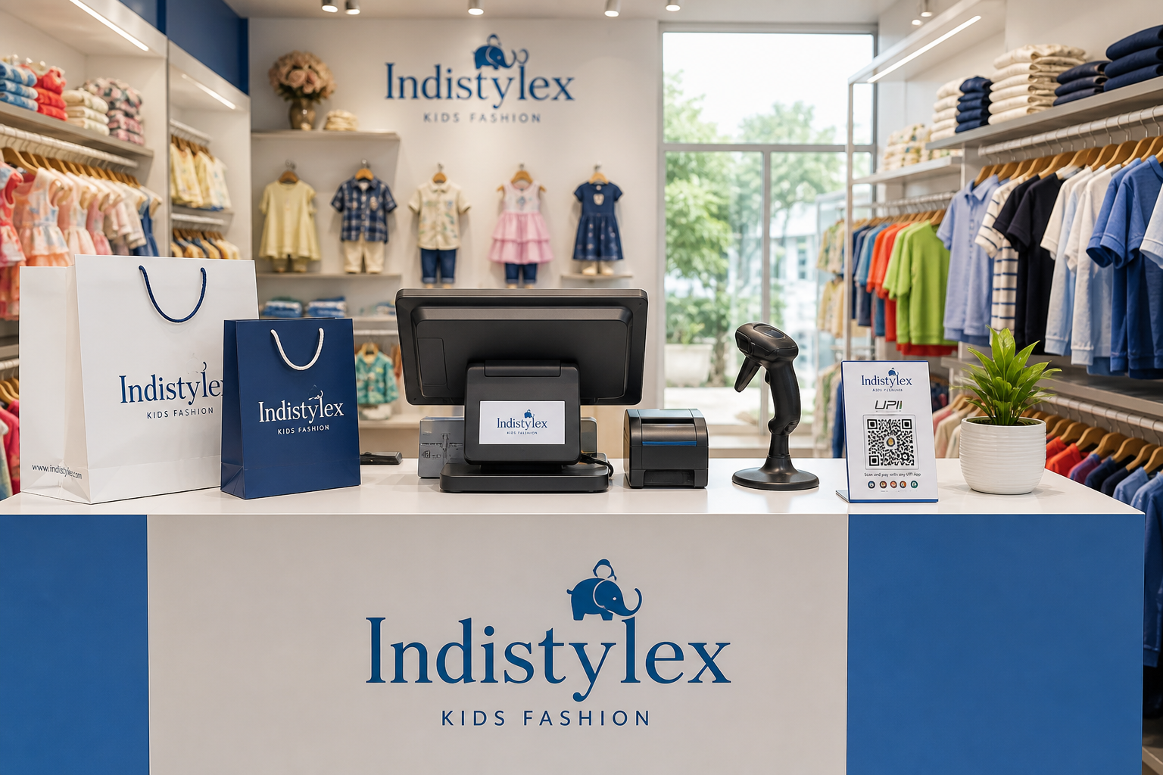
Figure 1 — Shop counter overview with billing setup

2. Budget equipment list (with prices & buy links)

A. Billing / POS setup
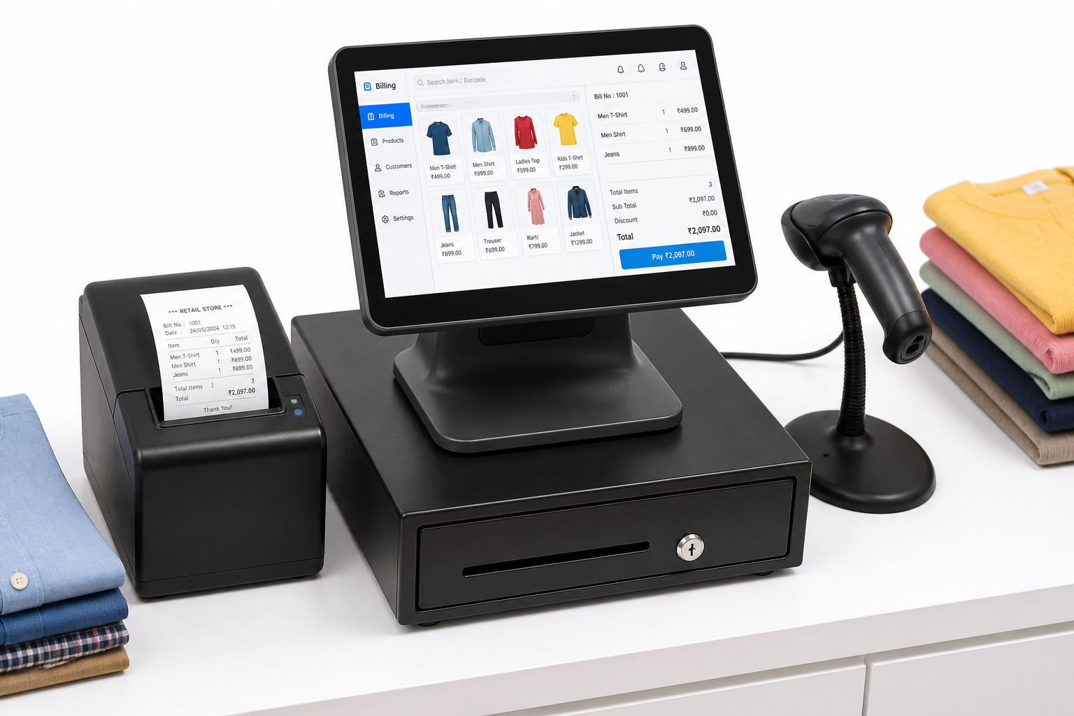
Figure 2 — Billing POS: computer + receipt printer + scanner

Item | Approx. price (₹) | Where to buy
Billing laptop / POS tablet | 12,000 – 25,000 | Amazon · Flipkart · local market
Garments billing machine (all-in-one) | 12,000 – 18,000 | IndiaMART · ClanSoft vendors
Thermal receipt printer 58mm | 2,500 – 4,500 | Amazon · Flipkart
Thermal receipt printer 80mm | 5,000 – 9,000 | Amazon
USB barcode scanner | 800 – 2,000 | Amazon · Flipkart
Wireless barcode scanner | 1,800 – 3,500 | Amazon
Cash drawer | 2,000 – 4,000 | IndiaMART
UPI QR / soundbox | 0 – 2,500 | PhonePe · Paytm · BharatPe
Garment billing software (GST) | 3,000 – 8,000/year | Setuverse · Zubizi · Busy

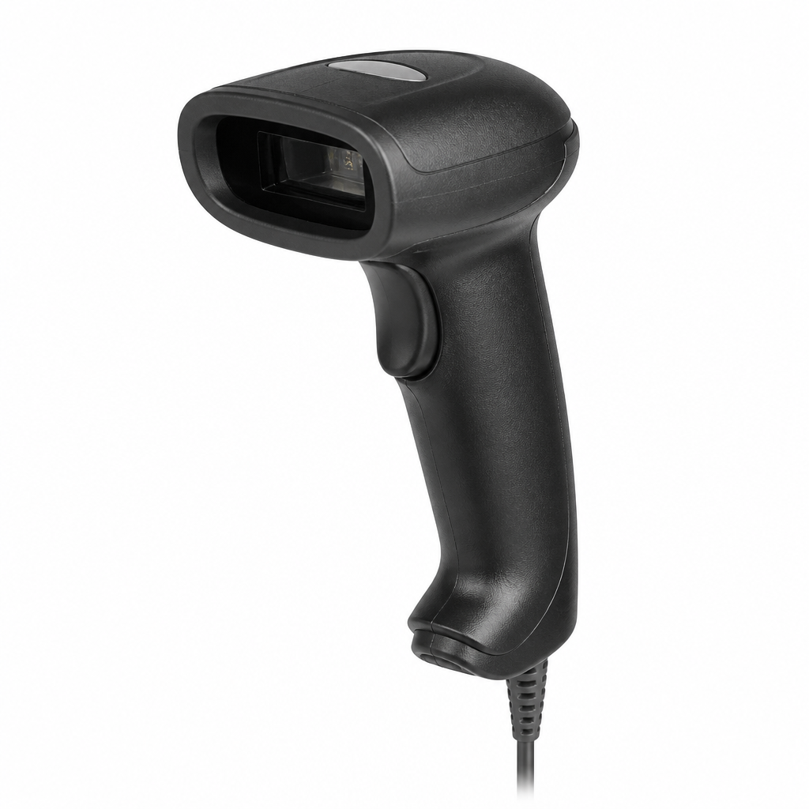
Figure 3 — USB barcode scanner for billing counter

Buy links — Billing hardware:
- Amazon — barcode scanner
- Amazon — 58mm thermal printer
- Amazon — 80mm thermal printer
- Flipkart — thermal printer
- IndiaMART — garment billing machine
- IndiaMART — POS cash drawer
- Setuverse garment billing software
- Zubizi garments billing software
- PhonePe Business (UPI QR)
- Paytm for Business
- BharatPe

Billing kit price summary
Kit | What you get | Approx. total
Ultra budget | Existing laptop + UPI + USB scanner + 58mm printer | ₹4,000 – 8,000
Recommended starter | Laptop + scanner + printer + billing software | ₹20,000 – 35,000
Comfort kit | POS + wireless scanner + 80mm printer + label printer + cash drawer | ₹45,000 – 70,000

B. Label / sticker equipment
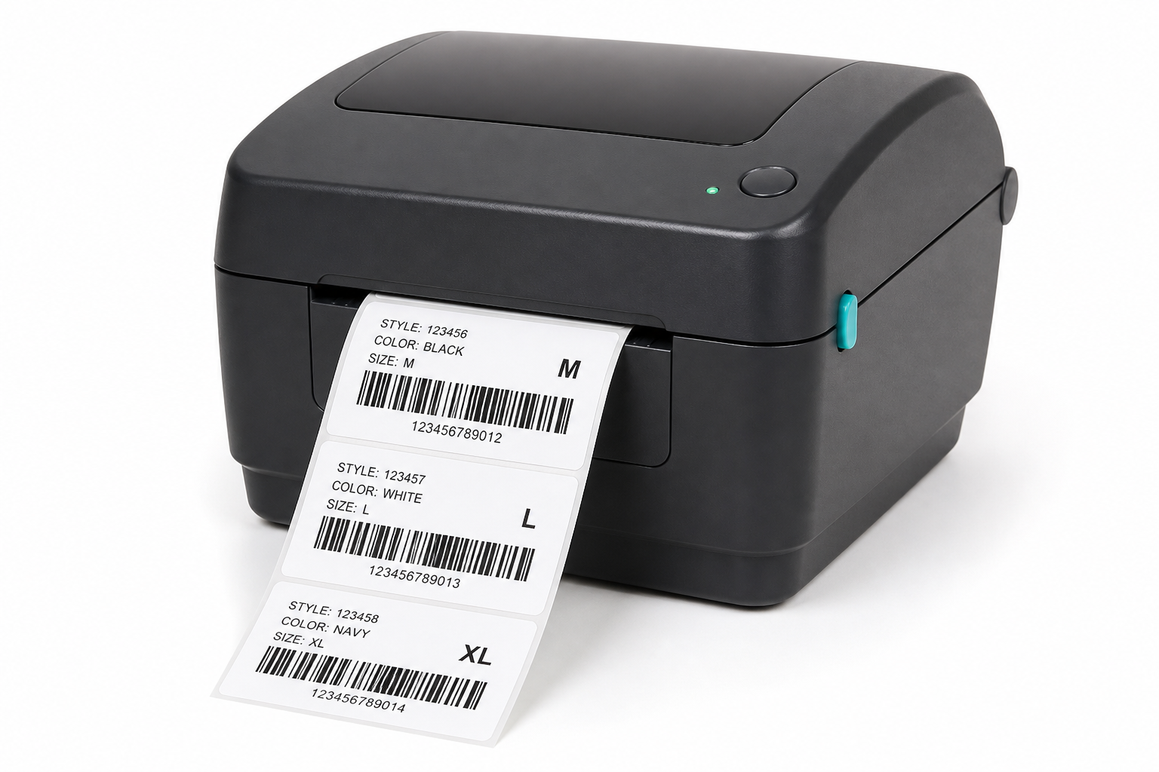
Figure 4 — Thermal barcode label printer for price stickers

Item | Use | Approx. price (₹) | Where to buy
Desktop barcode label printer | Price + barcode stickers | 6,000 – 15,000 | Amazon · BluPrints · IndiaMART
Portable Bluetooth label printer | Small stickers from phone | 3,500 – 8,000 | Amazon
Label rolls (40×30 / 50×30 mm) | Product stickers | 200 – 600/roll | Amazon · IndiaMART
Custom hang tags (Indistylex) | Brand on garment | 1 – 4/piece | Local printer · Canva · IndiaMART
Tag gun + fasteners | Attach hang tags | 50 – 400 | Amazon · IndiaMART
Woven care labels | Sewn inside garment | 1.5 – 5/piece | IndiaMART
Printed carry bags | Checkout branding | 3 – 12/bag | Local packaging · IndiaMART

Buy links — Labels & packaging:
- Amazon — barcode label printer
- Amazon — thermal label rolls 40x30
- Amazon — tag gun fasteners
- BluPrints India (label printers)
- IndiaMART — hang tags
- IndiaMART — woven labels
- IndiaMART — custom printed carry bags
- Canva (design hang tags)

3. Indistylex clothing labels & stickers — step by step
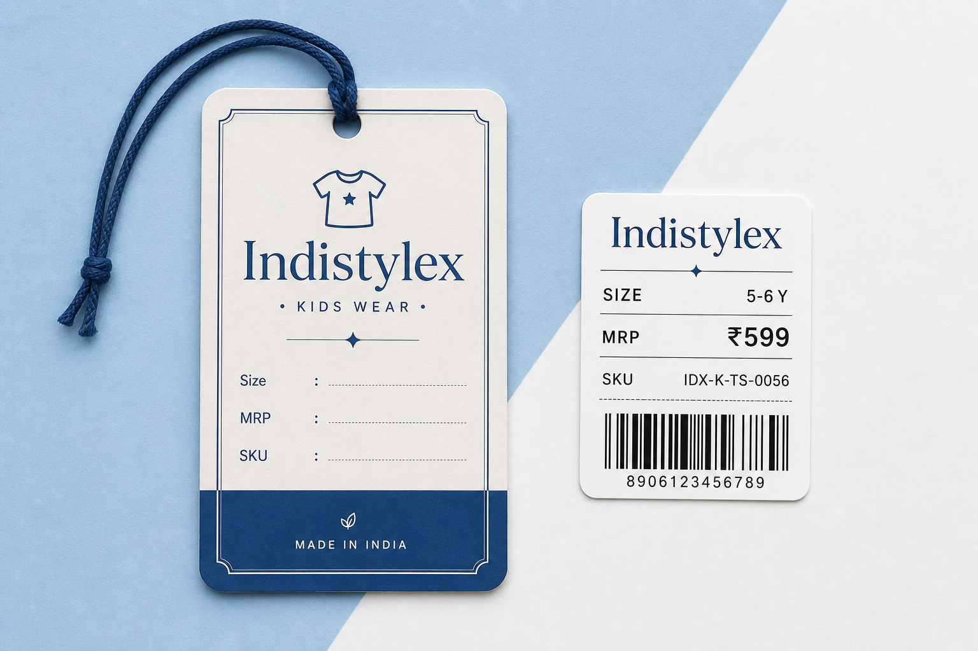
Figure 5 — Indistylex hang tag + barcode price sticker design

Label type | Where it goes | Must show
Hang tag | On garment with fastener | Logo, size, MRP, SKU, Indistylex
Barcode sticker | Back of tag or polybag | Barcode, SKU, size, colour, MRP
Woven care label | Inside neck/seam | Brand, fabric, wash care, Made in India
Size sticker | Near tag or shelf | Age band e.g. 2–3Y

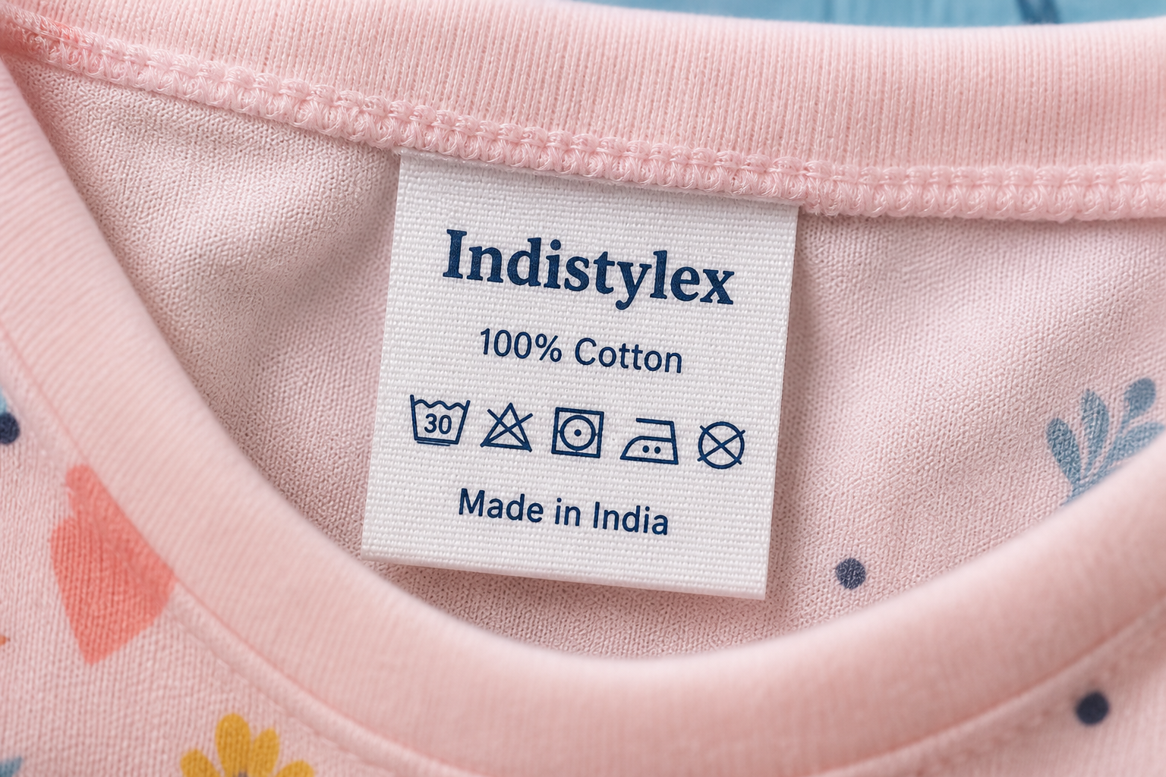
Figure 6 — Woven care label sewn inside garment

Brand rules
- Brand name: Indistylex
- Primary colour: deep blue #1E4D8C on white/cream tag
- MRP: always printed (Legal Metrology — inclusive of GST)
- SKU: same as website/admin variant (e.g. IX-FRK-PINK-34)
- Size: use age bands (2–3Y, 3–4Y…) matching website
- Website: indistylex.com on hang tag back

Option A — Print barcode stickers in shop (fastest)
- Buy direct thermal barcode printer + 40×30 mm or 50×30 mm label rolls.
- Install printer software or use billing software “Print barcode label”.
- For each variant print: Indistylex, product name, size, colour, SKU, MRP, barcode.
- Stick sticker on hang tag or polybag.
- Attach hang tag to garment with tag gun fastener.

Option B — Custom hang tags via Canva + local printer (best look)
- Design in Canva: 50×90 mm or 60×100 mm, front + back.
- Front: logo + brand + product line. Back: size, MRP, SKU, barcode space, website.
- Export PDF at 300 DPI.
- Print on art card 300–350 GSM with punch hole. Order 500–2000 pcs.
- Leave blank area on back for thermal barcode sticker (price changes without reprinting tags).

Option C — Woven care labels (bulk stock)
- Text: INDISTYLEX · fabric · wash icons · Made in India.
- Order 500–1000 pcs from IndiaMART label manufacturer.
- Size example: 60×20 mm, navy + white colours.
- Sew into garments before display.
Sample hang tag layout:
INDISTYLEX
Kids Wear
Floral Cotton Frock
Size: 3–4Y · Colour: Pink
MRP: ₹899 (Incl. GST)
SKU: IX-FRK-PINK-34
[barcode]
indistylex.com

4. Full shop setup — step by step (do in this order)

Phase 1 — Legal & accounts (Week 1)
- Confirm GST registration for proper billing.
- Open business bank account + UPI on shop mobile.
- Display trade name: Indistylex.
- Get shop & establishment licence if required in your city.
- Choose GST billing software (see links in Section 2).

Phase 2 — Buy equipment (Week 1–2)
- Pick starter kit (~₹23,000 without laptop) from Section 6.
- Order: scanner + receipt printer + label printer + label rolls.
- Order Indistylex hang tags + fasteners + carry bags.
- Set up one billing laptop/tablet used only for shop.
- Test: print sample bill + barcode + scan back into software.

Phase 3 — Store layout (Week 2)
- Entrance: Indistylex flex/board + “Kids Wear”.
- Racks grouped by Boys / Girls / Kids, then by age.
- Eye level: new arrivals and bestsellers.
- Counter: billing, scanner, UPI QR, bags, visiting cards.
- Trial corner: mirror + curtain + stool.
- Back room: unpacking and labelling table.
- Bright white LED lighting (true garment colours).

Phase 4 — Stock & labelling (Week 2–3)
- Export product list from Indistylex admin (SKU, size, colour, MRP, stock).
- Every piece: hang tag + barcode sticker + visible size.
- Shop SKU = website SKU (single source of truth).
- Shelf labels on racks: e.g. “Girls · 2–5Y”.
- Update admin inventory when shop sells.

Phase 5 — Staff & soft opening (Week 3)
- Train: scan → bill → UPI/cash → pack → thank you.
- Returns policy card at counter.
- Shop hours board + WhatsApp order number.
- Soft opening 2–3 days with friends/family.
- Grand opening + Google Business profile + social posts.

Phase 6 — Daily operations (Week 4+)
- Morning: cash check, printer paper, UPI test.
- Every sale: bill + update stock.
- Weekly: compare shop stock vs Indistylex admin.
- Re-print labels when MRP/offers change.
- Collect WhatsApp numbers (with permission) for restocks.

5. Daily shop workflow (SOP)
- OPEN → Lights/AC on · Load printer paper · Test 1 barcode scan · Check UPI QR
- SALE → Scan items · Confirm size/colour · UPI/cash/card · Print bill · Pack in Indistylex bag · Reduce stock
- CLOSE → Match cash + UPI with bills · Note low-stock SKUs · Switch off equipment

6. Starter purchase order (~₹23,000 without laptop)
Item | Qty | Approx. ₹
USB barcode scanner | 1 | 1,200
58mm thermal receipt printer | 1 | 3,000
Thermal barcode label printer | 1 | 8,000
Label rolls (mixed sizes) | 5 | 1,500
Custom hang tags (Indistylex) | 1000 | 2,500
Tag fasteners | 2000 | 200
Printed carry bags | 500 | 3,000
UPI QR stand | 1 | 300
Garment billing software (1 year) | 1 | 3,500
TOTAL (without laptop) |  | ~₹23,000

Add laptop/POS if needed: ₹15,000 – 25,000 extra.

7. Where to buy — all links
Online marketplaces:
- Amazon India — scanners, printers, tag guns
- Flipkart — printers, scanners, laptops
- IndiaMART — bulk labels, bags, POS (negotiate)
- Meesho — cheap bags, hangers
Store furniture (approx. prices):
Item | Approx. price | Where
Garment racks | ₹1,500 – 8,000 each | Local steel market · IndiaMART
Kids mannequins | ₹2,500 – 6,000 | IndiaMART
Trial room mirror | ₹800 – 3,000 | Local glass shop
LED shop lights | ₹300 – 1,200/tube | Amazon · electrical market
CCTV kit (optional) | ₹8,000 – 25,000 | Amazon · local installer

Local POS markets (offline): Delhi — Nehru Place · Mumbai — Lamington Road · Bangalore — SP Road · Tier-2 — ask for “billing machine / CCTV POS shop”.

8. Opening day checklist
☐ GST billing working — sample invoice printed
☐ UPI collecting to correct bank account
☐ Every garment has Indistylex hang tag + barcode
☐ SKUs match Indistylex website/admin
☐ Trial room ready
☐ Carry bags + bill rolls stocked
☐ Price list / offer board at entrance
☐ Google Business listing live with photos + hours
☐ Staff trained on returns policy
☐ Emergency contacts saved (electrician, CA)

Notes
- Pictures in this document are planning mockups — verify real product specs on seller pages before buying.
- Always print MRP inclusive of all taxes on tags (Indian Legal Metrology rules).
- Keep SKU identical between shop labels and Indistylex admin for online + offline stock.
- Prices are approximate India retail ranges (2025–26) and change by city and offers.

