**Create a Card as following Instructions**

1. On mobile it should display like following



1. On desktop it should show like following

**Default 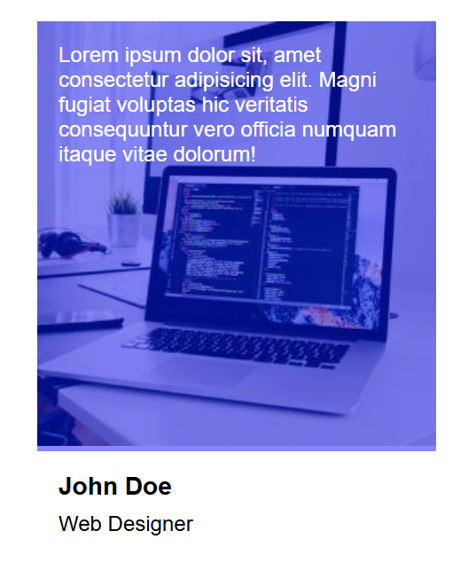 on Hover**