**Task 1**

In this task, you should create a grid into which the four child elements will auto-place. The grid should have three columns sharing the available space equally and a 20 pixel gap between the column and row tracks. After that, try adding more child containers inside the parent container with the class of grid and see how they behave by default.

Your final result should look like the image below:

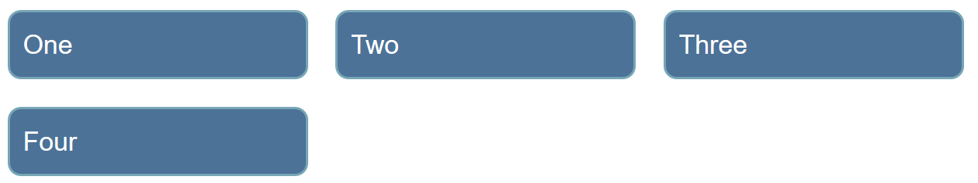

**Task 2**

In this task, we already have a grid defined. By editing the CSS rules for the two child elements, cause them to span over several grid tracks each. The second item should overlay the first as in the image below:

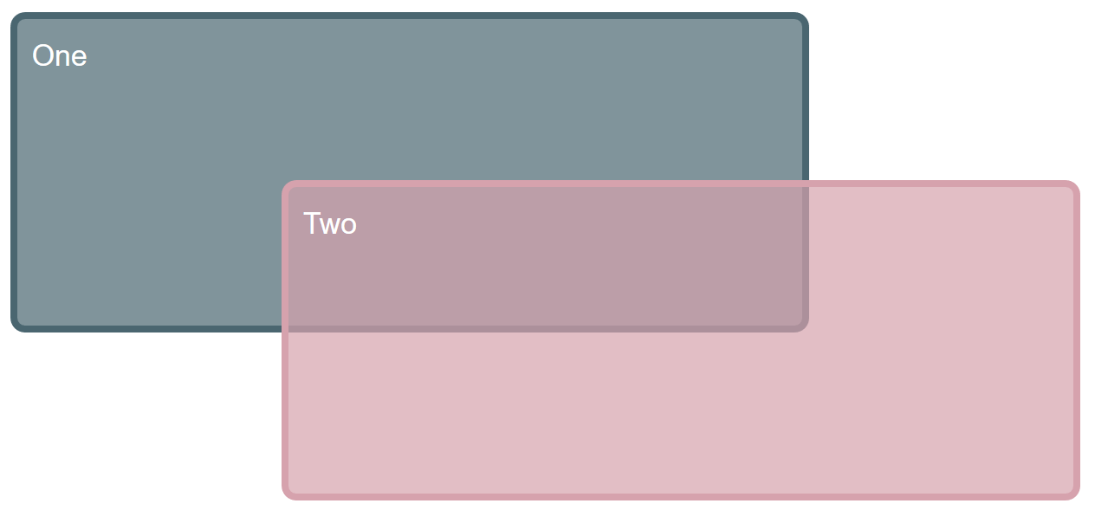

## [Task 3](https://developer.mozilla.org/en-US/docs/Learn_web_development/Core/CSS_layout/Grid_skills#task_3)

In this task, there are four direct children in this grid. The starting point has them displayed using auto-placement. Use the grid-area and grid-template-areas properties to lay the items out as shown in the image below:

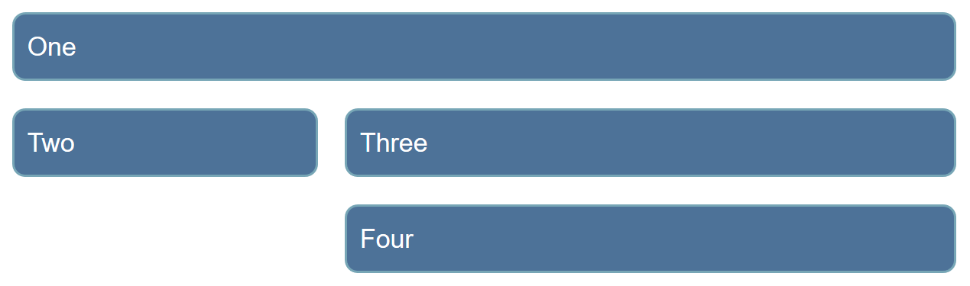

## [Task 4](https://developer.mozilla.org/en-US/docs/Learn_web_development/Core/CSS_layout/Grid_skills#task_4)

In this task, you will need to use both grid layout and flexbox to recreate the example as seen in the image below. The gap between the column and row tracks should be 10px. You do not need to make any changes to the HTML in order to achieve this.

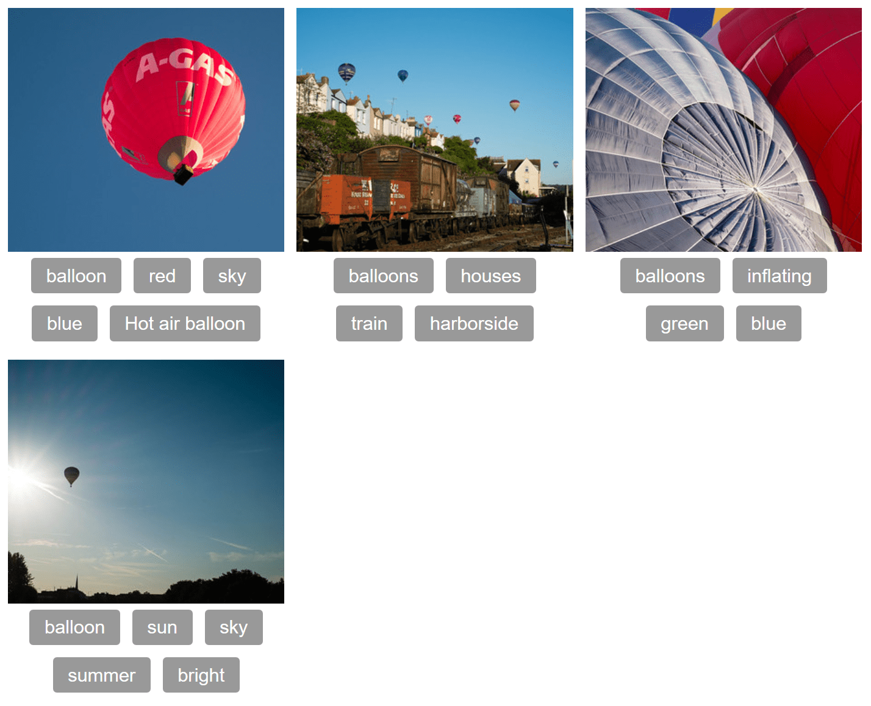

**Image Path**

<https://mdn.github.io/shared-assets/images/examples/balloons1.jpg>

<https://mdn.github.io/shared-assets/images/examples/balloons2.jpg>

<https://mdn.github.io/shared-assets/images/examples/balloons3.jpg>