## Task 1

In this task, the list items are the navigation for a site. They should be laid out as a row, with an equal amount of space between each item.

Your final result should look like the image below:



## Task 2

In this task, the list items are all different sizes, but we want them to be displayed as three equal sized columns, no matter what content is in each item.

Your final result should look like the image below:

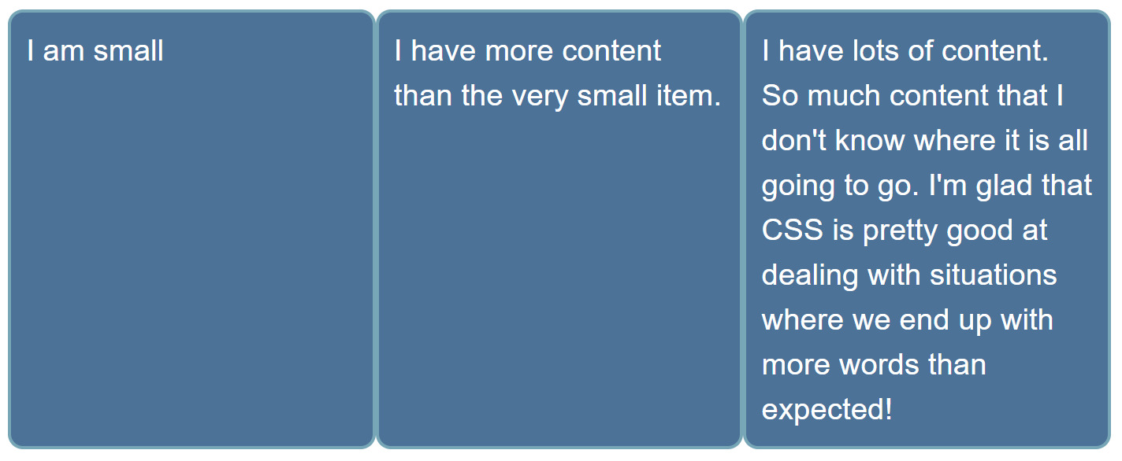

## Task 3

In this task, there are two elements in the HTML below, a <div> element with a class of parent which contains another <div> element with a class of child. Use flexbox to center the child inside the parent. There is more than one possible solution here.

Your final result should look like the image below:

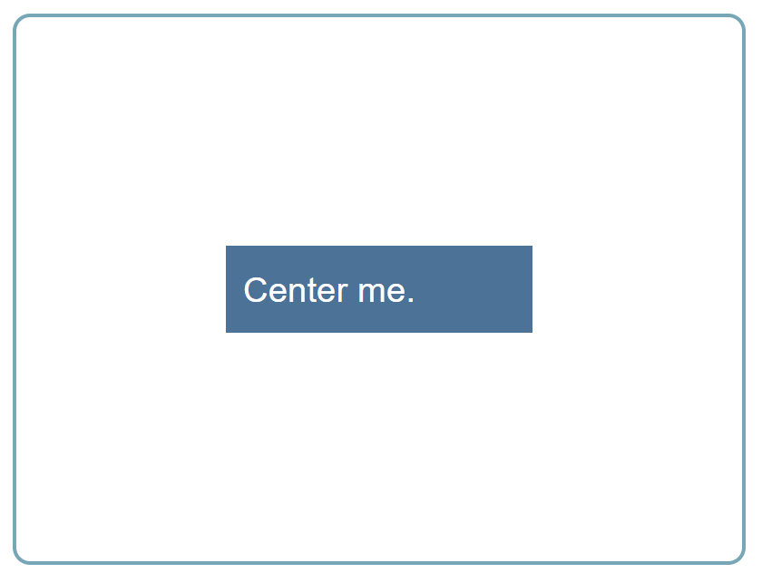

## Task 4

In this task, we want you to arrange these items into rows as in the image below:

