Responsive Theme-Based Dashboard Card
Create a responsive dashboard card layout using CSS variables for theming and media queries for layout changes across devices.
HTML:
<div class="dashboard">
<h1 class="title">Analytics Overview</h1>
<div class="cards">
<div class="card">
<h2>Users</h2>
<p>1,240</p>
</div>
<div class="card">
<h2>Revenue</h2>
<p>$8,430</p>
</div>
<div class="card">
<h2>Sessions</h2>
<p>12,320</p>
</div>
</div>
</div>

Requirements:
Base Styling (Desktop First)
- Use CSS variables for:
  - Colors
  - Padding
  - Border radius
- .cards should be displayed using CSS Grid
- Default layout:
  - 3 columns
  - Cards equally spaced
- Cards should have:
  - Background color from variable
  - Rounded corners
  - Subtle shadow
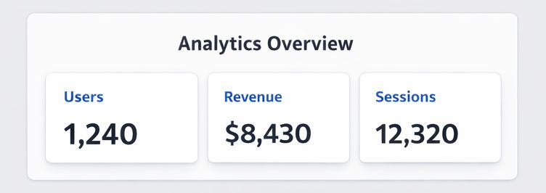
Responsive
On Tablet
  - Change grid to 2 columns
  - Slightly reduce card padding
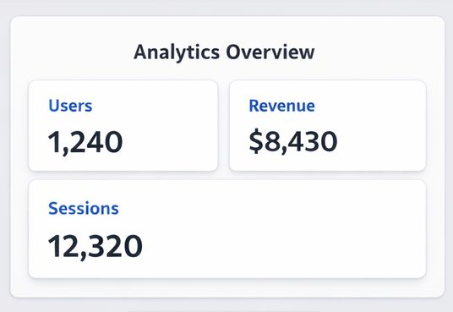
On Mobile
- Change grid to 1 column
- Center-align text inside cards
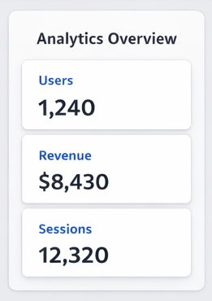
Theme Variation
Create a .dark-theme class that overrides:
- --background-color
- --card-bg
- --text-color
Apply the class on .dashboard to switch theme

