**Polymorphism – Articulate**

Polymorphism means something that happens in more forms. This is when classes relate to each other through inheritance. Methods are used to do different tasks. Polymorphism helps in creating reusable code and easy to debug.

I used polymorphism to create a program to track goals with the code below:

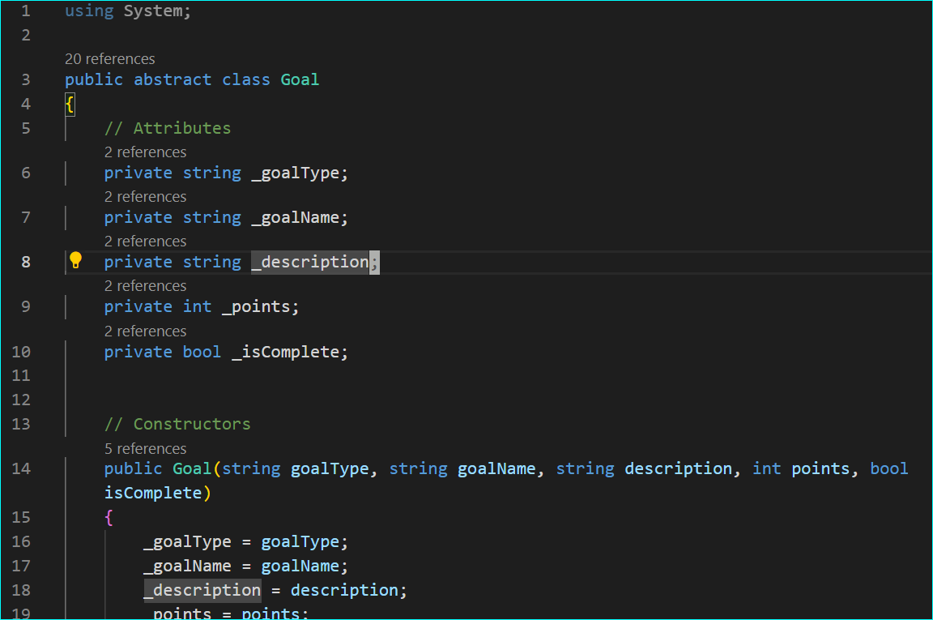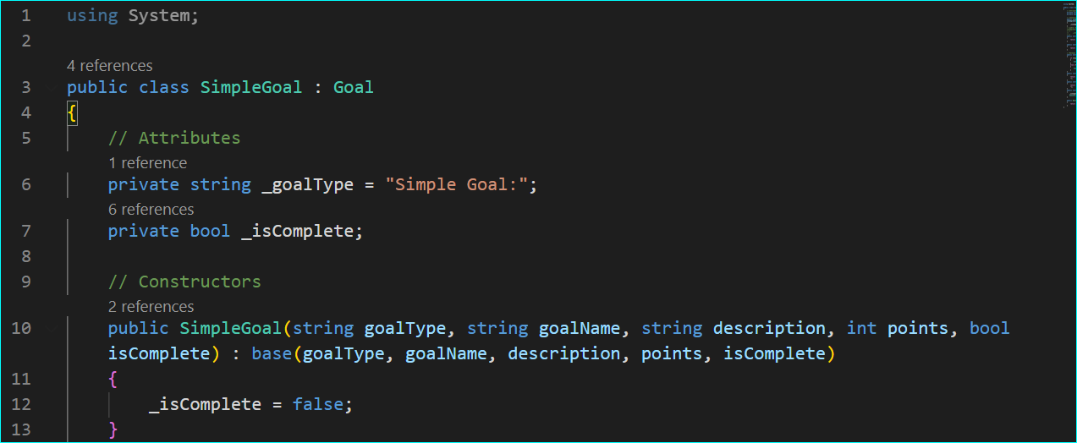

Goal class is the base class and simplegoal class inherits from the goal class. Many other classes inherit from the base class goal and use its methods in different ways.