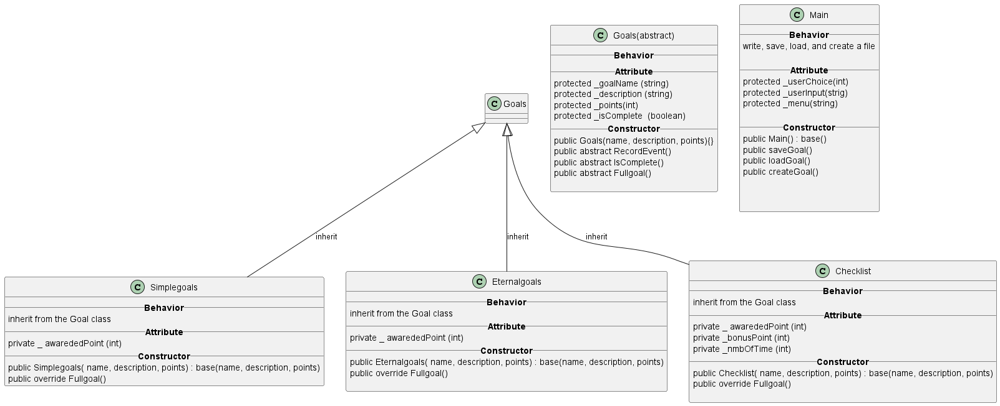

|  |
| --- |
| Program |
| Main Class   * Create new goal * Save goal * Load goal * Record Event * Exit   Goal Class   * Base class where all classes inherit from. * Abstraction from other classes |