Low Level Solution Design

Document Date: v1.0 25/11/2020

Table of Contents
1. Introduction................................................................................................................ 4
1.1 Purpose of the LLD............................................................................................. 4 1.2 Audience.............................................................................................................. 4 1.3 Executive Summary .............................................................................................. 4
1.3.1 System Overview Summary ....................................................................... 4 1.3.2 Document Organization................................................................................... 5

2. General Overview and Design Guidelines/Approach .......................................... 6
2.1 Roles ................................................................................................................... 6
2.2 Concerns.............................................................................................................. 6
2.3 Operational environment...................................................................................... 6
2.4 Development methods and contingencies........................................................... 6
2.5 Performance engineering.................................................................................... 6

3. Design Considerations.......................................................................................... 7
3.1 Software Architecture......................................................................................... 8
3.1.1 Software Elements.................................................................................... 8
3.1.2 Security Software Architecture.................................................................. 8
3.1.3 Performance Software Architecture.......................................................... 9
4. Process Modeling................................................................................................. 9
4.1 Business Requirements.................................................................................... 10
4.2 Database Design .............................................................................................. 10
4.2.1 Data Objects and Resultant Data Structures............................................... 10
4.2.2 File and Database Structures...................................................................... 18
4.2.2.1 Database Management System Files..................................................... 18
4.3 User Interface Design......................................................................................... 19
5. Operational Scenarios............................................................................................ 20
5.1 Major Operational scenarios................................................................................ 20
5.2 Major use cases .................................................................................................. 21

6. Detailed Design........................................................................................................ 32
6.1 Hardware detailed design.................................................................................... 32
6.2 Software detailed design...................................................................................... 33
6.3 Security detailed design....................................................................................... 33

7. Data Replication......................................................................................................... 34

1. Introduction
The Internet of Things is one of the most important and promising technological topics today. Some market researchers estimate that there are more than 20 billion connected devices and counting. Around us, there are smartphones, wearables, and other devices, all of which use sensors. Nowadays, sensors play an important role in our everyday life and in IoT. Sensors monitor our health status (e.g. a heartbeat), air quality, home security, and are widely used in the Industrial Internet of Things (IIoT) to monitor production processes. For these reasons, it is important to know how they work and how we can use them to acquire information.
Measuring temperature is one of the most common techniques used because it is important for many operations and tasks to be performed like in any industries where heaters/freezers are used. When it comes to sensing temperature, a temperature sensor is used that is installed at a place whose temperature is to be sensed. The temperature of that place can be monitored through the internet using the internet of things.
The web-based temperature monitoring system that can be accessed anywhere and anytime through the Internet is built. With this system a user can remotely monitor the room temperature from anywhere which could save the human expenses. IoT WebBased Temperature Monitoring is one type of temperature recorder that monitors a temperature in a room and stores the data into a database and displays the current temperature on the website through a web server. The system will continuously monitor the temperature condition of the room and the data can be monitored at any time and anywhere from the Internet.
The main purpose of this system model is to make it easy for the user to view the current temperature.
1.1 Purpose of the Low Level Design Document (LLD)
The goal of LLD or a low-level design document (LLDD) is to give the internal logical design of the actual program code. Low-level design is created based on the high-level design. LLD describes the class diagrams with the methods and relations between classes and program specs. It describes the modules so that the programmer can directly code the program from the document.

1.2 Audience
The intended audience of this document includes:
- Management Team

1.3 Executive Summary
1.3.1 System Overview Summary
The ability to demonstrate compliance with good storage practice (GSP) is a regulatory requirement in most countries. Effective temperature monitoring and associated record-keeping is a critical component of GSP in all areas. In addition, depending on the products being stored, it may be necessary to monitor and record other environmental parameters(Temperature and humidity). This system can monitor the temperature of the heater/freezer through the internet using the internet of things. IoT WebBased Temperature Monitoring is one type of temperature recorder that monitors a temperature in a room and stores the data into a database and displays the current temperature on the website through a web server. It also includes implementing capabilities like alerts and service request email system. Once the service request is received from end users, the mid user can fix the issue. The mail method of generating alerts is via email and mobile SMS.

Project goals include:
- Ability to monitor the current temperature and humidity of the freezer/heater
- Ability to send quick service requests
- Ability to receive service request
- Ability to generate alerts and reports
- Ability to check the battery level and offline/online status of the device
- Being able to send reports by email on a regular basis.
- Ability to show the graph of each devices
- It is possible to send alert and reports through email
- Ability to send automatic email alert when an error occurs
- Being able to set the destination of the form
- Report can be taken as csv format
- Web-based application that can be hosted or deployed locally
- User can recognize the current situation of store

The major new functional modules and extensions to support the goals above may include:
▪ Automated alert system
▪ Monitor the current status of the device
▪ Monitor service request status
▪ Send quick service request and closing of issue
User Types
Iot based temperature monitoring system is designed to serve the needs of many different types of users, with features and functions appropriate for each one:

▪ Indygo
Indygo user can control the system, he is the super user and the owner of the system with the right to register a new joint company.
▪ End users
The user can remotely monitor temperature and humidity of an object by installing the system that collects valuable data and stores it in the cloud over a simple internet connection.

▪ Mid users
The system provides information about the quick service status of the devices on store basis.

1.3.2 Document Organization
This document completely describes the system at the architecture level, including subsystems and their services, hardware mapping, data management, access control, global software control structure, and boundary conditions. The document is organized into nine major sections. Each section provides detailed sub-sections relevant to the major section. Charts, tables, and graphics have been inserted to explain or clarify content.

2. General Overview and Design Guidelines/Approach

2.1 Roles
The system is designed to serve the needs of two different types of users, with features and functions appropriate for each one:
▪ Indygo acts as the super user and the owner of the system who has the right to register a new joint company.
▪ End users who have observed temperature and humidity differences can send a quick service request to the middle user if the device has any problems. And it also allows to check the battery level and whether it is online or offline.

▪ Mid users can receive the service request from the end users. So they can monitor the service status of the device on a store basis.

2.2 Concerns
Due to the fact that the proposed system is simply additional features and will not require any design or architectural changes, there are no technical concerns.

2.3 Operational Environment
- Visual studio Code
- MongoDB Database
- Apache Web Server
- AWS
2.4 Development Methods & Contingencies
The basics of a good architecture is to layer the application into multiple autocratic and autonomous applications that can be replaced individually and allow us to keep the application running while we are working on a specific layer. The communication between each layer should be a RESTful API call.
Scalability
Ensure that the architecture can be scaled horizontally, across multiple servers and across multiple regions. That means that once your traffic goes up, you should be able to add and remove new servers as the solution requires.
Availability
The architecture should support a high availability environment. Infrastructure redundancy is required. This ensures the solution is available if multiple servers or an entire data center fail. The current availability of the

solution per the hosting providers service level agreement is 99.999% availability.
Security
Solution architecture should expose only the minimal amount of code possible. Most of the back-end pieces should be hidden away. In addition to that, security of each system should be multi-layered.
Extensibility
Architecture must be able to swap out modules, change layers, and add pieces to the application without having to worry about the underlying data contracts in place.
Separation of responsibility
System should be modular enough that each piece of code has a set of responsibilities and not more. The back-end should not create front end code nor should the front-end code include business logic.

Development Environment
Table 3: Software descriptions
Software | Description
Amazon Web Services | Cloud computing platform
MongoDB | Database
Bootstrap | UI Framework / Theme
Node / Node.js | Programing Language
AngularJS | Programming Framework for Web UI

Open API Centric
APIs allow for the creation of a minimal interface that is relatively stable that can be used by other software systems to access or manipulate the underlying systems or data. This allows for enhancements to the underlying systems or data without disturbing the software systems that use the API Usually implemented using REST, SOAP, or JSON. Third party application and database integration is simplified as long as all parties support the published API.
2.5 Performance Engineering
AWS provides multiple options to configure and procure related services to eliminate potential performance issues.

3. System Architecture and Architecture Design

3.1 Software Architecture
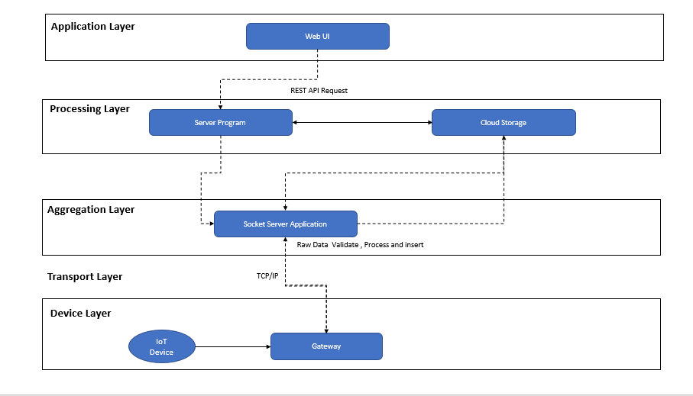
The Serverless Logic Tier
The logic tier of the three-tier architecture represents the brains of the architecture. The features of the two services allow you to build a serverless production application that is highly available, scalable, and
3.1.1 Software Elements

3.1.2 Security Software Architecture
There are a number of principles applied to current and proposed system security. • Apply security at all layers:
o Rather than running security appliances (e.g., firewalls) only at the edge of your infrastructure, use firewalls and other security controls on all of your resources (e.g., every virtual server, load balancer, and network subnet).
• Enable traceability:
o Log and audit all actions and changes to your environment.
• Implement a principle of least privilege:
o Ensure that authorization is appropriate for each interaction with your AWS resources and implement strong logical access controls directly on resources.
Figure 8: Security authentication

3.1.3 Performance Software Architecture
The most fundamental reason for performance concerns is that the tasks we set our systems to perform have become much more complex over time. The performance of the system depends on much more than the raw processing power of its hardware. The way that hardware is configured, the way resources are allocated and managed, and the way the software is written can have significant impacts on the system’s ability to meet its performance goals.
The scalability property of a system is closely related to performance, but rather than considering how quickly the system performs its current workload, scalability focuses on the predictability of the system’s performance as the workload increases.
4. Process Modeling
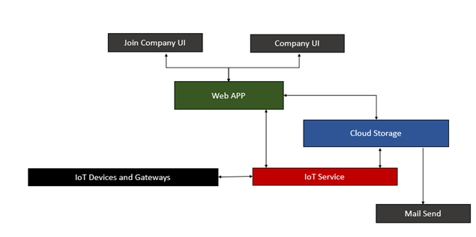
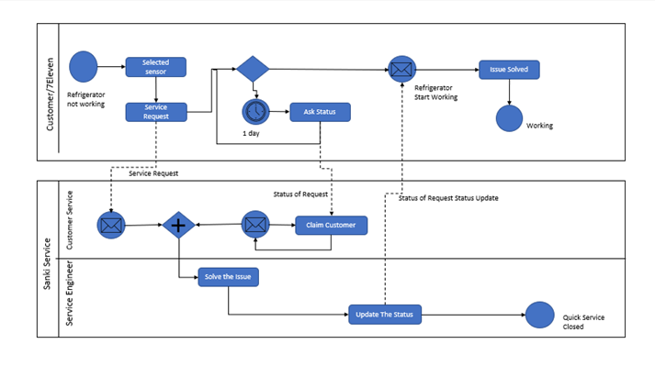

4.1 Business Requirements
4.2 Database Design
Data dictionary is provided as an attachment to this document.

4.2.1 Data Objects and Resultant Data Structures
The following table defines the data objects and schema for the proposed solution.

//Joincompany Collection
const JoincompanySchema = mongoose.Schema({
joinCompanyName: { type: String,required: true },
joinCompanyEmail: { type: String,required: true },
joinCompanyContact: { type: String,required: true },
isDeleted: {type: Boolean,default:false,required: true},
createdUser: { type: String,default:null},
createdDate :{type: Date,default: Date.now()},
lastUpdatedUser: { type: String,default:null},
lastUpdatedDate :{type: Date,default: Date.now()}
});

//Company Collection
const CompanySchema = mongoose.Schema({
joincompany_id: { type: ObjectId,required: true },
CompanyName: { type: String,required: true },
CompanyEmail: { type: String,required: true },
CompanyContact: { type: String,required: true },
isDeleted: {type: Boolean,default:false,required: true},
createdUser: { type: String,required: true },
createdDate :{type: Date,default: Date.now()},
lastUpdatedUser: { type: String,required: true },
lastUpdatedDate :{type: Date,default: Date.now()}
});

//UserGroup Collection
const UsergroupSchema = mongoose.Schema({
company_id: { type: ObjectId,required: true },
usergrpName: { type: String,required: true },
isDeleted: {type: Boolean,default:false,required: true},
createdUser: { type: String,required: true },
createdDate :{type: Date,default: Date.now()},
lastUpdatedUser: { type: String,required: true },
lastUpdatedDate :{type: Date,default: Date.now()}
});

//User Collection
const UserSchema = mongoose.Schema({
usergroup_id: { type: ObjectId,required: true },
company_id: { type: ObjectId,required: true },
username: { type: String,required: true },
email: {type: String, required: true },
password: {type: String,required: true},
tokenid: { type: String,default:null },
tokenCreateDate:{type: Date,default:null},
tokenExpireDate:{type: Date,default:null},
isActive :{type: Boolean,default:true,required: true},
isUser:{type: Boolean,default:false,required: true},
isAdmin:{type: Boolean,default:false,required: true},
companyLayer:{ type: String,required: true },
isSuperAdmin:{type: Boolean,default:false,required: true},
isDeleted: {type: Boolean,default:false,required: true},
createdUser: { type: String,required: true },
createdDate :{type: Date,default: Date.now()},
lastUpdatedUser: { type: String,required: true },
lastUpdatedDate :{type: Date,default: Date.now()}
});

//StoreArea Collection
const StoreareaSchema = mongoose.Schema({
company_id: { type: ObjectId,required: true },
areaName: { type: String,required: true },
isDeleted: {type: Boolean,default:false,required: true},
createdUser: { type: String,required: true },
createdDate :{type: Date,default: Date.now()},
lastUpdatedUser: { type: String,required: true },
lastUpdatedDate :{type: Date,default: Date.now()}
});

//Store Collection
const StoreSchema = mongoose.Schema({
company_id: { type: ObjectId,required: true },
storeName: { type: String,required: true },
serviceContract: {type: Boolean,default:false,required: true},
monitoringContract: {type: Boolean,default:false,required: true},
notificationstatus: {type: Boolean,default:false,required: true},
alertbusinesshours: {type: Boolean,default:false,required: true},
isActive: {type: Boolean,default:false,required: true},
isDeleted: {type: Boolean,default:false,required: true},
createdUser: { type: String,required: true },
createdDate :{type: Date,default: Date.now()},
lastUpdatedUser: { type: String,required: true },
lastUpdatedDate :{type: Date,default: Date.now()}
});

//StoreGroup Collection
const StoreGroupSchema = mongoose.Schema({
company_id: { type: ObjectId,required: true },
storearea_id: { type: ObjectId,required: true },
user_id: { type: ObjectId,required: true },
isDeleted: {type: Boolean,default:false,required: true},
createdUser: { type: String,required: true },
createdDate :{type: Date,default: Date.now()},
lastUpdatedUser: { type: String,required: true },
lastUpdatedDate :{type: Date,default: Date.now()}
});

//StoreGroupDetails Collection
const StoreGroupDtlSchema = mongoose.Schema({
storegroup_id: { type: ObjectId,required: true },
store_id: { type: ObjectId,required: true }
});

//ProductArea Collection
const ProductareaSchema = mongoose.Schema({
store_id: { type: ObjectId,required: true },
productareaname: { type: String,required: true },
isDeleted: {type: Boolean,default:false,required: true},
createdUser: { type: String,required: true },

createdDate :{type: Date,default: Date.now()},
lastUpdatedUser: { type: String,required: true },
lastUpdatedDate :{type: Date,default: Date.now()}
});

//Product Collection
const ProductSchema = mongoose.Schema({
store_id: { type: ObjectId,required: true },
productname: { type: String,required: true },
isDeleted: {type: Boolean,default:false,required: true},
createdUser: { type: String,required: true },
createdDate :{type: Date,default: Date.now()},
lastUpdatedUser: { type: String,required: true },
lastUpdatedDate :{type: Date,default: Date.now()}
});

//Gateway Collection
const GatewaySchema = mongoose.Schema({
company_id: { type: ObjectId,required: true },
store_id: { type: ObjectId,required: true },
gatewayMac :{ type: String,required: true },
gatewayName:{ type: String,required: true },
lastAlivetime:{type: Date,default: Date.now()},
isDeleted: {type: Boolean,default:false,required: true},
createdUser: { type: String,required: true },
createdDate :{type: Date,default: Date.now()},
lastUpdatedUser: { type: String,required: true },
lastUpdatedDate :{type: Date,default: Date.now()}
});

//Device Collection
const DeviceSchema = mongoose.Schema({
company_id: { type: ObjectId,required: true },
store_id: { type: ObjectId,required: true },
gatewayMac :{ type: String,required: true },

deviceIdentity:{ type: String,required: true },
isDeleted: {type: Boolean,default:false,required: true},
createdUser: { type: String,required: true },
createdDate :{type: Date,default: Date.now()},
lastUpdatedUser: { type: String,required: true },
lastUpdatedDate :{type: Date,default: Date.now()}
});

//DeviceDetails Collection
const DeviceDtlSchema = mongoose.Schema({
device_id: { type: ObjectId,required: true },
product_id: { type: ObjectId,required: true },
productarea_id: { type: ObjectId,required: true },
deviceNikname :{ type: String,required: true },
batteryStatus:{ type: String,required: true },
dynamicID:{ type: String,required: true }
});

//AlertSettingsSchema Collection
const AlertSettingsSchema = mongoose.Schema({
device_id: { type: ObjectId,required: true },
w_timeinterval:{ type: String,required: true },
c_timeinterval:{ type: String,required: true },
w_upperlmt:{ type: String,required: true },
w_lowerlimt:{ type: String,required: true },
c_upperlmt:{ type: String,required: true },
c_lowerlmt:{ type: String,required: true },
mailSend: {type: Boolean,default:true,required: true}
});

//Device Stream Collection
const DeviceStreamSchema = mongoose.Schema({
device_id: { type: ObjectId,required: true },
gatewayMac :{ type: String,required: true },
deviceIdentity:{ type: String,required: true },
sensorId:{ type: String,required: true },
timeInterval:{ type: String,required: true },
intervalType:{ type: String,required: true },
isActive: {type: Boolean,default:false,required: true}
});

//Device Threshold Collection
const DevicethresholdSchema = mongoose.Schema({
device_id: { type: ObjectId,required: true },
gatewayMac :{ type: String,required: true },
deviceIdentity:{ type: String,required: true },
sensorId:{ type: String,required: true },
thresholdValue:{ type: String,required: true },
isActive: {type: Boolean,default:false,required: true}
});

//AlertReason Collection
const AlertReasonSchema = mongoose.Schema({
device_id: { type: ObjectId,required: true },
tempstream_id: { type: ObjectId,required: true },
alertReason :{ type: String,required: true },
createdUser: { type: String,required: true },
createdDate :{type: Date,default: Date.now()},
closedUser: { type: String,default: null },
closedDate :{type: Date,default: null}
});

//QuickSerivce Collection
const QuickServiceSchema = mongoose.Schema({
company_id: { type: ObjectId,required: true },
store_id: { type: ObjectId,required: true },
device_id: { type: ObjectId,required: true },
servicerquestReason :{ type: String,required: true },
createdUser: { type: String,required: true },
createdDate :{type: Date,default: Date.now()},
serviceClosedReason :{ type: String,required: true },
closedUser: { type: String,default: null },
closedDate :{type: Date,default: null}
});

//Gateway Collection
const GatewaySchema = mongoose.Schema({
company_id: { type: ObjectId,required: true },
store_id: { type: ObjectId,required: true },
gatewayMac :{ type: String,required: true },
gatewayName:{ type: String,required: true },

lastAlivetime:{type: Date,default: Date.now()},
isDeleted: {type: Boolean,default:false,required: true},
createdUser: { type: String,required: true },
createdDate :{type: Date,default: Date.now()},
lastUpdatedUser: { type: String,required: true },
lastUpdatedDate :{type: Date,default: Date.now()}
});

//Device Collection
const DeviceSchema = mongoose.Schema({
company_id: { type: ObjectId,required: true },
store_id: { type: ObjectId,required: true },
gatewayMac :{ type: String,required: true },
deviceIdentity:{ type: String,required: true },
batteryStatus:{ type: String,required: true },
dynamicID:{ type: String,required: true },
isDeleted: {type: Boolean,default:false,required: true},
createdUser: { type: String,required: true },
createdDate :{type: Date,default: Date.now()},
lastUpdatedUser: { type: String,required: true },
lastUpdatedDate :{type: Date,default: Date.now()}
});

//TemperatureStreamdata Collection
const TemperatureStreamSchema = mongoose.Schema({
device_id: { type: ObjectId,required: true },
gatewayMac :{ type: String,required: true },
deviceIdentity:{ type: String,required: true },
sensorId:{ type: String,required: true },
temperatureValue: { type: String,required: true },
streamStatus: { type: String,required: true },
streamTime :{type:Date,required: true}
});

//HumidityStreamdata Collection
const HumidityStreamSchema = mongoose.Schema({
device_id: { type: ObjectId,required: true },
gatewayMac :{ type: String,required: true },
deviceIdentity:{ type: String,required: true },
sensorId:{ type: String,required: true },
humidityValue: { type: String,required: true },
streamTime :{type: Date,required: true}
});

//AlertSettingsSchema Collection
const AlertSettingsSchema = mongoose.Schema({
device_id: { type: ObjectId,required: true },
w_timeinterval:{ type: String,required: true },
c_timeinterval:{ type: String,required: true },
w_upperlmt:{ type: String,required: true },
w_lowerlimt:{ type: String,required: true },
c_upperlmt:{ type: String,required: true },
c_lowerlmt:{ type: String,required: true },
mailSend: {type: Boolean,default:true,required: true}
});

//Device Stream Collection
const DeviceStreamSchema = mongoose.Schema({
device_id: { type: ObjectId,required: true },
gatewayMac :{ type: String,required: true },
deviceIdentity:{ type: String,required: true },
sensorId:{ type: String,required: true },
timeInterval:{ type: String,required: true },
intervalType:{ type: String,required: true },
isActive: {type: Boolean,default:false,required: true}
});

//Device Threshold Collection
const DevicethresholdSchema = mongoose.Schema({
device_id: { type: ObjectId,required: true },
gatewayMac :{ type: String,required: true },
deviceIdentity:{ type: String,required: true },
sensorId:{ type: String,required: true },
thresholdValue:{ type: String,required: true },
isActive: {type: Boolean,default:false,required: true}
});

4.2.2 File and Database Structures
The following data model represents the current solution with the proposed solution highlighted.
4.2.2.1 Database Management System Files
The image below represents the high level ER diagram and object model for the current system
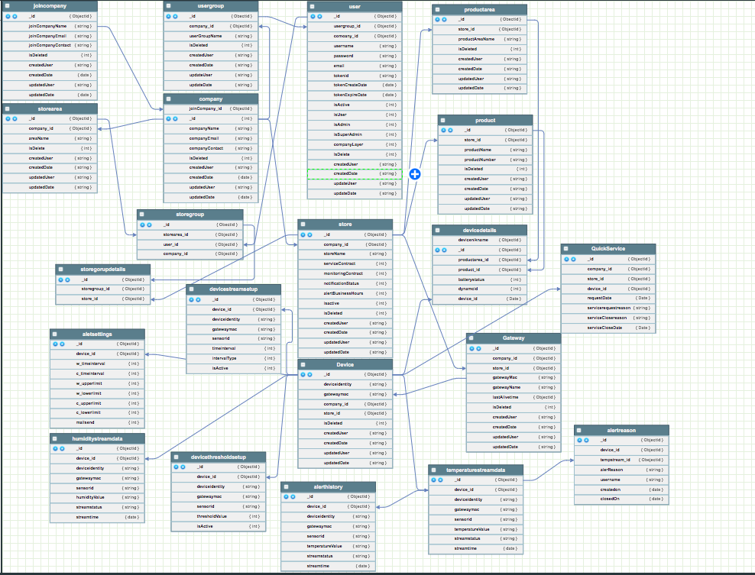
4.3 User Interface Design
User interface designs have not been completed for this document. It is anticipated that the development team will develop mockups based on final procurement specifications. The image below represents and example mockup.
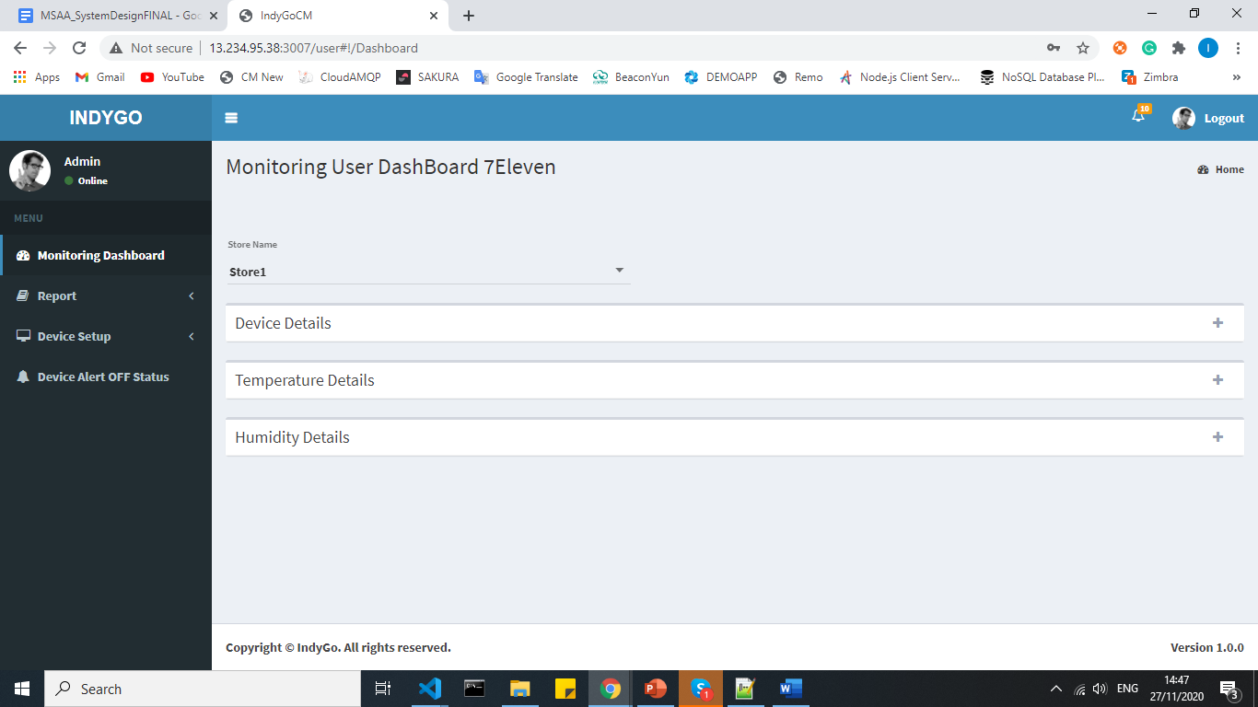

5. Operational Scenarios
Section 5 describes scenarios that show how the system will be used to perform its objectives and meet the user’s requirements. Each scenario can be illustrated by a use case. Develop sample usage scenarios (as realistic as possible) for each user class that show what inputs, outputs, and user interaction will be required.
5.1 Major Operational Scenarios
Overview
System IOT can be divided into 3 main sub systems.
1. Indygo management subsystem
2. Joint company management subsystem
3. Store management system
Indygo management sub system
This sub system provides the facilities that covers all the user management functionalities. Main use cases that comes under this subsystem includes
∙ User login
∙ New Joint company creation
∙ Edit profile and change password scenarios
Each user that interacts with the system is an actor of these use cases. Depending on the access levels, some actions will not be permitted.
Joint company management subsystem
This subsystem involves the main business login of the system. Main use cases that come under this subsystem includes
∙ Registering company
∙ Enroll User
∙ Registering store area
∙ Registering product area
∙ Registering product
∙ Registering gateway
∙ Registering device
∙ Device threshold setup
∙ Device maintenance
∙ User Grouping
Store management subsystem
∙ RealTime monitoring
∙ Mail Alert
∙ Device Data Report
∙ Customize Temperature
∙ Sensor stream setup

Process Purpose Description Priority Frequency

Sensor Monitoring | IoT Device Sensor data . | Store Can understand Refrigerator working and Product are fine inside the refrigerator | High | Daily
Sensor Alert | User can understand any problem in refrigerator (temperature variation) | Alert the Temperature value if it Cross over the Temperature | High | Daily
Alert ON/OFF | Email Alert On/OFF | Mail alert On/OFF system of each sensor | High | Daily
Quick Service Request | Service of refrigerator | This function help to send the service request for the refrigerator | High | Daily
Quick Service Closing | Request Service Closing | Immediate Service and Closing. | High | Daily
Automatic Email Send | Report and Alert | User can understand real time situation of store | High | Daily
Reporting | Reporting and Analytics | Users can run canned reports and dashboards. Users can create custom ad hoc reports. | High | Daily /  Weekly /  Monthly

5.2 Major Use Cases

1.1 User logs into the system
Login to the system.

Use case name | Login to the system
Scenario | Login to the system using username and password.
Triggering event | User enters the username and password and submit.
Brief description | When user inputs username and password, system checks for the validity and matching input values and redirects to the home page of user(the home page depends on the user and user type)
Actors | Indygo,Join company, Company
Related use cases | Null
Preconditions | The user should be a valid user (should possess a username and password)
Post condition | If the user is a valid user, he or she should be redirected to the correct home page.
Flow of events | User loads the login page.  User inputs the username and password and then submit  System check the validity of the entered password and username.  If this is a valid user, the user will get redirected to their respective home page.
Exception conditions | If the entered username and password is invalid, the user will be asked to enter them again .  If the user has forgotten the password, he can click “forget password”.

1.2 User invokes “forget password”

Use case name | User invokes “forget password”
Scenario | When the user forgets the password, he or she can invoke the forgotten password and go through a recovery process.
Triggering event | User clicks “forget password” button.
Brief description | When user clicks “forget password“, he can ask the system to send a mail to his email address, from which he can change the password to a new one
Actors | Join company, Company
Related use cases | Login to the system.
Preconditions | The user should be a valid user, and should have an email address that is saved in the system.
Post condition | User will be able to change the password.
Flow of events | User clicks the forget password.  Then using the window, user can ask for a mail which contents a security key.  User types that security key in the following interface.  Then if the code is correct, user will be redirected to change password page.
Exception conditions | If the user does not have a pre-set email address, the user can’t continue this process and the user should contact the system admin and reset the password.  If the user enters the wrong code, he can re-try and get a new code.

.1.4 User log outs from the system

Use case name | User logout from the system
Scenario | User who has currently logged into system logout
Triggering event | User clicks the logout button.
Brief description | When a user who has already logged in to the system clicks logout he will get logout from the system, so that a session variable will get reset.
Actors | Indygo, Join company, Company
Related use cases | Login to the system.
Preconditions | The user have logged in to the system already.
Post condition | User should get redirected to the login page.
Flow of events | System removes the session values for the user  User gets redirected to the the login page
Exception conditions | None.
1.5 Create a new join company

Use case name | Create new join company
Scenario | The Indygo create new join company account.
Triggering event | The indygo submit new join company creation activity
Brief description | When a new user add to the system the admin adds him using “create new join company” work flow. The new join company is the admin of the company.The user get new username and password and full access to the join company pages.
Actors | Indygo
Related use cases | None
Preconditions | The user should possess all the required attributes of the user entity.
Post condition | The new join company should get access to the system
Flow of events | New join company provide essential details to an Indygo  Indygo performs “create new join company” activity.  Indygo submit the form.  System save a new user account.  A new username and a password is given to the new join company.
Exception conditions | None

1.6 Create a new company

Use case name | Create new company
Scenario | The joint company creates a new company account.
Triggering event | The join company submit new company creation activity
Brief description | When a new user adds to the system the admin adds him using “create new company” work flow. The new join company is the admin of the company.The user gets a new username and password and full access to the company pages.
Actors | Join company
Related use cases | None
Preconditions | The company should possess all the required attributes of the company entity.
Post condition | The new company should get access to the system
Flow of events | New company provide essential details to an join company  Joint company performs “create new company” activity.  Joint company and submit the form.  System save a new user account.  A new username and a password is given to the new company.
Exception conditions | None
1.6 Create store

Use case name | Create a store area.
Scenario | The joint company create new store account.
Triggering event | The joint company submit new store creation activity
Brief description | When a new store adds to the system the admin adds him using “create new store” work flow.
Actors | Join company
Related use cases | None
Preconditions | The company should possess all the required attributes of the store entity.
Post condition | The new company should get access to the system
Flow of events | New company provide essential store details to an join company  Join company performs “create new store” activity.  Join the company and submit the form.  System save new store.
Exception conditions | None

1.6 Create new product area

Use case name | Create a product area
Scenario | The joint company creates a new product area.
Triggering event | The join company submit new product area creation activity
Brief description | When a new product area adds to the system the joint company adds him using the “create new product area” workflow.
Actors | Join company
Related use cases | None
Preconditions | The joint company should have logged into the system already.  The company should possess all the required attributes. of the company entity.
Post condition | The new product area added to the system
Flow of events | Store provide essential details to an join company  Joint company performs “create new product area” activity.  Joint company and submit the form.  System save a new product area.
Exception conditions | None

1.6 Create new product

Use case name | Create a product.
Scenario | The joint company creates a new product area.
Triggering event | The joint company submitted a new product creation activity.
Brief description | When a new product adds to the system the joint company adds him using the “create new product” workflow.
Actors | Joint company
Related use cases | None
Preconditions | The joint company should have logged into the system already.  The company should possess all the required attributes of the company entity.
Post condition | The new product added to the system
Flow of events | Store provide essential details to an join company  Joint company performs “create new product” activity.  Joint company and submit the form.  System save a new product.
Exception conditions | None

1.6 Create new gateway

Use case name | Create a gateway.
Scenario | The joint company creates a new gateway.
Triggering event | The joint company submitted a new gateway creation activity.
Brief description | When a new gateway adds to the system the joint company adds him using the “create new gateway” workflow.
Actors | Joint company
Related use cases | None
Preconditions | The joint company should have logged into the system already.  The company should possess all the required attributes of the company entity.
Post condition | The new gateway added to the system
Flow of events | jointCompany provide essential details to an join company.  Joint company performs “create new gateway” activity.  Joint company and submit the form.  System save a new gateway.
Exception conditions | None

1.6 Create new device

Use case name | Create a device.
Scenario | The joint company creates a new device.
Triggering event | The joint company submitted a new device creation activity.
Brief description | When a new device adds to the system the joint company adds him using the “create new device” workflow.
Actors | Joint company
Related use cases | None
Preconditions | The joint company should have logged into the system already.  The company should possess all the required attributes of the company entity.
Post condition | The new device added to the system
Flow of events | jointCompany provides essential details.  Joint company performs “create new device” activity.  Joint company and submit the form.  System save a new device.
Exception conditions | None

1.6 Create device threshold setup

Use case name | Create a device threshold setup.
Scenario | The joint company creates device threshold setup.
Triggering event | The joint company submitted device threshold setup activity.
Brief description | The device information already generated based on the the store and gateway.  The system validates the input value and and send nee threshold value to the gateway.
Actors | Joint company
Related use cases | None
Preconditions | The joint company should have logged into the system already.  The store and gateway information specified in the system
Post condition | The new device threshold setup added to the system and setup the gateway
Flow of events | jointCompany provides essential details.  Joint company performs “ Device threshold setup” activity.  Joint company and submit the form.  System save a new threshold setup and send the new threshold value to the gateway.
Exception conditions | None

1.6 Create user

Use case name | Create company employee
Scenario | The company creates employees.
Triggering event | The company submitted the employees creation activity.
Brief description | When a new employees adds to the system the company adds him using the “create user” workflow.
Actors | company
Related use cases | None
Preconditions | The company should have logged into the system already.  The company should possess all the required attributes to register the user.
Post condition | The new employee added to the system.
Flow of events | company performs “ Create user” activity.  company submit the form.  System saves a new employee.  A new username and password is given to the new employee.
Exception conditions | None

1.6 Create user grouping

Use case name | Create an Employee grouping.
Scenario | The company creates Employee grouping.
Triggering event | The company creates employee grouping activities.
Brief description | When a new Employee grouping adds to the system the company adds him using the “Employee grouping” workflow.  The company is assigning employees to manage and monitoring the device.One employees have multiple stores to manage.
Actors | company
Related use cases | None
Preconditions | The company should have logged into the system already.  The store information and user information should generate.
Post condition | The employees are assigned to manage the stores.
Flow of events | jointCompany provides essential details.  Joint company performs “ Device threshold setup” activity.  Joint company and submit the form.  System save a new threshold setup.
Exception conditions | None

1.6 RealTime monitoring

Use case name | Create a .
Scenario | The joint company creates device threshold setup.
Triggering event | The joint company submitted device threshold creation activity.
Brief description | When a new device adds to the system the joint company adds him using the “Device threshold setup” workflow.
Actors | Joint company
Related use cases | None
Preconditions | The joint company should have logged into the system already.  The company should possess all the required attributes of the company entity.
Post condition | The new device threshold setup added to the system
Flow of events | jointCompany provides essential details.  Joint company performs “ Device threshold setup” activity.  Joint company and submit the form.  System save a new threshold setup.
Exception conditions | None

1.6 Mail Alert OFF (Monitoring-Dashboard)

Use case name | Mail alert turned off .
Scenario | The Company employee turned off Mail Alert for a particular interval.
Triggering event | The company Employee submitted the Mail alert offf activity.
Brief description | The company turn off the mail alert alert system for a particular time interval for using monitoring dashboard “Alert off” workflow.
Actors | company
Related use cases | None
Preconditions | The company should have logged into the system already.  The device data should generate.
Post condition | The mail alert system is turned off for a particular interval.
Flow of events | company provides essential details to turn off the mail.  company performs “ Mail Alert off activity” activity.  company submit the form.  System save a new Mail alert off and stop mailing service for a particular interval.
Exception conditions | None

.1.6 Device Data Reporting

Use case name | Create a device threshold setup.
Scenario | The joint company creates device threshold setup.
Triggering event | The joint company submitted device threshold creation activity.
Brief description | When a new device adds to the system the joint company adds him using the “Device threshold setup” workflow.
Actors | Joint company
Related use cases | None
Preconditions | The joint company should have logged into the system already.  The company should possess all the required attributes of the company entity.
Post condition | The new device threshold setup added to the system
Flow of events | jointCompany provides essential details.  Joint company performs “ Device threshold setup” activity.  Joint company and submit the form.  System save a new threshold setup.
Exception conditions | None

1.6 Customize Temperature

Use case name | Create a device threshold setup.
Scenario | The joint company creates device threshold setup.
Triggering event | The joint company submitted device threshold creation activity.
Brief description | When a new device adds to the system the joint company adds him using the “Device threshold setup” workflow.
Actors | Joint company
Related use cases | None
Preconditions | The joint company should have logged into the system already.  The company should possess all the required attributes of the company entity.
Post condition | The new device threshold setup added to the system
Flow of events | jointCompany provides essential details.  Joint company performs “ Device threshold setup” activity.  Joint company and submit the form.  System save a new threshold setup.
Exception conditions | None

1.6 Sensor Streaming setting

Use case name | Create a device threshold setup.
Scenario | The joint company creates device threshold setup.
Triggering event | The joint company submitted device threshold creation activity.
Brief description | When a new device adds to the system the joint company adds him using the “Device threshold setup” workflow.
Actors | Joint company
Related use cases | None
Preconditions | The joint company should have logged into the system already.  The company should possess all the required attributes of the company entity.
Post condition | The new device threshold setup added to the system
Flow of events | jointCompany provides essential details.  Joint company performs “ Device threshold setup” activity.  Joint company and submit the form.  System save a new threshold setup.
Exception conditions | None
1.6 Device Data Reporting

Use case name | Create a device threshold setup.
Scenario | The joint company creates device threshold setup.
Triggering event | The joint company submitted device threshold creation activity.
Brief description | When a new device adds to the system the joint company adds him using the “Device threshold setup” workflow.
Actors | Joint company
Related use cases | None
Preconditions | The joint company should have logged into the system already.  The company should possess all the required attributes of the company entity.
Post condition | The new device threshold setup added to the system
Flow of events | jointCompany provides essential details.  Joint company performs “ Device threshold setup” activity.  Joint company and submit the form.  System save a new threshold setup.
Exception conditions | None
6. Detailed Design
6.1 Hardware Detailed Design
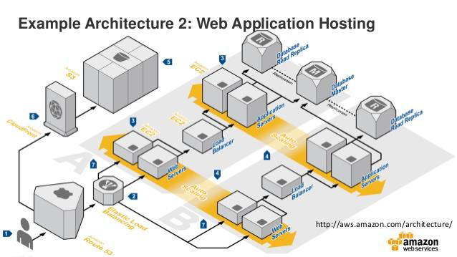
Example of Web Application Hosting
6.2 Software Detailed Design
Provide a detailed description for each system software service that addresses the following software service attributes. Much of the information that appears in this section should be contained in the headers/prologues and comment sections of the source code for each component, subsystem, module, and subroutine. If so, this section may largely consist of references to or excerpts of annotated diagrams and source code. Any referenced diagrams or source code excerpts should be provided at any design reviews.
• Service Identifier - The unique identifier and/or name of the software service
• Classification - The kind of service (e.g., application, data service, etc.)
• Definition - The specific purpose and semantic meaning of the service
• Requirements - The specific functional or nonfunctional requirements that the service satisfies
• Internal Data Structures - The internal data structures for the service

6.3 Security Detailed Design
Instructions: Provide a graphical representation with detailed information for each of the individual security hardware components. Specify the design for the below items as required.
• Authentication
• Authorization
• Logging and Auditing
• Encryption
• Network ports usage
• Intrusion Detection and Prevention

7. Data Replication
Data replication is the process of making multiple copies of data and storing them at different locations to improve their overall accessibility across a network. Similar to data mirroring, data replication can be applied to both individual computers and servers. The data replicates can be stored within the same system, on-site and off-site hosts, and cloud-based hosts.

Benefits of Data Replication
- Improve the availability of data
- Increase the speed of data access
- Enhance server performance
- Accomplish disaster

