
Human Resources Management System
Software Requirement Specification
Revision History
Version | Created / Modified By | Date | Reviewed By | Approved By | Remarks
1.1 | Ayana P Dharman | 01-12-2020

Software Requirement specification for HRMS Application.

Table of Contents
1 Introduction 6
1.1 Purpose 6
1.2 Scope 6
1.3 User Characteristics 6
2 Functional Requirements (Admin MODULE) 7
2.1 Admin User Login 7
2.2 Dashboard 7
2.2.1 Announcements 7
2.2.2 Calendar 7
2.3 LeaveType 8
2.3.1 SEARCH AND LIST Leavetype 8
2.3.2 CREATE leavetype 8
2.3.3 EDIT leavetype 9
2.3.4 DEACTIVATE leavetype 9
2.4 Announcements 9
2.4.1 SEARCH AND LIST Announcements 9
2.4.2 CREATEAnnouncements 10
2.4.3 EDIT Announcements 10
2.4.4 DEACTIVATE Announcements 11
2.5 Designation 11
2.5.1 SEARCH AND LIST Designation 11
2.5.2 CREATE Designation 11
2.5.3 EDIT Designation 12
2.5.4 DEACTIVATEDesignation 12
2.6 Location 12
2.6.1 SEARCH AND LIST Location 13
2.6.2 CREATE Location 13
2.6.3 EDIT Location 14
2.6.4 DEACTIVATE Location 14
2.7 Holiday 14
2.7.1 SEARCH AND LIST Holiday 14
2.7.2 CREATE Holiday 15
2.7.3 EDIT Holiday 15
2.7.4 DEACTIVATE Holiday 15
2.8 Client 16
2.8.1 SEARCH AND LIST Client 16
2.8.2 CREATE Client 16
2.8.3 EDIT Client 17
2.8.4 DEACTIVATE Client 17
2.9 User 17
2.9.1 SEARCH AND LIST User 17
2.9.2 CREATE User 18
2.9.3 Approvers and mail notifications LIST 18
2.9.4 CREATE/UPDATE Approvers and mail notifications 18
2.9.5 Delete Approvers and mail notifications 19
2.9.6 Employee Project LIST 19
2.9.7 CREATE/UPDATE Project 20
2.9.8 EDIT User 20
2.9.9 DEACTIVATEUser 21
2.10 Leave Allocation 21
2.11 Edit Admin Profile 21
2.12 Leave Application 22
2.13 WorkReport 23
2.14 Leave Report 23
2.15 Leave History 24
2.16 Project History 24
3 Functional Requirements (HR) 25
3.1 User Login 25
3.2 Forgot Password 25
3.3 Dashboard 26
3.3.1 Leave Approval LIST 26
3.3.2 Approve/Reject Leave 26
3.3.3 Pending leave 26
3.3.4 View pending leave status 26
3.3.5 Announcements 26
3.3.6 Calendar 27
3.3.7 Work Report 27
3.4 Edit Profile 27
3.5 Leave Application 28
3.6 WorkReport 28
3.7 Leave History 29
4 Functional Requirements (USER) 29
4.1 User Login 29
4.2 Forgot Password 30
4.3 Dashboard 30
4.3.1 Leave Approval LIST (approver) 31
4.3.2 Approve/Reject Leave (approver) 31
4.3.3 Pending leave 31
4.3.4 View pending leave status 31
4.3.5 Announcements 31
4.3.6 Calendar 31
4.4 Edit Profile 31
4.5 Leave Application 32
4.6 WorkReport 32
4.7 Leave History 33
5 Non-Functional Requirements 33
5.1 Performance Requirements 33
5.2 Security Requirements 33
5.3 Software System Attributes 34
5.3.1 Client Side Quality Attributes: 34
5.3.2 Server Side Quality Attributes: 34
6 Appendices 34

Introduction

Purpose
The purpose of this document is to present a detailed description of the HRMS Application. Description includes the purpose and features of the system, the interfaces of the system, the operations in the system and the constraints under which it must operate. This document is intended for both customers and developers of the system and shall be reviewed and approved by the customer, before proceeding with development of the system.

Scope
Primarily, the scope of this HRMS product feature which allow the end user (administrator or employee) having the access to request or approve Leave.
Some of the product scope is following:
- The HRMS application that automates the functionalities of the leave management.
- The target user is the HR Manager, Project Manager, Technical staffs and Non Technical staff.
- The main objective to develop this system is to automate the current leave application and record that is manually processed in Indocosmo Systems Pvt. Ltd.
- This application automatically calculates leave balance from a fix amount of annual leave and show to the user.
- It enables the Managers to record inapplicable leave in systematic database system.
- Improve the mechanism of receiving, approving and rejecting leave application through system

User Characteristics
There are two types of users in the system:
- Admin user: This user can create users and configure the essential things required for the user such as Leave Types, Leave allocation, Holidays, Announcements, Leave reports, work reports, work history, Client, Designation, Location and Approvers.
- HR user: This user can create users and see the leave reports, work reports, work history. And also apply leave and upload work reports of the users.
- Normal Users: These are the general users of HRMS Application created by Admin and they can apply and reject/approve (in case of Approver).

Functional Requirements (Admin MODULE)
The functionality of the HRMS application is to improve the mechanism of receiving, approving and rejecting leave application through system.

Admin User Login
The admin user can login into the admin module. After login, the admin module home will be displayed with modules Dashboard (as default home), Leave Type, Designation, Location, Holiday, Client, Announcements, User and Leave Allocation.

Dashboard

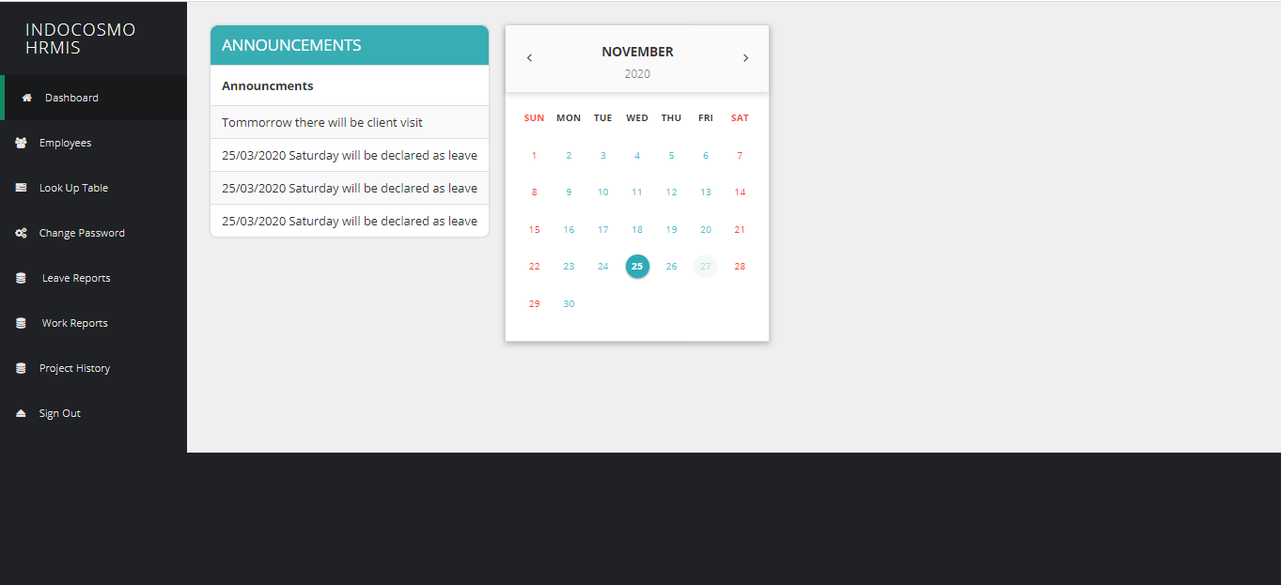
In the home page, Dashboard listing will be displayed by default. It should have the Calendar for viewing the Holidays and the important announcements.

Announcements
Admin Should be able to see important announcement

Calendar
Admin should be able to view the calendar with Holidays.

LeaveType
In the Leave Type module, Leave Type listing will be displayed by default, with pagination enabled. Leave types will be linked in the Leave Allocation for users correspondingly with location.

SEARCH AND LIST Leavetype
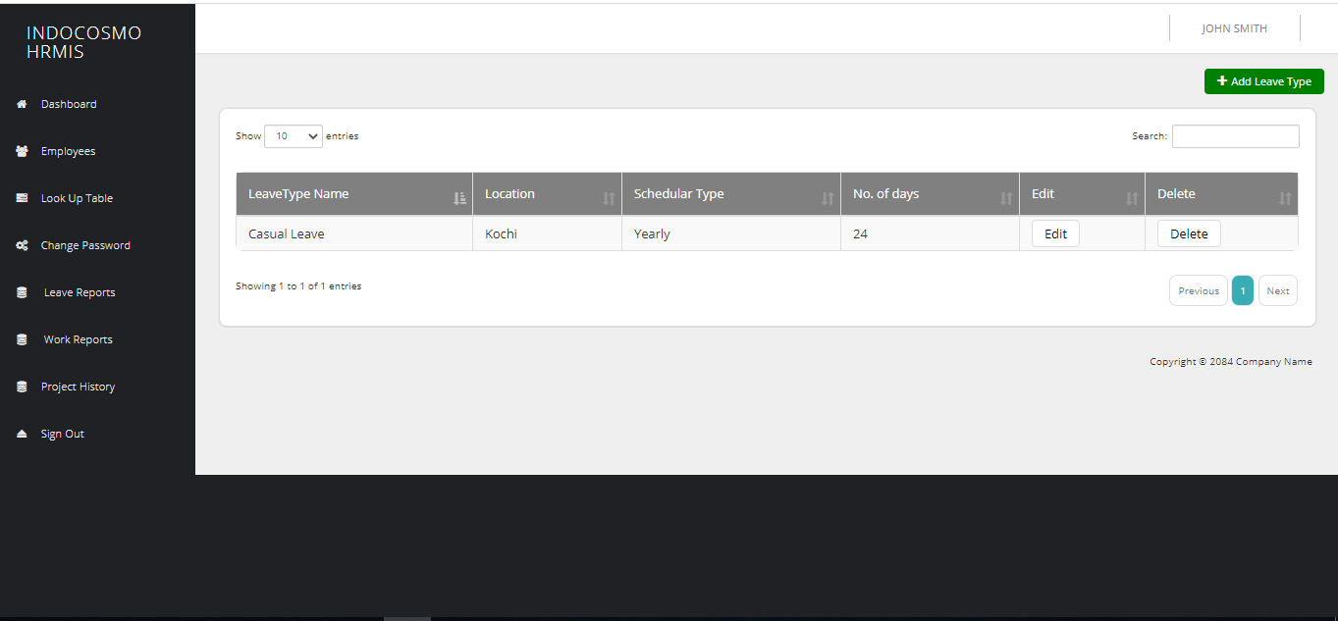
Admin user should be allowed to search Leave Type based on Leave Type’s name/leave code. Any changes in the Leave Type’s details such as new Leave Type creation, updating or deactivation will be reflected in the Leave Type list. Should be listed with Leave Name, Code, No. of Days and location.

CREATE leavetype
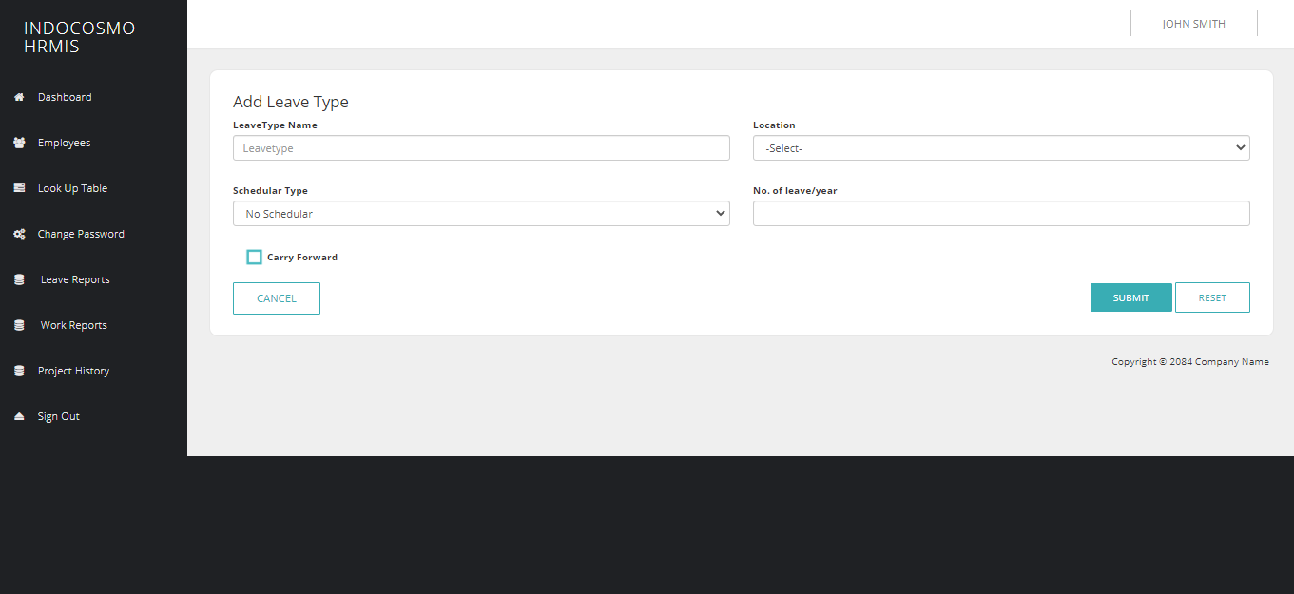
Admin user should be able to create Leave Type with Leave Code, Name, Location, Scheduler(Monthly/Yearly), Carry forward applicable and No. of Leaves.

EDIT leavetype
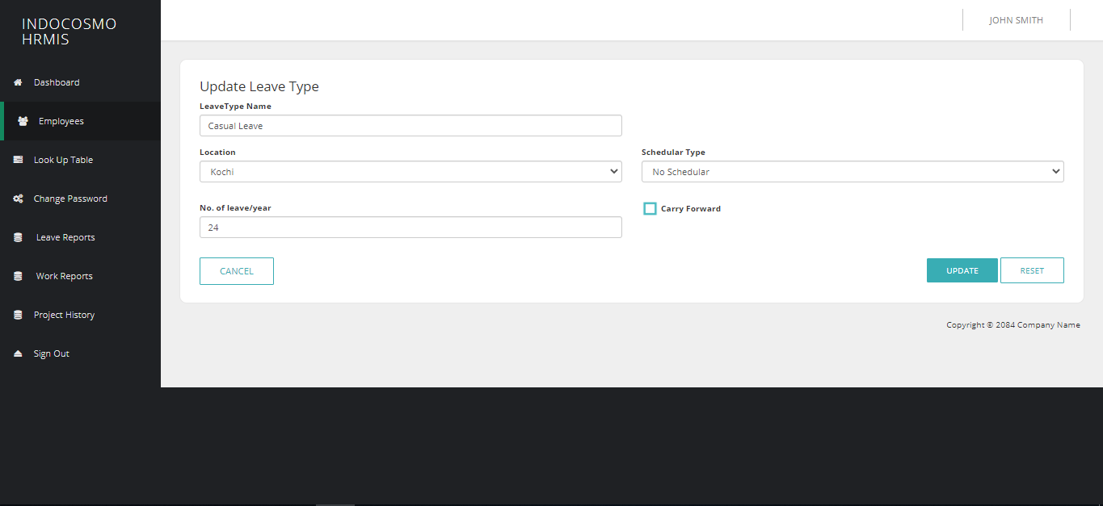
Admin User should be able to update all the details.

DEACTIVATE leavetype
Admin user should be able to deactivate user only if no user is linked with it.

Announcements
In the Announcements module, Announcements listing will be displayed by default, with pagination enabled. Active Announcements will listed to the Users.

SEARCH AND LIST Announcements
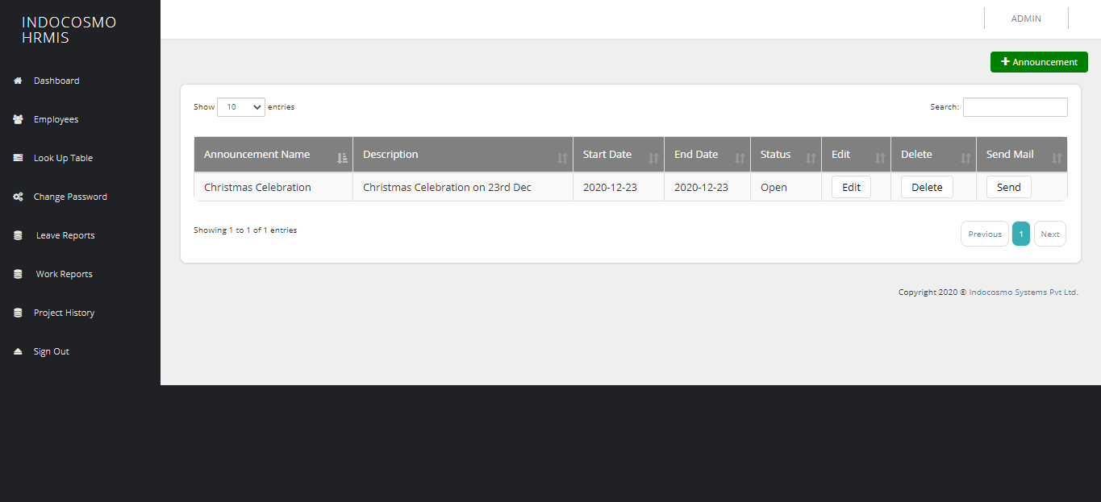
Admin user should be allowed to search Announcements based on Announcements name. Any changes in the Announcements details such as new Announcements creation, updating or deactivation will be reflected in the Announcements list. Should be listed with Announcements Name and Status.

CREATE Announcements
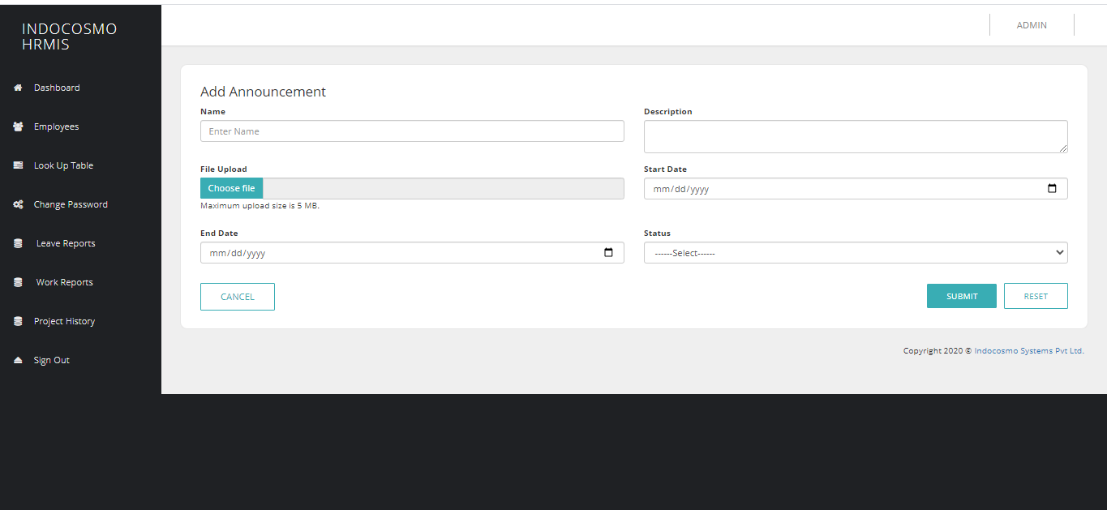
Admin user should be able to create Announcements with its Name andStatus(Active/InActive).

EDIT Announcements

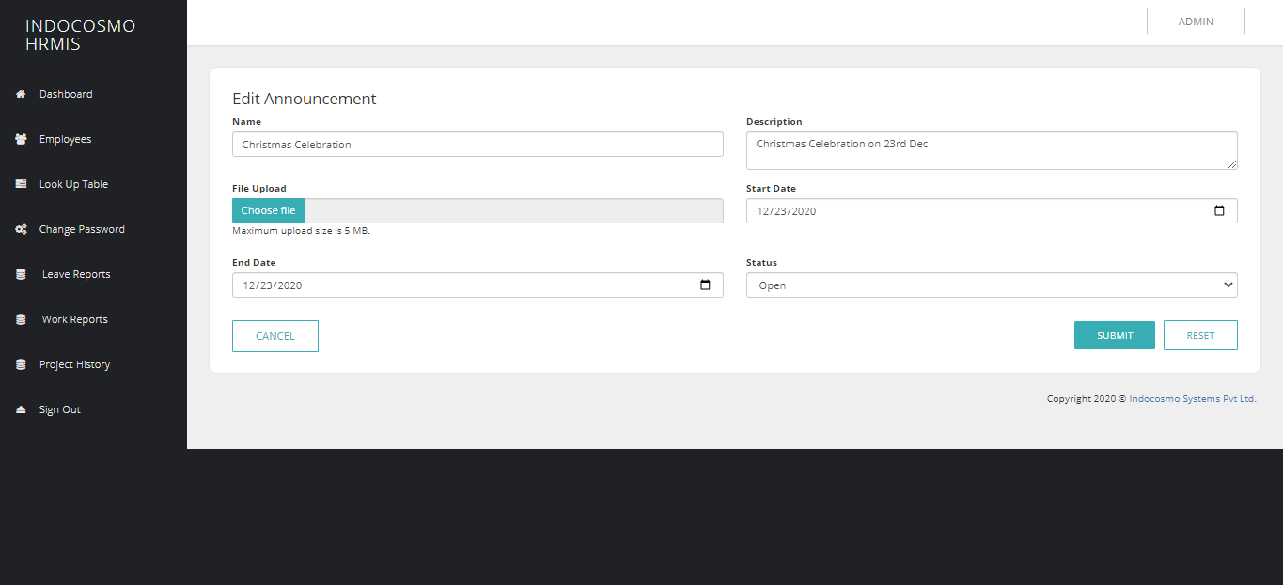
Admin User should be able to update all the details.

DEACTIVATE Announcements
Admin user should be able to deactivate Announcements.

Designation
In the Designation module, Designation listing will be displayed by default, with pagination enabled. Designation will be linked with corresponding Users.

SEARCH AND LIST Designation
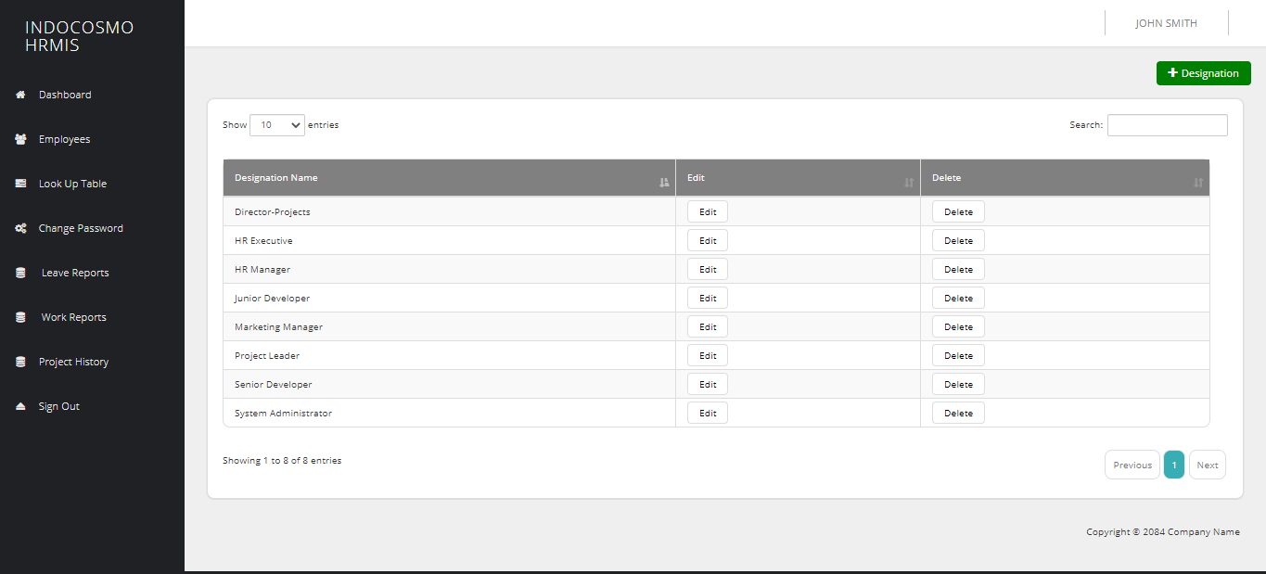
Admin user should be allowed to search Designation based on Designation’s name. Any changes in the Designation’s details such as new Designation creation, updating or deactivation will be reflected in the Designation list. Should be listed with Designation Name and Code.

CREATE Designation
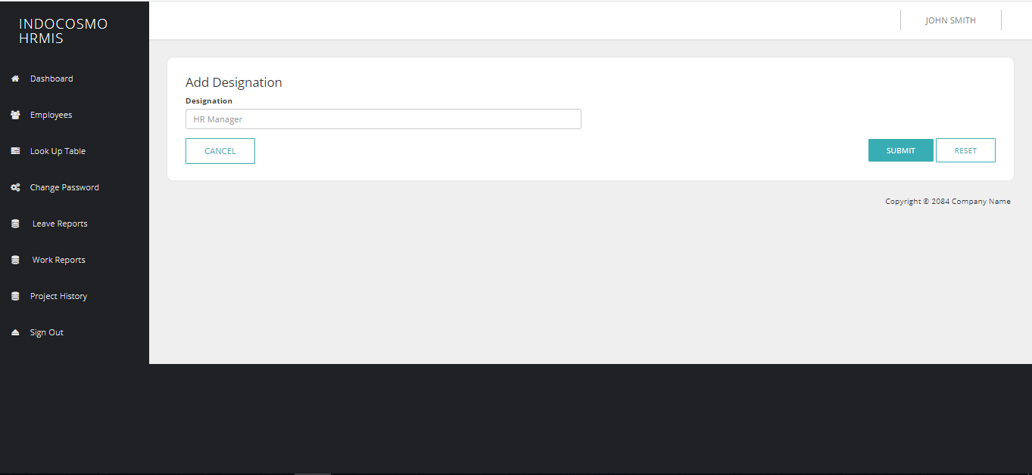
Admin user should be able to create Designation with its Name and Code.

EDIT Designation

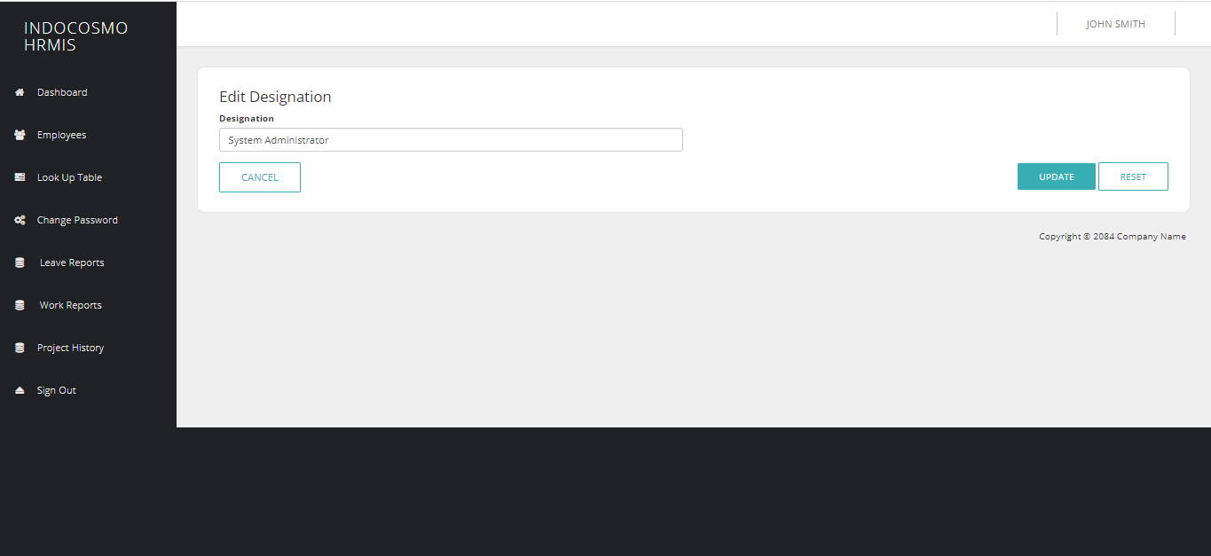
Admin User should be able to update all the details.

DEACTIVATEDesignation
Admin user should be able to deactivate user only if no user is linked with it.

Location
In the Location module, a Location listing will be displayed by default, with pagination enabled. Location will be linked in Leave Allocation, creation of Client and Users.

SEARCH AND LIST Location
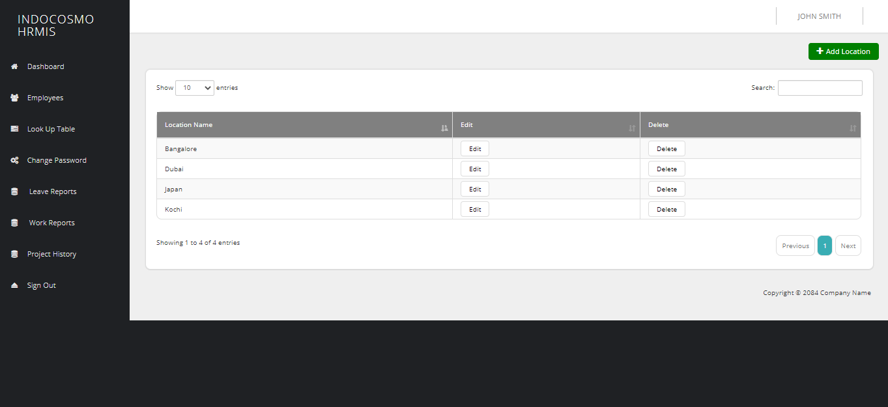
Admin user should be allowed to search Location based on Location’s name/code. Any changes in the Location’s details such as new Location creation, updating or deactivation will be reflected in the Location list. Should be listed with Location Name and Code.

CREATE Location

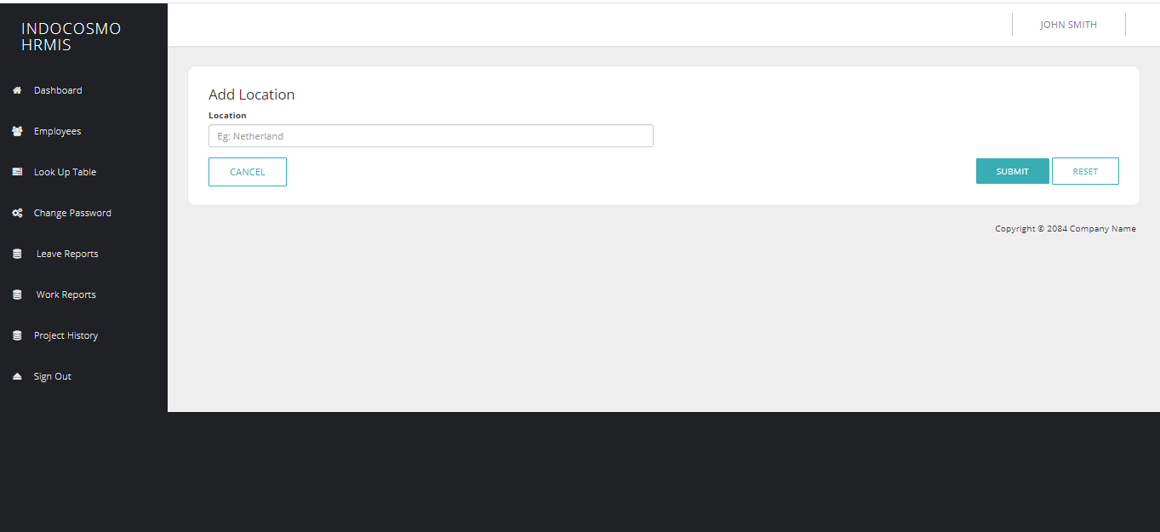
Admin user should be able to create Location with Code and Name.

EDIT Location
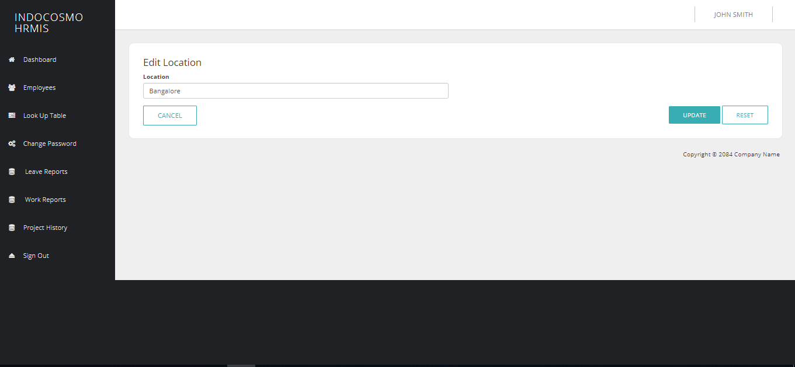
Admin User should be able to update all the details.

DEACTIVATE Location
Admin user should be able to deactivate Location only if no user and Leave Types are linked with it.

Holiday
In the Holiday module, a Holiday listing will be displayed by default, with pagination enabled. Holidays will be linked with corresponding companies.

SEARCH AND LIST Holiday
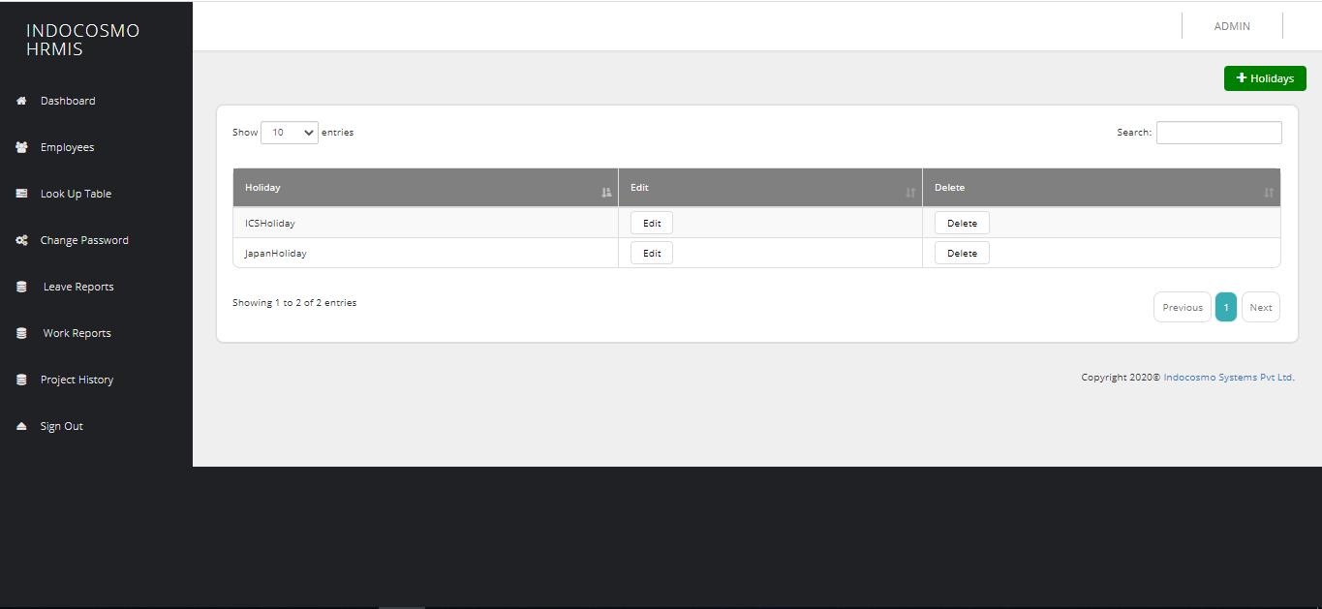
Admin user should be allowed to search Holiday based on Holiday’s name/Year. Any changes in the Holiday’s details such as new Holiday creation, updating or deactivation will be reflected in the Holiday list. Should be listed with Holiday Name, Date and Year.

CREATE Holiday
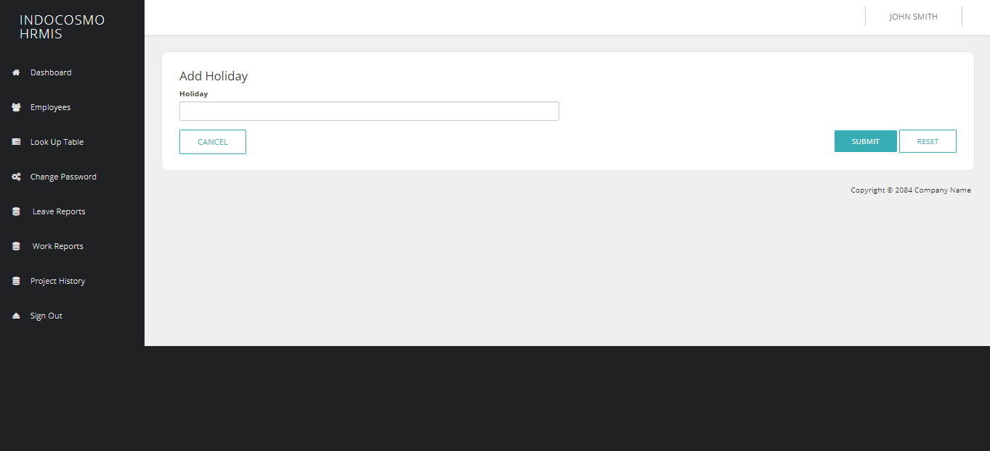
Admin user should be able to create Holiday with Name and corresponding Date and Year.

EDIT Holiday
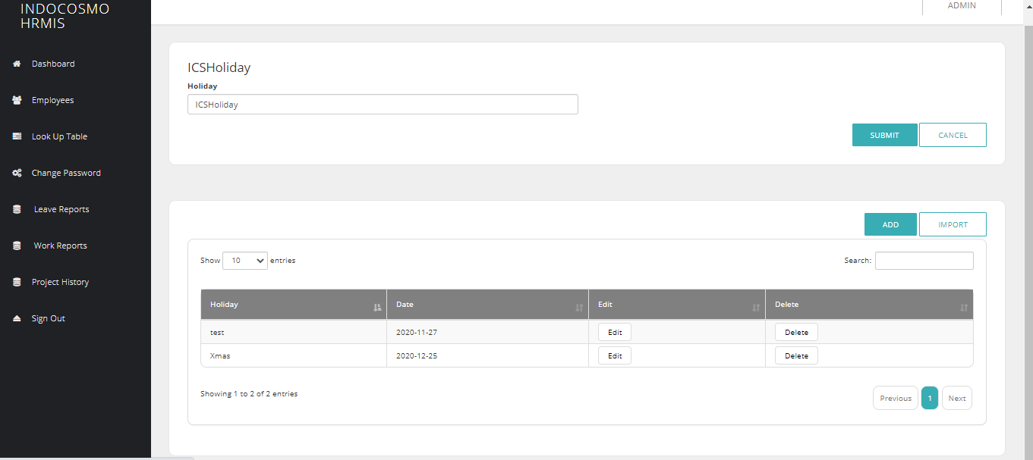
Admin User should be able to update all the details.

DEACTIVATE Holiday
Admin user should be able to deactivate Holiday only if no client is linked with it.

Client
In the Client module, a Client listing will be displayed by default, with pagination enabled. Companies will be linked as clients with the user.

SEARCH AND LIST Client
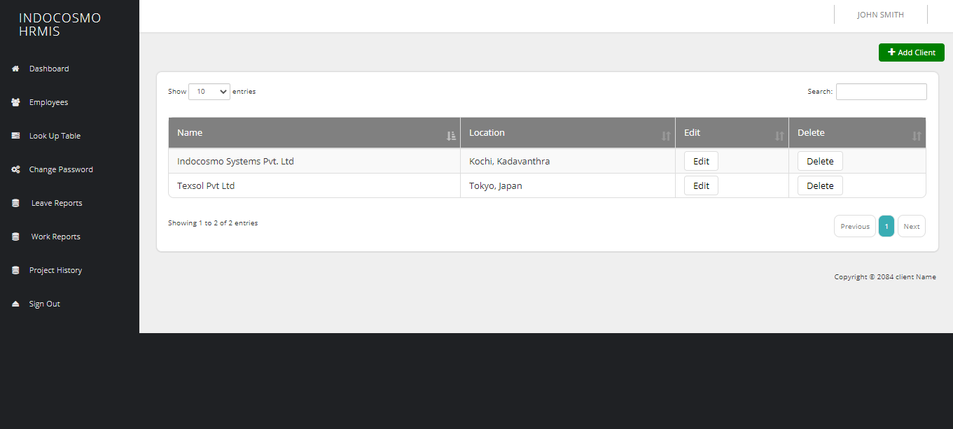
Admin user should be allowed to search Client based on Client’s name/code. Any changes in the Client’s details such as new Client creation, updating or deactivation will be reflected in the Client list. Should be listed with Client Name, Code and Location.

CREATE Client
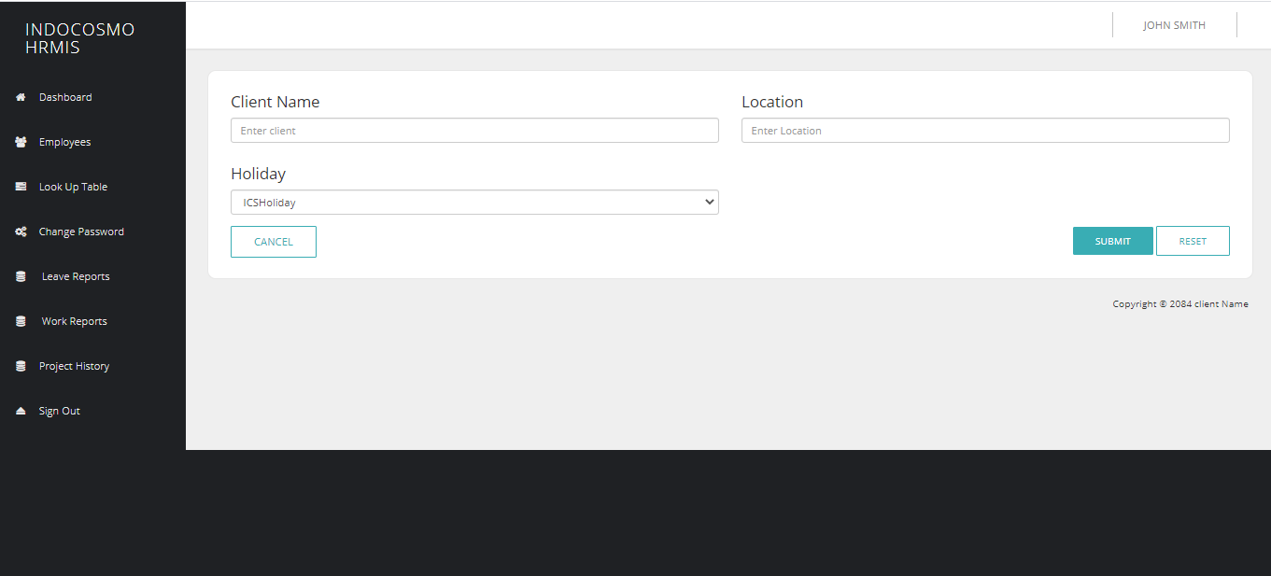
Admin user should be able to create Client with Code, Name, Manager, Projects, Address and Location.

EDIT Client
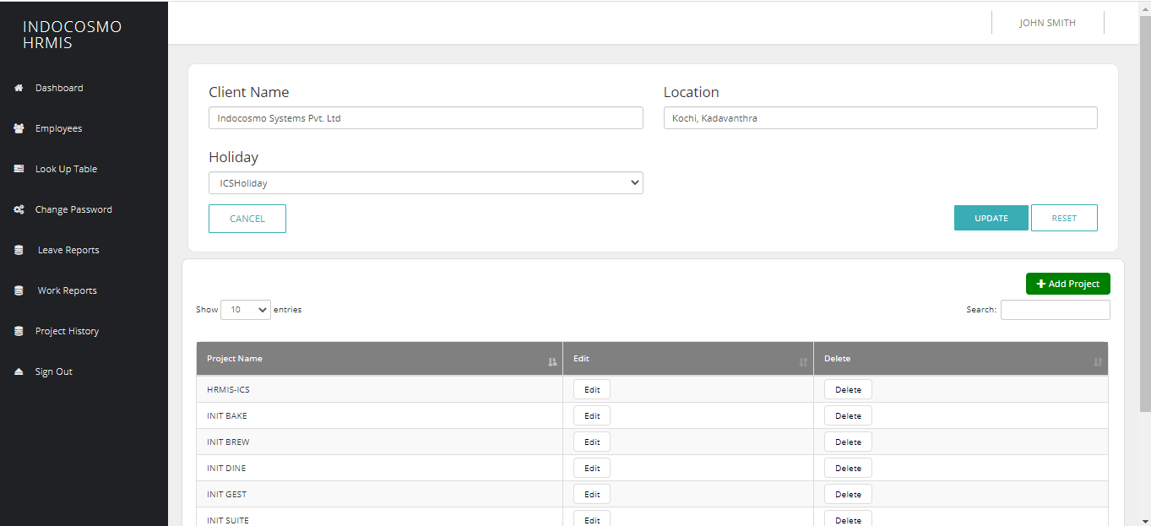
Admin User should be able to update all the details.

DEACTIVATE Client
Admin user should be able to deactivate Client only if no user is linked with it.

User
In the User module, a User listing will be displayed by default, with pagination enabled.

SEARCH AND LIST User
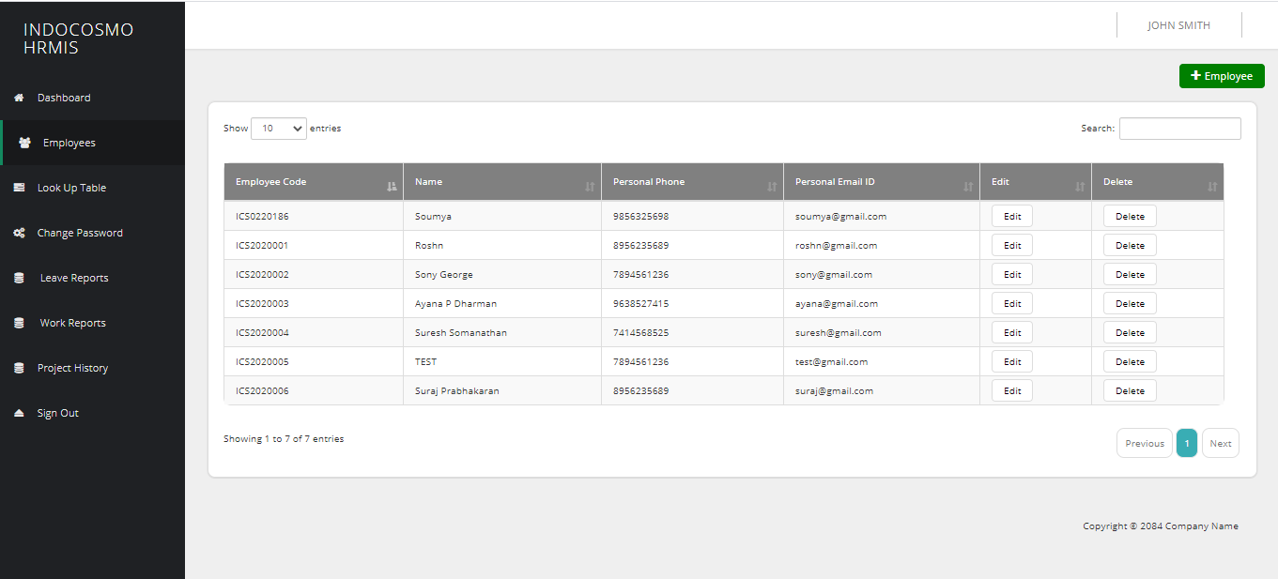
Admin user should be allowed to search User based on User’s name/code. Any changes in the User’s details such as new User creation, updating or deactivation will be reflected in the User list. Should be listed with User Name, Code, Designation and Location.

CREATE User
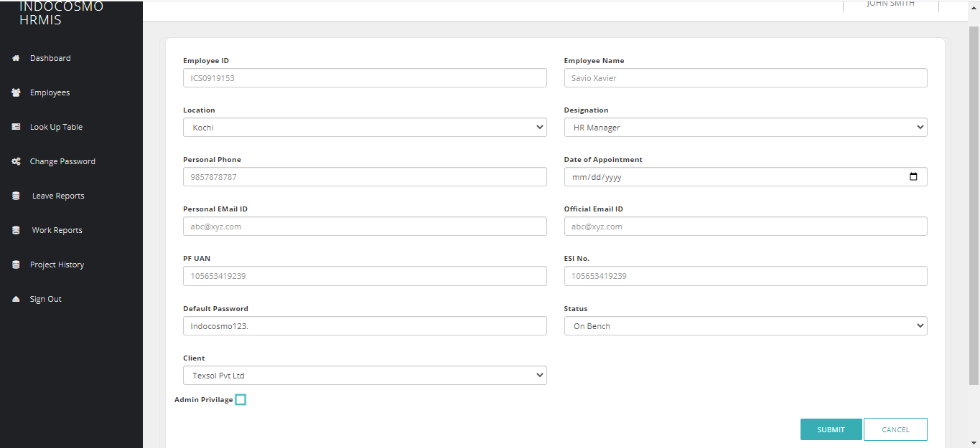
Admin user should be able to create User with Code, Name, Location, Designation, Personal Phone No, Date Of Appointment, Personal Mail-ID, Office Mail-ID, UAN No, max no. of continuous leaves, sandwich applicable, ESI No and Status ( On Bench, On Project – Trial, On Project - Permanent).

Approvers and mail notifications LIST

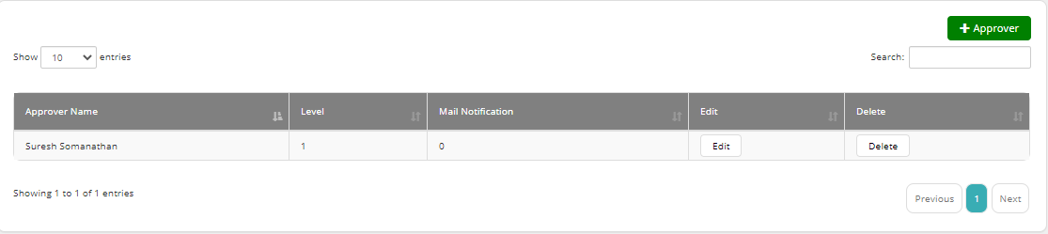
Admin User should be able to view the approver corresponding to the user listed with approver name, code, approver, approver level and mail notification.

CREATE/UPDATE Approvers and mail notifications

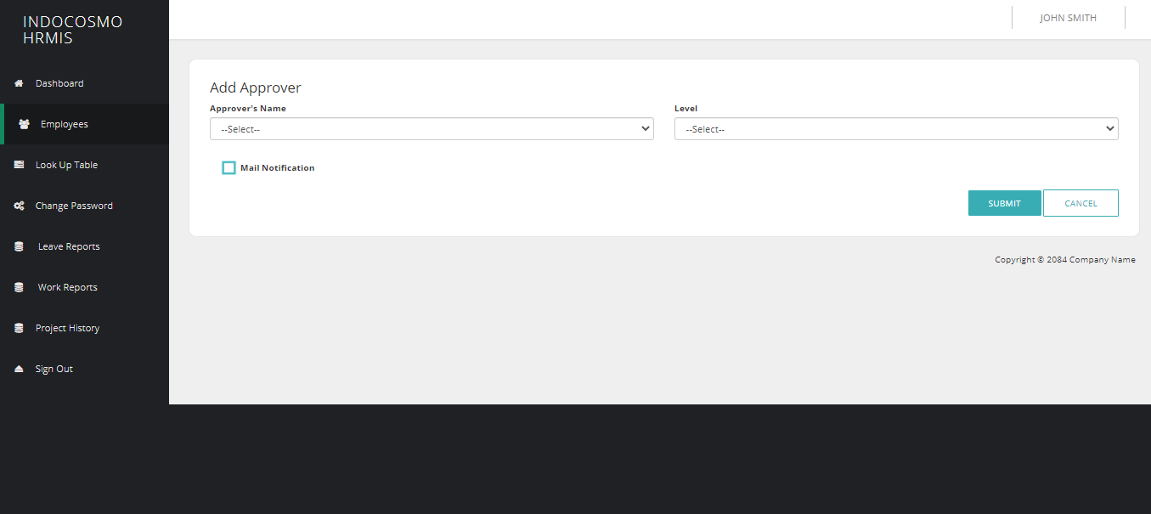
Admin User should able to configure approvers and the corresponding other users in need of mail notifications for the user. Should have approver name, Code, approver level and mail notification.

Delete Approvers and mail notifications
Admin user should able to delete the approvers. It is a soft deletion.

Employee Project LIST

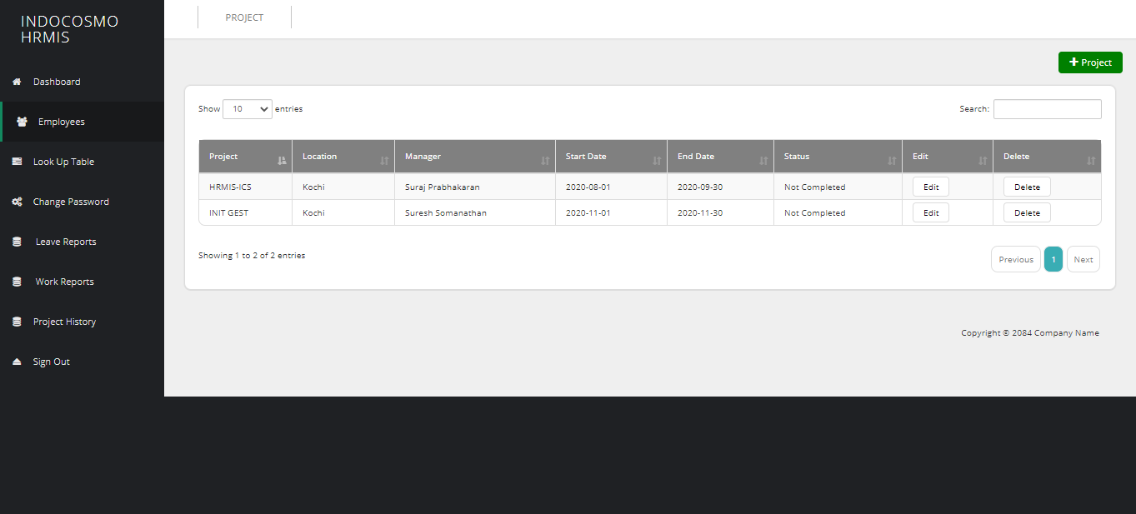
Admin User should be able to view the projects corresponding to the user listed with Project name, Manager, Technology, Project start date and End Date.

CREATE/UPDATE Project
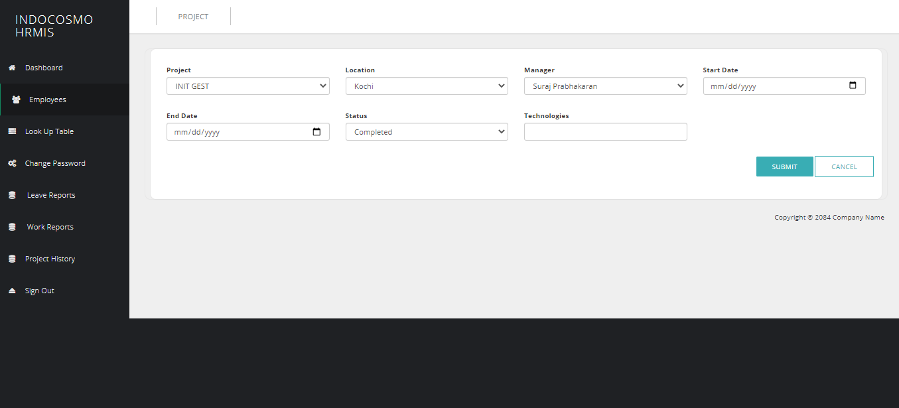
Admin User should able to configure project with Project name, Manager, Technology, Project start date and End Date.

EDIT User

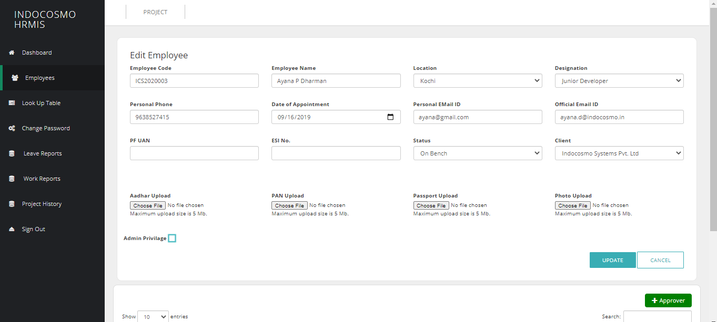
Admin User should be able to update all the details.

DEACTIVATEUser
Admin user should be able to deactivate User only if the deactivating user is not an approver.

Leave Allocation
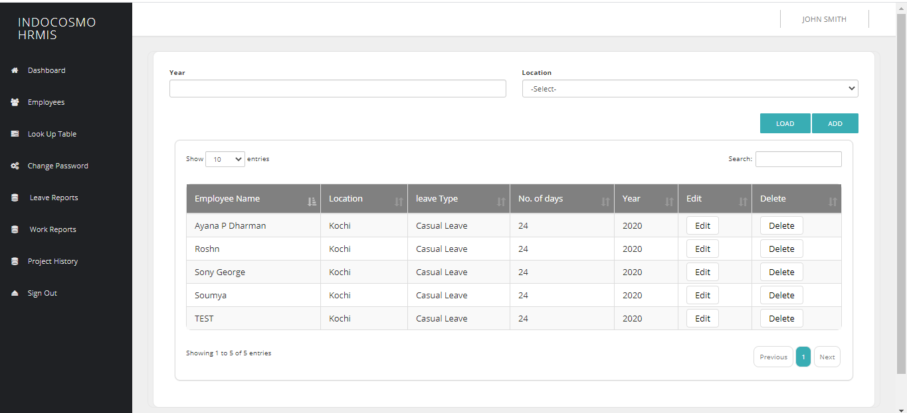
Admin user should be able to allocate the leave for the Users based on the Leave Types (either group or set corresponding to the location) and also be able to edit the already allocated leaves.

Edit Admin Profile

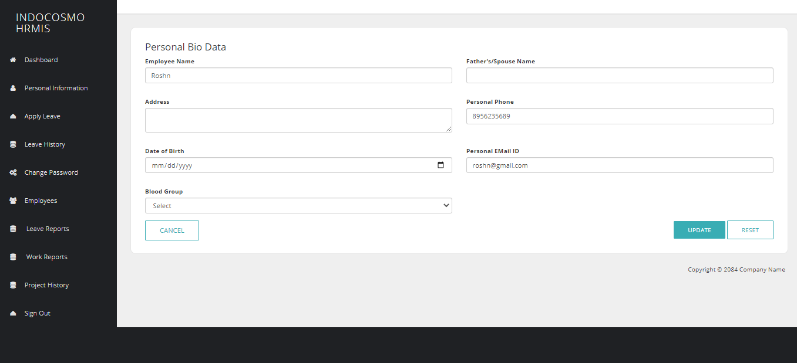
The admin user is allowed to update his profile details such as Personal Details(Employee name, Father/Spouse Name, Address, Personal Phone, Date of Birth, Personal Email-Id, Blood Group), Educational(Qualification, Board/University, Year(From-to), Marks(%)) and Professional Qualifications(Skills, Proficiency, Years of Exp).

Leave Application
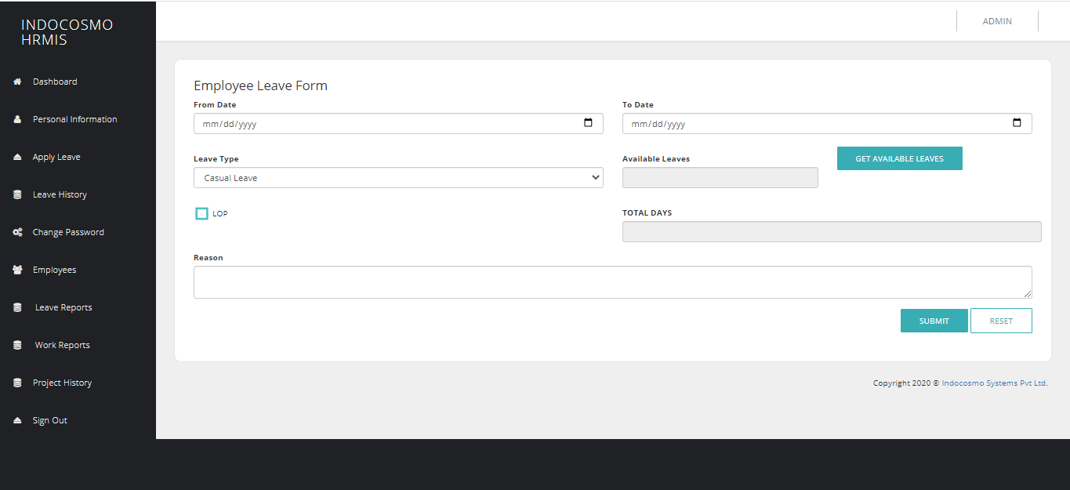
Admin User should able to apply leave for all the users and Should be able to apply with Leave Type/Comp Off (confirmation/Avail), From/To Date for leave and Loss of Pay(In case of informed Leaves/No available Leaves/exceeds no. of allowed continuous Leaves). It should show the Available Leaves and Comp Off. It should also check for Sandwich Leaves based on the user and Casual Leave should be enabled by default.

WorkReport
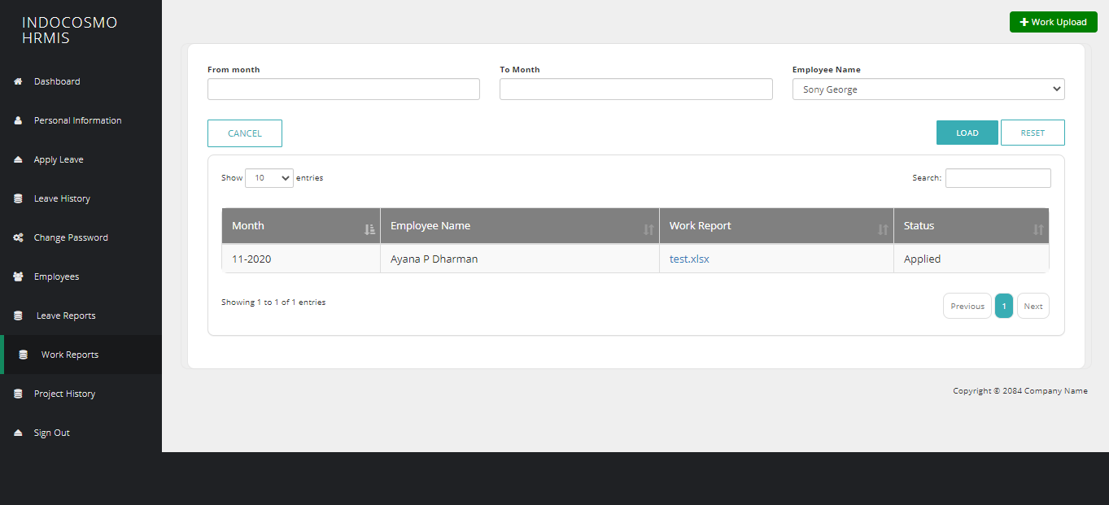
Admin should be able to upload WorkReport for the users. It should also show the Uploaded Workreports of all the users and its corresponding status (Approved/Unapproved) and also be able to filter between a period of months and users.

Leave Report
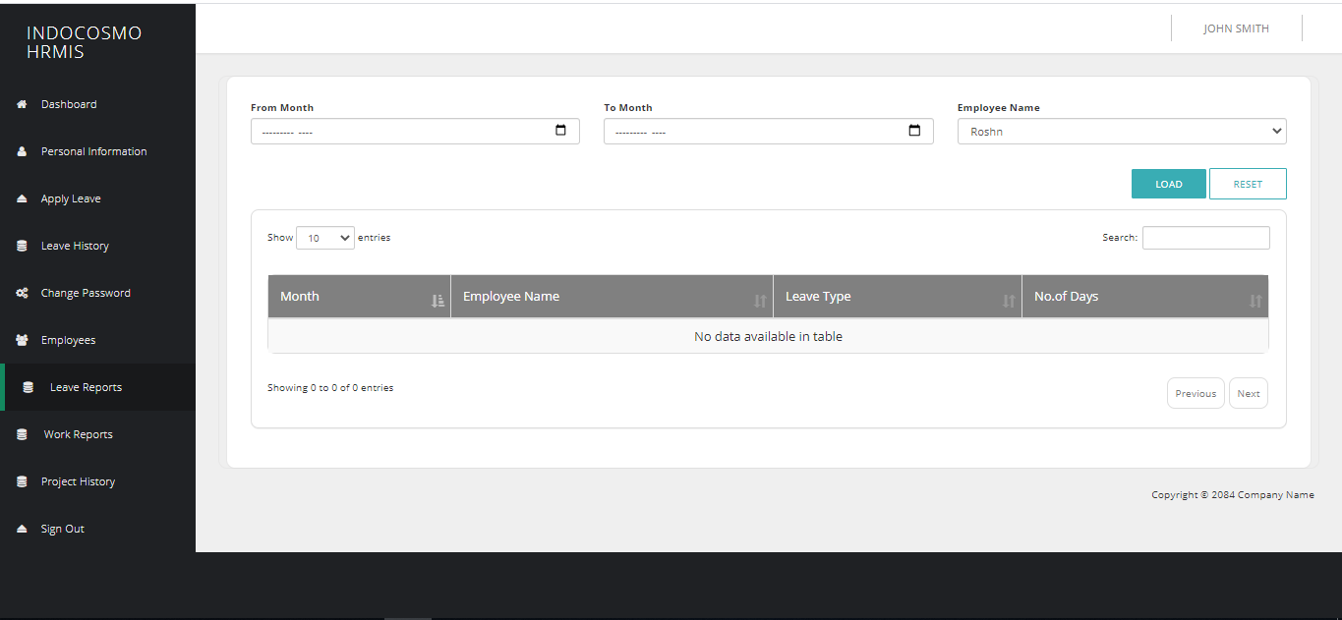
Admin User should be able to view the Leave history of all the users based on Year or in between a period of time, User and LeaveType. It should also show the total number of leaves, confirmed Leaves, available leaves, Loss of Pay, Comp off availed/available regarding to the user.

Leave History
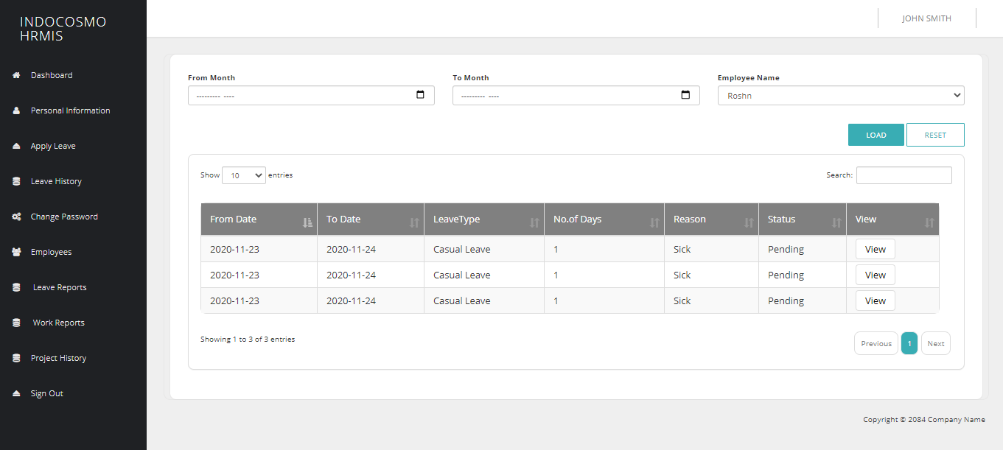
Admin User should be able to view the Leave history of him/other users based on Yearor in between a period of time, users and LeaveType. It should also show From/To Date, LeaveType, Total Days, Reason and status. Should also be able to revoke the Approved Leaves.

Project History
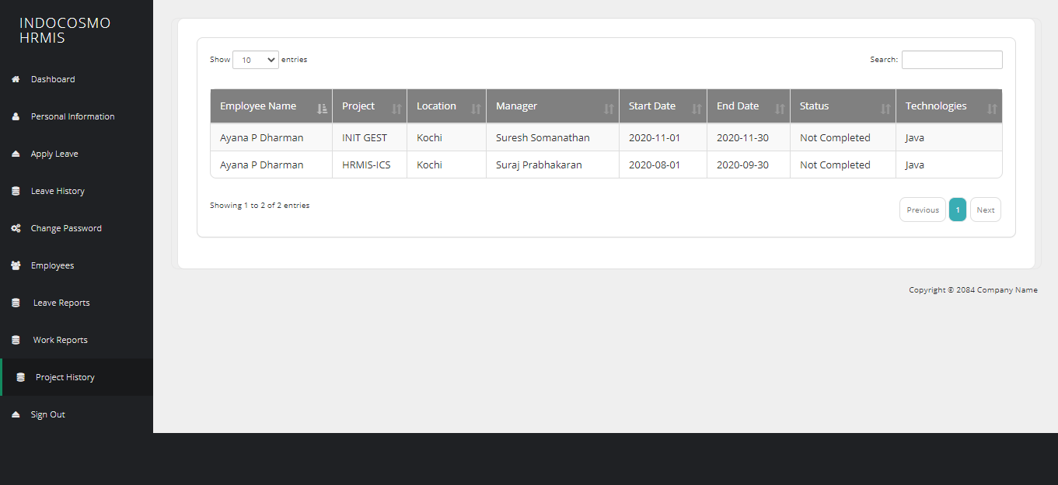
Admin User should be able to view the Project history of him/other users based on Year or in between a period of time, users and project. It should also showEmployee name, Location, Technology, Client, Division, Client manager name, Indocosmo manager name, Placed on Date, Expected project completion, status, no. of days and no. of months.

Functional Requirements (HR)

User Login

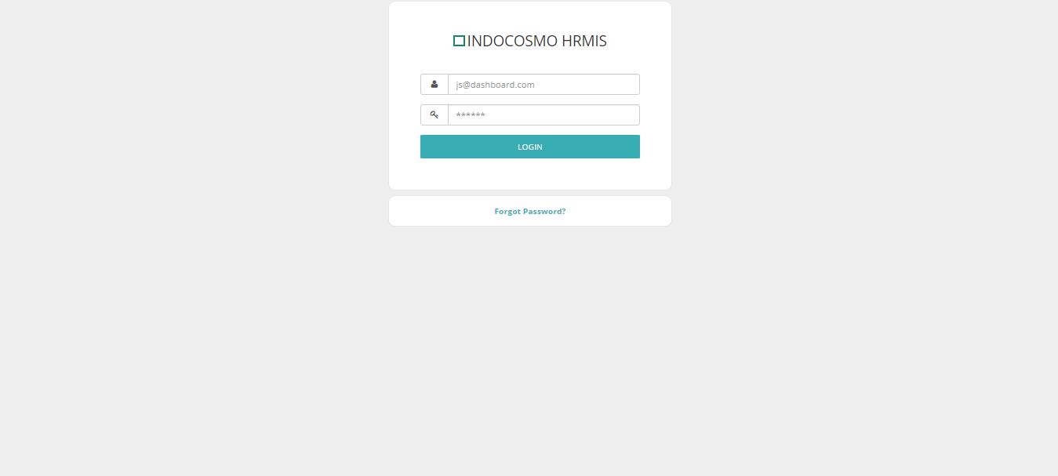
Once the Admin activated the User, will be able to login into the HRMIS application. After login, the user home will be displayed with modules Dashboard (as default home), Personal Bio Data and Leave.

Forgot Password

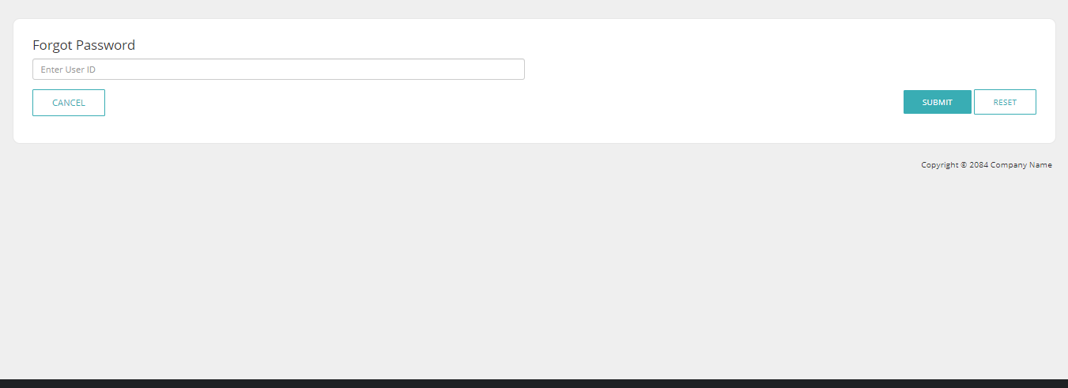
Whenever a user lost his password, he/she would be allowed to reset his/her password. The user should confirm his email, so that he/she should receive an authorization token by email. This would accept before resetting his/her password. A notification email will be sent to the user regarding the resetting password event

Dashboard

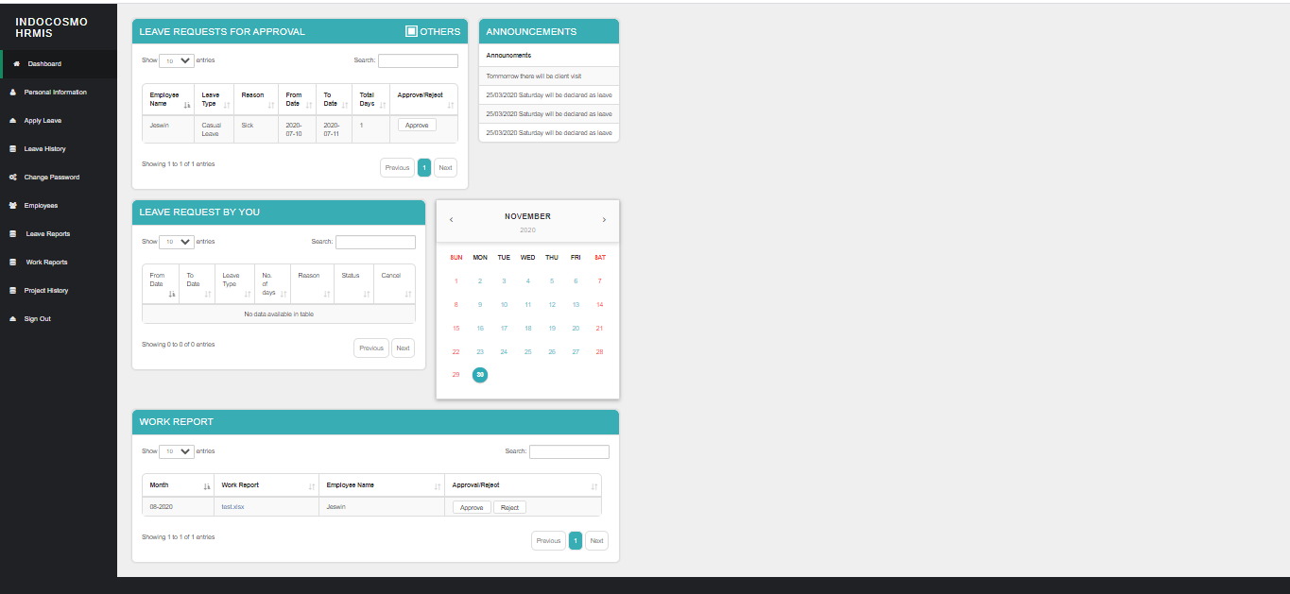
In the home page, Dashboard listing will be displayed by default. It should have the pending leave approvals of the other users, Confirmed/unapproved Leaves of the user, Calendar for viewing the Holidays and users who are in leave for the current week.

Leave Approval LIST
The List of Leaves pending for approval should be listed as a part inside the dashboard. Should be able to approve/reject by clicking on it. In addition, when Click the others checkbox shown in the table HR can see the leave requests for other approvers.

Approve/Reject Leave
It should be displayed in a pop-up inside the dashboard. The user should be able to modify the leave from/to dates, update comments, approve/reject the Leave. Once they are approved/rejected, can be viewed in the Leave History.

Pending leave
Leaves applied by the user and waiting for the approval should be listed part inside the dashboard. Should be able to approve/reject by clicking on it.

View pending leave status
Should be able to update comments, view the comments updated by the approver and also be able to update the leave corresponding to the approver comments.

Announcements
User Should be able to see important announcements.

Calendar
User should be able to view the calendar with Holidays.

Work Report
User should be able to see the list of work reports uploaded by the users and download the file for checking and then should be able to approve the work report.

Edit Profile
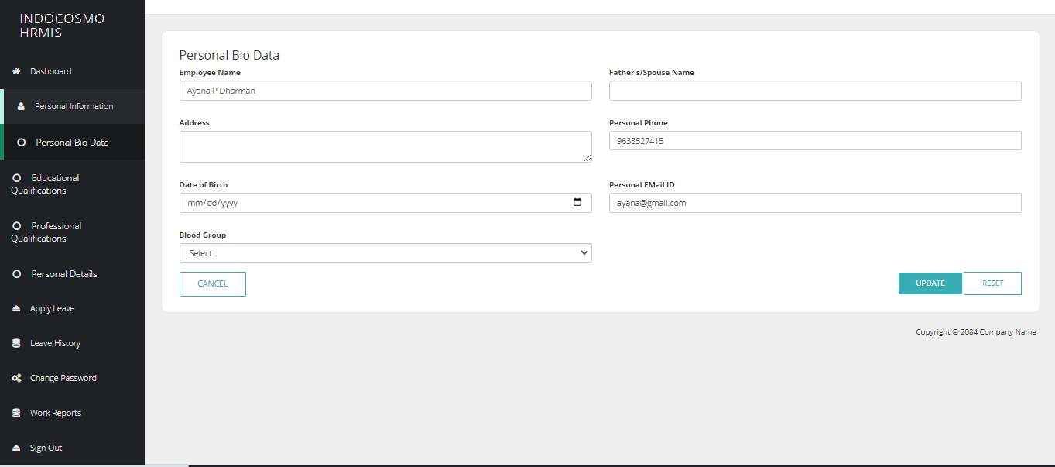
The admin user is allowed to update his profile details such as Personal Details(Employee name, Father/Spouse Name, Address, Personal Phone, Date of Birth, Personal Email-Id, Blood Group, Photo, Upload Documents(Aadhar, Passport, Pancard)), Educational(Qualification, Board/University, Year(From-to), Marks(%)) and Professional Qualifications(Skills, Proficiency, Years of Exp).

Leave Application
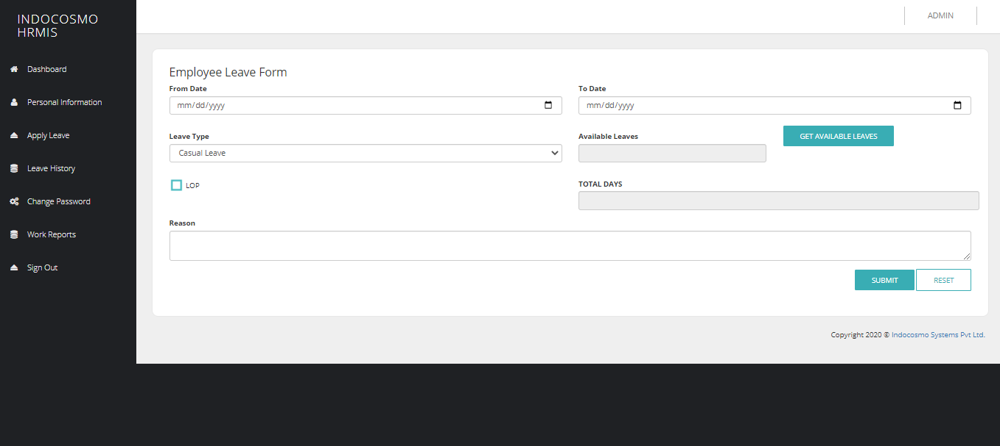
User should able to apply leave for him/users under him and should be able to apply with Leave Type/Comp Off (confirmation/Avail), From/To Date for leave and Loss of Pay(In case of informed Leaves/No available Leaves/exceeds no. of allowed continuous Leaves). It should show the Available Leaves and Comp Off. It should also check for Sandwich Leaves based on the user.

WorkReport
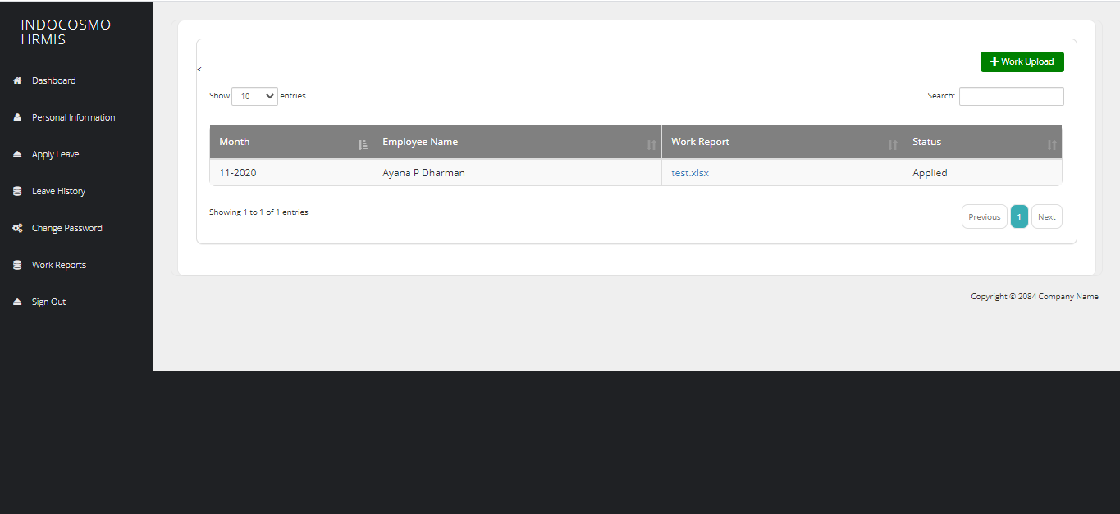
User should be able to upload WorkReport. It should also show the Uploaded Workreports and its corresponding status(Approved/Unapproved).

Leave History
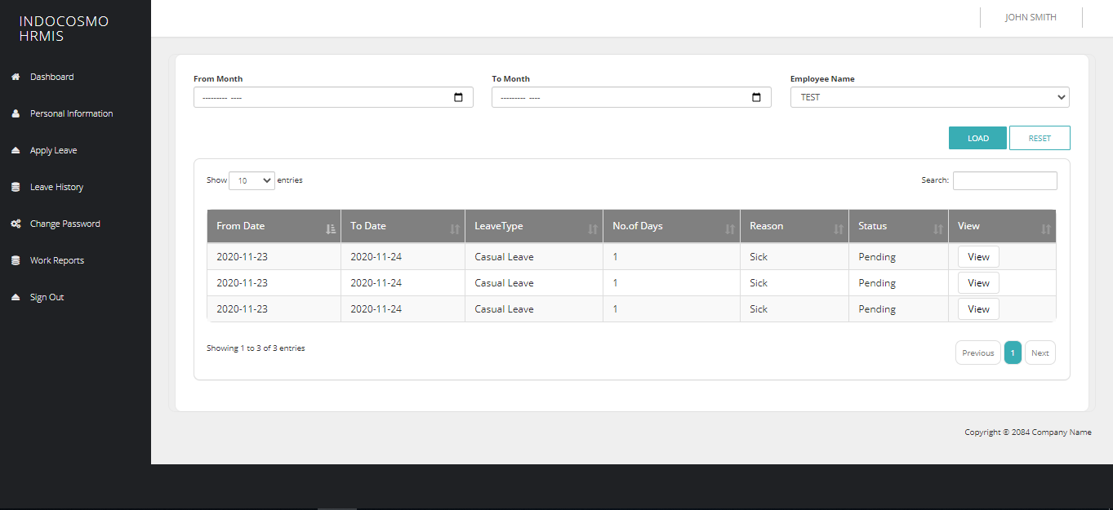
User should be able to view his Leave history based on Year or in between a period of time, users and LeaveType. It should also show From/To Date, LeaveType, Total Days, Reason and status. Should also be able to revoke the Approved Leaves.

Functional Requirements (USER)

User Login

Once the Admin activated the User, will be able to login into the HRMS application. After login, the user home will be displayed with modules Dashboard (as default home), Personal Bio Data and Leave.

Forgot Password

Whenever a user lost his password, he/she would be allowed to reset his/her password. The user should confirm his email, so that he/she should receive an authorization token by email. This would accept before resetting his/her password. A notification email will be sent to the user regarding the resetting password event

Dashboard

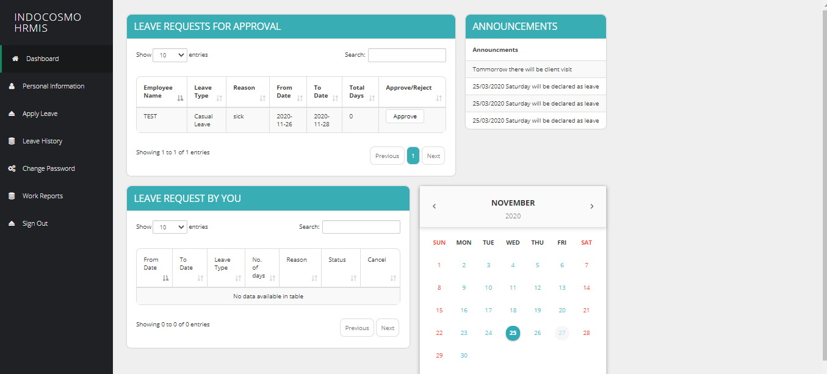
In the home page, Dashboard listing will be displayed by default. It should have the pending leave approvals of the other users, Confirmed/unapproved Leaves of the user, Calendar for viewing the Holidays and users who are in leave for the current week.

Leave Approval LIST (approver)
In case of the User is an Approver, The List of Leaves pending for approval should be listed as a part inside the dashboard. Should be able to approve/reject by clicking on it.

Approve/Reject Leave (approver)
It should be displayed in a pop-up inside the dashboard. The user should be able to modify the leave from/to dates, update comments, approve/reject the Leave. Once they are approved/rejected, can be viewed in the Leave History.

Pending leave
Leaves applied by the user and waiting for the approval should be listed part inside the dashboard. Should be able to approve/reject by clicking on it.

View pending leave status
Should be able to update comments, view the comments updated by the approver and also be able to update the leave corresponding to the approver comments.

Announcements
User Should be able to see important announcements.

Calendar
User should be able to view the calendar with Holidays.

Edit Profile
The admin user is allowed to update his profile details such as Personal Details(Employee name, Father/Spouse Name, Address, Personal Phone, Date of Birth, Personal Email-Id, Blood Group, Photo, Upload Documents(Aadhar, Passport, Pancard)), Educational(Qualification, Board/University, Year(From-to), Marks(%)) and Professional Qualifications(Skills, Proficiency, Years of Exp).

Leave Application
User should able to apply leave for him/users under him and should be able to apply with Leave Type/Comp Off (confirmation/Avail), From/To Date for leave and Loss of Pay(In case of informed Leaves/No available Leaves/exceeds no. of allowed continuous Leaves). It should show the Available Leaves and Comp Off. It should also check for Sandwich Leaves based on the user.

WorkReport
User should be able to upload WorkReport. It should also show the Uploaded Workreports and its corresponding status(Approved/Unapproved).

Leave History
User should be able to view his Leave history based on Year or in between a period of time, users and LeaveType. It should also show From/To Date, LeaveType, Total Days, Reason and status. Should also be able to revoke the Approved Leaves.

Non-Functional Requirements

Performance Requirements
As this is a web application hence it is not a resource hog and will run on almost every computer. Its functions and features are not computationally intensive. It does not require a powerful processor or graphics card, much RAM, or disk space. It only requires a latest browser.

Security Requirements
The user passwords saved in the database should not be in a readable format. This application as all the other web application requires the Internet availability, and is also requires that the user should keep his private keys safe and secure and the same should not be shared with anyone. User should keep his key safe. The system or the place where the key is stored should not be public. In the case if the user loses his key then he/she should immediately inform the system admin.

Software System Attributes

Client Side Quality Attributes:
The application provides a quite user-friendly interface with its operations accessible from the menu bar and the main toolbar. An average or casual user should not find any problem using the program to perform at least its main functions. Interoperability is guaranteed since this program runs on both Mac and PC (Linux,Windows or other operating system).

Server Side Quality Attributes:
Along with that our system provides the server which is scalable so that it can meet up any future requirements and is easily upgradeable. Admin can take a backup on a regular interval so in case of any failure or damage system can be restored easily.

Appendices
Not Applicable

