
Carry Park
User Guide
Revision History
Version | Author | Date | Remarks
1.0 | Lithin James | 28-05-2020

User Guide for Carry Park System.

Table of Contents
1 Introduction 4
1.1 Product / System Overview 4
2 SCREENWISE FUNCTIONALITIES 5
4.1 Splash Screen 5
4.2 Language selection screen 5
4.3 User type selection 6
4.4 Sign Up 6
4.5 LOGIN 7
4.6 QR code SCREEN 8
4.7 Device connect screen 8
4.7 Video instructionS screen 9
4.8 initial payment scrEen 10
4.9 Payment 10
4.10 lock Screen 11
4.11 lock Success Screen 12
4.12 IN USe screen 12
4.13 Final payment screen 13
4.14 Unlock screen 14
4.15 Unlock Success Screen 14
4.16 MORE Screen 15
4.17 Change PIN 15
4.18 Forgot PIN Screen 16
16
4.19 Login In new device 17

Introduction

Product / System Overview
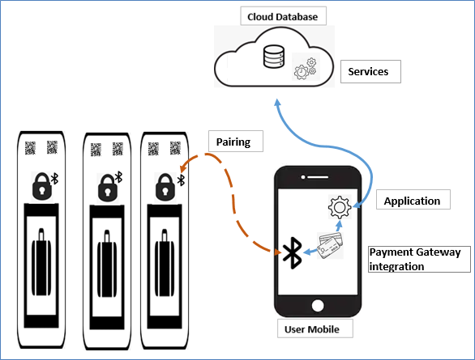

SCREENWISE FUNCTIONALITIES

4.1 Splash Screen


Splash screen showing on app launching Time after 1 second app navigate to language choose screen

4.2 Language selection screen
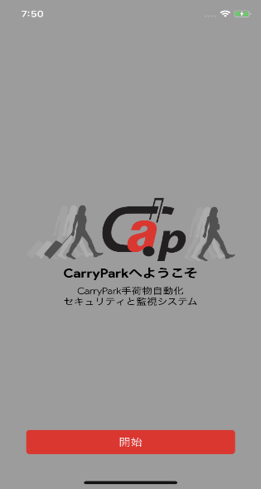
In android application there are 2 check box for selecting languages. iOS application set by default device language.
This screen also load user details and locked device details.

4.3 User type selection
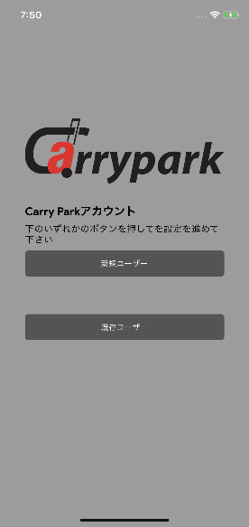
Screen where you can select the registration mode.
There are 2 buttons
1. I AM A NEW USER TO CARRY PARK – For new user registration
2. I AM AN EXISTING USER OF CARRY PARK – For already registered user login

4.4 Sign Up
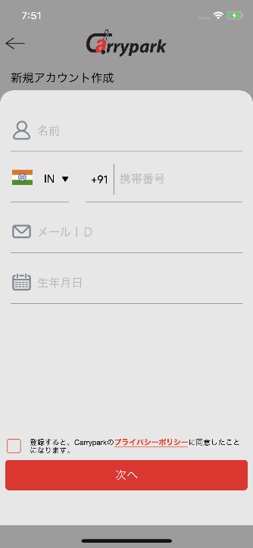
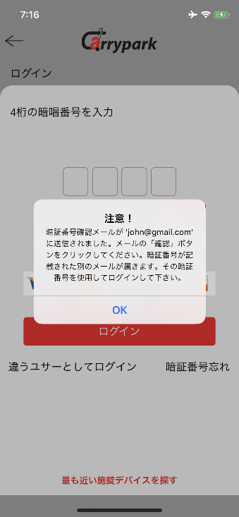
Screen A Screen B

New registration requires the following:
1. Name
2. Mobile Number
3. Email address
4. Date of Birth
5. Acceptance of terms & service and privacy policy
After a registration a 4 digit PIN send to registered email ID. And that PIN need to verify in Screen B. After verifying this PIN is used to Login. User able to can change their PIN in “Change PIN” in more screen

4.5 LOGIN
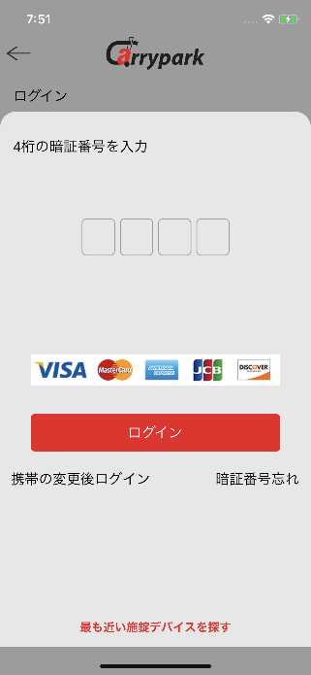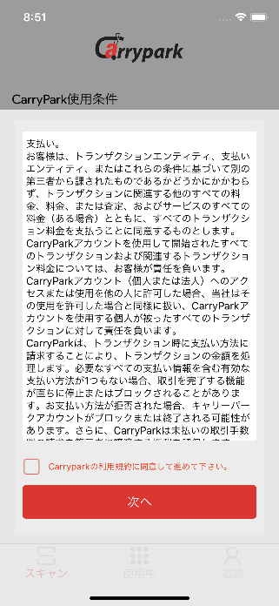
Screen A Screen B
User can login using their 4 digits PIN. Login screen display information of which payment methods are supporting. In this screen has following options.
- Forgot PIN
- Login In new device
- Search nearest locking device
After a successful login user can accept the terms and condition in first time

4.6 QR code SCREEN
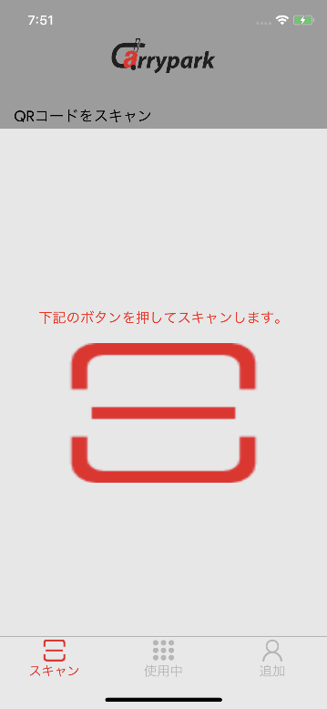
This screen used to scan the QR code. When taping the center of the screen (Scanner image button) camera get open and user need to focus on a QR code

4.7 Device connect screen
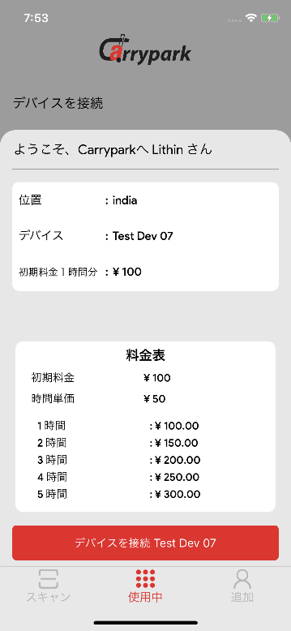

In this screen display scanned device information such as Device Name, Location, and initial price and also display a price details table.
Tap on the “Connect to <Device name>” button app connecting to the locker Bluetooth and check the device is ready to connect

4.7 Video instructionS screen
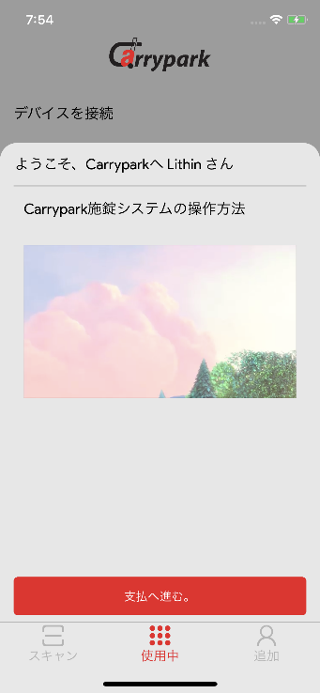
This screen play a video of how to use locker device. By tapping Proceed to payment button app start the payment procedure.

4.8 initial payment scrEen
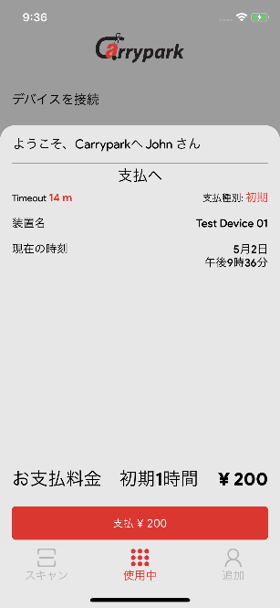
Initial payment screen display the payment information. Tapping the Pay button payment gateway get load.

4.9 Payment
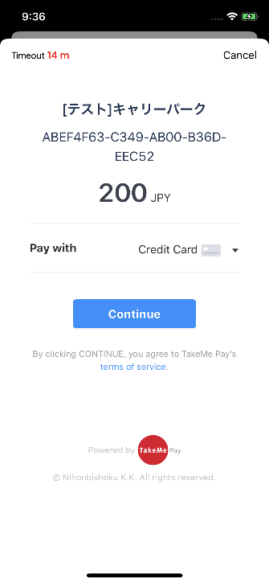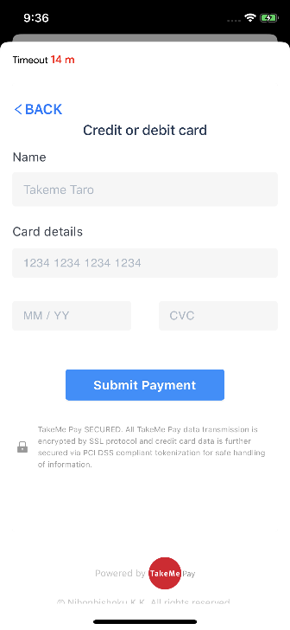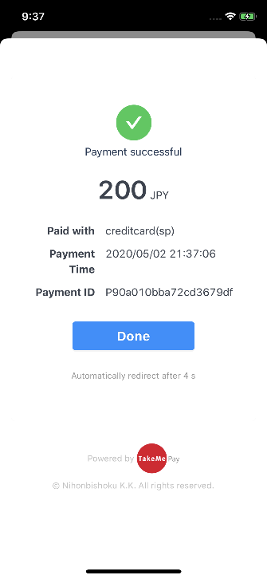
Screen A Screen B Screen C
In this screen user able to choose the payment type. Supporting payment methods are
- Credit card
- Alipay
Pay with drop down (Screen A) user can choose the payment method. Tapping continue button app proceed card detail screen and filling the card detail app complete the payment procedure and display success screen.
After payment completed. App redirect to the lock screen.

4.10 lock Screen
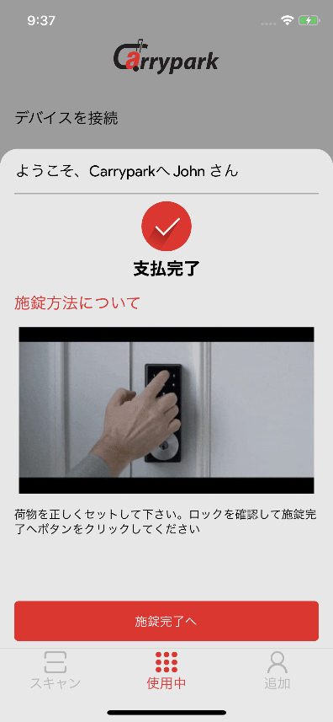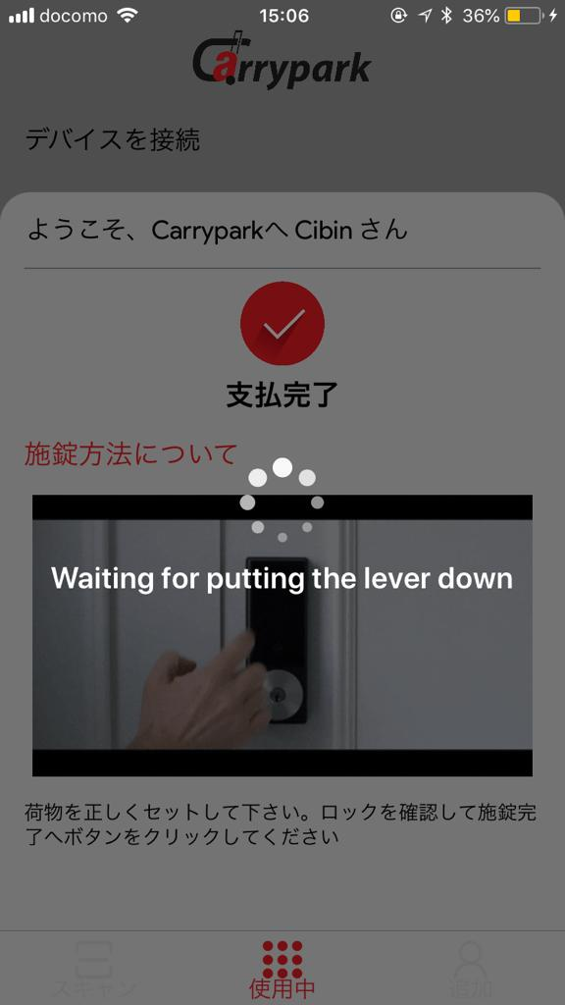
This screen play a gif video for locking instruction. By taping the “Lock” button app check some security process. After a successful security check locker ready to use. Else app display an error message.
After a successful security check app show a loader with alert “Waiting for putting the lever down”. In this time user place the luggage or bag to the locker and need to put the leaver to down for a Manuel lock. After that app start billing.

4.11 lock Success Screen
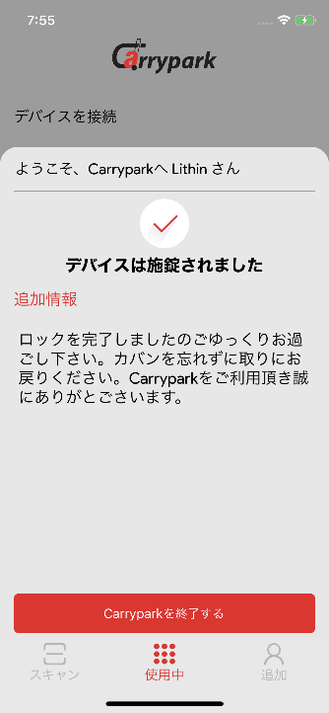

After a successful lock app showing a confirmation messages for your locking was successful.

4.12 IN USe screen
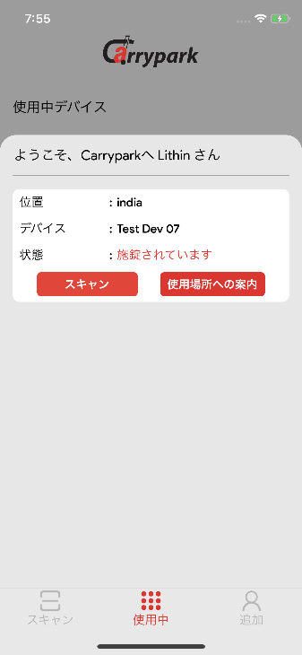
User can see their locker on this screen. The app provide 2 options
- Scan – Scan to corresponding QR code
- Get direction – User can find locker location in map
By taping the scan button app navigate to QR code screen, scan corresponding QR code and redirect to the Connect device screen. After a Bluetooth connection app check the security procedure for valid locker is connected or not. If a valid locker app go to final payment screen.

4.13 Final payment screen
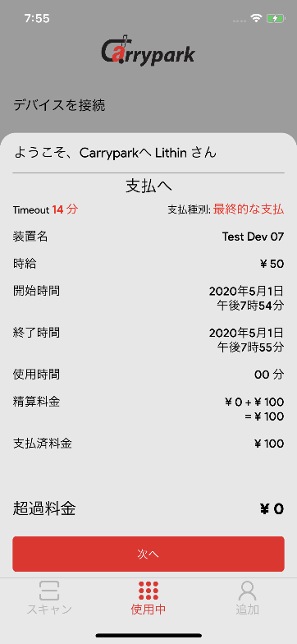
Final payment screen deal with the balance amount to be pay. This screen display the duration of using the locker and balance amount to pay.
If the payment amount is 0 app navigate to the unlock screen. Else load the payment gateway to complete the payment.

4.14 Unlock screen
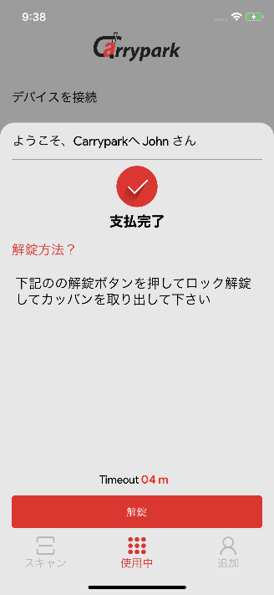
After a payment app redirect to the unlock screen. Display a confirm message of payment received. Without tapping unlock button in 5 minute App redirect to IN USE screen.
Taping the unlock button app check some security procedure for unlocking the locker. After security check your locker get unlocked.

4.15 Unlock Success Screen
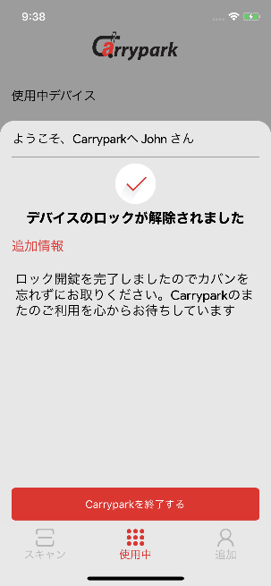
This screen just confirmed about your unlock was successful.

4.16 MORE Screen
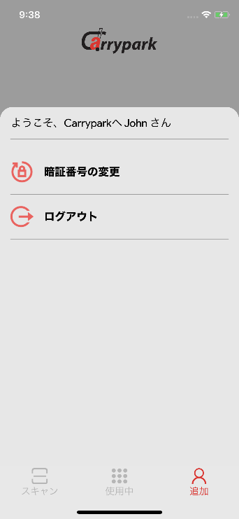
There are 2 options in more screen
- Change PIN
- Logout
In change PIN user can change their PIN and logout option for close the current user section from the app.

4.17 Change PIN
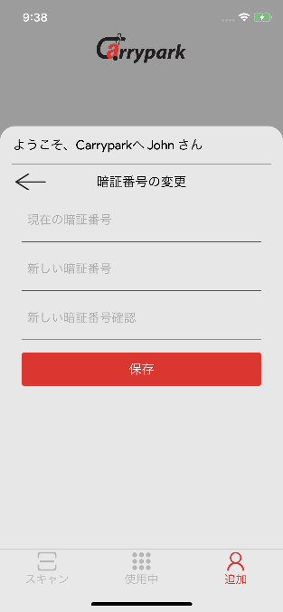
User can change their Login PIN on this screen. User need to input following filed.
- Current PIN
- New PIN
- Confirmation of New PIN

4.18 Forgot PIN Screen

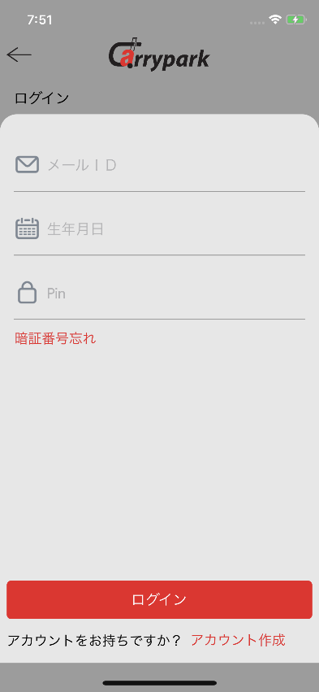
Screen A Screen B
In the case of user forgot their PIN. User able to reset their PIN. User need tap on forgot PIN (Screen A) then app navigate to Screen B. User need to input their Email id and Date of birth and tap to forgot pin button. In this time PIN is send to registered email ID. Now user can login using their PIN in screen A

4.19 Login In new device
Screen A Screen B
In the case of user lost his mobile phone, User can able to login in new phone. User need to install carry park app from Play store/App store and go to following steps: I AM AN EXISTING USER OF CARRY PARK -> Login in new device -> Input Email ID, DOB and PIN -> tap on proceed button. Now user is restored their account

