Indocosmo Systems

Indocosmo Systems Pvt. Ltd.
Hikari Bldg, 4F
K. P. Vallon Road,
Cochin-20, Kerala

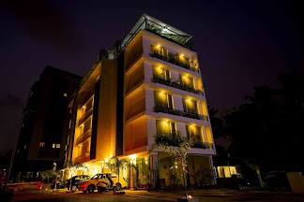

Products

Our Products

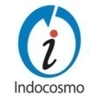

We at Indocosmo believe in and strive to bring you applications that provide you with useful and fast services to make your work simple and accurate. We currently offer the below 5 highly customizable and useful products.

Page 2 To Order Call: (0484) 2867625

Indocosmo Systems Page 3

Init Bake - Bakery Management Software 6

Init Suite - POS Software 0

Init Brew - Bar POS System 0

Init Dine - Restaurant Management System 10

Init Gest - Hotel Management Software 14

Table of Contents

Init Bake - Bakery Management Software

Init Bake is a cloud-enabled retail sales, inventory, production management system for retailers of any size, staring from a single outlet to multi outlet chains.

Init Dine - Restaurant Management System

Every restaurant needs a best in class, efficient, easy to use and enterprise-level sales management system. Here we have a system, which meets all these requirements.

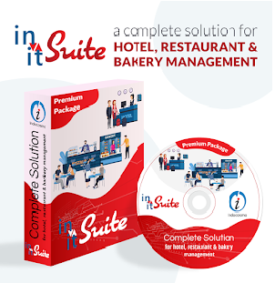

Init Brew - Bar POS System

Init Brew POS system is an end-to-end solution that includes a number of business-critical functions including Sales, Finance, Inventory, Manufacturing & Cost management capabilities. This ideal software for bars, nightclubs and pubs is available as “Terminal” and “Cloud” versions.

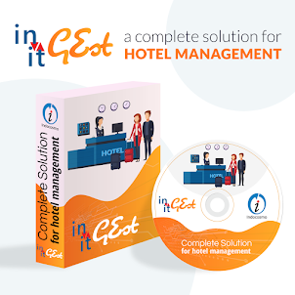
Init Suite – POS Software

Init Suite is our premium product with features of Sales, Finance, Inventory, Purchase, Manufacturing and Cost management capabilities. This custom software can fulfill any needs of bakery, restaurants; hotels are bars thus making it an All in one solution software for all your business needs.

Init Gest - Hotel Management Software

Init Gest is cloud-based hotel management software. It automates all the critical daily operations of any hotel's front desk and back office.

Indocosmo Systems Page 5

Page 4 To Order Call: (0484) 2867625
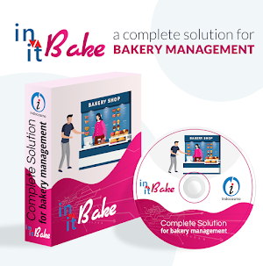

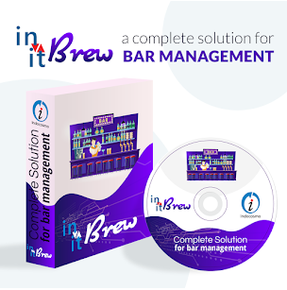

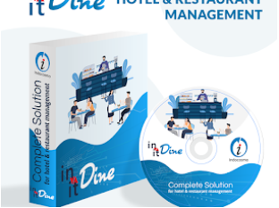

Basic Features
- Day start and day end
- Attendance
- Order entry

Various payment methods
- Debit cards
- Credit cards
- Company
- Coupons
- Refund

Init-Bake

End-to-end enterprise level bakeries management
End-to-end means that everything,from the first interacting with a diner to inventory or resource
management is made easier without the system. Data is also captured at every level, which is then analyzed to provide clients the opportunity to quickly identify and plan the best short and long-term business strategy available to them.

Billing services
- Table services
- Home delivery
- Take away
- Tips calculations
- Kitchen printing
- Billing to shops

Cost Effectiveness

- Runs on free OS like Linux
- Works with all POS peripherals
- Effective and efficient store management using minimum man power
- Easy to learn and operate

Scalability

- Supports single restaurants and multi-outlets chains

Bakery Management Software

Indocosmo Systems Page 7

Page 6 To Order Call: (0484) 2867625

Page 8 To Order Call: (0484) 2867625

Production & Inventory
- Multi-Location Inventory Management
- Reorder Level
- Minimum/Maximum stock level
- Accurate inventory
- Non-moving and Damaged items
- Stock valuation on multiple methods
- Shop wise orders
- Sales & purchase order processing
- Production tracking
- Production sales.
- Cost tracking
- GST compliant invoicing
Reports
- Shifts summary
- Midday reports
- End-of-day reports
- Payment details
- Separate reports for table service, home delivery and take away

Other features
- System locking
- User privileges
- Customer priority
- Tax settings
- Discount settings
- Multi-level item categorization
- Password protection
- Terminal protection
- Multiple kitchen support
- Open and close tills
- Order cancellation
- Android-based order taking system
- Custom kitchen display for chefs
- Automated messaging system.
- Supports multiple language
- User defined screen layouts
- Supports online and offline modes

Indocosmo Systems Page 9

Indocosmo Systems Page 11

Restaurant management System

Init Dine is an end-to-end restaurant management solution that integrates every client need – from a best-in-class POS system to an efficient enterprise level management system – into one easy to use package. At Indocosmo, we understand that the needs and requirements of each client will vary. This is why our complete, yet modular, package of software, hardware and support services can be refined to optimize the operations of restaurant types ranging from a single unit shop to multi-outlet chains. From us you get ready-to-use, fully supported solutions that guarantee satisfaction.

Billing services
- Table services
- Home delivery
- Take away
- Tips calculations
- Kitchen printing
- Billing to shops

Cost Effectiveness

- Runs on free OS like Linux
- Works with all POS peripherals
- Effective and efficient store management using minimum man power
- Easy to learn and operate

Scalability

- Supports single restaurants and multi-outlets chains

Page 10 To Order Call: (0484) 2867625

Init Dine

Basic Features
- Day start and day ends
- Attendance
- Order Entry

Various Payment methods
- Debit cards
- Credit cards
- Company
- Coupons
- Refund

Reports
- Shifts summary
- Midday reports
- End-of-day reports
- Payment details
- Separate reports for table service, home delivery and take away

Other features
- System locking
- User privileges
- Customer priority
- Tax settings
- Discount settings
- Multi-level item categorization
- Password protection
- Terminal protection
- Multiple kitchen support
- Open and close tills
- Order cancellation
- Android-based order taking system
- Custom kitchen display for chefs
- Automated messaging system.
- Supports multiple language
- User defined screen layouts
- Supports online and offline modes

Indocosmo Systems Page 13

Page 12 To Order Call: (0484) 2867625

Page 14 To Order Call: (0484) 2867625

Hotel Management System

Init Gest

Indocosmo Systems Page 15

Init Gest is scalable, cloud based hotel management software created using the latest technologies. It automates all the critical daily operations of any hotel’s front desk and back office. Our System provides the user with the features of reservations, occupancy rates, direct check-in, room management, etc. and many of these features are well customizable, so both small and large hotels can take advantage of this software. An automatic reporting and a calculation system can help to save a great deal of time in terms of revenue generation. Here at Indocosmo, we try to understand the requirements of our clients and this is why we can offer a complete, yet modular, software, to optimize the operations of individual or a chain of hotels. A hotel is a hive of numerous operations such as front office, booking and reservation, security, Housekeeping, Facility management, CRM and more. All these activities take place simultaneously and difficulty of managing these diverse activities manually led to the development & introduction of Hotel management system with the following features.

Basic Features
- Reservation
- Reception
- House keeping
- Shift Management
- Room Management
- Night Audit
- User Management
- Facility Management
- Departments
- Discounts
- Travel Agent Module

Scalability

Supports individual hotels to chain of hotels.

Page 16 To Order Call: (0484) 2867625
Other features

- Petty Cash
- Petty Cash Head
- Floor Management
- Request Management

Reports

- Expected & Actual Arrival list
- Expected & Actual Departure list
- Rooms per Day List
- Guest History Report
- Frequent guest analysis Report
- Plan and room List
- Room Booking Frequency report
- Occupancy List
- Country/Nationality statistics by Month
- Customer grading report
- In-house Guest list
- Reservation Report
- Cancellation Report
- Transaction List
- Transfer Transaction List
- Transaction Deleted List
- Cash Register closure Report
- Daily Revenue Report
- Monthly Closure Report
- Collection Register Report
- Tally Export
- Corporate List
- Folio Balance Report
- Shift-wise Transaction Report
- Shift-wise Transaction Transfer Report
- Requests Report
- Expense report
- Contra export report
- Payment export
- Payment ledger export

Indocosmo Systems Page 17

