
Customer Relationship Management
Software Requirement Specification

Revision History
Version | Author | Date | Remarks
1.0 | Livin C J | 15-05-2020 | Created
2.0 | Syamili mol k.v | 28-05-2020 | Updated

Table of Contents
Table of Contents 2
1 Introduction 4
1.1 Purpose 4
1.2 Scope 4
1.3 SOFTWARE TOOLS 4
1.4 User Characteristics 5
2 Functional Requirements (MODULE) 5
2.1 Login 5
Functional Requirements (Only For ADMIN) 5
2.2 DASHBOARD 6
2.3 USERS 6
2.4 MASTERS 7
2.4.1 BRANCH 8
2.4.2 CATEGORY 8
2.4.3 DESIGNATION 9
2.4.4 CONFIGURE MAILS 10
3 Functional REQUIREMENTS (ALL users) 11
3.1 DASHBOARD 11
3.2 Lead 11
3.3 PROSPECTS 13
3.3.1 prospects - Add prospect 13
3.3.2 prospects – prospect LIST 15
3.3.2 prospects – Locate prospect 16
3.4 Customer 16
3.4.1 Customer – customer details 18
3.4.1.1 customer: Users – note 18
3.4.2 Customer – Meeting / appointment calendar 18
19
3.4.3 Customer – Issue tracker 19
3.4.4 Customer – Client payment details 20
3.4.5 Customer – AMC Details 21
3.5 Daily report / Weekly report 21
3.6 Profile 21
3.7 Logout 22
4 Non-Functional Requirements 22
4.1 Performance Requirements 22
4.2 Security Requirements 22
4.3 Software System Attributes 23
4.3.1 Client Side Quality Attributes: 23
4.3.2 Server Side Quality Attributes: 23

Introduction

Purpose
The purpose of this document is to present a detailed description of the CRM Application. Description includes the purpose and features of the system, the interfaces of the system, the operations in the system and the constraints under which it must operate. This document is intended for both customers and developers of the system and shall be reviewed and approved by the customer, before proceeding with development of the system.

Scope
Primarily, the scope of these CRM product features helps the marketing segment.

Some of the product scopes are the following:

- The CRM application is to improve the efficiency and productivity of the marketing team.
- To support timely client follow-ups and their requirements.
- Management can easily understand the performance of the marketing team.
- Management can get the day to day report from marketing team.
- Management can analyse the product issues and review current marketing strategies

SOFTWARE TOOLS
Language : Laravel -5.7
Database : MySQL - 5.7
PHP Version: 7.1
Supported browsers
- Chrome 75 and above
- Safari 11
- Firefox 70
- Internet Explorer 10
- Opera 60

User Characteristics
There are two types of users in the system:
- Admin user: This user can create users and configure the essential things required for the user such as product & services, branches ,category and configure mails
- Users: These are the users (marketing staff) of CRM Application created by Admin and they can add leads, appointments etc.

Functional Requirements (MODULE)

Login
The system is protected against unauthorized access using login credentials. Each user has a unique username and password to log in to the system. The login screen looks like the following image.
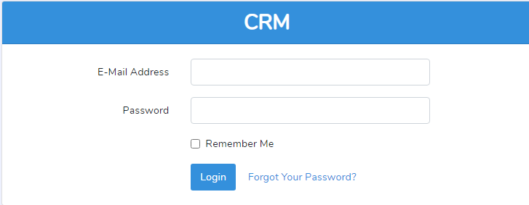
Fig 2.1.1

Functional Requirements (Only For ADMIN)
Admin have some super privileges compared to the normal user. Admin can manage dashboard, users, products & services, branches, categories, designations and can configure emails.

DASHBOARD
The dashboard is the first screen that the user will see after a successful login. This page is also called the ‘Home Page’.
Admin can view all appointments, all lead lists, and all prospect lists and the issue track-list. By default, all these data have appeared based on the current date. Admin can filter the data based on some search criteria from the dashboard.
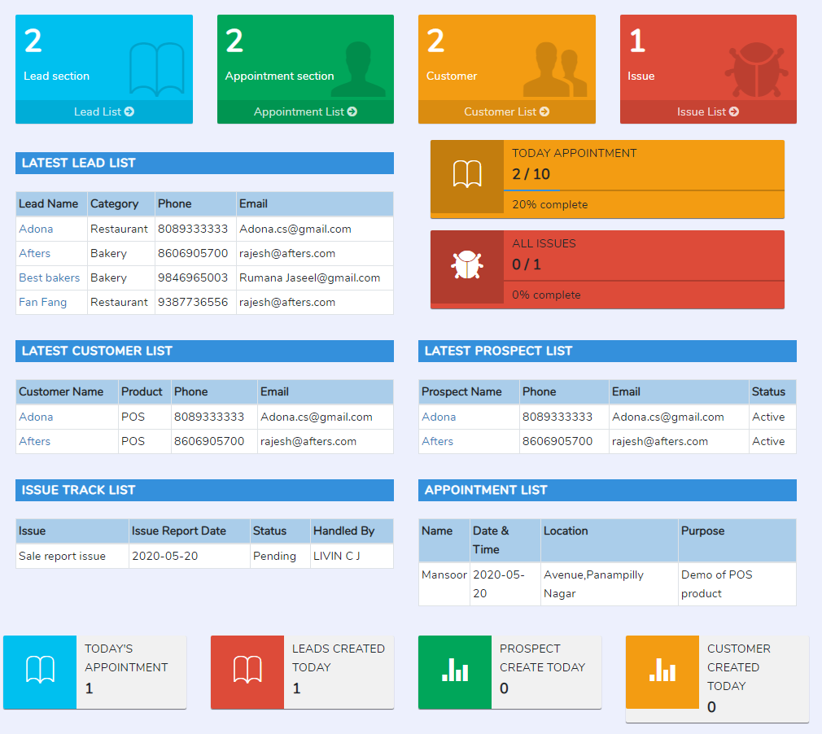
Fig 2.2.1

USERS
The user is nothing but the system user of this application. Only the admin can create and manage the user details. Admin can create a user with their basic details, login credentials, designation, and branch details. The login ID of the user is unique.
Admin can set the admin privileges to a normal user at the time of creating or modifying the user data. Admin can view the entire user list and can manage CRUD operations along with the user data.
Fig 2.3.1 shows the user list screen. While clicking on create new user button we can get the Fig 2.3.2 for creating new user.
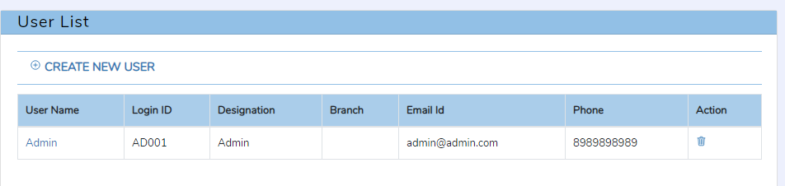
Fig 2.3.1 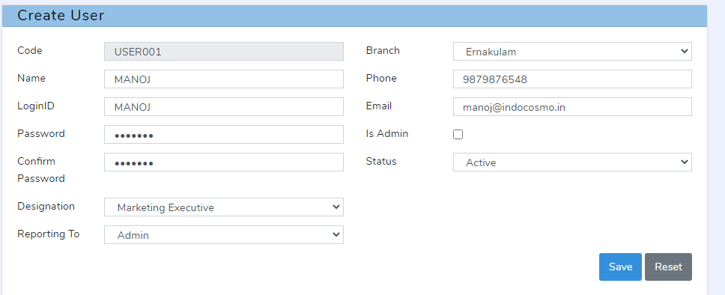
Fig 2.3.2

MASTERS
This is the menu option from where the admin can View / Edit / modify the master details. The masters are:
- Branch
- Category
- Designation
- Configure Mails

BRANCH
All the branches of the company (CRM using company) are comes under the menu branches. Admin can view the entire branch list, can create, modify and delete the branch details. A normal user can’t manage the branch details.
The fig 2.4.1.1 shows the branch details.
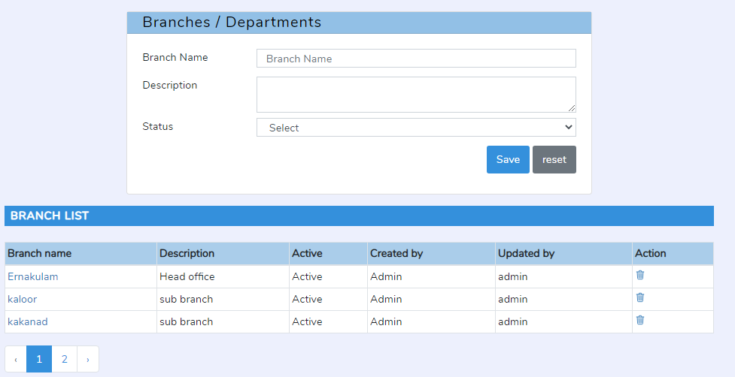
Fig 2.4.1.1

CATEGORY
Category of the client like a restaurant, bakery are managed under the menu master/ category. Admin can manage client category by adding new categories, modifying existing categories, and also can delete the category.
The Fig 2.4.1.2 shows all category lists and the category creation portion.

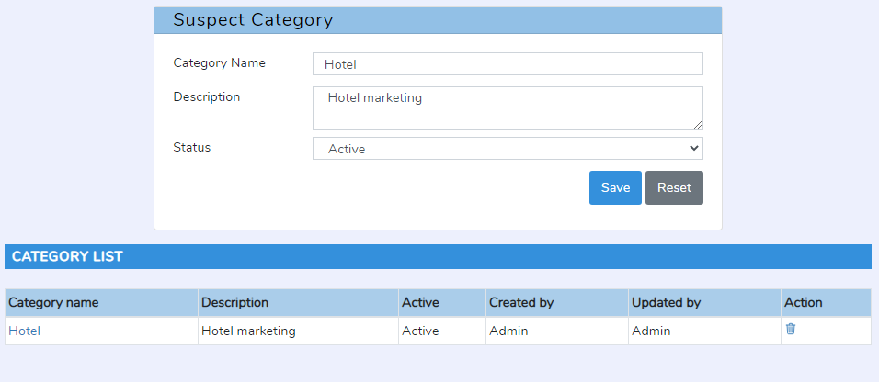
Fig 2.4.1.2

DESIGNATION
The user’s designation can manage here. While creating a user, the admin can set the designation also. Admin can view the entire designation list, can create, modify and delete the designation details. Some of the examples of designation are marketing executive, branch head.
The Fig 2.4.3.1 shows all designation lists and the designation creation portion.
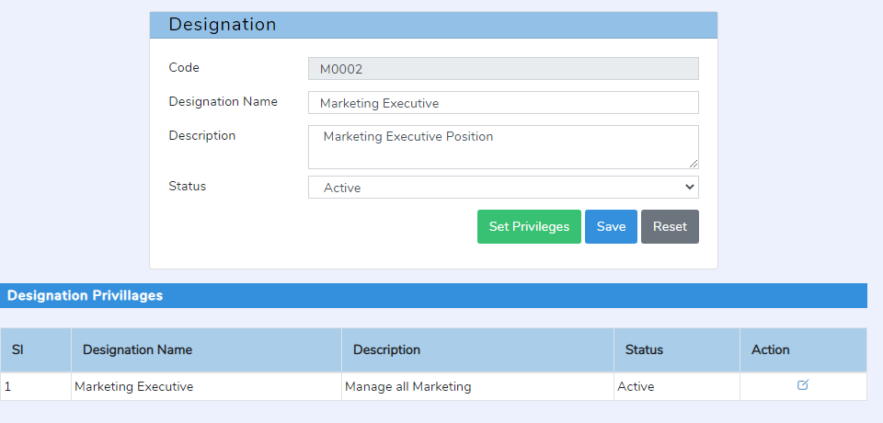
Fig 2.4.3.1
      - Designation Rights
Each designation has different privileges to access the system. So the privileges/rights can be added to the designation menu. A branch head can have more rights than a marketing executive. It is possible to set the rights of the designation against module names.
Admin can set and manage the permissions of each designation. Permission is set based on the designation. This section helps to restrict unwanted edits from users. . Please refer to the below screenshot for more details.
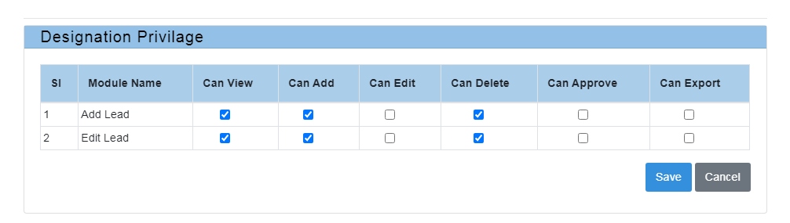
Fig 2.4.3.1

CONFIGURE MAILS
Admin can configure emails for the events on the system. The mail settings of each module should be different. From, to, cc, bcc, and subjects are included in clicking the edit button of the email configuration list. If the send option is on then the email will send automatically while the particular event occurs.
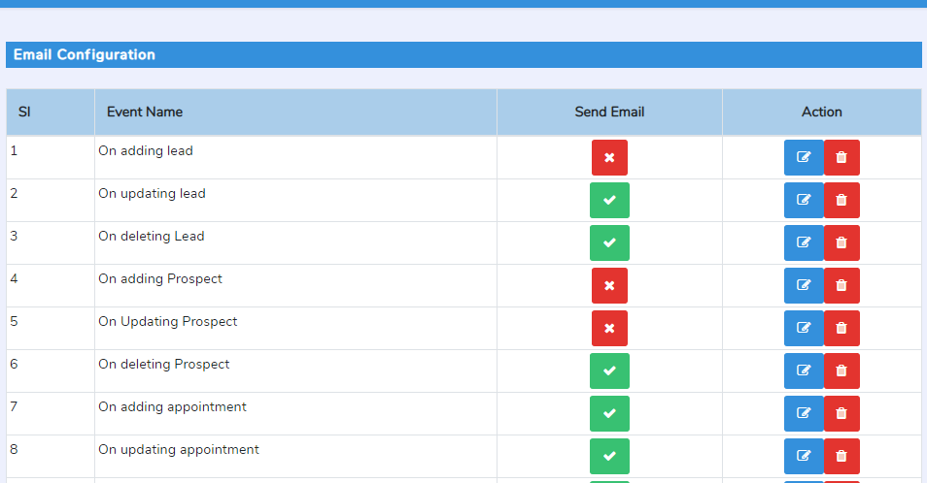
Fig 2.4.4.1

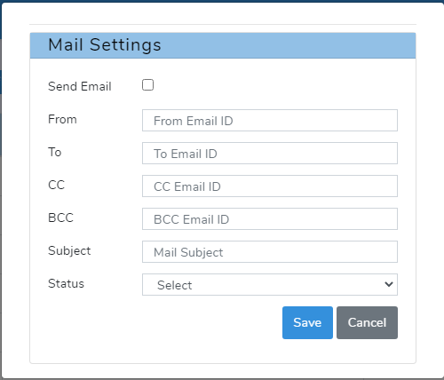
Fig 2.4.4.2

Functional REQUIREMENTS (ALL users)
All users can access these functions based on the user’s designation. The admin and user can access the modules such as lead, prospects, customer, appointments, issue tracker, client payments, and AMC details.

DASHBOARD
The user can view all their appointments, lead lists, and prospect lists and the issue track-list. By default, all these data have appeared based on the current date. User can filter the data based on some search criteria from the dashboard.

Lead
A lead is a person or company who shows interest in a products or services, which makes the person a potential customer. The user can manage lead by add, edit, view and delete. The lead detail includes basic details, person in charge details and notes. The user can enter lead details with remarks.
Fig 3.2.1 shows the lead list with different searching criteria’s. Edit and delete options are available on the list window. The searching criteria’s are
1. Search by Lead name.
2. Search by users.
3. Search by category.
4. Search by date.
5. Search by the status of the lead.
6. Search by keywords.
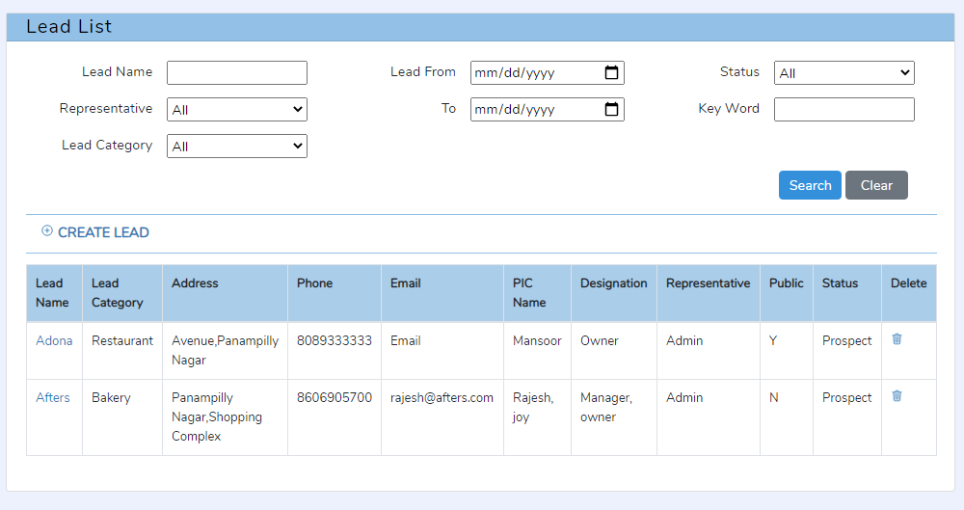
Fig 3.2.1
Fig 3.2.2 shows how to add lead details.
Mainly there are three sections available in the lead creation form. They are the lead details, lead status, and the person in charge section. The lead section includes the basic details of the leads with remarks. Lead status section is for changing the status. The person in charge details includes Name, Designation, phone, email and mobile. Name is mandatory.

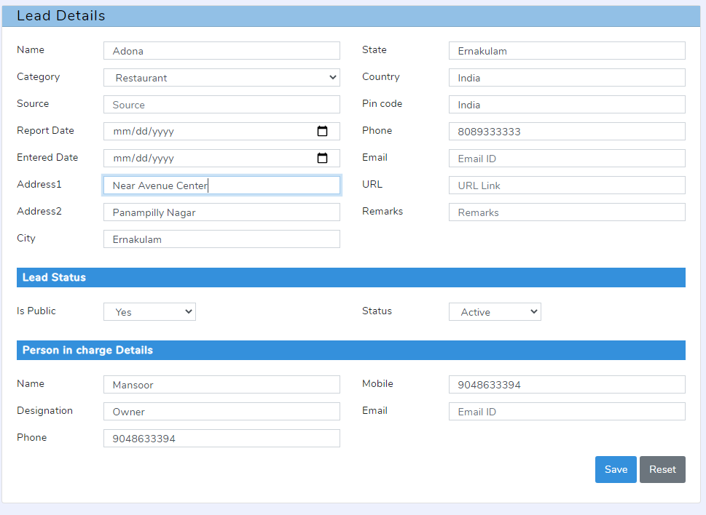
Fig 2.3.2

PROSPECTS
A prospect is a potential customer that has been qualified as fitting certain criteria and who has shown interest in your goods or services. Here a user can convert the leads in to prospect.
There are 3 sub menus in the Prospect menu.
1. Add prospect.
2. Prospect List.
3. Locate Prospect.

3.3.1 prospects - Add prospect
Users can add new prospect with name, lead name, product proposed, Token amount , Amount quoted, Remarks, status, location, Latitude, Longitude.
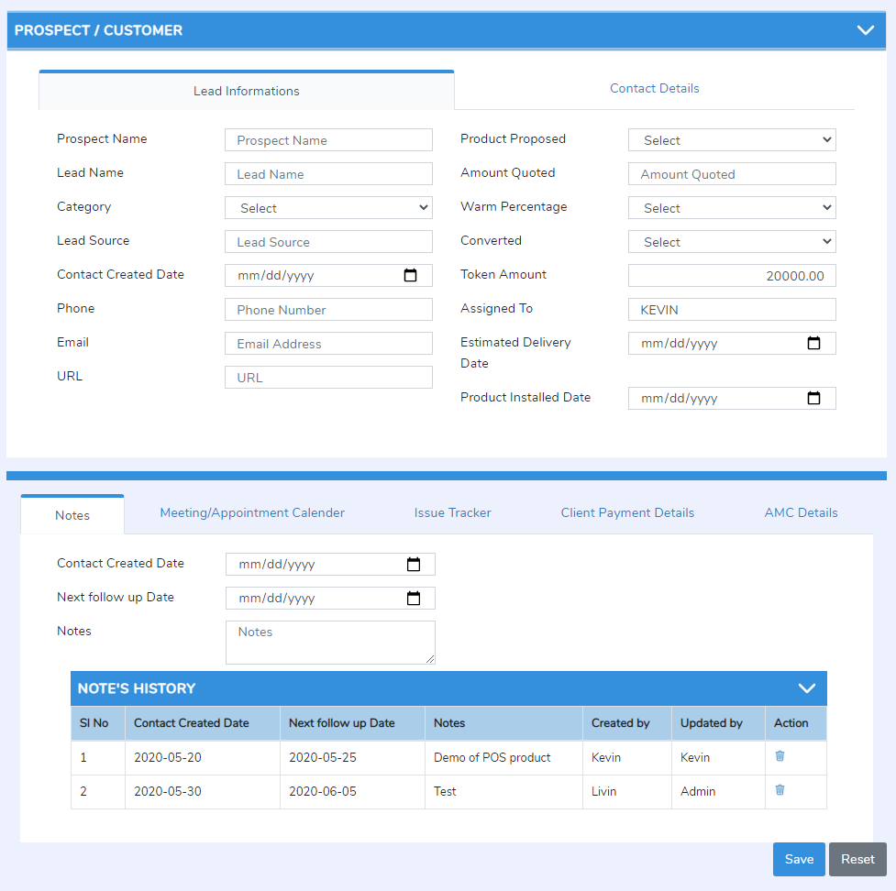
Fig 3.3.1.1
The lead information and contact details are displayed in two tabs. The lead details are filled automatically while selecting the lead name from the popup menu. Prospect name, Lead name, amount quotes, product proposed fields are mandatory.

3.3.2 prospects – prospect LIST
Here users can view the list of prospects in table format. The fields in the listing tables are prospect name, PIC name, PIC telephone, Username, Product name, Last update, created by, Exp. Price and status.
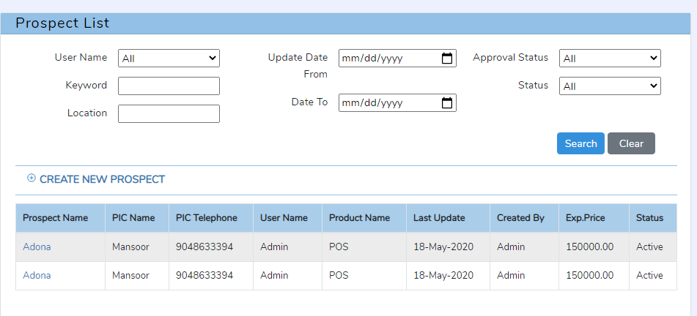
Fig 3.3.2.1
Only admin can change the status of the prospects (active or inactive). Other users only view the status result.
Multiple search criteria’s are added in the prospect list page. The searching criteria’s are
1. Search by user name.
2. Search by keywords.
3 Search by location.
4. Search by date.
5. Search by status.
6. Search by approval status.

3.3.2 prospects – Locate prospect
Here users can locate the prospect with the help Google maps.

Customer
A customer is a person or company that receives, consumes or buys a product or service and can choose between different goods and suppliers. A prospect is not a customer. So user can convert the prospect to customer by using this menu. If converted is Yes and they have given some token amount means we can call a prospect as a customer.
All the customer lists added by the user are listed in this section. In the case of admin, all customer lists added by different users displayed. A user can manage and get the customer list based on different search criteria. They are searched by customer name, from date to date, status, representative, product, and keyword.
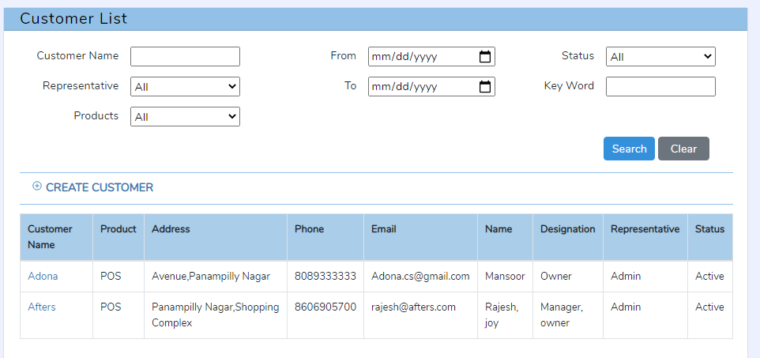
Fig 3.4.1
Fig 3.4.2 shows how to add a customer and its data.
There were 5 tabs in this section.
1. Customer details with note.
2. Meeting calendar.
3. Issue tracker.
4. Client Payment.
5. AMC Details.
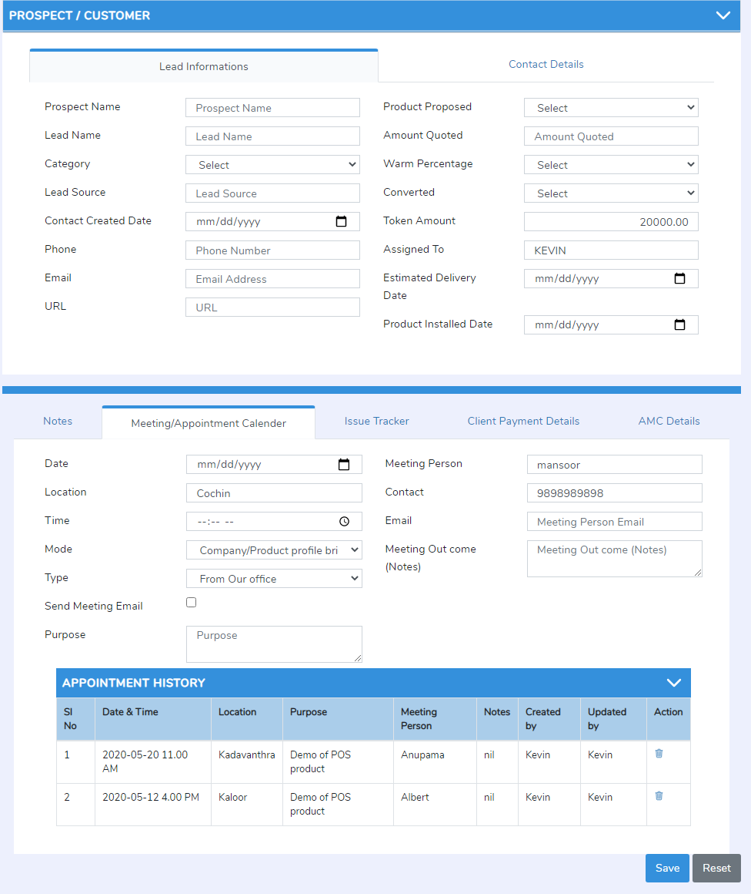
Fig 3.4.2

3.4.1 Customer – customer details
Customer details are shown here. The fields Client Name, Lead Category, Contact Created Date, Phone, Email, and URL are auto filled based on the prospect details (but user can also edit).
The rest of the fields Contact Person name, Contact Person Designation, Mobile No, Location ,Address, city, state, country, pin code, present status, existing product, amount details, estimated delivery date , installed date etc. are should be complete by the current user.
Converted -user can convert the prospect to customer by this field (drop down filed).

3.4.1.1 customer: Users – note
This is for users to note down the meeting details with the client. Users can add the notes with Date, Notes, Next follow-up date, Edit by name.
User can also view the list of the notes in the table format
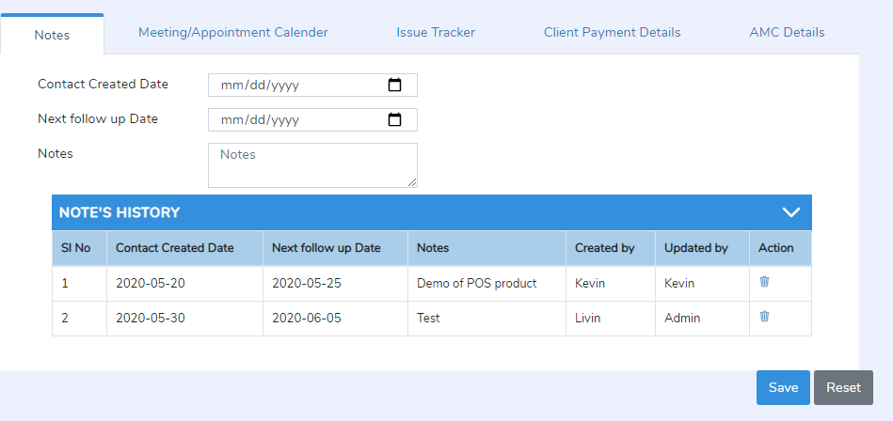
Fig 3.4.1.1.1

3.4.2 Customer – Meeting / appointment calendar
This is for scheduling appointments. The user can add the next schedule with the Date, Location, Time, Purpose, meeting person, meeting notes, meeting schedule mail.
User can also view the list of the meetings scheduled in the table format and calendar format.

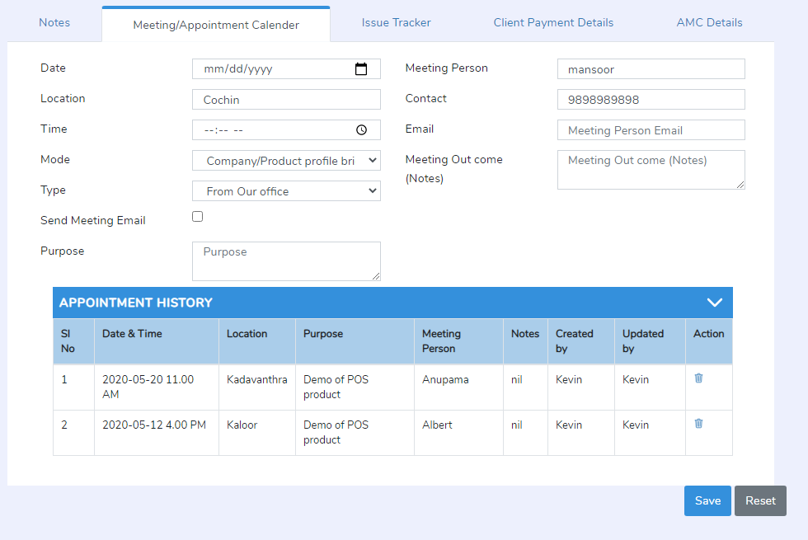

3.4.3 Customer – Issue tracker
Users can add the client side issues of the product with date, issue description, status, developer name, solved date.
Mail sent automatically for the developers about the issue.
Users and admin can view the issue track record in to the table format.
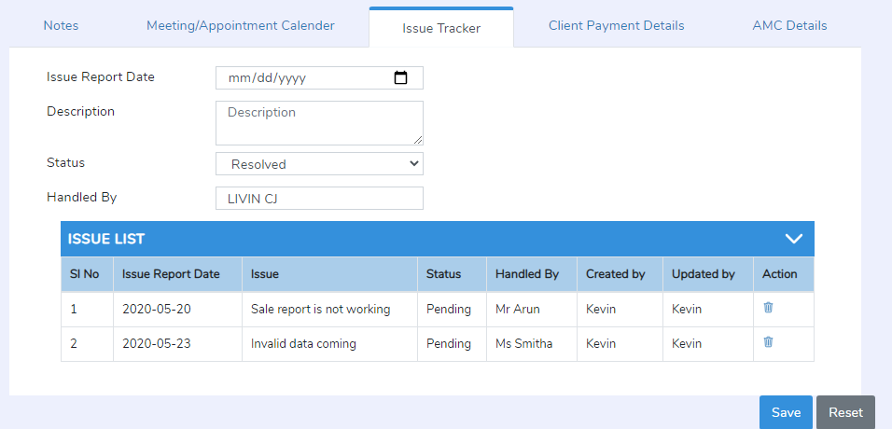

3.4.4 Customer – Client payment details
Users can follow up the payment details here. Users can easily find the payment pending, payment details and etc.
User can add the payment record with date and collected amount. Users can also view the payment details in to the form of table.
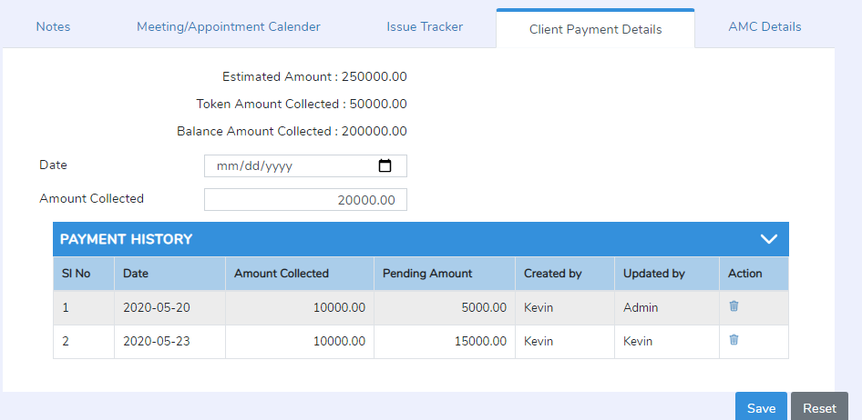

3.4.5 Customer – AMC Details
This is for the AMC details.
Users can follow up the AMC details here. Users can easily find the AMC pending, payment details and etc.
User can add the AMC record with date and collected amount. Users can also view the AMC details in to the form of table.
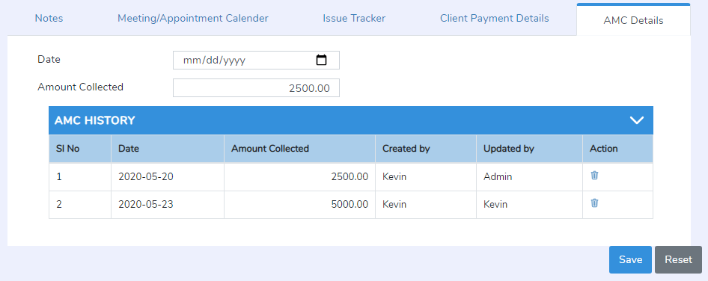

3.5 Daily report / Weekly report
Staff are update their daily report here. They can also view and edit their report.
There were 3 section
1. Search section : search the daily report based on the date, week, and staff name.
2. Add report : add the daily report with date and description.
3. List Daily report: List the Daily report in the table format, staff can edit report here.

3.6 Profile
Users profile section. User can change their username, password, phone, email id here.
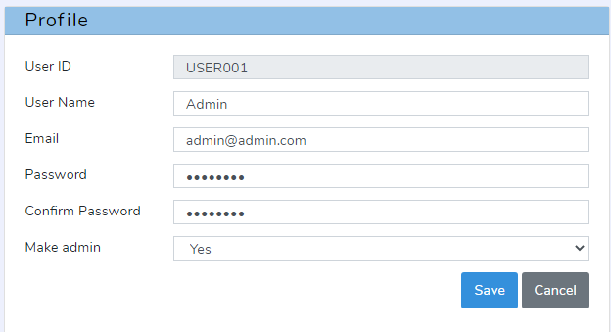

3.7 Logout
Users can logout from the system while clicking on the username that appeared at the top right corner of the window. The logout button is placed under the username. All session and cookies must be destroyed here.

Non-Functional Requirements

Performance Requirements
It is not a resource hog and will run on almost every computer. Its functions and features are not computationally intensive. It does not require a powerful processor or graphics card, much RAM, or disk space. It only requires a latest browser.

Security Requirements
The user passwords saved in the database should not be in a readable format. This application as all the other web application requires the Internet availability, and is also requires that the user should keep his private keys safe and secure and the same should not be shared with anyone. User should keep his key safe. The system or the place where the key is stored should not be public. In the case if the user loses his key then he/she should immediately inform the system admin.

Software System Attributes

Client Side Quality Attributes:
The application provides a quite user-friendly interface with its operations accessible from the menu bar and the main toolbar. An average or casual user should not find any problem using the program to perform at least its main functions. Inter-operability is guaranteed since this program runs on both Mac and PC (Linux, Windows or other operating system).

Server Side Quality Attributes:
Along with that our system provides the server which is scalable so that it can meet up any future requirements and is easily upgradeable. Admin can take a backup on a regular interval so in case of any failure or damage system can be restored easily.

