
Profield Chat v2
User Guide
Revision History
Version | Author | Date | Remarks
1.0 | Midhun KC | 27 Aug 2020 | Created

- Table of Contents
1 ADMIN MODULE 3
1.1 CATEGORY 3
1.2 PRODUCT 4
1.3 PRODUCT OWNER 6
1.4 CUSTOMER 7
1.5 VIEW CHAT 8
2 WEB APPLICATION (CLIENT) 9
1.1 CUSTOMER SIGN UP 9
1.2 PRODUCT OWNER 18
1.3 OFFLINE MESSAGE 18
1.4 DELETE MESSAGE 19
1.5 REPLY MESSAGE 20
1.6 ACCOUNT REACTIVATE 21

3 IOS APP (CLIENT)

ADMIN MODULE
The administrator can login to the system using the,
URL: https://hikari.in/dev-chat/admin/
User name :superadmin
Password : 123456
On successful login the Admin Main window will be displayed.
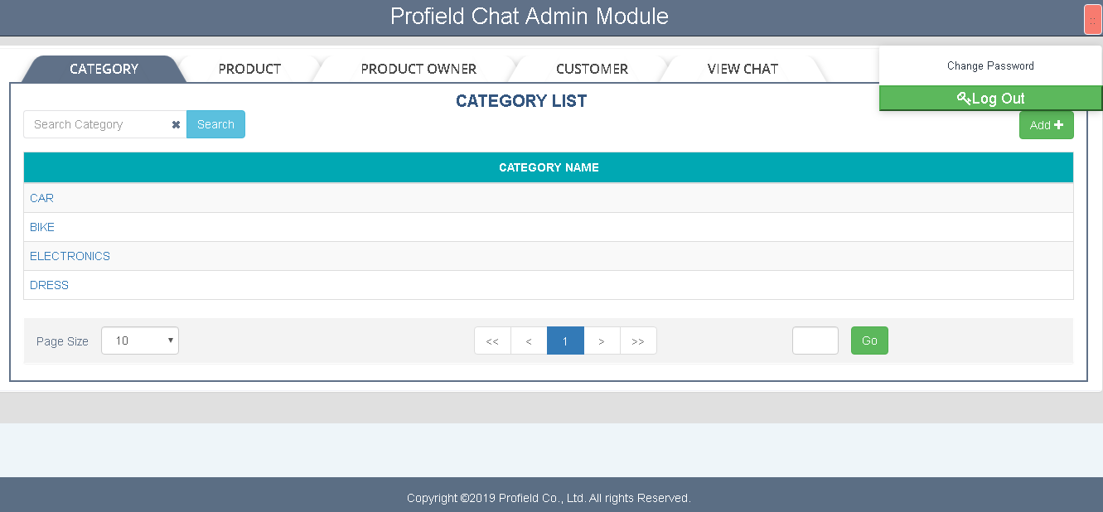
The admin module allow administrator to setup and maintain the Product, Customer, Product owner and view the chat messages:

CATEGORY
The admin has the right to add/update and delete the categories.
- Add Category : Clicking “ADD” button on the category tab enables adding a new ‘category’ to the system.
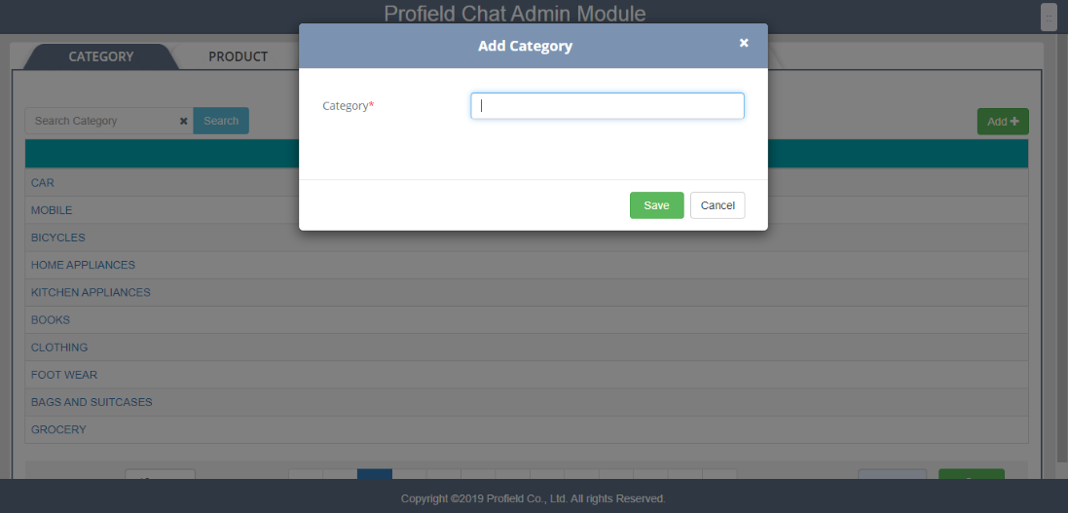
- Edit Category : We can edit any category from the category list by clicking on the category name from the list. If there is no other link between the current products, we can also delete any Category from the list.
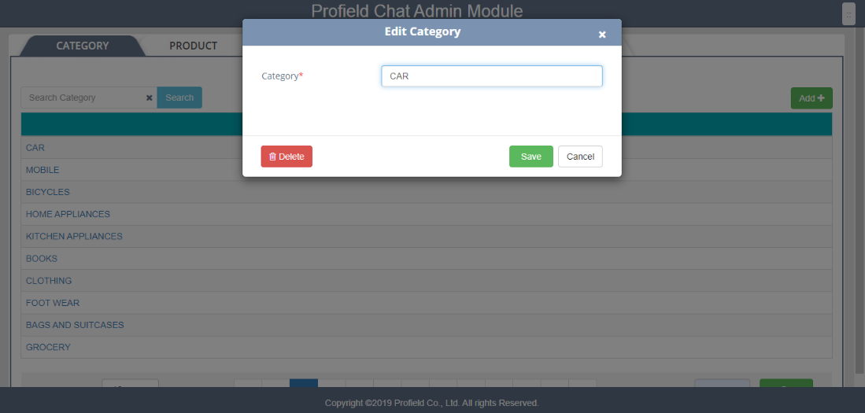

PRODUCT
The admin has the right to add/update and delete the products from the application. procedure of adding,editing and deleting the products are the same as the category but in the ‘product’ tab.
- Add Product :
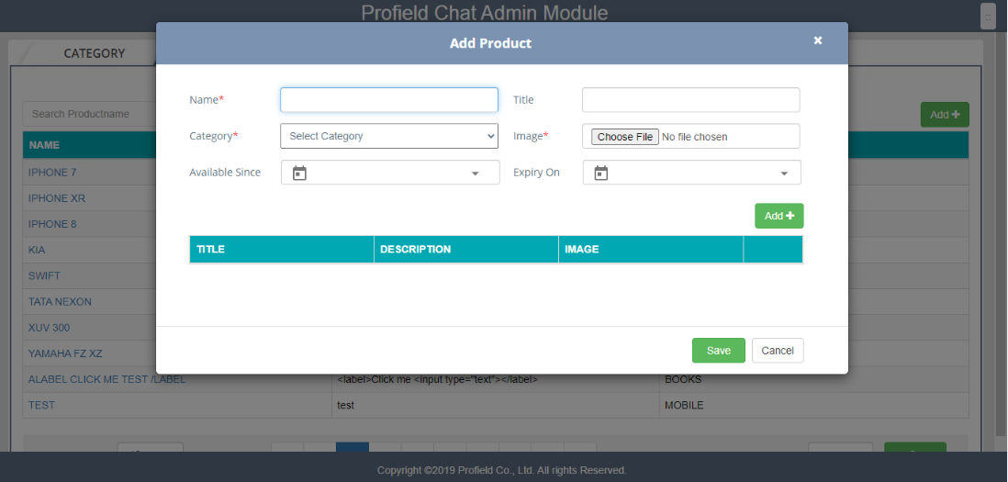
Adding Product attributes:
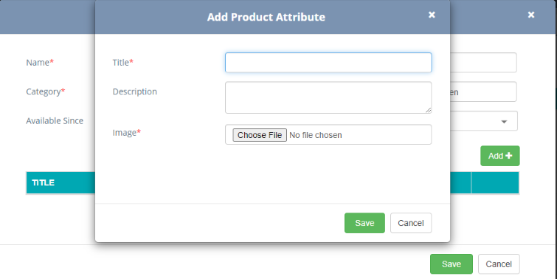

- Edit product :
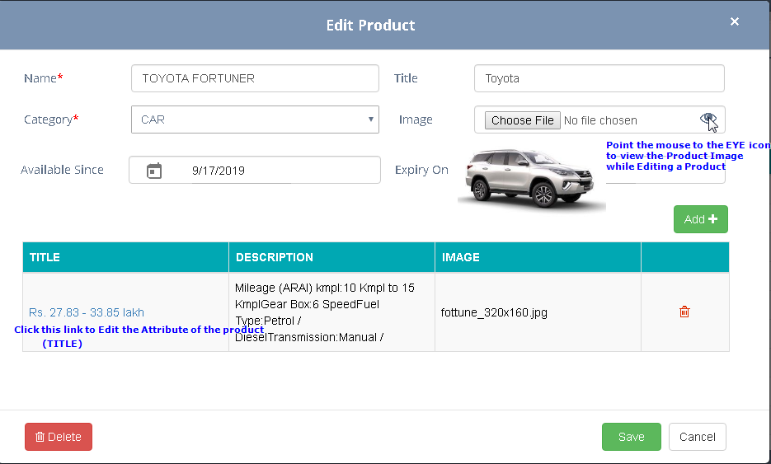
Edit attributes for the product
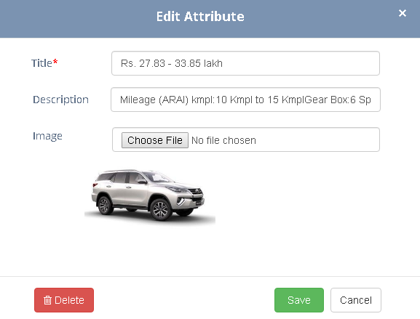

PRODUCT OWNER
The admin has the right to add/update and delete the product owners from the application. procedure of adding,editing and deleting the product owners are the same as the category but in the ‘product owner’ tab.

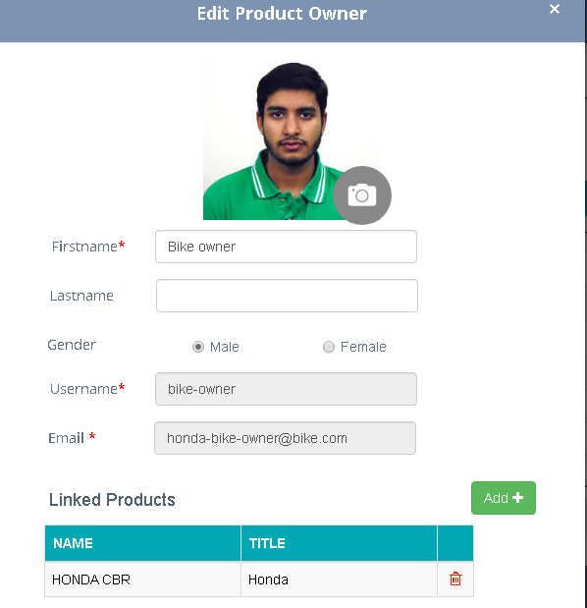
Select the products to be assigned for the product owner
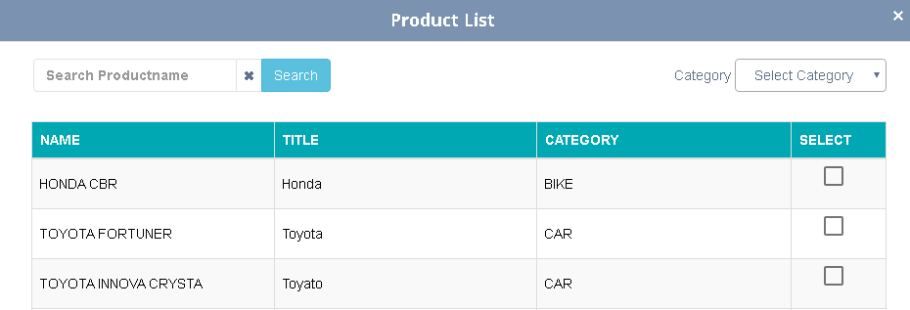

CUSTOMER
The admin has the right to add/update and delete the customers from the application. procedure of adding,editing and deleting the customers are the same as the category but in the ‘Customer’ tab.
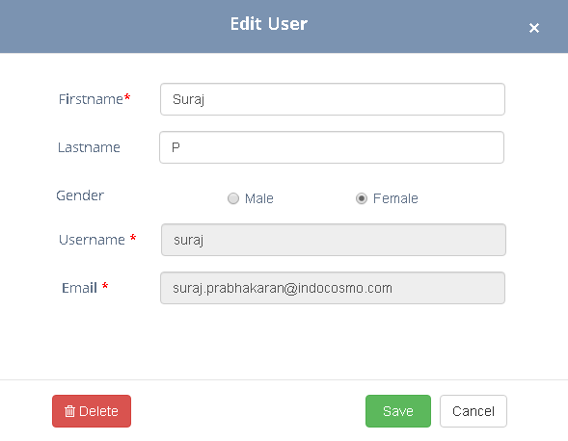

VIEW CHAT

Admin can view or clear the chat based on the Category/Product/Customer
- Select Category from the drop down
- Search on Product Name (Optional)
- Select Product List to view the Customers
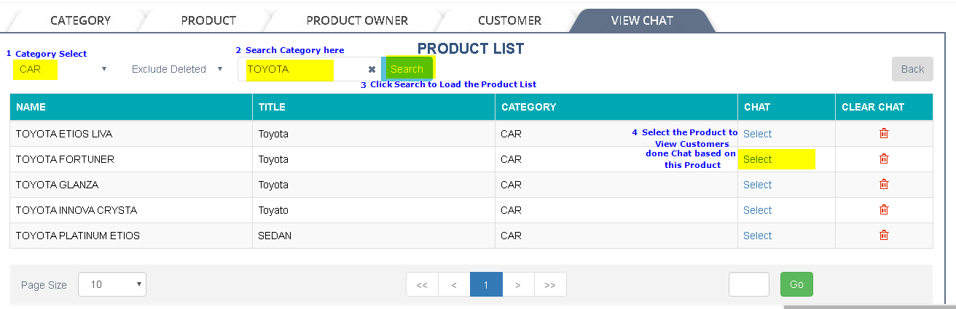
- Select the Customer to view the Chat belongs to the Customer for the specified product
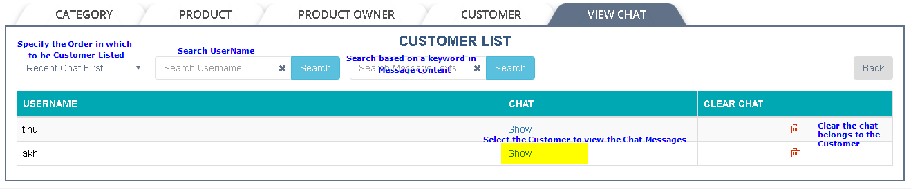
The message view is displayed here
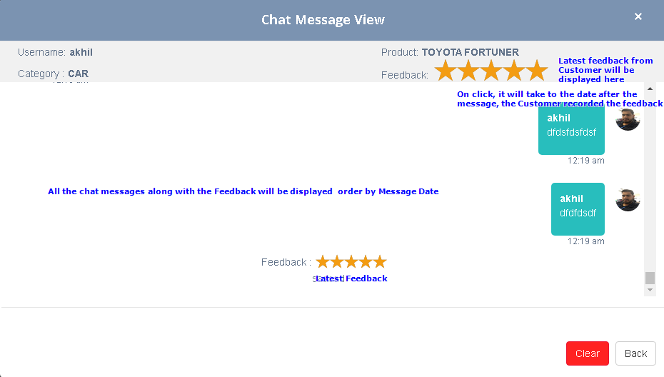

WEB APPLICATION (CLIENT)
A customer or a product owner can login to the application using the web application
Login URL :https://hikari.in/dev-chat/login

CUSTOMER SIGN UP
Anybody register using the ‘Sign up’ feature from the login screen becomes a Customer. Also customers defined through the admin module can also login to the application using the Username and password.
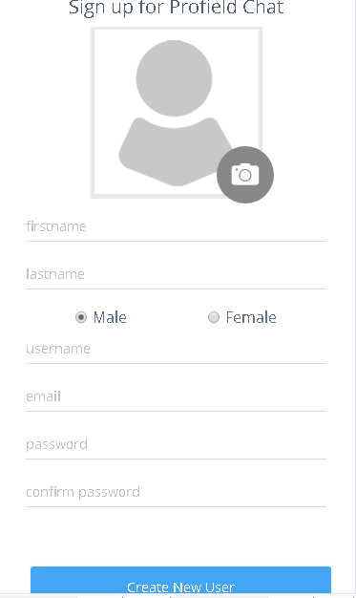
Customers can login to the application using the Username and password.
On successful login, the Home page for customers will be displayed.
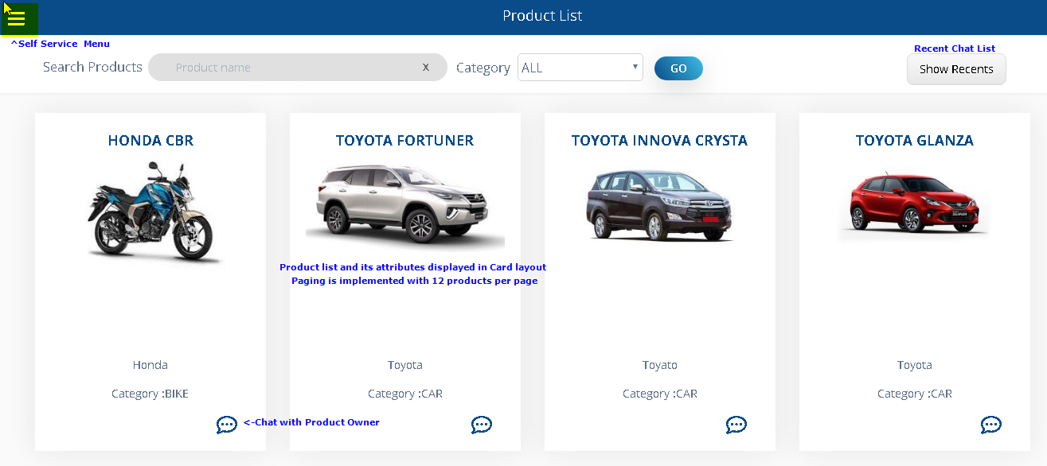
Product Attributes displayed with Page scroll controls.
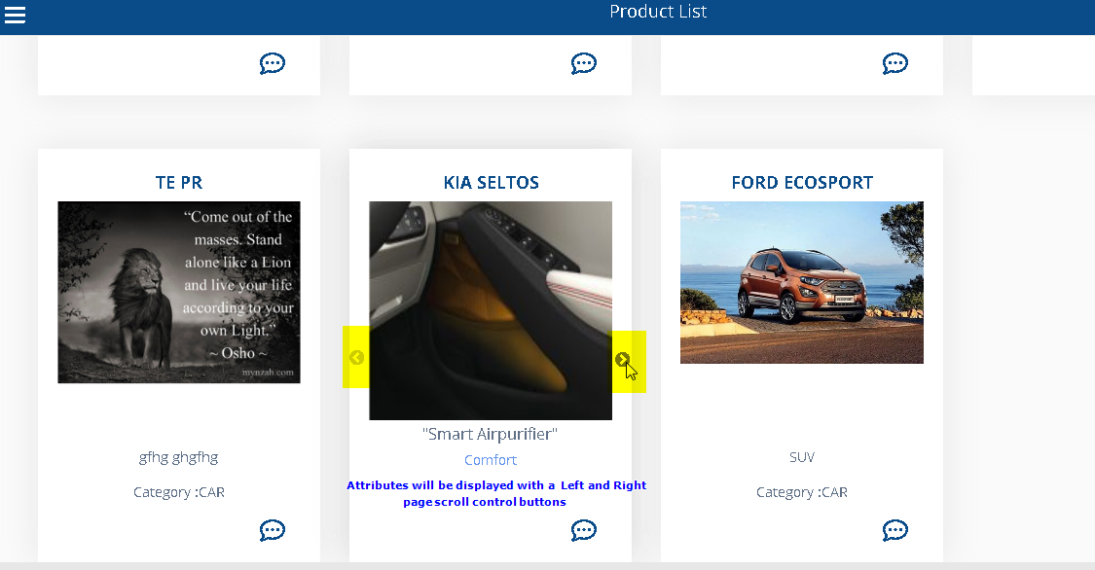
More Options :
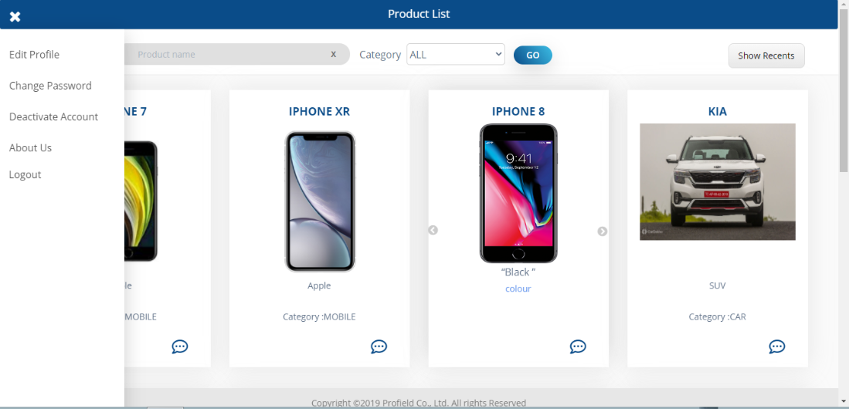
- Edit Profile : User/Product owner Can change their profile photo, Firstname, last name and gender
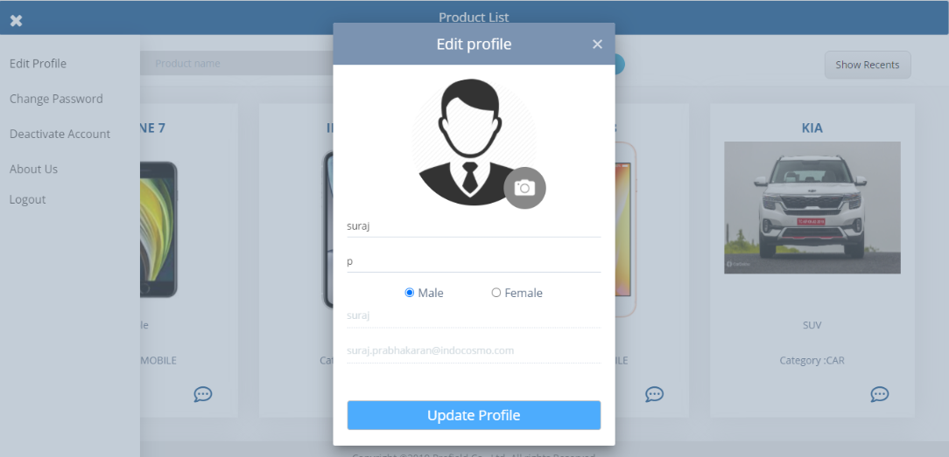
- Change Password : User/product owner can change their password
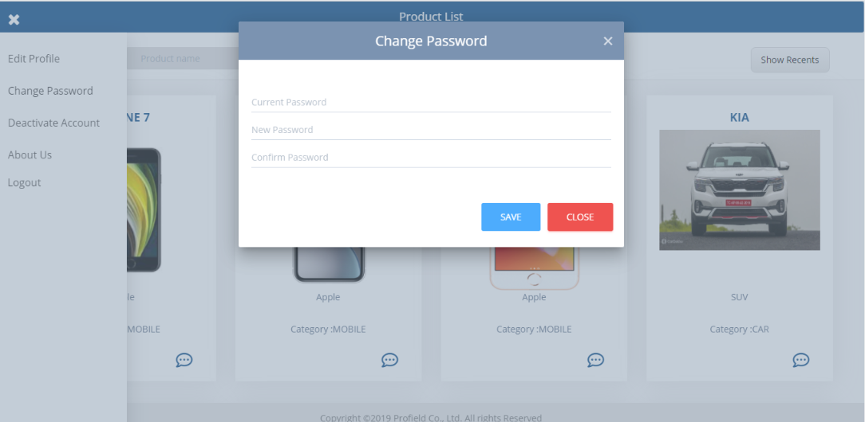

- Deactivate account : Only Users can deactivate their account.
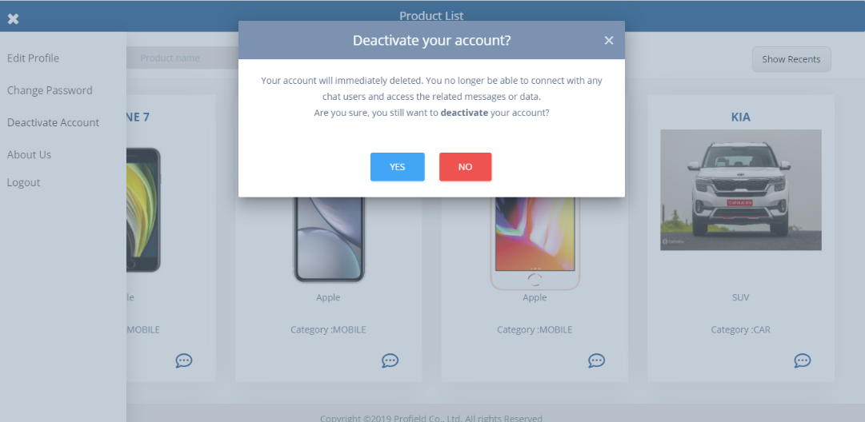
- About Us : It shows the details of the company and the current version of the application.
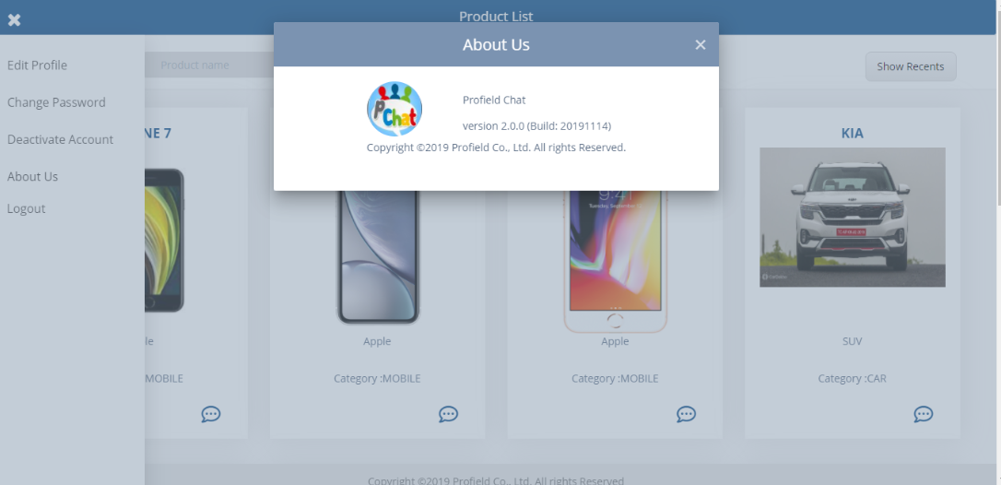
- Logout : Option for logout from the application.
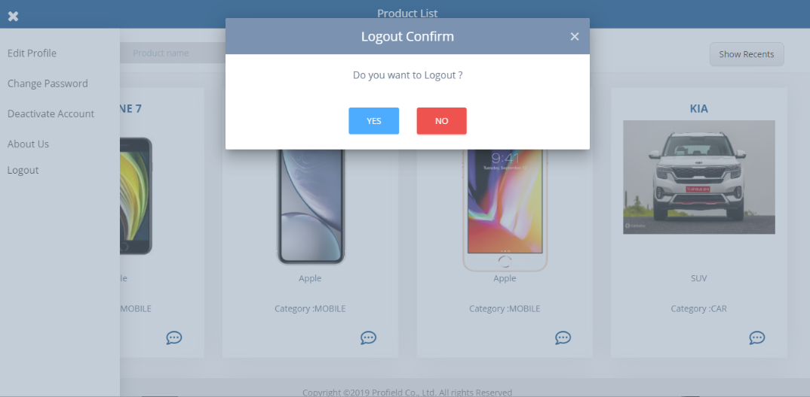

Recent Chat List (5 items) : Recent chat list shows recent 5 chat history, by clicking any of the products leads us to chat with the owner of that particular product.
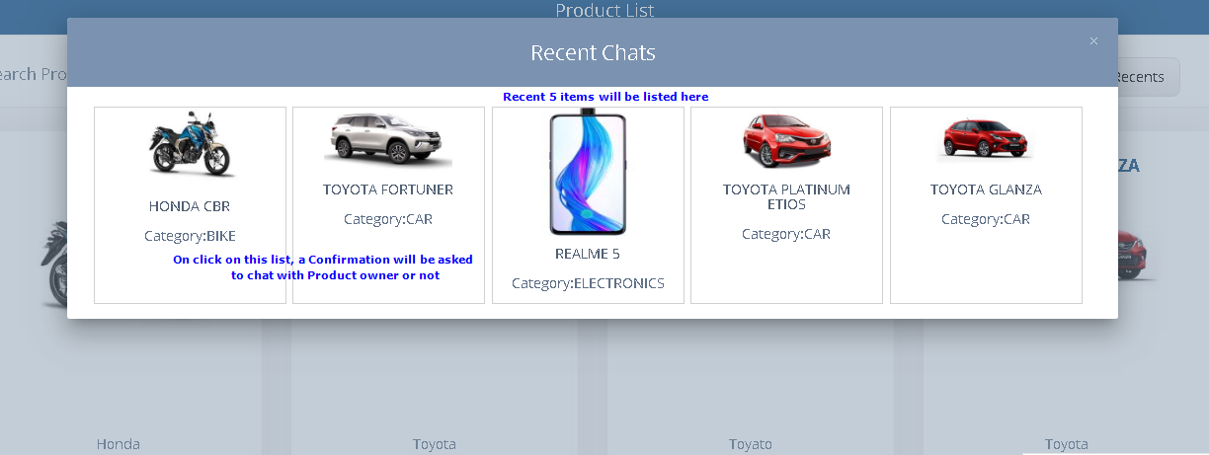
Confirmation with Customer whether to start the chat or not
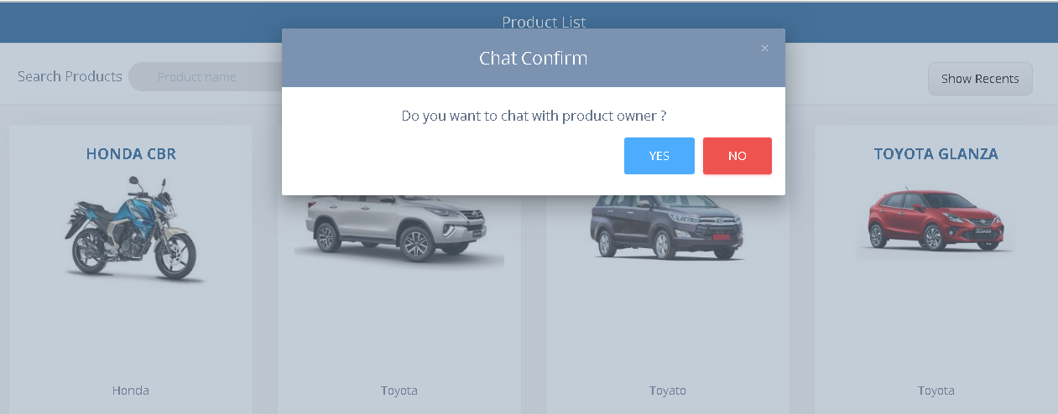

Customer Chat page :
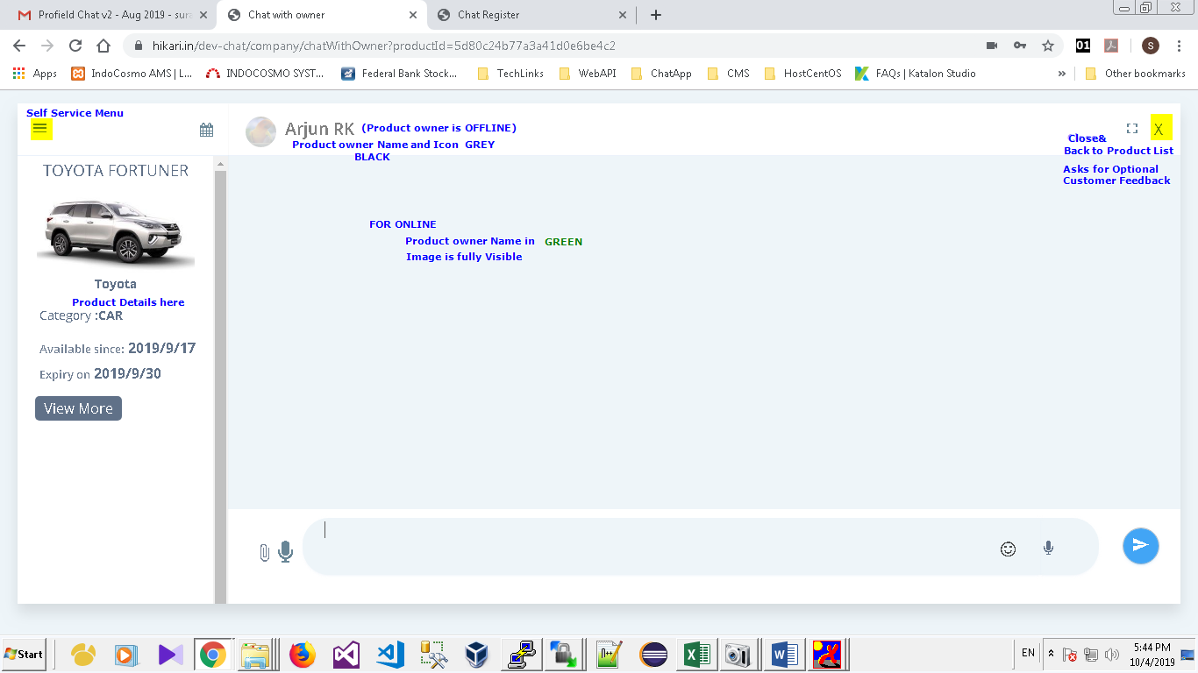

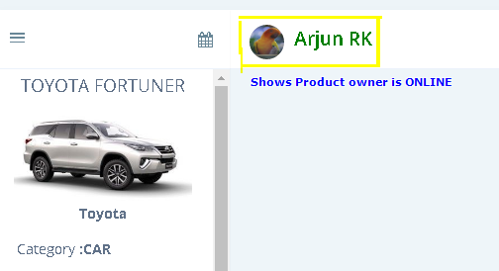
On Chat Close Customer Feedback will be collected.
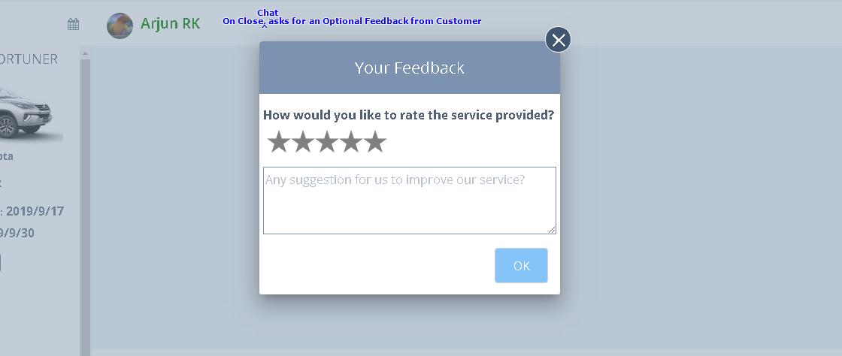

PRODUCT OWNER
Product owner’s home page
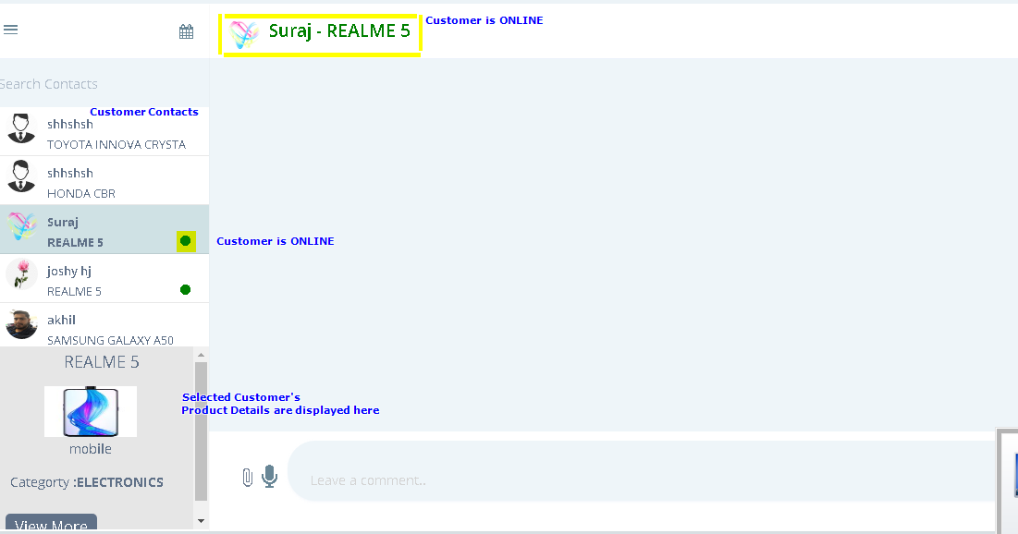

OFFLINE MESSAGE
Customer sends an offline message to Product Owner
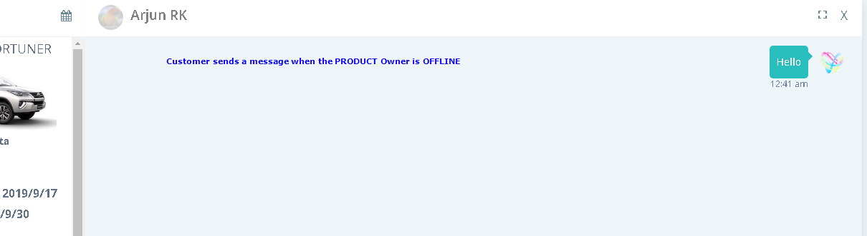

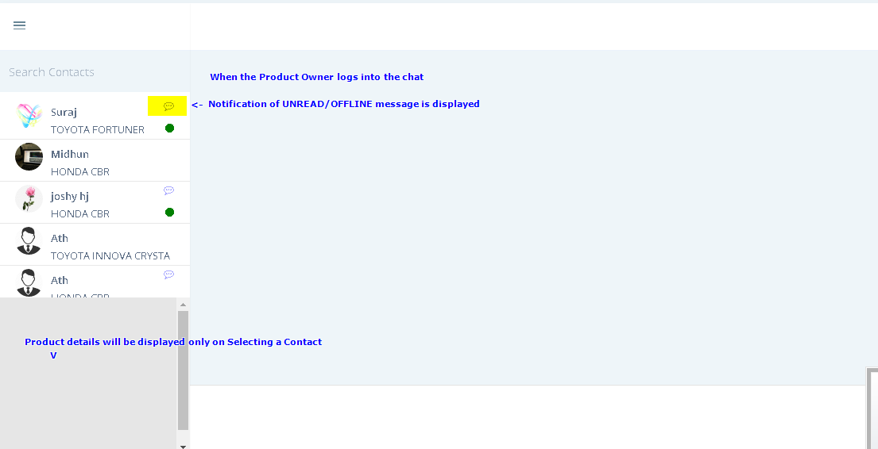
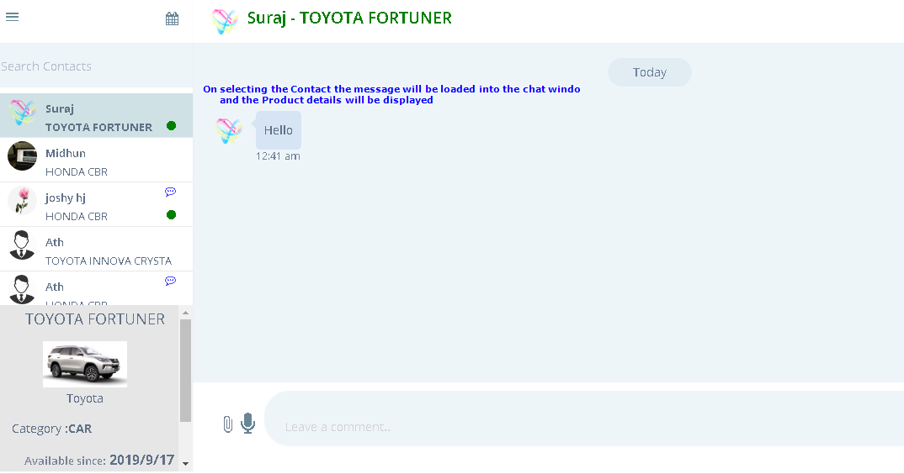

DELETE MESSAGE :
Users/Product owners can delete their own messages by double clicking on their messages.
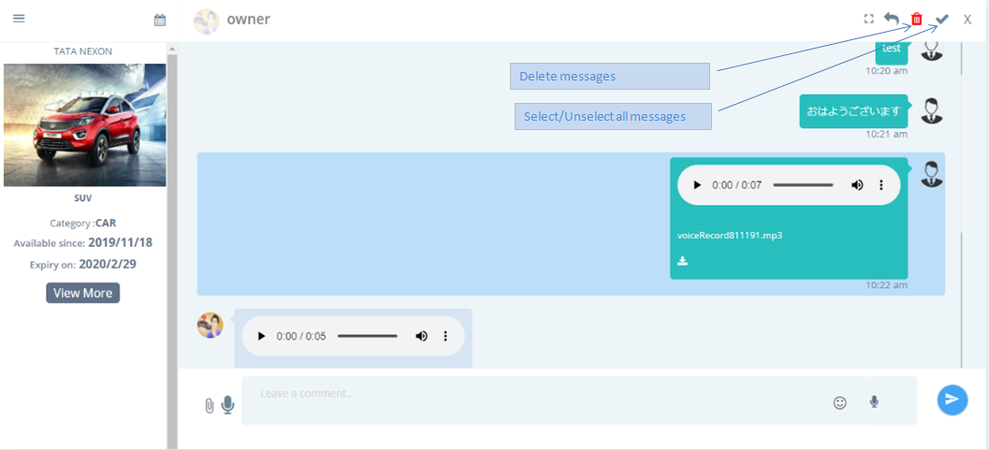

REPLY MESSAGE :
Users/Product Owners can reply to their own messages or opponent messages.
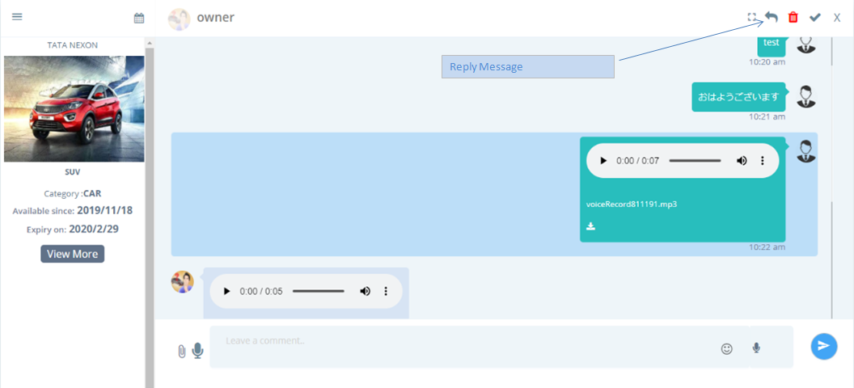

ACCOUNT REACTIVATE : Users can reactivate their account by sign up with the same email id, but On activation all messages related to the inactive user account will be deleted permanently.
