
User Manual
Carry Park Web Application

Revision History
Version | Author | Date | Remarks
1.0.0 | Dileep | 18-June-2020 | Created

Table of Contents
1. Login 3
2. Log out 3
3. Dashboard 3
4. Location 5
Add / Edit 5
5. Devices 7
Add / Edit 8
6. Contract Users 10
Add / Edit 11
Assign Device 12
Contract User Detail page 13
7. Payments 13
8. Users (CP Mobile App users) 15
9. Error log 16
10. Settings 16

Login
The system is protected against unauthorized access using login credentials. Each user has a specific Username and Password. For now, we only have Admin User role.

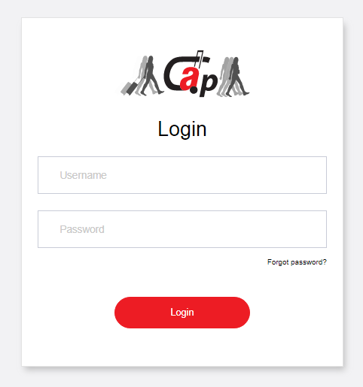
Fig 1.1
Process:
Registered users can Login through this screen and the server verifies the username and password and allows access to the functionalities on successful verification.

Log out
Logged in user exits from the web application.
Process:
Invalidate all the sessions for this user and log him/her out from all systems part of the website.

Dashboard
After a successful login a user will redirect to Dashboard screen and act as a ‘Home Page’. Following are the information displayed on the Dashboard.
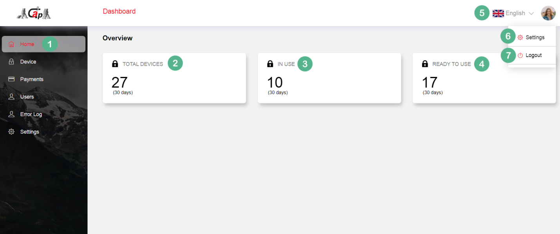
Fig 3.1

Sl# | Section | Description
1 | Menu Selection | The selected menu will show in a different color. Here Home is selected.
2 | Total Devices | This is the number of active devices.
3 | In use | This is the number of devices in use.
4 | Ready to use | This is the number devices which are free and ready to use.
5 | Language selection | This dropdown (select box) is used to choose the language of website.
6 | Settings | On click the user will be redirected to the settings page.
7 | Logout | On click the current logged-in user session will end and returns to the log in screen.

Location
Display the list of registered locations in CP system. List will display the location, landmark, pincode, latitude, longitude, status and an action button which contains view, edit and delete links.
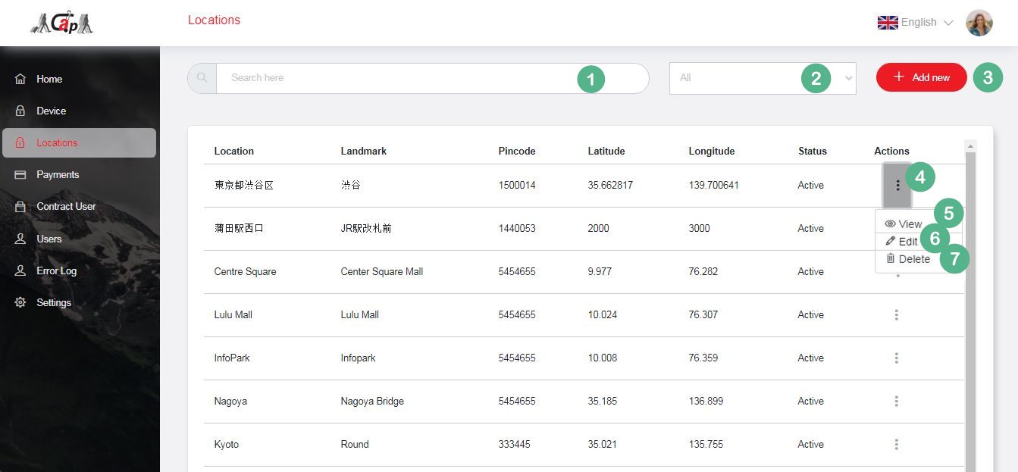
Fig 5.1

Sl# | Section | Description
1 | Search | User can search for specific locations
2 | Dropdown | This dropdown help to filter the location list based the on the selected criteria’s.
3 | Add new button | Click the button to redirect to the add location page.  Please see figure Fig 5.2
4 | Action button | View, Edit and Delete links
5 | View | Clicking the button to display the popup screen with the details of selected location.
6 | Edit | Clicking the button to redirect to edit location page.  Please see figure Fig 5.3
7 | Delete | Click the button to delete a location from the system.

Add / Edit
User can add new location or edit existing locations. Input the location information on the screen and click the save button to add/edit location. In the add new location screen the values like initial hours, initial charge, rate per hour and maximum hours are auto loaded from settings.
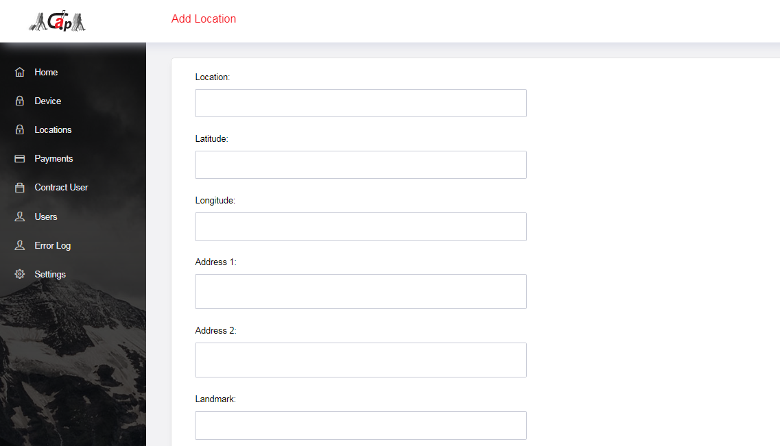
Fig 5.2: Add location screen

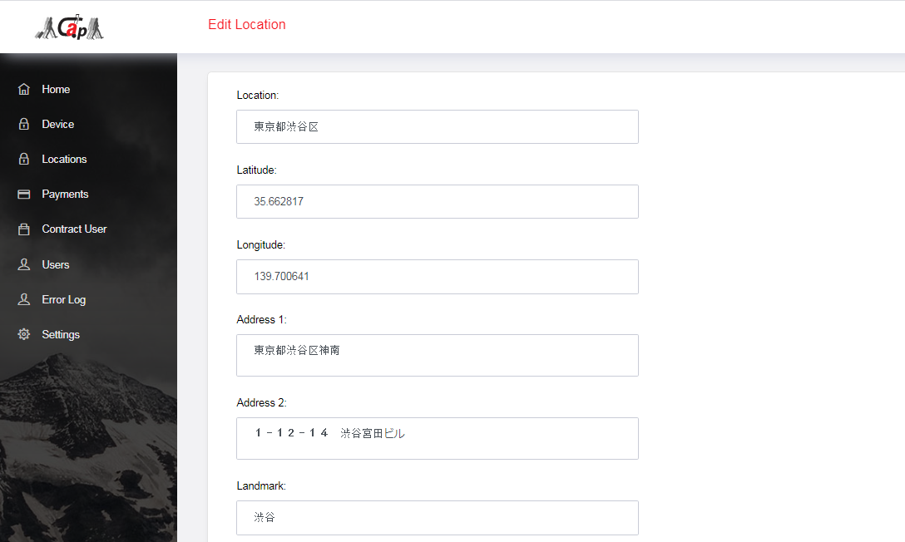
Fig 5.3: Edit location screen

Process:
Location information will be stored in system.
All these locations are listed at Location select box in Add/Edit screen of Devices. User can chooses a location from the list and the Latitude, Longitude, Location Name, Address 1, Address 2, Landmark and Pin code will be auto populated here. So the user doesn’t need to input the location details again for the devices in the same location.

Devices
Display the list of registered devices in CP system. List will display the Device name, Location, Status, QR code and an Action button which contains View, Edit and Delete links.
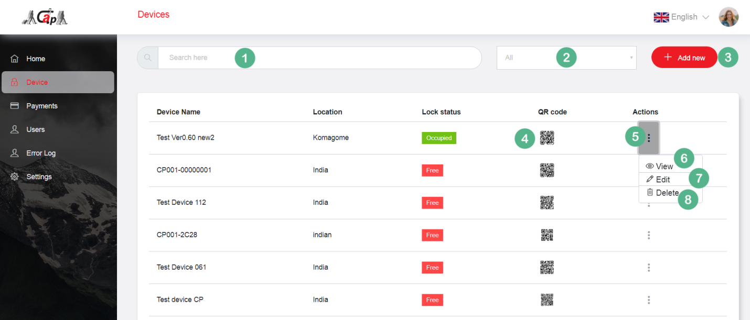
Fig 4.1

Sl# | Section | Description
1 | Search | The Device listing screen allows the user to search for devices
2 | Dropdown | This dropdown help to filter the device list based the on the selected criteria
3 | Add new button | Click the button to load the popup screen to add the new device.  Please see figure Fig 4.2
4 | QR code | Click the image(QR code) to show the enlarged image(QR code) as popup
5 | Action button | View, Edit and Delete links
6 | View | Click the button to load the popup screen with stored details of selected device.
7 | Edit | Click the button to load the popup screen to edit the details of a selected device.  Please see figure Fig 4.3
8 | Delete | Click the button to delete a selected device from the cloud.

Add / Edit
User can add new devices or edit existing device. Input the device information on the screen and click the save button to add/edit device. In the add new device screen the values like initial charge, rate per hour, maximum hours, serviceUUID and characteristicUUID are auto loaded from Settings.

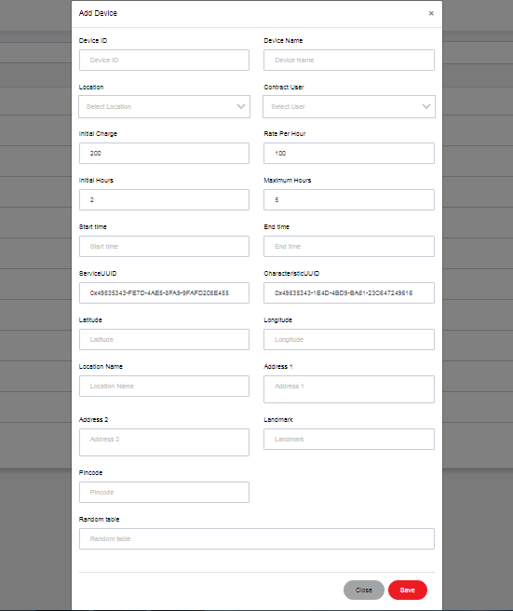
Fig 4.2: Add device screen
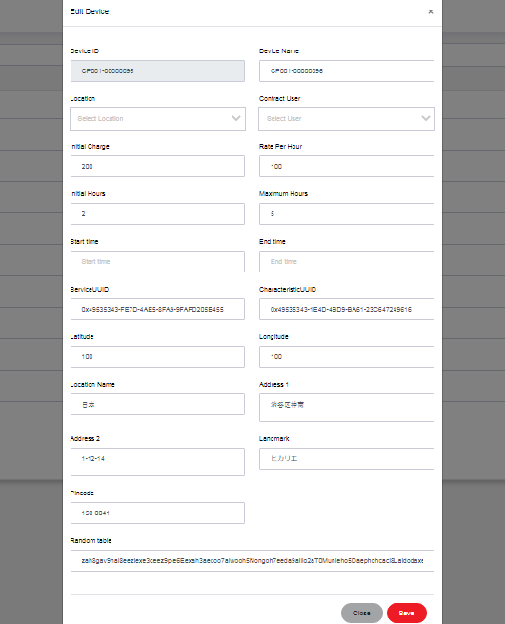
Fig 4.3: Edit device screen
Process:
Locking device information are stored in the database. Device ID will be unique for all devices.
Registered locations will be listed and the users can select the device location from the list. The Latitude, Longitude, Location Name, Address 1, Address 2, Landmark and Pin code will be loaded from Location settings and those data will be non-editable. We can change these values only from the Location screen (Location menu in sidebar).
Users can assign a contract company to device by selecting one from contract user list.
QR Code Generation
While registering the device the server generates a QR code using the device ID. The device ID will be stored in the QR code. As the device ID is unique for each device, the QR code is unique to every device.

Contract Users
Display the list of contract users in CP system. List includes the Name, Phone, Email, Contract type, Status and an Action button with View, Edit and Delete links.
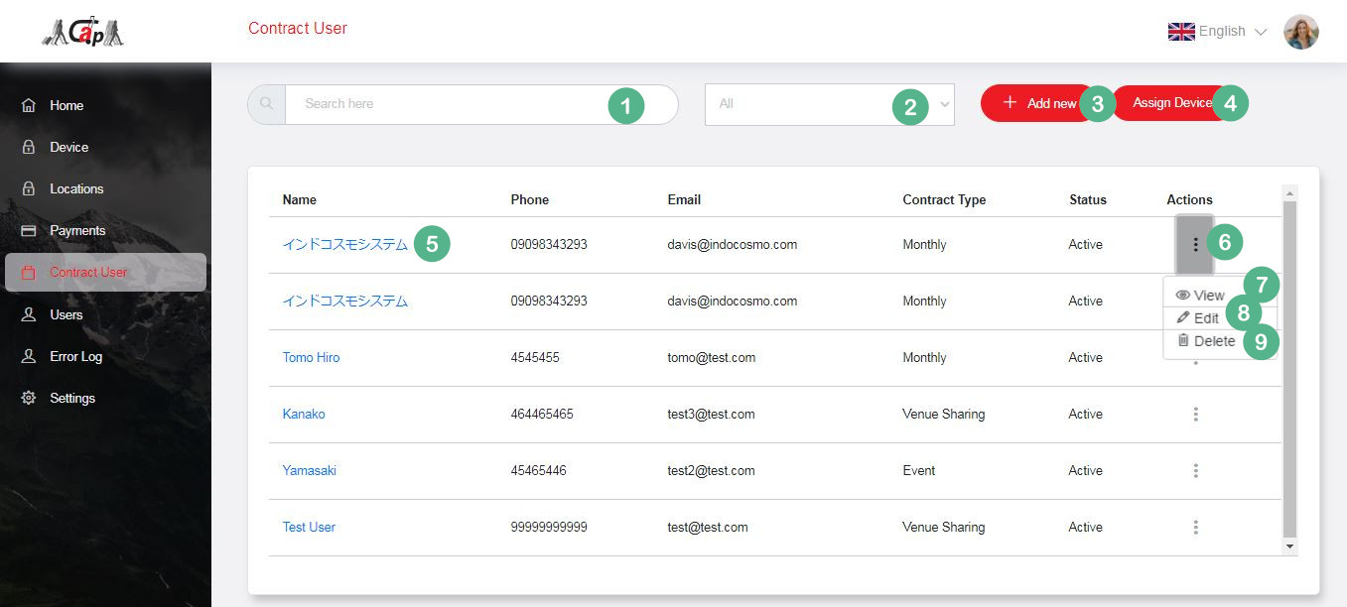
Fig 6.1

Sl# | Section | Description
1 | Search | The Contract user listing screen allows the user to search the Contract Users.
2 | Dropdown | This dropdown help to filter the user list based the on the selected user
3 | Add new button | Click the button to load the popup screen to add a new user.  Please see figure Fig 6.2
4 | Assign device | Click the button to redirect to assign device page.  Admin can assign multiple devices to a contract user here.  Please see figure Fig 6.4.
5 | User Details Page link | Click the button to redirect to Contract user details screen.  Please see figure Fig 6.6.
4 | Action button | View, Edit and Delete links
5 | View | Click the button to load the popup screen with the details of the selected user.
6 | Edit | Click the button to redirect to edit user page.  Please see figure Fig 6.3
7 | Delete | Click the button to delete a user from the list.

Add / Edit
User can add new contract user or edit existing contract user. Input the contract user information on the screen and click the save button to add/edit contract user.
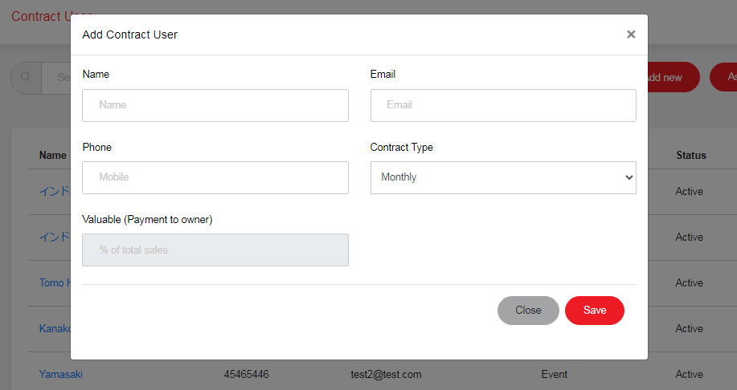
Fig 6.2: Add contract user screen

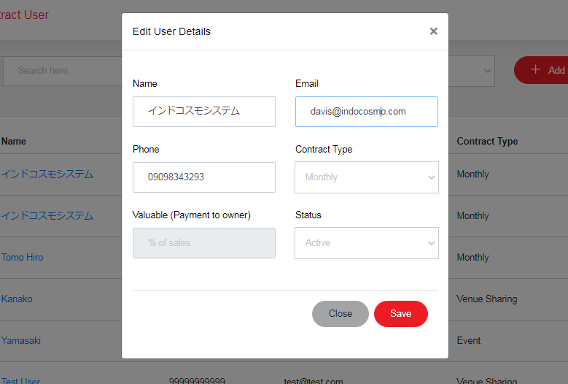
Fig 6.3: Edit contract user screen

Process:
Contract user information will be stored in database.
Currently we have 3 contract types 1) venue sharing 2) event and 3) monthly. Admin can choose the contract type from the contract type list.
For monthly type, payment to contract user is not required. So the rate information will be disabled for monthly type contract user.
All these contract users will be listed at contract user selection in Add/Edit screen of Devices. Admin can assign a device to a contract user in Add/Edit screen of device.

Assign Device
Admin user can assign multiple devices to a contract user in this screen.
User can select multiple devices as shown in the screen (Please see figure Fig 6.4). Select the location to filter the device list based on location. Click continue button after selecting the devices. Select contract customer from the list in popup (Please see figure Fig 6.5) and click assign button to finish the process.
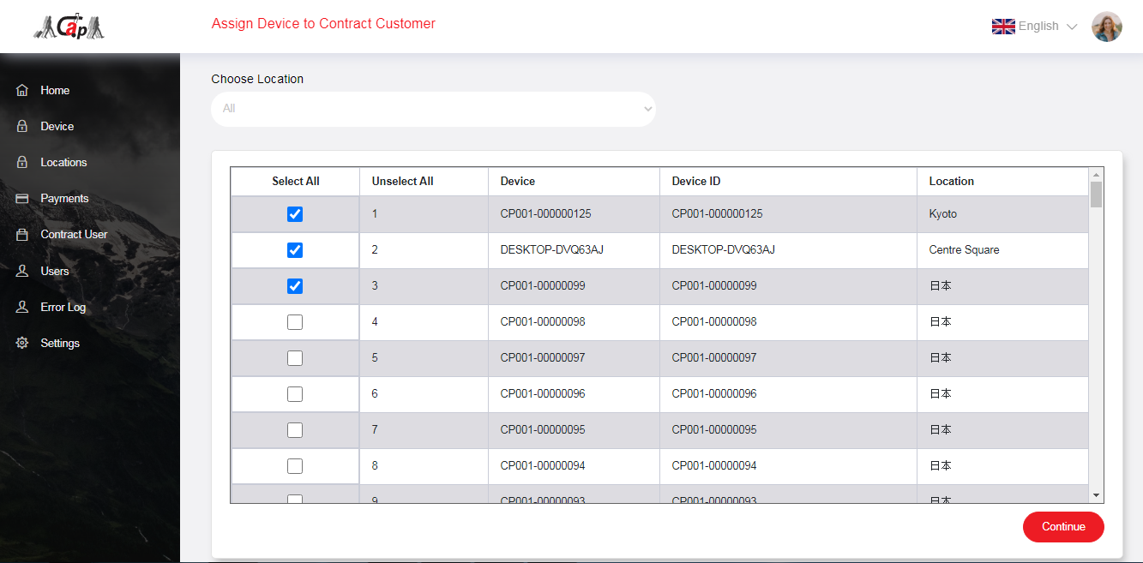
Fig 6.4: Assign device screen

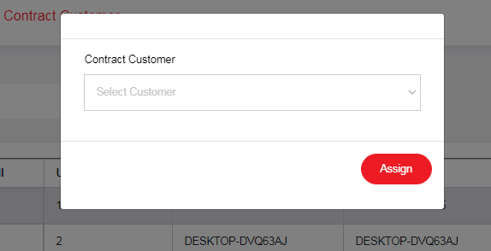
Fig 6.5: Select customer screen

Contract User Detail page
Display the Contract User details here. Details like number of devices, total number of transactions (locking transaction), contract type and transaction details are shown in this screen. Please see figure Fig 6.6
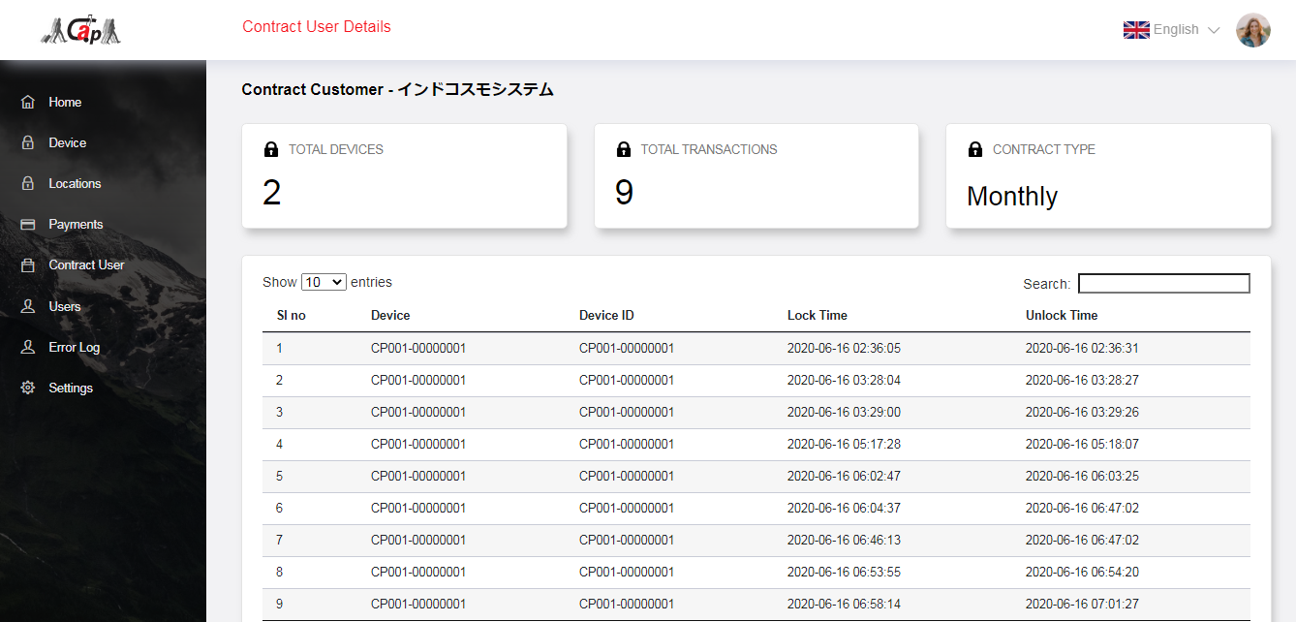
Fig 6.6: Contract user detail page

Payments
Displays the payment transaction list here. List includes the User name, Device name, Lock time, Unlock time, Total amount and a more button which shows detailed payment history (Please see the Figure Fig 7.2) including the Token, Payment ID, Payment method and Amount.
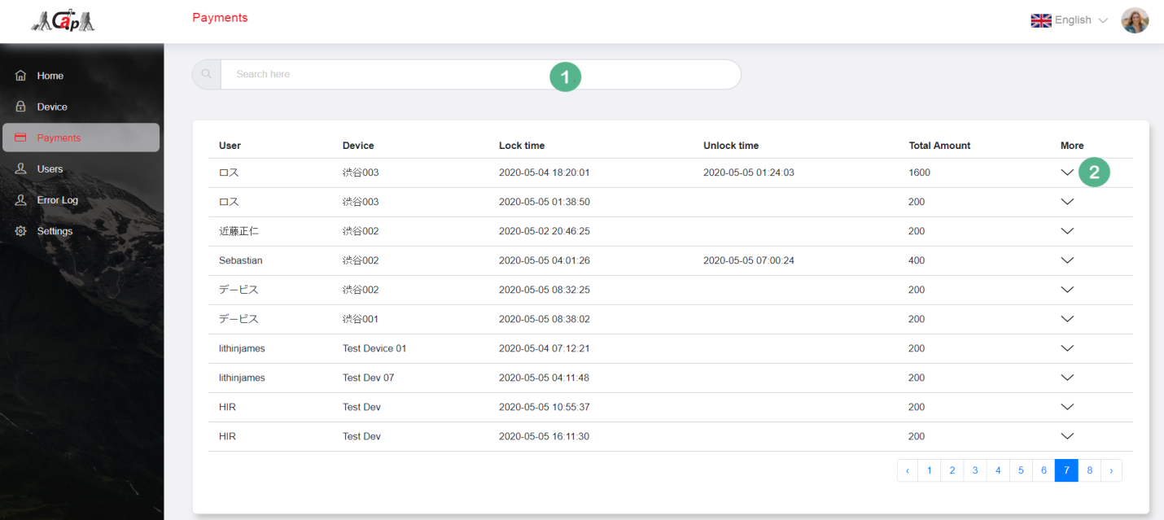
Fig 7.1
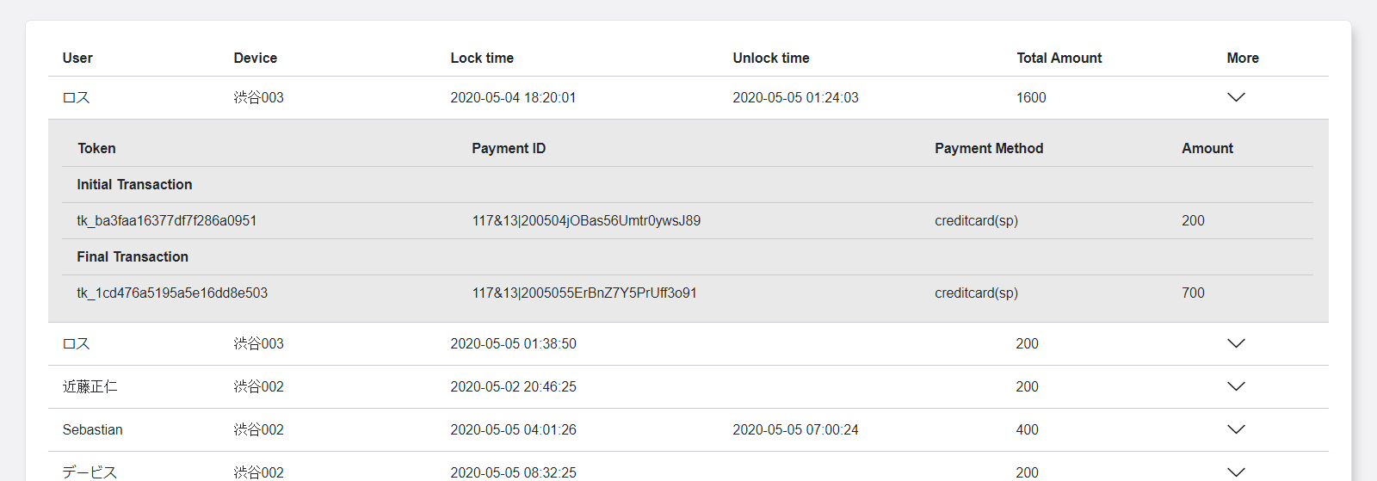
Fig 7.2

Sl# | Section | Description
1 | Search | The Payment listing screen allows the user to search for a payment information
2 | More button | Clicking this more button will expand the row and shows detailed payment history. Please see the Figure Fig 7.2

Users (CP Mobile App users)
Display the list of all registered Carry Park mobile app users. List includes the User name, Email, Mobile number, Date of Birth, Status and an Action button which contains View, Edit and Delete links.
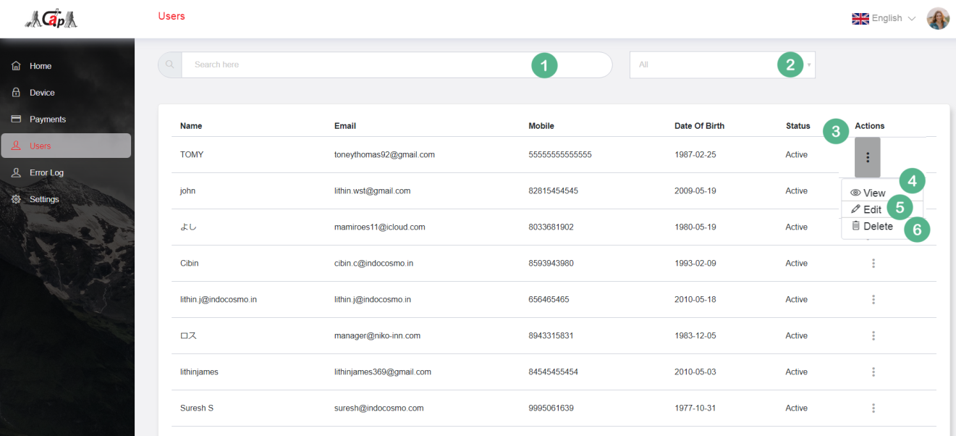
Fig 8.1
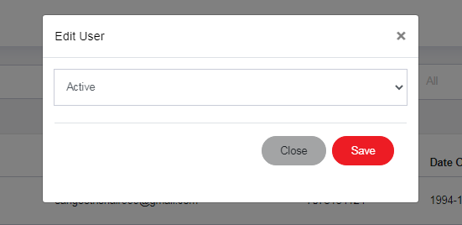
Fig 8.2

Sl# | Section | Description
1 | Search | The User listing screen allows the user to search for a user detail.
2 | Dropdown | This dropdown help to filter the user list based the on the selected criteria.
3 | Action button | View, edit and delete links
4 | View | Click the button to load the popup screen with the details of selected user.
5 | Edit | Click the button to load the popup screen to edit the status of user.  Please see figure Fig 8.2
6 | Delete | Click this button to delete a user from the cloud.

Process:
Mobile App users are registered through the registration screen in Carry Park’s mobile App (both iOS & Android). Admin user can make any mobile user inactive or active using the edit screen.

Error log
Display the list of all operational errors reported during the mobile app usage. List includes the Device name, User name, Error code, Error message and Time.
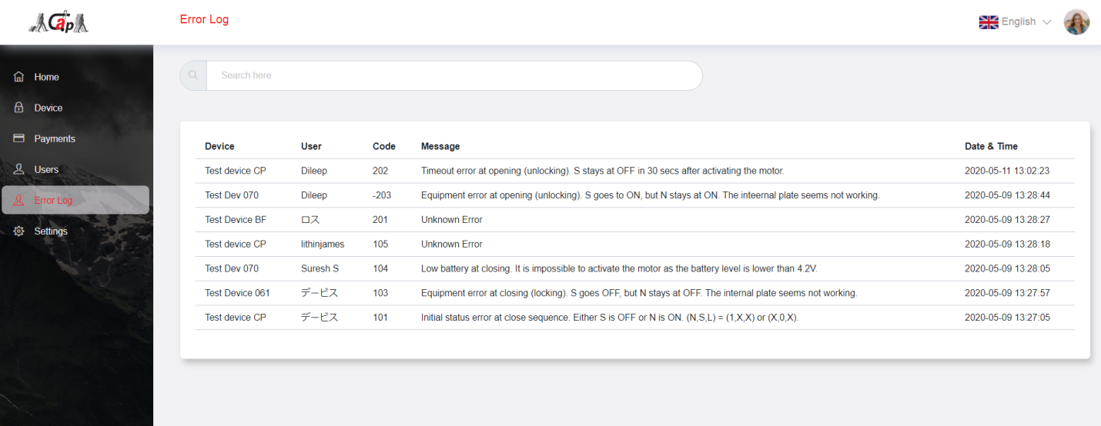
Fig 9.1
Process:
Carry Park Mobile App sends the operational errors happens during the communication with the Locker devices to the server. Error details will be stored in the cloud.

Settings
Users can set the general configuration details like initial charge, rate per hour, maximum hours, serviceUUID, characteristicUUID, wait time after QR scan and wait time after payment in this settings screen.
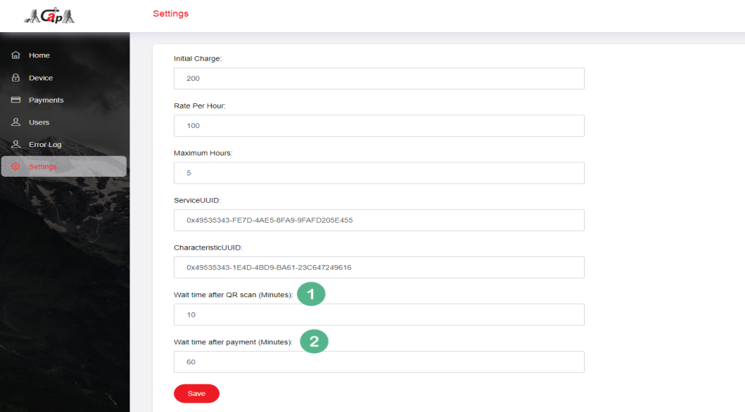
Fig 10.1

Sl# | Section | Description
1 | Wait time after QR scan(minutes) | If a user has scanned a device, that device is reserved for that user for a period of time. No other user can scan the same device during this period. Set the time in minute. For example: 10 minutes.
2 | Wait time after payment(minutes) | If a user has done the payment for a device, that device is reserved for that user for a period of time. No other user can scan and use the same device during this period. Set the time in minute. For example: 60 minutes.

Process:
Common values like Initial charge, Rate per hour, Max time, ServiceUUID, CharecteristicUUID is set here. When user register a device these values will be populated automatically.

